**Installation and Customization of Moodle ILMS**

**Introduction**

Moodle, an acronym for the Modular Object-Oriented Dynamic Learning Environment is an Integrated Learning Management System (ILMS) developed by Martin Dougiamas, an Australian technologist. It was developed as an open-source LMS and the first version was released in 2002. The current stable version of the software is version 3.10 released in January 2021. Presently the Moodle is available for Windows as well as Linux operating systems.

[[[The organization should not only analyze the characteristics of LMSs in question but also evaluate e-learning project and organizational capabilities before making the decision of open-source vs commercial options]]]

**Installation and initial configuration**

[[[there enough amount of hardware and network connection services available for the project?

Since there will not be a technical support service in an open source LMS, can IT unit of the organization merge their knowledge and expertise with documentations and forums to solve problems?

How much effort is required to adapt the LMS to existing systems?

Answers to these questions can be used as supporting factors in the decision of LMS selection. With a team capable and adaptable to new technologies, it is possible to implement powerful but low-cost e-learning projects by using an open source LMS. On the other hand, using an open source LMS with a team lacking enough capability and motivation will lead to failure, total amount of wasted time and resources may be higher than that of selecting a commercial LMS with expert advisors for the project.

*Learning Management Systems and Comparison of Open Source Learning Management Systems and Proprietary Learning Management Systems///*

*Doğancan Ülker, Yücel Yılmaz*

]]]

The present project started with the Moodle stable version 3.6 and later upgraded to the stable version 3.9 released in November 2020. The operating system used is Ubuntu linux version 18. The other supporting software tools used were:

1. Mariam DB
2. Apache
3. PHP

The hardware used for the installation are:

1. Dell Power Edge Server Copmuter
2. Memory:
3. Hard Disc

After installation, the site was accessed using the admin login credentials and the following settings and configurations were made.

1. **Setting up of the Site Homepage**

The site homepage was setup under Site Administration > Appearance > Front Page > Front Page Settings

The major front page settings made include the full site name, short name, items to be displayed on the front page, items to be displayed for the logged-in users. The full site is named as ‘E-learning @ AIISH’ and the short form as ‘AIISHeLearn’. Also, the default eGuru logo was replaced with a new logo titled ‘e-AiiSH’.

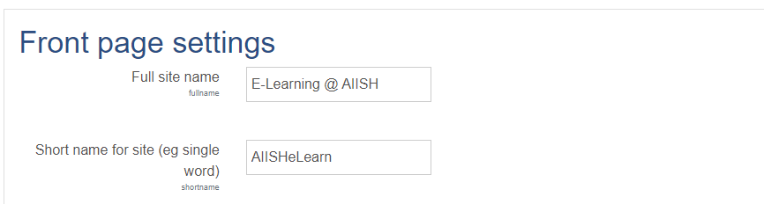

**Selection, Installation and Customization of Theme**

One of the major concerns of several moodle LMS users is its non-appealing and nonintuitive interface developed on either of the two standard themes bundled with the moodle installation package, *Boost* and *Classic*. However, hundreds of moodle themes are available for free downloading from the official website of the Moodle at [www.moodle.org](http://www.moodle.org) which are user-friendly and provide completely new look and feel for the site. These themes are developed by third parties. There are many other user-friendly and priced moodle themes available on the Internet. The moodle official website listed totally 94 themes supporting different versions of moodle. Of these 19 themes supported the moodle version 3.9. From them, the one titled Eguru was selected for the proposed site. The Eguru is a simple and responsive moodle theme with shorter navigation paths developed by M/s LMSACE E-learning Experts (Figure 1). It is adopted by more than 8,000 e-learning sited developed using moodle.

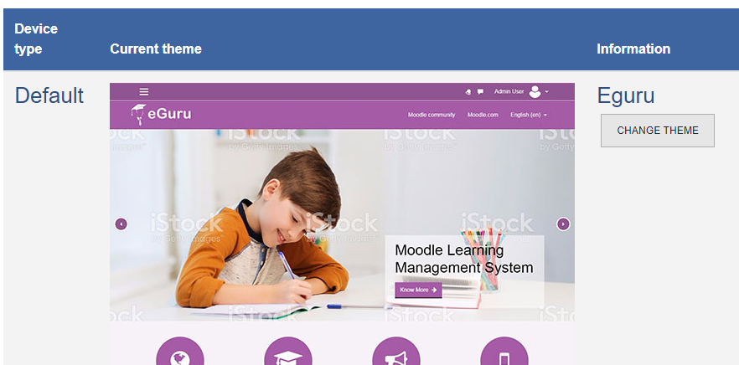

Figure 1: Eguru theme installation

The Eguru theme was further customized by incorporating a logo, images, static pages and banner as given in figure 2.



**e-AiiSH Homepage**

**Setting up of SSL certificate**

The SSL (Secure Socket Layer) certificate currently known as TLS (Transport Layer Security) certificate ensures privacy and confidentiality of the private information such as user login credentials, bank accounts, name, address, date of birth, telephone number etc. on a website through encryption process. Upon installing an SSL certificate, the hypertext transfer protocol (http) will change to hypertext transfer protocol secure (https) with a prefixed padlock icon. The SSL/TCS certificates are issued by the Certification Authorities (CAs), the trusted organizations who verify websites and ensure the reliability of the sites. There are both open and commercial certificate authorities.

**Outgoing mail configuration**

**User Authentication**

User authentication is the process of verifying and validating the credentials or identity of a person while he is trying to access a computer-based system. The objective is to avoaid unauthorized access to the system and resources.

The e-AiiSH has been completely protected from unauthorized access and allows access only through user-name and password. All the faculty and student accounts were created manually using the Admin rights with the provision for resetting username and password. The first name of the users in small letters is given as user name and Aiish@123 as password. All other Moodle authentication tools such as e-mail based self-registration, LDAP authentication, Shibolith authentication etc. were disabled.

**Implementing SSL Certification**

**Integration**

To enhance the learning experience, Moodle also offers several free and paid integrations.  Some of the certified integrations for Moodle are – BigBlueButton, Bongo, Intelliboard, SimCheck, GO1, JFusion, Joomdle, and Promoodle. Programs such as Respondus, StudyMate, BigBlueButton, Turning Tech, Turnitin2, Certificates, Attendance, Tegrity, Questionnaire, Virtual Programming Lab, and Badges work right in with Moodle.

Instructors can even use Camtasia and Snagit software for effective in-screen capture, recording and video editing.

Moodle has also developed integrations with other education systems, such as Student Information Systems (SIS’s). You can even integrate Moodle with WordPress and WooCommerce for [selling your Moodle courses via multiple payment gateways on WordPress powered by WooCommerce plugins.](https://edwiser.org/blog/sell-moodle-courses-automated/)

Apart from that, it offers Learning Tools Interoperability (LTI) that helps to integrate third-party tools with your course. LTI integration can be useful for creating digital lessons and activities so that other digital tools can be embedded within your canvas study materials. But most LTIs are only accessible via an actual course. [Here’s the list of all the integrations supported in Canvas](https://community.canvaslms.com/t5/Admin-Guide/What-integrations-are-supported-in-a-Canvas-account/ta-p/220).

You can even improve your course with other web applications and internet resources. Canvas integrates with third-party vendors extremely well.

These integrations allow you to use additional tools such as McGraw-Hill Connect, Kaltura, Box, Office 365, Google Drive, and many more to deliver course materials and pass grades back to the Canvas grade book. Along with integrated learning resources, you can also enjoy the benefit of integrated media reporting in Canvas LMS.

At the beginning of *term 1*, all first-year MBBS students (95 men

and 121 women, age: 20.10 _ 0.49 yr, mean _ SD) were requested

to self-register at the DPhysiol site using individual user names and

e-mail addresses. They were given a short briefing about DPhysiol

during their introductory week (all of them were first-time Moodle

users). Along with a set of instructions on the registration, students

were also provided with an enrollment key, which acted as an access

code to the site. When the enrollment key was first entered, students

were automatically placed into 10 separate groups based on their

tutorial grouping assigned by the faculty. Enrolment to DPhysiol was

made available from the beginning of *term 1* until the end of *term 2*

and was not made compulsory.

A total of seven lecturers from the Department of Physiology,

University of Malaya, were assigned as tutors in DPhysiol. The course

content was managed by K. Seluakumaran, who was also one of the

tutors. The installation and administration of Moodle (version 1.9)

was handled by the Academic Development Center’s personnel in our

university (http://adec.um.edu.my/code). The site was hosted by the

server of the Information Technology Center located on our campus.

**Integration of Video Conferencing System**

1. **Big Blue Button**: One of the major tasks in our Moodle implementation was the integration of Big Blue Button.

**Theme Selection**

Learner interface deals with the acceptability of the colors, background, layout, buttons, links, fonts and navigation experience of the users. The standard MOODLE theme was used in this study in which the colors, background, etc. were in the default mode.

As Malik (2009) highlighted that friendly interface of the online learning environment is one of the factors which influence student satisfaction towards online education.

Videoconferencing System

The videoconference tool has been tested on a virtual machine with 300MB of RAM with 20 people connected simultaneously and has shown no defect or excessive load.

**Announcement**

In Moodle the announcement functionality gets created automatically along with the course creation. Only the instructor can post to the Announcement. Also, they can attach files to the Announcement. Every enrolled student is forced to subscribe to the Announcement.

*Online Course Content*

The course content in Moodle is typically organized in topic format

(6, 30). A screenshot of DPhysiol is shown in Fig. 1. We designed

DPhysiol content using the following topic outlines.

**Moodie plug-ins**

The following Moodie plug-ins should be also provided **in addition to the Moodie core features:**

Essentia l theme

Questionnaire activity

Attendance activity

Checklist activ ity

Collapsible course format