**VIRTUAL CLASSROOM**

The digital replica of a traditional classroom is called **virtual classroom. Two** videoconferencing tools have been integrated and activated on the **eAiiSH** to facilitate virtual classroom. They are **BigBlueButtonBN**, an open source tool and **Congrea**, a proprietary application available in both free and paid versions. Both can be added to the courses like adding other activities such as assignment, quiz etc.

**Setting up of Virtual Classroom using BigBlueButtonBN**

As indicated above, the BigBlueButtonBN is an open source video conferencing tool. It has the following features and functionalities for teaching online: (i) Chat window for text communication, (ii) Webcam sharing , (iii) Audio sharing , (iv) Status indicators permitting participants to indicate emotion, opinion or status like happy, unavailable, raised hand to ask a question, (v) Break out rooms to encourage group discussion with learners, (vi) On the fly polls to solicit opinions and trends within the class, (vii) Whiteboard to visually support topic content (learners may also contribute to the whiteboard), (viii) Visuals as the focus of the session (E.g. video, images, slide shows, animations, web links) (xi) Desktop or application sharing to demonstrate processes or share a presentation.

1. **Click TURN EDITING ON button on the course page**
2. **Click 'Add an activity or resource' link** in the course page where you want to add the **Virtual Classroom**
3. **Choose BigBlueButtonBN**  from the list of activities and resources.

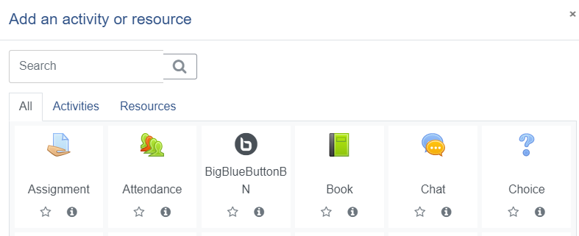

1. Select the **Instance type** as **Room/ Activity Only**
2. Under **General Settings** enter a **Name** for the virtual classroom, ideally the topic of discussion or presentation and a **description** if necessary.
3. The description may be made available on the course homepage.
4. Under Activity/Room settings, enter a Welcome message
5. Do not click the option **Session can be recorded**
6. Under **Participants, m**aintain the default settings for the **Add participant** entry. Also, make sure that, under **Participant List**, thesettingsfor ***All users enrolled*** *as* ***Viewer****, the* ***Role Teacher*** *as* ***Moderator*** *and the***Role** **Student** as **Viewer**.

Note: A **viewer**, usually  a *student* can chat, send/receive audio and video, respond to polls, and display an emoji such as raise hand. They can also draw on the whiteboard provided the presenter permits and join a breakout room. The viewer, however, doesn’t have any control over the session itself. That’s the role of the moderator.

A **moderator**, usually the *teacher*, has all the capabilities of a viewer plus the ability to mute/unmute other viewers, lock down viewers to restrict them from doing private chat, and assign anyone (including themselves) the role of presenter. A session can have multiple moderators. Moderators can also eject any user, start/stop recording, end the session at any time.

The **presenter** controls the presentation area. He can upload slides, annotate the current slide with the whiteboard controls, enable/disable multi-user whiteboard, start a poll, and share their screen for all to see. Only one person at a time can be presenter.

1. Under schedule for session mention the timing of the virtual class session using the **Join** **open** and **Join closed** options.
2. Maintain the default settings for the Common module, Restrict access, Activity completion, Tags, and Competencies.
3. Click SAVE AND DISPLAY button
4. In the resulting window, click JOIN SESSION button

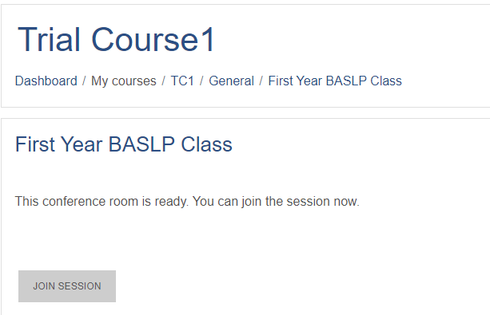

1. The system will first do an **echo test** for checking your computer’s audio
2. The introductory window has three portions: The main presentation area, left side chat area and an extreme left panel with users list and other facilities like public chat and shared notes.

In the participants list, the moderator’s icon will be in square shape and the participants’ icon in circle.

The teacher can mute the participants.

The teacher can also record the session and pause as and when required.

The teacher can lock the students and by doing so they can be prevented from viewing others’ webcam, private chat, public chat, sharing microphones,

From the users’ list any name can be clicked and make private chat with that person.

The shared notes section is a collaborative area where everyone can write.

The User can click against her own name in the participants list and set her status like Away, Raise, Undecided, Confused, Sad, Happy, Applaud, Thumbs Up, Thumbs Down

In order to open the webcam, click the icon at the bottom. Select Camera and click **sharing. The presentation area can be minimized and webcam can take the whole place.**

The Presenter can upload the slides and optionally downloadable by the students. The teacher can draw on the presentation slides. The students can also be permitted to draw on the whiteboard.

1. Click the + button at the bottom left side
2. Click the slide button to create whiteboard slides.
3. The whiteboard is with a toolset on the right side using which we can write on the board using text, pencil, draw trainle, square and **Undo** and **Clear** all the items wrtiien.

offered by integrating two web-based video-conferencing system. The teacher can

1. **Setting Up of Virtual Classroom Using CONGREA**

CONGREA is another open source video conferencing tool. Unlike BiBlueButtonBN, Congrea is a proprietary commercial video conferencing tool. The features of the Congrea for setting a virtual classroom include whiteboard, document sharing & annotation, online video sharing, screen sharing, poll, quiz, audio-visual interaction, collaborative real-time editor, HTML5 presentation sharing, private and public chat, ask question, notes and bookmarks, session recording and playback.

1. **Click TURN EDITING ON button on the course page**
2. **Click 'Add an activity or resource' link** in the course page where you want to add the *Virtual Classroom.*
3. **Choose Congrea** from the list of activities and resources.

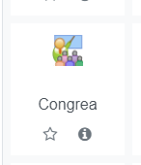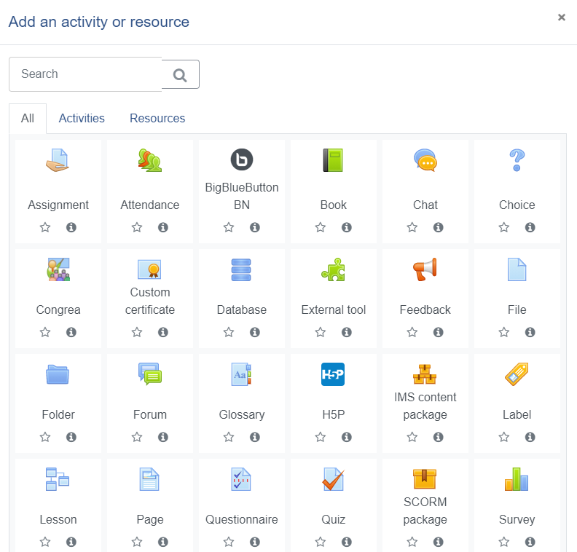

1. Under Generalsettings enter a **Name** (*congrea name*) for the virtual classroom, ideally the topic of discussion or presentation and a **description** if necessary.

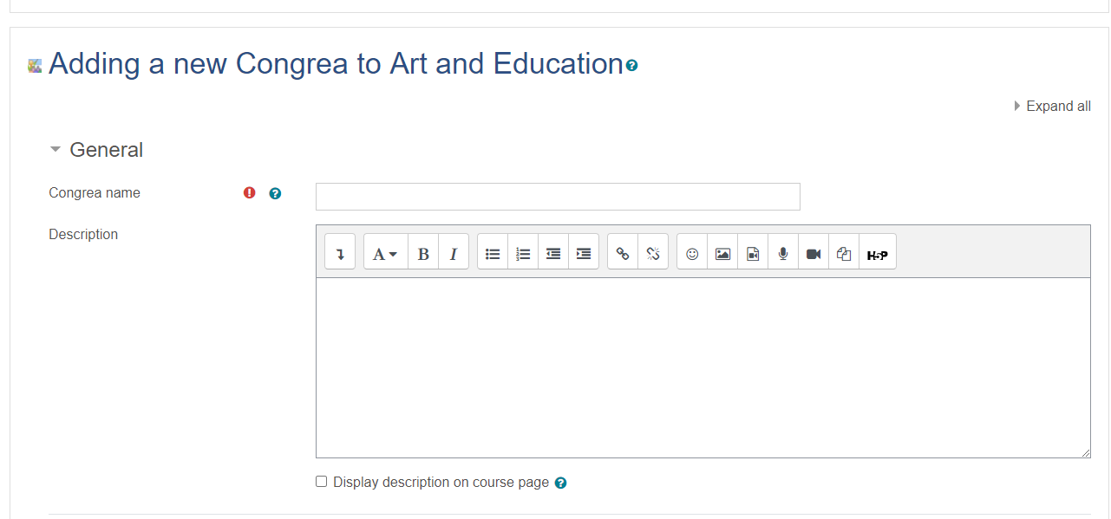

1. The *description* may be made available on the course homepage by ticking option.

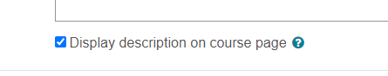

1. Maintain the default settings for Common module, Restrict access, Activity completion, Tags and Competencies.
2. Click SAVE AND DISPLAY button at the bottom.
3. In the resulting window, click on Schedule session(s) button

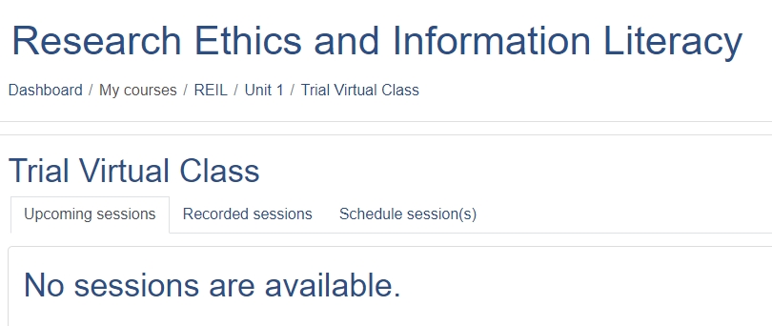

1. Under Schedule session(s) click ADD SESSION button

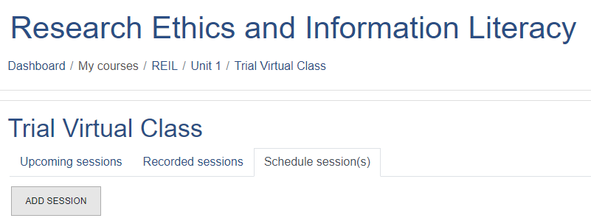

1. Schedule the session by entering Session start time, Time duration in minutes and selecting presenter (*The default presenter is teacher*).

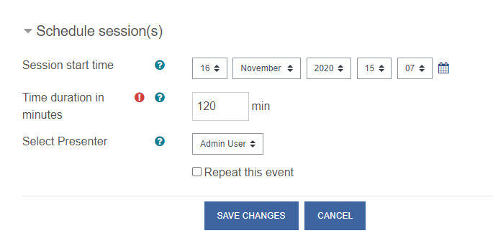

**Note**: In order to keep the session as open-ended i.e. without time limit, put ‘0’ as a value in the duration and then the classroom will stay open until this setting is changed.



1. To repeat the session, tick the repeat this event box and choose the number of weeks until you want your session to last, repeating session will allow you to run your session on the same day that you have scheduled it for the number of weeks that you have chosen. *It may be noted that open-ended sessions cannot be repeated.*
2. Click SAVE CHANGES button. The scheduled session will be reflected once you click the save changes.

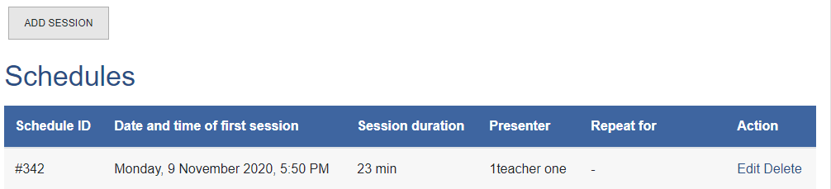

1. Multiple sessions can be added by clicking the ADD SESSION button above the **Schedules**
2. The already scheduled sessions can be edited or deleted by clicking the Scheduled Sessions button, and then clicking Edit / Delete button.

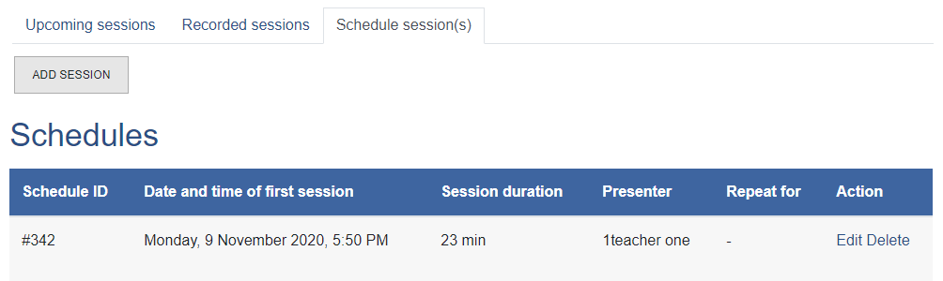

1. **Joining the session**
2. At the time of your scheduled session, click JOIN VIRTUAL CLASSROOM AS PRESENTER under **upcoming sessions** tab.

Note: A link to the upcoming virtual classroom session will also be created on the course main page/ dashboard

1. Upon clicking the JOIN VIRTUAL CLASSROOM AS PRESENTER button, the Congrea will first test (a) browser compatibility

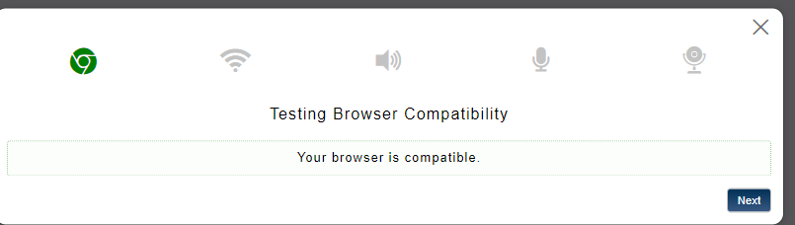

(b) Internet speed

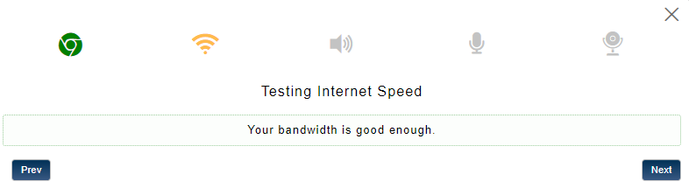

(c) Speaker

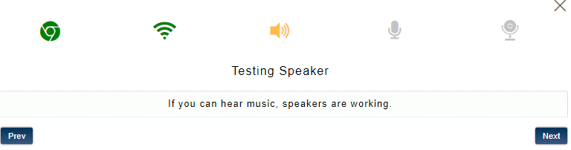

(d) Microphone

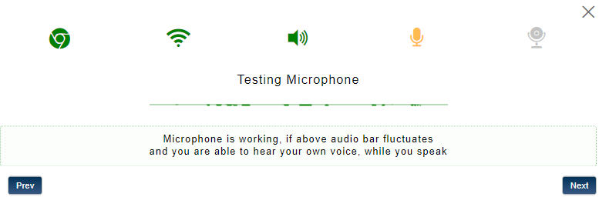

(e) Webcam

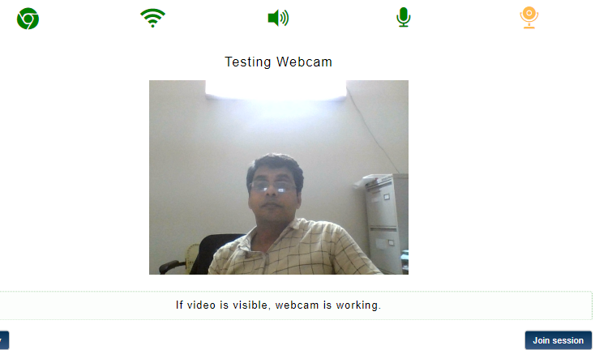

1. By clicking the join session button at the right corner of the *testing webcam* window the teacher can join the session.
2. The Congrea window consists of (a) A left side bar with various functionalities bar (b) Middle working space and (3) Right side frame with the presenters video on the top (*provided the video is on*) followed by the list of participants.

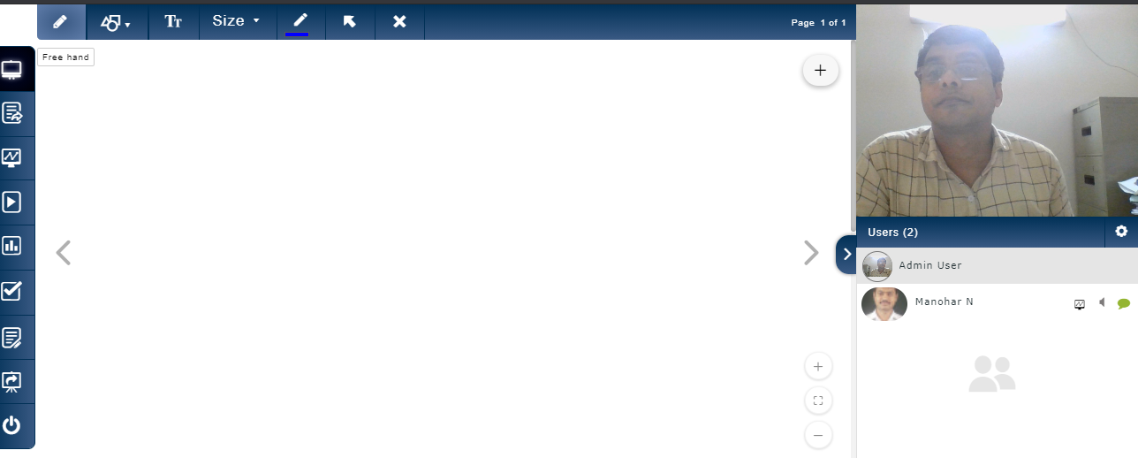

Document sharing

Session end

Presentation share

Quiz

Poll

Whiteboard

Screen share

Video share

Text editor

1. By default, the teacher will be taken to the whiteboard of the virtual classroom. (*The first icon on the left side bar*). On whiteboard, the teacher can write and delete the text using the tools set available on the top of the middle working space. It is also possible to use standard shapes with options to resize and color.
2.  The next icon is for sharing and annotating document with shapes and text. Document types supported include .pdf, .ppt, .docx, .gif, .txt, .xml, .pptx, .doc, .jpg and .png. Upon sharing a document, a *document* *dashboard* will appear at the bottom of the left sidebar using which the uploaded documents can be managed and sequenced.
3. The third icon is for sharing the screen of the presenter. The students can also share their screen if the teacher enables.
4. Using the fourth icon, the teacher can share video, either stored in the computer or from the You tube. Upon selecting the share video icon from the left bar, a new frame, as shown below, will appear at the bottom portion of the middle working space. In order to share the video from the local computer click **Upload video** button, and to share a Youtube video enter the URL of the video in the space provided and click **Save** button.



1. The fifth icon is used for creating instant polls during the class session. The teacher can take feedback/opinion or ask questions using the poll.

**Setting Up of Virtual Classroom using Zoom** (*free version*) **as External Tool**

**Zoom** **Meeting** is a US-based **web conferencing** or **video conferencing** tool with facilities for desktop client and a mobile app. It is available in both free and paid versions. The tool allows the users to meet online, with or without video.The eAiiSHfacilitatesvirtual class using Zoom Meeting by integrating it as an externally hosted learning tool. Following are the steps involved in using Zoom Meeting on eAiiSH.

**Creation of Zoom Account**

1. The teacher has to create a Zoom account on the official website of the Zoom at https://zoom.us/
2. Visit the site and click sign up (The faculty *already having a Zoom account may skip the step and continue with sl. no. 4* )

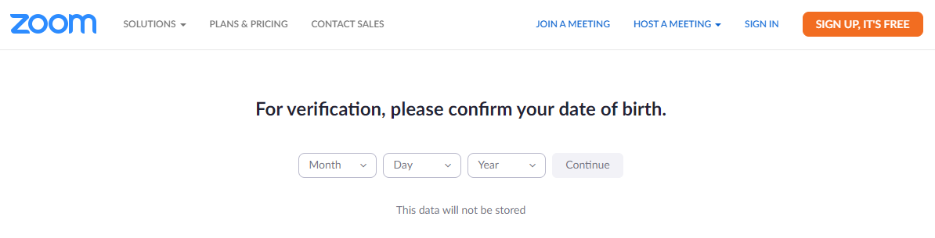

1. Enter your date of birth and click **continue** button
2. Enter the personal e-mail id (*It must be the same e-mail id registered with the eAiiSH*) and click **sign up** button
3. Open the email and check for an *auto activation link* sent by Zoom and click it to activate the account.
4. In the resulting registration window, enter the First name, Last name and Password.
5. Click **Yes** for the question *Are you signing up on behalf of a primary or secondary (K-12) institution?* andagree/accept the associated declarations. Then, click the **continue** button.

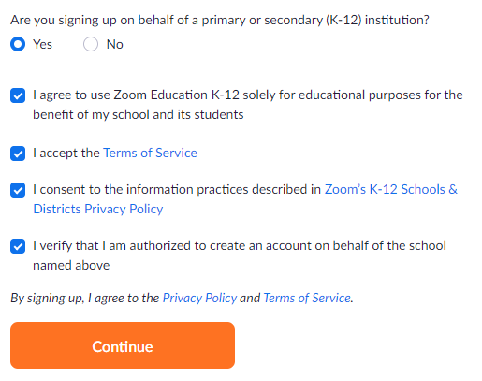

1. Skip the step **Don't Zoom Alone** byclickingthe button **Skip this step** at the bottom.
2. On the resulting **Start your test meeting** window, click the **Solutions** link on the top left.
3. Select **Marketplace** under **PRODUCTS**
4. Click on the **LTI PRO** icon under **All Categories**

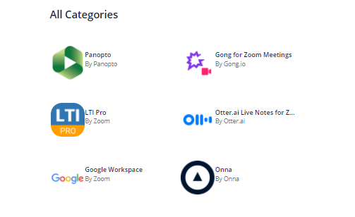

1. Turn on the **Pre-approve** button and then click **Install**

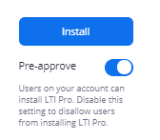

1. Click on **Authorize** in the resulting window titled **LTI Pro is requesting access to your Zoom account**

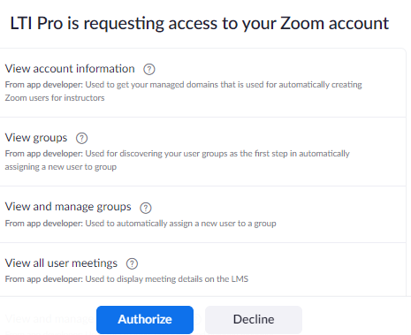

1. Click **Create a new credential** button in the new window

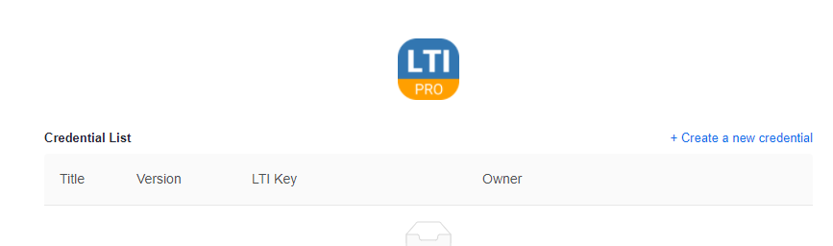

1. Create a credential by entering your name followed by a hyphen and the wording “Zoom meeting”. E.g. Manohar-Zoom meeting. Maintain the default selection of **LTI version** as **1.1.** and **SAVE**.

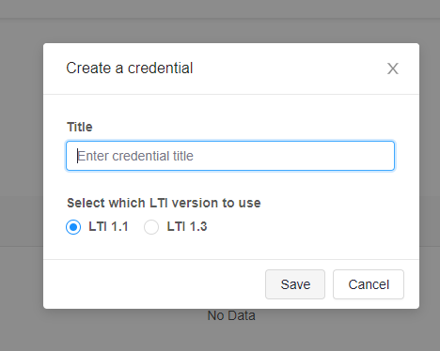

1. Copy the following into a Word document and sent to the eAiiSH administrator.
2. Credential title
3. LTI URL
4. LTI Consumer Key
5. LTI Secret Key

1teacher-ZoomMeet

**LTI URL**

**https://applications.zoom.us/lti/rich**

**OAuth Redirect URL**

**https://applications.zoom.us/lti/rich/oauth/complete**

**LTI Key**

**nR6hcOcoQTSO1syqUF1xUg**

**LTI Secret**

**RhXknybiIPIxDFp6Q8gX43SiP6yUepFFNZUN**

**Creation of Virtual Classroom**

Once, the Administrator pre-configured the teacher’s Zoom account on eAiiSH, the teacher can login to the eAiiSH using her credentials and create Virtual Classroom on Zoom

1. Click **Turn Editing On** button
2. Click Add an Activity or Resource
3. Select External Tool from the Activity chooser
4. Teacher’s Personal LTI key

Secret Key

Share the Personal LTI key, Secret Key with the Administrator