Audio & Video Resources

**Introduction**

Audio and video are two powerful resources which can be added to a course. Students can view or listen to the media content, catch up on lectures they have missed, and view demonstrations of the content discussed in class.

**Adding Video Resources to a Course**

The audio and video files can be added to a course by **uploading** / **embedding** / **linking** functionalities. In case of **uploading**, the media file will be stored locally in the computer and the media player will be displayed on the course area where it has been uploaded. Here, the teacher will have ultimate control over the media. When media is **embedded**, a media player appears directly on the page allowing students to view or listen without leaving the page. The **linking** takes the student to the website where the media is located.

*It is always suggested to use the embedding and linking features instead of uploading as there is server space restrictions.*

**Audio**  
To embed audio clips directly on your course page, insert the audio in a *Label*. The audio player takes up minimal page area and will fit nicely in your list of activities within a course *Section*. Audio can also be embedded in a Page, Forum post, Activity description, or anywhere you see the Moodle HTML Editor.

**Adding a YouTube Video**

There are several methods to add a YouTube to your Moodle course

1. **Using a URL resource**

The easiest way to add a YouTube video is to add a link to the video, by adding a URL resource.  Copy the URL of the YouTube video and paste it into the External URL box. (Figure )

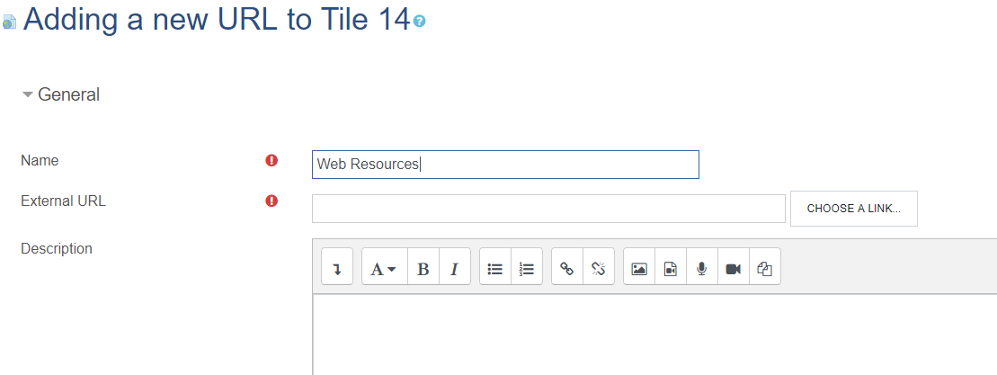

1. **Using a Label Resource**

Create a **Label** resource and inside the Text Editor click the chain icon (Figure ) on the toolbar of the text editor and enter the URL in the given textbox (Figure )

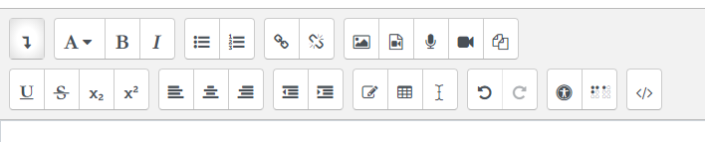

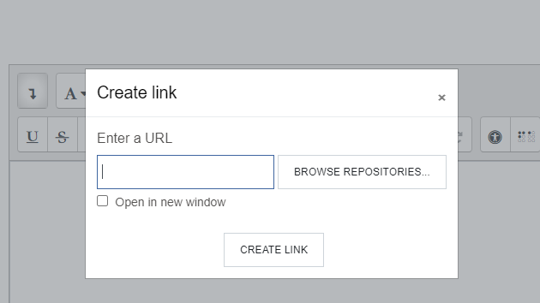

*It may please be noted that even though we are inserting a link, the system will replace the link with an embedded video.*

You can also embed a video from YouTube into your course using the following steps

* + Add a new **Page** in Moodle (under resources)
    - Go to the HTML source view by clicking on the filmstrip button   in the content box. A pop up will appear
    - Go to YouTube or Vimeo and copy the video embed code. This is under the "Share" link.
    - Head back to Moodle. In the pop up window, paste the video URL in the field labelled "Enter URL".
    - In the next field, give your video a friendly name.
    - Click the "Insert" button.

# **Adding a Video from Google Drive**

You can upload many common video files to Google Drive and view the videos right from within Google Drive.  This is handy if you want to control the permissions via Google Drive or want to avoid the ads in the YouTube interface.  Upload the video to Google Drive just as you would any other file.  When you click on the video it will display within the Google Drive interface (it may take a few minutes to process after you have uploaded the video).  To add the video to Moodle, copy the URL to video (or a folder with several videos) and add it to Moodle as a url link.  Make sure to set the permissions of the video appropriately.  Most instructors will allow anyone at Swarthmore or any users with the link to view the video.

Google Drive will compress and reduce the quality of the video a bit.  For most purposes this is fine, but if you require the highest quality video, you will likely prefer one of the other methods.

# **Uploading a video**

If you have your own video you want to add to Moodle, you can upload it just like any other file or embed it in a Moodle page using the Moodle Media button

## Embed a video file on a Moodle page

Moodle has a built-in media player that can play videos.  The player can be inserted into any text editing box.  Typically, most users create a new page in Moodle and then click on the "Insert Moodle Media" button (looks like a filmstrip) in the page editor.  From here you can upload your video and Moodle will embed the video within a player on the page.  You will not see the video player while editing the page, but it will show up when the page is saved.

# **Preventing Auto-Embedding of Videos**

Suppose you create a link to a YouTube video in a label, page, or other description field. In that case, Moodle will automatically embed the YouTube video instead of just linking to the video.  Similarly, if you insert a link to a video or audio file in a text editor, Moodle will convert the link to an embedded media player.

If you just want a simple link, you can do one of the following things:

1. Add the link by using**Add a resource or activity** → **URL**.  This will not embed the video.
2. Turn off automatic multimedia embedding for your course.  This can be set under**Gear Icon**(top right of page)**→ Filters → Multimedia plugins → Off**.  This setting will affect content in the entire course.  If you don't want to affect the entire course, you can turn the multimedia filter off for a single page by editing the page, clicking on**Gear Icon** (top right of page) **→ Filters** , and setting **Multimedia plugins**to**Off**.
3. Edit the YouTube link to prevent auto-embedding. For example, if the YouTube link is <http://www.youtube.com/watch?v=0PfzLRs7YC0>, adding a parameter to the middle will prevent auto-embedding: [http://www.youtube.com/watch?**embed=no&**v=0PfzLRs7YC0](http://www.youtube.com/watch?embed=no&v=0PfzLRs7YC0) (add the text in bold to the URL).  Note for advanced users: Moodle is looking for a match for watch?v=, so adding something to the middle disrupts the filter.