**Introduction**

The Course announcement as its name suggests, is a facility for making announcements related to a course. It appears automatically when a new course is created, at the top middle section of the course page. This is a useful feature and many use this forum in a Moodle course to announce exam dates, times or changes to exams, lectures or seminars, as well as important information about course work throughout a term or special announcements relating to events.

**Only the instructor can post in the New Forum. Students cannot post or reply.**

**E-mail notification**: When an announcement is posted via course announcements, an e-mail notification is sent to each user in the course. This can be an excellent way to ensure students are made aware of important course information, events or changes. Note that, If students have set their messaging notifications to not receive e-mail notifications, the e-mail will not be sent to them and you will not be notified of this. Announcements will appear immediately in the course announcement forum, however, the e-mail notification will be delayed for 30 minutes before being sent for distribution. This delay will allow you to edit the announcement before the e-mail notification is sent. This delay period is system-wide and not configurable by the teacher. However, teacher can force the announcement e-mail to be sent immediately at the time of its composing.

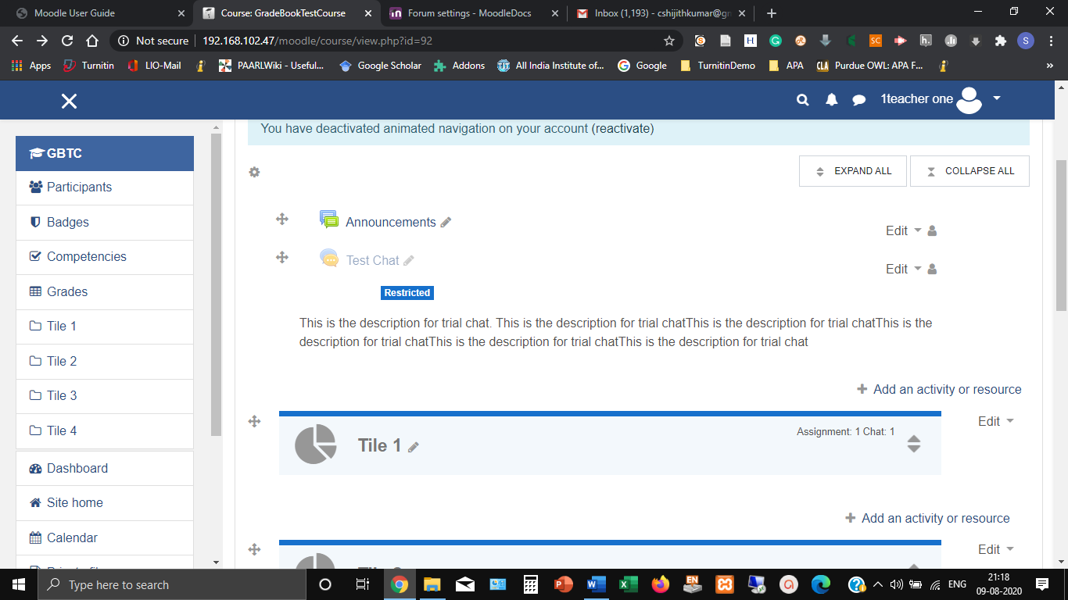

**Settings**

Follow the steps given below to configure the Course Announcement.

1. Click on Announcement button (with editing **turned off**) which will take you to a page for entering **Subject** and **Message** of the Announcement as shown in Figure.

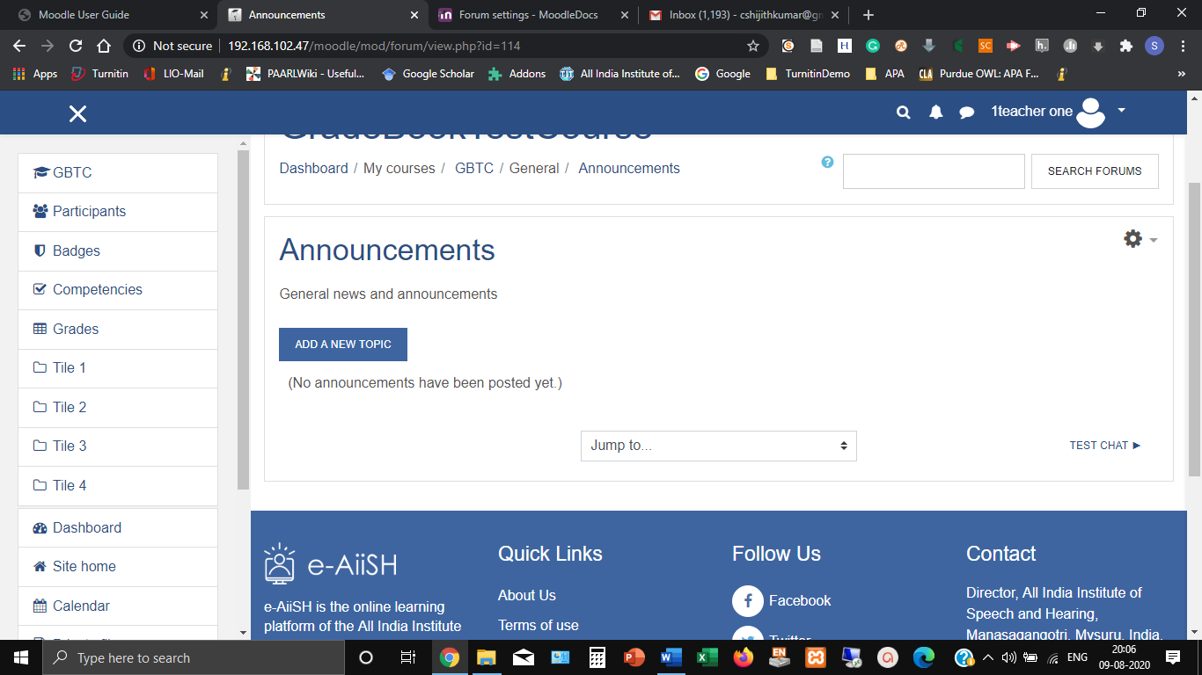

1. Enter the subject and the message to be announced. It may be noted that in addition to text message, the announcement can be also be in audio and video format and images, if any, can include in it. (Figure)
2. After entering the subject and message, click the **Advanced** tab below (Figure)

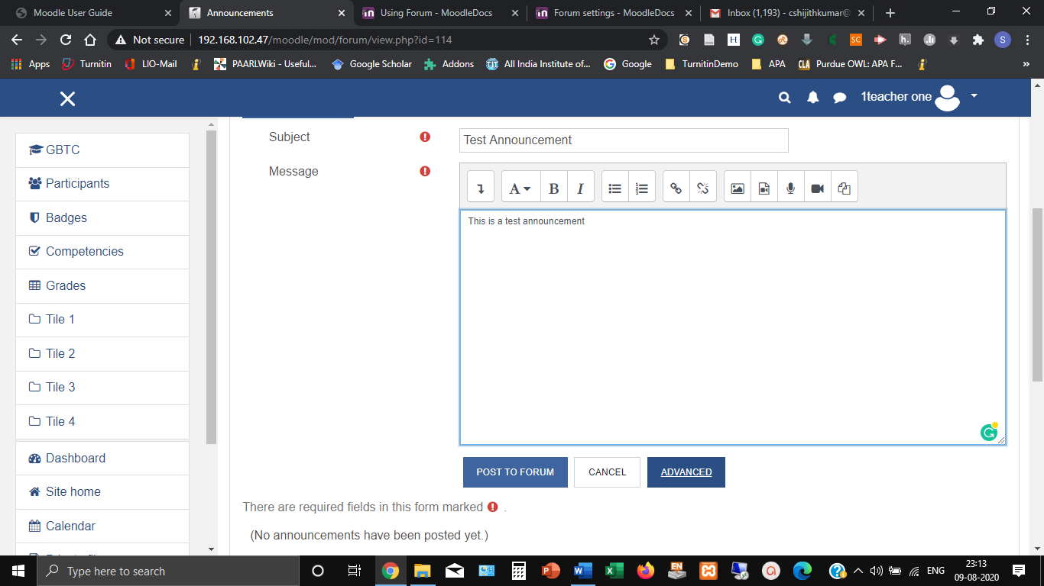

1. You can see that by default settings has been made for the announcement to be subscribed by all the users. (*If required, it can be made optional by the site administrator*)
2. The teacher can attach files, if any, along with the message.

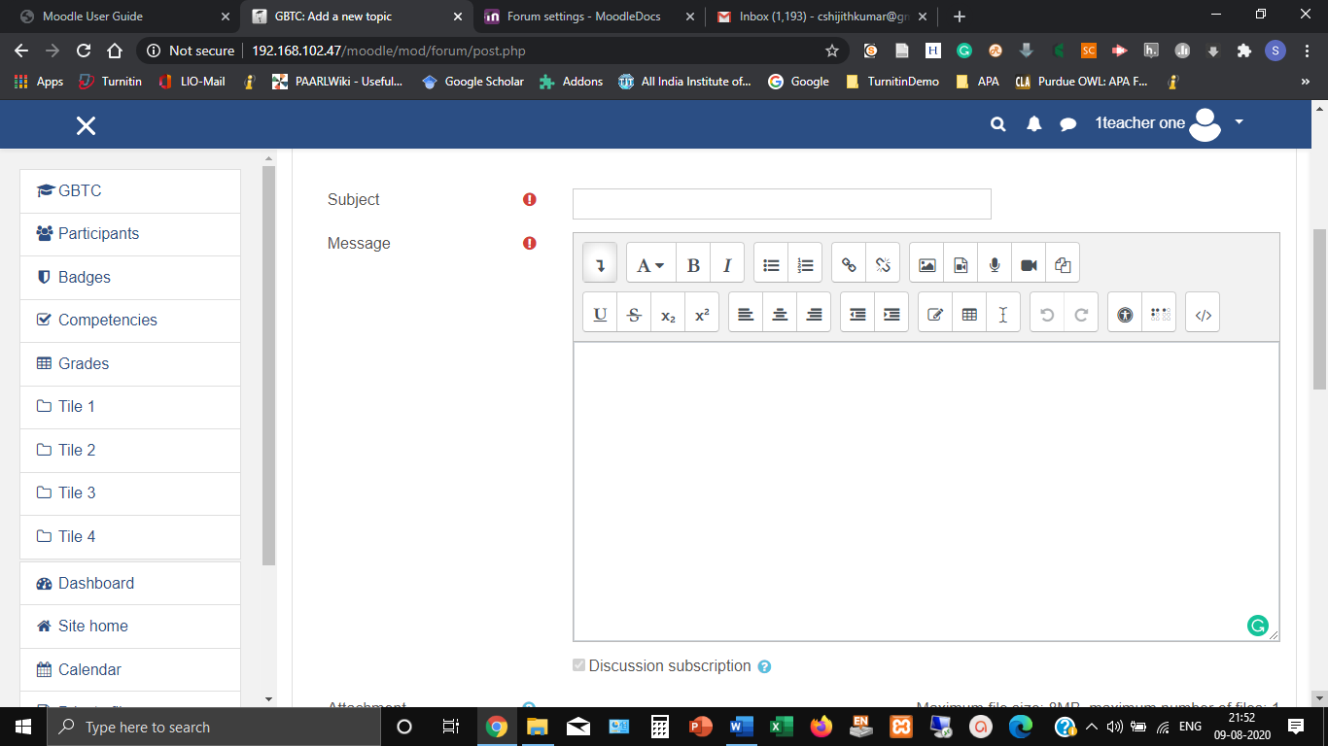

1. Tick ‘**Pinned**’ option to bring this announcement on the top of other announcements posting later (Figure).
2. **‘Send forum post notifications with no editing-time delay**’ will enable the user to distribute the announcement through e-mail without the default 30 minutes delay (Figure).

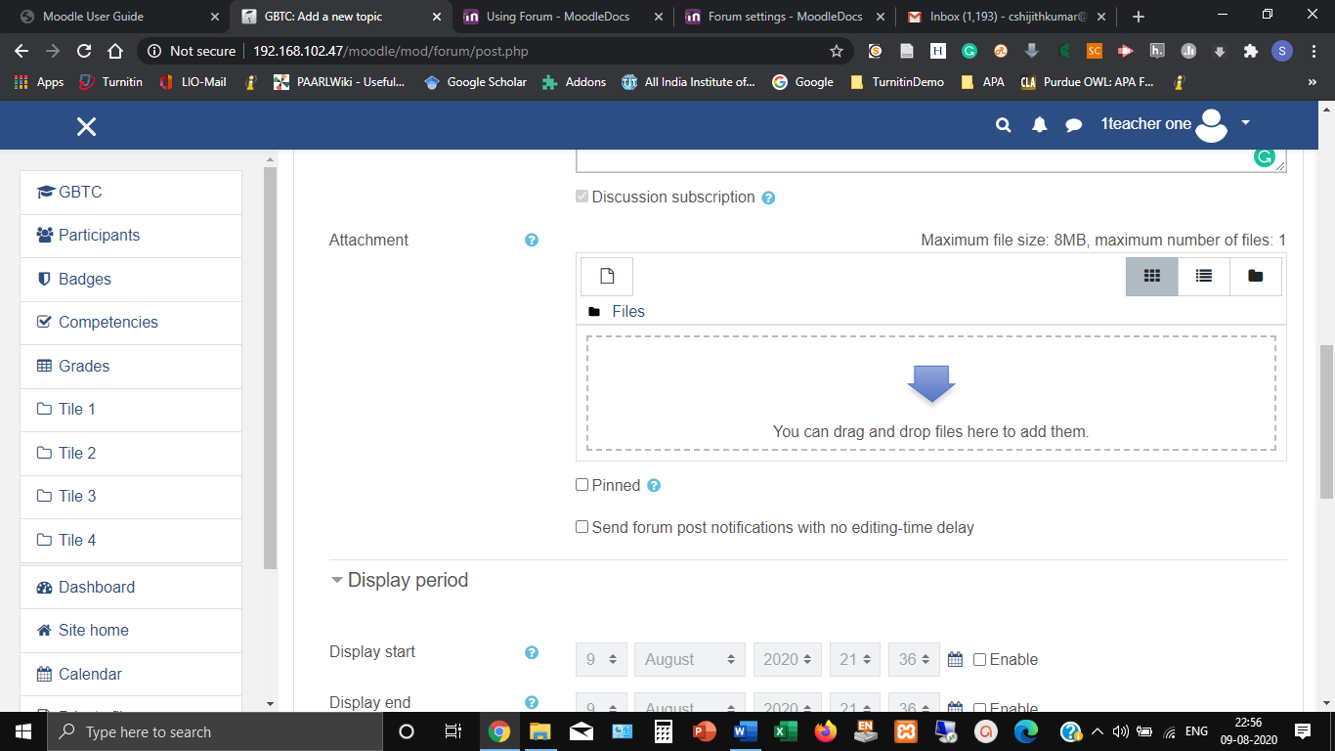

1. The teacher can set a display period of a date and time for the announcement to appear using the **Display Period** option (Figure).

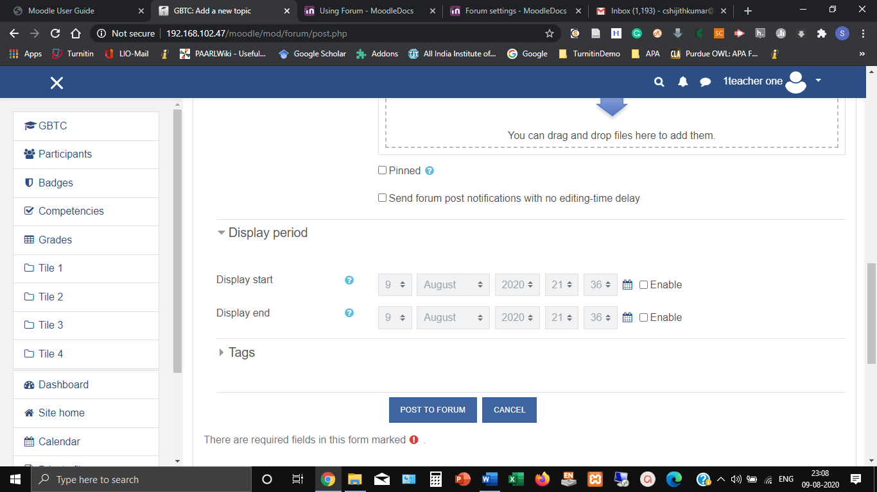

1. After setting the Display Period, click the tab ‘**Post to Forum**’.