**ALL INDIA INSTITUTE OF SPEECH AND HEARING, MYSORE**

**FORMAT FOR PROJECT REPORT**

**1. Title of the project and ARF project number**

Title of the Project: Design and Development of E-Learning Platform and Faculty Profile System

ARF Project Number: SH/CDN/ARF-Elect-3/2018-19 dated 09.10.18

**2. Principal investigator and co-investigator(s)**

Dr. Shijith Kumar, C., Dr. G. Malar & Mr. N. Manohar

**3. Implementing institution and other collaborating institutions**

All India Institute of Speech and Hearing, Mysuru, Karnataka, India

**4. Duration of the project**

24 months

**5. Date of approval/ sanction of the project**

SH/CDN/ARF-Elect-3/2018-19 dated 09.10.18

**6. Date of commencement of the project**

1st February 2019

**7. Date of completion of the project**

31st October 2020

**8. Extension of the project term, if any citing references to OMs conveying such extension(s)**

Totally, 9 months extension vide (1) SH/RCS/2019-20 dated 13.01.2020 for 4 months (2) SH/RCS/2019-20 dated 01.06.2020 for 2 months, and (3) SH/RCS/2019-20 dated 06.08.2020 for 3 months.

**9. Objectives of the project as approved in the RAC meeting**

The main objectives of the project are to design and develop an e-learning platform and a web-based faculty profile system for the institute using open-source tools and techniques. The specific objectives are:

1. To provide an open, flexible and reliable educational technology base for the institute
2. To create a blended learning environment conducive for both the learners and educators
3. To develop e-learning resources and tools that meet the educational requirements of the institute
4. To address the need for capacity building in e-learning technologies among the faculty and students
5. To formulate a policy on the adoption and use of e-learning system for the institute
6. To capture, preserve and disseminate the institute’s collective scholarly works and transform scholarly communication
7. To create an integrated and dynamic web-based record of scholarly output of the institute

**10. Remarks received during mid-term review of project progress (copy of the remarks from coordination section with authenticated signature to be enclosed)**

Nil

**11. Modifications of original objectives as approved during midterm review, if any, while implementing the project and reasons thereof (copy of the remarks of mid-term review from coordination section with authenticated signature to be enclosed)**

Nil

**12. Research work flow in detail giving full details of experimental set up, methods adopted, data supported by necessary tables, charts, diagrams, photographs, videos and digitized documents, appendices showing materials developed/adopted in the study, if unpublished, as and when applicable**

**12.1 Introduction**

“E-learning is not the next big thing. It is the now big thing” – Donna J. Abernathy

In most simple terms, e-learning or electronic learning can be described as electronically enabled learning. A technical description will explain e-learning as the process of knowledge acquisition employing electronic technological means, mechanisms, media and mode. It may manifest in the form of virtual generation, online transmission and/or digital management of educational process and products. These process and products in turn may be employed in a wide range of instructional endeavours from rendering supplements to conventional classroom-based instruction to serving as full-fledged substitution to traditional in-person instruction. In the course, e-learning may contribute to teaching-learning process through enriched efficiency, extended access, and enhanced organisation (Clark & Mayer, 2016; Guri-Rosenblit, 2005; Ruiz et al., 2006). E-learning has evolved over the years turning out diverse implications. However, till recently they were found predominantly effectual with mature learners capable of self-motivated, autonomous learning as in online collegiate, corporative training and adult education among others. Nevertheless e-learning presented immense scope in rendering need-based education to younger school-aged learners as well, especially in meeting differential abilities and diverse needs. But on condition that active adult interaction and supervision was obligatory for ensuring effective implementation. More recently, the advent of COVID pandemic has drawn out its universal, useful application overcoming natural as well as human-made barriers transforming it into the new normal in the general course of education (Ali, 2020; Arkorful & Abaldoo, 2015; Tamm, 2020).

**12.2 E-Learning in Higher Education**

**12.2.1 Premise for employing e-learning in higher education**

Initial forays of e-learning had been extensively adopted and applied in the domain of higher education. Within this sphere, its applications were diverted through two major streams of formal and non-formal education, with the latter in turn comprising distance and open learning courses. The major contribution of e-learning to higher education was in the form of fortifying its effectiveness and extending its flexibility. Fortification of instruction was realised through incorporation of diversity in instructional matter, presentation mode and programme management to become compatible to divergent abilities, interests and needs representing multitude of learners. Whereas flexibility materialised when such individualised instruction was delivered overcoming barriers of distance/ space, time, quantity/ numbers, and functional limitations in individuals and institutions among others. The ultimate impact was delivery of anytime-anywhere-anybody instruction that is competent, cost-effective and customised (Nguyen et al., 2019; OECD Observer, 2005; Zhanget al., 2011).

**12.2.2 Process of employing e-learning in higher education**

Digital technology is put to assorted use in augmenting quality and quantity in delivering formal and non-formal courses in higher education. Its application in the process of instructional delivery is known as *Computer-Assisted Instruction (CAI)* or *Computer-Assisted Learning (CAL)*. These applications make use of multimedia learning components comprising text, graphics, animations, sounds, speech and/or video to invigorate teaching-learning process by making it interesting and interactive. Such computer assisted instruction can be amalgamated with conventional classroom instruction as supplement to teachers’ input. Or they can also be delivered in the form of interactive materials for individualised self-learning substituting in-person instruction. The supplement or substitute learning courseware can be distributed either through storage devices such as CD-ROMs, flash/pen-drives, etc., or can be downloaded and stored to facilitate *offline learning*. These stored materials could be retrieved and/or reviewed at ease, especially by learners in remote or rural locations where online connectivity is unavailable or unstable. They can also be disseminated to learners outside classroom bounds via wired or wireless internet connections contributing to web-based, *online learning*. More frequently analogue and digital elements, and offline and online processes come together to result in composite modes like *blended learning* and *flipped classroom*. Blended learning is complementation of direct instruction delivered by the teacher with e-learning exercises both within and outside classroom. Flipped classrooms employ blended e-learning to provide preparatory experience that precedes teacher’s instruction. When happening online, e-learning can be *synchronous* with real-time interaction between teachers and learners from varied locations, or *asynchronous* with learners accessing recorded instruction hosted by the teachers and responding to it at times and from places convenient to enable *self-paced learning* (Isecke, 2016; Malaker, 2021; Tamm, 2021).

The details ahead describe the different modes of delivering e-learning and their employment in the course of instruction. E-learning can be further categorised with regards to the design employed in catering to learner needs to enable self and/or teacher-directed, learner-centred education. For instance, it could be *fixed e-learning* with uniform content for all learners versus *adaptive e-learning* where the learning content and course is adapted to suit individual learner characteristics. With regards to course of communication, *linear e-learning* allows only one-way flow of instruction to learner in contrast to *interactive e-learning* that facilitates two-way communication with active involvement of learner. Interactive e-learning can further expand to *collaborative learning* facilitating interaction amongst learners as well leading to *social learning* and networking as a contributing educational process. All designs and devices extending virtual learning employing multimedia components are configured and congregated through *Learning Experience Platforms (LEP/LXP)*(Lawless, 2018; Tamm, 2021).

When digital contrivances are appropriated for holistic organisation of educational programmes beyond mere instructional applications, the process is termed as *Computer Managed Learning (CML)*. This may apply across-the-board, starting from determination of learners and learning targets, continuing through management of learning experiences and learners, and culminating in evaluation and resolution of learning outcomes as well as programme efficiency. Originally e-learning was mostly delivered in the form of static webpage content which were passively perused by the learners. Improvisations over time led to additional incorporation of interactive multimedia components, assignments and quizzes. The enhancements in the quality and quantity of instructional transaction have been encountered with myriad encumbrances. These may impede the uninterrupted ongoing interaction between partakers, integration of instructional elements and coordination of related activities over extended time, and accumulation and analysis of pertinent information among others. This led to efforts for developing conglomerate software to manage instructional courses from the commencement of student enrolment to culmination with their evaluation and certification. Such dedicated applications were termed as *Course Management Systems (CMS)*, and later assumed the more pedagogically-oriented nomenclature of *Learning Management Systems (*henceforth referred to as LMS*)*. In view of their broad based applicability providing space for interactive user functioning, such software came to be known as platforms. The first such recorded effort was the web-based system of *eCollege* developed at the University of Colorado in the USA to offer online programmes in 1996. Soon it was followed by arrival of other proprietary platforms such as *Blackboard* at Cornell University and *WebCT* in University of British Columbia in 1997. An ensuing major breakthrough was the creation of open source platforms such as *Moodle* in 1999. At present Moodle seems to be the most vastly used platform with around 50,000 institutional users in over 200 countries (Killedar, 2018; Tamm, 2021).

**12.3 Learning Management Systems (LMS) for e-Learning**

**12.3.1 Functions of learning management systems in higher education**

The eventual end result expected from LMS by mundane teachers and learners is facilitation of access, development, integration and delivery of instruction, while enabling management and assessment of learnt knowledge and skills. In the process of realising these end results, LMS assume an all-encompassing role in organisation of instructional courses, extending a wide platform for semi/fully-automated and centralised administration of educational programmes. They are especially viable in higher education programmes involving mature learners capable of self-determination, self-reliance and self-regulation. Such ongoing self-driven systems extend scope for access to self-guided instructional services to wide array of learners, diverse in characteristics and numerous in numbers. Special features of these systems facilitate assembling, integrating and delivering instructional content and components of vast quantity and varied quality. Above all, they aid in consistent and consolidated teaching-learning transactions incorporating these constituents over a web-based platform. They further augment these instructional operations with supportive features like mobility, portability, networking and wider access to informational and instructional resources among others. Ultimately resulting in personalised instructional products and individualised learning process for multiple and repeated use with ease by both learners and teachers. Ever growing technological advancements are endeavouring to constantly enhance LMS produce with features like standardised configuration along with secured access and process. In all, these platforms are potential promoters of both on-ground and online, either stand-alone or blended learning, with necessary paraphernalia for development and dispensation (Ellis, 2009; K-12 Blueprint, 2014; Killedar, 2018).

In order to carry out these diverse functions effectively, LMS offer and operate range of assorted tools. Some of these tools are directly accessed and used by learners, while others are useful to educators involved in teaching instructional courses and/or administering educational programmes. The individual tools may bear different trademark names according to the brand of the platform, but most of their functional purposes are similar in nature. Some of the predominant purposes of the tools can be described in clusters according to their nature (Killedar, 2018), like – *Administration tools* that are employed in setting up courses through authentication of users (administrators/ institutions/ teachers), authorisation of course, registration of students, and similar organisational functions. *Communication tools* facilitate audio/ video conferencing, real time chat, discussions, emails, file access/ exchange, online notes/ journal, jam/ whiteboard tools, etc. These are useful in conducting instructional transactions between teachers and learners, as well as encouraging interaction among the latter and exploration beyond bounds of class. *Student-involvement tools* are an extension of communication tools that contribute to creating student portfolios, clustering and coordinating students for group work, and networking communities for learners’/ teachers’ ongoing development. *Content development tools* come handy to teachers by providing viable templates for instructional design, course structure, and customised web-appearance. They also enable authoring/ creating and integrating course content with ease and efficiency, especially incorporating accessibility features for the specially-abled. *Course delivery tools* are the next level of tools at the disposal of teachers after creating courses and compiling content for active conduct of the courses. These course management tools help in a range of instructional functions commencing with conduct of students through course materials and coordination of on-ground or online classes. They continue facilitating ongoing monitoring of learning outcomes through posting and receiving assignments, generating test-formats and banks of test-items, conducting tests, setting up rubrics, online correction and marking, and compiling results in gradebooks. Ultimately culminate in prompt certification of learners’ performance along with personalised feedback. In tandem with these primary tools, varied add-ons or plug-ins are offered to enhance functioning with facilities like audio/ video interface, calendar schedule, embedded mail contacts, induction tutorials, etc. (Ellis, 2009; K-12 Blueprint, 2014)**.**

**12.3.2 Availability of learning management systems**

There are several platform systems for learning management made available to institutions and individuals for conducting instructional courses and organising educational programmes. They may be open sourced or proprietary, and accordingly are free-of-cost or are available at premium charges. Open source platforms are freely retrievable online and may also allow customised modification by users. On the other hand, there are also platforms available for purchase, which may be installed in-house and maintained by the user. If server and other infrastructure necessary for installation and maintenance are not viable at the users’ end, software-as-a-service (SaaS) purchases facilitate housing and maintenance of the software by the supplier or another third party (Ellis, 2009; K-12 Blueprint, 2014; Killedar, 2018).

Familiar among such platforms are – *Blackboard*, a comprehensive platform that is collaborative in real-time and accommodates mobile applications. Its detailed tools for assessment including test generator, interactive rubrics, built-in reports, etc. are mentionable. *Desire2Learn* is an integrated suite of products for creation, delivery and management of online course incorporating features like mobile application, assessment data, live and on-demand capturing facilities among others. *Edmodo* is free online platform specially focusing on social networking of learners and teachers with facilities for mobile learning, assignments, assessment, etc. *NEO* is another platform with both free and premium offers that facilitates instructional content delivery, calendar, discussion, videoconferencing, blog, wiki tools, and assessment tools including online grade book, rubric generator and built-in reports. *Rcampus* is a collaborative as well as intuitive platform for managing instructional content, grade books, assessments including e-Portfolio application, real-time rubric builder with student interaction, progress reporting, etc. *Schoology* is a free platform with tools for media-embedding, online discussions, collaborative sharing of materials and integration of public content, and assessment tools to generate tests, provide direct student feedback, track progress. It also accommodates additional tools to observe and analyse student activity and engagement with course material (K-12 Blueprint, 2014).

Among these widely known platforms, the two applications currently sought-after and widely-used are *Google Classroom* and *Moodle*. Google Classroom is part of the expansive *G Suite for Education*. It is a customisable setup of classroom or learner groups, facilitating transaction of learning materials and assignments, and conduct and grading of assessments. Besides facilities for setting up a customised classroom with enrolment of students and offering course details and materials, it extends various facilitative features. These include maintaining interactive stream, making announcements, posing questions, and creating, conducting, grading and providing feedback on assessment activities like assignments, quizzes, tests, etc. Further, the major highlight of Google Classroom application is its facilitation of synchronous and/or asynchronous instruction with seamless integration with other Google products such as Calendar, Docs, Forms, Mail, Meet, etc. (Bell, 2015; Hurix, 2020; K-12 Blueprint, 2014)

Moodle is an open-source facility offering components in the form of a wide range of activities facilitating interactive delivery of lessons. Its activities for instructional communication and collaborative learning include access to books, chat, database, forum, glossary, media players, repositories, searches, wiki, workshop, etc. They further comprise activities for assessment such as assignments, portfolios, quizzes, questionnaires, reports, gradebooks and certification along with link to external tools like Turnitin plagiarism check. Customised setup and management of courses is facilitated by auxiliary apparatus like activity checklist, attendance, calendars, group formation/ self-selection, etc. The platform permits flexibility for customised combination of these various components and in scaling the size among several other customisation possibilities. It enables teachers to integrate in-built features along with incorporated plug-ins within a modular framework to design customised curriculum for versatile purposes. Such extended use in synchrony with other appliances is facilitated with employment of standardised applications such as Shareable Content Object Reference Model (SCORM) and Learning Tool Interoperability (LTI) (Hurix, 2020; K-12 Blueprint, 2014; University of Massachusetts Amherst, 2021).

Google Classroom is entirely a cloud-based application while Moodle involves both in-premises as well as cloud-based deployment. Google Classroom is advantageous in its ease of use with basic essential features and further need-based access to other Google products, while being limited in technical supports offered to its users. On the other hand, time-tested and user-augmented Moodle is meritorious in terms of its comprehensive features and customisable design, while being limited in its capacity for student intake in comparison to Google Classroom (Hurix, 2020). -

**12.4 Research Evidence on Utility of Learning Management Systems**

**12.4.1 General trends and issues**

In the new millennium, e-learning and installation of LMS for their execution have become a crucial requirement for advantageous conduct of higher education courses. Especially in advanced countries like the USA, 99% of the higher education institutes are reported to have installed LMS for the purpose of coordinating both conventional and e-learning programmes, and 85% of their faculty and 83% of the students are benefiting from the provisions. Among the teachers 74% opine that it is a valuable tool enhancing quality of instruction; while 56% of students report that these platforms are uniformly utilised in all courses (Brown et al., 2015;Rhode et al., 2017).

Though the utility of LMS rose to prominence with arrival of e-learning mode, their scope for application extends beyond digital or distance learning to conventional educational courses/ programmes/institutions. They could serve as a potential tool for comprehensive management, especially in programmes involving large number of students. They are useful in managing administrative matters, creating and increasing accessibility to course content/ materials, enriching instructional transactions and teacher/peer interactions, and extending scope of learning beyond classrooms to practical problem-solving, progressive learning, and participation in learning-communities (Govender & Govender, 2010).

Further, an array of notable applications like the *Blackboard*, *WebCT*, *Alpha* *LMS*, *Link2school*, *CentraOne*, *Consensus*, *Web*-guru, *Lmswizdom*, *Wiziq* and *Moodle* have drawn interest of both educational and technological connoisseurs. And in turn have led to scientific endeavours to explore their potency and probe their efficacy (Barge & Londhe, 2014; Moonsamy & Govender, 2018). Focusing on researches in the Asia-Pacific region, Turnbull and associates had surveyed the various designs and methods adopted in investigating the use of LMS. The researches in Asian countries like China were mostly confirmatory in nature, verifying existing notions and theories. On the other hand countries of the pacific region such as Australia undertook more of exploratory researches into new forays and possibilities. They observe that overall emphasis is on drawing empirical data and proof identifying and quantifying variables involved in LMS installation and implementation. And suggest need for more qualitative investigations that look into the nature of the contributions of these variables shedding light on both their subjective and objective impact. These will facilitate further constructive development of designs and contribute to advantageous use (Turnbull et al., 2021).

In comparatively better developed north-western continents on the globe, researches have been more reflective and proactive in nature looking into the existing gaps in execution, while devising plans for advanced functioning. Malcolm Brown, Joanne Dehoney and Nancy Millichap from EDUCAUSE, a USA-based not-for-profit organisation working for advancing the cause of higher education through employment of information technology, had embarked upon an exploratory research in collaboration with Bill and Melinda Gates Foundation ahead of 2015. In the process they had consulted leaders of 70 educational communities about capabilities of digital learning environments in meeting changing needs of higher education. Consequently, they identified major e-learning features that endorse and enhance these ventures. Most important is the interoperable ability of computer systems and software to interact and work in collaboration with other parallel and distributed machines and mechanisms. Next most important is the viability of customising them according to the circumstances and needs of individual and institutional users. Other functional features that are facilitative are ease of accessibility, comprehensive and contiguous conduct of teaching-learning-assessment procedures, analytical potentials and feasibility of universal design among others. They also reflect that a single application may not be able to deliver all these goods and services. This suggests need for adopting a *lego* approach involving combinations and permutations of diverse applications for successful smooth evolution of the next generation digital learning environment abbreviated as NGDLE (Brown et al., 2015).

**12.4.2 Prospects of e-Learning and Learning Management Systems in the Indian context**

India is home to the world’s largest population of around 50 crores of individuals in the age range of 5 to 24 years who can be potential recipients of education from primary to tertiary levels. Conceding to this massive requisite, the country hosts one of the largest and fairly well-organised public educational systems. The population of school-going children is over 25 crores, larger than any other country, with enrolment ratio of 93.50% at primary level and 79.30% in secondary level as of academic year 2016-17. A target enrolment of 30% had been set up to be realised by 2020, which of course would have been deflected due to the advent of COVID pandemic. In spite of having 14,67,680 primary schools and 2,60,155secondary schools; there is still a wide gap between demand and supply. It is reported that for optimising educational services, there is need for another 2,00,000 more schools, and 35,000 colleges and 700 universities. The annual budget for education exceeds a massive 100 billion US dollars with immense scope for further development. Especially with relevance to contemporary developments like incorporation of ICT in learning, the opportunities are said to be ever-growing and never-ending, more than ever at the higher education level. With the internet access across the country having reached 46.30% as of December 2018, the country is second only next to the USA providing the largest market for e-learning with around 95 lakh users (Aranca, 2019). Considerin**g** the immensity and diversity of consequent implications, there is need for substantial and sustainable LMS to streamline further developments.

Taking clue from successful e-learning ventures around the world like that of the UK Open University, higher education enterprises in India are increasingly venturing into e-learning. These efforts endorsed by the University Grants Commission (UGC) are progressively employing LMS for streamlining these exercises. Most of these endeavours have been either in higher education spheres of business management or technology like IIMs and IITS; or in professional capability enhancement exercises in the corporate sector. Reflecting the global trends, in India as well, Moodle has been one of the most popular and prevalent application employed for this purpose. The drive behind this choice may be the reported constructively interactive nature of the platform along with a unique combination of other perceived benefits. These include free open source availability, minimal complexity and technical hassles, flexibility, prompt and prolific technical supports, and consistent ongoing improvements made by the user-cum-developer communities. Faculty at the Symbiosis Institute of Operations Management, in Nashik city of Maharashtra had investigated the experience at their institute in employing Moodle for systematic learning engagement. They reported that the adoption of social constructivism in its application extended scope for individualised and diversified student-centred instruction. They were especially appreciative of its use in efficient conduct and monitoring of assessment procedures while conserving time and material resources in the process (Barge & Londhe, 2014).

**12.5 Advantageous Selection of Learning Management Systems**

The several platform systems in general extend benefits of a centralised learning system for organising e-learning. They offer one stop comprehensive solutions addressing a range of needs of learners as well as teachers enabling anytime-anywhere-anybody teaching-learning.. They have added ease and efficiency to development and dissemination of digital instruction. Digitised storage and retrieval of these products help conserve effort, energy, time and other resources at the disposal of the partakers, permitting further investment in improving instructional quality and programme efficiency. Online, ongoing interactive instruction extends scope for maintaining consistent standards in educational service delivery and enabling transparency in its administration. The major limitations encountered in utilising these benefits are lack of digital literacy and expertise among the target groups, and limited access to technological facilities, unreliable and unstable technical infrastructure and supports. However, the complaints regarding lack of technological expertise among users are progressively being overcome by user-friendly advancement in functionalities (Ellis, 2009; K-12 Blueprint, 2014; Killedar, 2018).

In optimal utilisation of LMS taking advantage of their merits while assuaging their demerits, convenient adoption of close at hand facilities may not be of use. Selection should be based on careful comparison between various available LMS platforms and their compatibility with instructional needs. The selection process commences with contemplation of user/institute related aspects such as aspired objectives, budget allocations, existing technical infrastructure and resources, curricular design, instructional schedule, mode of transaction, assessment strategies, and multimedia components/tools employed in the process(K-12 Blueprint, 2014). LMS offered either free or at premium cost have to be thoroughly appraised in terms of availability, accessibility, functions, applications, cost, variety, flexibility, technical supports and other supplier proposals. And in turn considered for their congruence with the functional provisions and requirements of specific educational courses or programmes (K-12 Blueprint, 2014; Ellis, 2009).

**12.5.1 Review of research evidences regarding existing learning management systems**

Atwang and Darus (2012) proposed to use Claroline, an open-source e-laearning system for teaching an undergraduate course on data communication. The Claroline was also used for developing a course on computer network at the University of Zagreb, Croatia (Karlovcec, N., Saina, S. & Skala, T. 2005). The participant teacher-trainee students of a study on usefulness of Claroline found the software as easy to use and fit for educational process ( Karolcik & Čipkova, 2013). Saeed (2013) compared and evaluated 15 e-learning platforms based on factors like security, flexibility, availability of tools for communication, administration, course delivery and content development, and found Moodle, Claroline, Mambo and Atutor as more capable platforms for delivering online programmes. Nichols ( 2016) compared iQualify and Moodle, two e-learning platforms from the students’ point of view, and majority preferred . iQualify over Moodle. A study that compared 36 modern e-learning platforms, concluded that majority had similar features (Kraleva, Sabani & Kralev, 2019)

**12.5.2 Moodle application as a learning management system**

Moodle, which expands as Modular Object-Oriented Dynamic Learning Environment, was initially created by Martin Dougiamas and formally released on 20 August 2002. He came with dual qualifications in computer-science and education and was employed in a university in Perth, Australia. His frustrating experience in making use of the LMS made available to him as a university faculty for conducting courses impelled him to evolve a viable alternative. Thus was born Moodle, which as a whole word in English also means working at one’s convenience and ease. The application was aspired to serve as a competent platform combining the art and science of the fields of education and technology. And as a consequence educators have been empowered in their endeavour to reach out to the twenty-first century learners with ease, efficiency and economical efforts. He attempted to create a package extending a course management system (CMS) now commonly termed as learning management system (LMS).The motive was to create a virtual learning environment (VLE) with facilities for learning content and course management which learners could access and use even with minimal browser equipment and internet connectivity. The open source software licensed by Free Software Foundation is offered for free use, download, modification and distribution under the GNU General Public License. The consistent and extensive utilisation of this warrant extends remarkable evidence to the autonomous, need-based, user-centred application of this platform. For example, in 2005 Moodle was offering 50 and odd language packs, while by 2015 its user-cum-developer community is said to have translated it into nearly a hundred and twenty-five odd languages for practical use. Its design and development is led by the philosophy of *social constructionist pedagogy*, which in simple terms could be explained as a process stimulating active and interactive learning by users (Singh, 2015; Williams et al., 2005).

Ngangbam Mohnish Singh (2010) highlights the special features of the software from students’ perspective. In his project report submitted in partial fulfilment of a bachelor’s course in technology, provides a detailed hypothetical survey of the features and functions of Moodle. He describes Moodle as a LMS that enables designing and creation of a virtual space or platform for enriched interactive interaction, collaborative learning and productive outcomes both on-ground and online. The wide-range of flexible facilities for enrolling and keeping track of student attendance, presenting instruction through multifarious activities and multimedia, accessing extended and extensive resource materials, conducting lively instructional interaction through chat or forums, distributing assignments and projects along with conduct of quizzes with ensuing possibility for objective and transparent assessment endorse Moodle’s popularity and potential prospects.

Jaswinder Singh (2015), in his manual for teachers, reiterates Moodle’s sound basis founded on educational philosophy and bolstered by an active as well as interactive world-wide user community. From teachers’ perspective he highlights how the platform empowers them to create and manage their own course websites supported by various facilitative features for – uploading and sharing instructional materials like syllabus, lecture notes, reading assignments, and articles for students; for extended teaching-learning interaction through chat and forums; and for continuous and comprehensive assessment through assignments, quizzes and record of grades among others.

With regards to practical evidence of these beneficial applications, Sáiz-Manzanares, Marticorena-Sánchez, Díez-Pastor and García-Osorio (2019) found that intelligent tutoring systems offered by Moodle helped to improve learning outcomes in higher education students. Smart tutoring features incorporated in flipped learning comprised instruction through virtual reality, subsequent access to in-depth explanations and interlinked information through hypermedia, simulated practice designed to reinforce understanding and promote skill-development, guided exercise-based learning for application and generalisation, and ongoing assessment with continuous feedback. Of the total 83 student-participants from a professional undergraduate course in occupational therapy in Spain, 41 students from the experimental group underwent instruction involving these features over Moodle architecture. Subsequently, they had displayed significant development of analytical approach to instructional information, intuitive synthesis of knowledge; competent skills demonstrated with conviction, self-regulatory study skills, reflective learning, and capability for self-evaluation among others. The quasi-experimental experience had evinced an advantage of 60% advancement in their learning over their 42 control group peers. Qualitative feedback from the participants positively reflected upon the flexible and frequent teacher-student interactions, convenient learning schedules, etc.

Shan Jin from Ningbo Dahongying University in Ningbo, China further ascertains Moodle’s effectiveness as an interactive platform in drawing out quality learning not only in higher education, but also among high school students. Following experimental establishment of a high school Moodle platform of information technology, she reports of consequent curriculum implementation, comprehensive assessment and learning outcomes of enhanced quality. She further elaborates that Moodle provisions at three levels had made these accomplishments feasible. First is the comprehensive administrative facilitation of site, course and user management. Next come the flexible facilities for accessibility and mundane use including, selection, logging, etc. And last but not the least are the expansive provision of diverse activity modules offered on the platform for conducting/carrying out tasks, chats, forums, assessment, etc.; altogether resulting in higher quality learning in students (Jin, 2012)

Carolina Costa, Helena Alvelos, Leonor Teixeira (2012) following a survey among 278 students of University of Aveiro in Portugal report that the potential of Moodle as a comprehensive and versatile tool for managing of learning processes is being under-utilised. Contemporary students’ tend to limit its utility as a repository of learning materials, especially in the form of textual content and presentation slides. In the coordinated conduct of various courses, teachers were reported to make use of the platform for making announcements to classes in the form of news, and for delivering assignments. The tools that facilitate interactive and collaborative learning like chat, forums and groups were being altogether neglected or subjected to minimal use. Nevertheless, the investigators conclude that motivating orientation of learners and upgrading competence in teachers can stimulate their involvement with interest to make comprehensive use the wide range of features and functionalities offered at this platform. These include both regular activities such as chats, forums and quiz and survey, as well as add-ons like bogs, questionnaire, wikis, and video conferencing (Costa et al., 2012).

In reiteration of Costa and associates’ report of under-utilised facilities of Moodle, Gabriela Carmen Oproiu (2015) from University Politehnica at Bucharest in Romania accounts for limited awareness among the users as the cause behind this lacuna. She opines that although e-learning could not replace conventional face-to-face instruction, it could add to the completeness and continuance of traditional education. Through a survey among 52 students pursuing diverse technological courses at the university using a 12-item questionnaire, she concludes that natural curiosity of technology-related developments kept them aware of the availability of Moodle platform at the university, but did not extend beyond into informed knowledge about its features and facilities. Reflections following detailed probe based on the questionnaire reveal students’ eagerness to learn more about the utilities especially those that would enable their extended interaction with the teacher leading to a congenial learning ambience. She further notes that this in turn will require stimulating and systematic utilisation of the platform by the teachers, with the pre-requisite necessity for fortifying their attitude and aptitude for the same (Oproiu, 2015).

In the event of systematic organisation and optimal utilisation, Moodle enabled e-learning is said to aid in overcoming time, space and other resource limitations of conventional instruction. Along with enriched instructional quality, it is also reported to enhance student ability and autonomy, especially at the levels of higher education. Ultimately resulting in learning outcomes improved in quality and quantity as evinced by Lan Umek, Damijana Keržič, Nina Tomaževič and Aleksander Aristovnik (2015) through a longitudinal survey conducted between 2008 and 2014 at the Faculty of Administration in the University of Ljubljana in Slovenia (Umek et al., 2015).

**12.6 Need for the Research Study**

In contemporary educational scenario, online e-learning operated via LMS has become an inevitable requisite for ensuring qualitative, learner-centred conduct of instructional courses. Especially, ensuring their autonomy, competence, interests, needs, and scope for continuous learning beyond the bounds of classrooms and courses in higher education. Besides their established advantage of hybrid instruction combined with e-learning over conventional chalk-and-talk methods, their viability has also been proved in encountering unexpected impediments like the contemporary COVID pandemic. Among the several platform systems, Moodle offers features and facilities that enable cost-effective, user-ascertained optimal utilisation(Singh, 2015). However, in India LMS are found to be more frequently utilised for the purpose of enhancement of professional capabilities in corporate business rather than for primary, secondary and tertiary educational purposes. A minority of higher education centres and miniscule proportion of schools are reported to use learning platforms to ensure competent, resourceful and economic delivery of well-organised educational services. Though many institutions, especially at the tertiary level, express interest in promoting their use; lacunae in expertise, infrastructure and other resources are found preventing productive and profitable engagements with LMS (Zameer & Leema, 2015). It is high time that these issues were resolved for the gainful employment of LMS in Indian educational scenario one of the largest in the world with economically viable effectiveness (Sociology Group, n.d.). Exemplars of such initiatives have to be taken forward by the governments at various levels and their educational agencies. As mentioned afore, explorative and experimental initiatives are viable to generate concrete and conclusive outcomes at the higher educational levels.

The All India Institute of Speech and Hearing (henceforth referred to as AIISH) located in the cultural city of Mysuru in the south-Indian state of Karnataka is an autonomous clinical-cum-higher education institute functioning under the aegis of the Ministry of Health and Family Welfare, Government of India. It is the apex organisation at the national level spearheading rehabilitation for communication disorders through its programmes for academic training, research and development of model clinical services and public education. It is a pioneer in the field not only in the country, but in the entire south-Asian region. Especially, its academic programmes have been the trendsetting prototypes for establishing national standards and replication of programmes in the region. As of the academic year 2021-22, the institute offers three post-secondary diploma programmes, two bachelor programmes leading to graduate degrees, five post-graduate diploma programmes, three master programmes leading to post-graduate degrees, doctoral programmes in five disciplines apart from post-doctoral fellowship. The generation of human resources span the core fields of audiology and speech-language pathology along with allied fields like linguistics, special education and technology with a maximum capacity for student intake being a hundred short of one thousand. This substantial strength of students of whom nearly 15% receive instruction through quasi-distance mode programmes from satellite centres in medical institutions around the country are served by an efficient cadre of more than 50 faculty members from diverse disciplines such as audiology, bio-statistics clinical psychology, electronics, linguistics, otorhinolaryngology, special education, speech-language sciences and/or pathology, apart from visiting faculty from other academic disciplines. With conduct of academic programmes of intense content and structure and immense value; it is crucial that a LMS is set in place to streamline their systematic conduct and ensure consistent efficiency of their accomplishments.

With realisation of the above imminent needs, the reported project was undertaken with the purpose of designing and developing an e-learning platform and creating faculty profile system encompassing the academic programmes at AIISH. This main purpose was supplemented with the specific objectives of –

* Providing an open, flexible and reliable educational technology base for AIISH;
* Creating a blended learning environment conducive for both the students and educators;
* Developing e-learning resources and tools that meet the educational requirements of AIISH;
* Addressing needs for capacity building in e-learning technologies among the faculty and students of AIISH;
* Formulating policy for the adoption and use of e-learning system at AIISH;
* Capturing, preserving and disseminating collective scholarly works available/ generated at AIISH and transform them into scholarly communication; and
* Ultimately creating an integrated and dynamic web-based record of scholarly output of AIISH.

**12. 7 Method**

**12.7.1 Research Design**

The research project involved a constructive experimental research design, which involved setting up two soft infrastructures, one for facilitating execution of e-learning as part of academic programmes at AIISH and other for developing a platform for showcasing the scholarly output of the faculty at AIISH.

**12.7.2 Procedure**

The research was to be conducted through two distinct, parallel courses of execution involving development of e-learning platform and building up of faculty profile system. The flow of work undertaken has been outlined herein under:

* **Course 1: Creation of e-learning platform**

The primary course of action involved setting up of an e-learning platform for all academic training programmes conducted and/or coordinated by AIISH. The sequence of developments involved in the process is as follows:

* **Step 1:** Appropriate software for the development of e-learning platform was selected through a comparative evaluation of the major open-source learning management systems including *Moodle* and *ATutor*. Criteria like community support and ease of access were considered while evaluating the prospective software applications.
* **Step 2:** Beta installation of the selected learning management software, that is Moodle, on a temporary system with limited computing power was accomplished. Further customization of the software tools as per the requirements of the academic programmes of AIISH was carried out.
* **Step 3:** Component course structures of all the academic programmes conducted at AIISH were ensconced in the Moodle platform.
* **Step 4:** Trial pilot executions were undertaken to check with the viability of Moodle facilities, as well as additional features plugged in to further augment its efficacy like the *BigBlueButton* (henceforth referred to as BBB) application for video conferencing.
* **Step 5:** The customised configuration of Moodle learning management system for use at AIISH was finalised by launching it on a permanent server.
* **Step 6:** A detailed multi-module manual was developed for faculty and students of AIISH for accessing and utilising Moodle platform for teaching-learning.
* **Course 2: Creation of faculty profile system**
* **Step 1:** VIVO,a faculty profile system used in higher education institutions, especially in west, was selected for developing the faculty profile system.
* **Step 2:** Beta installation of the selected software on a temporary system with limited computing power was carried out.
* **Step 4:** Information on AIISH faculty publication, funded research projects, and other scholarly activities were extracted from the Institute annual reports.
* **Step 5:** The trial run andfinal establishment of the system on a permanent server failed due to an unknown fatal error. Though efforts were made to rectify the error with the support of online documentation on VIVO, could not succeed. Post-research efforts shall be undertaken to develop a Faculty Profile System with the support of Information and Library Network (INFLIBNET), the autonomous inter-university centre of the University Grants Commission (UGC). The INFLIBNET already initiated the development of a Faculty Profile System based on VIVO, covering the entire higher education institutions across the country and we received a circular in this regard.

**12.7. 3 Participants**

In order to field test the feasibility and functional hassles in using Moodle, a comprehensive trial was undertaken among the students. The trials involved a pre-post experimental exercise encompassing all core as well as add-on features of Moodle platform. The participants for the exploratory trial were identified through convenient sampling from the academic courses conducted at AIISH. The selection criteria were that they should be fulltime pursuers of any course of a regular academic programme at AIISH.

The participants thus identified were of two major streams and levels of academic training. First, 60 students of M.Sc. programme in speech-language pathology (henceforth referred to as SLP) were involved in a one-time trial exposure to a plugged-in video conferencing facility. The trial exposure was followed by two methodical experiments in which 13 students of the B.Ed.Spl.Ed. (HI) programme 2019-21 batch along with a coordinating special education faculty participated in the process. The batch comprised 2 male and 11 female students, all of whom were adults of 20 years of age and above. They came with basic prequalification of graduation, and in addition two of them were trained teachers. Their participation was through two phases during their two-year academic programme. One as part of a theory course in the initial, first semester and another as part of practical training in the fourth and final semester.

*Figure 1*. Profile of student-participants.

In all, 73 students were involved at the stage of trial pilot executions. Of whom 18% were graduate student-teachers who underwent experimental exposure to all core features and essential add-on facilities of Moodle platform. Their systematic participation was organised during the opening and closing semesters across the two-year academic programme of B.Ed.Spl.Ed. (HI) involving one theory and one practicum course, respectively. The rest of 82% of student-participants were post-graduate trainee-clinicians who were involved in a one-time exposure to a plugged-in video conferencing facility to check with its viability for large-group instruction.

**12.7.4 Tools and Materials**

The process of research involved development of materials and/or tools as depicted in the Figure 2.

*Figure 2*. Materials and tools developed.

* **Configuration of customised software**

The mainstay product evolved through the research project was an open-sourced software that were customised for use at AIISH.

* One of the essential installations was that of ***Moodle platform*** hosted in a permanent server at the institute accommodating theory courses at diploma, graduate and post-graduate levels in the disciplines of audiology, speech-language pathology and special education. The platform included around 10 standard activities and resources of Moodle as well as need-based applications that were plugged-in.

As described afore in review of literature, Modular Object-Oriented Dynamic Learning Environment, or Moodle in short, is an Integrated Learning Management System (ILMS) developed by Martin Dougiamas, an Australian education technologist. Initially it had been developed as an open-source LMS and the first version was released in 2002. The current stable version 3.11 released in January 2021 is available for Windows as well as Linux operating systems. The same had been considered for customisation for use at AIISH. The process of customisation has been described in detailed steps herein after.

* **Stage I: Installation and Initial Configuration**

The Moodle LMS platform was set up on the Server computer of the Library and Information Centre at AIISH having the following hardware configurations.

1. Dell Power Edge Server Computer
2. Memory: 64 GB
3. Hard Disc: 12 TB

The latest stable versions of the Moodle were identified from the official website [www.moodle/org](http://www.moodle/org). A contemporary viable version of the Moodle (Moodle 3.11) was available in both Windows and Linux operating systems. It was decided to use the Linux-based Moodle, as it is the default development platform of Moodle. In order to install Moodle on Linux, the following set of supporting software applications were used.

1. Ubuntu Linux version 18
2. Mariam DB
3. Apache
4. PHP

The process of initial installation involved the following meticulous steps –

* + **Step 1: Installation of Ubuntu Linux**

As the first step of Moodle installation, Ubuntu Linux version 18 was installed.

* + **Step 2: Installation of Apache Web Server**

The Moodle requires a web server to function, and Apache is one of the most popular open-source web servers available today. The version of Apache, supporting Moodle 3.11 was installed. The following commands were used for installing Apache on Ubuntu

“sudo apt update”

“sudo apt install apache”

* + **Step 3: Installation of MariaDB on Ubuntu Linux**

The content of the Moodle platform needs to be stored in a database. To setup a database, a database server is required. Moodle supports MySQL, MariaDB and PostgreSQL. MariaDB is one of the best database servers to run Moodle content. It is a fork and improved version of MySQL database server. It is the default database server of the Linux-based web servers and is fast and secure. The MariaDB was installed by running the commands given below:

“sudo apt install mariadb-server”

“sudo apt install mariadb-client”

* + **Step 4: Installation PHP on Ubuntu Linux**

Moodle is developed on the scripting language, php. It is mandatory to install and configure php for the effective functioning of Moodle. Hence, the php was installed and configured using the following commands:

“sudo apt install php7.4-fpm php7.4-common php7.4-mysql php7.4-gmp php7.4-curl php7.4-intl php7.4-mbstring php7.4-xmlrpc php7.4-gd php7.4-xml php7.4-cli php7.4-zip”

* + **Step 5: Creation of Moodle database**

In the **next** step, using the MariaDB database server, an empty database was created for Moodle and assigned a user name and password using the following comments:

“sudo mysql -u root -p”

“CREATE DATABASE moodle”

“CREATE USER 'moodleuser'@'localhost' IDENTIFIED BY

'new_password_here”

“GRANT ALL ON moodle.* TO 'moodleuser'@'localhost' WITH GRANT

OPTION”

“FLUSH PRIVILEGES”

“EXIT”

* + **Step 6: Downloading and installation of Moodle**

Finally, the Moodle was downloaded from the official Moodle site at [www.moodle.org](http://www.moodle.org) and installed on the Ubuntu Linux. The present project started with the Moodle stable version 3.7 and later upgraded to the stable version 3.11.4 released in May 2021. (Figure 1). After installation, the Moodle platform was accessed using the admin login credentials and further configurations were made.

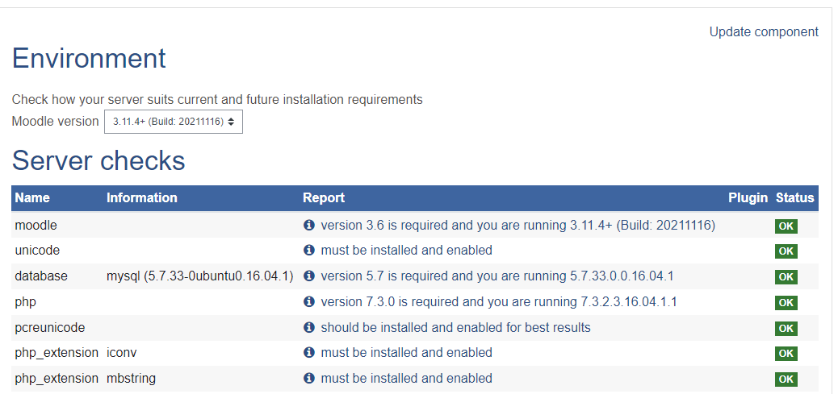

*Figure 1:* Moodle version.

* **Stage II: Setting up of Domain**
  + **Step 1: Assigning public IP to the server**

A Public IP was obtained for the platform from the Institute Network Administrator and replaced the local IP address with the Public IP (Figure 2).

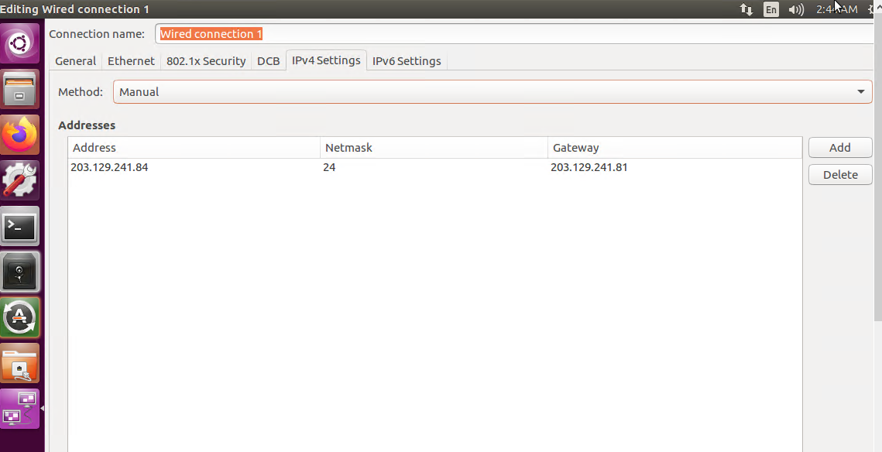

*Figure 2*. Replacement of IP address.

* + **Step 2: Assigning domain name**

The Institute already had an active, but currently unused domain registered with ERNET India with the name [www.aiishpress.ac.in](http://www.aiishpress.ac.in) for the publication division. The same was used for deploying the Moodle platform on the Internet by pointing the domain name to the Public IP.

* **Stage 3: Setting Up of the Site Homepage**

The site homepage was setup under *Site Administration*>*Appearance*>*Front Page*>*Front Page Settings*

The major front-page settings made include the full site name, short name, items to be displayed on the front page, items to be displayed for the logged-in users. The full site is named as ‘**E-learning @ AIISH**’ and the short form as ‘AIISHeLearn’ (Figure 3).

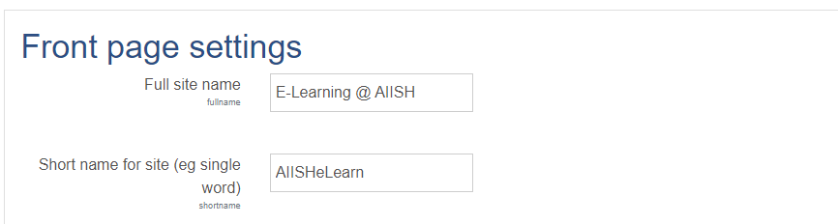

*Figure 3*. Front-page setting.

* **Stage 4: Selection, Installation and Customization of Theme**

One of the major concerns of several Moodle LMS users is its non-appealing and non-intuitive interface developed on either of the two standard themes bundled with the Moodle installation package, *Boost* and *Classic*. However, hundreds of Moodle themes are available for free downloading from the official website of the Moodle at [www.moodle.org](http://www.moodle.org) which are user-friendly and provide completely new look and feel for the site. These themes are developed by third parties. There are many other user-friendly and priced Moodle themes available on the Internet for download. The Moodle official website listed totally 94 themes supporting different versions of Moodle. Of these, 19 themes supported the Moodle version 3.11. From them, the one titled ‘**eGuru**’ was selected for the proposed site. The **eGuru** is a simple and responsive Moodle theme with shorter navigation paths developed by M/s LMSACE E-learning Experts (Figure 4). It is adopted by more than 8,000 e-learning sited developed using Moodle.

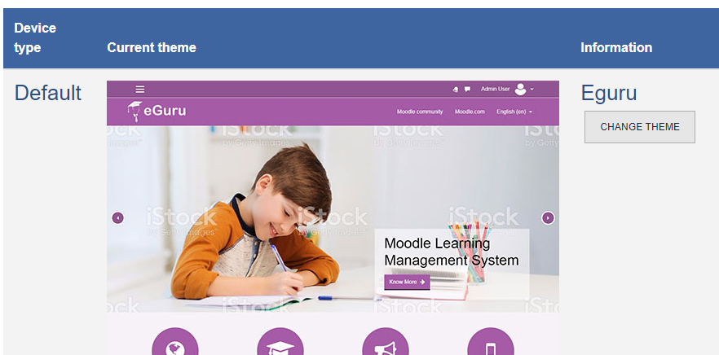

*Figure 4*. eGuru theme installation.

The eGuru theme was customized by incorporating a logo, images, static pages and banner as given in figure 5. The default **eGuru** logo was replaced with a new logo titled ‘e-AiiSH’.

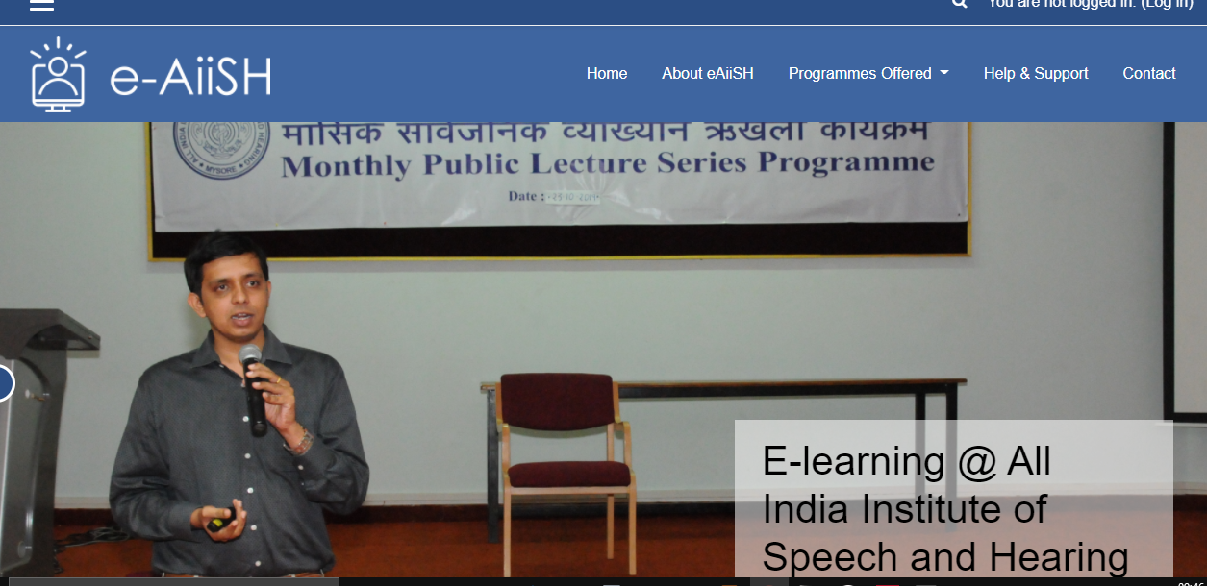

*Figure 5*. Customized homepage.

* **Stage 5: Enabling HTTPS on the Server**

The default connection protocol for installing Moodle is HTTP (HyperText Transfer Protocol). However, upgrading HTTP to HTTPS (HyperText Transfer Protocol Secure) will ensure safety and security in network communication. Also, in Moodle, in order to make use features like RecordRTC (Record Real-time Communication) and open-source video-conferencing system like BigBlueButton, HTTPS server is mandatory.

In order to enable HTTPS on a website, a Transport Layer Security (TLS) certificate also known as Secure Socket Layer (SSL) a certificate, typically a file, needs to be obtained from a Certificate Authority (CA), The CAs are trusted organizations who verify websites and ensure the reliability of the sites. The TLS certificate ensures privacy and confidentiality of the private information such as user login credentials, bank accounts, name, address, date of birth, telephone number etc. on a website through encryption process. Upon installing a TLS certificate, the HTTP will change to HTTPS with a prefixed padlock icon. There are both open and commercial certificate authorities.

The TLS certificate was obtained from ‘Let’s Encrypt’, a free, automated, and open certificate authority. The ‘Let’s Encrypt’ is a service sponsored by the Internet Security Research Group (ISRG), a US-based public-benefit corporation working on Internet security.

* **Stage 6: Outgoing Mail Configuration**

In order to send and receive email on Moodle platform, necessary settings were done. Moodle permits e-mail settings either through PHP mail function or SMTP (Simple Mail Transfer Protocol). Most often, the mails sent via PHP mail function are treated as spam by the receiving mail servers. Hence, the preferred email setting is through SMTP. Therefore, the Gmail SMTP server for configuring mail on the custom-developed Moodle platform and settings were made by entering *SMTP hosts (smtp.gmail.com:465), SMTP security (SSL), SMTP Auth Type (LOGIN), and SMTP username (aiishlibrary@gmail.com)* under *Site administration>Server>Email>Outgoingmail configuration*  as depicted in Figure 6.

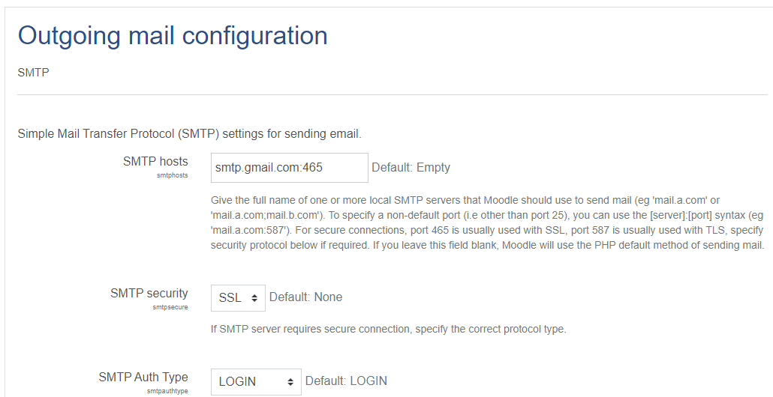

Figure 6. Outgoing mail configuration.

* **Stage 7: Incoming mail configuration**

The incoming mail also configured to enable the users to respond to forum posts using their email and send files to private file folder as email attachment. The Gmail Incoming Mail Server was configured to make the settings under *Site administration*>*Server*>*Email*>*Outgoingmail configuration*> Incoming mail configuration as depicted in Figure 7.

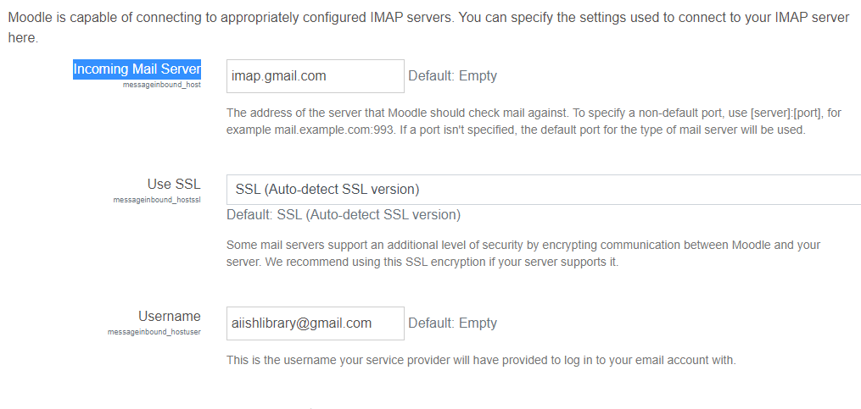

Figure 7. Incoming mail configuration.

* **Stage 8: User Authentication**

User authentication is the process of verifying and validating the credentials or identity of a person while he is trying to access a computer-based system. The objective is to avoid unauthorized access to the system and resources.

The e-AiiSH has been completely protected from unauthorized access and allows access only through user-name and password. All the faculty and student accounts were created manually using the Admin rights with the provision for resetting username and password. The first name of the users in small letters is given as user name and Aiish@123 as password. All other Moodle authentication tools such as e-mail based self-registration, LDAP authentication, Shibolith authentication etc. were disabled.

* **Stage 9: Installation and Integration of BigBlueButton**

The BigBlueButton (BBB) is the most popular open-source videoconferencing system for online learning. It facilitates sharing of audio, video and whiteboard. The installation of BigBlueButton is a complex process.

A dedicated server was set up through virtualization using HyperV with the following components as per the mandatory requirements for successful installation of BBB version 2.2: Ubuntu Linux Operating System (64 bit, 16.04 version), swap-enabled memory of 16 GB, 8 CPU cores, 500 GB free disk space, accessibility to hypertext transfer protocol port 83, hypertext transfer protocol (secure) port 443, transmission control protocol ports 16384 and 32768, exclusive access to transmission control protocol port 80 and 443, hostname with SSL certificate, 250 Mbits/sec bandwidth, and IPV4 & IPV6 address.

Followed by this, the BBB was installed by entering the commands in command prompt of Ubuntu.

“sudo apt-get install bigbluebutton”

“sudo apt-get install bbb-html5”

Further as depicted in Figure 8, an API Demo was installed using the command

“sudo apt-get install bbb-demo”

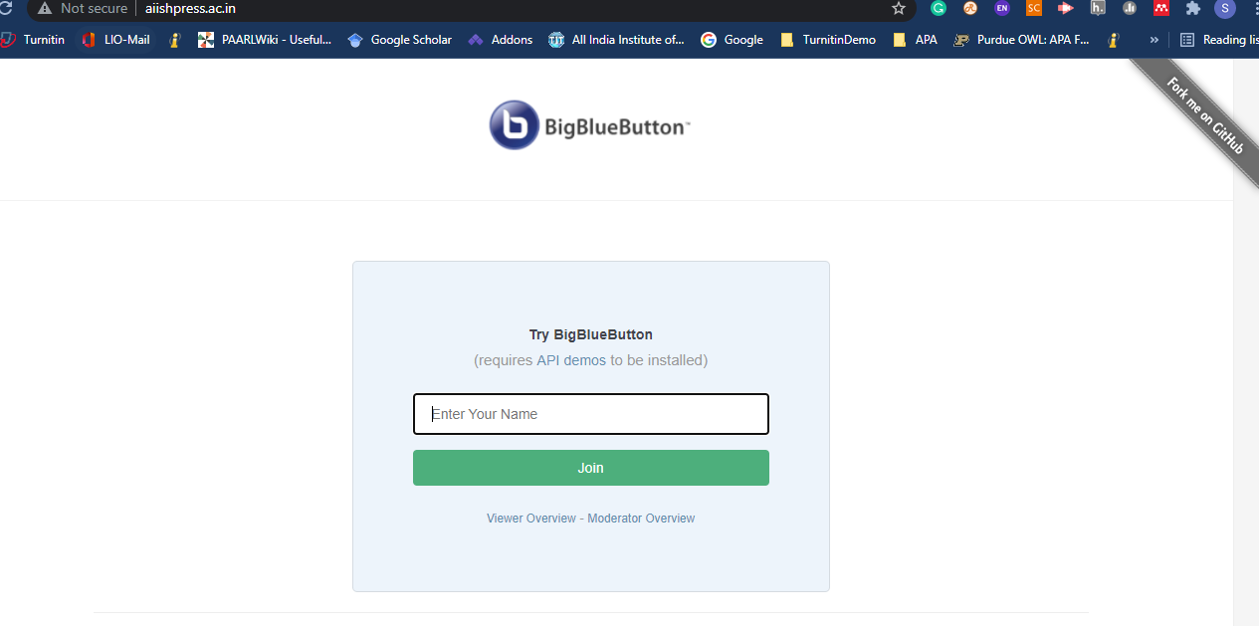

*Figure 8.* Installed BigBlueButton.

* **Stage 10: Integration of Additional Plugins and Functionalities**

In addition to BigBlueButton, the Moodle facilitates integration of a number of other plugins and functionalities for enhancing the learning and teaching experience of the platform. There are free as well as paid plugins and functionalities developed by third parties to integrate with Moodle. We have integrated the following free plugins and functionalities on the eAiiSH platform.

1. Attendance
2. Survey
3. Mfreak Avatar
4. Opencast Videos
5. Quickmail
6. RecordRTC
7. Student Folder

* **Development of training materials**

The next important products were training materials of two distinct nature, that is for purpose of orienting faculty and/or students in using Moodle, and conducting theoretical instruction and/or practical training of students.

* **Modules for training in users in Moodle applications:** The primary one was a detailed training manual for faculty with descriptive instruction in the nuances of using Moodle platform. It comprised of step-by step procedures on how to use various resources and conduct activities on Moodle.
* **Materials for theoretical instruction of students (as part of experimentation):** Further for the purpose of the experimental exposure involving B.Ed.Spl.Ed. (HI) student-participants, course materials for comprehensive theoretical instruction and practical training had been prepared. The materials for imparting theoretical knowledge as part of their involvement in the first semester included ten presentations covering 50% of the entire course content. That is, two units with five sub-units each. These presentations were in the form of illustrated webpage content for one of the two units, and PowerPoint slideshows for the other. Each entity of instructional materials was further appended with assignments involving application exercises and links to additional informational resources. Theoretical instruction was interspersed with two quizzes administered as formative assessment measures which shall be described in detail as tools for data collection in the next sub-section.
* **Materials for practical training of students (as part of experimentation):** The material for practical training was in the form of a nine-step activity plan concerning pedagogy of teaching English to high school students. The exercise was carried through two sessions of two and one hour each, during which different component applications of the plugged-in BBB video-conferencing facility were experimented with. They included video-audio interface, embedded slide show, shared whiteboard, poll, sharing of notes and links to external resources, break room activities and feedback.
* **Feedback questionnaire for student-participants:** As described afore, trial experiment with Moodle platform involving student-participants included two phases with the total of three constituent stages. The first single stage phase involved one-time, large group trial exposure of conducting classes via BBB video conferencing to M.Sc. (SLP) students. The real-time practical observation and ensuing qualitative, verbal feedback received from concerned faculty and student-participants were noted down by the principal investigator for due consideration.

The second phase engaged B.Ed.Spl.Ed. (HI) students over an extended tenure across the two-year academic programme. The first stage of the second phase commenced with theoretical instruction in the initial, first semester making use of all core activities of the platform. The second stage imparted practical training in the final, fourth semester via the plugged in BBB facility for video conferencing. Qualitative feedback was sought from the students at the end of each of these exercises in the second phase. Two distinct questionnaires had been developed for the purpose and distributed online via the Google Form application.

The first form seeking feedback on student-participants’ experience of undergoing theoretical instruction over Moodle platform had a total of 20 statements reflecting on the ease of access and use, instructional utility and interactive facilities among others. The student-participants had to respond expressing their agreement or disagreement with the claim. The second form despatched subsequent to practical training consisted of 24-items which were predominantly choice items like multiple choice and checkbox grid, except two items related to student identity. Among the rest of the 22 items, three were regarding the devices and connectivity streams at the disposal of student-participants. Eight items each enquired about the general functionality and specific special features of the BBB application; while two queries were on facilitation of instruction and interaction as part of the practical training.

* **Formative and summative assessment of student-participants:** This included two quizzes incorporated as ongoing assessment as part of the trial theoretical instruction during their first semester tenure. Each of the quiz consisted of five multiple choice items covering content of just concluded unit of instruction. Each correct response was awarded a score of 1 while incorrect or no responses were scored 0, thus with scope for maximum score 5 to a minimum of 0. Theoretical instruction interspersed with brief, objective exercises as formative assessment concluded with a more detailed, descriptive exercise for summative assessment. While the former was conducted online making use of Google Form application, the latter was a classroom-bound paper-pen test. It was for a total of 10 marks with five descriptive questions for two marks each. Both the cycles of assessments were conducted within set time boundaries of relevant duration.

**12.7.5 Data Collection, Compilation and Analysis**

The data from student-participants were collected through individual, online distribution of e-questionnaires/ tests. The responses were compiled on Excel spreadsheets that come with Microsoft package of office applications. Consequently, the qualitative feedback about the theoretical and practical instructional experiences was subjected to descriptive analysis. The quantitative measurement of performance in formative assessment as part of theoretical instruction was subjected to inferential treatment. These statistical analyses were carried out through statistical tools of Microsoft Excel application as well as authentic statistical calculators available online such as social science statistics resources available for use by social scientists at www.socscistatistics.com/. Results drawn from these exercises have been presented and discussed in the ensuing section.

**13. Detailed Analysis of Results Indicating Contributions Made Towards Enhancing the Status of Knowledge in the Subject**

**13.1 Formulation of Research Hypotheses**

The two core purposes of the research project led to conception of two sets of hypotheses concerning –

1. The platform of learning management system offered by Moodle is –

(i) Viable for installation, access and use at AIISH.

(ii) Effectual in facilitating academic instruction at AIISH.

2. The proposed setting up of web-based faculty profile system is –

(i) Useful in promoting professional efficacy of faculty at AIISH.

**13.2 Research Outcomes**

**13.2.1 Rationale Selecting Moodle as Learning Management System (LMS) for Academic Course Management at All India Institute of Speech and Hearing (AIISH)**

Like many other software applications and tools, the LMS are appearing in two streams: Proprietary and Open-source. The proprietary applications are usually priced and the right to modify the features and functionalities of such applications rests with the proprietor. The open-source applications on the other hand are freely available, modifiable and upgradable. Thus, they are significantly beneficial in terms of cost and functionality over the proprietary applications. Hence, many organizations are adopting open-source LMS as their e-learning platforms.

As discussed already, the fundamental aim of the project was to develop an e-learning platform for AIISH using a suitable open-source software learning management system (OSSLMS) to conduct its long-term and short-term academic programmes in a blended manner. In order to identify the most appropriate LMS. a context-referenced survey on the available OSSLMS under GNU/GPL was carried out through literature databases like, PubMed, J-gate and ERIC as well as the leading commercial publishers’ websites Science Direct, SprinkerLink, Wiley Online. The literature search centred on various combination of keywords such as ‘Opensource software’ and ‘E-learning’ ‘Opensource e-learning’; ‘Opensource software’ and ‘Learning Management System’; ‘OSS’ and E-learning’; ‘Integrated Learning Management System’ and ‘Opensource software’; among others for locating literature on opensource LMS. In consequence, investigators were able to trace mention of 12 open-source LMS from the literature published in the last 10 years. These are – *ATutor*, *Canvas*, *Claroline*, *Chamilo*, *Dot Learn,* *Forma*, *Ilias*, *Moodle*, *Open edX*, *Open**eLMS, Open OLAT* and *Sakai*. Consequently, comparative details about these LMS were compiled for relative analysis as detailed below.

* **ATutor**: *ATutor* is one of the oldest web-based open-source LMS. The focus of the *ATutor* is ‘Accessibility for All’. It was initially developed by Greg Gay as his graduate school project at the end of 1990’s. Later, Adaptive Technology Resource Centre of the University of Toronto, Canada took over the project and developed *ATutor* as an adaptive and accessible learning management platform. The platform was officially released towards the end of 2002. Presently, the *ATutor* is hosted on the *SourceForge* and maintained by Greg Gay, along with Cindy Qi Li and Harris Wong with the support of developer community. It is possible for the organizations to freely download and self-host the *ATutor*. The *ATutor* supports all types of learning environments.
* **Canvas**: The *Canvas*, published by M/s Instructure since the year 2011, is one of the most leading LMS today. It is used in more than 4,000 institutions around the world as of 2020. The Canvas is published as open-source and paid versions. The paid version is available as a cloud-hosted solution by the Instructure. However, the paid version has extra features and functionalities which are not available in open-source version. In other words, open-source release of Canvas is not a replica of its paid version. The LMS is suitable for schools, higher education institutions and business organizations.
* **Claroline**: Prof. Marcel Lebrun and Thomas De Praetere of the Catholic University of Louvain, Belgium initiated the *Claroline* project in late 1990s. *Claroline* stands for Classroom Online. The developers of *Claroline* consider it as the first real-time open-source LMS dedicated to the learning process rather than teaching process. *Claroline* was known for its ease of use when compared to its contemporaries like *Moodle*, *WebCT* and *Ilias*. However, from 2015 the open-source version of *Claroline* is being published only for the purpose of testing, and not for production. Instead, a paid version called *Claroline Connect* is being published. The *Claroline Connect* has additional features and functionalities.
* **Dot Learn**: The *Dot Learn* written as LRN is an open-source e-learning solution supported by .LRN Consortium, an international non-profit organization promoting open-source educational technology based in USA. It was originally developed at the *The Dot Learn*, and is currently developed on a software framework for building scalable, community-oriented web applications called Open Architecture Community System (OpenACS). It is suitable for deploying e-learning solution in schools, higher education institutions, non-profit and government organizations. However, the *Dot Learn* is not active since 2010 and many of the links on the official website of the solution are non-functional.
* **Chamilo**: The *Chamilo* is a completely open-source LMS published by Chamilo Association, Spain. It was originated from another LMS called *Dokeos* in 2010 whereas the *Dokeos* was forked from the *Claroline* LMS project in 2004. *Chamilo* is a collaborative product of various organizations, establishments and individuals. The LMS is mainly used in Spanish-speaking countries. The latest version of *Chamilo*, 1.11.16 was published in 2021. The *Chamilo 2.0*, which is currently under development, is expected to incorporate more features and functionalities into the software.
* **Forma**: *Forma* is a relatively new open-source learning management system released in 2012. The *Forma* is basically designed for corporate learning, but suitable for other learning environments also. It was originated from *Docebo* e-learning software freely released under a GPL V. 2.0 license. In 2011, *Docebo* decided to shift its operation from open-source to commercial mode. In consequence, the old *Docebo* users formed a new community and worked in collaboration with a group of partnering companies on the open-source code ‘abandoned’ by *Docebo*. They fixed the bugs, developed patches and added new features to the erstwhile *Docebo* open-source software and created the *Forma* LMS. The founders of *Forma* established an overseeing company in 2017 known as Forma.association. Currently, Forma.association is responsible for maintaining, developing and promoting the LMS. The latest version of the software is available for downloading only for the association members and contributors. The membership in Forma.association is payment-based. However, the previously released stable versions of the *Forma* are available for everyone to download.
* **Ilias:** The *Ilias* started as an e-learning project at the University of Cologne, Germany in 1998. Since 2009, it has been published as an open-source LMS under GPL by ILIAS Open-Source E-learning Society. It is a very active online learning platform across the world, especially in European countries. The latest version of the *Ilias* is 7.2 published in June 2021. The name ILIAS is an acronym for the German phrase, *Integriertes Lern-, Informations- und Arbeits kooperations System* meaning integrated learning, information and work-cooperation system.
* **Moodle:** *Moodle* is the world’s most famous open-source LMS published since 2002. The word *Moodle* stands for Modular Object-Oriented Dynamic Learning Environment. It was originally developed by Martin Dougiamas, a computer engineer from Australia. Currently Moodle is published by Moodle Proprietary Limited Company, Australia headed by Martin Dougiamas. The latest version of *Moodle* is 3.11, published in 2021. *Moodle* is used by schools, colleges, universities and business organizations across the world. In addition to the completely open-source version, the *Moodle* is also available as a cloud-hosted solution by Moodle Pty Ltd. Also, there are professional *Moodle* service providers certified by the *Moodle* functioning across the world to assist the installation and customization of the LMS on payment basis.
* **Open edX**: The *Open edX* is open-source learning software developed by the edX Incorporation, one of the popular MOOCs (Massive Open Online Courses) providers. *edX* is a non-profit organization jointly established by the Massachusetts Institute of Technology*(*MIT*) and* Harvard University*,* the two world famous universities in Cambridge, USA. The e*d*X released *Open edX* in 2013 and it is supported by a huge community of users. The *Open edX* is completely free and organisations can download and install in their local servers and create own institutional learning management system.
* **Open eLMS**: A UK based e-learning company by name eLearning WMB started the *Open eLMS* software in 2005. The company released the software under open-source model in late 2006 and made available as SourceForge project in 2007. However, from 2018, the company made the software as proprietary and it is available for schools, colleges, universities and business organizations on payment basis.
* **Open OLAT**: Formerly known as *OLAT* which stands for Online Learning And Training. The Department of Computer Science, University of Zurich, Switzerland developed the *OLAT* learning management platform in 1999. In 2011, M/s frentix, GmbH, Zurich, Switzerland initiated an open-source project based on the version 7.1 of the *OLAT* and named it as *OpenOLAT*. It is available for free download as open-source under Apache license. Unlike many other open-source LMS, *OpenOLAT* has no developer community. However, it is available as a cloud-hosted learning platform with frentix on payment basis for schools, companies, universities and other institutions. The version 1 of *OLAT* ( i.e. *OpenOLAT* 8.0) was released in 2011 and the latest, version 16 in 2021.
* **Sakai:** *Sakai* is another well-known open-source LMS developed as a collaborative project by five US-based Universities, namely**,** Indiana University, University of California, [Massachusetts Institute of Technology](https://en.wikipedia.org/wiki/Massachusetts_Institute_of_Technology), [Stanford University](https://en.wikipedia.org/wiki/Stanford_University), and University of Michigan. The Sakai project was started in 2005 with an objective of developing a collaborative learning environment from the existing e-learning tools of each of the participating organizations. Currently, the project is managed by Apereo Foundation, USA, and there is a 16-member Sakai Management Committee for taking strategic decisions. The Sakai LMS is completely open-source which can be deployed locally. Also, there are commercial affiliates providing fee-based support to install, customize and host the *Sakai*. The leading commercial affiliates of the Sakai project are Learning Experiences, Michigan, USA, Entornos de Formación (EDF), Valencia, Spain, Unicon, Arizona, United States, and Longsight , Ohio, United States. **Sakai** is availablein two versions.

Of these 12 LMS, six including *ATutor*, *Claroline*, *Canvas*, *Dot Learn*, *Open* *eLMS* and *Forma* were excluded from further consideration owing due to the following reasons:

* The *Claroline* is not available as open-source version for production environment since 2015.
* The *Canvas* LMS released as open-source versions is not the exact replica of its fee-based cloud-hosted solution. The cloud-hosted platform provides extra features and functionalities.
* The *Dot Learn* is not updated since 2010 and the *ATutor* since 2018.
* The *Open eLMS* is no longer available as open-source LMS.
* The latest version of the *Form* LMS is not available for free download. Also, it has been developed focusing on corporate training.

The remaining six LMS websites were verified for availability of technical supporting service in India. However, it was found that except, Moodle, none of the LMS are providing any technical support in the country. Moodle on the other hand, has four active, certified service providers in the country, namely, Vidya Mantra EduSystems Pvt. Ltd., Noida,eAbyas Info Solutions, Hyderabad,Ballistic Learning, Faridabad and Nomad Communications LLP, Mumbai. Hence, ultimately *Moodle* LMS was chosen for customised used at AIISH.

The pilot trials subsequent to successful final installation of customised Moodle platform permanently at the server facilities at AIISH rendered useful pointers about the feasibility and utility of the learning management system. As described under the section on method, the pilot ventures were carried out with students from the disciplines of speech and hearing, and special education at the levels of post-graduation and under-graduation, respectively.

**13.2.2 First phase of field trial with M.Sc. (SLP) students**

This exercise involved trial demonstration of online classes on Moodle platform utilising video conferencing facilities over BBB application. The trial session involved 60 students. The session was coordinated and observed by the Principal Investigator. Qualitative oral remarks and suggestions from the student-participants for further improvisations and troubleshooting were noted down. The exercise endorsed feasibility of the specified video-conferencing application for synchronised large class, instruction.

**13.2.3 Second field trial involving theoretical instruction to B.Ed.Spl.Ed. (HI) students**

The second field trial was detailed experiment involving 13 students of a theoretical course in special education during the first semester of the two-year B.Ed.Spl.Ed. (HI) programme. The students were taught in the conventional method during the first half of the course and over the Moodle platform in the concluding half of the course. Both the segments of instruction extended over duration of eight-weeks each covering two units of content of the total four units comprising the course. It was ensured that all core activities of the platform were utilised in the course of opening introduction, progressive instruction, and ongoing as well as concluding assessment. The instructional efficiency in terms of performance of the student-participants in the two modes of instruction was quantitatively compared. Further their perceived satisfaction and suggestions regarding the integrated learning management system were qualitatively compiled.

To commence with the empirical data sets in the form of student-participants’ performance scores were subjected to test for normality. Both the pre and post-intervention scores were found to be normally distributed leading to use of parametric statistical measures. These included paired samples t-test for measuring pre and post-test variances and Pearson product-moment correlation for determining correlation were made use of.

The empirical results derived from comparative analysis of influence of Moodle platform on learning outcomes evinced tentative impressions that –

* Instruction through Moodle platform was effective in advancing learning and performance in the student-participants. There was 12% overall advancement in the performance-scores in comparison to the first stage of conventional instruction (77%) following facilitation of learning through Moodle platform (89%). Subjection to statistical measure of t-test for paired samples statistically endorsed the significance of the advantageous outcome (t = 3.22; p < 0.001).
* The ongoing augmentation of assessment through Moodle platform also seemed to sustain a credible and consistent learning pattern among the students with strong and substantial trends of correlation between formative and summative performances (r = 0.98; p < 0.001).

Compilation of qualitative feedback gathered from the student-participants and coordinating staff in the trial theoretical instructional exercise led to the following insights regarding their disposition with respect to Moodle experience:

* From teacher’s perspective the Moodle platform was advantageous in –
* easy distribution of learning materials and providing extended access to additional informational resources;
* timely conduct of ongoing assessment and ensuring dissemination of prompt, personalised feedback;
* individualising assignments according to differential abilities and diverse interests of students;
* providing extended scope for application and generalising learning outside classroom bounds; and
* conserving students’ and teachers’ efforts and active instructional durationthusmaking available surplus time and energy for continuing learning beyond class sessions and space.
* Compilation of student-participants’ feedback collected through e-questionnaires revealed mixed perspectives as gathered from their responses –
* In the context of instructional transaction, the major perceived advantage (89%) was the access to comprehensive learning material and individualised learning exposure enabled with the aid of Moodle platform.
* However moderate affirmation (50%) concerning the interest generated and addition to workload indicates need for further exploration of diverse prospects of multimedia forays that effectively engage the students without taxing them.
* Student-participants’ satisfaction about formative assessment is also not optimal with only 58% assent for prompt and confidential assessment. The reasons being spelt out that assessment accessed out of bounds of classroom provided space for lenience and delinquency on part of student-participants. Future measures have to be directed to make assessment processes fool and tamper-proof.
* Student-centred features facilitating anytime anywhere learning as well as the possibility for making up for missed instructional sessions was appreciated by substantial numbers of student-participants (79%).
* They also highly commended (94%) the extended access to additional information resources and diversity of teaching-learning materials employed via Moodle platform.
* This pilot field trial over a short duration of four weeks does not seem adequately long enough to stimulate sufficient interaction with teacher and among student-participants outside the classroom bounds as implied by the lukewarm responses (38%). In future, focused efforts like initiating forums and organising break out room activities will have to be undertaken systematically to make up for the lacunae.
* Deficient technical expertise in student-participants and under-provided technological facilities were negligible deterrents in this trial experiments with Moodle as 83% of the student-participants were satisfactorily provided with both.
* Considerable numbers of student-participants (58%) opined that Moodle could best supplement conventional classroom instruction rather than substitute, especially because of its impersonal nature.
* Through their descriptive remarks student-participants had recommended for fool-proofing assessment exercises, include more active assignments in the form of projects, and provision of alternate conventional resources like printed handouts for students who do not have 24X7 access to ICT facilities.

**13.2.4 Third field trial involving practical training of B.Ed.Spl.Ed. (HI) students**

The third and final field trial involved imparting practical training via BBB video-conferencing application to the same batch of B.Ed.Spl.Ed. (HI) students. At the time of this phase of exercise they were placed in the final fourth semester of the academic programme. Following exposure involving two sessions of a total three hours, qualitative feedback from the student-participants was obtained.

Among the student-participants 60% were using smart phones connected through internet. The other 40% used laptops with either wireless broadband (20%) or wifi dongle connections (20%). Substantial numbers among the student-participants found accessing the BBB video-conferencing session easy (60%) and quick (30%), however few found the process difficult and slow (10%). While 20% of the student-participants reported that the connectivity was consistent without intermissions lending full-fledged access to all features of BBB, while another 20% encountered frequent interruptions.

Concerning the fundamental features of video-conferencing application, that is audio and video interface through BBB, majority of the student-participant were satisfied with the clear (60%), loud-enough audibility (70%) and could follow the presentation without interruptions (40%). Regarding visibility, 60% of student-participants reported it to be stable and clear/ precise. While 30% each, expressed that the visual appearances and arrangements were well-framed and of adequate size, while they could also make them visible to the group at convenience. The auxiliary use of interactive text facilitated by BBB received commendable appreciation as easy to access and (55.6%), with well-contrasted, readability (604%). Further 604% of the student-participants also reported that beyond passive reading they were also able to actively create and/or edit content.

Besides the basic facilities, the student-participants were appreciative of the ample special features made available (70%) and found them useful (80%). Most of them (70%) found them easy to use, while an infinitesimal number (10%) expressed exasperation with the complicated processes. Further specific reflections about the seven special features, namely, chat, emoji, polling, shared notes, video, whiteboard and break out room were also drawn. Facility to chat using text and shared whiteboard were reported by the student-participants to be the most useful (90%) followed closely by shared notes and video (88.9%) and polling (87.5%). Special features facilitating expressive sharing of emotions and opinions such as emoji (90%) and polling (87.5%) were most effective in drawing their interest. While most of the facilities were found convenient to access and use, minor difficulties were encountered in accessing (20%) and engaging (10%) in break out room activities, as well as in inserting chat text (10%).

On the whole, 60% of the students found BBB application contributing appreciatively to instructional input and student interaction, while the other 40% expressed satisfaction. Fifty percent found the application easy to operate, while the other 50% were able to manage without much difficulty. In the process, 20% reported facing no or negligible interruptions, while 20% were encountered with frequent and frustrating intermissions. Seventy percent were able to easily troubleshoot these disruptions, while the rest 70% were able to manage without much difficulty. Ultimately a majority of 80% expressed ultimate appreciation for utility value of BBB application while 20% found it fairly useful. Through their qualitative remarks, student-participants opined that it was a good initiative to make e-learning more viable and found the trial experience both educative and enjoyable; while also expressing that lack of prior preparatory experience and tardy technological access made the going difficult and frustrating at times.

The findings of this study endorse earlier research evidences generated across the globe over the years (Jin, 2012; Sáiz-Manzanares et al., 2019;Umek et al., 2015) regarding the usefulness of Moodle platform in enhancement of teaching exercises and consequent advancement of learning outcomes. However as expressed by researchers like Costa and associates (2012) and Oproius (2015), trial instructional executions through Moodle platform led to the realisation that technical capacity-building among teachers and students was an essential pre-requisite for materialisation of these benefits.

**13.3 E-Learning Policy**

An e-learning policy for the All India Institute of Speech and Hearing was developed as a part of the project (Appendix-1).

**13.4 Verification of Research Hypotheses**

Experiential cognisance along with empirical findings presented afore led to the following ratification of research hypothesis –

* Hypothesis 1 (i) that learning management system platform offered by Moodle is viable for installation, access and use from the server at AIISH has been practically endorsed through the trial field experiment. The viability was in evidence for both small and large classes, as well as theoretical instruction and practical training.
* Hypothesis 1 (ii) that Moodle platform is effectual in facilitating academic instruction at AIISH is accepted following significant advancement in learning outcomes of student-participants.
* Hypothesis 2 (i) regarding the usefulness of the system in promoting professional efficacy of faculty at AIISH could not be tested due to interruption in its full-fledged installation.

**14. Conclusions Summarizing the Achievements and Indications of Scope for Future Work**

In corroborating with its aims and objectives, the research project work was successful in setting up a versatile online learning platform primarily making use of Moodle open-source software along with other add-on applications such as BBB. The platform could sustain all the courses at diploma, under-graduate and post-graduate levels offered by AIISH. The field trials drew out the capability of the platform for comprehensive and constructive instruction as well as assessment. They also provided pointers for making it more robust. The research study faced limitations in realising the objective of developing faculty profile system. It was due to inevitable technical issues. However, a faculty profile system for the Institute will be developed in collaboration with the INFLIBNET Centre, Gandhi Nagar, an Inter-University Centre of the University Grants Commission.

**15. Acknowledgments to Funding Source, Participants and Other Supports**

We acknowledge the support and encouragement provided by Dr. M. Pushpavathi, Director, AIISH in carrying out the project.

**16. S & T Benefits Accrued:**

**i. List of research publications with complete details: title of paper, authors, year, name of journal, vol.(no.), page.**

Nil

**ii. Manpower Trained on the Project**

**a. Research Scientists or Research & b. Other Technical Personnel Trained**

One faculty and 13 students of B.Ed.Spl.Ed. (HI) programme 2019-21 batch in technical skills for accessing and making use of Moodle platform for teaching-learning

**iii. Products Developed (if any)**

Customised Institutional Learning Management System

Training Manual on Moodle

**iv. Patents taken, if any**

Nil

**v. Institutional/ Regional/ National/ International Beneficiaries to Be Clearly Indicated**

Fifty faculty from clinical psychology, electronics, ENT, special education, and speech hearing disciplines working at AIISH. Along with around 400+ students from speech and hearing, and special education disciplines from post-secondary diploma to post-doctoral research.

**17. Abstract of the Project for inclusion in the Annual Report/Website (300 words, in the following format)**

**i. Objectives:** The reported research project was undertaken for the purpose of designing and developing an e-learning platform and creating faculty profile system encompassing the academic programmes organised by AIISH.

**ii. Design:** An experimental research for designing and developing e-learning platform along with faculty profile system was conceived for the purpose. This involved verification of its viability and investigation of resultant impact on student learning outcomes and professional development of faculty.

**iii. Results:** The findings of the trial pilot experiment found customised installation of learning management system available through open-sourced Moodle practically viable. Teacher and student-participants in the process found the core as well as add-on features of the application valuable. Application of blended instruction via Moodle platform was able to induce concrete gain in learning outcomes over conventional classroom instruction.

**iv. Conclusions:** Moodle-based LMS will be made available for full-fledged use during the current academic year 2021-22, so as to promote professional empowerment and proficient educational services at AIISH. One of the initial targets, the development of faculty profile system could not be accomplished due to technical limitations. Investigators shall endeavour to carry out and complete the same.

**18. Copy of Ethical Committee Report (if any, to be enclosed)**

Nil

**19. Plagiarism Report to Be Enclosed**

Enclosed

# References

Ali, W. (2020). Online and remote learning in higher education institutes: A necessity in light of COVID-19 pandemic. *Studies in Higher Education*, *10*, 16-25.

Aranca. (2019, April). *Education and Training* [Presentation]. India Brand Equity Foundation.

Arkorful, V., & Abaldoo, N. (2015). The role of e-learning, advantages and disadvantages of its adoption in higher education. *International Journal of Instructional Technology and Distance Learning*, *12*(1), 29-42.

Atwang & Darus (2012). Evaluation of An Open Source Learning Management System: Claroline. *The 3rd International Conference on e-Learning, ICEL2011*, 23-24 November 2011, Bandung, Indonesia.

Bargea, P., & Londhe, B. R. (2014). From teaching, learning to assessment: MOODLE experience at B’School in India. *Procedia Economics and Finance*, *11*, 857-856.

Bell, K. (2015). *The teacher's guide to Google Classroom*. Shakeup Learning, LLC.

Brown, M., Dehoney, J., & Millichap, N. (2015). *The next generation digital learning environment(NGDLE)*. EDUCAUSE Learning Initiative.

Brown, M., Dehoney, J., & Millichap, N. (2015). What's next for the LMS? *EDUCAUSE Review*, *July/August 2015*, 40-51.

Clark, R. C., & Mayer, R. E. (2016). *e-Learning and the science of instruction: Proven guidelines for consumers and designers of multimedia instruction* (4thed.). Wiley.

Costa, C., Alvelos, H., & Teixeira, L. (2012). The use of Moodle e-learning platform: A study in a Portuguese university. *Procedia Technology*, *5*(2012), 334-343.

Ellis, R. K. (2009). *A field guide to learning management systems*. American Society for Training and Development–ASTD .

Govender, I., & Govender, D. W. (2010). An exploratory study: The effectiveness of a learning management system (LMS) in the delivery of a face-to-face programming course [Conference presentation]. *ICETI 2010: The International Conference on Education, Training and Informatics*. Orlando, Florida, the United States of America, 6-9April, 2010.

Guri-Rosenblit, S. (2005). ‘Distance education’ and ‘e-learning’: Not the same thing. *Higher Education*, *49*(4), 467-493. https://doi.org/10.1007/s10734-004-0040-0.

Guskey, T. R. (2009). Mastery learning. In T. L. Good, *21st century education: A reference handboo*k (vol1) (pp. 194-202). Sage Publications.

Hurix. (2020, June 29). *Google Classroom or Moodle – Which is the better option for you?* Retrieved September 29, 2021, from Hurix Digital: https://www.hurix.com/google-classroom-moodle-better-option/

Isecke, H. (2016, June 13). *The differences between blended learning and the flipped classroom*. Retrieved September 29, 2021, from LinkedIn: https://www.linkedin.com/pulse/differences-between-blended-learning-flipped-classroom-harriet-isecke

Jin, S. (2012). Design of an online learning platform with Moodle [Conference proceedings]. *7th International Conference on Computer Science and Education - ICCSE 2021*, Melbourne, Australia, 14-17 July, 2012. ThF1.7, pp. 1710-1714. Institute of Electrical and Electronics Engineers–IEEE

K-12 Blueprint. (2014). *Learning Management system (LMS) guide*. Retrieved September 29, 2021, from k12blueprint: <https://www.k12blueprint.com/sites/default/files/Learning-Management-System-Guide.pdf>

Karlovcec, N., Saina, S. & Skala, T. (2005). Computer networks course: Claroline-based e-learning model. In G. Richards (Ed.), *Proceedings of E-Learn 2005--World Conference on E-Learning in Corporate, Government, Healthcare, and Higher Education* (pp. 794-799). Vancouver, Canada: Association for the Advancement of Computing in Education (AACE). Retrieved from <https://www.learntechlib.org/primary/p/21276/>.

Karolcik, S. & Čipkova, E. (2013). LMS Claroline is as seen by future teachers. *Journal of Technology and Information Education*, 5(2), 45-51

Killedar, M. (2018). Block 4 - Interactive delivery methods: Unit 20 – Learning management systems. In *IGNOU Self Learning Material (SLM) for Staff Training and Research Institute of Distance Education (STRIDE): Master of Arts in Distance Education (MADE)*. Indira Gandhi National Open University–IGNOU.

Kraleva, R., Sabani, M. & Kralev, V. (2019). An analysis of some learning management systems. *International Journal on Advanced Science, Engineering and Information Technology*, *9* (4), 1191-1999.

Lawless, C. (2018, November 29). *The ultimate glossary of e-learning terms*. Retrieved September 29, 2021, from LearnUpon: https://www.learnupon.com/blog/elearning-glossary/

Malaker, A. (2021, June 03). *Online vs offline education – Advantages and disadvantages*. Retrieved September 20, 2021, from My-India: https://my-india/social-issues/online-vs-offline-education-advantages-and-disadvantages

Moodle. (n.d.). *Activities*. Retrieved October 09, 2021, from Moodle: https://moodle.org/plugins/browse.php?list=category&id=1

Moonsamy, D., & Govender, I. (2018). Use of Blackboard learning management system: An empirical study of staff behavior at a South African university. *Eurasia Journal of Mathematics Science and Technology Education*, *14*(7), 3069-3082.

Nguyen, Q. L., Nguyen, P. T., & Huynh, V. D. (2019). Roles of e-learning in higher education. *Journal of Critical Reviews*, *6*(4), 7-13. http://dx.doi.org/10.22159/jcr.06.04.02.

Nichols, M. (2016). A comparison of two online learning systems. *Journal of Open, Flexible and Distance Learning, 20(*1), 19-32.

Organisation for Economic Cooperation and Development–OECDObserver. (2005). *Policy brief: E-learning in tertiary education*. Secretary-General, OECD Public Affairs and Communications Directorate–Public Affairs Division.

Oproiu, G. C. (2015). A Study about using e-learning platform (Moodle) in university teaching process. *Procedia Social and Behavioural Sciences*, *180*, 426-432.

Rhode, J., Ritcher, S., Gowen, P., Miller, T., & Cameron, W. (2017). Understanding faculty use of the learning management system. *Online Learning*, *21*(3), 68-86. https://doi.org/10.24059/olj.v%vi%i.1217.

Ruiz, J. G., Mintzer, M. J., & Leipzig, R. M. (2006). The impact of e-learning in medical education. *Academic Medicine*, *81*(3), 207-212.

Saeed, F.A. (2013). Comparing and evaluating open source e-learning platforms. *International Journal of Soft Computing and Engineering, 3* (3), 244-249.

Sáiz-Manzanares, M. C., Marticorena-Sánchez, R., Díez-Pastor, J. F., García-Osorio, & Ignacio, C. (2019, February 12). Does the use of learning management systems with hypermedia mean improved student learning outcomes? *Frontiers in Psychology*, n. pag., https://doi.org/10.3389/fpsyg.2019.00088.

Singh, J. (2015). *How to use Moodle: Teacher's manual for the world's most popular LMS*. Author.

Singh, N. M. (2010). *Moodle and its features. National Institute of Technology, Electronics and Communication Engineering*. National Institute of Technology (NIT)–Rourkela.

Sociology Group. (n.d.). *The Indian education system: Features, pros, cons and way forward*. Retrieved October 09, 2021, from Sociology Group: https://www.sociologygroup.com/indian-education-system-features-pros-cons/

Tamm, S. (2021, January 21). *Types of e-learning*. Retrieved September 29, 2021, from e-student: https://e-student.org/types-of-e-learning/

Tamm, S. (2020, December 21). *What is e-learning?* Retrieved September 29, 2021, from e-student: https://e-student.org/what-is-e-learning/

Turnbull, D., Chugh, R., & Luck, J. (2021). Learning management systems: A review of the research methodology literature in Australia and China. *International Journal of Research and Method in Education*, *44*(2), 164-178. https://doi.org/10.1080/1743727X.2020.1737002.

Umek, L., Keržič, D., Tomaževič, N., & Aristovnik, A. (2015). Moodle e-learning system and students’ performance in higher education: The case of public administration programmes [Conference proceedings]. *6th International Conference on e-Learning*, Belgrade Metropolitan University, 24-25 September, 2015 (pp. 97-104). e-Learning Industry.

University of Massachusetts Amherst. (2021). *Activity types of Moodle*. Retrieved October 09, 2021, from Information Technology: https://www.umass.edu/it/support/moodle/activity-types-moodle

Williams, B. C., Riordan, M., & Dougiamas, M. (2005). *Moodle: For teachers, trainers and administrators* (3rd ed.). In B. C. Williams (Ed.), Vol. V.1.4.3. Free Software Foundation, Inc.

Zameer, G., & Leema, A. (2015). An exploratory analysis of learning management system as an emerging ICT tool in India. *Bonfring International Journal of Industrial Engineering and Management Science*, *5*(2), 95-99. https://doi.org/10.9756/BIJIEMS.8087.

Zhang, J., Ma, J., & Yao, Q. (2011). Application of e-learning in college education [Conference proceedings]. *2011 International Conference on Computer Science and Service System (CSSS)*, Nanjing, China, 27-29 June, 2011, n. pag. https://ieeexplore.ieee.org/document/5974468. https://doi.org/10.1109/CSSS.2011.5974468. IEEE.

**Appendix-I**

**All India Institute of Speech and Hearing, Mysuru**

**E-learning Policy**

**Preamble**

The All India Institute of Speech and Hearing, Mysuru functioning as an autonomous organization under the Ministry of Health and Family Welfare, Govt. of India, mandated to provide education and training, conduct research, deliver clinical care, and carry out public education related to communication disorders.

This e-learning policy is drafted with the intent that it will strengthen and support the education and training activities at the Institute.

**Core Policy**

1. The operational mode for e-learning exercises to be undertaken at AIISH will be mixed mode amalgamating face-to-face instruction with need-based substitution of key elements such as online lectures, discussions, projects, collaborative work, etc. and supplementation of supportive elements such as online notes, email use, links to resources, etc.
2. The e-learning exercises will be conducted with use of appropriate computer-based tools, web-based technologies and multimedia-based techniques.
3. Basic infrastructure essential for robust e-learning practices such as Institutional Learning Management System based on Moodle, built on Ubuntu Linux server, and auxiliary facilities like open-source video conferencing tool like BBB, etc. have been set-up and shall be stabilised and upgraded further on.
4. Staff and student capacities for effective use of ICT necessary for efficient e-learning shall be updated and upgraded on a regular basis through annual induction workshops.
5. Research-based e-content development of digital learning objects, virtual simulation tools, open education resources, etc. through annual week-long faculty development programmes.
6. Standard framework for qualitative online testing including distinct structures for objective and descriptive test formats with appropriate rubrics for all courses conducted at the institute shall be laid out and distributed to the concerned faculty.
7. Effective e-learning platform shall to constructed for use by faculty and students of AIISH ensuring:
8. Standard quality in instructional process.
9. Enhanced classroom learning with incorporation of e-learning/ICT.
10. Cost-effective delivery of instruction services employing e-learning for increasing reach, reuse, etc.
11. User-centred flexibility of learning.
12. E-learning shall be mainstreamed as part of regular instructional procedures/process at AIISH and made mandatory for use by all faculty and students.
13. Time-bound strategic framework for implementing e-learning practices at AIISH to be accomplished in the space of one-academic year after commencement shall laid out. After trial practice during the first year, review exercises shall be carried out involving all concerned faculty before finalisation of modes and norms for regular ongoing use.
14. In the third consecutive academic-year of implementation, guidelines for implementing e-learning at AIISH in conformation to the ethical, legal and safety considerations in India will be developed. This shall involve regularising issues related to intellectual property rights, as well.
15. Scattered efforts across the institution shall be unified and individualised applications shall be made uniform, avoiding wasteful duplication of efforts.
16. For ongoing, harmonious execution of e-learning exercises at AIISH, key staff/ teams shall formed for – framing policies, informing/ instructing users, monitoring practices, evaluating outcomes, etc.

**Auxiliary Aspects**

1. Means for improving quality and increasing quantitative impact of e-learning such as mobile compatible e-content packaging and delivery systems shall be explored continuously through concerted and consistent efforts.
2. Framework for assessing qualitative and quantitative assessment of e-learning endeavours shall be constructed for periodical execution.
3. Further means for adapted, personalised/ learner-centred e-learning shall be explored and/or experimented, especially with reference to differentially-abled learners.
4. Dissemination of good practices through professional publications, organisation of programmes such as workshops including extramural participants, etc. shall be undertaken on regular basis.
5. Innovation and successful experiments through initiation relevant research projects, especially focusing on novel tools/ technologies/ applications such as 3D-laboratories, artificial intelligence (AI), gamification, interactive experiments, microlearning, simulations like augmented reality (AR) and virtual reality (VR), etc. shall be promoted.
6. Means for maximising staff and student use by improving practical knowledge and promoting experimental usage shall be sought and utilised
7. Exploration and use outside bounds of classrooms/ institute shall be encouraged among faculty and students.
8. Empirical evidence to showcase successful efforts and highlight interesting practices shall be generated and disseminated.