**Installation and Customization of Moodle ILMS**

**Introduction**

Moodle, an acronym for the Modular Object-Oriented Dynamic Learning Environment is an Integrated Learning Management System (ILMS) developed by Martin Dougiamas, an Australian education technologist. It was developed as an open-source LMS and the first version was released in 2002. The current stable version of the software is version 3.10 released in January 2021. Presently the Moodle is available for Windows as well as Linux operating systems.

1. **Installation and initial configuration**

The Moodle platform was decided to set up on the Server computer of the Institute Library and Information Centre with the following hardware configurations.

1. Dell Power Edge Server Computer
2. Memory:
3. Hard Disc

The latest stable versions of the Moodle were identified from the official website of the Moodle at [www.moodle/org](http://www.moodle/org). The latest version of the Moodle (Moodle 3.7.6) was available in both Windows and Linux operating systems. It was decided to use the Linux-based Moodle, as Linux is the default development platform of Moodle. In order to install Moodle on Linux, the following set of supporting software applications were used.

1. Ubuntu Linux version 18
2. Mariam DB
3. Apache
4. PHP
   1. **Installation of Ubuntu Linux**

As the first step of Moodle installation, Ubuntu Linux version 18 was installed (Figure 1)

## **Installation of Apache Web Server**

The Moodle requires a web server to function, and Apache is one of the most popular open source web servers available today. The …….. version of Apache, supporting Moodle 3.11 was installed (Figure ). The following commands were used for installing Apache on Ubuntu

sudo apt update

sudo apt install apache

## **1.3 Installation of MariaDB on Ubuntu Linux**

The content of the Moodle platform needs to be stored in a database. To setup a database, a database server is required. Moodle supports MySQL, MariaDB and PostgreSQL. MariaDB is one of the best database servers to run Moodle content. It is a fork and improved version of MySQL database server. It is the default database server of the Linux-based web servers and is fast and secure. The MariaDB was installed by running the commands given below:

sudo apt install mariadb-server

sudo apt install mariadb-client

## **1.4 Install PHP on Ubuntu Linux**

Moodle is developed on the scripting language, php. It is mandatory to install and configure php for the effective functioning of Moodle. Hence, the php was installed and configured using the following commands

sudo apt install php7.4-fpm php7.4-common php7.4-mysql php7.4-gmp php7.4-curl php7.4-intl php7.4-mbstring php7.4-xmlrpc php7.4-gd php7.4-xml php7.4-cli php7.4-zip

## **1.5 Creation of Moodle database**

In the next step, using the MariaDB database server, an empty database was created for Moodle and assigned a user name and password using the following comments.

sudo mysql -u root -p

CREATE DATABASE moodle;

CREATE USER 'moodleuser'@'localhost' IDENTIFIED BY 'new_password_here

GRANT ALL ON moodle.* TO 'moodleuser'@'localhost' WITH GRANT OPTION;

FLUSH PRIVILEGES;

EXIT

## **1.6 Downloading and Installation of Moodle**

Finally, the Moodle was downloaded from the official Moodle site at [www.moodle.org](http://www.moodle.org) and installed on the Ubuntu Linux. The present project started with the Moodle stable version 3.7 and later upgraded to the stable version 3.11.4 released in May 2021. (Figure 1). After installation, the Moodle platform was accessed using the admin login credentials and further configurations were made.

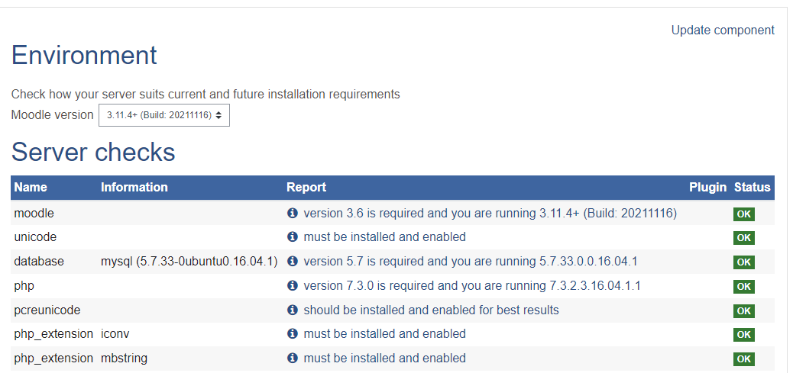

Figure 1: Moodle Version

1. **Setting up of Domain**
   1. **Assigning Public IP to the Server**

A Public IP was obtained for the platform from the Institute Network Administrator and replaced the local IP address with the Public IP (Figure 2).

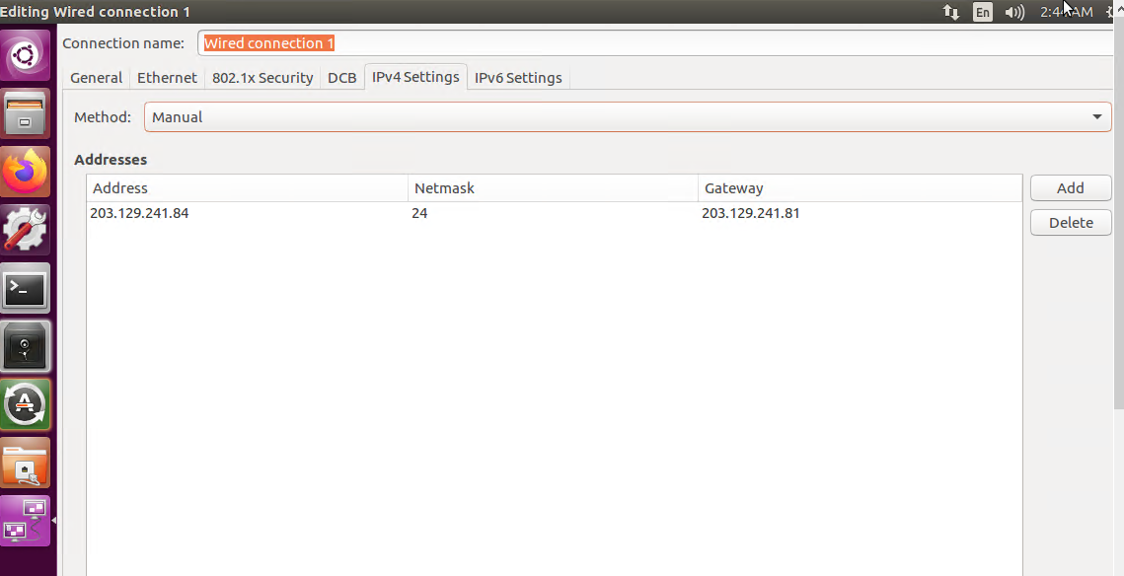

Figure 2: Replacement of IP Address

* 1. **Assigning Domain Name**

The Institute already had an active, but currently unused domain registered with ERNET India with the name [www.aiishpress.ac.in](http://www.aiishpress.ac.in) for the publication division. The same was used for deploying the Moodle platform on the Internet by pointing the domain name to the Public IP.

1. **Setting up of the Site Homepage**

The site homepage was setup under *Site Administration* > *Appearance* > *Front Page* > *Front Page Settings*

The major front-page settings made include the full site name, short name, items to be displayed on the front page, items to be displayed for the logged-in users. The full site is named as ‘**E-learning @ AIISH**’ and the short form as ‘AIISHeLearn’ (Figure 2).

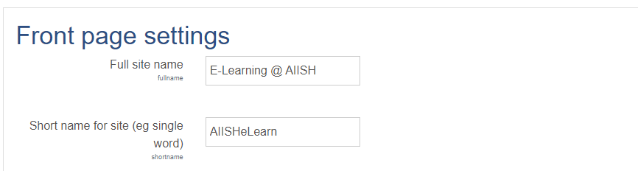

Figure 2: Front-page Setting

**4 Selection, Installation and Customization of Theme**

One of the major concerns of several Moodle LMS users is its non-appealing and non-intuitive interface developed on either of the two standard themes bundled with the Moodle installation package, *Boost* and *Classic*. However, hundreds of Moodle themes are available for free downloading from the official website of the Moodle at [www.moodle.org](http://www.moodle.org) which are user-friendly and provide completely new look and feel for the site. These themes are developed by third parties. There are many other user-friendly and priced Moodle themes available on the Internet for download. The Moodle official website listed totally 94 themes supporting different versions of Moodle. Of these, 19 themes supported the Moodle version 3.7.6 From them, the one titled ‘**eGuru**’ was selected for the proposed site. The **eGuru** is a simple and responsive Moodle theme with shorter navigation paths developed by M/s LMSACE E-learning Experts (Figure 3). It is adopted by more than 8,000 e-learning sited developed using Moodle.

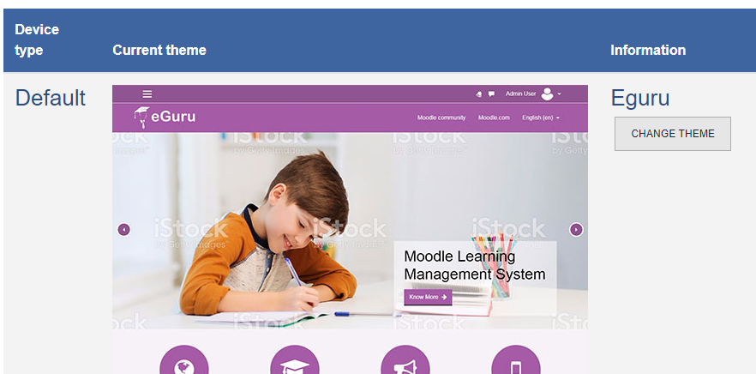

Figure 3: eGuru theme installation

The eGuru theme was customized by incorporating a logo, images, static pages and banner as given in figure 4. The default **eGuru** logo was replaced with a new logo titled ‘e-AiiSH’.



**Figure 4: Customized Homepage**

**5 Enabling HTTPS on the Server**

The default connection protocol for installing Moodle is HTTP (HyperText Transfer Protocol). However, upgrading HTTP to HTTPS (HyperText Transfer Protocol Secure) will ensure safety and security in network communication. Also, in Moodle, in order to make use features like RecordRTC (Record Real-time Communication) and open-source video-conferencing system like BigBlueButton, HTTPS server is mandatory.

In order to enable HTTPS on a website, a Transport Layer Security (TLS) certificate also known as Secure Socket Layer (SSL) a certificate, typically a file, needs to be obtained from a Certificate Authority (CA), The CAs are trusted organizations who verify websites and ensure the reliability of the sites. The TLS certificate ensures privacy and confidentiality of the private information such as user login credentials, bank accounts, name, address, date of birth, telephone number etc. on a website through encryption process. Upon installing a TLS certificate, the HTTP will change to HTTPS with a prefixed padlock icon. There are both open and commercial certificate authorities.

We obtained the TLS certificate from ‘Let’s Encrypt’, a free, automated, and open certificate authority. The ‘Let’s Encrypt’ is a service sponsored by the Internet Security Research Group (ISRG), a US-based public-benefit corporation working on Internet security.

Figure:

**6 Outgoing mail configuration**

In order to send and receive email on Moodle platform, necessary settings were done. Moodle permits e-mail settings either through PHP mail function or SMTP (Simple Mail Transfer Protocol). Most of the time, the mails send via PHP mail function are treated as spam by the receiving mail servers. Hence, the preferred email setting is through SMTP. We used the Gmail SMTP server for configuring mail on our Moodle platform and settings were made by entering SMTP hosts (smtp.gmail.com:465), SMTP security (SSL), SMTP Auth Type (LOGIN), and SMTP username (aiishlibrary@gmail.com) (Figure 4) under *Site administration* > *Server* > *Email* > *Outgoing* *mail configuration*

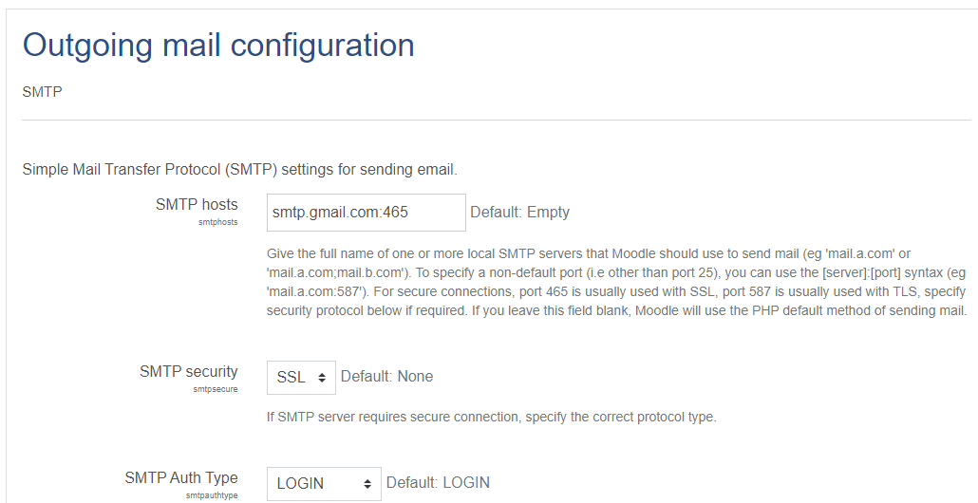

Figure 4: Outgoing mail configuration

**7 Incoming mail configuration**

The incoming mail also configured to enable the users to respond to forum posts using their email and send files to private file folder as email attachment. The Gmail Incoming Mail Server was configured to make the settings under *Site administration* > *Server* > *Email* > *Outgoing* *mail configuration* > Incoming mail configuration. (Figure 5)

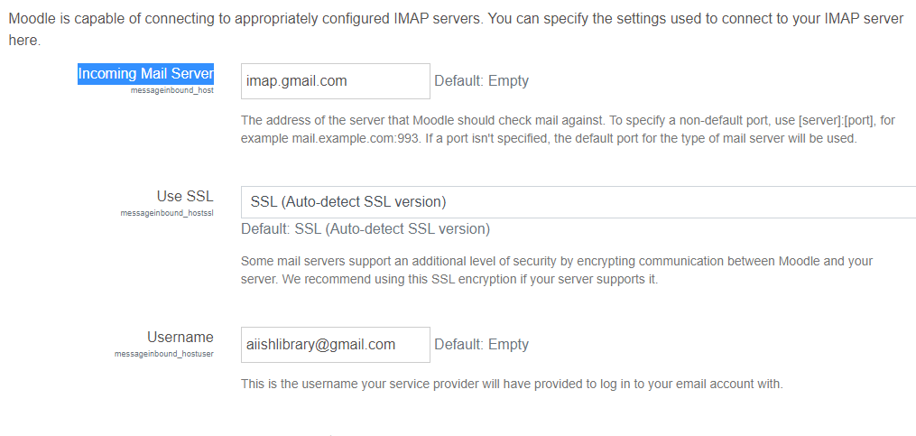

Figure 5: Incoming mail configuration

1. **User Authentication**

User authentication is the process of verifying and validating the credentials or identity of a person while he is trying to access a computer-based system. The objective is to avoid unauthorized access to the system and resources.

The e-AiiSH has been completely protected from unauthorized access and allows access only through user-name and password. All the faculty and student accounts were created manually using the Admin rights with the provision for resetting username and password. The first name of the users in small letters is given as user name and Aiish@123 as password. All other Moodle authentication tools such as e-mail based self-registration, LDAP authentication, Shibolith authentication etc. were disabled.

1. **Installation and Integration of BigBlueButton**

The BigBlueButton (BBB) is the most popular open-source videoconferencing system for online learning. It facilitates sharing of audio, video and whiteboard. The installation of BigBlueButton is a complex process.

A dedicated server was set up through virtualization using HyperV with the following components as per the mandatory requirements for successful installation of BBB version 2.2: Ubuntu Linux Operating System (64 bit, 16.04 version), swap-enabled memory of 16 GB, 8 CPU cores, 500 GB free disk space, accessibility to hypertext transfer protocol port 83, hypertext transfer protocol (secure) port 443, transmission control protocol ports 16384 and 32768, exclusive access to transmission control protocol port 80 and 443, hostname with SSL certificate, 250 Mbits/sec bandwidth, and IPV4 & IPV6 address.

Followed by this, the BBB was installed by entering the commands “sudo apt-get install bigbluebutton” and “sudo apt-get install bbb-html5” in command prompt of Ubuntu. Also, an API Demo was installed using the command “sudo apt-get install bbb-demo”. (Figure …)

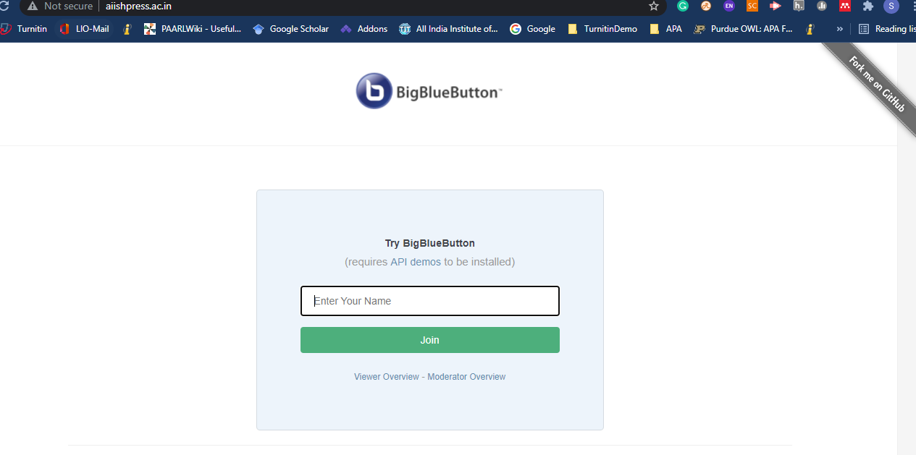

Figure: Installed BigBlueButton

1. **Integration of Additional Plugins and Functionalities**

In addition to BigBlueButton, the Moodle facilitates integration of a number of other plugins and functionalities for enhancing the learning and teaching experience of the platform. There are free as well as paid plugins and functionalities developed by third parties to integrate with Moodle. We have integrated the following free plugins and functionalities on the eAiiSH platform.

1. Attendance: This plugin helps the teacher to maintain an online attendance register and is suitable for blended-learning environments.
2. Survey
3. Mfreak Avatar
4. Opencast Videos
5. Quickmail
6. RecordRTC
7. Student Folder

To enhance the learning experience, Moodle also offers several free and paid integrations.  Some of the certified integrations for Moodle are – BigBlueButton, Bongo, Intelliboard, SimCheck, GO1, JFusion, Joomdle, and Promoodle. Programs such as Respondus, StudyMate, BigBlueButton, Turning Tech, Turnitin2, Certificates, Attendance, Tegrity, Questionnaire, Virtual Programming Lab, and Badges work right in with Moodle.

Instructors can even use Camtasia and Snagit software for effective in-screen capture, recording and video editing.

Moodle has also developed integrations with other education systems, such as Student Information Systems (SIS’s). You can even integrate Moodle with WordPress and WooCommerce for [selling your Moodle courses via multiple payment gateways on WordPress powered by WooCommerce plugins.](https://edwiser.org/blog/sell-moodle-courses-automated/)

Apart from that, it offers Learning Tools Interoperability (LTI) that helps to integrate third-party tools with your course. LTI integration can be useful for creating digital lessons and activities so that other digital tools can be embedded within your canvas study materials. But most LTIs are only accessible via an actual course. [Here’s the list of all the integrations supported in Canvas](https://community.canvaslms.com/t5/Admin-Guide/What-integrations-are-supported-in-a-Canvas-account/ta-p/220).

You can even improve your course with other web applications and internet resources. Canvas integrates with third-party vendors extremely well.

These integrations allow you to use additional tools such as McGraw-Hill Connect, Kaltura, Box, Office 365, Google Drive, and many more to deliver course materials and pass grades back to the Canvas grade book. Along with integrated learning resources, you can also enjoy the benefit of integrated media reporting in Canvas LMS.

At the beginning of *term 1*, all first-year MBBS students (95 men

and 121 women, age: 20.10 _ 0.49 yr, mean _ SD) were requested

to self-register at the DPhysiol site using individual user names and

e-mail addresses. They were given a short briefing about DPhysiol

during their introductory week (all of them were first-time Moodle

users). Along with a set of instructions on the registration, students

were also provided with an enrollment key, which acted as an access

code to the site. When the enrollment key was first entered, students

were automatically placed into 10 separate groups based on their

tutorial grouping assigned by the faculty. Enrolment to DPhysiol was

made available from the beginning of *term 1* until the end of *term 2*

and was not made compulsory.

A total of seven lecturers from the Department of Physiology,

University of Malaya, were assigned as tutors in DPhysiol. The course

content was managed by K. Seluakumaran, who was also one of the

tutors. The installation and administration of Moodle (version 1.9)

was handled by the Academic Development Center’s personnel in our

university (http://adec.um.edu.my/code). The site was hosted by the

server of the Information Technology Center located on our campus.

**Integration of Video Conferencing System**

1. **Big Blue Button**: One of the major tasks in our Moodle implementation was the integration of Big Blue Button.

**Theme Selection**

Learner interface deals with the acceptability of the colors, background, layout, buttons, links, fonts and navigation experience of the users. The standard MOODLE theme was used in this study in which the colors, background, etc. were in the default mode.

As Malik (2009) highlighted that friendly interface of the online learning environment is one of the factors which influence student satisfaction towards online education.

Videoconferencing System

The videoconference tool has been tested on a virtual machine with 300MB of RAM with 20 people connected simultaneously and has shown no defect or excessive load.

**Announcement**

In Moodle the announcement functionality gets created automatically along with the course creation. Only the instructor can post to the Announcement. Also, they can attach files to the Announcement. Every enrolled student is forced to subscribe to the Announcement.

*Online Course Content*

The course content in Moodle is typically organized in topic format

(6, 30). A screenshot of DPhysiol is shown in Fig. 1. We designed

DPhysiol content using the following topic outlines.

**Moodie plug-ins**

The following Moodie plug-ins should be also provided **in addition to the Moodie core features:**

Essentia l theme

Questionnaire activity

Attendance activity

Checklist activ ity

Collapsible course format