Complete install packages are available from Moodle.org's [Windows download page](https://download.moodle.org/windows/) and also from [Bitnami stacks](https://bitnami.com/stacks).

The packages are designed for new installations on a standalone computer. All them use the popular [XAMPP Apache Friends packages](https://www.apachefriends.org/). The complete install package can be used on a server, but **it is not recommended that it be used as a production site**. Please note Moodle.org's [Standard install packages](http://download.moodle.org/) only contain the Moodle code.

This document provides instructions for using the Windows packages. Separate instructions are available for [Mac OS X packages](https://docs.moodle.org/36/en/Complete_Install_Packages_for_Mac_OS_X).

The complete install packages allow Moodle to be installed, along with the prerequisites that includes a web server, Apache, database, MySQL, scripting language, PHP and Moodle all wrapped in the Xampp-lite shell. Several versions of the complete install package are available. The instructions on the download page provide guidance on which version is likely to be most suitable.

In short, complete install packages are designed to create a matched webserver and Moodle site on a standalone computer with minimal effort.

**CONTENTS**

 [[hide](https://docs.moodle.org/36/en/Complete_install_packages_for_Windows)]

* [1 System requirements](https://docs.moodle.org/36/en/Complete_install_packages_for_Windows#System_requirements)
  + [1.1 Port 80 Conflict if Skype is already installed](https://docs.moodle.org/36/en/Complete_install_packages_for_Windows#Port_80_Conflict_if_Skype_is_already_installed)
  + [1.2 Vista and Windows 7/8/10](https://docs.moodle.org/36/en/Complete_install_packages_for_Windows#Vista_and_Windows_7.2F8.2F10)
* [2 Install complete package process](https://docs.moodle.org/36/en/Complete_install_packages_for_Windows#Install_complete_package_process)
  + [2.1 First create file structure](https://docs.moodle.org/36/en/Complete_install_packages_for_Windows#First_create_file_structure)
    - [2.1.1 Download the package](https://docs.moodle.org/36/en/Complete_install_packages_for_Windows#Download_the_package)
    - [2.1.2 Unpack the package](https://docs.moodle.org/36/en/Complete_install_packages_for_Windows#Unpack_the_package)
  + [2.2 Second - start the webserver](https://docs.moodle.org/36/en/Complete_install_packages_for_Windows#Second_-_start_the_webserver)
  + [2.3 Third - start Moodle installation](https://docs.moodle.org/36/en/Complete_install_packages_for_Windows#Third_-_start_Moodle_installation)
    - [2.3.1 Set language](https://docs.moodle.org/36/en/Complete_install_packages_for_Windows#Set_language)
    - [2.3.2 Diagnostic results](https://docs.moodle.org/36/en/Complete_install_packages_for_Windows#Diagnostic_results)
    - [2.3.3 Moodle paths](https://docs.moodle.org/36/en/Complete_install_packages_for_Windows#Moodle_paths)
    - [2.3.4 Database configuration](https://docs.moodle.org/36/en/Complete_install_packages_for_Windows#Database_configuration)
    - [2.3.5 Check server](https://docs.moodle.org/36/en/Complete_install_packages_for_Windows#Check_server)
    - [2.3.6 Confirm initial language pack](https://docs.moodle.org/36/en/Complete_install_packages_for_Windows#Confirm_initial_language_pack)
    - [2.3.7 Confirm config.php](https://docs.moodle.org/36/en/Complete_install_packages_for_Windows#Confirm_config.php)
    - [2.3.8 Moodle copyright & agreement](https://docs.moodle.org/36/en/Complete_install_packages_for_Windows#Moodle_copyright_.26_agreement)
    - [2.3.9 Current release and unattended option](https://docs.moodle.org/36/en/Complete_install_packages_for_Windows#Current_release_and_unattended_option)
    - [2.3.10 Installation modules and blocks screens](https://docs.moodle.org/36/en/Complete_install_packages_for_Windows#Installation_modules_and_blocks_screens)
    - [2.3.11 Administrator user profile](https://docs.moodle.org/36/en/Complete_install_packages_for_Windows#Administrator_user_profile)
    - [2.3.12 Front page settings](https://docs.moodle.org/36/en/Complete_install_packages_for_Windows#Front_page_settings)
    - [2.3.13 Moodle on](https://docs.moodle.org/36/en/Complete_install_packages_for_Windows#Moodle_on)
  + [2.4 Congratulations - Moodle has been installed](https://docs.moodle.org/36/en/Complete_install_packages_for_Windows#Congratulations_-_Moodle_has_been_installed)
* [3 More tips and cautions](https://docs.moodle.org/36/en/Complete_install_packages_for_Windows#More_tips_and_cautions)
* [4 Security matters (A MUST READ!)](https://docs.moodle.org/36/en/Complete_install_packages_for_Windows#Security_matters_.28A_MUST_READ.21.29)
* [5 Apache and MySQL tweaks](https://docs.moodle.org/36/en/Complete_install_packages_for_Windows#Apache_and_MySQL_tweaks)
  + [5.1 Installing Apache and MySQL as services](https://docs.moodle.org/36/en/Complete_install_packages_for_Windows#Installing_Apache_and_MySQL_as_services)
  + [5.2 Apache Notes](https://docs.moodle.org/36/en/Complete_install_packages_for_Windows#Apache_Notes)
    - [5.2.1 Troubleshooting](https://docs.moodle.org/36/en/Complete_install_packages_for_Windows#Troubleshooting)
  + [5.3 MySQL notes](https://docs.moodle.org/36/en/Complete_install_packages_for_Windows#MySQL_notes)
* [6 If you are installing Moodle complete install package under Windows 7](https://docs.moodle.org/36/en/Complete_install_packages_for_Windows#If_you_are_installing_Moodle_complete_install_package_under_Windows_7)
* [7 See also](https://docs.moodle.org/36/en/Complete_install_packages_for_Windows" \l "See_also)

System requirements

* 256 MB RAM (minimum), 1GB RAM (recommended)
* 500 MB free Fixed Disk (more space will be needed depending on user uploads)
* For old versions of Moodle:
  + Windows 98/ME (minimum)
  + Windows NT/2000/XP/2003 (recommended)
* For Moodle 3.1 and later versions:
  + Windows Vista/7/8/10/2008/2012
  + Microsoft Visual C++ 2015 Redistributable package is required for PHP ([download link)](https://www.microsoft.com/en-us/download/details.aspx?id=48145). This must be the **vc\_redist.x86.exe** download as the PHP build is 32-bit.

Port 80 Conflict if Skype is already installed

As the Moodle Windows package uses the same port (80) as [Skype](http://www.skype.com/en/) does, it will not work if the computer has Skype already installed.

The fix is very simple: Exit Skype (don't just close the window), then start the Moodle Windows package. Once Moodle for Windows is running, it should be safe to start Skype again. If the local Moodle is using the port 80, Skype will automatically select a different port when it is run.

Vista and Windows 7/8/10

Packages generated for Moodle 3.1 and later versions should work with Vista/7/8/10 out of the box. They include PHP 7 and MariaDB instead of MySQL, resulting in a smoother experience than previous versions of the packages.

If you have Windows 7, you must check if [you need to increase Apache default stack size](https://docs.moodle.org/36/en/Errors_FAQ#Check_if_you_need_to_increase_Apache.E2.80.99s_default_stack_size).

People facing problems with the new packages are advised to:

* Check the PC with a good antivirus. Be very cautious when choosing a free/paid Windows antivirus. Good places to look for are [old, reliable, solid PC magazines](https://www.pcmag.com/article2/0,2817,2372364,00.asp) and [old, reliable, solid PC blogs](https://www.tomsguide.com/us/best-antivirus,review-2588-5.html). Beware of many malicious malware programs posing as antivirus solutions! Google for any chosen solution before installing it.
* Check the problem text: If it says that the connection was reset, read [this documentation page](https://docs.moodle.org/36/en/Errors_FAQ#.27The_connection_was_reset.27_when_using_a_Moodle_Windows_complete_install_package_for_recent_versions_in_a_modest_hardware) for diagnosis and fix.
* Read the Requirements and Troubleshooting information, both here and in the package's README.txt file.
* Report any consistent problem in the [Moodle Tracker](https://tracker.moodle.org/), so it can be investigated and, hopefully, fixed.
* Consider installing a virtual machine (eg, [VirtualBox](https://www.virtualbox.org/)) with a windows or linux LAMP stack and then install Moodle there.
* Switch to:
  + a Windows 10 PC O.S. ([if your hardware supports it](https://www.microsoft.com/en-us/windows/windows-10-specifications) and you can afford it),
  + a Linux (best option) O.S., [Ubuntu](https://www.ubuntu.com/) is a popular Linux flavour as [most PCs can support it](https://help.ubuntu.com/lts/installation-guide/armhf/ch02.html?_ga=2.1106225.1061556046.1528904082-1294294419.1525365952),
  + a Mac if you are tired of Windows problems and money is not an issue.
* Use other Moodle-ready alternatives [out there](https://moodlecloud.com/).
* Read the documentation for [Errors FAQ](https://docs.moodle.org/36/en/Errors_FAQ)

Install complete package process

The complete install package is a zip file that contains a webserver called [Apache](https://docs.moodle.org/36/en/Apache), plus Moodle and Moodle's required [MySQL](https://docs.moodle.org/36/en/MySQL) database and [PHP](https://docs.moodle.org/36/en/PHP" \o "PHP)program.

There are three basic parts to the this install process.

1. Download and unpack the complete install package.
2. Start the webserver.
3. Install Moodle using a web browser.

First create file structure

Download the package

[Download Windows](http://download.moodle.org/windows) packed-zip file from Moodle.

Unpack the package

Unpack (extract files by clicking on) the zip file you downloaded to a drive or partition of your choice. The extract process will create three files ("Start Moodle", "Stop Moodle", and "README") and a subfolder called "server".

* Do NOT rename the "server" subfolder

*Note:* There will also be a folder under this server subfolder, called \moodle that holds the Moodle program.

*TIP:* Create a folder and extract the files there. For example, you might have one folder called Moodle254 and another one called Moodle281 for different versions or purposes.

*TIP:* Make path to "server" subfolder simple. Best way if it will be in drive root. Like "D:\moodle281\server". A long path, especially with any strange symbols, can prevent XAMPP from working properly.

*NOTE:* If you will be installing a server with a language other than English, the install process will need to download the corresponding language pack, which will take some time, and you will likely get a script timeout error. To prevent this, you will need to edit the server/php/php.ini file and change the line that has 'max\_execution\_time = 30' into 'max\_execution\_time = 600'.

Second - start the webserver

Now you are ready to start the webserver. Use the "Start Moodle.exe" file which you should find in the top directory. Once the "Start Moodle.exe" program is open, don't close it; use "Stop Moodle.exe" for that purpose.

*Note:* These programs control both Apache and MySQL programs that operate the webserver. Some sites will individually start and stop Apache and MySQL with the Xampp bat files found in the "server" subfolder.

*Tip:* Alternatively, on a standalone computer with several potential webservers that might be running, you can use the "xampp\_restart.exe" file in the "server" subfolder.

*Tip:* You can also add shortcuts to the commands that start and stop the site in your Windows "start" menu.

Now you are ready to start the Moodle installation.

*Warning:* Windows XP requires the msvcr71.dll library file in order to run Xampp. Installing the [.Net 1.1 framework](http://www.microsoft.com/downloads/details.aspx?familyid=262D25E3-F589-4842-8157-034D1E7CF3A3&displaylang=en) (not .Net 2.0 and upper) could resolve it. You can also search for the file on Google, download it and copy it into the server/apache/bin folder.

Third - start Moodle installation

Start your web browser and type localhost, or http://127.0.0.1 or http://localhost in the address bar. You will either start your first time Moodle installation or if it is already installed you will enter the Moodle site's [Front Page](https://docs.moodle.org/36/en/Front_Page) or Login screen.

[https://docs.moodle.org/36/en/images_en/d/da/Moodle_Setup_localhost_browser.jpg](https://docs.moodle.org/36/en/File:Moodle_Setup_localhost_browser.jpg)

A browser's addressbar showing "localhost". Click on the green Goto arrow will go to the installed Moodle site.

*Tip:* After Moodle installs, put the site in your "favorites" or as a "bookmark" in you browser.

Set language

The initial install page will be displayed after you type "localhost".

[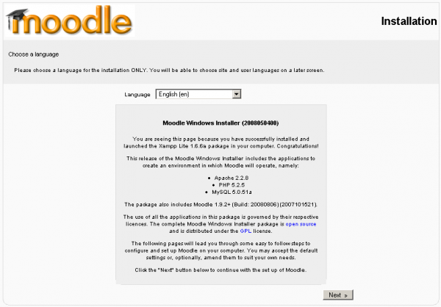](https://docs.moodle.org/36/en/File:C_Install_Windows_1.png)

Set initial language

* Choose your preferred language (English is used in this example) and click the “Next” button.

Diagnostic results

A diagnostic report is displayed – hopefully it will look like this, if not you may need to address some issues.

[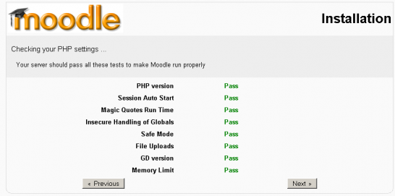](https://docs.moodle.org/36/en/File:Complete_Windows_Install_2.png)

Moodle liked and gave a Pass

* Click the “Next” button to continue.

Moodle paths

The paths for your Moodle installation are shown – if you are only using this as a local testing server, accept the ones that are shown on your screen.

What you enter in the "Web Address" field depends on what you intend to use the new Moodle installation for. If you are just going to use it for local testing, then use 'http://localhost'. If you are going to test the new installation on a LAN, and will be accessing it from other machines on that LAN, then put the private IP address or network name of the serving machine, followed by a forward slash and moodle: Web Address - <http://192.168.1.1/moodle> If you are going to test the installation on the internet, then you will need to put the public ip address followed by a forward slash and moodle: <http://your_ip_address/moodle> or you can put your domain name here instead.

[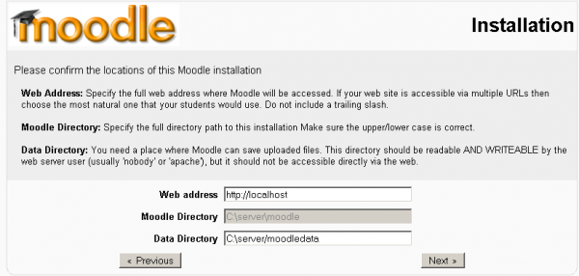](https://docs.moodle.org/36/en/File:Complete_install_Windows_3.png)

Installation paths

* Click the “Next” button to continue.

Database configuration

* In the next fields, we enter the database settings. The fields are populated with some suggested values.
* We strongly recommend you place a user name and password in this screen. (Don't forget them).
* DO NOT USE THE “ROOT” USER WITHOUT A PASSWORD FOR PRODUCTION INSTALLATIONS AS THIS CREATES A SECURITY VULNERABILITY

[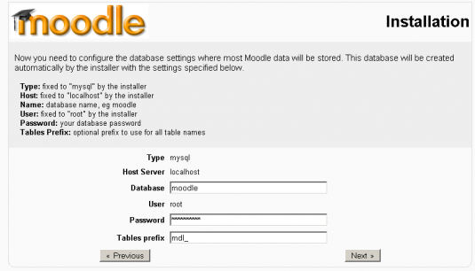](https://docs.moodle.org/36/en/File:Complete_install_Windows_4.png)

Installation's database settings

* When the fields have been populated, click the “Next” button to continue.

Check server

The install process checks the server is installed. All the checks should pass as far as the [system requirements](https://docs.moodle.org/36/en/Complete_install_packages_for_Windows#System_requirements) have been fulfilled.

[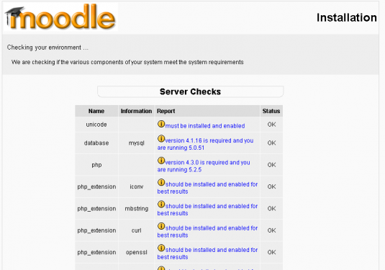](https://docs.moodle.org/36/en/File:Complete_install_Windows_5.png)

Check server environment screen

* Click the “Next” button to continue.

Confirm initial language pack

Moodle will now check to see if the language pack is available for the language you selected at the first step. If it is not, Moodle will continue with the install in English.

[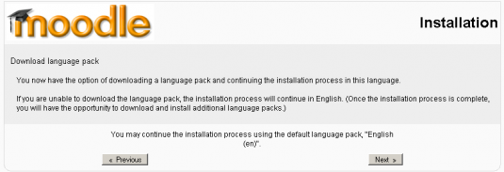](https://docs.moodle.org/36/en/File:Complete_install_Windows_6.png)

Language pack check

Confirm config.php

Provided the Moodle folder is writable, a message confirming the configuration has been completed will be displayed.

[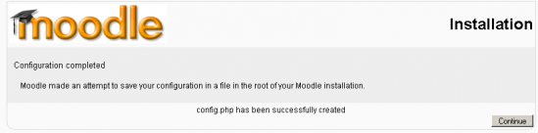](https://docs.moodle.org/36/en/File:Complete_install_Windows_7.png)

Confirmation that config.php has been created

* Click the “ Continue” button to proceed.

Moodle copyright & agreement

The Moodle copyright / license notices are displayed.

[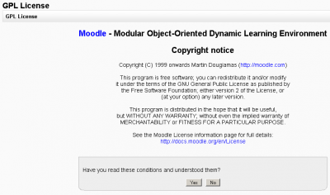](https://docs.moodle.org/36/en/File:Complete_install_Windows_8.png)

Copyright notice and agreement

* Click the “Yes” button to continue.

Current release and unattended option

The current release information is shown. **Check off the unattended operations box**. This will automatically advance through many screens. If you would like to watch the install screen by screen, do not check this box and be prepared to press the "continute button" many times.

* Click the "Continue" button and wait.

[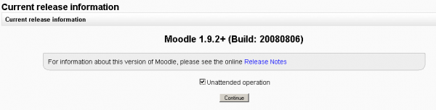](https://docs.moodle.org/36/en/File:Complete_install_Windows_9.png)

Current release and "unattended" check box

Installation modules and blocks screens

In most cases this will be followed by a series of screens that have a continue button on the bottom. This process stops with Admin user profile settings which needs to be filled out.

Administrator user profile

[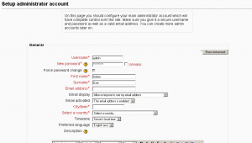](https://docs.moodle.org/36/en/File:Complete_install_Windows_10.png)

The administrator's users profile screen

Fill out the required fields.

* Click on "Save" to continue

Front page settings

The next screen is the Front Page settings page. There are two parts to it. The first part will ask for your Full site name and a short name for the navigation bar. There is also a place for a description. You can change these later.

[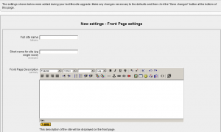](https://docs.moodle.org/36/en/File:Complete_install_Windows_11a.png)

The Moodle sites [Front Page](https://docs.moodle.org/36/en/Front_Page) information

The second part on the bottom instructs Moodle if you will disable the new user self [authentication](https://docs.moodle.org/36/en/Authentication) through email process. The default is to disable. This can be changed later in the [site administration block](https://docs.moodle.org/36/en/Site_administration_block).

[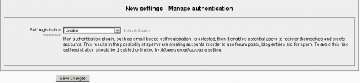](https://docs.moodle.org/36/en/File:Complete_install_Windows_11ba.png)

Determine if users can create their own profiles when they log onto the side via email self authentication

* Click on "Save changes" button to go to Moodle sites home page.

Moodle on

**Now you are ready to Moodle !**

[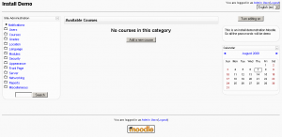](https://docs.moodle.org/36/en/File:Complete_install_Windows_12.png)

Blank Front page of your new site

The Site Administration block is on the left, the "Turn edit on" button in the upper right corner, withe the site description block just below it.

Congratulations - Moodle has been installed

This finishes the installation of a complete package. Type http://localhost (or what ever you set for web address earlier in the setup!) in your browser and Moodle will open.

Your next task will be to configure Moodle to meet your needs. Don't worry, it is easy to change any of the settings now that Moodle is up and running.

* Check *Settings > Site administration* for further links.

More tips and cautions

* For installation on a Windows 2000 or Windows 2003 production server it is good practice to perform a manual install (see the manual installation section in [Windows Installation](https://docs.moodle.org/36/en/Windows_installation)).
* After installing the Windows package, you may wish to add additional contributed modules and plugins. Theset may involve more customization of configuration files.
* The latest complete install package version components, may not be backwardly compatible. Always check version compatibility of each component if you intend to develop materials on a later version of Moodle than the version installed on your "main" Moodle site. In short, complete install packages are designed for first time install on a "clean" machine.

Security matters (A MUST READ!)

As mentioned before, XAMPP is not meant for production use but only for developers in a development environment. The way XAMPP is configured is to be open as possible and allowing the developer anything he/she wants. For development environments this is great but in a production environment it could be fatal. Here a list of missing security in XAMPP:

The MySQL administrator (root) has no password. The MySQL daemon is accessible via network. Examples are accessible via network.

To fix most of the security weaknesses simply call the following URL:

http://localhost/security/

The root password for MySQL and also a XAMPP directory protection can be established here.

Note that on the Windows installer package, some (all?) of these issues have been fixed already by default and the above link does not work.

If in doubt, more info is [here](http://www.apachefriends.org/en/faq-xampp-windows.html)

Apache and MySQL tweaks

Most of the time it is not necessary to tweak Apache or MySQL after completing the complete install package. Nor is it necessary to individually start and stop them because that is what the Xampp\_start, Xampp\_restart and Xammp\_stop files are for.

Installing Apache and MySQL as services

(This is only for NT4 | Windows 2000 | Windows XP operating systems)

\xampplite\apache\apache\_installservice.bat = ==> Install Apache 2 as service

\xampplite\apache\apache\_uninstallservice.bat = ==> Uninstall Apache 2 as service

\xampplite\mysql\mysql\_installservice.bat = ==> Install MySQL as service

\xampplite\mysql\mysql\_uninstallservice.bat = ==> Uninstall MySQL as service

==> After all Service (un)installations, please restart your system!

Apache Notes

You can use the apache\_start and apache\_stop bat files to start and stop apache from running. However the Xampp\_start or Xampp\_restart and Xampp\_stop is recommended to turn on/off both Apache and MySQL.

Troubleshooting

If you find that Apache is very flaky, with the page often not loading properly or even at all (especially on localhost), try adding these lines to the end of C:\your\_moodle\_installer\_directory\apache\conf\httpd.conf

EnableSendfile Off

EnableMMAP Off

Win32DisableAcceptEx

If You edit some .php files but browser still show old state of them, try to disable eAccelerator extension in \server\php\php.ini

[eAccelerator]

;extension=eaccelerator.dll

MySQL notes

Again, the recommendation to start and stop the entire webserver is to use the xampp\_start or Xampp\_restart and the Xampp\_stop. The following maybe useful if you wish to tweak the system further. Please be careful.

(1) The MySQL server can be started by double-clicking (executing) mysql\_start.bat. This file can be found in the same folder you installed xampp in, most likely this will be C:\xampplite\. The exact path to this file is X:\xampplite\mysql\_start.bat, where "X" indicates the letter of the drive you unpacked xampp into.This batch file starts the MySQL server in console mode. The first intialization might take a few minutes.

Do not close the DOS window or you'll crash the server! To stop the server, please use mysql\_shutdown.bat, which is located in the same directory.

(2) To use the MySQL Daemon with "innodb" for better performance, please edit the "my" (or "my.cnf") file in the /xampplite/mysql/bin directory or for services the c:\my.cnf for windows NT/2000/XP. In that director, activate the

"innodb\_data\_file\_path=ibdata1:30M"

statement. Attention, "innodb" is not recommended for 95/98/ME.

To use MySQL as Service for NT/2000/XP, simply copy the "my" / "my.cnf" file to C:\my, or C:\my.cnf. Please note that this file has to be placed in C:\ (root), other locations are not permitted. Then execute the "mysql\_installservice.bat" in the mysql folder.

(3) MySQL starts with standard values for the user id and the password. The preset user id is "root", the password is "" (= no password). To access MySQL via PHP with the preset values, you'll have to use the following syntax:

mysql\_connect("localhost","root","");

If you want to set a password for MySQL access, please use of mysqladmin. To set the password "secret" for the user "root", type the following:

\xampplite\mysql\bin\mysqladmin -u root password secret

Have a lot of fun! Viel Spaß! Bonne Chance!

If you are installing Moodle complete install package under Windows 7

* Check [if you need to increase Apache's default stack size](https://docs.moodle.org/36/en/Errors_FAQ#Check_if_you_need_to_increase_Apache.E2.80.99s_default_stack_size)

See also

* [Installation guide - Moodle 1.9 for Windows on a USB Memory Stick](https://docs.moodle.org/19/en/Installation_guide_-_Moodle_for_Windows_on_a_USB_Memory_Stick)
* Return to [Windows installation](https://docs.moodle.org/36/en/Windows_installation)
* [Multiple web servers, on 1 computer](https://docs.moodle.org/36/en/Windows_1_computer_many_servers) similar to windows installation page, with some tips
* [Troubleshooting](https://docs.moodle.org/en/Windows_installation_using_XAMPP#Troubleshooting)if you are running Skype.
* [Installing\_AMP](https://docs.moodle.org/36/en/Installing_AMP) lots of XAMPP stuff. XAMPP stands for X (cross platform), Apache, MySQL,PHP and Perl. XAMPP used in Moodle does not include Perl. MAMP stands for Mac, Apache, MySQL and PHP.
* [Installation Package for OS X](https://docs.moodle.org/36/en/Installation_Package_for_OS_X)

[Categories](https://docs.moodle.org/36/en/Special:Categories):