**Design, Development and Validation of Open Source Platform for AIISH Digital Repository and Online Public Access Catalogue**

A Non-funded Research Report

**Principal Investigator**

Dr. Shijith Kumar, C

**Co-Investigators**

Mr. Nanjunda Swamy, M.,

Mr. Raghavendra, G.N.

Mr. Lokesh, P

Mr. Nidheesh David Kuruvila

**2021**

Library and Information Centre

**All India Institute of Speech and Hearing**

**Mysuru**

**Contents**

**Preliminary Section Pages**

1. Project Summary
2. Acknowledgement
3. Contents

**Main Section**

**Chapter 1 Introduction**

1.1 Institutional Repository: Concept, Definition and Content Types

1.2 Advantages of Institutional Repository

1.3 Online Public Access Catalogue: Concept and Definition

1.4 Advantages of the Online Public Access Catalogue

1.5 Current international and national status of IRs and OPACs

* 1. Statement of the Problem

1.7 Objectives of the Study

1.8 Importance of the Present Project

1.9 Work Plan

**Chapter 2 Evaluation of the Existing System**

2.1 Evaluation of the OPAC

2.2 Evaluation of the Institutional Repository

2.3 Inferences

**Chapter 3 Software Selection and Installation**

3.1 Selection and Installation of Institutional Repository Software

3.2 Selection and Installation of Koha Software

**Chapter 4 System Design and Development**

**4.1 Design and Development of Online Public Access Catalogue**

**4.2 Design and Development of Institutional Repository**

**Chapter 5 Discussion and Conclusion**

5.1 Discussion

5.2 Conclusion

**References**

**SUMMARY**

**Project Summary**

The All India Institute of Speech and Hearing is one of the early implementers of the Institutional Repository (IR) and Integrated Library Management System (ILMS) among the higher educational Institutions in the country. However, both the solutions were developed on proprietary software platforms with limited functionalities and are being continued even today without any further modification or addition of features. On the other hand, the IR and ILMS fields at present are dominated by freely available open source applications with advanced features and functionalities. This project designed and developed an open source-based IR and Online Public Access Catalogue, the end-user component of the ILMS. The new platform serves as a single-point access to all the resources and services of the Library and Information Centre, All India Institute of Speech and Hearing, Mysuru.

**Acknowledgements**

We sincerely acknowledge Dr. M. Pushpavathi, Director, All India Institute of Speech and Hearing, Mysore for her encouragement and support towards the completion of the project. We are grateful to Dr. S.R. Savithri, former Director for sanctioning the project and we thank her for her confidence in us. Thanks are also due to Mr. Mahendra, Clerical Assistant, Ms. Bhanumathi, Clerical Assistant and all our colleagues in the Library and Information Centre, AIISH, Mysore.

.

**Investigators**

**Contents**

**Preliminary Section Pages**

1. Project Summary
2. Acknowledgement
3. Contents

**Main Section**

**Chapter 1 Introduction**

1.1 Institutional Repository: Concept, Definition and Content Types

1.2 Advantages of Institutional Repository

1.3 Online Public Access Catalogue: Concept and Definition

1.4 Advantages of the Online Public Access Catalogue

1.5 Current international and national status of IRs and OPACs

* 1. Statement of the Problem

1.7 Objectives of the Study

1.8 Importance of the Present Project

1.9 Work Plan

**Chapter 2 Evaluation of the Existing System**

2.1 Evaluation of the OPAC

2.2 Evaluation of the Institutional Repository

2.3 Inferences

**Chapter 3 Software Selection and Installation**

3.1 Selection and Installation of Institutional Repository Software

3.2 Selection and Installation of Koha Software

**Chapter 4 System Design and Development**

4.1 Design and Development of Online Public Access Catalogue

4.2 Design and Development of Institutional Repository

**Chapter 5 Discussion and Conclusion**

5.1 Discussion

5.2 Conclusion

**References**

**Chapter 1**

**INTRODUCTION**

Institutional Repository (IR) also known as digital repository or digital library is a solution for gathering, preserving and disseminating intellectual output of an educational and research organization, and Online Public Access Catalogue (OPAC) is a tool for preserving and retrieving the bibliographic elements of its collection of information resources. The availability of user-friendly Open-Source Software applications, i.e. the applications with their source codes open for inspection, modification, and improvement by adding features to them, and increase in the I.T. literate information user community have made IRs and OPACs a common place in educational institutions across the world.

* 1. **Institutional Repository: Concept, Definition and Content Types**

Lynch (2003) defined an institutional repository as a “set of services that a university offers to the members of its community for the management and dissemination of digital materials created by the institution and its community members”. According to Swan, they are “digital collections of the outputs created within a university or research institution”. The IRs are built on a set of global technical standards which make them ‘interoperable’. These standards are known as Open Access Initiative-Protocol for Metadata Harvesting or OAI-PMH, in short. Earlier, the IRs were considered as online channels for the dissemination of ‘grey literature’, the unpublished theses, dissertations, term papers, presentations etc. of an organization which are typically not available or accessible for the scholarly community outside the organization. However, the recent trend is to promote IRs as and other open access repositories as primary channels of scholarly communication, and thus reduce the monopoly of commercial journal publishers in the scholarly world.

Any scholarly piece of information, generated at an Institutional level is qualified to incorporate in the Institutional repository. In general, IRs have the following types of resources.

1. Theses
2. Dissertations
3. Conference papers
4. Conference Presentations
5. Teaching notes
6. Class presentations
7. Peer-reviewed journal articles or pre-prints
8. Research datasets
9. Books and Monographs

**1.2** **Advantages of Institutional Repository**

The major advantages and benefits of establishing an Institutional Repository are the following.

1. Dissemination of scholarly output of the organization to a wider audience
2. Increase in the citation to the research works
3. Showcasing of the scholarly performance of the organization
4. Long-term preservation of the scholarly content
5. Opening of opportunities for collaborative and inter-disciplinary research

**1.3** **Online Public Access Catalogue: Concept and Definition**

The Online Public Access Catalogue or OPAC in abbreviation, is the computerized version of traditional library catalogue. Typically, OPAC functions as a subsystem or module of a software package known as Integrated Library Management System (ILMS) or Integrated Library System (ILS) which is used for managing the entire library operations and services.

**1.4 Advantages of the Online Public Access Catalogue**

The advantages of using OPAC include:

1. Enhancement in the way of searching and identifying the needed information
2. Elimination of paper cards
3. Simultaneous access to multiple users
4. Saving of physical storage space
5. Ease of up-dation

**1.5 Current International and National Status of IRs and OPACs**

There has been a proliferation in the number of IRs and OPACs both internationally and nationally in the last few years with the emergence of Open Source Software solutions in the field. According to the Ranking Web of Repositories (2016), totally there are 2297 no. of IRs all over the world and in India there are 43 repositories. These repositories differ greatly in content, size, scope and objectives and majority of the IRs operating in India are open source based (Gohain 2011). Two active national repositories in India at present are Shodhganaga, a repository of Indian doctoral theses and Shodhagangotri, a repository of Indian doctoral research in progress, both developed by the INFLIBNET, a constituent of UGC, Govt. of India. The National Digital Library is a new repository from India developed at the IIT, Kharagpur as a part of the National Mission on Education through Information and Communication Technology of the Ministry of Human Resource Development, Govt. of India.

**1.6 Statement of the Problem**

All India Institute of Speech and Hearing (AIISH), the premier institution in the country in the field of communication disorders established in the year 1965. The Institute functions under the Ministry of Health and Family Welfare, Government of India. The Library and Information Centre of the All-India Institute of Speech and Hearing, Mysore, has been in existence since the establishment of the Institute on 9th August 1965. It is rich in print and electronic information resources and provides a number of traditional and electronic information services. The library is running an Institutional repository of theses and dissertations. Also, all its operations have been automated using an Integrated Library management System with an OPAC module. Both the applications were developed by third party using proprietary software tools. Presently, the repository contains more than 1700 records consisting of postgraduate and doctoral dissertations, and the funded research project reports. The OPAC contains the bibliographic records of 20,000 plus print collection of the Institute library. Both the IR and OPAC are being maintained on payment basis by the third parties who developed them. Our working experience with the applications and the feedback we have been receiving from our user community strongly suggest a thorough modification in the functionalities and upgradation of both the digital repository and OPAC. However, upgradation and modification processes require additional expenses from the part of the Institute as the applications are running on proprietary software developed by third parties and getting it done by making payment is not feasible considering the fact that the upgradation may be needed frequently. On the other hand, there are plenty of free open-source applications for building digital repository and OPAC with advanced features and functionalities. Upgradation is also free on this software. Hence, this project proposes to design and develop an open-source platform for the digital repository and OPAC and migration of the existing digital repository collection and the OPAC bibliographic records to the new system.

**1.7 Objectives of the Study**

The objectives of the project are the following.

1. To systematically evaluate and summarize the drawbacks of the existing IR and OPAC of AIISH.
2. To identify suitable open-source software alternatives for the existing IR and OPAC.
3. To design and develop an open source platform and migration of the resources
4. To expand and enrich the content base of the repository by additionally incorporating new material types
5. To facilitate content based searching of digital repository and discoverability on search engines.
6. To generate a new comprehensive set of metadata for the IR and OPAC as per the international standards
7. To facilitate interoperability for the IR with the related institutional and national repositories across the world.
   1. **Importance of the Present Project**

A review of the current international and national status of the subject reveals the importance of developing Institutional Repositories. Also, majority of the repositories that have been developed in India are on open source platform and they have a lot of features and functionalities such as content based searching, e-mail alerts, interoperability with other IRs, web search engine discoverability, etc. which AIISH digital repository does not have. Hence, it is imperative to develop a repository for the Institute on open source platform for the benefit of its user community.

**1.9 Work Plan**

**1.9.1 Materials and Methods**

1. **Analysis of the existing Digital Repository and OPAC**

The present system of digital repository and OPAC will be analyzed to identify its strength and weakness by the following methods.

1. Conducting an evaluation survey among the end users on their usability.
2. Testing and evaluation of the system against a check list developed by the project team
3. **Selection of Open-Source Software**

The available Open-Source Softwarefor building digital repository and OPAC will be identified by conducting a literature survey in the field of digital information management. The other associated open-source software applications needed for developing the system namely, MySQL, PHP, Apache and Tomcat will also be downloaded and installed.

1. **System Design and Development**

Based on the analysis, a new system will be designed, taking into consideration of the limitations of the existing system and the need for incorporating new resources with additional features and functionalities. The software applications selected will be integrated, customized, modified and additional features will be incorporated by writing necessary codes/ programmes. MySQL based databases will be set up and necessary configurations will be made on other software applications. Also, web based interfaces will be designed and developed for both the repository and OPAC.

1. **Rectification of the OPAC Records**

In order to ensure accuracy of information and improve the OPAC based search results, the existing bibliographic records of the print collection (more than 20,000) will be completely replaced by importing the corresponding Machine Readable Catalogue (MARC) records from the official website of the Library of Congress, USA ( Library of Congress, n.d.) available for free downloading as a part of its Cataloging in Publication programme. The records which are not available with the Library of Congress will be created manually.

1. **Metadata Creation**

Metadata are the elements for describing information resources in a collection. In order to index and describe the resources included in both the Digital Repository and OPAC, appropriate metadata will be created from the Dublin Core Metadata Set, an international standard for information resource description developed by Dublin Core Metadata Initiative (DCMI), a non-profit organization and ratified as ISO 15836:2009, ANSI/NISO Z39.85-2007, and IETF RFC 5013 (DCMI n.d.). Metadata such as contributor, coverage, description, year of publication, format, publisher, subject, title, ISBN, accession number and location will be considered for inclusion.

1. **Uploading of the Materials**

All the materials will be uploaded to the new system developed by assigning suitable metadata elements selected. Wherever possible bulk uploading will be done by writing necessary scripts in PHP language.

1. **Trial Running, Error Rectification and Finalization of the System**

Trial running will be carried out after development of the system. Then, errors, if any will be rectified and the system will be finalized.

**Chapter 2**

**Evaluation of the Existing System**

The existing AIISH Institutional Repository and the Online Public Access Catalogue were evaluated by conducting a questionnaire survey among the end user community. The details are explained in this chapter.

**2.1 Evaluation of the OPAC**

An eight-item questionnaire was developed for collecting the opinion of the Online Public Access Catalogue by the end users at the Institute (Appendix-1). Totally, 50 questionnaires were distributed and 30 users (60%) responded to the survey.

The respondents include 11 staff and 19 students. Among the respondents, 21 had been with the Institute for more than three years and nine joined the Institute in less than a year. The respondents were screened initially based on whether they use OPAC or not. The non-users were requested to return the questionnaire after indicating the reasons for not using the facility. Further questions were limited to those were using the OPAC.

Only two respondents (6.6%) did not use the Online Public Access Catalogue. The reasons cited for non-use include ‘I don’t know the benefit of using OPAC’ and ‘I prefer searching the books directly on the shelves’,

The questionnaire received from the remaining 28 respondents were further analysed for understanding their pattern of use, difficulties faced and suggestions for features in the new OPAC.

The respondents came to know about the OPAC facility from ‘colleagues and friends’ (32%, 9 no.), library staff (57%, 16 nos.), library website (18%, 5 nos.), teachers in the class (3 nos., 11%), and library orientation (64%, 18 nos.). Thus the majority came to know about the facility through the library orientation programme.

To a question on the functionalities of OPAC that were being used, the respondents indicated book author searching, searching (17 nos, 60%), title searching (21 nos., 75%), keyword searching (13 nos., 46%), location (26, 93%), no. of copies of books (9 nos., 32%), new arrivals (2 nos., 7%). No one used the facility for book reservation and for checking outstanding due.

Fifteen respondents (54%) used OPAC on weekly basis and the remaining 46% used it rarely.

The respondents faced difficulties in using OPAC and book circulation. These include missing the due date of book return (10 nos., 36%), lack of information on the total fine due (11 nos., 39%), unskilled in OPAC searching (2 nos., 7%), lack of information on new arrivals (7 nos., 25%), inadequacy in the no. of books issued (7 nos., 25%), and inconvenient book circulation timing (2 nos., 7%).

The respondents suggested features and functionalities for the new OPAC such as user review on books (11 nos. 39%), international database search facility ( 7 nos., 25%), common search interface for all the library resources ( 17 nos., 61%), feedback ( 4 nos., 14%), table of contents ( 20 nos., 71 %), and book suggestion facility (15 nos., 54%).

**2.2 Evaluation of the Institutional Repository**

A 16-item questionnaire was developed for collecting the feedback on existing IR from the end-user community. (Appendix-II). Totally, 50 questionnaires were distributed and 31 persons (62%) responded to the survey. 17 respondents (55%) had been with the organization for more than five years. Seven (23%) had three to five years’ experience and the remaining seven respondents (23%) joined the Institute in less than three years. Four out of 31 respondents never used the IR. The reasons include, ‘It is not relevant for my information needs’ (50%, 2 nos.), and ‘I don’t know how to use it’ (50%, 2 nos.).

The questionnaire received from the 27 respondents, who were the users of the IR, were further analysed for understanding their pattern of use, views on different aspects of Institutional repository, difficulties faced and suggestions for functionalities and features in the new OPAC.

Majority of the respondents (63%, 17 nos.) came to know about the repository through the library orientation programme. Other sources of information about the IR were, colleagues and friends (48%, 13 nos.), teachers in the classroom (30%, 8 nos.), and library website (22%, 6 nos.).

In an attempt to find out the awareness of the resources available in IR, the respondents were requested to identify the resources from among a list. The list included items which were not available in the repository. Only 37% (10 nos.) of the respondents were able to tick the correct combination of resources in the repository.

Of the four types of resources content, the PG dissertations were used frequently or very frequently by majority of respondents (59%, 16 nos.). This is followed by doctoral theses which were used frequently or very frequently by 37% (10 nos.). Only 22% (6 nos.) used the Independent Project reports very frequently or frequently. A considerable number of end-user respondents (37%, 10 nos.) never used the Independent Project reports.

Another awareness question was asked regarding the nature of accessibility to the repository. Only 19% of the respondents answered the correct combination of repository accessibility options.

Majority of the respondents (78%, 21 nos.) did not use any repository other than AIISH Institutional repository. The major reasons for not using other repositories were ‘Didn’t find any other useful repository’ (37 %, 10 nos.) and ‘Need did not arise’ (41%, 11 nos.). The respondents who reported as using other repositories (22%, 6 nos.) were asked to name them. However, the names they entered were not actually repositories.

The level of satisfaction of the respondents with regard to 12 functionalities and features of the repository was measured on a five-point scale. Of these, 52% (14 nos.) reported dissatisfaction on the content types of the repository. 22% (6 nos.) were satisfied and the remaining 26% ( 7 nos.) stood neutral.

48% (13 nos.) were satisfied with the *content quantity* whereas 22% (6 nos.) were dissatisfied. The *search and retrieval* ability of the repository was dissatisfying for 67% of the respondents. Only 11% (3 nos.) were satisfied on this aspect. A huge 85% were dissatisfied with the *navigation* facility of the repository. However, 55% (15 nos.) expressed satisfaction on the *content up-dation* of the repository. 81% expressed satisfaction on *open accessibility* of the repository content and as well as *content accuracy*. 70 % were not satisfied with the *look and feel* of the repository. A huge majority (93%) reported that the repository had useful content. 53% are satisfied with the readability of the content. Only 15% (4 nos.) were satisfied with the speed of access and 7% with the username and password-based access.

The end-users were asked a question on their knowledge of the copyright ownership of the content and answers of 67% were wrong.

To an open-ended question on additional resources, they wish to access in the repository, the respondents suggested publications and presentations.

The respondents indicated additional features like ability to download the full-text content (78%), more types of content (59%), display of most popular/ most retrieved items (56%), E-alert on new deposit (52%), feedback mechanism (48%), peer-reviewing (41%), facility for self-deposit (33%), and availability of research datasets (33%). 67% (18 nos.) reported difficulties in using the repository. These include access interruption, more downloading time, issue with the flash player, username and password based access and limited search facility.

To a question on the perceived benefits of making the research works available in IR, all the respondents reported enhancement of citation, getting protection for the work from plagiarism (93%), easy communication of research results (85%), long-term preservation (18%), easy identification of works by others (14%), making the research available with very little effort on the part of contributor (20%), making the research available faster than the traditional publishing process (41%), improve the quality of research work in the field (40%) and enhancement of quality of teaching-learning process (63%).

The major concerns of the respondents in contributing their research work to a repository are, repositories in general have low prestige(15%), repositories in general are harmful to research rather than helpful (12%), others might copy the work without my permission (48%), by depositing the work in the repository I may not be able to publish it elsewhere (60%) and there is no motivation and incentives for contributing to the repository (64%).

**2.3 Inferences**

**Online Public Access Catalogue**

* The end users are not using all the features and functionalities of the existing OPAC.
* The usage rate of OPAC is fairly good. The users are facing issues related to book circulation. The major ones are the missing of due date and fine accrued due to late return.
* Though the OPAC is listing newly arrived books, the users demanded new arrivals functionality in the new OPAC. Probably, the new arrival section of the existing OPAC is not getting enough visibility.
* The major functionalities required in new OPAC are book review, link to international databses, common search interfaces for all the resources, table of contents of books, feedback system and suggestion for new books.

**Digital Repository**

* Though a minority, there are end-users who are not using the existing repository due to the lack of skills.
* The library orientation programmes played a major role in inducting skills on using the repository. Also, a considerable number of respondents learned to use IR from their colleagues.
* The End-users are not fully aware of all types of resources available with the repository.
* Post graduate dissertations are the most frequently used repository type.
* Surprisingly, only less number of end-users are aware of the fact that the repository content are fully accessible from across the world free of cost.
* All the respondents participated in the survey were using only AIISH Institutional Repository. No other IR is as useful as AIISH IR for the respondents.
* Though the respondents were not fully aware of the types of the repository content, they expressed dissatisfaction about the content types which is contradictory.
* A considerable no. of respondents was not happy with the quantity of the content also.
* The respondents required improved search/ retrieval and navigation facility for the repository. Also, they were not happy with the look and feel of the repository. However, they were satisfied with the content updating, content accuracy and open accessibility to the content. Slightly more than half of the respondents were who satisfied with the readability of the repository.
* Access speed of the repository much to be improved. Also, the respondents were not happy with the user-name and password based access to the repository.
* The end-users had little knowledge about the ownership and copyright of the repository content.
* The respondents demanded faculty publications and presentation in the repository.
* The additional functionality required for the repository include full-text downloading, additional content types, display of popular or most viewed items, e-alert, self-depositing and research data set.
* The respondents were well aware of the benefits of depositing their research materials in the repository. However, they were concerned whether they could publish their work elsewhere if they deposit them in the repository. Also, they were less motivated as there is no incentives in depositing content to the repository.

**Chapter 3**

**Software Selection and Installation**

The aim of the project was to develop a new Institutional Repository and Online Public Access Catalogue for the Institute using open-source framework. This chapter details the selection and installation of suitable software applications and supporting tools for developing IR and OPAC.

**3.1 Selection and Installation of Institutional Repository Software**

**3.1.1 Selection of Institutional Repository Software**

The specific repository software was selected from the Directory of Open Access Repositories (Open DOAR), a global directory of open access repositories started in 2005. It is a collaborative project of the University of Nottingham and Lund University, funded by Open Society Institute (OSI), Joint Information Systems Committee (JISC), SPARC Europe and Scholarly Publishing and Academic Resources Coalition and CURL. As of June 2021, the directory listed 5608 repositories worldwide, including subject repositories and institutional repositories. Of these, 2234 repositories were built on the open-source software called D-Space, followed by E-Prints (616 nos.). The complete list of software-wise list of repositories as per the Open DOAR is given in Table 1.

**Table 1**

*Repository Software-wise list of OpenDOAR*

|  |  |  |
| --- | --- | --- |
| **Sl. No.** | **Repository Software** | **Number of Installation** |
| 1 | DSpace | 2234 |
| 2 | EPrints | 616 |
| 3 | WEKO | 532 |
| 4 | Digital Commons | 296 |
| 5 | Islandora | 145 |
| 6 | CONTENTdm | 100 |
| 7 | OPUS | 87 |
| 8 | HAL | 75 |
| 9 | dLibra | 64 |
| 10 | Fedora | 63 |
| 11 | PURE | 57 |
| 12 | Greenstone | 51 |
| 13 | Drupal | 36 |
| 14 | Invenio | 28 |
| 15 | Earmas | 24 |
| 16 | Digibib | 23 |
| 17 | Wildfire | 22 |
| 18 | SciELO | 19 |
| 19 | Diva-Portal | 19 |
| 20 | VITAL | 15 |
| 21 | DigiTool | 15 |
| 22 | MyCoRe | 13 |
| 23 | Omeka | 12 |
| 24 | Fez | 9 |
| 25 | XooNIps | 7 |
| 26 | Cybertesis | 6 |
| 27 | Equella | 6 |
| 28 | Open Repository | 6 |
| 29 | Others | 1072 |
| **Total** | | **5652** |

The DSpace, the most heavily used application, was selected for developing the open-source based IR of AIISH. It was decided to use the latest available version of the DSpace for Windows.

**Supporting Tools**

The supporting applications and tools were also finalized as given below.

1. Java jdk -version 8
2. Tomcat-version 9
3. Apache maven- version 3.6.3
4. Apache Ant - version 1.9.15
5. Postgresql - version 9.6 and pgAdmin

**Hardware Infrastructure**

The selected applications were deployed on the server of the Library and Information Centre, AIISH having the following hardware infrastructure.

1. Processor: Intel(R) Xeon(R) Gold 6152 CPU @2.10GHz
2. RAM: 64 GB
3. System type: 64 bit, x64-based processor
4. Storage: 8 TB
5. Operating system: Linux/Ubuntu 18.04 LTS; Windows Server 2016

**3.1.2 Installation of Institutional Repository Software**

1. Downloaded Apache Ant and Maven copied to the folders created in the server computer as ‘Apache Ant’ and ‘Apache Maven’
2. Environmental variables were set up for JAVA, Ant and Maven and checked its functioning.
3. PostreSQL was installed by creating a path, providing a service name account name password, port no., eabling procedural language and contrib modules
4. pgAdmin was started and database was connected by right clicking PostgreSQL .
5. A login role was added for the DSpace and created a database by name ‘dspace’
6. Following the installation of PostgreSQL, Apache Tomcat was installed by choosing the installer location, connector port, admin user name and password, and selecting the path of the Java virtual machine on the system.
7. The DSpace software for Windows was downloaded from the official website of the software at [www.duraspace.org/dspace/download](http://www.duraspace.org/dspace/download)
8. The downloaded software was extracted to a directory created as ‘dspace’
9. Started PostgreSQL server and in the command line entered ‘dspace’ directory and ran maven by entering ‘maven package’

By following the above procedures the DSpace software was successfully installed.

**3.2 Installation of Koha Software**

The Koha software was installed on Debian Linux operating system as explained below.

1. The latest version of Koha was installed by entering the following commands

“sudo apt install -y koha-common”

1. Next, the domain name and port numbers were edited. The port number of Koha was given as 8080 using the command “INTRAPORT=”8080”
2. This is followed by the installation of MariaDB Server by entering the command” sudo apt install -y mariadb-server”
3. A root password was assigned for the MariaDB by following the command “  
   sudo mysqladmin -u root password “
4. A Koha instance was created by applying the following commands “  
   “sudo a2enmod rewrite” “sudo a2enmod cgi” and “sudo service apache2 restart” followed by “sudo koha-create --create-db library“
5. The port 808 was assigned to Koha staff client and 80 for the OPAC. The new port was added to the Apache by following “sudo mousepad /etc/apache2/ports.conf”
6. The initial parameters such as branch, item, super user etc. are created and restarted Memcached service and opened Koha web installer.
7. The Koha staff client was opened and set up the library.

**Chapter 4**

**System Design and Development**

The new Online Public Access Catalogue and Institutional Repository were designed and developed based on the need analysis and feedback obtained from the end-users of the existing systems. In addition, the project team members who have been managing the existing AIISH Institutional Repository and OPAC evaluated them using a check list developed based on a review of literature.

**4.1 Design and Development of Online Public Access Catalogue**

The Online Public Access Catalogue was designed on Koha, an internationally reputed Integrated Library Management System. The whole library and information centre website was redesigned over the OPAC module of the Koha software.

**4.1.1 Resource Types**

The entire library resources were categorized under the following collections and made available for searching through OPAC.

1. ARF project reports
2. Book CD-ROMs
3. Damaged books
4. E-books
5. Extramural Funded Project Reports
6. Kannada books
7. Literature books
8. PG dissertations
9. PhD thesis
10. Reference books
11. Reference textbooks
12. Stack textbooks
13. Standards
14. Written off books

**4.1.2 Creation of Administrator Account**

An admin account was created for managing the entire operations of the Integrated Library Management. The admin homepage is given in figure 1.

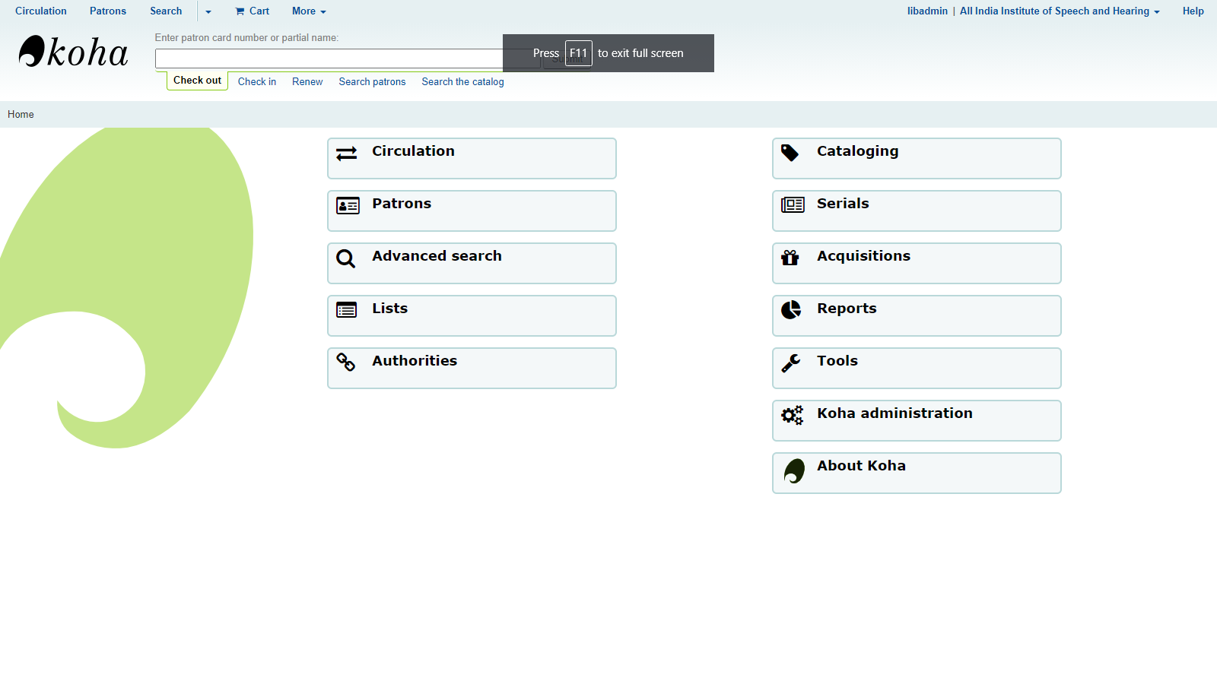

Figure 1: Admin Home Page

**4.1.3 Adding of Z39.50 Servers**

Z39.50 is network protocol for searching and retrieving bibliographic records from the remote databases. Majority of the books in the library are international publications and the Koha software has an option for connecting to Z39.50 Servers for downloading bibliographic details of the books. This will save a lot of time from manually entering the bibliographic information of each book in the database. Hence, setup was made to retrieve data from Z39.50 Servers (Figure 2).

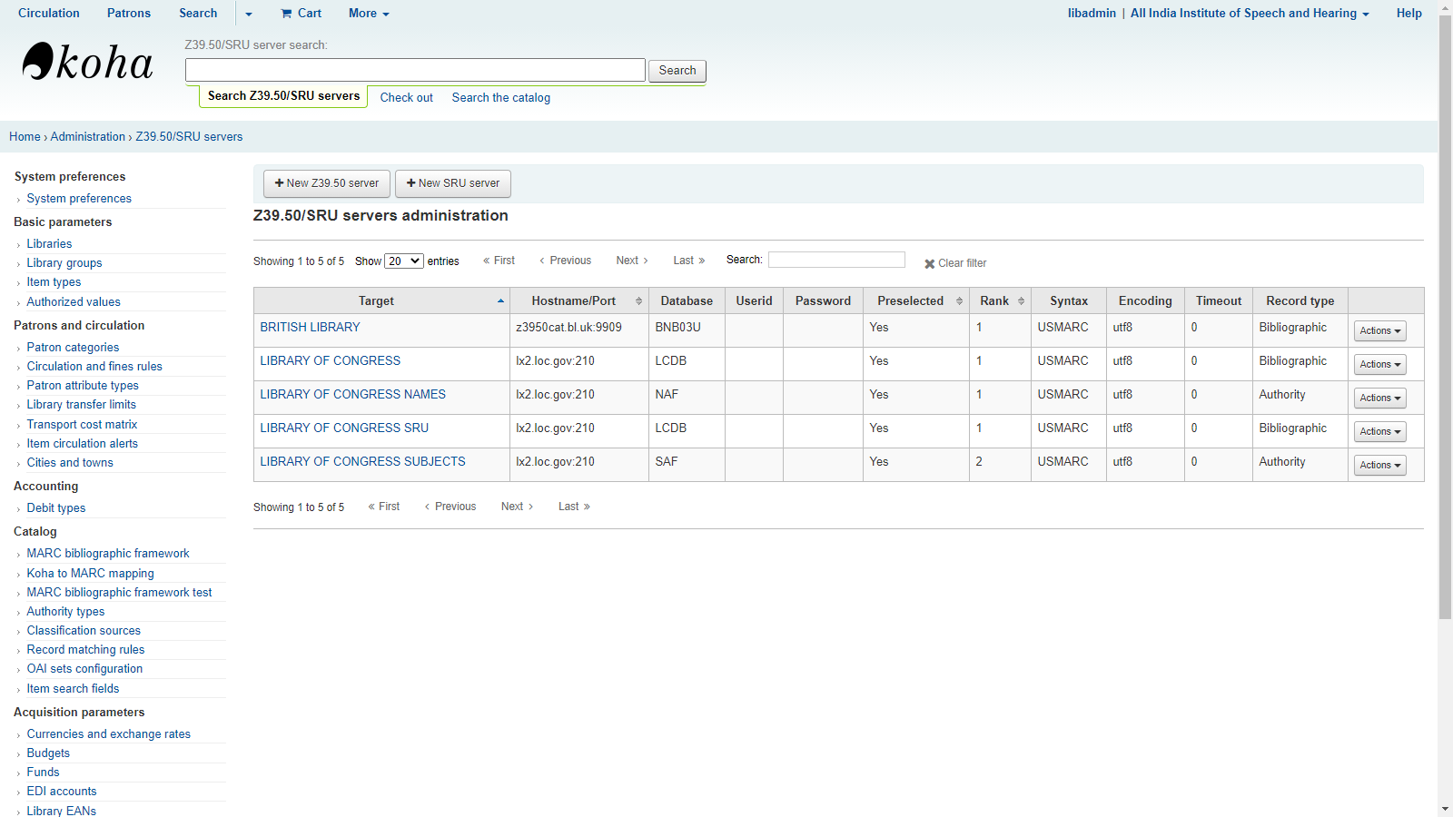

Figure 2: Z39.50 Servers

**4.1.4 Creating Item Types**

The item types for all the 14 types of resources mentioned above were created in the software (Figure 3)

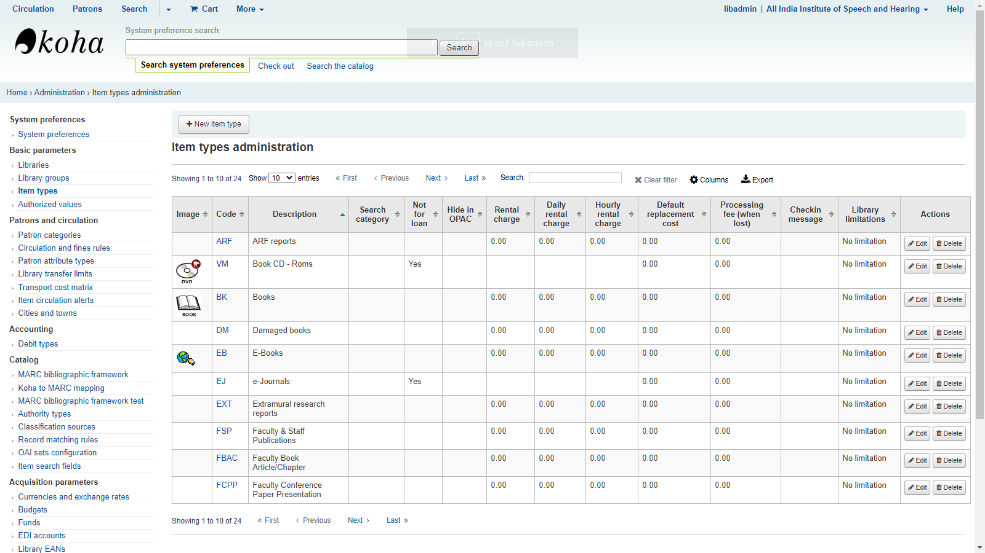

Figure 3: Creation of Item Types

**4.1.5 Adding Marc Records**

The Marc records were added for each type of item types to standardise the data entry (Figure 4).

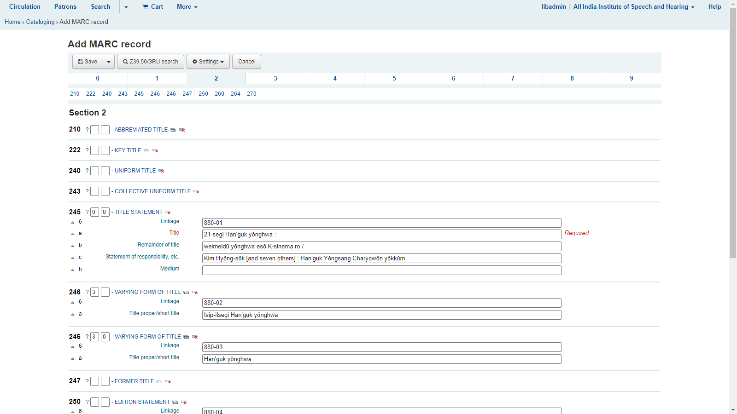

Figure 4: Adding Marc Records

**4.1.6 Cataloguing Items**

Bibliographic details of each book in the library were tried to fetch from the Z39.50 servers automatically. Mainly the Library of Congress Server was used for this purpose. (Figure 5).

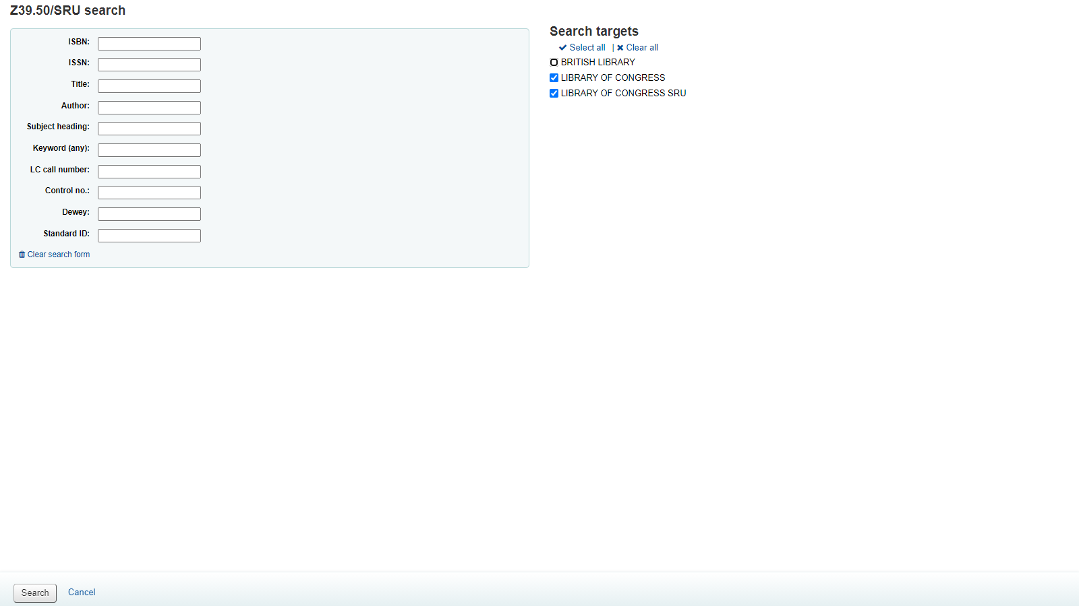

Figure 5: Fetching bibliographic details from Z39.50 server

**4.1.7 Importing and Assigning Accession number**

Each record was imported to our database (Figure 6) and assigned a unique accession number followed by location / rack number (Figure 7)

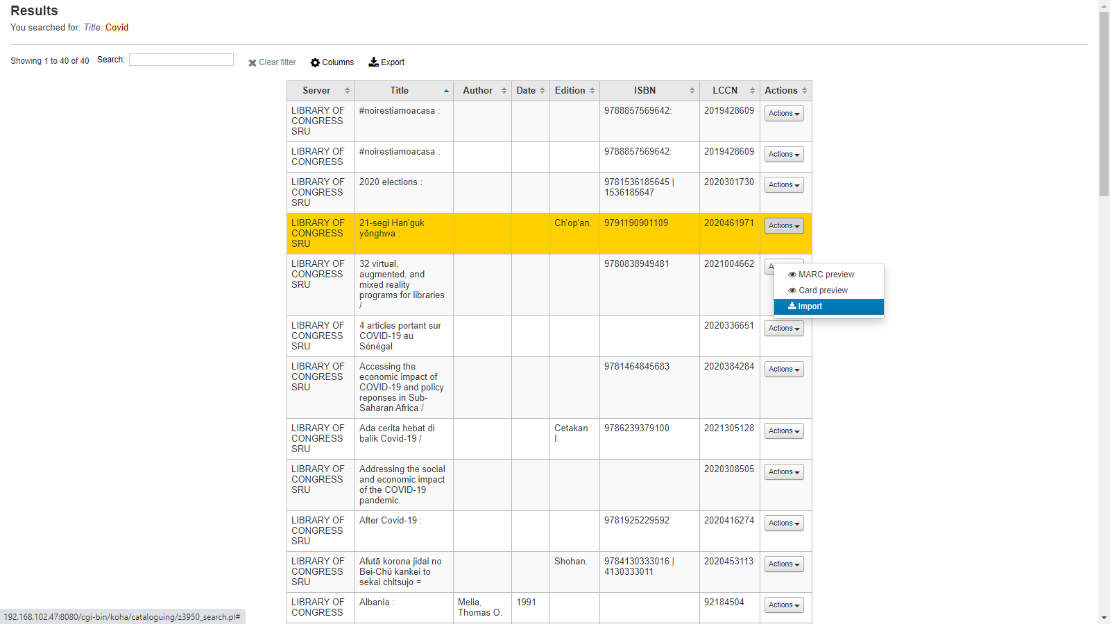

Figure 6: Importing record

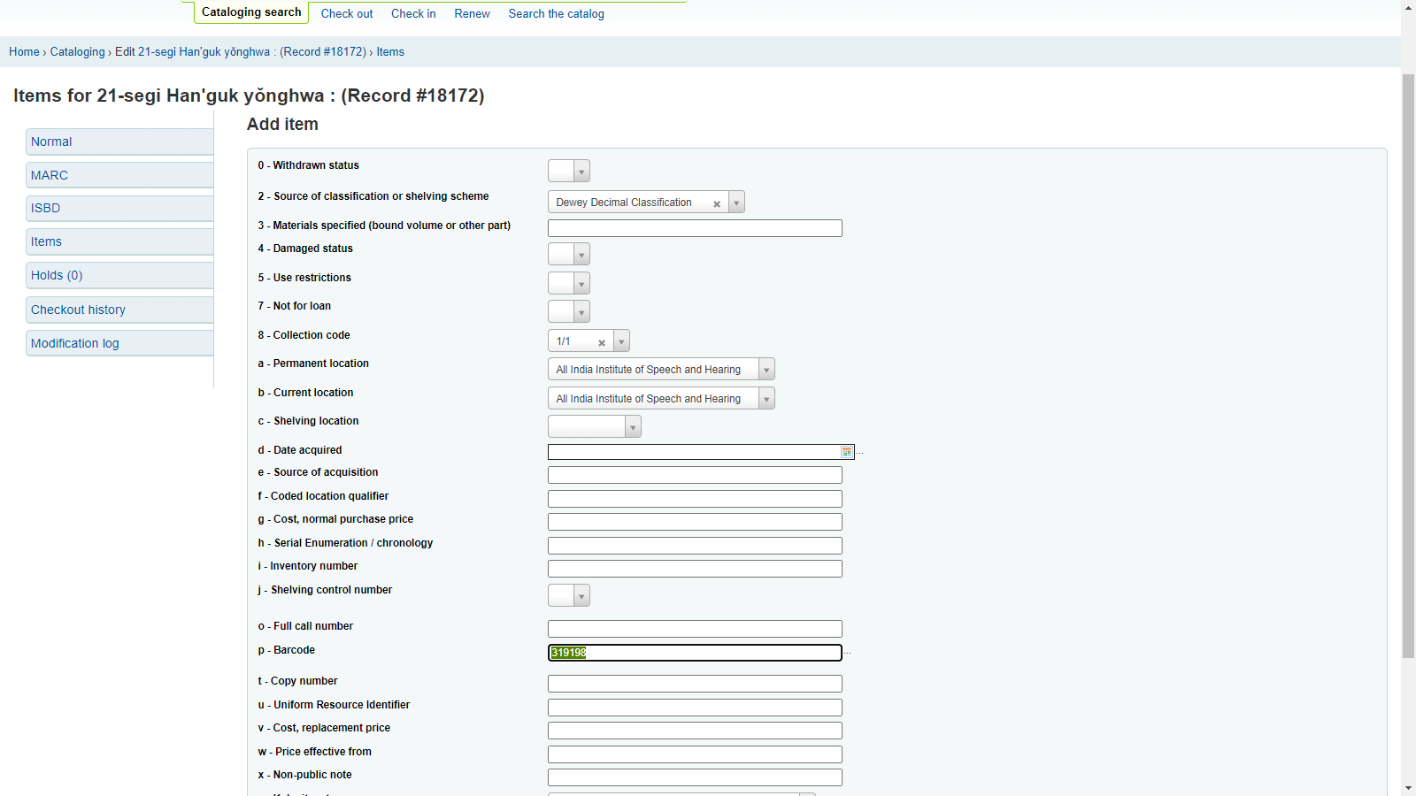

Figure 7: location / rack number

**4.1.8 Manual Cataloguing**

The resources for which we could not retrieve bibliographic details from the Z 39.50 servers were carried out manually (Figure 8).

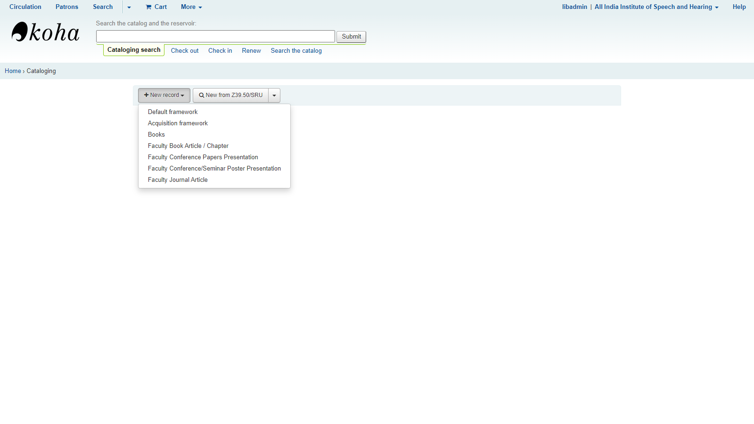

Figure 8: Manual cataloguing

**4.1.9 Creation of Patron categories**

Based on the types of library users, patron categories were created on the database. These were students, assistant professor, associate professor, professor and technical staff (Figure 9).

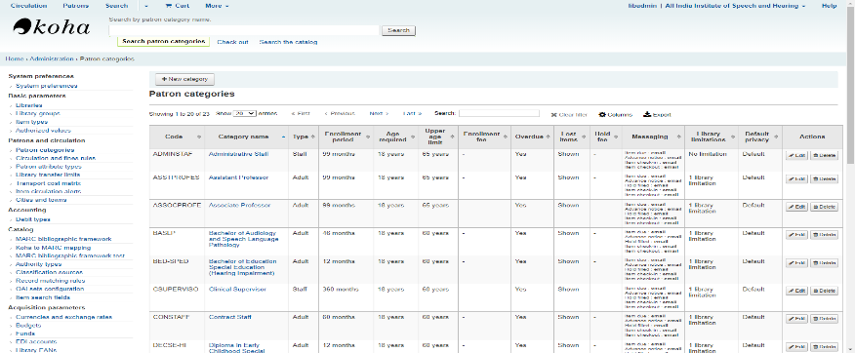

Figure 9: Creation of Patron categories

**4.1.10 Setting up of circulation and fine rules**

The book circulation and late return fine rules were set (Figure 10).

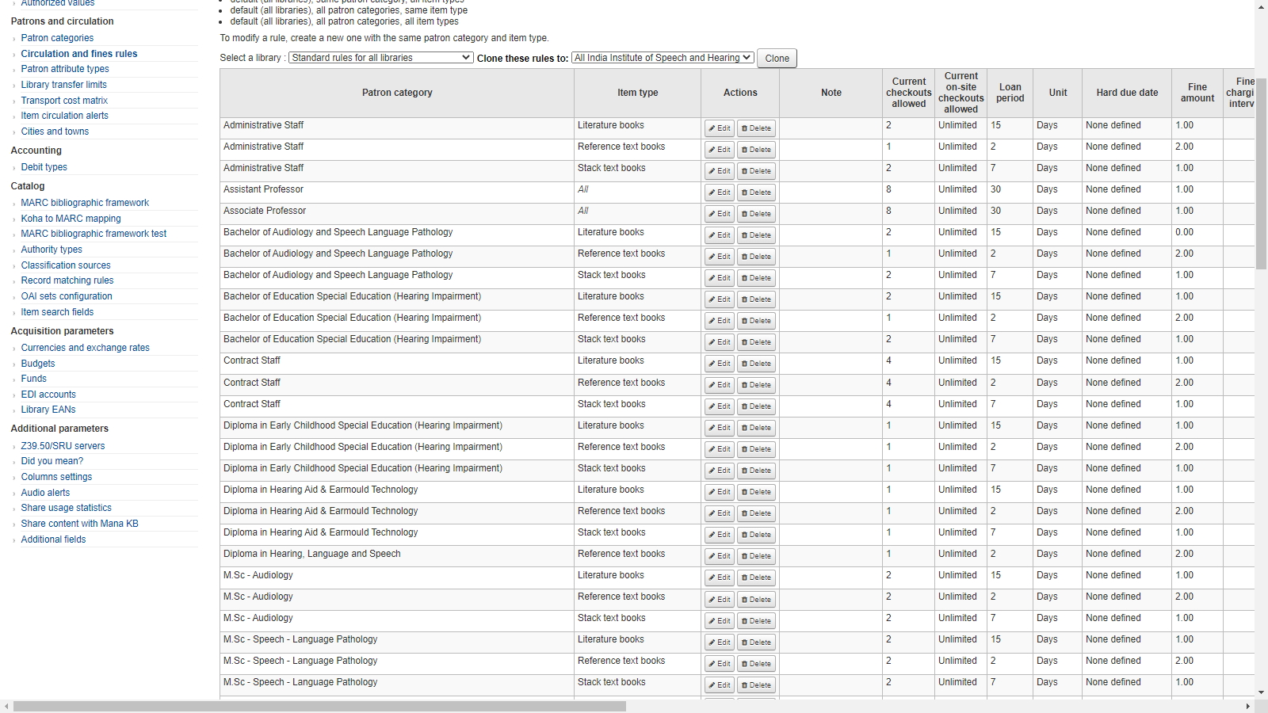

Figure 10: Setting up of circulation and fine rules

**4.1.11 Checkout and hold policy**

### The checkout and hold policy were set according to the patron category (Figure 11)

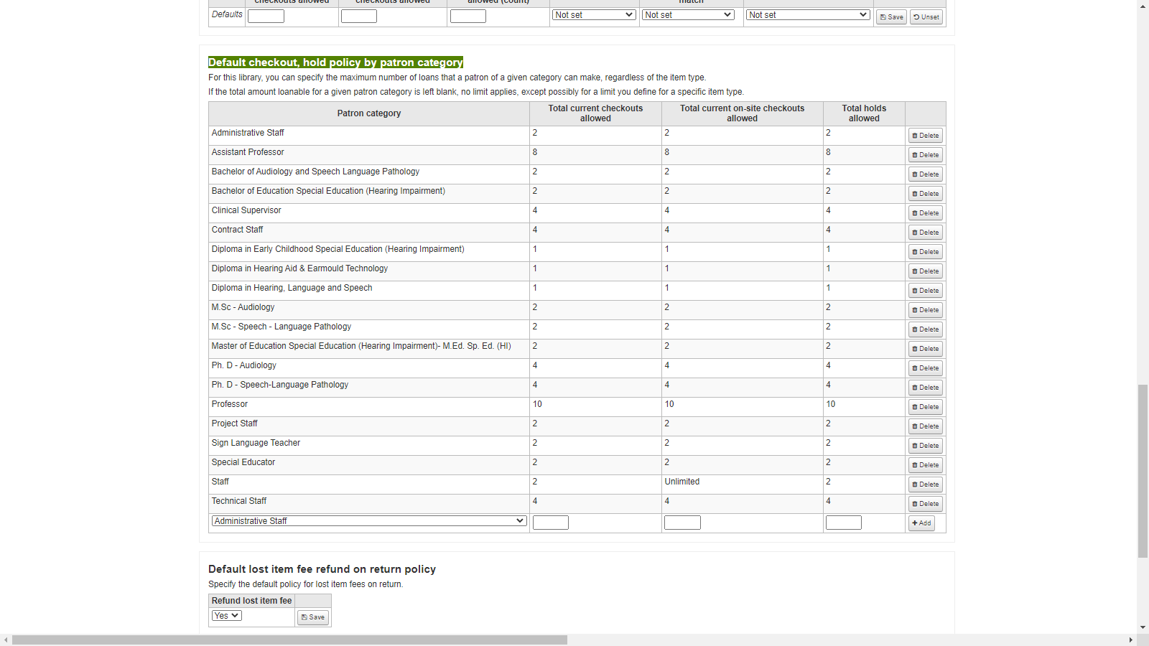

Figure 11: checkout and hold policy

**4.1.12 Creation of patrons**

Patron accounts were created for all the library users (Figure 12).

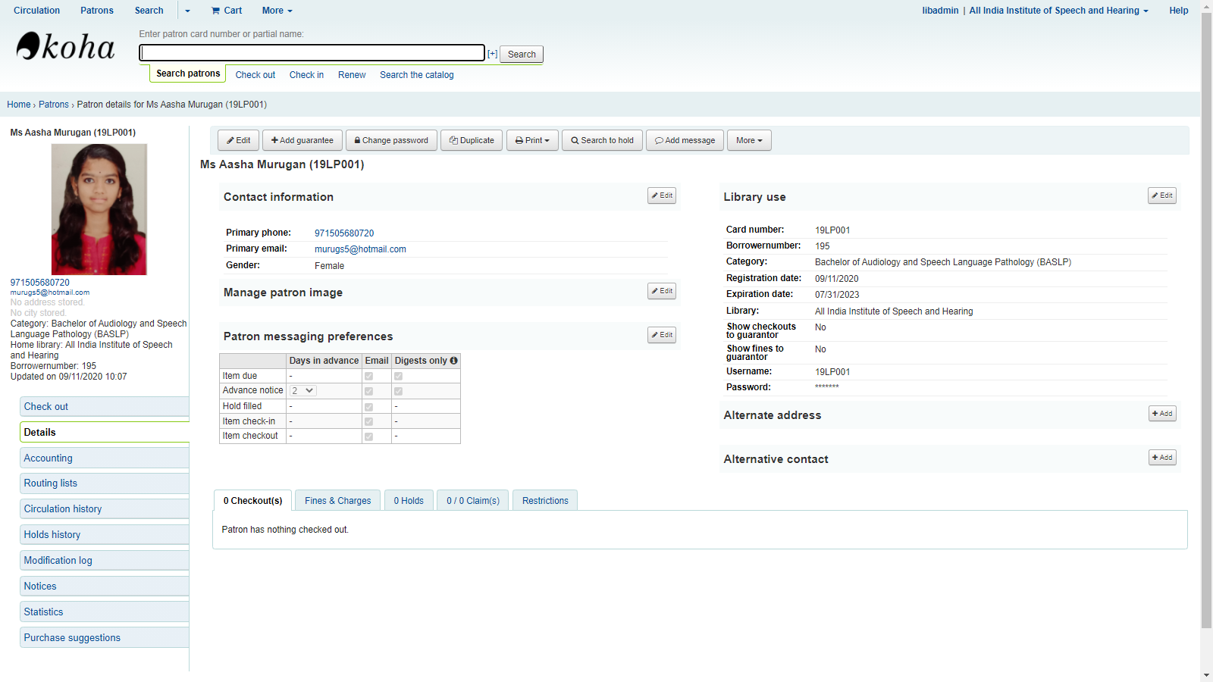

Figure 12: Patron account creation

**4.1.13 Setting up of Check Out and Check-in**

The system set up for check-out and check-in of the library resources were carried out (Figure 13 and 14).

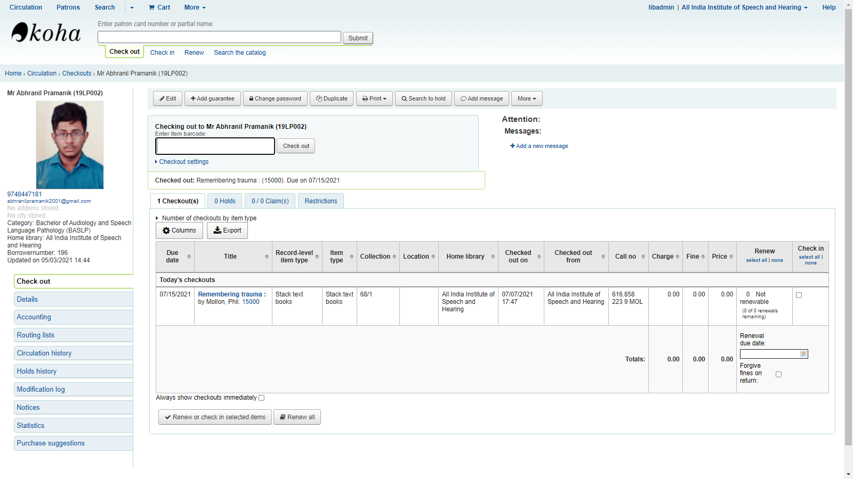

Figure 13: Check out

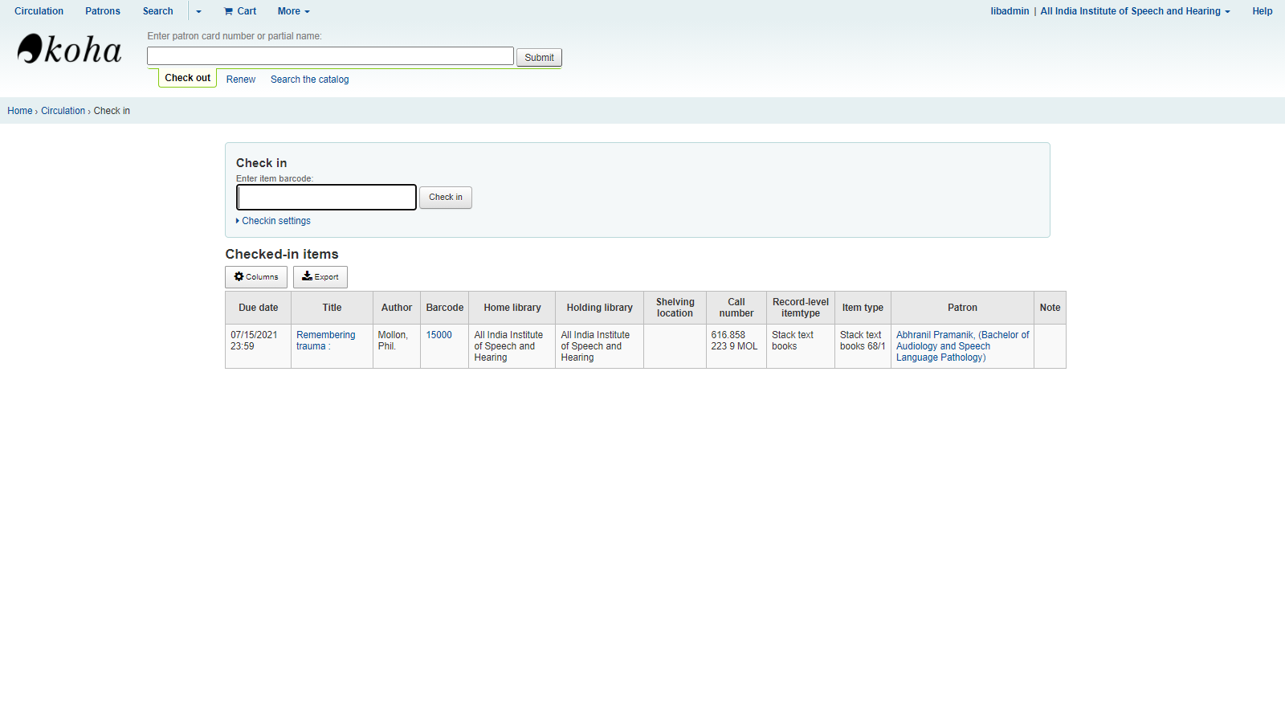

Figure 14: Check–in

**4.1.14 Setting up of Reports**

Various types of reports necessary for book circulation and patron management were created (Figure 15)

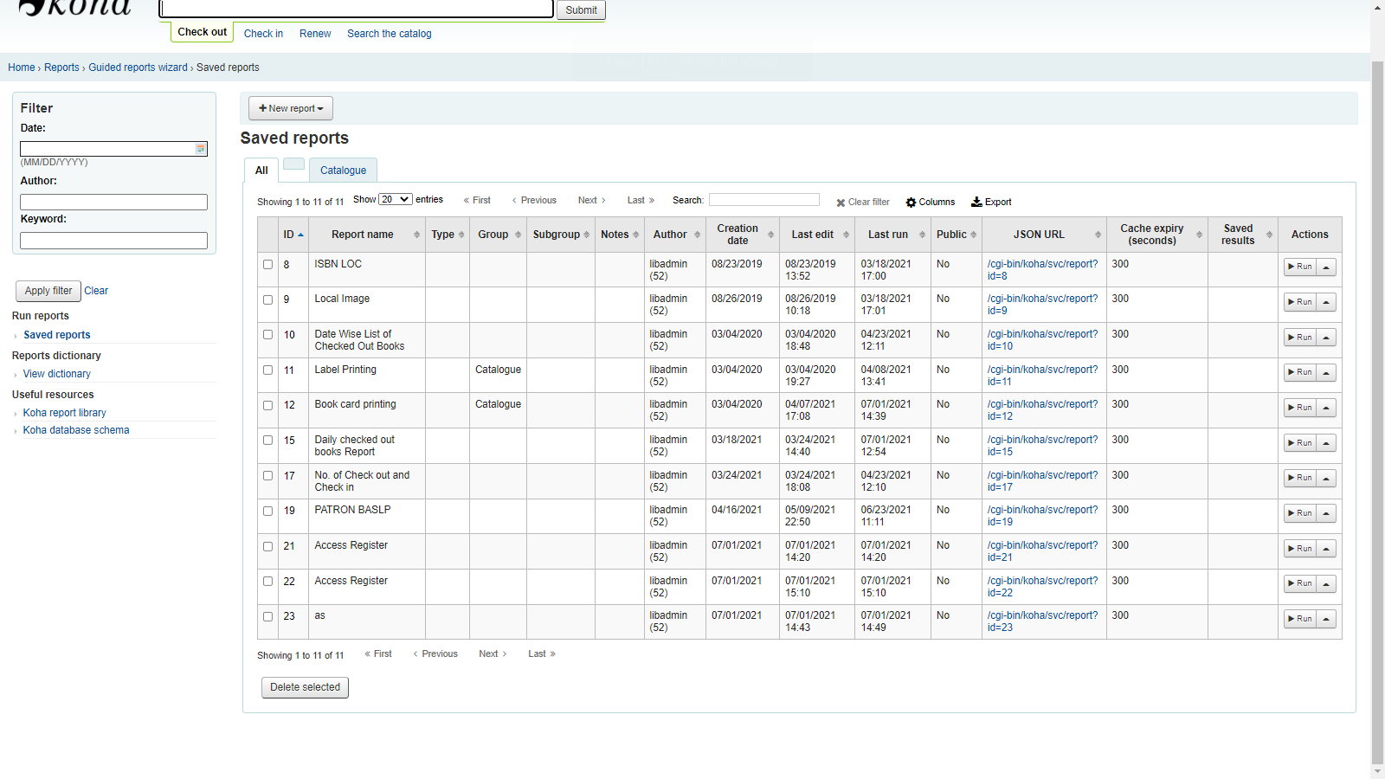

Figure 15: Types of Reports

**4.1.15 Setting up of Searching System**

The database searching system including the display of search results and record description was set up (Figure 16 & 17).

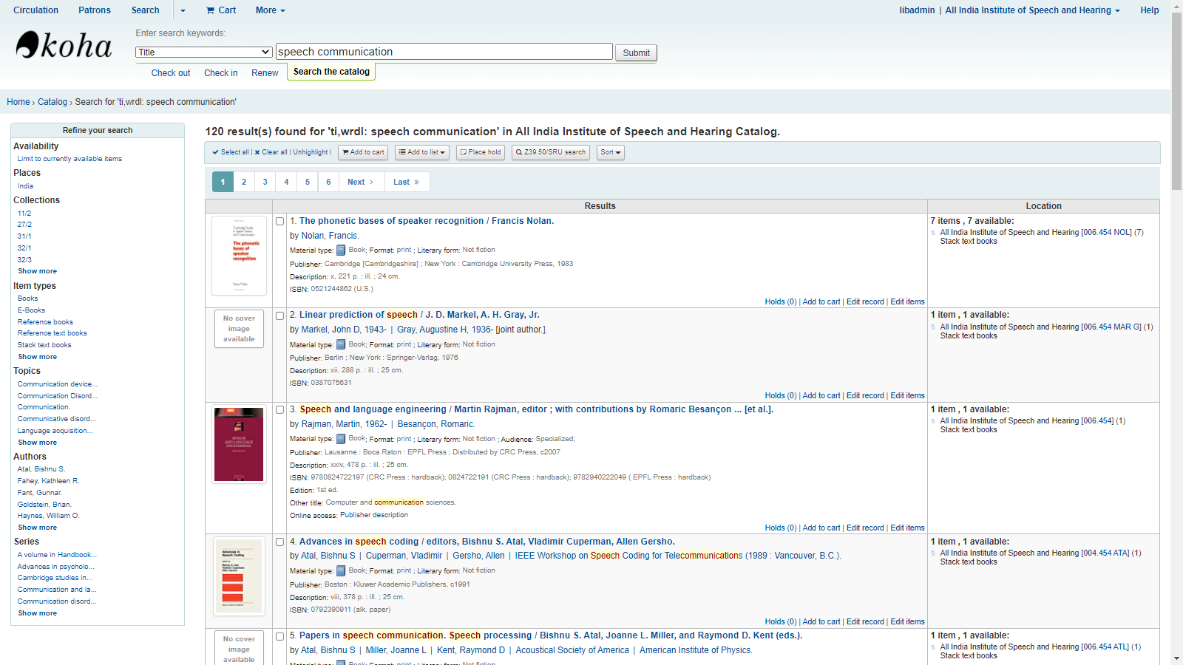

Figure: 16: Search results

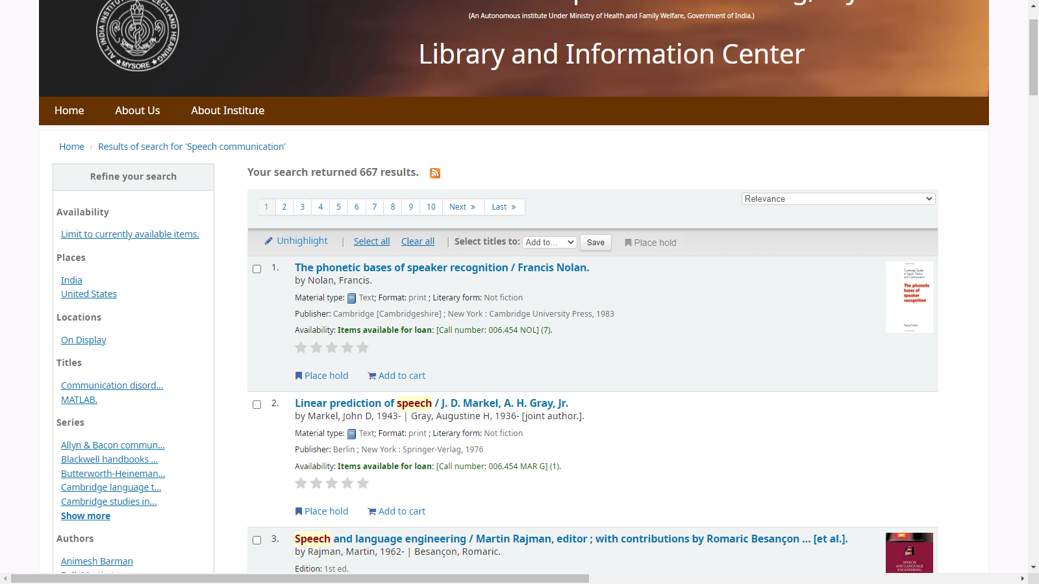

Figure 17: Record Description

**4.1.16 Front-Page Development**

A front-page was developed to serve as a common interface for the entire library information resources and services (Figure 18).

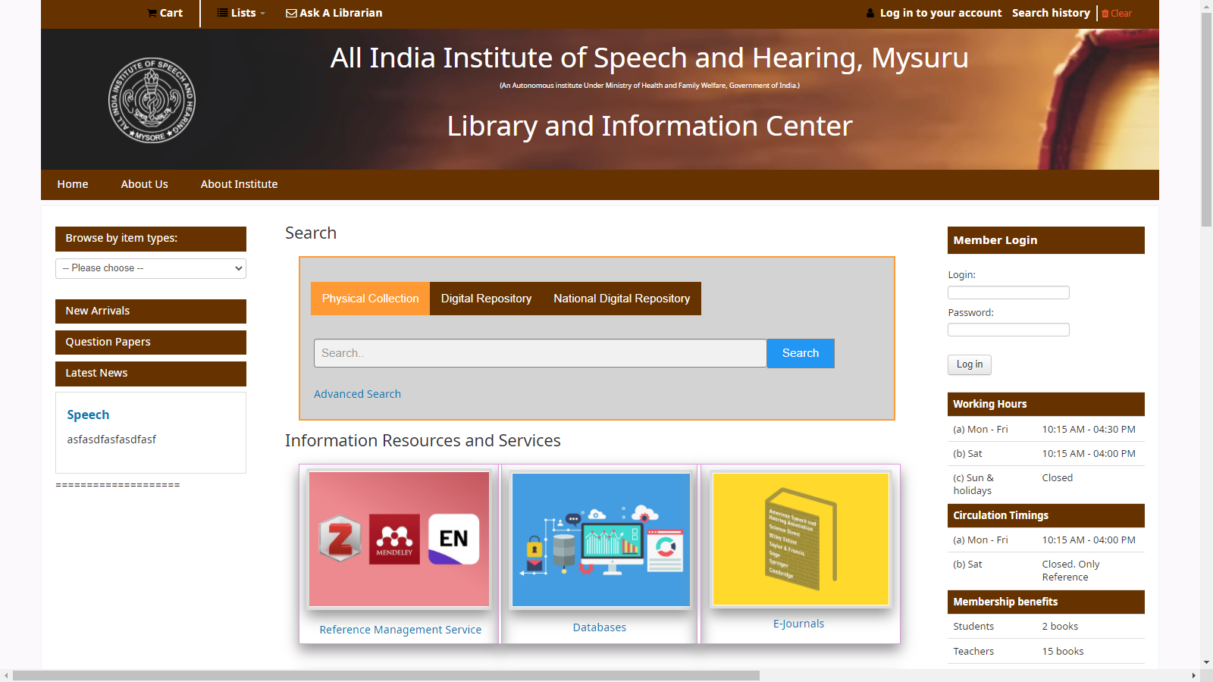

Figure 18

**4.2** **Design and Development of Institutional Repository**

The Institutional repository was developed on DSpace open-source application. The repository was linked on the front page of the library website developed on Koha.

**4.2.1 Resource Types and Organization**

In addition to the existing fou types of resources, i.e. PG dissertations, PhD theses, ARF projects and Independent projects, it is decided to incorportae faculty publications in the form of books, book chapters, journal articles, conference proceedings, presentations and previuos question papers in the new repository. All the resources are organized under the parent Departments in which the faculty are working.

As per the hierarchical system provided by the DSpace, a top-level community was created in the name *All India Institute of Speech and Hearing*, and *sub-level communities* in the names of ten Departments of the Institute as follows:

1. Department of Audiology
2. Department of Clinical Psychology
3. Department of Clinical Services
4. Department of Electronics
5. Department of ENT
6. Department of Special Education
7. Department of Prevention of Communication Disorders
8. Department of Speech-Language Pathology
9. Department of Speech-Language Sciences
10. Tele-Centre for Persons with Communication Disorders

Under these Departments, the following collection of resources were made

1. Books
2. Book chapters
3. Journal articles
4. Conference papers
5. Conference presentations
6. Previuos question papers
7. Guest Lectures
8. PG dissertations
9. PhD theses
10. ARF projects
11. Independent projects
12. Extramural projects

Inside these collections, the items are stored as files and metadata.

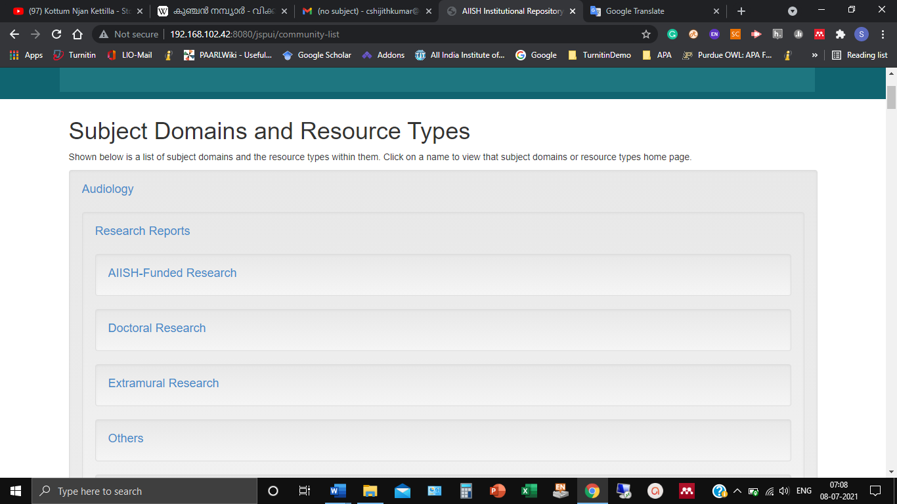

Figure 19: Content organization

**4.2.2 Metadata Creation**

**The following metadata were created for describing the items in the collection;**

**Journal Articles**

* Author(s)
* Title
* Journal Name
* ISSN No.
* National/International
* Volume No.
* Issue No.
* Page No.
* Year
* Department
* Language
* Keywords
* Abstract
* DOI
* Full text

**Conference Papers/ Proceedings**

* Author(s)
* Title
* Conference Name
* Conference Place
* National/International
* Volume No.
* Issue No.
* Page No.
* Year
* Department
* Language
* Keywords
* Abstract
* DOI
* Full text

**Conference/Seminar Presentation**

* Author(s)
* Title of the Presentation/Poster
* Conference/Seminar Name
* Conference/Seminar Place
* National/International
* Presentation Date
* Keywords
* Department
* Language
* Presentation File

**Invited Talk**

* Name of the Faculty/Staff
* Title of the Lecture
* Subject
* Conference/Seminar/Workshop etc.
* Organizer
* Organizer Place
* Lecture Delivered Date
* Department
* Language

**Book Chapter**

* Author(s)
* Title of the Chapter
* Book Name
* Book Editor
* Subject
* Publisher
* Publisher Place
* Page No.
* Year
* Keywords
* Department
* Language
* DOI
* Abstract
* Full text

**Book**

* Author(s)/Editor(s)
* Title of the Book
* Subject
* Publisher
* Publisher Place
* Year
* No. of Pages
* ISBN
* Keywords
* Department
* Language
* DOI
* Abstract
* Full text

**Book CD-ROMs**

* Author(s)
* Title
* Subject
* Publisher
* Publisher Place
* Year
* ISBN
* Accession No.
* Language
* Keywords
* CD-ROM Contents

**ARF Project Reports**

* Principal Investigator(s)
* Co-Investigator(s)
* Title
* Subject
* Abstract
* Amount
* Period
* Full-text

**Extramural Project Reports**

* Principal Investigator(s)
* Co-Investigator(s)
* Title
* Abstract
* Subject
* Funding Agency
* Amount
* Period
* Full-text

**PG Dissertations**

* Author(s)
* Title
* Subject
* Abstract
* Guide
* Year
* Full-text

**Independent Projects**

* Author(s)
* Title
* Subject
* Abstract
* Guide
* Year
* Full-text

**Question Papers**

* Title
* Subject
* Year
* File

**4.2.3 Front Page Development**

A front page was developed for the repository as shown in figure 19.

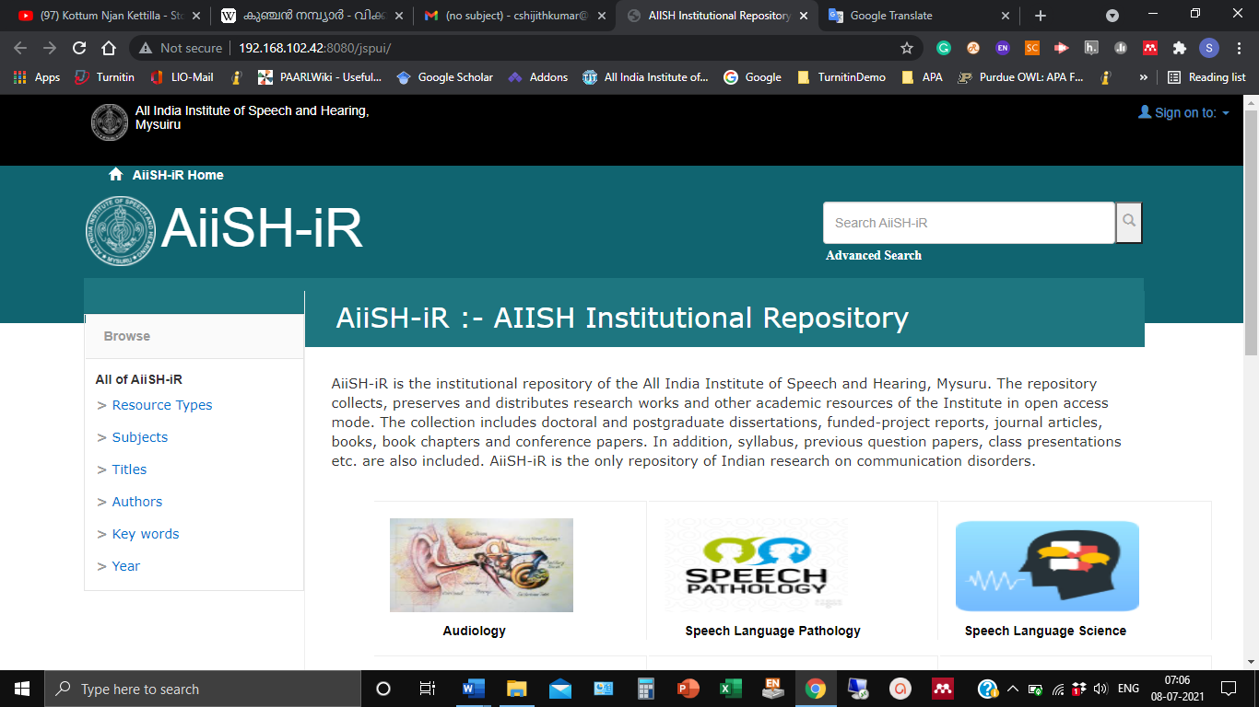

Figure 19: Front Page of the IR

**Chapter 5**

**Discussion and Conclusion**

**5.1 Discussion**

Institutional repositories play an important role in showcasing the scientific output of a higher education institution and Online Public Access Catalogue is an important information retrieval tool of a modern library and information centre.

One of the major inadequacies of the existing IR of AIISH is related to the content which is restricted to postgraduate and doctoral research reports along with the institute-funded research reports. The newly designed repository has additional content like post-print and pre-print of faculty publications, teaching notes, presentations etc. The issues and concerns related to depositing pre-print and post-print of faculty publications will be addressed by developing a suitable policy for the repository in consultation with the competent authority.

Inclusion of teaching notes, classroom presentations, syllabus, question papers etc. in the repository will surely add value to the repository and it will serve as a reliable learning and teaching support tool.

One of the best practices of the existing AIISH IR is its openness. It is a true open access repository providing free access to the full-text content to the scientific community across the world. The new repository, now developed on the open-source platform also follows the same policy of open-ness. It will serve the affiliated users i.e. the academic community within the organization and non-affiliated users from across the world.

The new repository, the resources are organized broadly under the subject or discipline dealt at the Institute followed by the type of resources.

The repository is set up in such a way that the affiliated end-user community can submit the resources directly to the repository. The system also has a mechanism to review the submitted item by the repository administrator to determine the authority of the submitter, subject area, type of item, and metadata. The item submitted may be rejected during the review stage if the submitter is not an authorized person. It may also be returned to the submitter for revision and resubmission. Hopefully, the provision for self-submission will enhance the quantity of the repository content.

AS the repository is set up to accommodate different types of resources, provision is made for accepting a wide range of file formats.

The major drawbacks of the existing OPAC are related to late return fine, new arrival display and absence of common search interface. The new OPAC has features and functionalities to address all these issues.

**5.2 Conclusion**

Institutional Repository and Online Public Access Catalogue are integral parts of a modern library and information system. The AIISH library and information centre deployed its Institutional Repository and Online Public Access Catalogue ten years back using proprietary software applications. In this project, the existing IR and OPAC were redesigned and developed using the latest versions of the world’s most reputed software applications in the field. The IR was built on DSpace software and the OPAC on Koha software. The newly developed applications have a number of additional features and functionalities when compared with the existing ones. They will be maintained inhouse and upgraded with the latest versions of both the applications.

**References**

Cybermetrics Lab. (2016). Ranking Web of Repositories. Retrieved June 19, 2016 from http://repositories.webometrics.info/en.

DCMI Technical Updates. (n.d.). Retrieved August 9, 2016, from [http: // dublincore.org/](http://dublincore.org/)

Find, create, and publish open source software for free. (n.d.). Retrieved August 9, 2016, from <https://www.sourceforge.net/>

Gohain Rekha. (2011). Current trend and development of institutional repositories in India. *International Journal of Information Research, 1* ,1.

Library of Congress. Cataloging in Publication Program. (n.d.). Retrieved August 9, 2016, from <https://www.loc.gov/publish/cip/>

Lynch, C.A.: Institutional Repositories: Essential Infrastructure for Scholarship in the Digital Age. *ARL Bimonthly Report* (2003) 1-7.