Database on Communication Disorders Published in India

**A Project Funded by the AIISH Research Fund**

**Project Report**

**Principal Investigator**

Dr. Shijith Kumar, C

**Co-Investigators**

Mr. Nanjunda Swamy, M

Mr. Nandeesha, B

All India Institute of Speech and Hearing

Mysore – 570 006

**Contents**

**Page No.**

List of Tables and Figures iii

Abstract iv

1. Introduction 1-6

1.1 Statement of the Problem 1

1.2 Aims and Objectives 2

1.3 Scope 2

1.4 Previous Studies 3-4

1.5 Materials and Methods 5-6

2. Systems Design 7-14

2.1 Determining Functionalities and Features 7

2.2 Subject Organization 8

2.3 User-types, roles, and permissions 8

2.4 Workflow 11

2.5 System Selection 12-14

3. Systems Development 15-23

3.1 Indian Publications and Presentations on Communication Disorders 15-18

3.2 Software Installation 18-19

3.3 Creation of Database Users 19

3.4 Content Organization 19-20

3.5 Content Uploading 20

3.6 Searching System 20-22

3.7 User Interface 22-23

3.8 Personal Support 23

3.9 System Testing 23

4. Discussion and Conclusion 24-26

4.1 Discussion 24-26

4.2 Concluding Remarks 26

4.3 Future Plans 26

5. References 27

**List of Tables and Figures**

**Tables Page No**

Table 1 Repository Software-wise list of OpenDOAR 13

Table 2 Indian Scholarly Journals on Communication Disorders 15-16

Table 3 Indian Journals on Communications disorders & allied areas Indexed in Databases 16-17

Table 4 Indian Publications on Communication Disorders 18

**Figures**

Figure 1 Viewer Role 9

Figure 2 Author Role 9

Figure 3 Administrator Role 10

Figure 4 Overall Workflow 11

Figure 5 Admin/Author Login Interface 19

Figure 6 Content Organization 20

Figure 7 Browse by Author 20

Figure 8 Browse by Title 21

Figure 9 Browse by Year 21

Figure 10 Browse by Subject 21

Figure 11 Basic Search 22

Figure 12 Advance Search 22

Figure 13 User Interface 23

**Acknowledgements**

We sincerely acknowledge Dr. S.R. Savithri, Director, All India Institute of Speech and Hearing, Mysore for sanctioning the project and for her encouragement and support throughout the completion of the project. Thanks are also due to all our colleagues in the Library and Information Centre, AIISH, Mysore.

Dr. Shijith Kumar, C

Mr. M. Nanjunda Swamy

Mr. Nandeesha B

**Abstract**

The growth in scientific literature coupled with the developments in computer storage and communication technologies resulted in the emergence of bibliographic and full-text scholarly literature databases. Thousands of literature databases are available in different branches of knowledge. However, databases covering Indian literature on communication disorders are hardly available. The present study addressed the development of an Indian literature database on Communication Disorders using open-source applications. The details of scientific literature on communication disorders published in the country in the form of journal articles, books, book chapters and conference papers were collected using various methods. A database titled Indian Literature database on Communication Disorders was designed and developed using DSpace, the world’s most heavily used open-source software for developing institutional and subject repositories. Deployed on Ubuntu linux 18.04 LTS, the database used Apache as web server, PHP as programming language and MySQL as relational database. The bibliographic details collected on Indian publications were entered into the database by organizing the content into audiology and speech-language pathology, the two sub-domains of communication disorders. The Indian Literature database on Communication Disorders will facilitate global visibility and greater access to Indian scientific publications on communication disorders and increase the citation of the scientific publications.

**Chapter 1**

**Introduction**

The world’s first scientific journal, *The Philosophical Transactions of the Royal Society* started publishing in the year 1665 and since then the scientific literature is growing exponentially both in the number and types of resources. De Solla Price (Price & Price 1986), reported the exponential growth in the journal production way back in 1975. According to Varian (2003) in every three years, the quantity of published literature in the form of paper, film, and optical media are getting doubled. A later study (Larsen 2010) reported an increasing trend in peer-reviewed journal publication and fast growth in publication of conference papers, web pages and open archives. The increase in the number of publications coupled with the computer storage, processing and networking capabilities resulted in the rise of literature databases in both bibliographic and full-text formats. The literature databases help the researchers in effortless retrieval of required information from the vast pool of publications.

**1.1 Statement of the Problem**

Today, thousands of literature databases are available in various disciplines based on publications from different parts of the world. Some of them such as Web of Science and Scopus are general in nature covering every knowledge fields. Others focus on single domains. For example, *Medline* database covers medical and health science feilds, *Agricola* covers agricultural sciences, and *Compendex,* engineering sciences. Many of them are international in coverage while others are restricted to the scholarly works produced in specific countries or regions of the world.

Only a few databases are operating at the national level in India such as IndMed

(<http://medind.nic.in/imvw/>), covering the scientific literature reported in 100 medical journals published from the country, Traditional Knowledge Digital Library (TKDL) ([www.tkdl.res.in](http://www.tkdl.res.in)/),a database on traditional knowledge in the field of Ayurveda, Unani and Siddhaand Open Index Initiative (OII) (<http://oii.igidr.ac.in/> ) a database consists of Indian Social Science literature from selected Indian social science Journals and working papers/discussion papers/occasional papers, and thesis/dissertations are emanating from Indian social science institutes.

The field of communication disorders deals with the disorders related to speech and hearing. Considerable amount of research is taking place in countries across the world on various aspects of communication disorders. Comdisdome, published by the Proquest Incorpn, USA is the only known exclusive database on communication disorders’ literature. The Proquest also publishes a related database known as Linguistics and Language Behaviuor Abstracts (LLBA), which covers the literature on language disorders.

India has been contributing dynamically to the global scholarly literature on communication disorders by conducting noteworthy studies on numerous aspects of the disorders. Though the Comdisdome is international in coverage, the Indian studies are meagerly represented in the database. Hence, there is a need for a system that provides centered access to the research publications on communication disorders published from India and facilitate better visibility to them. This project addressed creation of such common platform of Indian scholarly literature on communication disorders using open-source tools.

**1.2 Aims and Objectives**

The project aimed to design and develop an open-source software-based Indian Literature database on Communication Disorders (ILCD). The specific objectives were the following:

1. To serve as an online gateway to the Indian scholarly literature on communication disorders
2. To provide an organized collection of resources on communication disorders published in India
3. To create appropriate metadata and facilitate effective retrieval of resources
4. To enable the collection, preservation, and sharing of published research output on communication disorders in India
5. To facilitate quantitative analysis of Indian literature on communication disorders

**1.3 Scope**

The study covered Indian literature on speech, language, and hearing disorders published as journal articles, books, book chapters, and conference proceedings from 1956 to 2020. It excluded the Indian studies published outside the country. The database primarily included bibliographic records of publications and presentations. Wherever permissible and obtainable, the abstracts and full-text are included.

**1.4 Previous Studies**

The first literature database developed in the bio-medical field was MEDLARS (Medical Literature Analysis and Retrieval System) by the National Library of Medicine, USA, in 1964. In 1971, it was converted to an online database, called MEDLINE (MEDLARS Online). (Adams, 1972). Two other major bio-medical literature databases developed during the initial days of technology applications in information science were BIOSIS in 1969 (Van, 1977) and EMBASE in 1974 (“Embase” 2014). The emergence of bibliographic standards and advanced technologies resulted in more comprehensive, sophisticated, and user-friendly literature databases. Subramanyama et al. (2017) reported the developments in storage technologies as one of the factors contributing to the growth in the number of biomedical databases.

J-Gate is a noteworthy literature database published from India covering international journal literature on agriculture & biological sciences, arts & humanities, basic sciences, biomedical sciences, engineering & technology, and social & management sciences. It is considered as the largest combined database of open-access and subscription-based journals. (<https://jgateplus.com>). J-Gate was developed by Informatics India, Bengaluru in 2001 (Sathyanarayana, 2006). Though the J-Gate covered Indian journals adequately this is not the case with many other international databases. Researchers pointed out the under-representation of studies carried out in developing countries as well as the journals published from these countries in international databases. Day (1997) observed that the reputed literature databases like MEDLINE and the Science Citation Index cover only two percent of scientific journals from developing countries. To overcome the situation, a number of literature databases were developed in different domains at national level. Sukula (2006) pointed out the importance of developing knowledge databases indigenously in India and discussed the factors that necessitates the database creation. Singh (2001) observed that India produces world-class research in healthcare and biomedicine while the Indian studies are hardly available for reference on international bibliographic databases.

To increase the visibility, access, and quality of the health science literature in the Latin American and Caribbean region, a database called LILACS (<https://lilacs.bvsalud.org>) was developed in 1984. The database covers scientific articles from many well-known health science journals published from 19 Latin American and Caribbean countries. The database also indexes scientific books, monographs, doctoral theses, conference papers, scientific reports, and governmental communications. The motive of developing LILACS was under-representing Latin American and Caribbean health science literature in international databases. Giri and Das (2011) reported creating an abstracting and citation database based on the articles published in Indian journals related to biological sciences, health sciences, and agriculture. In 2001, the Indian MEDLARS Centre designed and developed a bibliographic database based on the Indian biomedical literature called IndMED, t[he Index to Indian Biomedical Journals](http://indmed.nic.in/). The IndMED was developed in line with the MEDLINE database of the National Library of Medicine, USA. It started indexing with 75 Indian medical journals from 1985. (Singh et al., 2003). The Indira Gandhi Institute of Development Research, Mumbai, developed an online indexing database of articles, books and conference papers based on the information published in Indian Social Science journals known as Open Index Initiative (OII). The OII was compiled to address the scarcity of Indian social science literature in International databases (Manjunath & Sangam, 2005).

In order to fill the gap of non-availability of health and biomedical journals published in the region in the international indexing and abstracting sources, the World Health Organization’s Regional Office for the Eastern Mediterranean (EMRO), developed an indexing database called Index Medicus for the Eastern Mediterranean Region (IMEMR). The database development started in 1987, and in 1999, the Index was published in five printed volumes. Of the 408 journals indexed in the IMEMR, only 181 journals were published in electronic format. The ultimate goal of these indexes is to create a global index medicus that can bridge the gap resulting from lack of indexing of "third world" biomedical literature in MEDLINE and other international systems (Al-Shorbaji, 2008).

Alam et al (2012) presented an experimental prototype of a web portal to access space science grey literature called SpaceGL to address the difficulty in identifying and accessing the Indian grey literature in space science. The system was completely developed on open-source software tools and acted as a central hub for collecting and disseminating Indian space science grey literature.

Munnolli (2009) observed that access to thousands of medical information resources produced every year is limited to the authors and their affiliated organizations. He recommended to resolve the issue by applying the modern Information and Communication Technologies.

The previous studies highlighted the importance of developing indigenous literature databases in India as well as in other developing countries to overcome the lack of coverage of scholarly works published in these countries in international databases.

**1.5 Materials and Methods**

The following materials and methods were used for carrying out the project work.

1. **Determining of subject domains and resource types**

The field of communication disorders is basically constituted of two sub-domains: audiology and speech-language pathology. The scholarly resources published in the country in both the sub-domains were broadly categorized into the following types:

1. Journal articles
2. Books
3. Book chapters
4. Conference papers
5. **Collection of publication and presentation information**

Using various strategies and methods as discussed below, the details of Indian scientific publications and presentation on communication disorders scattered across the print and electronic media were collected.

1. The websites of the Indian higher education and research institutions on communication disorders, as listed on the official website of the Rehabilitation Council of India (RCI), were visited to find out the details of scholarly publications, if any, produced from these organizations, in the form of journals, books, and conference proceedings.
2. The official documents such as annual reports and publications like newsletters available on the websites of these organizations were also checked for information regarding the individual scholarly works published and presented by the faculty, staff, and students.
3. The Directory of Open Access Journals (DOAJ) and the Directory of Open Access Books (DOAB) were searched for Indian works on communication disorders.
4. J-Gate, the literature database of 49,000 journals, and the Online Catalogue of National Library of Medicine, USA (used for Medline indexing ) were searched for peer-reviewed Indian journals in the field of health sciences. These journals were further searched for articles on communication disorders.
5. An online questionnaire was developed to contact the individual speech and hearing professionals working in different organizations to collect their publication details.

**iii) System Design and Development**

1. A list of functionalities and features required for the proposed Indian Literature database on Communication Disorders (ILCD) was prepared by referring COMDISDOME, the international literature database on communication disorders.
2. The two most popular open-source applications used for developing institutional repositories as per the OpenDOAR, the global directory of open access repositories, were short-listed for developing the ILCD.
3. The features and functionalities of the short-listed repository applications were cross-checked with those identified to be required for ILCD earlier. Based on this, the most suitable repository software was selected for developing ILCD. Also, selected the supporting open-source software applications to integrate with the repository software towards the development of the database.
4. All the selected applications were installed, configured and customized as per the requirements. The system thus developed was put on test, and the errors rectified.

**Chapter 2**

**System Design**

System design is the process of delineating the entire requirements of a system. It is a crucial phase in the development of a computer-based application like ILCD. The functionalities and features of the database, system interface, its users, and workflow of ILCD are determined here.

**2.1 Determining Functionalities and Features**

The functional requirements were determined by reviewing the basic features of Comdisdome, the international literature database on communication disorders published by M/s ProQuest LLC, USA. The Comdisdome database content is broadly categorized under two sub-domains of communication disorders: audiology and speech-language pathology. Each of these sub-domains is further divided into several topics. The database facilitates both basic and advanced search. Also, there is an option to browse by publication year, source type, document type, subject, language, publication title, etc. The database has an in-built tool called 'My Research' , which helps the researchers to create a personal account and save the search results. It also enables the creation of an email alert on database updates following the user's choice. The main types of resources included in the database are: journal articles, books, and conference papers. Each record in the database is provided with metadata fields such as author, title, source (in case of journal articles), publication year, date, and persistent URL or DOI. Besides, each record contains 'cite', and 'cited by' information. The search results are retrievable in various citation styles like APA and MLA, save as pdf and other document formats, and export to different reference management tools. Comdisdome, like other ProQuest databases, incorporates a comprehensive help and support manual. The following functionalities and features of the Comdisdome database were chosen to incorporate in the ILCD.

1. Content organization
2. Basic and advanced search
3. Browsing
4. Personal account creation
5. Help and support

**2.2 Resource Organization**

As mentioned earlier, it is determined to organize information resources in the form of Books, Book Chapters, Journal Articles, and Conference Papers under Audiology and Speech-language Pathology, the two su-domains of communication disordes.

**2.3 User-types, roles, and permissions**

The ILCD intends to address the research information needs of a broad constituency of end-users such as students, full-time researchers, faculty, and clinicians in the field of communication disorders. When it is put to use, user contribution of content to the database needs to be encouraged and the Database Administrator has to verify the such user-contributed content needs for its authenticity. Given the above, the user-types of the ILCD were segmented into three: (1) Viewer, (2) Author, (3) Administrator

The Viewer can only access and view the database content. The Author contributes to content, and the Administrator supervises and manages the submission of the content and organizes them into various categories. The Author is constituted of the contributors of content to the ILCD from among the end-users. The Administrator user type is comprised of the persons managing and administering the ILCD. The viewer comprises all the end-users of the ILCD like faculty, students and researchers, and practicing clinicians. No account creation is required for viewing the content. To perform the role of Authors, the end-user has to regitsre with ILCD and create a personal profile. Similarly, to perform the role of Administrator a registered account is required. The User Type, Administrator, will be registered by default at the time of system installation. The roles of Viewer, Author and Administrator are depicted in figure 1, 2 and 3 respectively.

**Figure 1**

*Viewer Role*

Search/Browse

**ILCD**

**Viewer**

View/Read

**Figure 2**

*Author Role*

Request for registration

**Author**

**ILCD**

Receive the registration link

Fill in the personal details

Set the username and password

Access the database

Submit content

Search and browse the content

View the content

**Figure 3**

*Administrator Role*

Access the database

**ILCD**

**Administrator**

Manage & organize the content

Search for new content submission

Check the authenticity

Approve & accept if authentic

Reject if not authentic

**2.4 Workflow**

The overall workflow of the Indian Literature on Communication Disorders is depicted in Figure 4.

**Figure 4**

*Overall Workflow*

**Author**

**Administrator**

**Viewer**

**Submit Content**

**View Database Content**

**Send Submitting Acknoweldgement**

**Author Submitted Content**

**Review Content**

**ILCD**

**Content Acceptable**

**Send Rejecting Acknoweldgement**

No

**Content to the Database**

Yes

**Send Acceptance Acknowledgement**

**2.5 System Selection**

System selection is the process of selecting various hardware and software that are needed for developing the system**.** The digital platform developed for collecting, organizing, preserving, and disseminating the intellectual output of organizations is known as institutional repository and the software used for developing an institutional repository is known as repository software. With the progress in technology, the repository software applications have been used as online platform for publishing and showcasing the entire spectrum of an institution's scholarly output, such as journal articles, journals, books, book chapters, theses, dissertations, and conference papers. The repository software applications are also used for developing subject-specific scholarly platforms spanning across the organizations.

It is decided to develop ILCD using an open-source repository software. The specific repository software was selected from the Directory Of Open Access Repositories (Open DOAR), a global directory of open access repositories started in 2005. It is a collaborative project of the University of Nottingham and Lund University, funded by Open Society Institute (OSI), Joint Information Systems Committee (JISC), SPARC Europe and Scholarly Publishing and Academic Resources Coalition and CURL. As of December 2021, the directory listed 5608 repositories worldwide, including subject repositories and institutional repositories. Of these, 2192 repositories are built on the open-source software called DSpace, followed by EPrints (617 nos.). The complete list of software-wise list of repositories as per the Open DOAR is given in table 1.

**Table 1**

*Repository Software-wise list of OpenDOAR*

|  |  |  |
| --- | --- | --- |
| **Sl. No.** | **Repository Software** | **Number of Installation** |
| 1 | DSpace | 2192 |
| 2 | EPrints | 617 |
| 3 | WEKO | 532 |
| 4 | Digital Commons | 293 |
| 5 | Islandora | 145 |
| 6 | CONTENTdm | 100 |
| 7 | OPUS | 87 |
| 8 | HAL | 75 |
| 9 | dLibra | 64 |
| 10 | Fedora | 63 |
| 11 | PURE | 57 |
| 12 | Greenstone | 51 |
| 13 | Drupal | 36 |
| 14 | Invenio | 28 |
| 15 | Earmas | 24 |
| 16 | Digibib | 23 |
| 17 | Wildfire | 22 |
| 18 | SciELO | 19 |
| 19 | Diva-Portal | 19 |
| 20 | VITAL | 15 |
| 21 | DigiTool | 15 |
| 22 | MyCoRe | 13 |
| 23 | Omeka | 12 |
| 24 | Fez | 9 |
| 25 | XooNIps | 7 |
| 26 | Cybertesis | 6 |
| 27 | Equella | 6 |
| 28 | Open Repository | 6 |
| 29 | Others | 1072 |

DSpace and EPrints, the two most popular institutional repository open-source software applications as per the OpenDOAR were locally installed and evaluated for functionalities and features determined for the ILCD as discussed above. It is found that both applications support the necessary features and functionalities. Hence, the DSpace, the most heavily used application, was selected for developing ILCD. It was decided to use the latest available version of the DSpace for Linux. i.e. version 6.3. The supporting applications and tools were also finalized as given below.

1. Java jdk -version 8
2. Tomcat-version 9
3. Apache maven- version 3.6.3
4. Apache Ant - version 1.9.15
5. Postgresql - version 9.6

It was also planned to temporarily deploy the system on the Library and Information Centre, AIISH server having the following hardware facilities.

1. Processor: Intel(R)Xeon(R) Gold 6152 CPU @2.10GHz
2. RAM: 64 GB
3. System type: 64 bit, x64-based processor
4. Storage: 8 TB
5. Operating system: Linux/Ubuntu 18.04 LTS

**Chapter 3**

**System Development**

The final stage of of developing the ILCD is discussed here. It includes the quantitative analysis of the Indian scholarly works on communication disorders, repository software installation, customization, development of variuos functional components of the database, content uploading and testing.

**3.1 Indian Publications and Presentations on Communication Disorders**

The quantitative details of Indian scholarly publications and presentations on communication disorders collected in different ways are presented below.

1. A visit to the official websites of the Indian higher education and research organizations in the field of communication disorders (as approved by the Rehabilitation Council of India) and the official website of the Indian Speech and Hearing Association, identified seven scholarly serial publications from these organizations as listed in table 2. The bibliographic details of all the articles published in the entire issues of these journals were collected for indexing in ILCD.

**Table 2: Indian Scholarly Journals on Communication Disorders**

|  |  |  |  |
| --- | --- | --- | --- |
| S.N. | Journal | Publisher | Publication period |
| 1 | The Journal of All India Institute of Speech and Hearing | All India Institute of Speech and Hearing, Mysuru | 1970-2019 |
| 2 | AYJINHH- Journal of Communication Disorders | Ali Yavar Jung National Institute of Speech and Hearing Disabilities, Mumbai | 2016-2017 |
| 3 | Journal of Cochlear Implant | Ali Yavar Jung National Institute of Speech and Hearing Disabilities, Mumbai | 2017 |
| 4 | Student Research at AIISH: Audiology | All India Institute of Speech and Hearing, Mysuru | 2002-2013 |
| 5 | Student Research at AIISH: Speech-Language Pathology | All India Institute of Speech and Hearing, Mysuru | 2003-2006 |
| 6 | The Journal of Indian Speech and Hearing Association | Indian Speech and Hearing Association, Mysuru | 1981-2020 |

1. Besides, from the annual reports and newsletters published by the above organizations made available online, the details of individual published works and presentations of the academic community members were collected.
2. The Directory of Open Access Journals (DOAJ), J-Gate, the hybrid database which indexes more than 49, 000 journals, and the Online Catalogue of the National Library of Medicine (NLM), the USA, used for Medline indexing were searched for the health science journals published from India. From these health science journals, the journals related to communication disorders and related areas were listed out (table 3). All the available published issues online were further checked and noted down the bibliographic details of the articles on communication disorders.

**Table 3: Indian Journals on Communications disorders & allied areas Indexed in Databases**

|  |  |  |
| --- | --- | --- |
| **S.N.** | **Database** | **Indexed Indian Journals** |
| 1 | DOAJ | 1. Journal of Cleft Lip Palate and Craniofacial Anomalies 2. [Bengal Journal of Otolaryngology and Head &Neck Surgery](https://doaj.org/toc/2395-2407) 3. [Noise and Health](https://doaj.org/toc/1463-1741) 4. [Online Journal of Health & Allied Sciences](https://doaj.org/toc/0972-5997) |
| 2 | NLM Catalogue | 1. Journal of neurology, neurosurgery & psychiatry research 2. Acta scientific neurology 3. The Neurologist 4. Edorium Journal of Disability and Rehabilitation 5. Journal of Cleft Lip Palate and Craniofacial Anomalies 6. Journal of psychosocial rehabilitation and mental health 7. **Online Journal of Health & Allied Sciences** 8. Noise & Health 9. Indian journal of otolaryngology and head and neck surgery 10. Neurology India |
| 3 | J-Gate | 1. ARC Journal of Neuroscience 2. [Asian Journal of Oral Health and Allied Sciences](javascript:openJournalTOCPage('allJournal','','','131192','','','','1','1');) 3. [Bengal Journal of Otolaryngology and Head Neck Surgery](javascript:openJournalTOCPage('allJournal','','','152819','','','','1','1');) 4. [Edorium Journal of Otolaryngology](javascript:openJournalTOCPage('allJournal','','','145242','','','','1','1');) 5. [Indian Journal of Anatomy and Surgery of Head, Neck, and Brain](javascript:openJournalTOCPage('allJournal','','','162854','','','','1','1');) 6. [Indian Journal of Cerebral Palsy](javascript:openJournalTOCPage('allJournal','','','159690','','','','1','1');) 7. [Indian Journal of Clinical Psychology](javascript:openJournalTOCPage('allJournal','','','138429','','','','1','1');) 8. [Journal of Cleft Lip Palate and Craniofacial Anomalies](javascript:openJournalTOCPage('allJournal','','','144748','','','','1','1');) 9. [Indian Journal of Otolaryngology and Head & Neck Surgery](javascript:openJournalTOCPage('allJournal','','','104023','','','','1','1');) 10. [Indian Journal of Otology](javascript:openJournalTOCPage('allJournal','','','133834','','','','1','1');) 11. [International Journal of Advanced Otolaryngology](javascript:openJournalTOCPage('allJournal','','','139505','','','','1','1');) 12. [International Journal of Advanced Speech and Hearing Research](javascript:openJournalTOCPage('allJournal','','','137390','','','','1','1');) 13. [International Journal of Allied Medical Sciences and Clinical Research](javascript:openJournalTOCPage('allJournal','','','176435','','','','1','1');) 14. [International Journal of Head and Neck Surgery](javascript:openJournalTOCPage('allJournal','','','131566','','','','1','1');) 15. [International Journal of Health and Allied Sciences](javascript:openJournalTOCPage('allJournal','','','135942','','','','1','1');) 16. [International Journal of Health and Rehabilitation Sciences](javascript:openJournalTOCPage('allJournal','','','139856','','','','1','1');) 17. [International Journal of Neuro and Psychological Disorders](javascript:openJournalTOCPage('allJournal','','','150469','','','','1','1');) 18. [IP Journal of Otorhinolaryngology and Allied Science](javascript:openJournalTOCPage('allJournal','','','172239','','','','1','1');) 19. [Journal of Head and Neck Physicians and Surgeons](javascript:openJournalTOCPage('allJournal','','','144013','','','','1','1');) 20. [Journal of Indian Speech-Language and Hearing Association](javascript:openJournalTOCPage('allJournal','','','159717','','','','1','1');) 21. [Noise and Health](javascript:openJournalTOCPage('allJournal','','','101610','','','','1','1');) 22. [Online Journal of Health and Allied Sciences](javascript:openJournalTOCPage('allJournal','','','100975','','','','1','1');) 23. [Otolaryngology Online Journal](javascript:openJournalTOCPage('allJournal','','','134733','','','','1','1');) |

1. Though a similar search was conducted on the Directory of Open Access Books, no relevant titles were retrieved on books on communication disorders and allied areas.
2. An attempt was made to contact the individual speech and hearing professionals working in different settings in the country directly to collect their scholarly publication and presentation details by developing an online questionnaire. However, the initial response to the online questionnaire was feeble, and also, the project team could not get the complete email ids of the professionals in the country. Hence, the data collected in this way was not processed further.

The details of the various types of Indian publications on communication disorders collected in different ways are given in table 4. Of the 2394 records collected, 1533 were journal articles and 705 conference papers.

**Table 4**

*Indian Publications on Communication Disorders*

|  |  |  |
| --- | --- | --- |
| **S.N.** | **Resource Type** | **Numbers** |
| 1 | Journal Articles | 1533 |
| 2 | Conference Papers | 705 |
| 3 | Book Chapters | 109 |
| 4 | Books | 47 |
| **Total** | | **2394** |

The details of the Indian publications on communication disorders, published from 1956 to till 2020, coming under the above four categories were included in the database.The bibliographic details of the collected resources were entered in a spreadsheet sofware for bulk uploading onto the database.

**3.2 Software Installation**

DSpace, the open-source software selected for developing ILCD was jointly built by Hewlett Packard labs, and the Massachusetts Institute of Technology, USA in 2002 and it is widely used for managing published content focusing on long-term storage, access, and preservation. The latest version of the DSpace and the supporting applications and tools were installed for customizing and developing ILCD.

**3.3 Creation of Database Users**

Three user roles were created for the database as per the workflow discussed in Chapter 2, System Design. They were: Administrator, Author, and Viewer. The database administrator is the person responsible for the overall management of the database. Author is the person submitting the resource to the database and viewer is the person who access the database for viewing the content. Login name and password-based access settings were made for the Administrator and Authors (Figure 5). However, unrestricted access is provided for ordinary user or viewer to make maximum use of the system.

**Figure 5**

*Admin/Author login interface*

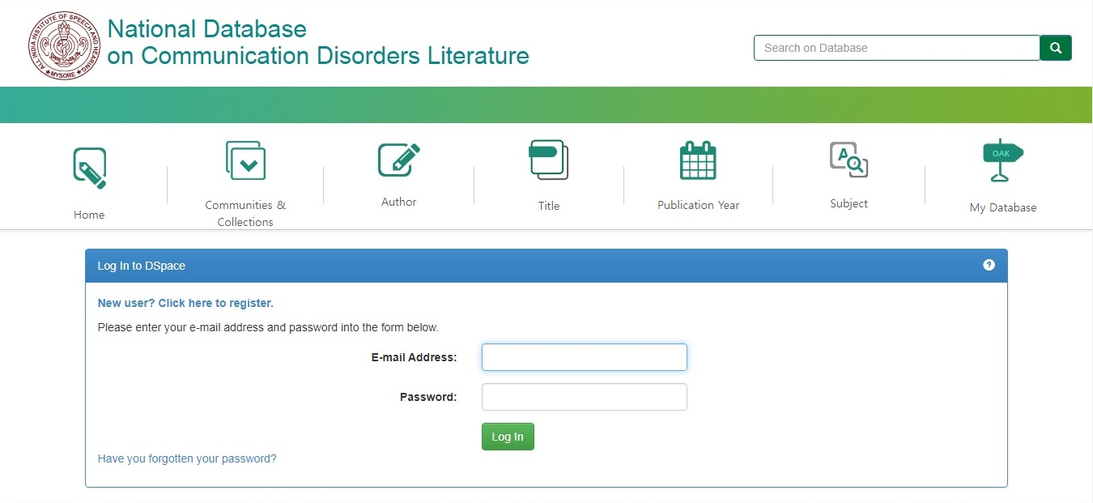

**3.4 Content Organization**

The DSpace facilitates organization of digital content into a hierarchy. It consists of a top-level community and hierarchical sub-communities. The communities in turn, can have collections. Inside the collection, items are stored in the form of files and metadata. The basic content hierarchy of the DSpace was customized to accommodate various types of resources. The domain *Communication Disorders* was designated as the *Top-Level Community* and Speech-Language Pathology and Audiology as the *sub-level communities*. Under each of the sub-communities, the resources in the form of Journal Articles, Books, Book Chapters and Conference Papers were organized as *collections.* Wherever available and permissible, the abstract or the full-text of each *item* in the collection is decided to store as a file and the item metadata separately. A screenshot of the content organization of the ILCD is given in figure 6.

**Figure 6**

*Content Organization*

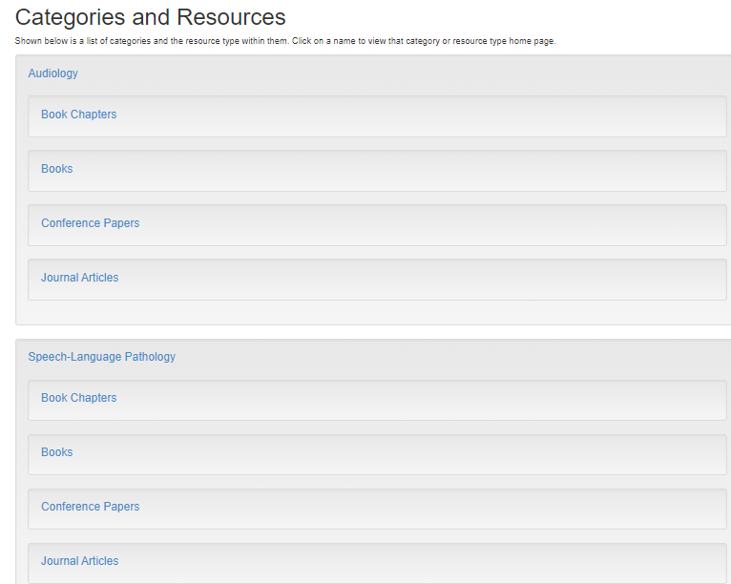

**3.5 Content Uploading**

The bibliographic records created in the spreadsheet were uploaded in bulk on to the database using the Admin login. However, a provision was made to submit the individual publication records by the Author and then approve and upload to the database by the Administrator. Also, for direct uploading of individual records by the Administrator.

**3.6 Searching System**

A browsing functionality was created for the users to browse the database content. It facilitates browsing the records by Author (Figure 7), Title (Figure 8), Year (Figure 9), and Subject (Figure 10).

**Figure 7**

*Browse by Author*

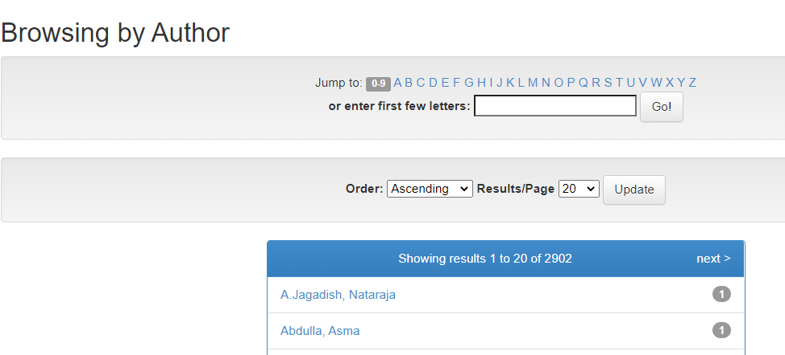

**Figure 8**

*Browse by Title*

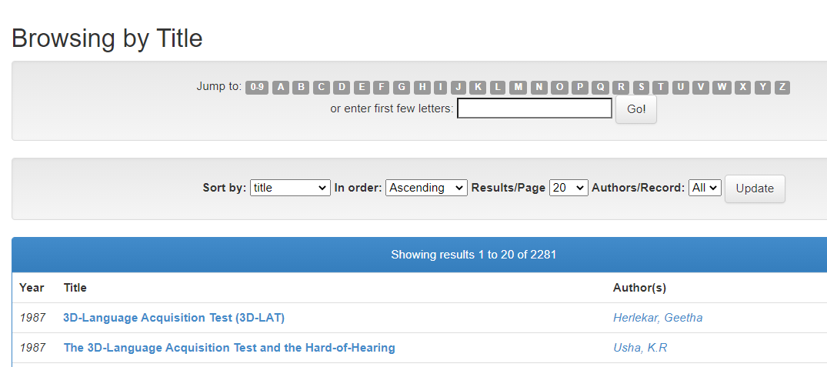

**Figure 9**

*Browse by Year*

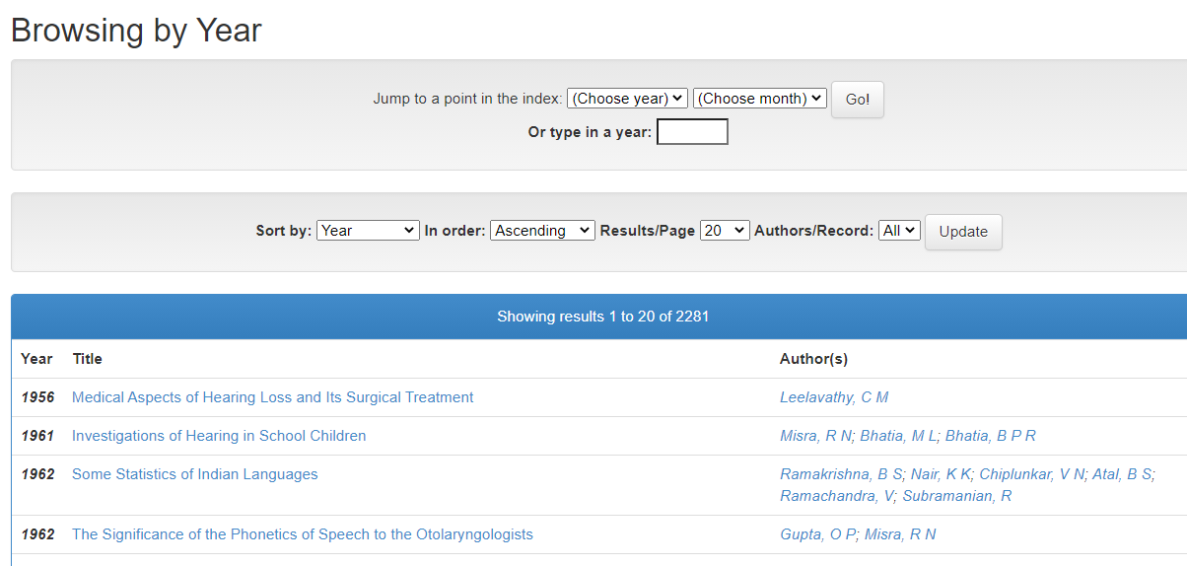

**Figure 10**

*Browse by Subject*

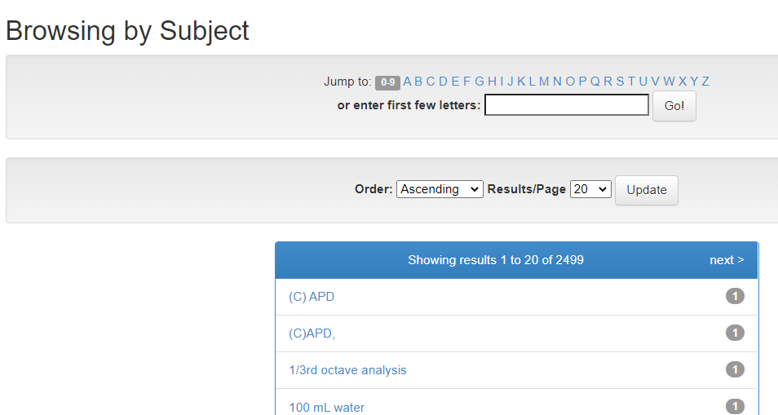

Both basic and advanced search facilities were incorporated into the database. The basic search with a simple search box (Figure 11) facilitates free-text or keyword searching across the Author, Title, and Subject fields. The advanced search facility (Figure 12) enables to restrict the search to specific fields.

**Figure 11**

*Basic Search*

 Figure 12

*Advanced search*

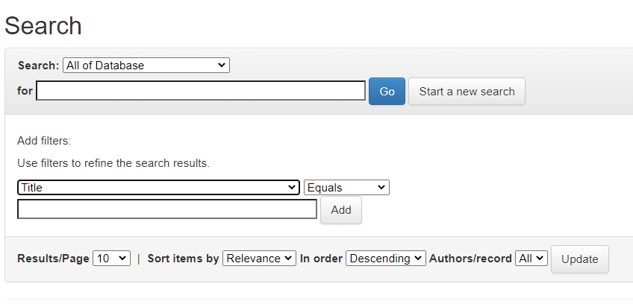

**3.7 User Interface**

The user interface is a crucial factor that affects the usability of an online system. The user interface of the ILCD was carefully developed by referring to similar literature databases available online and the technical feasibility of the selected open-source software application. A common interface was created for all the users as given in figure 13.

Figure 13

*User Interface*

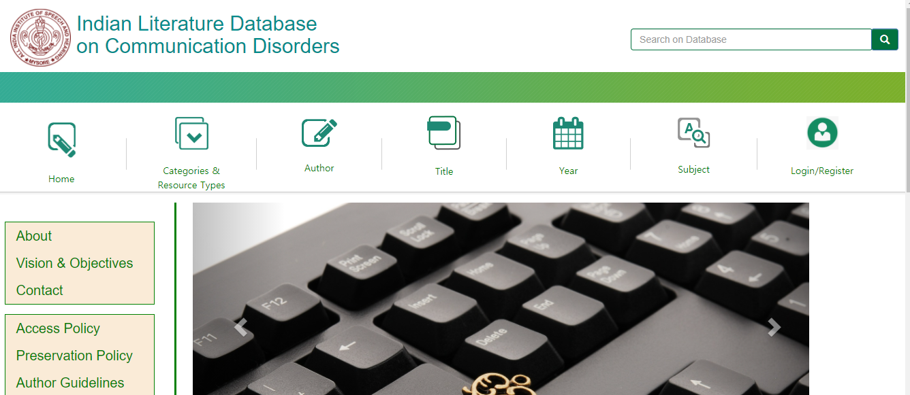

**3.8 Personal Support**

An e-mail notification system was configured in the database to facilitate notification on database updates to the registered users.

**3.9 System Testing**

The system developed was tested multiple times. The cross-browser compatibility of the interface was verified on three different web browsers: Google Chrome, Mozilla Firefox and Microsoft Edge and ensured compatibility.

The system has been integrated onto the web server of the Library and Information Centre, All India Institute of Speech and Hearing with public IP at <http://203.129.241.91:8080/>

**Chapter 4**

**Discussion and Conclusion**

**4.1 Discussion**

Identifying the Indian scholarly works in communication disorders was an uphill task as there was no single source listing them all. Like the Indian publications in other subject domains, many were published in a print-only format making it difficult to obtain the information online. Hence, different strategies were adopted to collect the details. The vast majority of the documents collected for indexing in the ILCD were journal articles followed by conference papers. The journal articles' primary sources were the Journal of All India Institute of Speech and Hearing and the Journal of Indian Speech and Hearing Association, the two well-known peer-reviewed Indian journals on communication disorders.

The ILCD was developed on DSpace, the most popular open-source software used by higher education institutions worldwide to create online platforms for disseminating scholarly information. The database's design and development were focused on three aspects: resource organization, user management, and resource identification.

The DSpace follows a hierarchical content organization with a top-level community and hierarchical sub-communities. The sub-communities, in turn, have collections. Inside the collection, the items were stored in the form of files and metadata. The DSpace's in-built hierarchical system was customized to create a top-level community for the domain Communication Disorders with two hierarchical sub-communities, speech-language pathology and audiology. All the resources were organized under these two sub-domains for easy retrieval.

Though the DSpace software supports many user roles, only three roles were configured in ILCD: (1) Administrator who by default is the person responsible for managing the database (2) Author who can create an account and receive an email alert on database update and submit materials to the database, and (3) Viewer, who needs no account creation but view the database content.

The ILCD is provided with extensive searching and browsing facilities. The DSpace, comes packaged with a search platform that enables searching and browsing of all the materials indexed in the database. Both the metadata fields and full-text are searchable.

Since many Indian publications on communication disorders are in print format, their preservation is a concern. We regard the ILCD as a good move towards the long-term conservation of Indian publications on communication disorders. Right now, only the bibliographic records are created on the database because of copyright issues. The database will be upgraded to a full-text resource paving the way for total preservation in the future.

Quantifying research output is an important measure of academic performance. The ILCD facilitates the quantitative analysis of Indian publications on communication disorders in an objective manner. Author, publication year, subject, publication type, and discipline-wise publication output can be generated quickly from the database.

Promotion and advocacy have to be undertaken to increase the visibility of the ILCD among the academic and research community in the field across the world. Upon making the database available on the Internet with an appropriate domain name registered, steps will be taken to increase the site's search engine visibility. The database's availability will be announced through professional forums on communication disorders, social media, and by sending email and postal communication to the academic and research organizations on communication disorders.

The sustainability and usability of a literature database depend on its currency and coverage of resources. Both can only be attained with the support of the researchers and professionals working in the field. Keeping this in mind, a provision was made on the database homepage for the researchers to share the details of their presentations and publications. Hopefully, the self-submit feature will enhance the number of items in the database.

The majority of the records in the database contain only the bibliographic details of the published works. Incorporating abstracts followed by full-text would contribute to its usefulness and elevate the database to a higher level of professionalism. The database's browse option is limited to author, subject, title, and year of publication fields. The non-availability of the contributors' institutional affiliation-based search and retrieval is another drawback. The records were created without the institutional affiliation of authors due to the time constraints of the project.

However, by facilitating centralized access to the Indian scientific literature on communication disorders, the ILCD, with all its limitations, will likely be a valuable source of information for researchers across the world in the field. Moreover, it will contribute to boosting the visibility and citation of scholarly works. In a study on developing open access repositories, Jayakanth and others (2012) rightly pointed out that many Indian journals are not indexed in any of the reputed international databases resulting in low visibility and usage of Indian studies.

**4.2 Concluding Remarks**

The Indian Literature database on Communication Disorders is an open-access database developed on DSpace digital repository software. The database currently includes the articles published in Indian journals, books and book chapters, and conference papers. It is still in the early stage of development, and in the future, ILCD will be expanded to include other types of digital resources with advanced features. However, the success of the ILCD depends on the voluntary contribution of scholarly content by the professionals and organizations in the field of communication disorders across the country.

**4.3 Future Plans**

1. Expansion of the collection with the support of speech and hearing professionals and organizations across the country.
2. Inclusion of Indian studies reported in foreign journals, books, and conference proceedings.
3. Inclusion of grey literature such as reports of doctoral and postgraduate research reports and funded research reports on communication disorders in Indian academic institutions.
4. Real-time updation of the bibliographic records of Indian journals on communication disorders and allied areas in collaboration with the journal publishers.
5. Adding abstracts to the database content with the support of authors and professionals in the field.
6. Convert the database to a full-text resource in partnership with the Indian publishers in the field.
7. Inclusion of the database in Google Scholar and Directory of Open Access Open access Repositories (OpenDOAR)
8. Optimization of the database website to make easy identification via search engines such as Google

**References**

Adams S. (1977). The way of the innovator: notes toward a prehistory of MEDLARS. *Bulletin of Medical Library Association, 60*(4), 523–33.

Al-Shorbaji, N. (2008). Index medicus for the Eastern Mediterranean region. *Emerging Themes in Epidemiology, 5*:14

Alam, M.N., Pandey, P. & Dutta, C. (2012). SpaceGL: An Indian portal for space science grey literature. *DESIDOC Journal of Library & Information Technology, 32*(4), 335-338.

Day, M. (1997, November 1). Focus: The price of prejudice - the world may miss out because the fruits of research in developing countries seldom make it to the pages of top journals. https://www.newscientist.com/article/mg15621063-000-focus-the-price-of-prejudice-the-world-may-miss-out-because-the-fruits-of-research-in-developing-countries-seldom-make-it-to-the-pages-of-top-journals/

Embase: What is it and why is it needed?" *(PDF)*. Elsevier B.V. Retrieved *2014-05-12*.

Giri, R. & Das, A.K. (2011).Indian Citation Index: a new web platform for measuring performance of Indian research periodicals. *Library Hi Tech News,3*,: 33-35, 10.1108/07419051111145154

Jayakanth, F., Minj, F. & Dastidar, P.G. (2012). Setting up an open access digital repository: A case study. *Annals of Library and Information Studies, 59*, 16-24

Larsen, P.O. & von Ins, M. (2010). The rate of growth in scientific publication and the decline in coverage provided by Science Citation Index. *Scientometrics,* 84, 575–603 https://doi.org/ 10.1007/s11192-010-0202-z

Manjunath, G.K. &  Sangam, S. L. (2005, December). Open Index Initiative: A cooperative effort to develop an online database for Indian social science literature [Paper presentation]. 51st All India Conference of ILA, Haryana, India. Retrieved November, 10,2020 from <http://eprints.rclis.org/7034/>

Munnolli, S.S. (2009). An overview of health science information system in India: Librarian’s point of view. Retrieved from <https://espace.library.uq.edu.au/>

Sathyanarayana, N.V. (2008). Open access and open J-Gate. *DESIDOC Journal of Library and Information Technology*, *28*(1), 57-60.