**Database on Communication Disorders Published in India**

**Chapter - 1**

**Introduction**

The scientific world has been witnessing explosive growth in the number and types of information resources since the publication of the first scientific journal, The Philosophical Transactions of the Royal Society in the year 1665. The exponential growth in the scientific journal publications was reported way back in 1975 by De Solla Price (Price & Price 1986), and a later study (Varian 2003) estimated that the amount of new information stored on paper, film, magnetic tape and optical media are getting doubled in three years. The growth in scientific literature coupled with the developments in computer storage and communication technologies resulted in the emergence of bibliographic and full-text databases. These databases help the scientists in searching and locating the relevant information very easily from a vast pool of scientific knowledge generated from across the world.

**Statement of the Problem**

Corresponding to the growth in the published literature in different branches of knowledge, thousands of literature databases have been developed across the world. Majority of them are international in nature covering the scholarly works reported in the scientific journals published across the world. Some of these databases are general covering all the fields of knowledge such as Web of Science and SCOPUS, and others are specialised such as MEDLINE on medicine, AGRICOLA on agricultural sciences, COMPENDEX on engineering sciences. Only a few databases are operating at the national level in India such as INDMED, covering the scientific literature reported in 100 medical journals published from the country.

Traditional Knowledge Digital Library (TKDL) is a collaborative project between Council of Scientific and Industrial Research (CSIR), Ministry of Science and Technology and Department of Ayurveda, Yoga & Naturopathy, Unani, Siddha and Homoeopathy (AYUSH), Ministry of Health and Family Welfare. TKDL involves documentation of the knowledge available in public domain on traditional knowledge from the existing literature related to Ayurveda, Unani and Siddha in digitized format, in five international languages which are English, French, German, Spanish and Japanese. So far, the TKDL includes about 2.12 lakh medicinal formulations ( Ayurveda: 82,900; Unani: 1,15,300; Siddha: 12,950 ), from 148 books available in public domain, and the database exists in 34 million A4 size pages. Creation of TKDL – Yoga is under process and till date about 900 no. of Yoga postures from 14 old yoga books in public domain have been transcribed, which will also be videographed and added to TKDL database. [[[ <http://www.tkdl.res.in//Traditional> knowledge Digital library]]]

The field of communication disorders deals with the disorders related to speech and hearing, and a considerable amount of research is taking place in countries across the world on various aspects of communication disorders. India also has been contributing dynamically to the global scholarly literature on communication disorders by conducting noteworthy studies on various aspects the disorders. However, there is only one database exclusively based on the scientific literature on communication disorders, namely COMDISDOME published by the Proquest Incorpn, USA. The Proquest also publishes a related database known as Lingustics and Language Behaviuor Abstracts (LLBA) which covers the literature on language disorders. Both the COMDISDOME and LLBA are international in coverage but with meagre representation of Indian studies. Hence, there is a need for a system that provides access to the research publications on communication disorders published from India and give them greater visibility to a world wide audience. It will address the need of a common platform where the researchers can access all the studies carried out in the country in the field of communication disorders. This project addressed the design and development of a web-based database on Indian scholarly literature on communication disorders using open source tools.

**Aim and Objectives**

The aim of the project was to design and develop an open source software-based platform for the Indian literature on communication disorders. The specific objectives were the following:

1. To serve as a single entry point to access the Indian literature on communication disorders
2. To provide organized access and facilitate easy retrieval of resources
3. To facilitate an online gateway of Indian literature on communication disorders
4. To create and develop metadata contents and facilitate searching and browsing of the multimedia contents
5. To facilitate information sharing among users through notification, file sharing, and co-operative document preparation
6. To facilitate quantitative analysis of Indian literature on communication disorders
7. To act as a resource discovery tool on communication disorders in India

**Scope**

The study included only the Indian literature pertaining to the speech, language and hearing disorders in the form of journal articles, books and book chapeters, and the papers published in the conference proceedings. It excluded the Indian studies published outside the country. Also, only the abstracts of the studies were provided with a link to the full-text wherever applicable.

**Materials and Methods**

The following materials and methods were used for carrying out the project work.

**1. Determining the Subject Categories and the Content Type**

Using the Dewey Decimal Classification (Mitchell, 2011), the international code for organizing information resources in the Library and Information Centres across the world, the literature pertaining to the field of communication disorders were classified under three broad divisions: Speech, Language and Hearing. They were further divided into topics such as Articulation/Phonological Disorders; Augmentative and Alternative Communication; Clinical Audiology; Communication Sciences & Disorders; Diagnostic Audiology; Hearing Science; Language Development & Disorders; Motor Speech Disorders; Neuroscience for Communication Disorders; Pediatric Audiology; Phonetics and Linguistics; Rehabilitative Audiology; Speech/Language Intervention; Speech and Hearing Science; Speech Pathology Assessment/Diagnosis; Stuttering/Fluency; Swallowing/Feeding Disorders/ Dysphagia.

**2. Collection of Publication Details**

The details of the Indian publications on communication disorders were collected in the following ways:

1. By visiting the official websites of the Speech and Hearing Institutions in the country and by going through their annual reports.
2. By verifying all the issues of the peer-reviewed journals exclusively on communication disorders published from the country
3. By verifying all the issues of the peer-reviewed journals in the allied areas published from the country.
4. By verifying the available proceedings of the conferences and seminars on communication disorders conducted in India.
5. From the individual speech and hearing professionals working in different organizations across the country by developing an online questionnaire indigenously using PHP web development tool (*Appendix I*).

3.**Selection of Software Application**

A suitable open source software application was identified for building the database by conducting a comparative evalaution of the features of three most heavily used open source software applications in the field of information management as per the Registry of Open Access Repositories (ROAR 2016), namely E-Prints, Fedora and D-Space. The Criteria Based Software Evaluation Checklist developed at the Software Sustainability Institute, University of Edinburg, UK according to the ISO/ IEC 25010:2011-Software engineering (Jackson 2011) was used for evaluation and selection of the software.

**4. Customization and Development of the Database Platform**

The selected software application was customized as per the requirements and the database was developed.

**5. Population of the Database Content**

The

**6. Trial run and finalization**

**Project Outcome**

The outcome of the project is a model of Database on Communication Disorders using open source software. The database will facilitate to deposit the scientific publication to respective communities and collection. Retrieval and interface of the database are modified to our requirement. The other outcomes include

* 1. Scholarly publications of the communication disorder published in India.
  2. Global visibility and greater access to the scientific publications such as journal articles, conference proceedings, books and books chapters, etc.
  3. Increase in the citation of the scientific publications.
  4. Wider reach of Indian literature on communication disorders.

**Chapter – 2**

**Background of the Study**

Sukula (2006)8, discusses nationally developed databases, various aspects related to the creation of databases in India. Behind this development of such databases and some factors such as indigenous knowledge need, strategic culture, managerial capability, technological thrust and organizational interest responsible for developing databases in India are highlighted. Other features such as quality assessment control and network‐based indigenous knowledge database access and information delivery are discussed. The study concludes with the idea of pacing in the right direction for developing balanced and information service‐oriented indigenous knowledge system.

Indira Gandhi Institute of Development Research developed an online and searchable bibliographical database is called Open Index Initiative (OII)5. It consists of Indian Social Science literature and resources available in Indian libraries. OII indexes selected Indian social science Journals and working papers/discussion papers/occasional papers, and thesis/dissertations are emanating from Indian social science institutes and departments.

ICMR funded project produced “National Databases of Indian Medical Journals (IndMED)11” IndMED database indexing the journals from 1985 onwards. The IndMED catering to the literature with Indian references. Moreover, it would be of immense use for researchers on diseases and medical problems more prevalent in India. The IndMED database aims to provide bibliographical details to those indexed Indian medical journals or provide free full-text access to their articles. The IndMED database is covering prominent peer-reviewed Indian biomedical journals. This database designed to provide medical professionals/researchers/students and the medical library professional quick and easy access to Indian literature.

Singh & Gautam (2004)1, attempt to present an overview of some of the important electronic databases developed in India or on Indian topics.

Indian Council of Social Science Research9 developed a database of the union catalogue of social science periodicals and serials. This complete database was published 32 volumes, 31, 125 journals records in 550 libraries, in 17 states and two union territories, including the separate volume of the National Library, Kolkata.

Informatics developed J-Gate7 bibliographical database, is an electronic gateway to global e-journal literature either full text and bibliographical information. This database provides 55 million journal articles in all subject domains such as Agriculture & Biological Sciences, Arts & Humanities, Basic Sciences, Biomedical Sciences, Engineering & Technology, Social & Management Sciences.

**Chapter - 3**

**Software Evaluation and Selection**

Identifying an appropriate Open Source Software (OSS)nfor developing a given application based on a set of requirements is a challenging job. The case is especially true when there are a number of OSS available for a particular application and there are no generally accepted criteria for evaluating those OSS. In the field of Information management, In the present study,

An evaluation of the open source software and the selection of the most suitable one which meets the requirement of the Database on Communication Disorders published in India.Identification, selection, and implementation of open source software were done to manage the digital collection. The software packages for this project were identified through web namely, DSpace, E-Prints, and Fedora.

1. **DSpace:** DSpace2 software is a jointly developed by HP Labs, and MIT in 2002. DSpace software developed as an open source software to manage research, scholarly, and other published content in a digital repository, focusing on long-term storage, access, and preservation. It's easily customized and fit the needs of any institute or organization.
2. **E-Prints:** E-Prints6 software developed by University of Southampton School of Electronics and Computer Science and released under a [GPL](https://en.wikipedia.org/wiki/GPL) license. This software is compliant with web-based OAI-PMH.
3. **Fedora:** Fedora software jointly developed by Cornell University and the University of Virginia Library. Fedora is an open source repository system for the management and dissemination of the digital content.

**Evaluation and Selection**

All three software packages evaluated based UNESCO3 software comparison for the following criteria such as Infrastructure; Front end design; content organization; content discovery; publishing tools; reporting; multimedia; social media; Interoperability; authentication; preservation. These are given in table 1.

|  |  |  |  |
| --- | --- | --- | --- |
| **Infrastructure** |  |  |  |
|  | **DSpace** | **E-Prints** | **Fedora** |
| Locally Installed Software Solution | Yes | Yes | Yes |
| Community Support | Yes | Yes | Yes |
| Flexible Repository Structure | Yes | Limited | Limited |
| Customized Metadata | Yes | Yes | Yes |
| Current Version | 6.3 Ver. | 3.4 Ver. | 3.0 Ver. |
| Administrator Configurations | Yes | Yes | Yes |
| Supports Standard User Roles | Yes | Yes | Yes |

|  |  |  |  |
| --- | --- | --- | --- |
| **Front-end Design** |  |  |  |
|  | **DSpace** | **E-Prints** | **Fedora** |
| Integrated front-end Design | Yes | Yes | No |
| Customizable Repository Design | Yes | Yes | Yes |

|  |  |  |  |
| --- | --- | --- | --- |
| **Content Organization** |  |  |  |
|  | **DSpace** | **E-Prints** | **Fedora** |
| Access Controls | Yes (IP Range) | Yes (User & request a copy) | Customize |
| Community Publication | Yes | No | No |
| Supports Standard File Types | Yes | Yes | Yes |
| Customizable Metadata | Yes | Yes | Yes |
| Creative Commons License | Yes | Yes | Yes |

|  |  |  |  |
| --- | --- | --- | --- |
| **Content Discovery** |  |  |  |
|  | **DSpace** | **E-Prints** | **Fedora** |
| Integrated Search Engine | Yes | Yes | Yes |
| Advanced Search with Facets | Yes | No | No |
| Browse Options | communities &  collections,  publication date,  author, title, subject,  and document type | department, subject,  year | collections and  search facets |
| Graphical Navigation of Content | Yes | Image only | No |
| Search Engine Optimization | Yes | Yes | No |
| Indexed in Google Scholar | Yes | Yes | No |
| DOI and Persistent URLs | Yes (Handle System) | Yes (DOI) | Yes (Persistent  Identifiers) |
| Citation Export | Yes | Yes | Yes |

|  |  |  |  |
| --- | --- | --- | --- |
| **Publication Tools** |  |  |  |
|  | **DSpace** | **E-Prints** | **Fedora** |
| Flexible Publishing Workflows | Yes | Yes | Yes |
| Customizable Submit Forms | Yes | Yes | Yes |
| Batch Import | Bibliographic  import tool and  simple archive  format | BibTeX, XML | XML import |
| Batch Revision | Yes | No | No |

|  |  |  |  |
| --- | --- | --- | --- |
| **Reporting** |  |  |  |
|  | **DSpace** | **E-Prints** | **Fedora** |
| Usage/Download Reports | Yes | Add on service | Add on service |
| Google Analytics Integration | Add on service | Yes | No |

|  |  |  |  |
| --- | --- | --- | --- |
| **Multimedia** |  |  |  |
|  | **DSpace** | **E-Prints** | **Fedora** |
| Streaming Multimedia | Add on service | No | Add on service |
| Images | Yes | Yes | Yes |
| Slideshows | Add on service | Yes | Add on service |
| Audio | Yes | Yes | Yes |
| Video | Yes | Yes | Yes |

|  |  |  |  |
| --- | --- | --- | --- |
| **Social Feature** |  |  |  |
|  | **DSpace** | **E-Prints** | **Fedora** |
| RSS | Yes | Yes | Yes |
| Book Mark | No | Yes | No |
| Share | Add on service | Add on service | Add on service |
| Saved Searches | Yes | Yes | No |

|  |  |  |  |
| --- | --- | --- | --- |
| **Interoperability** |  |  |  |
|  | **DSpace** | **E-Prints** | **Fedora** |
| Harvesting (OAI-PMH) | Yes | Yes | Yes |
| Integration with Discovery Platforms | Yes | Yes | Yes |

|  |  |  |  |
| --- | --- | --- | --- |
| **Authentication** |  |  |  |
|  | **DSpace** | **E-Prints** | **Fedora** |
| LDAP | Yes | Yes | Yes |
| CAS | Yes | Yes | Yes |
| System Accounts | Yes | Yes | Yes |
| Shibboleth | Yes | Yes | Yes |

|  |  |  |  |
| --- | --- | --- | --- |
| **Preservation** |  |  |  |
|  | **DSpace** | **E-Prints** | **Fedora** |
| Content Back Up | Archival Information Packages back up | XML export | Yes |
| LOCKSS-compliant | Add on service | No | Add on service |
| Format Migration Tools and Services | Managed by institution | Integrated format migration risks tools offer format advice for administrators | Managed by institution |
| Target Platforms Supported |  |  |  |
| Community Support |  |  |  |
|  |  |  |  |

The DSpace features differ from other open source software. It supports collections for storing of data objects. These collections divided into communities. Communities are organized into a tree structure. This software supports a workflow process for inserting new digital objects. DSpace supports Dublin Core metadata format and full-text searching for different file formats like plain text, MSWord, PDF, HTML and other digital objects. Considering all those things and also most worldwide used open source software is on DSpace. DSpace was selected for design and developing the online database on communication disorders in Indian literature. DSpace has a strong developer community, and the source code is getting reviewed and updated on a regular basis.

**Chapter 4**

**Indian Literature on Communication Disorders**

**Resource Collection and Categorization**

This chapter is on the scholarly literature on communication disorders published in India. It discusses the different methods adopted for collecting the details of the publications, their categorization and quantification.

**Categorization and Classification of Resources**

The MIT Encyclopedia of Communication Disorders (MITECD) defines communication disorders as those that affect the production and comprehension of spoken language and include especially disorders of speech production and perception, language expression, language comprehension, voice, and hearing. The present study categorized literature on communication disorders into four:

1. Journal Articles
2. Books
3. Book Chapters
4. Conference Papers

Then they were classified into different subject fields based on the Dewey Decimal Classification code as mentioned in the previous chapter. The three broad divisions were: Speech, Language and Hearing which were further divided into topics such as Articulation/Phonological Disorders; Augmentative and Alternative Communication; Clinical Audiology; Communication Sciences & Disorders; Diagnostic Audiology; Hearing Science; Language Development & Disorders; Motor Speech Disorders; Neuroscience for Communication Disorders; Pediatric Audiology; Phonetics and Linguistics; Rehabilitative Audiology; Speech/Language Intervention; Speech and Hearing Science; Speech Pathology Assessment/Diagnosis; Stuttering/Fluency; Swallowing/Feeding Disorders/ Dysphagiathe literature on the above topics and their subcategories based on the classification available with the Dewey Decimal Classification code. The subcategories include Articulation/Phonological Disorders; Augmentative and Alternative Communication; Clinical Audiology; Communication Sciences & Disorders; Diagnostic Audiology; Hearing Science; Language Development & Disorders; Motor Speech Disorders; Neuroscience for Communication Disorders; Pediatric Audiology; Phonetics and Linguistics; Rehabilitative Audiology; Speech/Language Intervention; Speech and Hearing Science; Speech Pathology Assessment/Diagnosis; Stuttering/Fluency; Swallowing/Feeding Disorders/ Dysphagia.

**Collection of Publication Details**

The details of the Indian publications on communication disorders were collected in the following ways:

1. By visiting the official websites of the Speech and Hearing Institutions in the country and by going through their annual reports.
2. By verifying all the issues of the peer-reviewed journals exclusively on communication disorders published from the country
3. By verifying all the issues of the peer-reviewed journals in the allied areas published from the country.
4. By verifying the available proceedings of the conferences and seminars on communication disorders conducted in India.
5. From the individual speech and hearing professionals working in different organizations across the country by developing an online questionnaire indigenously using PHP web development tool.

The data on the published works were collected

The domain of Communication Disorders has been

1. Design an online questionnaire and collected the bibliographical information from the speech and hearing professionals.
2. Identified and collected scientific publication information published in Indian journals.
3. Identified and collected Indian literature of conference proceedings, books, book chapters, etc.

**1. Design an online questionnaire**

The questionnaire is the main tool used in the collection of data. A Structurally designed questionnaire has been adopted for the purpose. We designed an online questionnaire for collecting bibliographical information from speech and hearing professionals. The questionnaire has been designed by dividing it into two sections as enumerated below:

**Section A** : consists of covering letter

**Section B**: Personal information: comprising five questions such as Name, Designation, Department, Organization, Telephone.

**Section C**: Scientific publication information: comprising four questions such as Articles in Indian journals, Indian conference proceedings, Book chapters, and Books

Other than this above section, given another option to upload MSWord file for scientific publication information. The following figures are shown in an online questionnaire.

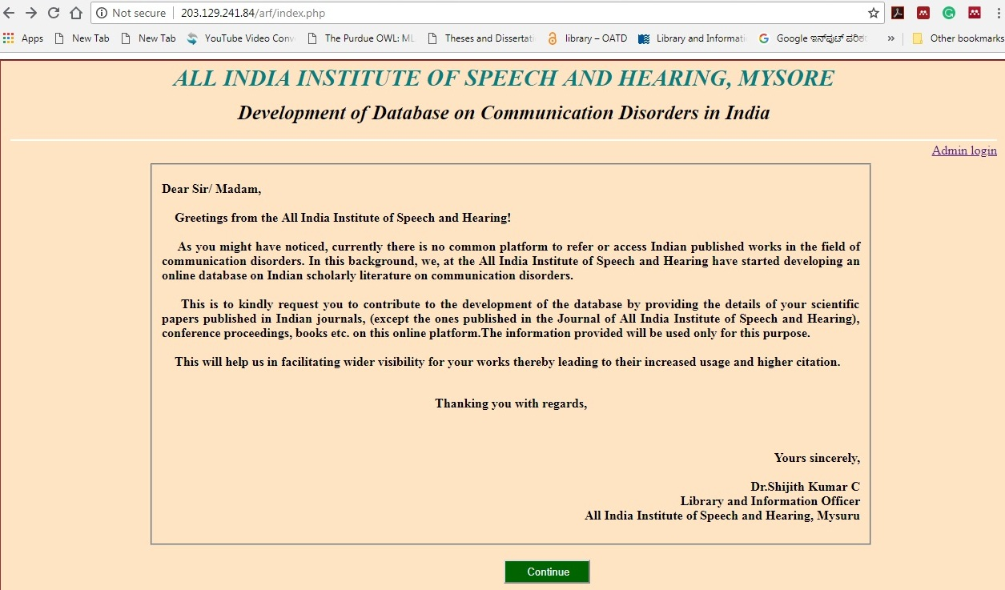

Section A: Fig 1: Covering Letter of the Questionnaire

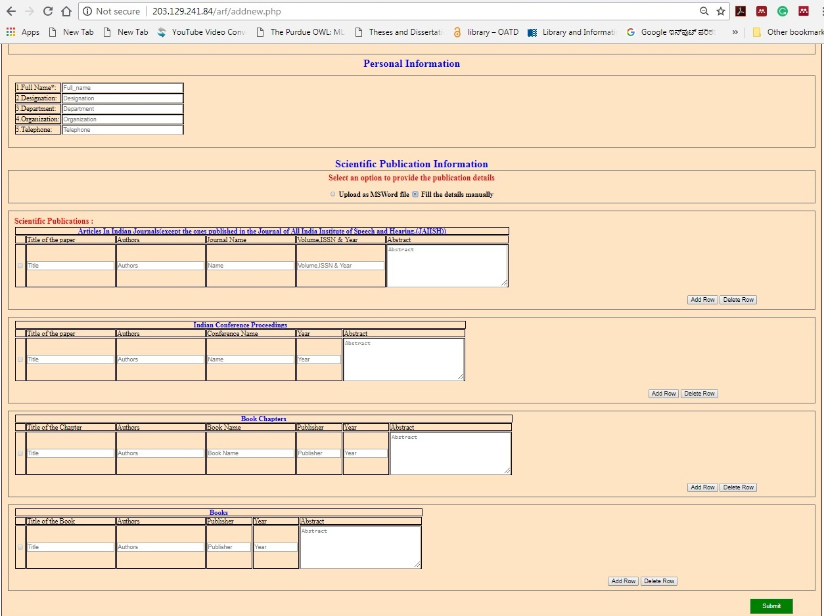

Section B & C: Figure 2: Manual entry for filling of Scientific Publication Information

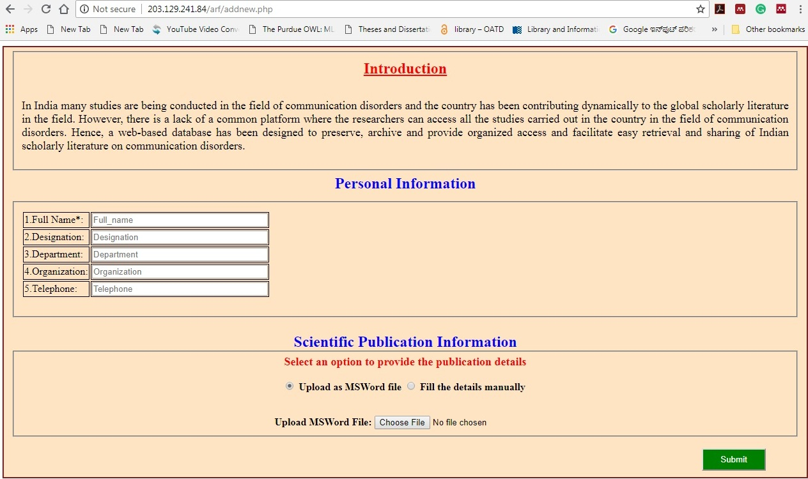

Fig 3: Upload MSWord file for scientific publication information

After designed an above online questionnaire, we emailed an online questionnaire link to the respected speech and hearing professionals and received data few of them

**2. Identified and collected scientific publication information from Indian journals**

The first step to identified Indian journals through a search engine using different keywords pertaining to the communication disorders and also included All India Institute of Speech and Hearing published journals. Individually gone through the all the journals volumes, issues and year, evaluated and collected scientific publication information. Data were collected from Indian journals and international journals published by Indian origin in the field of communication disorders. We were collected scientific publication information more than 1500 nos. from 78 Indian journals. The following table-1 shown in a number of publications in different journals.

**Table - 1: Number of Scientific Publication in Journals**

|  |  |  |
| --- | --- | --- |
| **S/N** | **Journal Name** | **No. of Scientific Publication** |
| 1 | Acoustic Waves | 1 |
| 2 | Advances in Life Science and Technology | 1 |
| 3 | Annals of Indian Academy of Neurology | 9 |
| 4 | Annals of the National Academy of Medical Sciences | 1 |
| 5 | Asia Pacific Journal of Research | 17 |
| 6 | Asian Journal of Disability Matters | 1 |
| 7 | Asian Journal of Science and Technology | 1 |
| 8 | AYJINHH- Journal of Communication Disorders | 2 |
| 9 | Asian Journal of Disability Matters | 1 |
| 10 | AYJNISHD-Journal of Cochlear Implant | 3 |
| 11 | Clinical Epidemiology and Global Health | 3 |
| 12 | Clinical Linguistics and Phonetics | 1 |
| 13 | Disabilities and Impairments | 7 |
| 14 | Disability CBR & Inclusive Development | 8 |
| 15 | Forensic Science Journal | 1 |
| 16 | Global Journal for Research Analysis | 1 |
| 17 | Hearing Aid Journal | 4 |
| 18 | Indian Drugs and Pharmaceutical Industry | 1 |
| 19 | Indian Journal of Applied Linguistics | 6 |
| 20 | Indian Journal of Clinical Psychology | 6 |
| 21 | Indian Journal of Community Medicine | 1 |
| 22 | Indian Journal of Dental Research | 1 |
| 23 | Indian Journal of Gerontology | 1 |
| 24 | Indian Journal of Medical Research | 2 |
| 25 | Indian Journal of Mednodent and Allied Sciences | 1 |
| 26 | Indian Journal of Otolaryngology and Head and Neck Surgery | 106 |
| 27 | Indian Journal of Otology | 129 |
| 28 | Indian Journal of Science and Technology | 1 |
| 29 | Indian Journal of the Applied Linguistics | 1 |
| 30 | Interdisciplinary Journal of Linguistics | 1 |
| 31 | Interdisciplinary Journal of Linguistics | 1 |
| 32 | International Journal of Advanced Research in Electrical, Electronics and Instrumentation Engineering | 1 |
| 33 | International Journal of Applied Ayurveda Research | 1 |
| 34 | International Journal of Dravidian Linguistics | 4 |
| 35 | International Journal of Electrical, Electronics and Data Communication | 1 |
| 36 | International Journal of English and Education | 1 |
| 37 | International Journal of Health Sciences and Research | 20 |
| 38 | International Journal of Innovative Research and Development | 2 |
| 39 | International Journal of Interdisciplinary Research | 1 |
| 40 | International Journal of Laryngology and Phonosurgery | 1 |
| 41 | International Journal of Management and Social Sciences | 1 |
| 42 | International Journal of Medical and Health Sciences | 1 |
| 43 | International Journal of Medical Research & Health Sciences | 3 |
| 44 | International Journal of Mind, Brain, and Cognition | 2 |
| 45 | International Journal of Multidisciplinary Research | 1 |
| 46 | International Journal of Multidisciplinary Research and Development | 2 |
| 47 | International Journal of Multidisciplinary Research Review | 1 |
| 48 | International Journal of Otorhinolaryngology and Head and Neck Surgery | 36 |
| 49 | International Journal of Research in Medical Sciences | 13 |
| 50 | International Journal of Science and Applied Research | 1 |
| 51 | International Journal of Science and Research | 1 |
| 52 | International Journal of Scientific Research | 3 |
| 53 | International Research Journal of Engineering and Technology | 1 |
| 54 | IOSR Journal of VLSI & Signal Processing | 1 |
| 55 | Journal of All India Institute of Speech and Hearing (JAIISH) | 412 |
| 56 | Journal of Cleft Lip Palate and Craniofacial Anomalies | 13 |
| 57 | Journal of Computer Science | 1 |
| 58 | Journal of Disability Management and Rehabilitation | 2 |
| 59 | Journal of Evolution of Medical and Dental Science | 1 |
| 60 | Journal of Indian Society of Pedodontics and Preventive Dentistry | 1 |
| 61 | Journal of ITC Sangeet Research Academy | 1 |
| 62 | Journal of Indian Speech and Hearing Association (JISHA) | 188 |
| 63 | Journal of Laryngology and Voice | 15 |
| 64 | Journal of Rehabilitation Council of India | 5 |
| 65 | Journal of Speech, Language, and Hearing | 2 |
| 66 | Journal of the Acoustical Society of India | 35 |
| 67 | Journal of the Indian Academy of Applied Psychology | 1 |
| 68 | Journal of the Linguistic Society of India | 1 |
| 69 | Journal of Advance Linguistic Studies | 2 |
| 70 | Language in India | 22 |
| 71 | National Journal of Technology | 1 |
| 72 | Nepal Journal of Medical Sciences | 1 |
| 73 | NIMHANS Journal | 1 |
| 74 | Online Journal of Health and Allied Sciences | 6 |
| 75 | Paripex-Indian Journal of Research | 2 |
| 76 | Research in Developmental Disabilities | 1 |
| 77 | Student Research at AIISH: Audiology | 210 |
| 78 | Student Research at AIISH: Speech-Language Pathology | 179 |

1. **Identified and collected scientific publication information from Indian conference proceedings, books, book chapters**

We were gone through the various speech and hearing institute annual reports and individual professional profiles. Evaluated institute annual reports in the research section and collected scientific information from conference proceedings, books, book chapters. Data were collected more than 250 scientific publication information consists of conference proceedings, books, and book chapters. The following table-2 shown in a number of publications in different categories

**Table - 2: Number of Scientific Publications in Different Category**

|  |  |  |
| --- | --- | --- |
| **S/N** | **Category of Resources** | **No. of Scientific Publication** |
| 1 | Conference Proceedings | 196 |
| 2 | Books | 13 |
| 3 | Book Chapters | 76 |

The data was collected from multiple sources. In the initial stage collected data has been uploaded into MS Excel sheet and categorized Journals articles, conference proceedings, books, and book chapters. Later collected data migrate to DSpace software.

**References**

[Anil Singh](https://www.emeraldinsight.com/author/Singh%2C+Anil), [J.N. & Gautam](https://www.emeraldinsight.com/author/Gautam%2C+JN). (2004). Electronic databases: the Indian scenario. *The Electronic Library.* 22(3), 249-260. <https://doi.org/10.1108/02640470410541642>

1. DSpace Archive. (n.d.). Retrieved from <https://duraspace.org/dspace/>
2. Gabriel, Bankier Jean & Kenneth, Gleason (2014). *Institutional repository software comparison*. France: UNESCO. Retrieved from <http://unesdoc.unesco.org/images/0022/002271/227115E.pdf>
3. Price, D. J. S., & Price, D. J. S. (1986). *Little science, big science-- and beyond*. New York: Columbia University Press.
4. Retrieved from http://oii.igidr.ac.in/prog/jan21/index.html
5. Retrieved from <http://www.eprints.org/uk/>
6. Retrieved from https://jgateplus.com/
7. [Sukula](https://www.emeraldinsight.com/author/Kanaujia+Sukula%2C+Shiva)¸ Shiva Kanaujia. (2006). Developing indigenous knowledge databases in India. *The Electronic Library*. 24(1), 83 93. <https://doi.org/10.1108/02640470610649263>
8. Union Catalogues. (n.d.). Retrieved from http://www.icssr.org/union-catalogues
9. Varian, Hal. (2003). How much information? 2003. Retrieved from http://www.ischool.berkeley.edu/research/projects/howmuchinfo2003
10. Welcome to IndMED - IndMED. (n.d.). Retrieved from http://indmed.nic.in/

Mitchell, J. (Ed.). (2011). Dewey Decimal Classification, 23rd edition.

**Chapter 5**

**Conclusion**

In future, the database will be expanded to include the following:

* Theses and dissertations
* Indian studies reported in foreign journals, books and conferences