**Database on Communication Disorders Published in India**

**Chapter - 1**

**Introduction**

The scientific world has been witnessing explosive growth in the number and types of information resources since the publication of the first scientific journal, The Philosophical Transactions of the Royal Society in the year 1665. The exponential growth in the scientific journal publications was reported way back in 1975 by De Solla Price (Price & Price 1986), and a later study (Varian 2003) estimated that the amount of new information stored on paper, film, magnetic tape and optical media are getting doubled in three years. The growth in scientific literature coupled with the developments in computer storage and communication technologies resulted in the emergence of bibliographic and full-text databases. These databases help the scientists in searching and locating the relevant information very easily from a vast pool of scientific knowledge generated from across the world.

**Statement of the Problem**

The field of communication disorders deals with the disorders related to speech and hearing, and a considerable amount of research is taking place in countries across the world on various aspects of communication disorders. In India also many studies are being conducted in the field and the country has been contributing dynamically to the global scholarly literature on communication disorders. However, there is a lack of a common platform where the researchers can access all the studies carried out in the country in the field of communication disorders. This project addressed the design and development of a web-based database on Indian scholarly literature on communication disorders using open source tools.

**Aim and Objectives**

The aim of the project was to design and develop an open source software-based platform for the Indian literature on communication disorders. The specific objectives were:

1. to serve as a single entry point to access the Indian literature on communication disorders
2. to provide organized access and facilitate easy retrieval of resources
3. to facilitate an online gateway of Indian literature on communication disorders
4. to create and develop metadata contents and facilitate searching and browsing of the multimedia contents
5. to facilitate information sharing among users through notification, file sharing, and co-operative document preparation
6. to facilitate quantitative analysis of Indian literature on communication disorders
7. to act as a resource discovery tool on communication disorders in India

**Scope**

The study focused on the design and development of an online database for the Indian publications in communication disorders. The study covers for identification of Indian publication brought by different sources. Design and customization of retrieval of scientific publications by the users.

**Methodology**

The implementation of “Database on Communication Disorders published in India” performed systemically. Major steps involved in the process of evolving a model for effective and efficient storage and dissemination of publications built around repository is as follows:

**1. Subject Coverage**

The database includes both bibliographic and full-text Indian literature in the field of communications disorders with a focus on speech-language pathology and audiology. The resources classified into the broad topics derived according to the Dewey Decimal Classification System such as Articulation/Phonological Disorders; Augmentative and Alternative Communication; Clinical Audiology; Communication Sciences & Disorders; Diagnostic Audiology; Hearing Science; Language Development & Disorders; Motor Speech Disorders; Neuroscience for Communication Disorders; Pediatric Audiology; Phonetics and Linguistics; Rehabilitative Audiology; Speech/Language Intervention; Speech and Hearing Science; Speech Pathology Assessment/Diagnosis; Stuttering/Fluency; Swallowing/Feeding Disorders/ Dysphagia.

**2. Categories of Resources**

The database includes the different categories of publications in both print and electronic formats, such as Journal articles; Books and book chapters; Conference papers.

**3. Collection of Resources**

The following ways data collection did the studies on communication disorders published in the country under the above categories.

1. Design an online questionnaire and collected bibliographical of scientific publications from speech and hearing professionals.
2. Examining bibliographical details of scientific publication published by All India Institute of Speech and Hearing in-house journals namely, Journal of All India Institute of Speech and Hearing; Student Research at AIISH: Audiology; Student Research at AIISH: Special Education; Student Research at AIISH: Speech-Language Pathology.
3. Examining bibliographical details of scientific publications Indian journals and international journals published by Indian origin in the field of communication disorders such as, [Disability CBR & Inclusive Development](http://dcidj.org/issue/archive), Indian Journal of Applied Linguistics, Indian Journal of Clinical Psychology, Indian Journal of Otolaryngology and Head and Neck Surgery, Indian Journal of Otology, International Journal of Dravidian Linguistics, Journal of Disability Studies, [Journal of Rehabilitation Council of India,](http://www.rehabcouncil.nic.in/writereaddata/journal%20vol%206%20103.pdf) Journal of the Acoustical Society of India, Language in India, The Journal of rehabilitation in Asia, Journal of Disability Management and Rehabilitation. Journal of Cleft Lip Palate and Craniofacial Anomalies, Journal of Indian Speech and Hearing Association (JISHA), Journal of Laryngology and Voice, AYJNISHD-Journal of Cochlear Implant, Online Journal of Health and Allied Sciences, Annals of Indian Academy of Neurology, Indian Journal of Medical Research, Clinical Epidemiology and Global Health, Asia Pacific Journal of Research, International Journal of Otorhinolaryngology and Head and Neck Surgery, Disabilities and Impairments, International Journal of Health Sciences and Research, International Journal of Multidisciplinary Research and Development, International Journal of Medical Research & Health Sciences and etc.
4. Examining bibliographical details of scientific publications published by All India Institute of Speech and Hearing proceedings of the conferences organized in the field of communication disorders.

**Project Outcome**

The outcome of the project is a model of Database on Communication Disorders using open source software. The database will facilitate to deposit the scientific publication to respective communities and collection. Retrieval and interface of the database are modified to our requirement. The other outcomes include

* 1. Scholarly publications of the communication disorder published in India.
  2. Global visibility and greater access to the scientific publications such as journal articles, conference proceedings, books and books chapters, etc.
  3. Increase in the citation of the scientific publications.
  4. Wider reach of Indian literature on communication disorders.

**Chapter – 2**

**Background of the Study**

Sukula (2006)8, discusses nationally developed databases, various aspects related to the creation of databases in India. Behind this development of such databases and some factors such as indigenous knowledge need, strategic culture, managerial capability, technological thrust and organizational interest responsible for developing databases in India are highlighted. Other features such as quality assessment control and network‐based indigenous knowledge database access and information delivery are discussed. The study concludes with the idea of pacing in the right direction for developing balanced and information service‐oriented indigenous knowledge system.

Indira Gandhi Institute of Development Research developed an online and searchable bibliographical database is called Open Index Initiative (OII)5. It consists of Indian Social Science literature and resources available in Indian libraries. OII indexes selected Indian social science Journals and working papers/discussion papers/occasional papers, and thesis/dissertations are emanating from Indian social science institutes and departments.

ICMR funded project produced “National Databases of Indian Medical Journals (IndMED)11” IndMED database indexing the journals from 1985 onwards. The IndMED catering to the literature with Indian references. Moreover, it would be of immense use for researchers on diseases and medical problems more prevalent in India. The IndMED database aims to provide bibliographical details to those indexed Indian medical journals or provide free full-text access to their articles. The IndMED database is covering prominent peer-reviewed Indian biomedical journals. This database designed to provide medical professionals/researchers/students and the medical library professional quick and easy access to Indian literature.

Singh & Gautam (2004)1, attempt to present an overview of some of the important electronic databases developed in India or on Indian topics.

Indian Council of Social Science Research9 developed a database of the union catalogue of social science periodicals and serials. This complete database was published 32 volumes, 31, 125 journals records in 550 libraries, in 17 states and two union territories, including the separate volume of the National Library, Kolkata.

Informatics developed J-Gate7 bibliographical database, is an electronic gateway to global e-journal literature either full text and bibliographical information. This database provides 55 million journal articles in all subject domains such as Agriculture & Biological Sciences, Arts & Humanities, Basic Sciences, Biomedical Sciences, Engineering & Technology, Social & Management Sciences.

**Chapter - 3**

**Software Evaluation and Selection**

An evaluation of the open source software and the selection of the most suitable one which meets the requirement of the Database on Communication Disorders published in India.Identification, selection, and implementation of open source software were done to manage the digital collection. The software packages for this project were identified through web namely, DSpace, E-Prints, and Fedora.

1. **DSpace:** DSpace2 software is a jointly developed by HP Labs, and MIT in 2002. DSpace software developed as an open source software to manage research, scholarly, and other published content in a digital repository, focusing on long-term storage, access, and preservation. It's easily customized and fit the needs of any institute or organization.
2. **E-Prints:** E-Prints6 software developed by University of Southampton School of Electronics and Computer Science and released under a [GPL](https://en.wikipedia.org/wiki/GPL) license. This software is compliant with web-based OAI-PMH.
3. **Fedora:** Fedora software jointly developed by Cornell University and the University of Virginia Library. Fedora is an open source repository system for the management and dissemination of the digital content.

**Evaluation and Selection**

All three software packages evaluated based UNESCO3 software comparison for the following criteria such as Infrastructure; Front end design; content organization; content discovery; publishing tools; reporting; multimedia; social media; Interoperability; authentication; preservation. These are given in table 1.

|  |  |  |  |
| --- | --- | --- | --- |
| **Infrastructure** |  |  |  |
|  | **DSpace** | **E-Prints** | **Fedora** |
| Locally Installed Software Solution | Yes | Yes | Yes |
| Community Support | Yes | Yes | Yes |
| Flexible Repository Structure | Yes | Limited | Limited |
| Customized Metadata | Yes | Yes | Yes |
| Current Version | 6.3 Ver. | 3.4 Ver. | 3.0 Ver. |
| Administrator Configurations | Yes | Yes | Yes |
| Supports Standard User Roles | Yes | Yes | Yes |

|  |  |  |  |
| --- | --- | --- | --- |
| **Front-end Design** |  |  |  |
|  | **DSpace** | **E-Prints** | **Fedora** |
| Integrated front-end Design | Yes | Yes | No |
| Customizable Repository Design | Yes | Yes | Yes |

|  |  |  |  |
| --- | --- | --- | --- |
| **Content Organization** |  |  |  |
|  | **DSpace** | **E-Prints** | **Fedora** |
| Access Controls | Yes (IP Range) | Yes (User & request a copy) | Customize |
| Community Publication | Yes | No | No |
| Supports Standard File Types | Yes | Yes | Yes |
| Customizable Metadata | Yes | Yes | Yes |
| Creative Commons License | Yes | Yes | Yes |

|  |  |  |  |
| --- | --- | --- | --- |
| **Content Discovery** |  |  |  |
|  | **DSpace** | **E-Prints** | **Fedora** |
| Integrated Search Engine | Yes | Yes | Yes |
| Advanced Search with Facets | Yes | No | No |
| Browse Options | communities &  collections,  publication date,  author, title, subject,  and document type | department, subject,  year | collections and  search facets |
| Graphical Navigation of Content | Yes | Image only | No |
| Search Engine Optimization | Yes | Yes | No |
| Indexed in Google Scholar | Yes | Yes | No |
| DOI and Persistent URLs | Yes (Handle System) | Yes (DOI) | Yes (Persistent  Identifiers) |
| Citation Export | Yes | Yes | Yes |

|  |  |  |  |
| --- | --- | --- | --- |
| **Publication Tools** |  |  |  |
|  | **DSpace** | **E-Prints** | **Fedora** |
| Flexible Publishing Workflows | Yes | Yes | Yes |
| Customizable Submit Forms | Yes | Yes | Yes |
| Batch Import | Bibliographic  import tool and  simple archive  format | BibTeX, XML | XML import |
| Batch Revision | Yes | No | No |

|  |  |  |  |
| --- | --- | --- | --- |
| **Reporting** |  |  |  |
|  | **DSpace** | **E-Prints** | **Fedora** |
| Usage/Download Reports | Yes | Add on service | Add on service |
| Google Analytics Integration | Add on service | Yes | No |

|  |  |  |  |
| --- | --- | --- | --- |
| **Multimedia** |  |  |  |
|  | **DSpace** | **E-Prints** | **Fedora** |
| Streaming Multimedia | Add on service | No | Add on service |
| Images | Yes | Yes | Yes |
| Slideshows | Add on service | Yes | Add on service |
| Audio | Yes | Yes | Yes |
| Video | Yes | Yes | Yes |

|  |  |  |  |
| --- | --- | --- | --- |
| **Social Feature** |  |  |  |
|  | **DSpace** | **E-Prints** | **Fedora** |
| RSS | Yes | Yes | Yes |
| Book Mark | No | Yes | No |
| Share | Add on service | Add on service | Add on service |
| Saved Searches | Yes | Yes | No |

|  |  |  |  |
| --- | --- | --- | --- |
| **Interoperability** |  |  |  |
|  | **DSpace** | **E-Prints** | **Fedora** |
| Harvesting (OAI-PMH) | Yes | Yes | Yes |
| Integration with Discovery Platforms | Yes | Yes | Yes |

|  |  |  |  |
| --- | --- | --- | --- |
| **Authentication** |  |  |  |
|  | **DSpace** | **E-Prints** | **Fedora** |
| LDAP | Yes | Yes | Yes |
| CAS | Yes | Yes | Yes |
| System Accounts | Yes | Yes | Yes |
| Shibboleth | Yes | Yes | Yes |

|  |  |  |  |
| --- | --- | --- | --- |
| **Preservation** |  |  |  |
|  | **DSpace** | **E-Prints** | **Fedora** |
| Content Back Up | Archival Information Packages back up | XML export | Yes |
| LOCKSS-compliant | Add on service | No | Add on service |
| Format Migration Tools and Services | Managed by institution | Integrated format migration risks tools offer format advice for administrators | Managed by institution |

The DSpace features differ from other open source software. It supports collections for storing of data objects. These collections divided into communities. Communities are organized into a tree structure. This software supports a workflow process for inserting new digital objects. DSpace supports Dublin Core metadata format and full-text searching for different file formats like plain text, MSWord, PDF, HTML and other digital objects. Considering all those things and also most worldwide used open source software is on DSpace. DSpace was selected for design and developing the online database on communication disorders in Indian literature. DSpace has a strong developer community, and the source code is getting reviewed and updated on a regular basis.

**Chapter 4**

**Resource Collection and Categorization**

This chapter contains the methodology adopted for the collection of resources. While collecting resources, few methods have been adopted.

1. Design an online questionnaire and collected the bibliographical information from the speech and hearing professionals.
2. Identified and collected scientific publication information published in Indian journals.
3. Identified and collected Indian literature of conference proceedings, books, book chapters, etc.

**1. Design an online questionnaire**

The questionnaire is the main tool used in the collection of data. A Structurally designed questionnaire has been adopted for the purpose. We designed an online questionnaire for collecting bibliographical information from speech and hearing professionals. The questionnaire has been designed by dividing it into two sections as enumerated below:

**Section A** : consists of covering letter

**Section B**: Personal information: comprising five questions such as Name, Designation, Department, Organization, Telephone.

**Section C**: Scientific publication information: comprising four questions such as Articles in Indian journals, Indian conference proceedings, Book chapters, and Books

Other than this above section, given another option to upload MSWord file for scientific publication information. The following figures are shown in an online questionnaire.

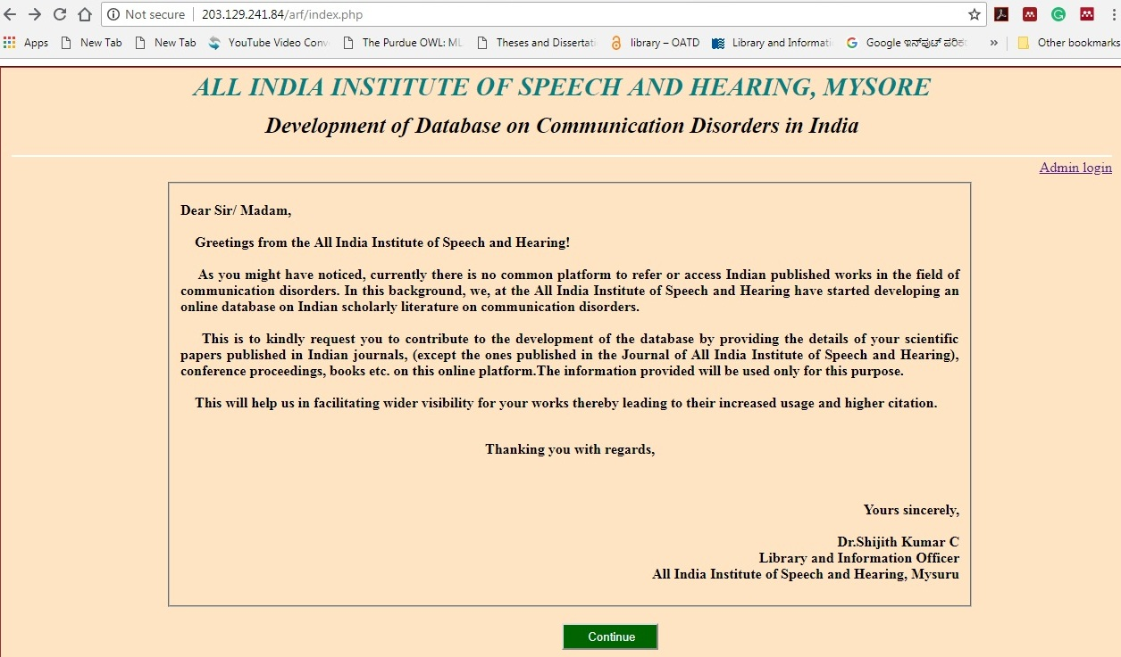

Section A: Fig 1: Covering Letter of the Questionnaire

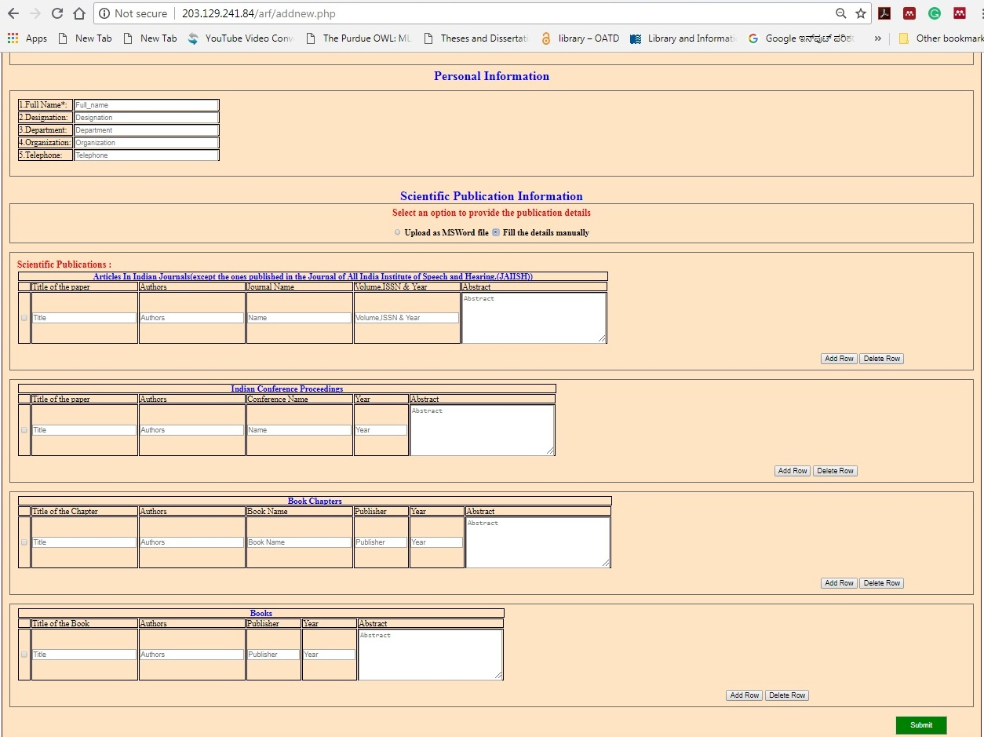

Section B & C: Figure 2: Manual entry for filling of Scientific Publication Information

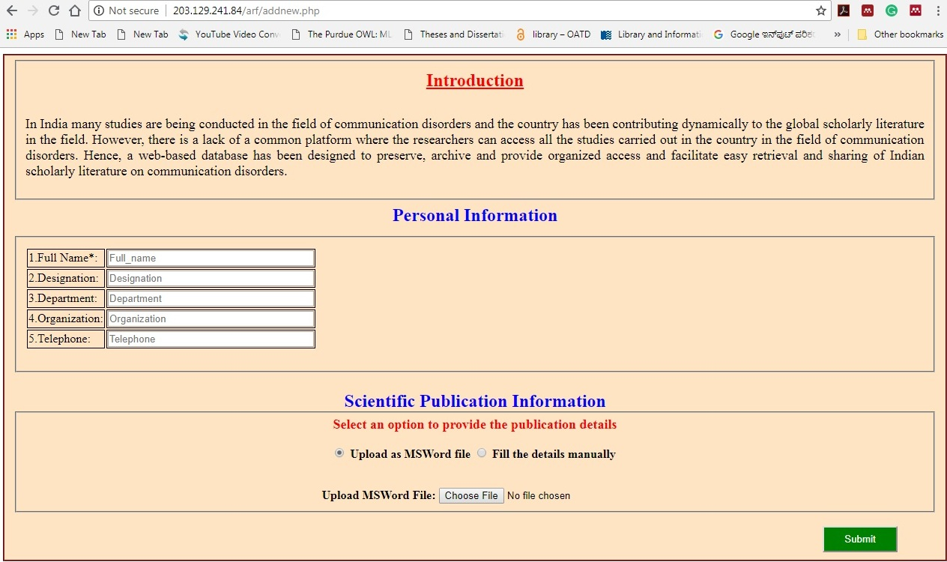

Fig 3: Upload MSWord file for scientific publication information

After designed an above online questionnaire, we emailed an online questionnaire link to the respected speech and hearing professionals and received data few of them

**2. Identified and collected scientific publication information from Indian journals**

The first step to identified Indian journals through a search engine using different keywords pertaining to the communication disorders and also included All India Institute of Speech and Hearing published journals. Individually gone through the all the journals volumes, issues and year, evaluated and collected scientific publication information. Data were collected from Indian journals and international journals published by Indian origin in the field of communication disorders. We were collected scientific publication information more than 1500 nos. from 78 Indian journals. The following table-1 shown in a number of publications in different journals.

**Table - 1: Number of Scientific Publication in Journals**

|  |  |  |
| --- | --- | --- |
| **S/N** | **Journal Name** | **No. of Scientific Publication** |
| 1 | Acoustic Waves | 1 |
| 2 | Advances in Life Science and Technology | 1 |
| 3 | Annals of Indian Academy of Neurology | 9 |
| 4 | Annals of the National Academy of Medical Sciences | 1 |
| 5 | Asia Pacific Journal of Research | 17 |
| 6 | Asian Journal of Disability Matters | 1 |
| 7 | Asian Journal of Science and Technology | 1 |
| 8 | AYJINHH- Journal of Communication Disorders | 2 |
| 9 | Asian Journal of Disability Matters | 1 |
| 10 | AYJNISHD-Journal of Cochlear Implant | 3 |
| 11 | Clinical Epidemiology and Global Health | 3 |
| 12 | Clinical Linguistics and Phonetics | 1 |
| 13 | Disabilities and Impairments | 7 |
| 14 | Disability CBR & Inclusive Development | 8 |
| 15 | Forensic Science Journal | 1 |
| 16 | Global Journal for Research Analysis | 1 |
| 17 | Hearing Aid Journal | 4 |
| 18 | Indian Drugs and Pharmaceutical Industry | 1 |
| 19 | Indian Journal of Applied Linguistics | 6 |
| 20 | Indian Journal of Clinical Psychology | 6 |
| 21 | Indian Journal of Community Medicine | 1 |
| 22 | Indian Journal of Dental Research | 1 |
| 23 | Indian Journal of Gerontology | 1 |
| 24 | Indian Journal of Medical Research | 2 |
| 25 | Indian Journal of Mednodent and Allied Sciences | 1 |
| 26 | Indian Journal of Otolaryngology and Head and Neck Surgery | 106 |
| 27 | Indian Journal of Otology | 129 |
| 28 | Indian Journal of Science and Technology | 1 |
| 29 | Indian Journal of the Applied Linguistics | 1 |
| 30 | Interdisciplinary Journal of Linguistics | 1 |
| 31 | Interdisciplinary Journal of Linguistics | 1 |
| 32 | International Journal of Advanced Research in Electrical, Electronics and Instrumentation Engineering | 1 |
| 33 | International Journal of Applied Ayurveda Research | 1 |
| 34 | International Journal of Dravidian Linguistics | 4 |
| 35 | International Journal of Electrical, Electronics and Data Communication | 1 |
| 36 | International Journal of English and Education | 1 |
| 37 | International Journal of Health Sciences and Research | 20 |
| 38 | International Journal of Innovative Research and Development | 2 |
| 39 | International Journal of Interdisciplinary Research | 1 |
| 40 | International Journal of Laryngology and Phonosurgery | 1 |
| 41 | International Journal of Management and Social Sciences | 1 |
| 42 | International Journal of Medical and Health Sciences | 1 |
| 43 | International Journal of Medical Research & Health Sciences | 3 |
| 44 | International Journal of Mind, Brain, and Cognition | 2 |
| 45 | International Journal of Multidisciplinary Research | 1 |
| 46 | International Journal of Multidisciplinary Research and Development | 2 |
| 47 | International Journal of Multidisciplinary Research Review | 1 |
| 48 | International Journal of Otorhinolaryngology and Head and Neck Surgery | 36 |
| 49 | International Journal of Research in Medical Sciences | 13 |
| 50 | International Journal of Science and Applied Research | 1 |
| 51 | International Journal of Science and Research | 1 |
| 52 | International Journal of Scientific Research | 3 |
| 53 | International Research Journal of Engineering and Technology | 1 |
| 54 | IOSR Journal of VLSI & Signal Processing | 1 |
| 55 | Journal of All India Institute of Speech and Hearing (JAIISH) | 412 |
| 56 | Journal of Cleft Lip Palate and Craniofacial Anomalies | 13 |
| 57 | Journal of Computer Science | 1 |
| 58 | Journal of Disability Management and Rehabilitation | 2 |
| 59 | Journal of Evolution of Medical and Dental Science | 1 |
| 60 | Journal of Indian Society of Pedodontics and Preventive Dentistry | 1 |
| 61 | Journal of ITC Sangeet Research Academy | 1 |
| 62 | Journal of Indian Speech and Hearing Association (JISHA) | 188 |
| 63 | Journal of Laryngology and Voice | 15 |
| 64 | Journal of Rehabilitation Council of India | 5 |
| 65 | Journal of Speech, Language, and Hearing | 2 |
| 66 | Journal of the Acoustical Society of India | 35 |
| 67 | Journal of the Indian Academy of Applied Psychology | 1 |
| 68 | Journal of the Linguistic Society of India | 1 |
| 69 | Journal of Advance Linguistic Studies | 2 |
| 70 | Language in India | 22 |
| 71 | National Journal of Technology | 1 |
| 72 | Nepal Journal of Medical Sciences | 1 |
| 73 | NIMHANS Journal | 1 |
| 74 | Online Journal of Health and Allied Sciences | 6 |
| 75 | Paripex-Indian Journal of Research | 2 |
| 76 | Research in Developmental Disabilities | 1 |
| 77 | Student Research at AIISH: Audiology | 210 |
| 78 | Student Research at AIISH: Speech-Language Pathology | 179 |

1. **Identified and collected scientific publication information from Indian conference proceedings, books, book chapters**

We were gone through the various speech and hearing institute annual reports and individual professional profiles. Evaluated institute annual reports in the research section and collected scientific information from conference proceedings, books, book chapters. Data were collected more than 250 scientific publication information consists of conference proceedings, books, and book chapters. The following table-2 shown in a number of publications in different categories

**Table - 2: Number of Scientific Publications in Different Category**

|  |  |  |
| --- | --- | --- |
| **S/N** | **Category of Resources** | **No. of Scientific Publication** |
| 1 | Conference Proceedings | 196 |
| 2 | Books | 13 |
| 3 | Book Chapters | 76 |

The data was collected from multiple sources. In the initial stage collected data has been uploaded into MS Excel sheet and categorized Journals articles, conference proceedings, books, and book chapters. Later collected data migrate to DSpace software.

**References**

1. [Anil Singh](https://www.emeraldinsight.com/author/Singh%2C+Anil), [J.N. & Gautam](https://www.emeraldinsight.com/author/Gautam%2C+JN). (2004). Electronic databases: the Indian scenario. *The Electronic Library.* 22(3), 249-260. <https://doi.org/10.1108/02640470410541642>
2. DSpace Archive. (n.d.). Retrieved from <https://duraspace.org/dspace/>
3. Gabriel, Bankier Jean & Kenneth, Gleason (2014). *Institutional repository software comparison*. France: UNESCO. Retrieved from <http://unesdoc.unesco.org/images/0022/002271/227115E.pdf>
4. Price, D. J. S., & Price, D. J. S. (1986). *Little science, big science-- and beyond*. New York: Columbia University Press.
5. Retrieved from http://oii.igidr.ac.in/prog/jan21/index.html
6. Retrieved from <http://www.eprints.org/uk/>
7. Retrieved from https://jgateplus.com/
8. [Sukula](https://www.emeraldinsight.com/author/Kanaujia+Sukula%2C+Shiva)¸ Shiva Kanaujia. (2006). Developing indigenous knowledge databases in India. *The Electronic Library*. 24(1), 83 93. <https://doi.org/10.1108/02640470610649263>
9. Union Catalogues. (n.d.). Retrieved from http://www.icssr.org/union-catalogues
10. Varian, Hal. (2003). How much information? 2003. Retrieved from http://www.ischool.berkeley.edu/research/projects/howmuchinfo2003
11. Welcome to IndMED - IndMED. (n.d.). Retrieved from http://indmed.nic.in/

**Chapter 5**

**Design and Development of the Database**