Database on Communication Disorders published in India

**A Project funded by the AIISH Research fund**

**Project Report**

**Principal investigator**

Dr. Shijith Kumar, C

**Co-investigators**

Mr. Nanjunda Swamy, M

Mr. Nandeesha, B

All India Institute of Speech and Hearing

Mysore – 570 006

Table of Contents

|  |  |  |
| --- | --- | --- |
| **Sl.No** | **Chapters** | **Page no.** |
|  | Introduction | 1 |
|  | Collection of Resources | 5 |
|  | Sofware Evaluation and Selection | 13 |
|  | Design and Development of the Systems | 28 |
|  | Concluding Remarks | 47 |
|  | References |  |

Acknowledgements

We sincerely acknowledge Dr. S.R. Savithri, Director, All India Institute of Speech and Hearing, Mysore for sanctioning the project and for her encouragement and support throughout the completion of the project. Thanks are also due to all our colleagues in the Library and Information Centre, AIISH, Mysore.

Dr. Shijith Kumar, C

Mr. M. Nanjunda Swamy

Mr. Nandeesha B

System design

Introduction

The scientific world has been witnessing explosive growth in the number and types of information resources since the publication of the first scientific journal, The Philosophical Transactions of the Royal Society in the year 1665. The exponential growth in the scientific journal publications was reported way back in 1975 by De Solla Price (Price & Price 1986), and a later study (Varian 2003) estimated that the amount of new information stored on paper, film, magnetic tape and optical media are getting doubled in three years. The growth in scientific literature coupled with the developments in computer storage and communication technologies resulted in the emergence of bibliographic and full-text databases. These databases help the scientists in searching and locating the relevant information very easily from a vast pool of scientific knowledge generated from across the world.

**Statement of the Problem**

Corresponding to the growth in the published literature in different branches of knowledge, thousands of literature databases have been developed across the world. Majority of them are international in nature covering the scholarly works reported in the scientific journals published across the world. Some of these databases are general covering all the fields of knowledge such as Web of Science and SCOPUS, and others are specialised such as MEDLINE on medicine, AGRICOLA on agricultural sciences, COMPENDEX on engineering sciences. Only a few databases are operating at the national level in India such as INDMED, covering the scientific literature reported in 100 medical journals published from the country, Traditional Knowledge Digital Library (TKDL) a database on traditional knowledge in the field of Ayurveda, Unani and Siddha in five international languages, English, French, German, Spanish and Japanese, and Open Index Initiative (OII)a database consists of Indian Social Science literature from selected Indian social science Journals and working papers/discussion papers/occasional papers, and thesis/dissertations are emanating from Indian social science institutes.

The field of communication disorders deals with the disorders related to speech and hearing, and a considerable amount of research is taking place in countries across the world on various aspects of communication disorders. India also has been contributing dynamically to the global scholarly literature on communication disorders by conducting noteworthy studies on various aspects the disorders. However, there is only one database exclusively based on the scientific literature on communication disorders, namely COMDISDOME published by the Proquest Incorpn, USA. The Proquest also publishes a related database known as Lingustics and Language Behaviuor Abstracts (LLBA) which covers the literature on language disorders. Both the COMDISDOME and LLBA are international in coverage but with meagre representation of Indian studies. Hence, there is a need for a system that provides access to the research publications on communication disorders published from India and give them greater visibility to a world wide audience. It will address the need of a common platform where the researchers can access all the studies carried out in the country in the field of communication disorders. This project addressed the design and development of a web-based database on Indian scholarly literature on communication disorders using open source tools.

**Aim and Objectives**

The aim of the project was to design and develop an open source software-based platform for the Indian literature on communication disorders. The specific objectives were the following:

1. To serve as a single-entry point to access the Indian literature on communication disorders
2. To provide organized access and facilitate easy retrieval of resources
3. To facilitate an online gateway of Indian literature on communication disorders
4. To create and develop metadata contents and facilitate searching and browsing of the multimedia contents
5. To facilitate information sharing among users through notification, file sharing, and co-operative document preparation
6. To facilitate quantitative analysis of Indian literature on communication disorders
7. To act as a resource discovery tool on communication disorders in India

**Scope**

The study included only the Indian literature pertaining to the speech, language and hearing disorders in the form of journal articles, books and book chapters, and the papers published in the conference proceedings. It excluded the Indian studies published outside the country. Also, only the abstracts of the studies were provided with a link to the full-text wherever applicable.

**Materials and Methods**

The following materials and methods were used for carrying out the project work.

**1. Determining the Subject Categories and the Content Type**

Using the Dewey Decimal Classification (Mitchell, 2011), the international code for organizing information resources in the Library and Information Centres across the world, the literature pertaining to the field of communication disorders were classified under three broad divisions: Speech, Language and Hearing. They were further divided into topics such as Articulation/Phonological Disorders; Augmentative and Alternative Communication; Clinical Audiology; Communication Sciences & Disorders; Diagnostic Audiology; Hearing Science; Language Development & Disorders; Motor Speech Disorders; Neuroscience for Communication Disorders; Pediatric Audiology; Phonetics and Linguistics; Rehabilitative Audiology; Speech/Language Intervention; Speech and Hearing Science; Speech Pathology Assessment/Diagnosis; Stuttering/Fluency; Swallowing/Feeding Disorders/ Dysphagia.

**2. Collection of Resources**

The Indian publications on communication disorders were collected in the following ways:

1. By visiting the official websites of the Speech and Hearing Institutions in the country and by going through their annual reports.
2. By verifying all the issues of the peer-reviewed journals exclusively on communication disorders published from the country
3. By verifying all the issues of the peer-reviewed journals in the allied areas published from the country.
4. By verifying the available proceedings of the conferences and seminars on communication disorders conducted in India.
5. From the individual speech and hearing professionals working in different organizations across the country by developing an online questionnaire indigenously using PHP web development tool.

3.**Selection of Software Application**

A suitable open source software application was identified for building the database by conducting a comparative evaluation of the features of three most heavily used open source software applications in the field of information management as per the Registry of Open Access Repositories (“Registry of Open Access Repositories,” 2016), namely E-Prints, Fedora and D-Space. The criteria based software evaluation checklist developed by Bankier and Gleason (2014) was used for evaluation and selection.

**4. Customization and Development of the Database Platform**

The selected software application was customized as per the requirements and the database was developed.

Collection of Resources

**Categorization and Classification**

The MIT Encyclopedia of Communication Disorders (MITECD) defines communication disorders as those that affect the production and comprehension of spoken language and include especially disorders of speech production and perception, language expression, language comprehension, voice, and hearing. The present study considered four categories of literature on communication disorders:

1. Journal Articles
2. Books
3. Book Chapters
4. Conference Papers

They were classified into different subject fields based on the Dewey Decimal Classification code as mentioned in the previous chapter. The three broad divisions were: Speech, Language and Hearing which were further divided into topics such as Articulation/Phonological Disorders; Augmentative and Alternative Communication; Clinical Audiology; Communication Sciences & Disorders; Diagnostic Audiology; Hearing Science; Language Development & Disorders; Motor Speech Disorders; Neuroscience for Communication Disorders; Pediatric Audiology; Phonetics and Linguistics; Rehabilitative Audiology; Speech/Language Intervention; Speech and Hearing Science; Speech Pathology Assessment/Diagnosis; Stuttering/Fluency; Swallowing/Feeding Disorders/ Dysphagiathe literature on the above topics and their subcategories based on the classification available with the Dewey Decimal Classification code. The subcategories include Articulation/Phonological Disorders; Augmentative and Alternative Communication; Clinical Audiology; Communication Sciences & Disorders; Diagnostic Audiology; Hearing Science; Language Development & Disorders; Motor Speech Disorders; Neuroscience for Communication Disorders; Pediatric Audiology; Phonetics and Linguistics; Rehabilitative Audiology; Speech/Language Intervention; Speech and Hearing Science; Speech Pathology Assessment/Diagnosis; Stuttering/Fluency; Swallowing/Feeding Disorders/ Dysphagia.

**Collection of Publication Details**

The details of the Indian publications on communication disorders, published till 31st March 2018, coming under the above four categories were collected from the following sources.

(a) the peer-reviewed Indian journals on communication disorders,

(b) the peer-reviewed Indian journals on allied areas,

(c) the official websites of the Indian Speech and Hearing Institutions,

(d) the available annual reports of the Indian Speech and Hearing Institutions,

(e) the available proceedings of the conferences and seminars on communication disorders conducted in India.

(f) the individual speech and hearing professionals working in different organizations across the country through an online questionnaire.

The following are the peer-reviewed journals exclusively on Communication Disorders published from the country.

1. The Journal of All India Institute of Speech and Hearing
2. The Journal of Indian Speech and Hearing Association
3. AYJINHH- Journal of Communication Disorders
4. Student Research at AIISH: Audiology
5. Student Research at AIISH: Speech-Language Pathology

Of these, all the scientific articles publshed in the the Journal of All India Institute of Speech and Hearing, the AYJINHH- Journal of Communication Disorders, Student Research at AIISH: Audiology and Student Research at AIISH: Speech-Language Pathology since the inception of the journals were included. Except a few issues, all the scientific articles publshed in the Journal of Indian Speech and Hearing Association was also covered.

A search was made in the medical and allied health journals published from the country for scientific articles on communication disorders and retrieved relevant articles from the following peer-reviewed allied health journals.

1. Annals of Indian Academy of Neurology
2. Annals of Indian Academy of Neurology
3. Asian Journal of Disability Matters
4. Disabilities and Impairments
5. Disability CBR & Inclusive Development
6. Indian Journal of Applied Linguistics
7. Indian Journal of Applied Linguistics
8. Indian Journal of Clinical Psychology
9. Indian Journal of Community Medicine
10. Indian Journal of Gerontology
11. Indian Journal of Medical Research
12. Indian Journal of Mednodent and Allied Sciences
13. Indian Journal of Otolaryngology and Head and Neck Surgery
14. Indian Journal of Otology
15. Indian Journal of the Applied Linguistics
16. Interdisciplinary Journal of Linguistics
17. International Journal of Dravidian Linguistics
18. International Journal of Laryngology and Phonosurgery
19. International Journal of Mind, Brain, and Cognition
20. International Journal of Otorhinolaryngology and Head and Neck Surgery
21. Journal of Cleft Lip Palate and Craniofacial Anomalies
22. Journal of Disability Management and Rehabilitation
23. Journal of ITC Sangeet Research Academy
24. Journal of Laryngology and Voice
25. Journal of Rehabilitation Council of India
26. Journal of the Acoustical Society of India
27. Journal of the Indian Academy of Applied Psychology
28. Journal of the Linguistic Society of India
29. Journal of Advance Linguistic Studies
30. Language in India

The list of publications available on the official websites of the India speech and hearing and their annual reports were checked and all the Indian publications were listed out.

The available proceedings of the seminars and conferences on communication disorders held in -the country were collected and the details of the papers presented were extracted.

In addition, an online questionnaire was developed indigenously using PHP and requested the speech and hearing professionals in the country to provide their publication details. Only a meagre number of professionals responded to the request. The screen shot of the online questionnaire is given in figure 1.

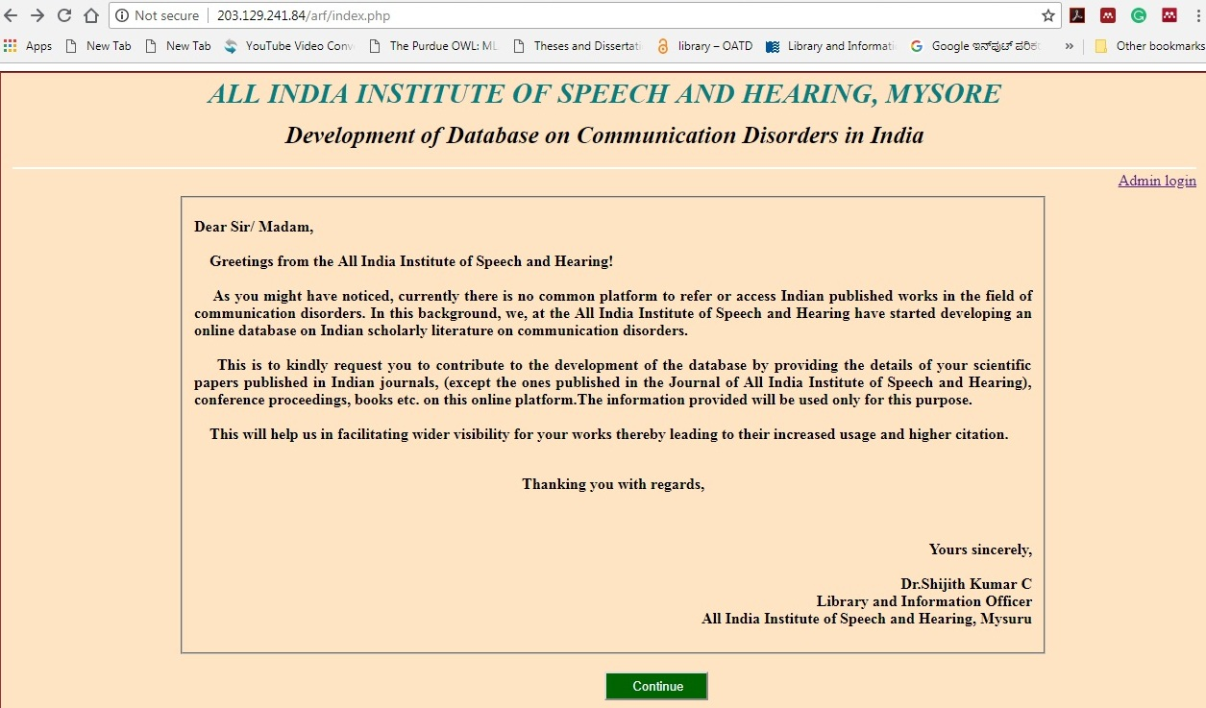

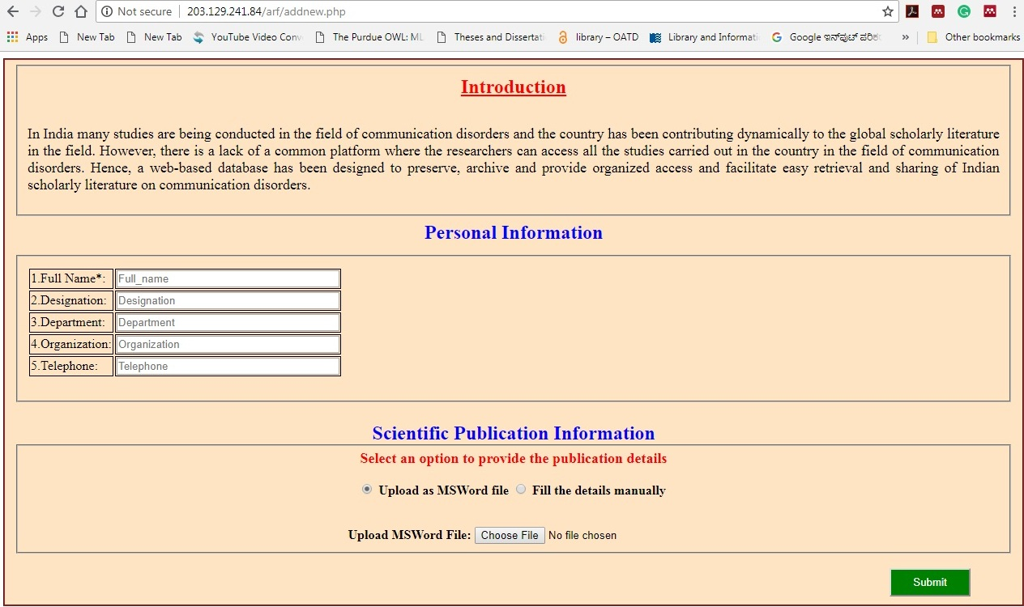

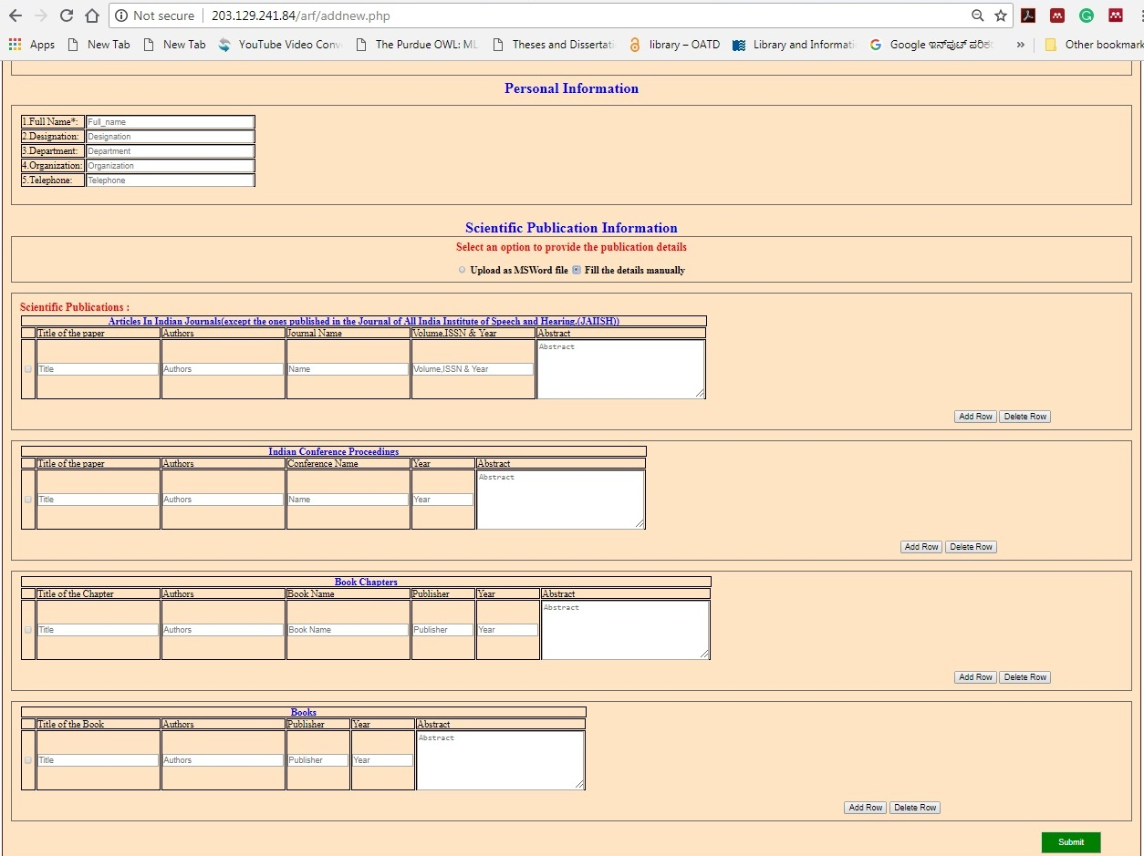

Fig. 1: Online questionnaire

The number of resources collected under each category using different methods are given below.

|  |  |  |
| --- | --- | --- |
| **S/N** | **Resource Type** | **Numbers** |
| 1 | Journal Articles | 2174 |
| 2 | Conference Proceedings/Paper Presentation | 1141 |
| 3 | Book Chapters | 142 |
| 4 | Books | 61 |
| **Total** | | **3518** |

Software Evaluation and Selection

**Identification of Candidate Software**

The three most heavily used open source software applications in the field of information management as per the Registry of Open Access Repositories (ROAR 2016), namely E-Prints, Fedora and D-Space were selected as the candidate tools for developing the platform.

1. **DSpace:** DSpace software was jointly developed by Hewlett Packard (HP) Labs, and The Massachusetts Institute of Technology (MIT), USA in 2002 as an open source software to manage research, scholarly, and other published content in a digital repository, focusing on long-term storage, access, and preservation.
2. **E-Prints:** E-Prints software was developed by the   School of Electronics and Computer Science, University of Southampton, USA. It is a leading open-source application for developing digital research repositories.
3. **Fedora:** Fedora software was jointly developed by Cornell University and the University of Virginia Library, USA. This is also an open source repository system for the management and dissemination of the digital content.

**Evaluation and Selection**

Each of the three candidate software packages were locally installed and further evaluated based on a detailed set of evaluation criteria developed by Bankier and Gleason (2014) as given in table 1.

Table 1: Check List for Evaluation of the Software

|  |  |  |  |
| --- | --- | --- | --- |
| **Criteria** | **Candidate Software** | | |
| **Infrastructure** | **DSpace** | **E-Prints** | **Fedora** |
| Locally Installed Software Solution | Yes | Yes | Yes |
| Community Support | Yes | Yes | Yes |
| Flexible Repository Structure | Yes | Limited | Limited |
| Customized Metadata | Yes | Yes | Yes |
| Current Version | 6.3 Ver. | 3.4 Ver. | 3.0 Ver. |
| Administrator Configurations | Yes | Yes | Yes |
| Supports Standard User Roles | Yes | Yes | Yes |
| **Front-end Design** | **DSpace** | **E-Prints** | **Fedora** |
| Integrated front-end Design | Yes | Yes | No |
| Customizable Repository Design | Yes | Yes | Yes |
| **Content Organization** | **DSpace** | **E-Prints** | **Fedora** |
| Access Controls | Yes | Yes | Customize |
| Community Publication | Yes | No | No |
| Supports Standard File Types | Yes | Yes | Yes |
| Customizable Metadata | Yes | Yes | Yes |
| Creative Commons License | Yes | Yes | Yes |
| **Content Discovery** | **DSpace** | **E-Prints** | **Fedora** |
| Integrated Search Engine | Yes | Yes | Yes |
| Advanced Search with Facets | Yes | No | No |
| Browse Options | Yes | Yes, but limited | Yes, but limited |
| Graphical Navigation of Content | Yes | Image only | No |
| Search Engine Optimization | Yes | Yes | No |
| Indexed in Google Scholar | Yes | Yes | No |
| DOI and Persistent URLs | Yes | Yes | Yes |
| Citation Export | Yes | Yes | Yes |
| **Reporting** | **DSpace** | **E-Prints** | **Fedora** |
| Usage/Download Reports | Yes | Add on service | Add on service |
| Google Analytics Integration | Add on service | Yes | No |
| **Multimedia** | **DSpace** | **E-Prints** | **Fedora** |
| Streaming Multimedia | Add on service | No | Add on service |
| Images | Yes | Yes | Yes |
| Slideshows | Add on service | Yes | Add on service |
| Audio | Yes | Yes | Yes |
| Video | Yes | Yes | Yes |
| **Social Feature** | **DSpace** | **E-Prints** | **Fedora** |
| RSS | Yes | Yes | Yes |
| Book Mark | No | Yes | No |
| Share | Add on service | Add on service | Add on service |
| Saved Searches | Yes | Yes | No |
| **Interoperability** | **DSpace** | **E-Prints** | **Fedora** |
| Harvesting (OAI-PMH) | Yes | Yes | Yes |
| Integration with Discovery Platforms | Yes | Yes | Yes |
| **Authentication** | **DSpace** | **E-Prints** | **Fedora** |
| LDAP | Yes | Yes | Yes |
| CAS | Yes | Yes | Yes |
| System Accounts | Yes | Yes | Yes |
| Shibboleth | Yes | Yes | Yes |
| **Preservation** | **DSpace** | **E-Prints** | **Fedora** |
| Content Back Up | Archival Information Packages back up | XML export | Yes |
| LOCKSS-compliant | Add on service | No | Add on service |

More ‘yes’ , were obtained for DSpace software. Hence, it was selected for developing the database. The DSpace has a strong developer community and the source code is getting reviewed and updated on a regular basis.

System Planning, Design and Development

**System Planning and Design**

Proper planning was carried out for the successful implementation of the national database on communication disorders by taking the following decisions.

* The resources to be included in the database: journal articles, book chapters, books and conference papers in the field of communication disorders published from the country with provision to include more types of resources in future.
* The end user community was defined as faculty, technical staff, research scholars, students and administrators of the Speech and Hearing organizations across the country and abroad.
* The content uploading in future by the researchers or the contributors themselves with the verification by the database administrators at the Library and Information Centre.
* Restrict the content only to the abstracts with link to the full-text wherever available with provision to accommodate the full-text directly in future.
* Supporting file type: PDF with provision to support more file types in future.
* Restrict access only for the registered users and provision for free registration
* Facility for author, title, subject, year, Institution, resource type and keyword based searching.
* Facility for usage report generation by the administrators
* Facility for data backup by the system administrator
* Item description using metadata standard
* User interface to design for End Users, Submitters and System Administrators
* To develop the database on DSpace with the required tables created using MySQL and apache web server. Codes/ scripts to be written using PHP scripting language.
* Creation of Top Level Communities under (a) Speech-Language, (b) Hearing (c) Speech & Hearing.
* Creation of Collections under Journal Articles, (b) Books, (c) Book Chapters, (d) Conference Papers.

**Work Flow**

User Access

Already registered?????

Register

No

Yes

Enter username & access

Submit resource?

Access submission form & submit

Yes

No

Refer the resources

**System Development**

1. Home Page

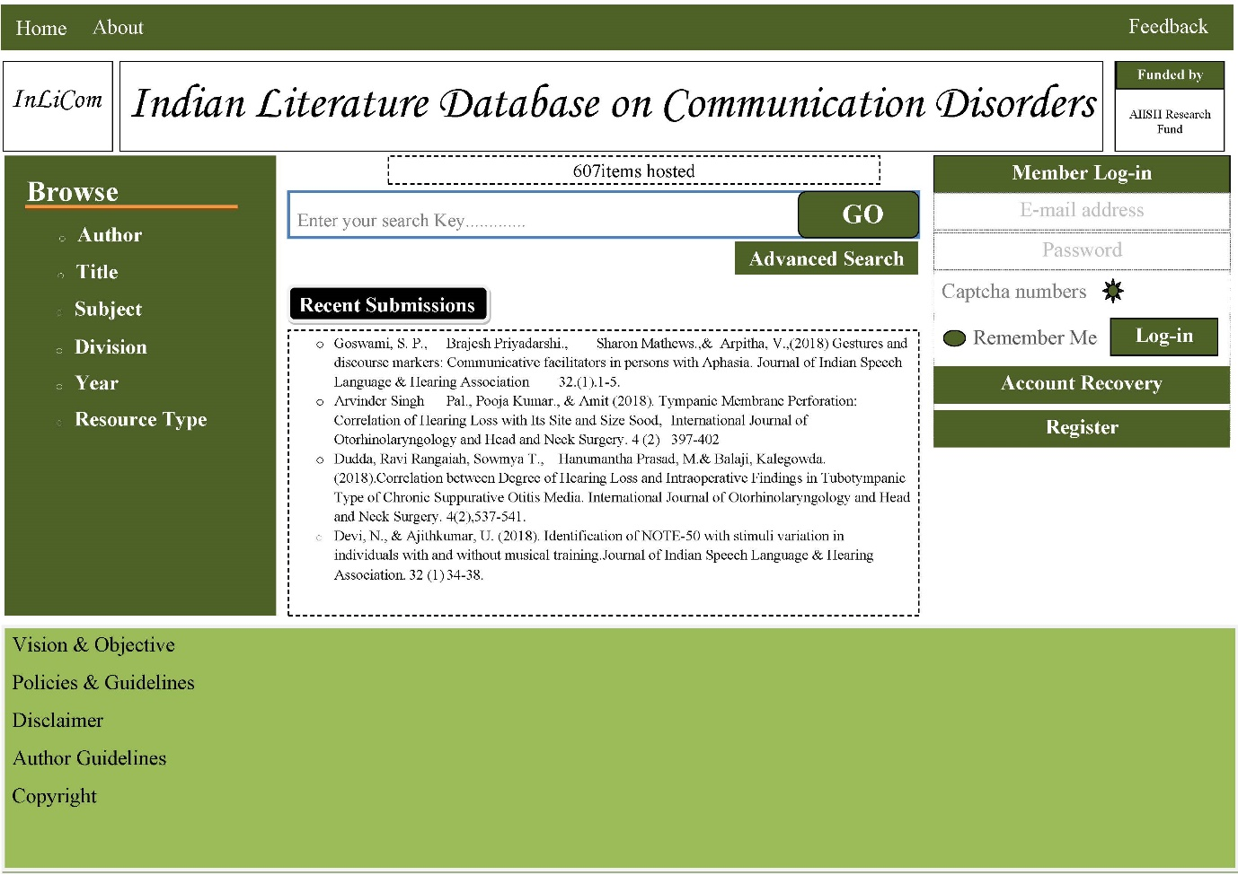

1. Author Search Interface

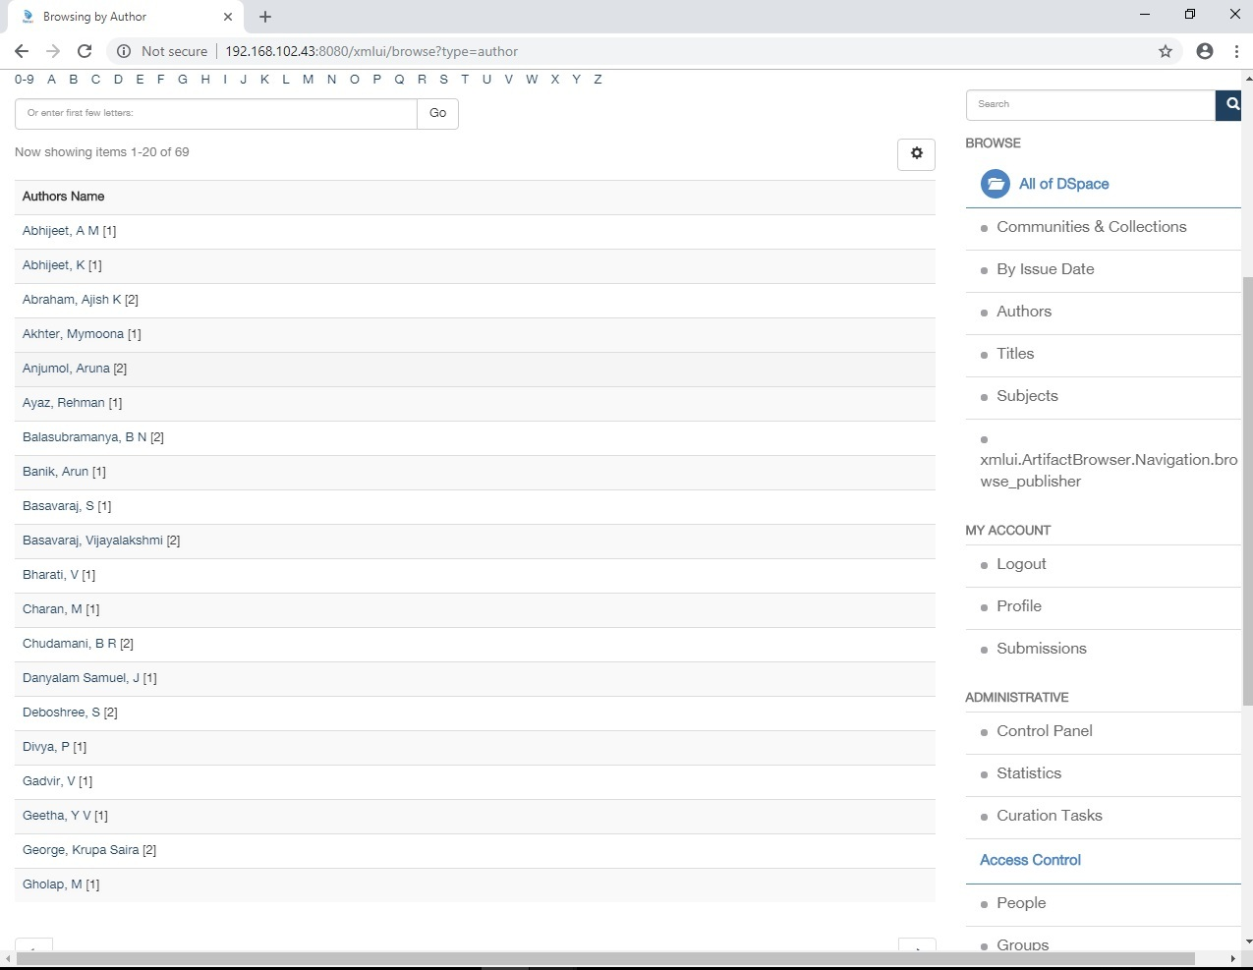

1. Book Chapter Search Interface

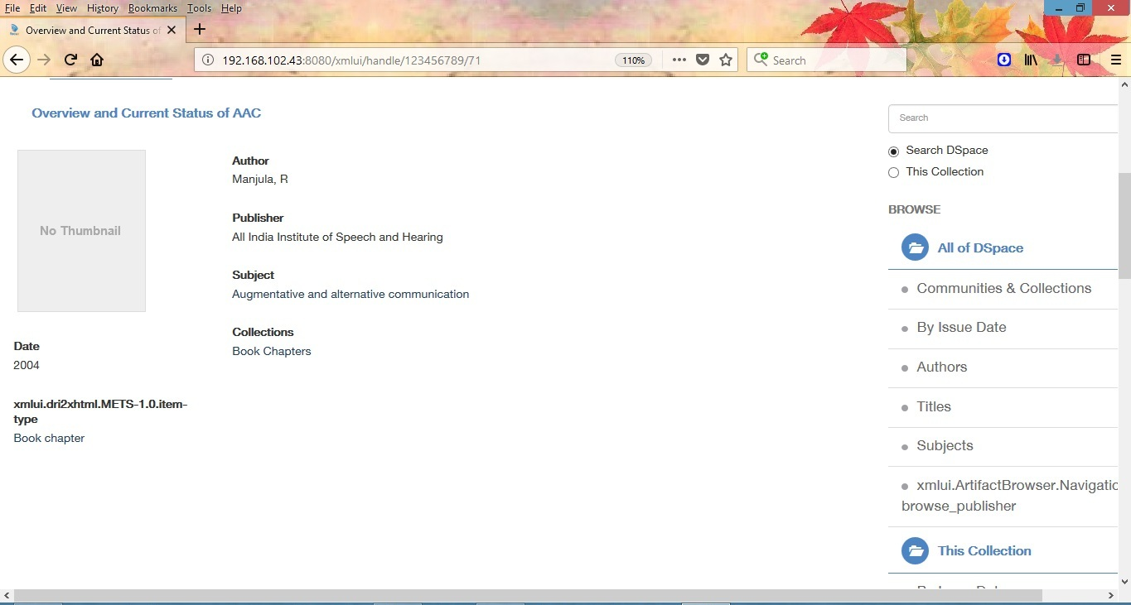

1. Book Search Interface

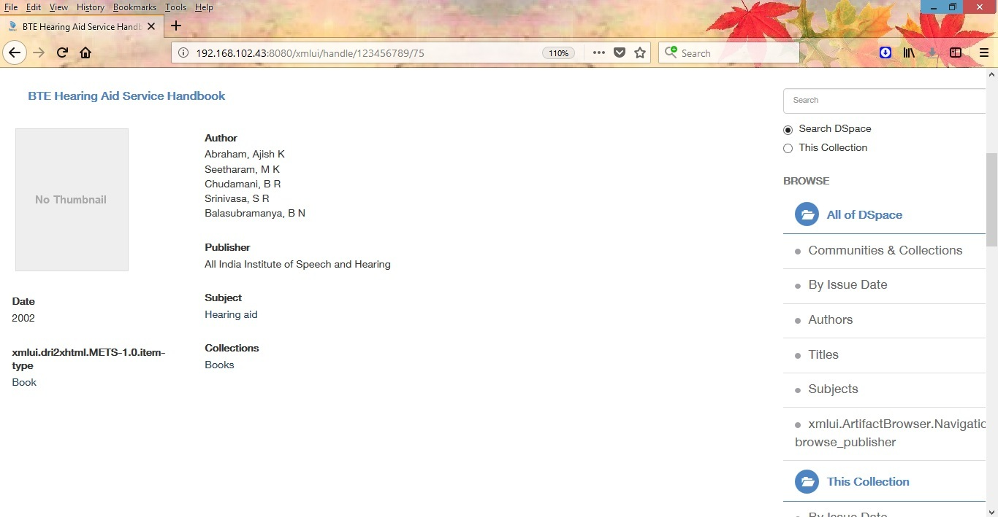

1. Journal Article Search Interface

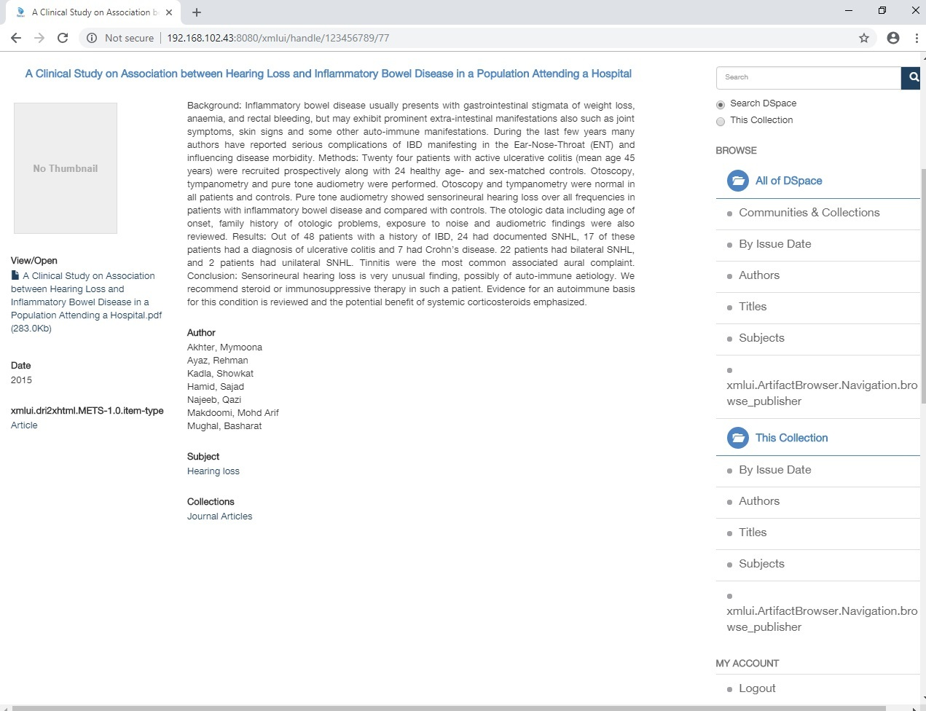

1. Conference Paper Search Interface

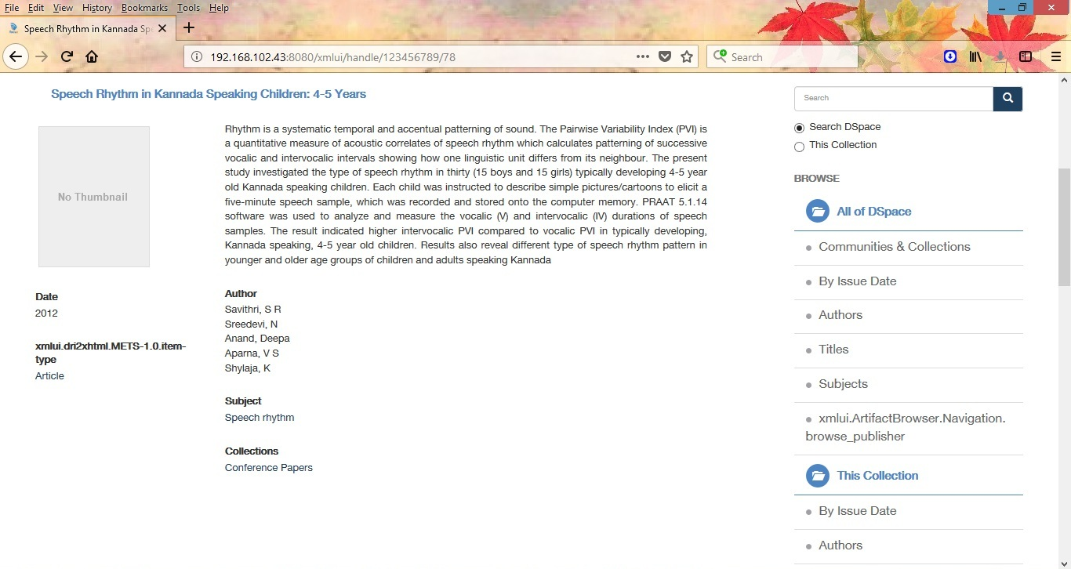

Concluding Remarks

The present project developed a literature database on communication disorders published in India. The system will facilitate centralized access to the Indian scientific literature on communication disorders and increase the visibility of Indian publications which in turn will lead to increase in the citation of our publications. The database is developed on DSpace, an open source digital library software used world over for building digital library applications. Currently, the database includes the journal articles published in Indian journals, books and book chapters and the conference papers. In future, the database will be expanded to include theses and dissertations carried out in different speech and hearing organizations across the country and the Indian studies reported in foreign journals, books and conference proceedings. Also, the Editors of the India journals in the field will be contacted to provide the bibliographic details of the articles published on a real time basis.

References

Gabriel, B. J. & Kenneth, G. (2014). Institutional repository software comparison. France: UNESCO. Retrieved from http:// unesdoc.unesco.org/ images/ 0022/002271 /227115E.pdf

Mitchell, J. (Ed.). (2011). Dewey Decimal Classification (23rd ed.) . Dublin, OH: OCLC.

Price, D. J. S., & Price, D. J. S. (1986). Little science, big science and beyond. New York: Columbia University Press.

Registry of Open Access Repositories (2016). Retrieved from <http://roar.eprints.org/>

Varian, H. (2003). How much information?. Retrieved from http:// [www.ischool.berkeley.edu](http://www.ischool.berkeley.edu) /research/projects/howmuchinfo2003