Design Development of Prototype for Institute Journals

A Project funded by the AIISH Research fund

Project Report

Principal investigator
Dr. Shijith Kumar, C
Library and Information Officer
Library and Information Centre
All India Institute of Speech and Hearing, Mysore

Co-investigators
Dr. Yeshoda, K
Mr. Nanjunda Swamy, M

All India Institute of Speech and Hearing
Naimisham campus, Manasagangothri
Mysore – 570 006

Table of Contents

Sl.no | Chapters | Page no.
 | Introduction | 1
 | Analysis of the existing system | 5
 | Proposed System | 13
 | Software Evaluation and Selection | 28
 | Design and Development of the Proposed Systems | 31
 | Concluding Remarks | 47
Appendix-I
Bibliography

Acknowledgements

We sincerely acknowledge Dr. S.R. Savithri, Director, All India Institute of Speech and Hearing, Mysore for sanctioning the project and for her encouragement and support throughout the completion of the project. We thank Mr. Raghavendra, Software Engineer, Department of Electronics, AIISH, Mysore for writing computer programmes and doing all the customization and configurations required for the development of the software application. We also thank Mr. Shiva Sumanth Reddy, Assistant Professor, Vidya Vikas Institute of Engineering & Technology, Mysore for providing technical consultancy for the project. We also acknowledge Prof. Ajish K, Abraham, Head, and Mr. Purushotham, S.S Technical Officer, Department of Electronics for their technical and networking support towards the completion of the project. Thanks are also due to all our colleagues in the Library and Information Centre, AIISH, Mysore.

Dr. Shijith Kumar, C
Dr. Yeshoda, K
Mr. M. Nanjunda Swamy

LIST OF TABLES
Sl. | Title of the Table | Page no.
 | Publication Frequency of JAIISH | 5 – 6
 | Journal Sections | 7
 | Authorship pattern of JAIISH | 7 – 8
 | Student Research at AIISH: Publication Frequency and Subject Coverage | 10
 | Check List for Evaluation of the Software | 29 - 30

Introduction
Scholarship is about the generation and sharing of knowledge and one of the most important means of scholarly communication is the academic journal. The World Wide Web has been providing the publishers with alternative publishing models with useful new features and facilities that are not available with the print publications (Clarke, 2010).¹ Corresponding to these developments, more and more academic journals are being produced in electronic format. Also, many reputed journals traditionally published in print format are migrating to electronic platforms. Studies have reported (Atkins& Wright 2003; Bergstrom 2001; Björk & Lauri 2009)²⁻⁴that the publication costs of e-journals are much less that of print journals. The emergence of free and open source software have further reduced the cost of electronic publishing. The benefits of electronic publishing using open source software are significant, including superior knowledge dissemination and the ability to reach a far wider audience (Willinsky, 2007)⁵.
Background
The All India Institute of Speech and Hearing, Mysore, the premier institute in the country pertaining to communication disorders that offers academic programmes, conducts research, provides clinical care and carries out public education pertaining to communication disorders. The institute is also actively involved in the communication of scientific knowledge pertaining to the communication disorders and has been publishing two scholarly publications, namely, the Journal of All India Institute of Speech and Hearing (JAIISH), a peer reviewed national journal on communication disorders published yearly since 1970and the Student Research at AIISH, an annual publication started in the year 2008 based on the postgraduate research carried out at the Institute. Even though electronic dissemination of scientific findings and knowledge is particularly important in highly specialized fields like speech and hearing, both the journals are being published only in print format.
Statement of the Problem
Development of Prototypes for Electronic Publishing of Institute Journals

Definition of the terms
Prototypes: A prototype is a primary operational model of a product usually made for demonstration or as part of the improvement mechanism.
Electronic Publishing: Publication in computer readable format
Institute Journals: Periodical research publications by the All India Institute of Speech and Hearing, Mysore, namely, the Journal of All India Institute of Speech and Hearing and the Student Research at AIISH.
Aim and Objectives
The aim of the project is to facilitate setting up of a cost-effective, self-sustainable and state of the art journal publishing system for the institute. The specific objectives are:
- To investigate the existing Institute journal publication system
- To evaluate the available open source e-publishing software packages and select a suitable one.
- To design and develop web based platform for the journals.
- To facilitate entire process of the journal publications online
- To build up a searchable online archive of back volumes of the journals
- To offer suggestions for improving the quality of the journals and their up gradation
Project Need and Justification
- The JAIISH being a peer-reviewed journal discussing various aspects of communication disorders, must reach all the professionals who are involved in the management of the disorders in the country and abroad thereby facilitating wider application of research findings reported in the journal.
- In the present scenario of e-publishing, the researchers and practitioners expect all the scientific and research information online and a journal that cannot be traced on the web is ultimately ‘invisible’ to the researchers. Though the articles published in the JAIISH are subsequently made available on the institute website in PDF, it cannot be considered as an electronic counterpart of the print journal. By making it electronic, the JAIISH will get enhanced visibility at national and international level.
- Meaningful and qualitative research works are being carried out at the postgraduate level at the institute and the full-text of the research reports are being uploaded to the library web portal to enable global access. However, making available the Student Research at AIISH as an online journal will enable more visibility and its acceptance will be more among the intended audience as it will facilitate easy reference and downloading. Moreover, the postgraduate students at the Institute will get acquainted with the online scientific publication procedures and practices.
- A lot of time, effort and money are required for the publication of the journals in print format which can be saved by converting them into electronic format.
Scope of the Project
The study is limited to the design and development of web based platforms for the two journal publications namely, the Journal of All India Institute of Speech and Hearing (JAIISH) and the Student Research at AIISH.
Methodology
- The existing procedures and practices in the publication and distribution of the journals were analyzed by conducting informal interview with the present and past Journal Coordinators/ Assistant Editors /Compilers and by examining the published issues of the journals.
- A set of new procedures and practices including workflow were formulated for both the journals
- A literature review and a deeper scan of the web were performed and shortlisted the electronic publishing software that are: (i) open source and freely available and (ii) appropriate for academic journal publishing.
- The benefits and potential limitations of each of the shortlisted open source software were evaluated further based on a list of criteria and the most suitable one was selected for the development of web-based platform for the institute journals.
- The selected software was installed and necessary customizations were made to adapt to the newly formulated procedures and practices.
- All the archival issues of both the journals were digitized and uploaded to the databases designed.
- Web based platforms were developed for the journals by incorporating various functionalities and usability test was conducted.
Project Outcome
The main outcome of the project is the design and development of electronic formats for the Institute journals with advanced features and functionalities. The associated outcomes include:
- Scholarly recognition of the Institute at the international level
- Considerable reduction in the time, effort and cost involved in the publication of the journals
- Considerable reduction in the delay of publication
- Global visibility and greater access to the journal articles
- Increase in the citation of the journal articles
- Wider reach of Indian research on communication disorders

Analysis of the Existing System
An analysis of the existing Institute journal publication system was performed to document the publication procedures and practices, identify the lacunae and define the new requirements. The analysis was carried out based on the information gathered using informal interviews with the key personnel involved in the publication of both the journals and by inspecting the previous journal issues.
Journal of All India Institute of Speech and Hearing
The Journal of All India Institute of Speech and Hearing (JAIISH ) is a reputed peer-reviewed national journal which covers original and review articles on assessment, diagnosis, and management of speech, language and hearing disorders. It started publishing in the year 1970, stopped in 1994 and resumed publication in 2007. Totally, 32 volumes of the journal have been published till 2014.
Frequency of Publication: Except the V.29, 2010 published in two issues, all other journal volumes were published in single issues, annually. Some of the volumes of two successive years were combined and published. Also, many of the issues were published much later than the scheduled year of publication. Postgraduate dissertations were the major contents of eight volumes, published before the discontinuation of the journal in the year 1994. The details of the frequency of the journal publication since its inception are given in table 1.
Table 1: Publication Frequency of JAIISH
Volume No.& Year | Actual Year of publication | Journal Contents |  |  | Remarks
 |  | Research Articles | Dissertation Abstracts | Case Reports
V.1, 1970 | 1970 | 17 | - | 8
V.2, 1971 | 1971 | 20 | - | 2
V.3, 1972 | 1972 | 17 | - | 3
V.4, 1973 | 1973 | 22 | - | 1
V.5, 1974 | 1975 | 15 | - | - | V.5 & V. 6 published as combined volume
V.6, 1975
V.7, 1976 | 1976 | 20 | - | -
V.8, 1977 | 1977 | 17 | - | 1
V.9, 1978 | 1988 | - | 34 | -
V.10, 1979 | 1984 | - | 25 | -
V.11, 1980 | 1988 | - | 41 | -
V.12, 1981 | 1981 | 19 | - | -
V.13, 1982 | 1982 | 14 | 13 | -
V.14, 1983 | 1983 | 6 | 11 | -
V.15, 1984 | 1984 | 16 | - | 1
V.16, 1985 | 1986 | 8 | 4 | - | V.16 & V.17 published as combined volume
V.17, 1986
V.18, 1987 | 1987 | - | 35 | -
V.19, 1988 | 1988 | 9 | 2 | -
V.20, 1989 | 1990? | 11 | 6
V.21, 1990 | 1991? | 7 | 1 | -
V.22, 1991 | 1992? | 6 | 46 | -
V.23, 1992
V.24, 1993 | 1994 | 8 | 66 | - | V.24 & V.25 published as combined volume
V.25, 1994
The journal discontinued in the year 1995 and resumed publication in 2007
V.26, 2007 | 2007 | 17 | - | -
V.27, 2008 | 2008 | 19 | - | 1
V.28, 2009 | 2009 | 25 | - | 1
V.29, 2010 | 2010  2011 | 14  19 |  | 1  - | Published in two issues
V.30, 2011 | 2012 | 28 | - | -
V.31, 2012 | 2013 | 28 | - | -
V.32, 2013 | 2014 | 30 | - | -

Journal Sections: The content organization in different volumes of the journal since its inception was examined and the details are given in table2. The Editorial Section was included in V.1 to 17, V.19 to 21, V. 26 to 29 and V. 31 to 32. Except V.9 to 11 and V. 18, all the issues were published with research articles. Masters Dissertation Abstract Section was started with V.9 of the journal and it was continued in V. 10 to 11, V. 13 to V.14 and V.16 to V.25. Case Reports were included in V. 1 to V.4, V.8, V.15 and V.27 to V.29. In V. 28, a Book Review Section was incorporated but it was discontinued in later volumes.
Table 2: Journal Sections
S.No. | Section Name | Volume Nos. | Remarks
1 | Editorial | V.1 to 17; 19-21; 26-29; 31-32
2 | Research Articles | V.1 to V.8; 12-17;19- 32 | From V.26 the research article section has been divided into Speech, Language & Hearing Sections
3 | Case Reports | V.1 to 4;8;15;21;27;29-32
4 | Book Reviews | V.28
5 | Dissertation Abstracts | V.9-14;16-20;22-25

Authorship Pattern of the Research Articles Published: Totally 412 articles were published in the journal from V.1 to V.32. These include 148 single authored, 127 two-authored, 95 three-authored and 42 multi-authored articles. Totally 844 authors contributed to the journal and 532 of them were from AIISH, 261 from other Indian organizations and 51 from foreign organizations. The details of the authorship pattern are given in table 3.
Table 3: Authorship pattern of JAIISH
Volume & Year of Publication | Total Research Articles | Number of authors |  |  |  | Author affiliation
 |  | 1 | 2 | 3 | 3< | AIISH | Other Indian | Foreign
V.1, 1970 | 17 | 14 | 3 | - | - | 17 | 2 | 1
V.2, 1971 | 20 | 18 | 2 | - | - | 18 | 1 | 3
V.3, 1972 | 17 | 11 | 5 | 1 | - | 12 | 10 | -
V.4, 1973 | 22 | 14 | 5 | 1 | 2 | 20 | 12 | 5
V.5, 1974 | 15 | 10 | 4 | 1 | - | 10 | 2 | 9
V.6, 1975
V.7, 1976 | 20 | 8 | 4 | 6 | 2 | 10 | 30 | 1
V.8, 1977 | 17 | 9 | 4 | 3 | 1 | 10 | 16 | 4
V.9, 1978 | -
V.10, 1979 | -
V.11, 1980 | -
V.12, 1981 | 19 | 14 | 2 | 3 | - | 19 | 7 | 1
V.13, 1982 | 14 | 6 | 4 | 4 | - | 21 | 3 | 2
V.14, 1983 | 6 | 2 | 3 | 1 | - | 3 | 3 | 3
V.15, 1984 | 16 | 8 | 4 | 4 |  | 27 | - | 1
V.16, 1985 | 8 | 4 | 3 | 1 | - | 7 | 2 | 2
V.17, 1986
V.18, 1987 | -
V.19, 1988 | 9 | 6 | 2 | 1 | - | 7 | 2 | 2
V.20, 1989 | 11 | 7 | 2 | 2 | - | 13 | 2 | 2
V.21, 1990 | 7 | 2 | 4 | 1 | - | 5 | 4 | 2
V.22, 1991 | 6 | 1 | 4 | 1 | - | 6 | 4 | 2
V.23, 1992
V.24, 1993 | 8 | 4 | 3 | 1 | - | 5 | 4 | 2
V.25, 1986
V.26, 2007 | 17 | 4 | 7 | 6 | 1 | 23 | 10 | 1
V.27, 2008 | 19 | - | 13 | 5 | 1 | 29 | 16 | 2
V.28, 2009 | 25 | 2 | 7 | 13 | 3 | 31 | 34 | 1
V.29, 2010 | 33 | - | 10 | 11 | 12 | 68 | 38 | 1
V.30, 2011 | 28 | 1 | 7 | 9 | 11 | 54 | 23 | 3
V.31, 2012 | 28 | 2 | 10 | 11 | 5 | 62 | 10 | 1
V.32, 2013 | 30 | - | 16 | 9 | 5 | 55 | 26 | -
Total | 412 | 148 | 127 | 95 | 42 | 532 | 261 | 51

Work Flow: The various steps involved in the publication process of the journal at present are the following.
- Inviting of papers to the journal by sending letters to the organizations pertaining to the field (Journal Coordinator/ Editor in Chief)
- Receiving of the manuscripts and initial reviewing for the subject content (Journal Coordinator)
- Rejecting of the paper and informing the author in case the manuscript content does not suit with the journal. (Journal Coordinator/ Editor in Chief)
- Plagiarism checking of the paper in case the manuscript content is acceptable for the journal (Journal Coordinator/ Editor in Chief/)
- Requesting the author(s) to revise the manuscript in case the matching contents are more/ Reject the paper (Journal Coordinator/ Editor in Chief) and informing the author
- Sending the paper for peer reviewing(Journal Coordinator/ Editor in Chief)
- Peer reviewing (Editorial Board Members)
- Accepting of the paper with/without revision as per the recommendation of the reviewer(Journal Coordinator/ Editor in Chief)/ Rejection of the paper (Journal Coordinator/ Editor in Chief)
- Copyediting, layout editing and proof reading of the paper accepted (Journal Coordinator)
- Proof reading and finalization of the papers (Editor in Chief)
- Compilation of all the papers (Journal Coordinator)
- Printing (Editor in Chief / Journal Coordinator/ Purchase section/)
Student Research at AIISH
The Student Research at AIISH, the annual serial publication based on the postgraduate research of the institute was started publishing in the year 2005-06 by publishing the abstracts of 467 PG dissertations carried out during the years 1972-2002. It was published in 4 volumes under the title Research at AIISH: Dissertation Abstracts. From the year 2008,the journal has been publishing full-text articles based on postgraduate dissertations under the title the Student Research at AIISH. The first five volumes of the Student Research at AIISH with full-text articles based on the dissertations carried out in 2002-2007 period were published in the year 2008. Since then the Student Research at AIISH has been publishing regularly every year with articles based on PG dissertations carried out in the previous academic year.
Publication Frequency and Subject Coverage: The Student Research at AIISH was started publishing in the year 2008 containing the full-text articles based on the PG research carried out during the period 2002-03. From volume 6, the journal has been publishing in three parts: Part A Audiology, Part B Speech Language pathology and Part C Special Education. The publication frequency and the subject coverage of the articles published in the Student Research at AIISH are given table 4.
Table 4: Student Research at AIISH: Publication Frequency and Subject Coverage
S.N. | Vol. & Year | Actual Pub. Year | No. of Articles in Student Research at AIISH |  |  | Remarks
 |  |  | Part A : Audiology | Part B: Speech Pathology | Part C:  Special  Education
1 | V.1, 2002-03 | 2008 | 10 | 13 | -
2 | V.2, 2003-04 | 2008 | 9 | 15 | -
3 | V.3, 2004-05 | 2008 | 15 | 13 | -
4 | V.4, 2005-06 | 2008 | 15 | 12 | -
5 | V.5, 2006-07 | 2010 | 18 | 19 | -
6 | V.6, 2007-08 | 2010 | 19 | 20 | 6 | Part C initiated
7 | V.7, 2008-09 | 2010 | 20 | 20 | 4
8 | V.8, 2009-10 | 2011 | 32 | 35 | 4
9 | V.9, 2010-11 | 2011 (Part-C)  2012(Part-A &B) | 36 | 32 | 3
10 | V.10, 2011-12 | 2014 (Part-A) | 36 | - | -

Journal Workflow: The workflow of the Student Research at AIISH are given below.
- Submission of the manuscripts prepared out of the PG dissertations (Students Author)
- Plagiarism checking (Compiler)
- Requesting the authors to revise the paper , if required (Compiler / Chief Editor)
- Revising of the paper (Students Author )
- Compilation and formatting of the revised paper (Compiler / Chief Editor)
- Editing and Proof reading (Chief Editor)
- Printing
Journal Readership: The informal interview with the journal coordinator and the compilers of Student Research at AIISH revealed the following with respect to the readership.
- The major subscribers of the journal are the students of the Institute from whom the subscription amount are being collected at the time of admission.
- The institutional as well as individual subscribers to the journals are remarkably less.
Inferences
- Majority of the journal issues both that of JAIISH and Student Research at AIISH were published behind the schedule.
- The major share of the research articles in JAIISH was contributed by the staff of AIISH, the publishing organization of the journal, followed by those who were working in other educational organizations, hospitals and clinics across the country.
- Contribution to the journal from the scientists working abroad is very less.
- There was no consistency with respect to the JAIISH contents. Many issues were lacking even research articles. Though a Book Review Section was initiated in V.28 of the journal, the later issues were missing the section.
- No comprehensive journal policy has been outlined for the JAIISH
- All the major works related to the publication of JAIISH including the clerical works are being carried out by the Journal Coordinator, later designated as Assistant Editor, under the supervision of the Chief Editor. Other editorial board members are assigned with only the peer reviewing of the manuscripts.
- Similarly, all the major works related to the publication of the Student Research at AIISH including the clerical works are being carried out by the compiler under the supervision of the Director.
- The editorial board of the JAIISH is constituted of the subject experts in the publishing organization and those working in similar organizations across the country.
- No editorial board has been constituted for the Student Research at AIISH.
- No publication schedule has been outlined for both the journals and the publication processes are stretching throughout the year
- Though it is a national journal, manuscripts are being accepted only during a limited period of time in a year for JAIISH.
- Each volume of JAIISH after resuming publication in 2007, published 25 articles on an average.
- No publicity has been done for the journal other than inviting papers from authors of sister institutions in the country once in a year.
- No comprehensive journal policy has been outlined
- No consistency is observed with respect to frequency of publication and timeliness in both the journals.
- The major subscribers of the JAIISH are the students of the Institute from whom the subscription amount are being collected at the time of admission. The institutional as well as individual subscribers to the journals are remarkably less.

Proposed System
In this chapter, a modified publication system based on a web based platform has been proposed for the Journal of All India Institute of Speech and Hearing (JAIISH) and the Student Research at AIISH in view of the observations made on the existing journal publication system and procedures in chapter 4 .
- System Proposed for JAIISH
- Journal Title
The existing journal title may be changed by a concise one, but at the same time, reflecting the subject coverage of the journal. Very long titles are inconvenient for all stake holders of a journal including the authors, readers and database vendors. Moreover, modern scientific journal titles very rarely carry publisher’s name, especially when they are being published by individual educational/research institutions. The society publications are exceptional. Also, name of the institution with the title will create an impression of an in-house publication among the indented audience. The proposed title is:
Briefing in Communication Disorders with an acronym BiCoD.
- Journal Sections
The following sections are proposed for the journal which may be consistently followed for all the issues.
- Editorial Section
The Editorials may be written for every issue by the Chief Editor or the Managing Editor. In the first issue of the electronic format, a detailed account on the new format of the journal publication may be given. The Editorials of the subsequent issues may be used to keep the readers informed of the topics covered in the particular issues, journal policy changes, if any etc.
- Research Article Section
The Research Article Section may be continued as in the previous volumes of the journal published with the following sub categories. (a).Speech, (b). Language, (c). Hearing.
- Case Report Section
A Case Report Section for reporting the previously undocumented diagnosis and management procedures of various types of Communication Disorders may be incorporated in the journal.
- Book Review Section
The Book Review Section initiated in V. 28 of the current journal may be revived and reputed publishers in the field of communication disorders and allied areas may be informed of sending copies of the latest books published on a regular basis for reviewing.
- Editorial Board
The existing system of managing the journal publishing may be completely revamped by bringing the system under a newly constituted Editorial Board with the following roles and job responsibilities. Competent and dedicated faculty members and technical staff of the Institute and the experts working in other organizations of similar kind in the country and abroad may be inducted to the Editorial Board.
- Chief Editor
The Director of the publishing institute may be taken over the charge of the Chief Editor of the journal with the following responsibilities.
- Overall management of the Journal
- Selection of suitable persons to different roles for the management of the journal
- Chair the editorial board meeting
- Approval of the journal contents
- Authority to take final decision regarding different aspects of the journal including editorial and publication processes
- Managing Editor
A senior professor in the publishing Institute with sufficient research experience and who served/ has been serving the editorial boards of scientific journals on communication disorders and allied areas may be assigned the role of Managing Editor with the following responsibilities.
- Officer in-charge of the Journal
- Formulation of policies and procedures of the journal with the approval of the Chief Editor.
- Supervision and coordination of the entire publishing process including manuscript acceptance, editorial process, reviewing and final publication of issues.
- Content creation and updating for the different sections of the journal
- Preparation of the editorial content with the approval of the Chief Editor
- Assigning of the manuscripts received to the respective Section Editors.
- Taking of decision regarding the acceptance/rejection of a manuscript submitted to the journal in consultation with the Chief Editor
- Creation of issues, scheduling of publication date and timely publication of the journal issues
- Making all the correspondence relating to the journal
- Section Editors- Research Articles
Faculty members with necessary research experience in the areas of speech, language, hearing may be assigned with the role of Section Editors to deal with the three Research Article Sections of the journal. Initially those working in the publishing Institute may be assigned the job. The Research Articles Section Editors may be given the following responsibilities.
- Assisting the Managing Editor in taking decision regarding acceptance/ rejection of manuscripts pertaining to the Section.
- Plagiarism checking of the manuscripts initially accepted for publication.
- Coordinating and supervising of peer reviewing, copy editing, layout editing and proof reading activities of the manuscripts accepted for publication strictly adhering to the time schedule.
- Making necessary communication with the corresponding authors and the reviewers, copy editors, layout editors and proof readers involved in peer reviewing, copy editing, layout editing and proofreading activities of the manuscripts.
- Section Editor- Case Reports
A senior staff with necessary clinical and research experience in the areas of speech and hearing may be assigned the role of Section Editor for the Case Report Section. Initially, the staff working in the publishing Institute may be considered for the post. The Case Report Section Editor may be given the following responsibilities.
- Assisting the Managing Editor in taking decision regarding acceptance/ rejection of manuscripts pertaining to the Section.
- Plagiarism checking of the manuscripts initially accepted for publication.
- Coordinating and supervising peer reviewing, copy editing, layout editing and proof reading of the Case Reports strictly adhering to the time schedule
- Making necessary communication with the corresponding authors, and those involved in peer reviewing, copy editing, layout editing and proofreading activities of the manuscripts.
- Section Editor- Book Review
One faculty member with necessary research experience in the areas of speech, hearing or allied sciences may be assigned the role of Section Editor to deal with the Book Review Section of the journal. Initially, the one working in the publishing Institute may be considered for the post. The Book Review Section Editor may be given the following responsibilities.
- Coordinating and communicating with the reputed publishers in the area of communication disorders and allied sciences and make available the relevant books for reviewing to the interested book review authors.
- Evaluation and acceptance/ rejection of the review in consultation with the Managing Editor/ Chief Editor
- Coordinating and supervising the paper submission, copy editing, layout editing and proof reading activities of the manuscripts accepted for publication strictly adhering to the time schedule,
- Making necessary communication with the corresponding authors, and those involved in peer reviewing, copy editing, layout editing and proofreading activities of the manuscripts.
- Associate Editors-Peer Reviewing
A minimum of twenty experienced research scientists in the field may be appointed as Associate Editors with the responsibility of peer reviewing the manuscripts for the journal. The associate editors may be drawn from the experts working in reputed organizations across the country and abroad. It is important to have associate editors from other countries in order to make the editorial board international.
- Assistant Editors- Copy Editing
Three skilled technical staff in the area of speech and hearing may be assigned the role of Assistant Editors- Copy Editing with the following responsibilities, initially. As copy editing is one of the major activities that determines the quality of a journal it is strongly suggested hiring of an experienced scientific copyeditor, later.
- Improving the clarity and correcting the grammatical errors in the manuscripts.
- Coordinating/ working with the authors for improving various aspects of manuscripts such as grammar, clarity in writing /meaning, bibliographic formatting and technical styles.
- Checking of the reference linking and identification of dead links, if any.
- Assistant Editors- Layout Editing
Three skilled technical staff in the area of speech and hearing may be assigned the role of Assistant Editors- Layout Editing with the following responsibilities.
- Conversion of the copy edited manuscripts received from the Copy Editor in MS Word format to HTML/PDF galley formats using suitable software.
The graphic designers working with the publishing Institute may be assigned the job of assisting the layout editors in doing the work.
- Assistant Editors - Proof Reading
Three faculty members in the area of speech and hearing may be assigned the role of Assistant Editors- Proof Reading with the following responsibilities.
- Careful reading of the manuscript made in PDF and HTML galleys along with the author and identifying the typographic and formatting errors, if any, and informing the same to the Layout Editor.
- Assistant Editor - Marketing
A skilled technical/administrative staff may be assigned the role of Assistant Editor- Marketing with the following responsibilities.
- Regular analysis of journal usage statistics
- Developing marketing strategies to promote the journal
- Design and development of journal flyers
- Communicating the presence of the journal among the professional community by traditional and electronic means at regular intervals
- Keeping a monthly record of marketing activities carried out and report the same to the Managing Editor
- Journal Manager
The Library and Information Officer of the publishing organization may be assigned the role of Journal Manager with the following responsibilities.
- Overall management of the journal publishing website
- Setting up of the different functionalities for the Journal Website in consultation with the Managing Editor/ Chief Editor
- Identifying the latest e-publishing features and functionalities and incorporating them on the e-journal platform.
- Creating/ enrolling and managing various user roles on the journal website such as Managing Editor, Section Editors, Reviewers, Copy Editors, Proof Readers and Layout Editors.
- Attend to the issues with respect to the access and use of journal website by the editorial board members, authors and readers.
- Site Administrator
A software engineer from the Department of Electronics and a library professional of the publishing organization may be jointly assigned the role of Site Administrator with the following responsibilities.
- Maintenance and up gradation of the journal website
- Fixing of errors or issues on the website in a timely manner
- Monitoring of the system security and taking backup at regular intervals
- Monitoring the performance of hardware components and timely intimation of replacements/ up gradation of components, if any.
- Deciding the system maintenance and shut down schedule and intimation of the same to the website users well in advance.
- Closely monitoring the performance of the website especially the uploading and downloading speed.

- Journal Workflow
The following workflow is proposed for the journal.
Paper matches with subject coverage of the journal?
Noo
Managing Editor
Reject the paper and notify the author with the approval of chief editor

Managing Editor
Login and checking of the paper for subject content

Author
Login and submission of paper
Author
Registering with
journal site
A
Section Editor
Reject the paper & inform the author with the approval of Managing/ Chief editor

Section Editor
Inform the author and get back the revised paper

Yes
Yes
No
No
The paper has to be revised?
Copy editor
Login and do the initial copy editing

Section Editor
Select a copy editor & request for copy editing

The paper has to be rejected?
Yes
No
Yes
Paper is highly plagiarized beyond revision?
Managing Editor
Send the paper to the concerned Section Editor to see through plagiarism checking, reviewing and editorial process

No
Is revision required?
Section Editor
Login and check the paper for plagiarism

Yes
Yes
Section Editor
Reject the paper and intimate the author with the approval of Managing / Chief Editor

Section Editor
Inform the author and get the paper revised

Section Editor
Select an appropriate reviewer and request for review

Section Editor
Login and check review comments

Reviewer
Complete the review and inform the decision to the Section Editor

Reviewer
Login and peer review

Reviewer accepted request?

Section Editor
Approach another reviewer

No

Author
Login and view copy, make remarks and intimate copy editor / section editor

Copy editor / Section editor
Intimate the author about the completion of initial copy editing

Copy editor
Intimate the Section Editor about the completion of initial copy editing

A

Section editor
Acknowledge the layout editor

Layout editor
Login, prepare galleys of PDF & HTML & intimate Section editor

Section editor
Acknowledge copy editor, select & assign a layout editor

Copy editor
Complete the final copy editing and intimate Section Editor

Proof reader
Login and proofread along with author’s comments and intimate completion to Section editor

Section editor
Select & assign a proof reader

Author
Proofread galleys and intimate section editor

Section editor
Request author to proof read

Managing editor
Create issue and notify users

Section editor
Intimate the Managing editor of the completion of the work

Section editor
Acknowledge the proofreader and author

- Setting up of an Editorial Office
An editorial office may be setup for coordinating various activities pertaining to the journal publications and for addressing queries regarding the journals. Also, an editorial/administrative assistant may be posted in the office.
- Formulation of Comprehensive Journal Policy
It is imperative to have a stated policy covering all aspects of journal publishing.
- Making Available of Article Template
An article template may be designed and made available along with the information for authors which will facilitate easy preparation of manuscript by the prospective authors conforming to the Style.
- Implementing Peer Reviewing Form
In order to ensure objective and qualitative reviewing of the manuscripts submitted to the journal for publication a manuscript evaluation form may be designed for reviewers to make constructive comments to the authors and editors.
- Rewarding the Journal Management Team Members
As the processes involved in the publication of the journal are time consuming and intellectual, the personnel involved in it may be rewarded by issuing an official certificate of acknowledgement duly signed by the Chief Editor upon completion of each volume of the journal.
- Implementing Digital Object Identifier
The Digital Object Identifiers (DOI) which uniquely identify the digital objects may be procured from the CrossRef, the international agency providing the DOI and assigned to the individual articles. As the DOI is quite expensive, it may be implemented at a later stage.
- Changing the Format and Frequency of Publication
Publishing the journal in print format may be completely stopped and the journal may published only in electronic format which in turn can save time, money and effort. Also, the publication frequency may be increased from yearly to quarterly with five to six articles per issue considering the fact that at present the yearly published print journal contains on an average 25 articles per volume/issue. Moreover, increasing the frequency in electronic format requires no additional effort from the part of the journal management team. Also, increase in the publication frequency can attract more readers as well as authors to the journal.
- Providing Open Access to Contents
The contents of the journal may be made freely accessible online to attract more readers and increase the citations to the journal articles. This can be compensated by implementing author fee at a later stage.
- Open Access Policy
The Creative Commons Open Access Policy namely Creative Commons Attribution-Non Commercial-No Derives (CC BY-NC-ND) may be adopted for making the articles freely available. The CC BY-NC-ND permits others distribute and copy the article, and to include in a collective work (such as an anthology), provided they credit the author(s), do not alter or modify the article, and use it non- commercially.
- Enhancing the Readership
The readers constitute a crucial component of a scientific publication and the success of the publication can be measured by the volume of readership. Hence, concerted steps may be taken to widen the readership of the journal. A strong and consistent reader base at the international level must be built by giving wide publicity and identifying the target audience of the journal in different parts of the world.
- Getting the Impact Factor
Impact Factor, generated by M/s Thomson Reuters, one of the world’s leading scientific publishing company is the most widely accepted instrument for evaluating the quality of a scientific journal. In order to get the Impact Factor the journal must be included in any one of the citation databases published by M/s Thomson Reuters such as Science Citation Index and the selection the journals to the databases is done by a rigorous evaluation process. Adherence to the stated frequency of publication, international diversity, uniqueness of coverage and quality of contents are some of the major criteria of evaluation. Hence, steps may be taken to accomplish the basic criteria for selecting the journals to M/s Thomson Reuters’s citation databases.
- Making the Journal International
Though there is no standard definition for ‘International Journal’, a journal which is managed by an editorial board consisting of experts from organizations around the world, publishing studies carried out in different countries, having audience beyond the boundary of its country of publication is generally considered as an International Journal. Hence, the following steps may be taken to make the journal international.
- Constitution of an International Editorial Board with eminent experts in the field working in reputed organizations across the world.
- Making concerted effort to invite the eminent scientists in the field to contribute to the journal
- Getting contributions to the journal from the scientists across the world.
- Developing reader base at international level
- Publishing Quality Research Works
The editorial board should ensure quality of the contents of the journal. This may clearly be mentioned in the author guidelines. Publication of quality contents can also attract readers and reputed authors to the journal.
- Publication of Interdisciplinary Research Articles
Interdisciplinary research articles may be encouraged and the same may be incorporated in the journal policy. This will also help in enhancing the readers and authors
- Timeliness of Publication
The editorial board may formulate a fixed time schedule for various activities involved in the journal publication such as initial reviewing, peer reviewing, copy editing, layout editing, proof reading and final publication of an issue.
- Provision for User Feedback
The journal website must have a provision for users to provide feedback on various aspects of the journal.
- Providing Publicity
Wide publicity may be given regarding the journal under the leadership of Assistant Editor- Marketing. As already mentioned, the number of readers is the cornerstone of success of a scientific journal. The readership base may be frequently reviewed and thoroughly analyzed and appropriate steps may be taken to enhance IT. The following publicity measures may be taken:
- Preparation of print brochures on the journal and dissemination of the same among the professional community including professional associations/forums in the field of communication disorders and allied areas across the world.
- Making available the journal flyers on the website for downloading.
- Publicizing over social media networks by posting messages and providing links to articles.
- Advertising in other online and print magazines/periodicals in the field
- Creation of facebook, google⁺ and twitter accounts for the journal and sharing of articles
- Encouraging the editorial board members and other regular readers to publicize the journal issues
- Analysis of Usage Analysis
The usage statistics of the journal may be done periodically analyzed appropriate steps may be taken to enhance the usage.
- Registering Own Domain Name
A domain name may be registered for the journal based exclusively on the abbreviation of the journal title such as www.bicod.in. This is important for giving own identity for the journal independent of the institute. Also, this will facilitate easy access for users by directly typing the journal site address and instant identification of the site through the general and meta search engines.
- Hosting the Website
It is strongly proposed to have own infrastructure and management of the system using the technical personnel of the Institute. The hardware system must be strong with backup facility as we have to ensure the availability of the journal online, 24 x 7 x 365. Regular downtime due to unreliable hardware components will lead to undermining of credibility of the journal. The Linux Server may preferred over Windows as the Linux platform is famous for consistency, reliability and security which are very important for an international journal.
However, hosting the site with a reputed private web hosting agency may also be considered at the initial stage of operation.
- Generating Revenue
The institute can generate income from the proposed system by the following ways.
- Collecting fee from the authors of the accepted manuscripts (Already mentioned).
- Providing space for advertising on the website
- Providing technical assistance for converting print journals published by other organizations and by giving space for hosting them on the Institute publication site.
Getting included in Indexing/ Abstracting Databases
Enhancing the visibility of the journal is important for building a regular readership. Inclusion of the journal in reputed abstracting/indexing databases pertaining to Science, Technology and Medicine (STM) such as PubMed, Web of Science, PsychInfo etc. will enhance its reputation among the scientific community and attract readers and authors from across the world. Quality, originality, importance of the scientific content and consistent following of the publication frequency are some of the major considerations in assessing a journal to be considered for inclusion in these databases.
Getting e-ISSN
e-ISSNs may be obtained for the proposed e-journals from the National Science Library, Ned Delhi which acts as National Centre for ISSN in the country.
- System Proposed for the Student Research at AIISH
            - Up gradation of the journal and changing the Title
The Student Research at AIISH journals may be upgraded from in-house publications bringing out the articles based on the postgraduate research carried out at AIISH to national level scholarly communication platform disseminating postgraduate research findings on communication disorders carried out at institutions across country. However, the current practice of accepting all the dissertation based articles prepared by the P.G. students of the institute may be continued and only selective articles may be accepted from outside organizations. A national level editorial board with peer reviewers from across the institutions in the country may be constituted in this regard.
In this regard, The journal may be stopped publishing under a common title Student Research at AIISH and the Part A- Audiology, Part-B Speech Language Pathology and Part- C Special Education may be published as three independent online only journals with articles based on postgraduate research pertaining to the respective fields. The following names have been proposed for the independent journals.
- Indian Postgraduate Research in Audiology - IPRA
- Indian Postgraduate Research in Speech - IPRS
- Indian Postgraduate Research in Special Education - IPRSE
Also, to cop up with the expected increase in paper submission to the journal, the frequency of the publication may be increased.
            - All other proposals made for JAIISH are also applicable for the Student Research at AIISH with suitable modifications.
A Cost-benefit Analysis of E-publishing of JAIISH
The potential costs and benefits of publishing the Journal of All India Institute of Speech and Hearing (JAIISH) in e-format using open source solutions are discussed below.
The only cost of setting up the journal in e-format is for developing I.T. infrastructure as detailed below.
- A personal computer with sufficient storage space, memory and processor speed which can serve as a server system.
- Internet connectivity with sufficient speed.
- Website domain registration
However, since the above mentioned infrastructure facilities are already available with the publishing organization, namely, the All India Institute of Speech and Hearing, they can be shared for hosting the journal. In other words, it is not necessary that the above mentioned infrastructure including the website domain should be developed exclusively for running e-journal.
The potential benefits of converting the journal into e-format on the other hand are many. The major ones are the financial and time savings. The Institute spent on an average of Rs. 58,000/- per year (as per the purchase orders issued by the Institute for printing of the journal in 2014-15, 2015-16 & 2016-17) in the last three years towards printing of the journal. This can be saved by making the journal in e-format. Another major benefit is time saving in all the stages of journal publication from paper submission through peer reviewing, editing and final production and publication. Presently, the process is getting completed in a year. Other benefits include global visibility for the journal and increased citations to its articles.

Software Evaluation and Selection
This chapter explains the evaluation of the open source publishing software and the selection of the most suitable one which meets the requirement of the publication of the Journal of All India Institute of Speech and Hearing and the Student Research at AIISH.
Identification of Candidate Software
The candidate software packages for the project were identified by conducting an in depth scan of the web and searching the literature that meet the following criteria.
- Suitable for serial publication
- Open source and available free of cost
Four software packages met with the criteria. They are:
- Ambra,¹ a web-based, innovative open-source platform for publishing research articles in all areas of science, developed by the Public Library of Science (PLoS) and licensed under the Apache License, Version 2.0.
- Digital Publishing System (DPubS),² an open-source software system designed to enable the delivery of scholarly journals, monographs and other common and evolving means of academic discourse. DPubS was conceived by Cornell University Library to aid colleges and universities in managing and disseminating the intellectual discoveries and writing of scholars and researchers.
- Drupal³, an open source content management platform which allows easy organization and management of content including journal articles with an endless variety of customization. It' is developed and maintained by Mr. Dries Buytaertand distributed under the terms of the GNU General Public License. ³
- Open Journal System (OJS)⁴, a journal management and publishing system that has been developed by the Public Knowledge Project (PKP) through its federally funded efforts to expand and improve access to research.

Evaluation and Selection
Each of the four candidate software packages were locally installed and further evaluated based on a detailed set of evaluation criteria derived from literature and the Open Source Standard Evaluation criteria proposed by the ISO 9126 software quality criteria⁵. These are given in table 6.
Table 5: Check List for Evaluation of the Software
S.N | General Criteria | Software
 |  | Ambra |  | DPubS | Drupal | OJS
1 | Wiki based support | N |  | Y | Y | N
2 | Blog based support | Y |  | N | N | Y
3 | Availability of mailing list | N |  | Y | N | N
4 | Commercial support | Y |  | N | Y | Y
5 | Online tutorial | Y |  | N | Y | Y
6 | Technical documentation | N |  | Y | Y | Y
7 | Development of User Manual | Y |  | Y | Y | Y
8 | Active User Community | N |  | N | Y | Y
9 | Error report submission availability | N |  | N | N | N
10 | Help desk support | N |  | N | Y | N
11 | Facility for reporting bug | N |  | N | Y | Y
12 | Fixing of bugs | N |  | N | Y | Y
13 | Ability to run on windows platform | N |  | N | Y | Y
14 | Readability of the source code | N |  | Y | N | Y
15 | International diversity | Y |  | N | N | Y
16 | Easy to install | Y |  | N | Y | Y
E-publishing Capability Evaluation Criteria
17 | Support for multiple publication | Y | Y |  | Y | Y
18 | Configurability of metadata fields | N | N |  | N | Y
19 | Configurability of administrative setup | N | Y |  | Y | Y
20 | Configurability of editorial workflow | N | N |  | N | Y
21 | Facility for designing style sheets | Y | N |  | Y | N
22 | Full text search and retrieval facility | N | N |  | N | Y
23 | Mechanism for user authentication | N | Y |  | N | Y
24 | Support for publishing in multiple format | Y | Y |  | Y | Y
25 | Capturing and creation of metadata for all contents | N | N |  | Y | N
26 | Ability to define optional and mandatory metadata | Y | Y |  | N | N
27 | Facility to control access through user name and password | N | N |  | N | Y
28 | Facility to control access through IP | N | N |  | N | Y
Y= Yes; N= No
Totally, 9 points each were obtained for Ambra and DPubS, 15 for Drupal and 20 for Open Journal System. Based on this, OJS was selected for developing the publication system of the Institute journals. The OJS has a strong developer community and the source code is getting reviewed and updated on a regular basis for both linux and windows platform. The system is very flexible in that at any time it can be shifted from Windows to Linux or vice versa. Thousands of scientific publishers world over have been using the Open Journal System for publishing their journals. A list of Speech and Hearing journals based on Open Journal System is provided in Appendix-I.

Development of the Proposed System
In this chapter the design and development of the proposed system using the selected software application have been discussed. The required tables were created using MySQL Database and an Apache web server was configured. Codes/ scripts were written using PHP scripting language for necessary customization of the software to suit the requirements of the proposed system features and functionalities mentioned in the previous chapter.
Development of Prototype Hosting System
A common hosting system has been developed for all the four proposed journals namely,
- Briefing in Communication Disorders
- Indian Postgraduate Research in Audiology
- Indian Postgraduate Research in Speech
- Indian Postgraduate Research in Special Education
The common hosting system will facilitate easy and effective management of the journals at one place by the Journal Manager and Site Administrators. A screen shot of the hosting system developed is given in figure 1.
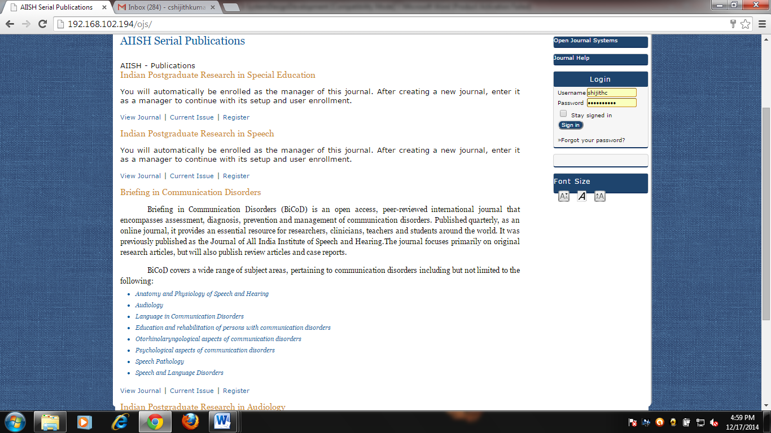
Fig. 1: Journal Hosting System
Prototype for the Journal of All India Institute of Speech and Hearing
As proposed a website has been designed for JAIISH in the name Briefing in Communication Disorders, the home page of which is given in figure 2.
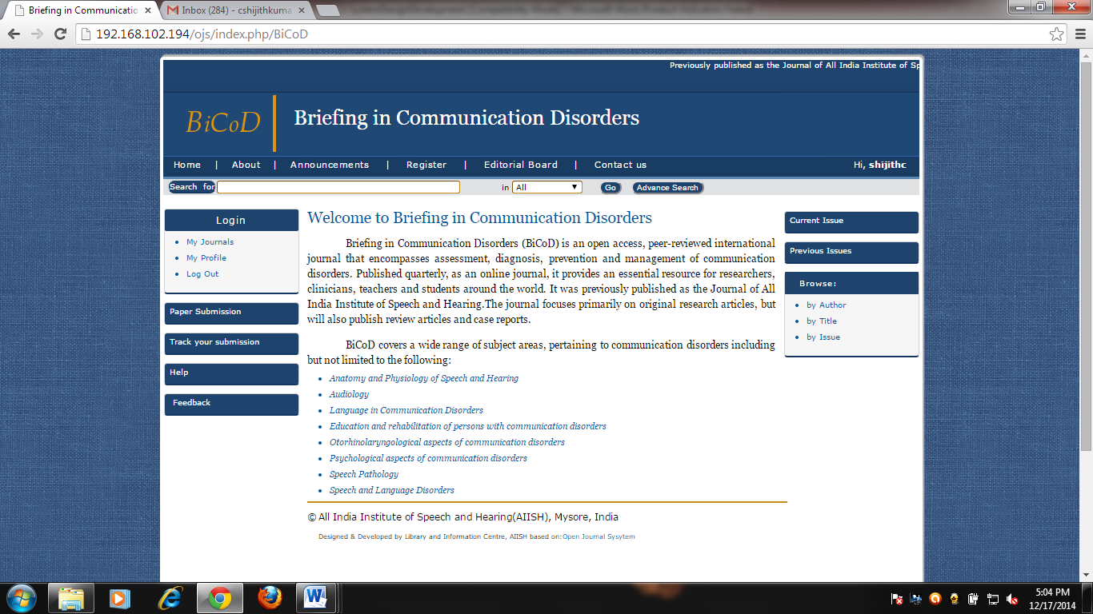
Fig.2: Home page of Briefing in Communication Disorders
Design and Development of Journal Sections: The following five sections have been developed for the journal. Of these, Hearing, Language and Speech are the research article sections. The journal sections are given in figure 3.
- Hearing
- Language
- Speech
- Case Reports
- Book Review
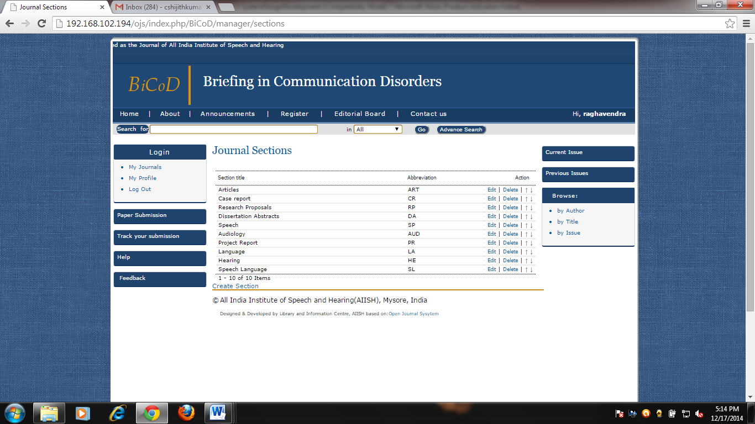
Fig.3: Journal Sections
Functional/ Working Roles: The following roles have been set up for carrying out various activities from submission of manuscript by an author to publication of an issue, and the journal website management and maintenance. Of these, the Section Editor, Copy Editor, Layout Editor, Proof Reader, Reviewer, Author and Reader roles have been configured to accommodate more number of users.
- Site Administrator ( Figure 4)
- Journal Manager (Figure 5)
- Managing Editor (Figure 6)
- Section Editors (Figure 7)
- Reviewer (Figure 8)
- Copy Editor (Figure 9)
- Layout Editor (Figure 10)
- Proof Reader (Figure 11)
- Author (Figure 12)
- Reader (Figure 13)
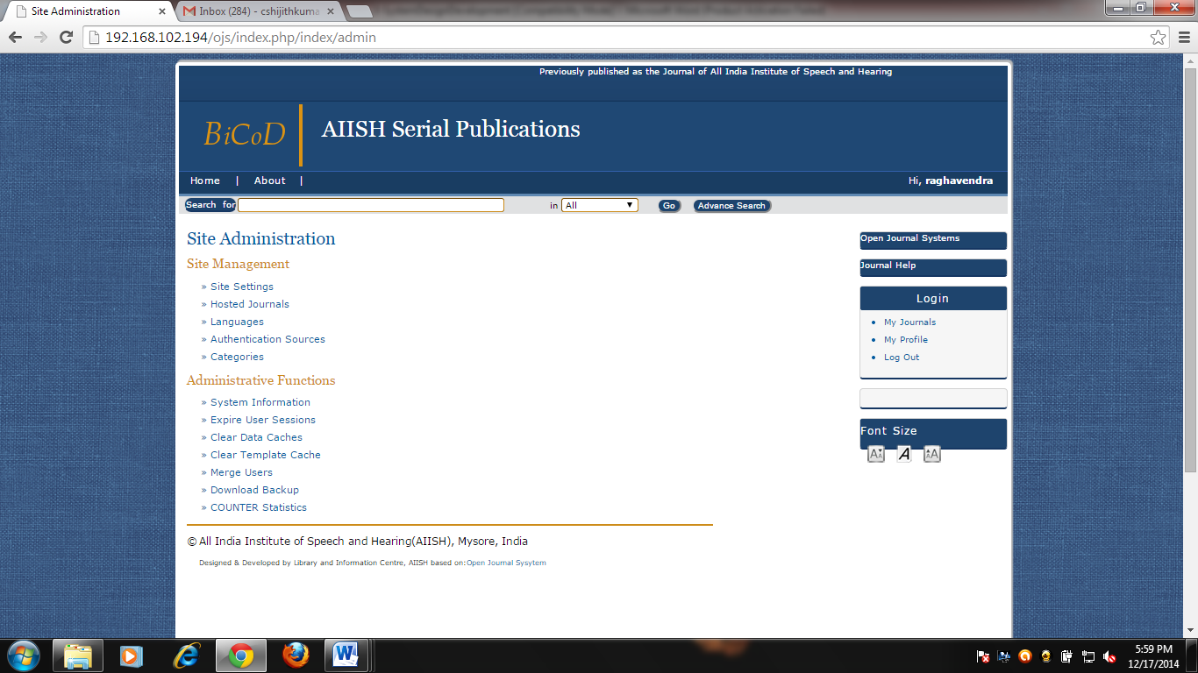
Fig.4: Site Administrator’s Interface
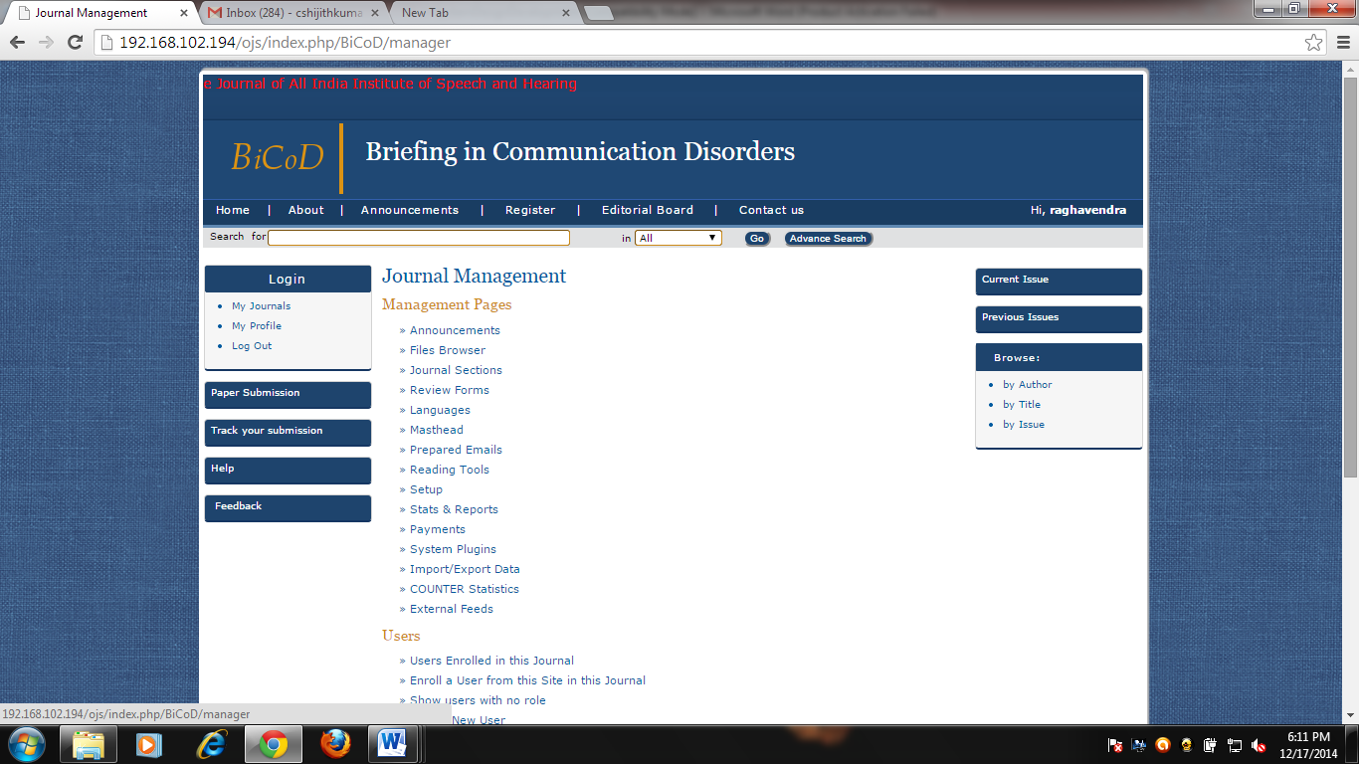
Fig. 5: Journal Manager’s Interface

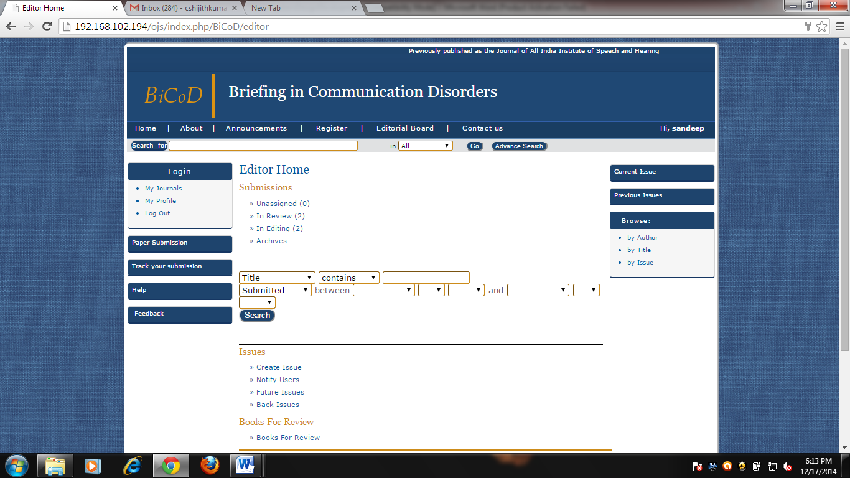
Fig. 6: Managing Editor’s Interface

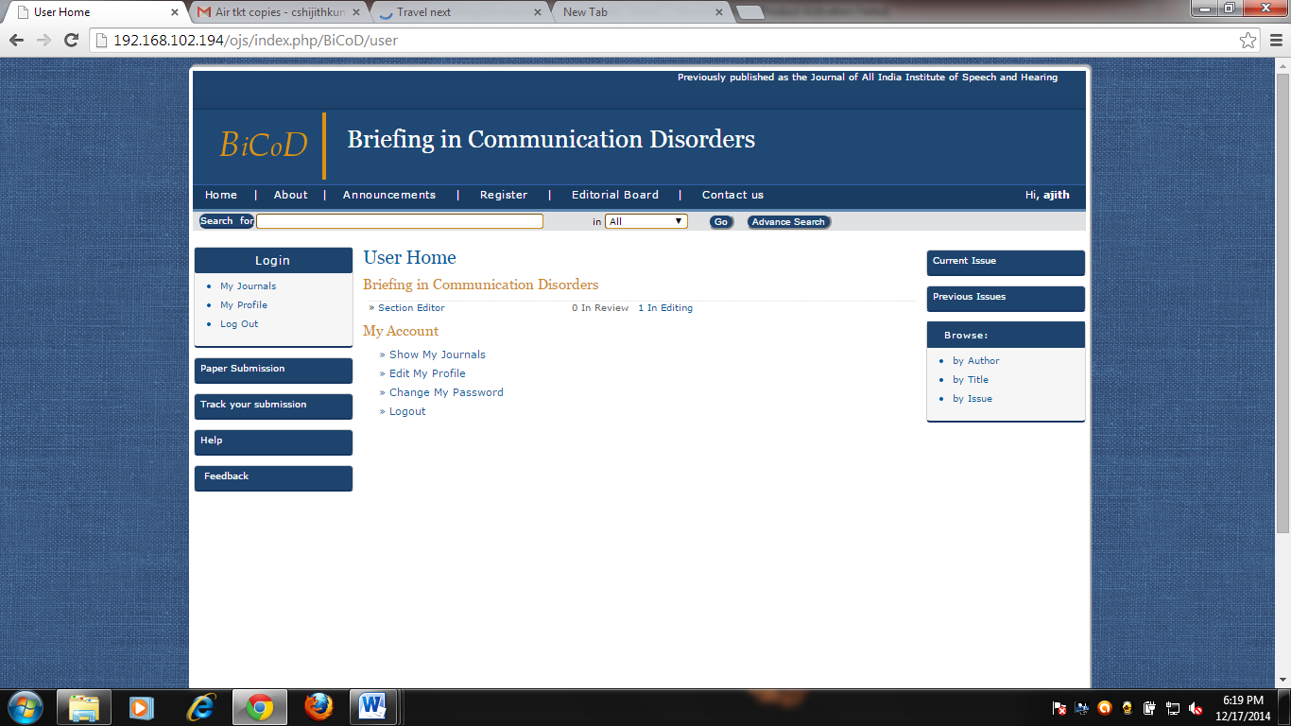
Fig. 7: Section Editor’s Interface

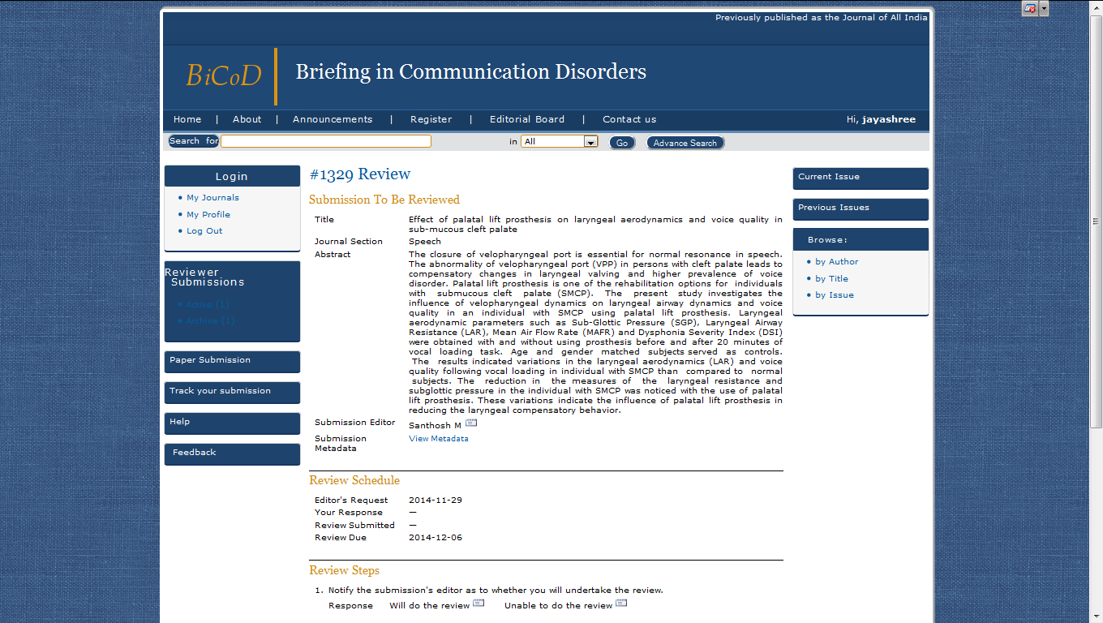
Fig.8: Reviewer Interface
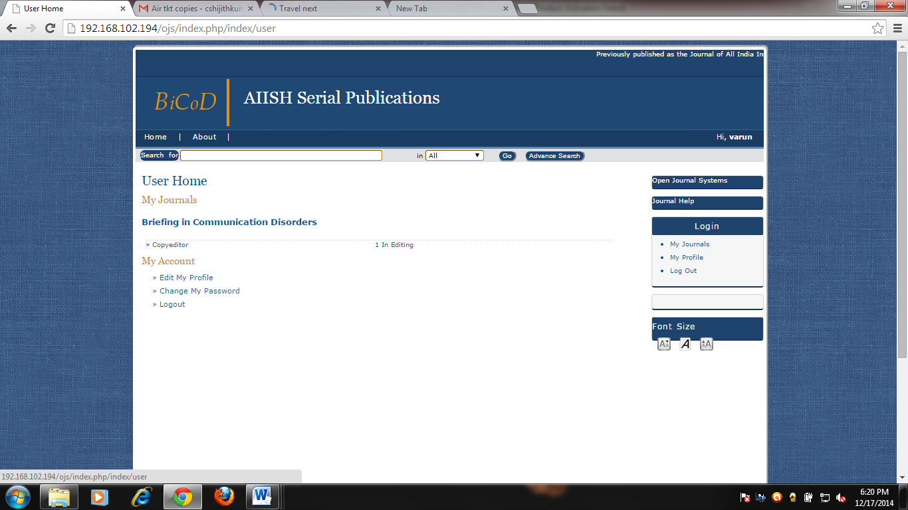
Fig. 9 : Copy Editor’s Interface
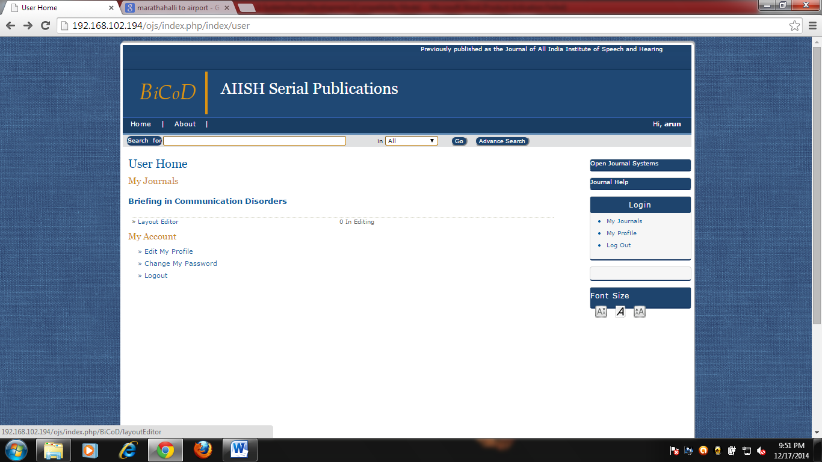
Fig. 10: Layout Editor’ Interface

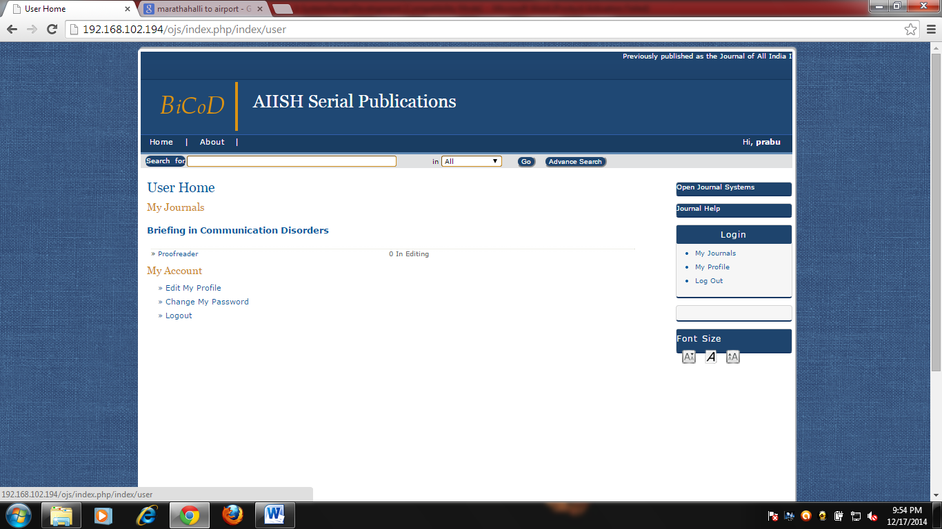
Fig. 11: Proof Reader’s Interface

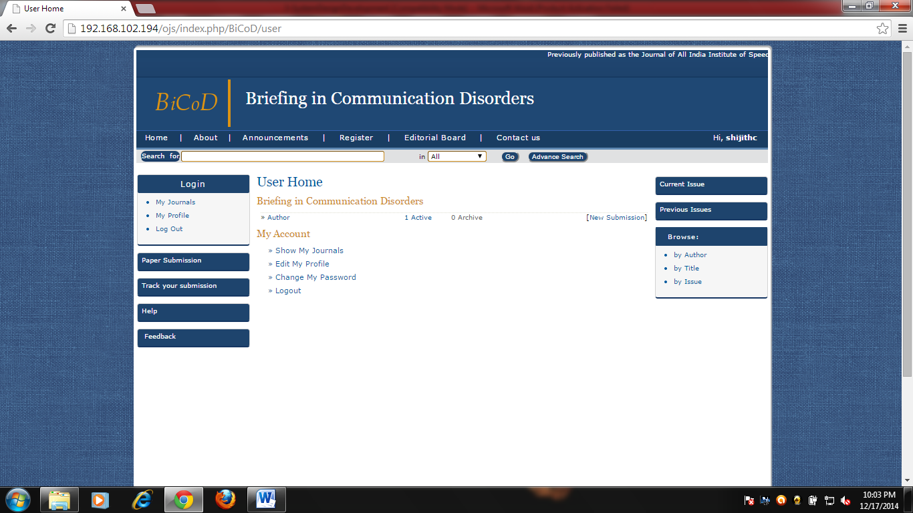
Fig.12: Author’s Interface

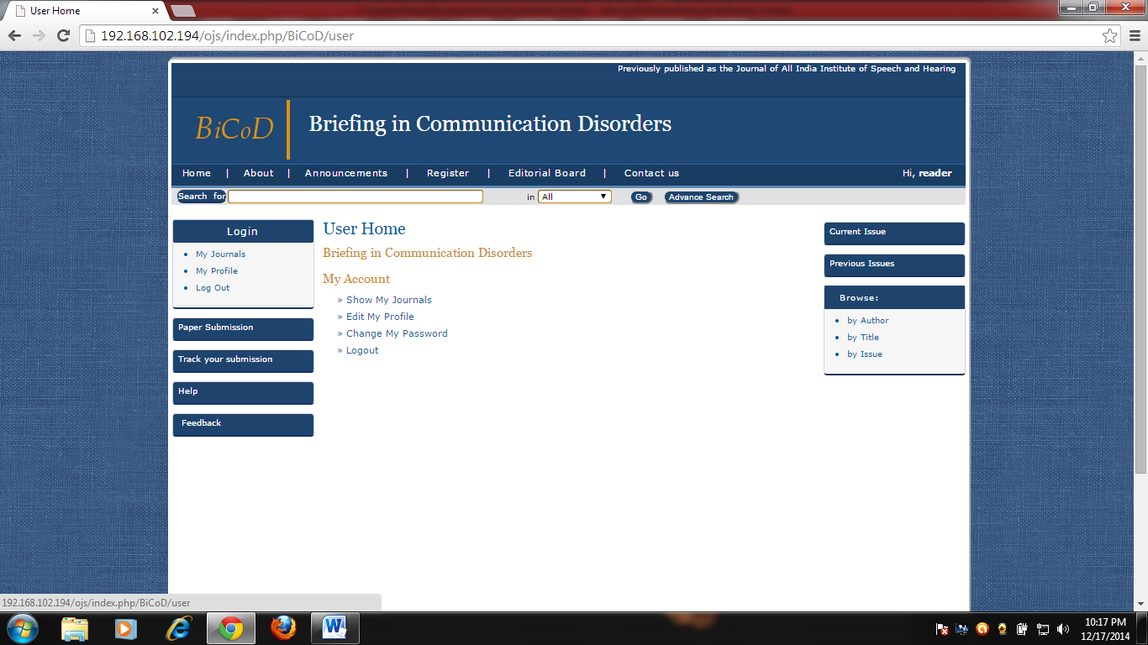
Fig.13:Reader’s Interface

User Registration: It has been made mandatory for the users to register with a valid e-mail id on the website to submit manuscripts to the journal as well as to read the articles published. A registration form has been designed and developed in this regard as shown in figure 14.Provisions have been made in the form to register as author or reader or both.
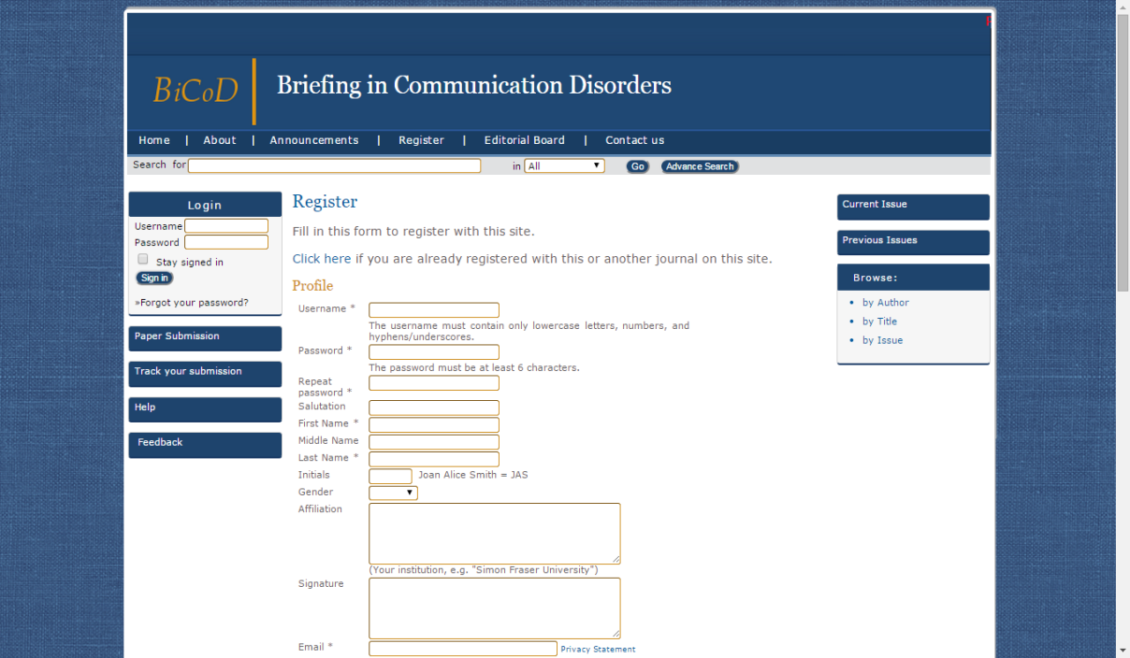
Fig.14: Online User Registration Interface
Manuscript submission: The online manuscript submission process to the journal has been designed and developed as a five step process as shown in figure 15.
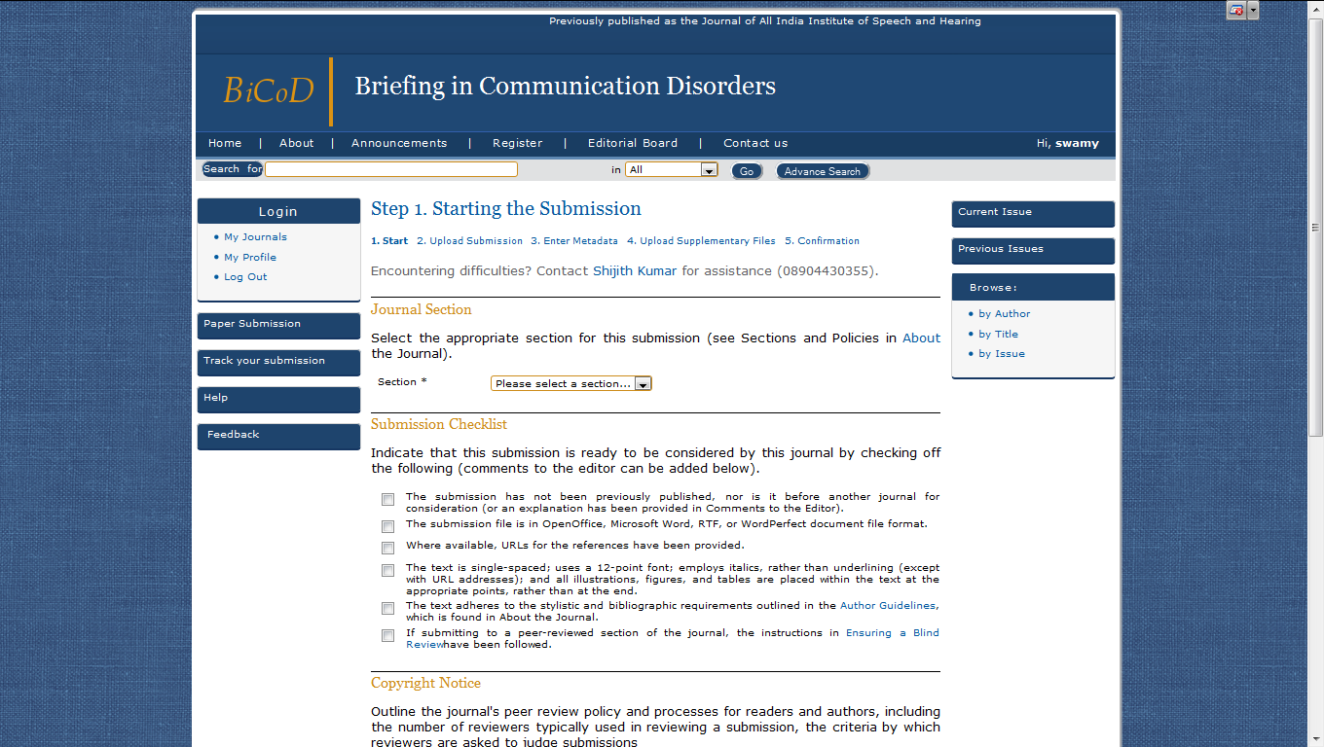
Figure 15: Manuscript Submission Interface
Editorial, Peer Review and Publication Processes: Settings have been made for taking the manuscript accepted for publication to initial editorial review, peer review, copy editing, layout editing , proof reading and the final publication of the issue as shown in figures 16-21.
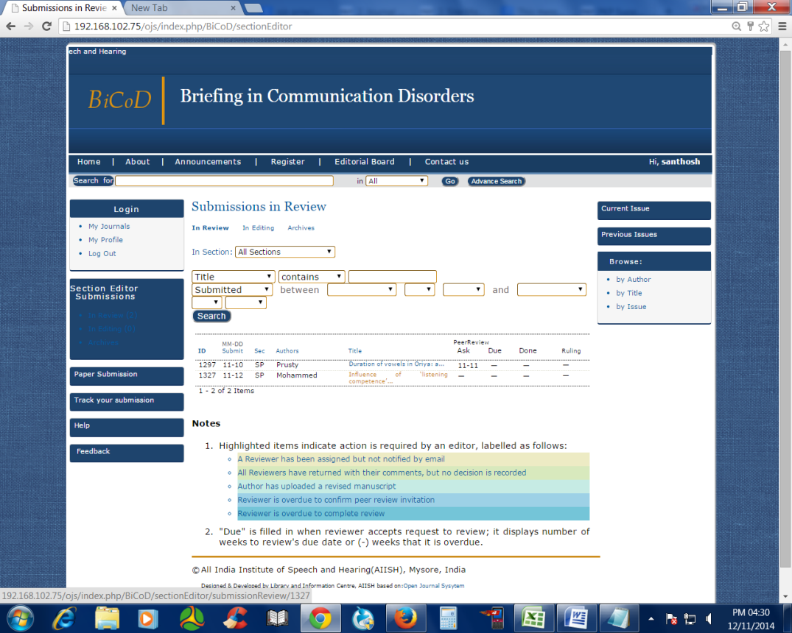
Fig. 16: Initial reviewing by the Section Editor
Fig. 17: Peer Reviewing of the manuscript

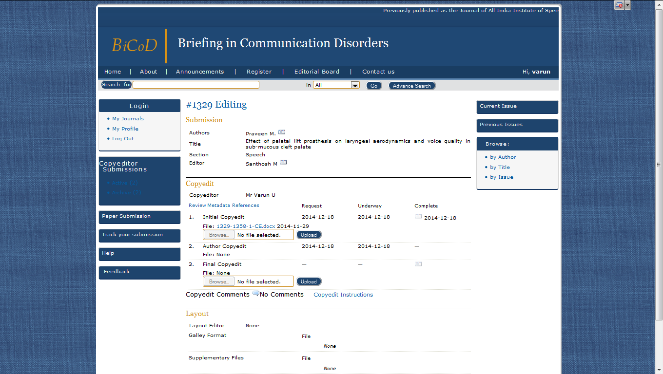
Fig. 18: Copy Editing

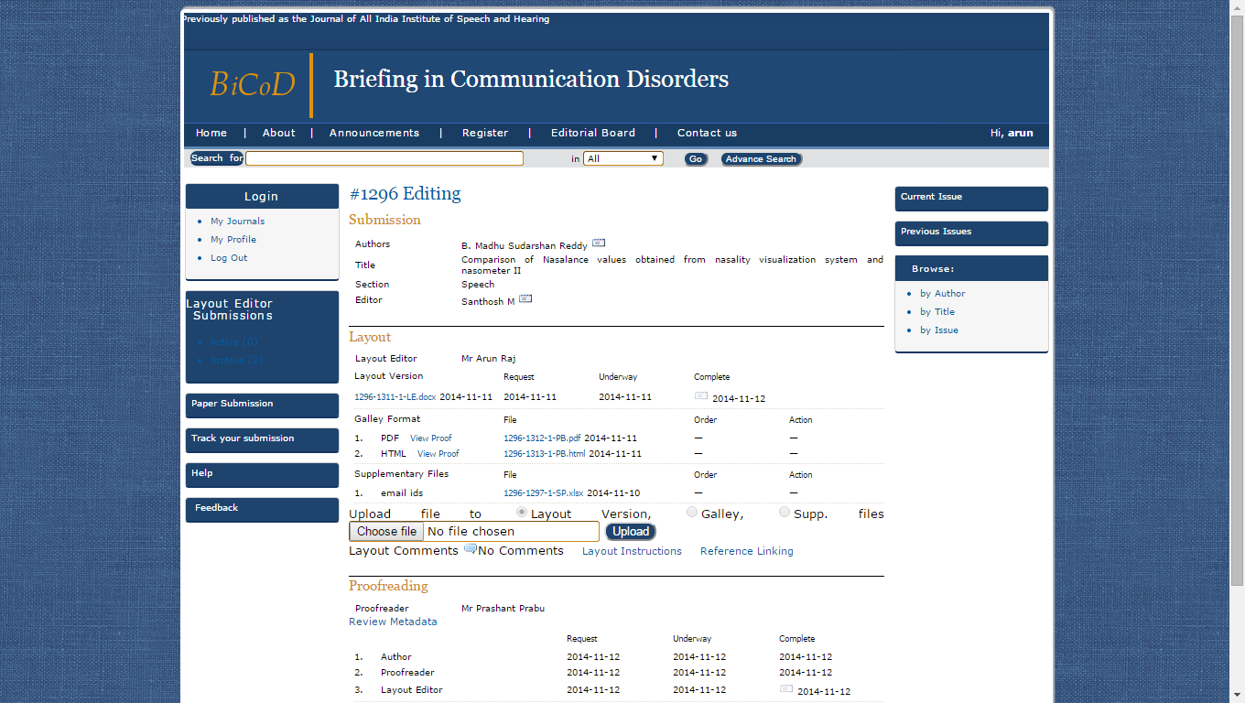
Fig.19: Layout Editing
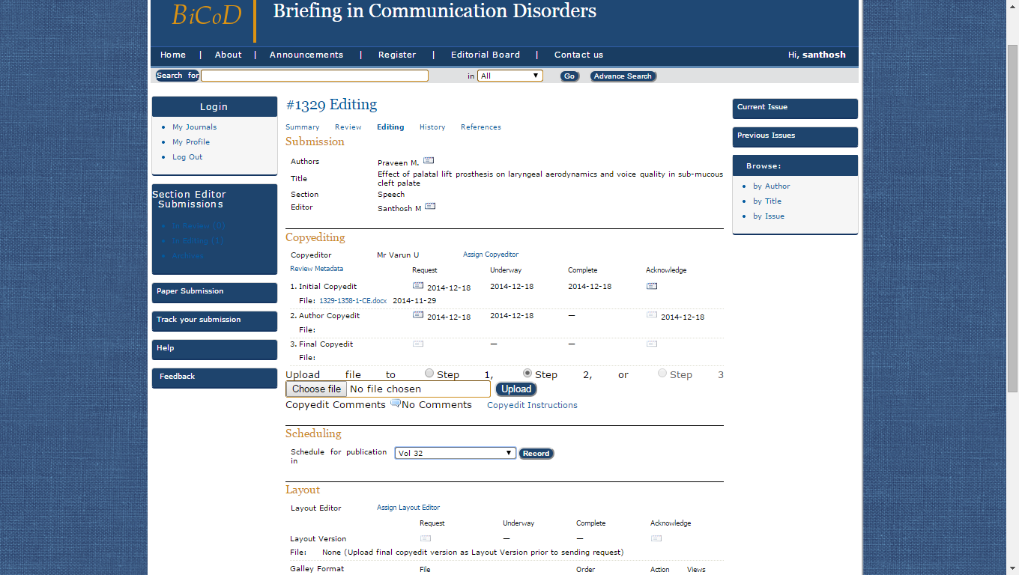
Fig. 20: Proof Reading
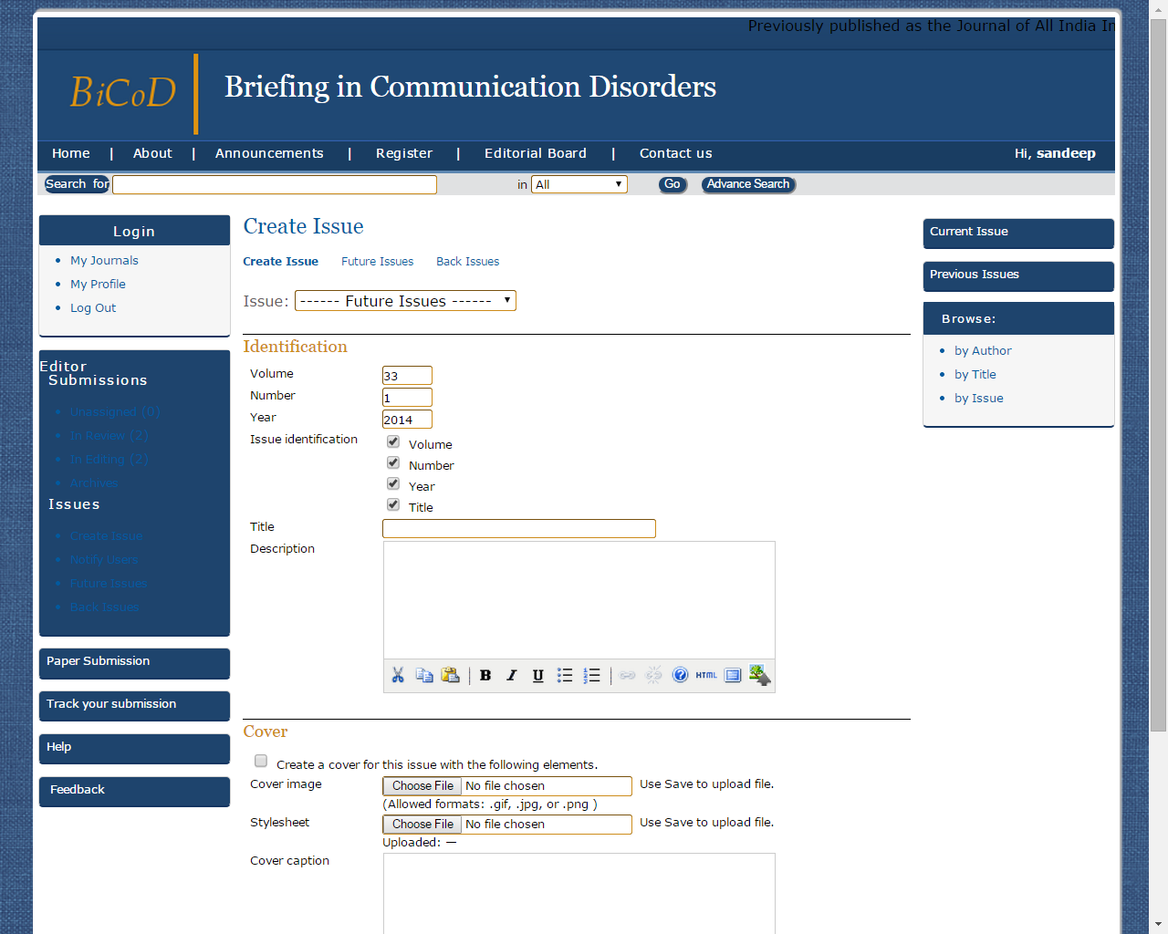
Fig. 21: Creation of issues
Access to Archival Issues: Settings has been made to access all the previous issues of the journal as given in figure 22.
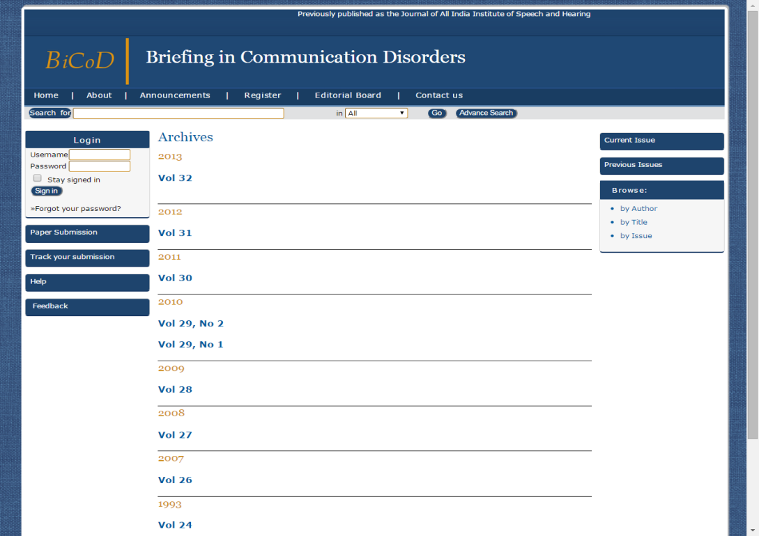
Fig. 22 : Archival Issues
Design and Developing of Searching System: A comprehensive search system has been developed to enable author, title, and keyword searching of the journal issues as given in figures 23 to 27.
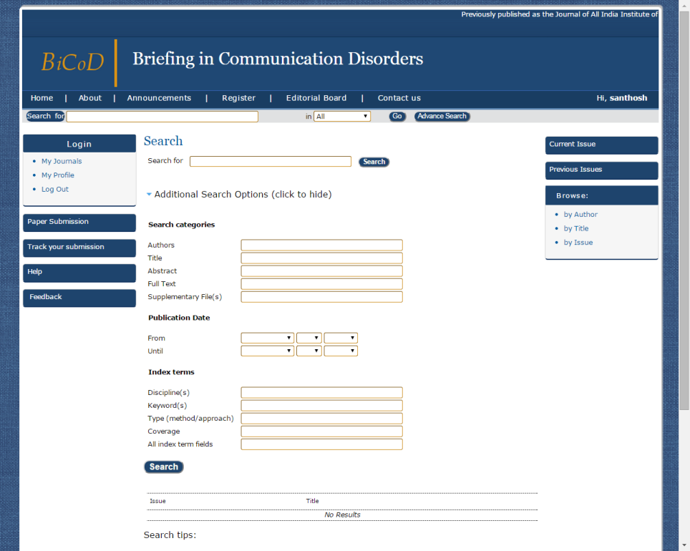
Fig. 23: Searching Interface 1
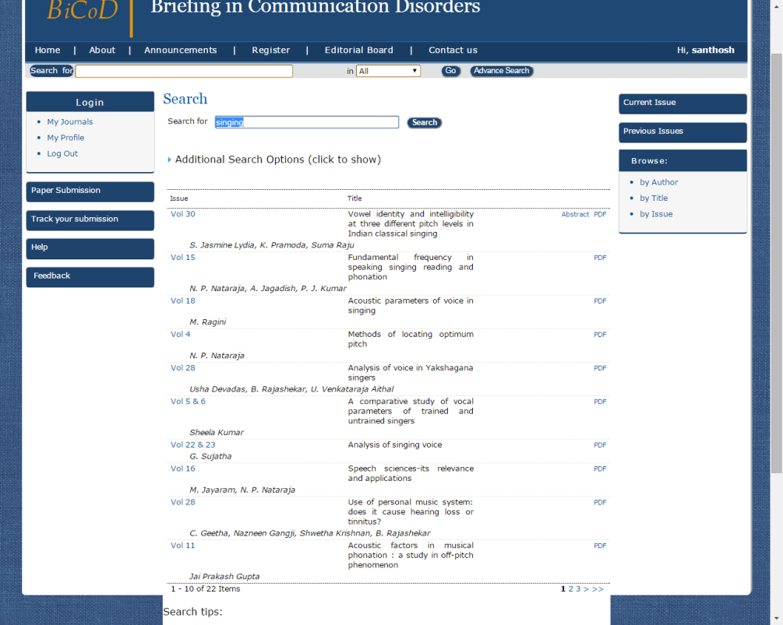
Fig. 24: Searching Interface 2

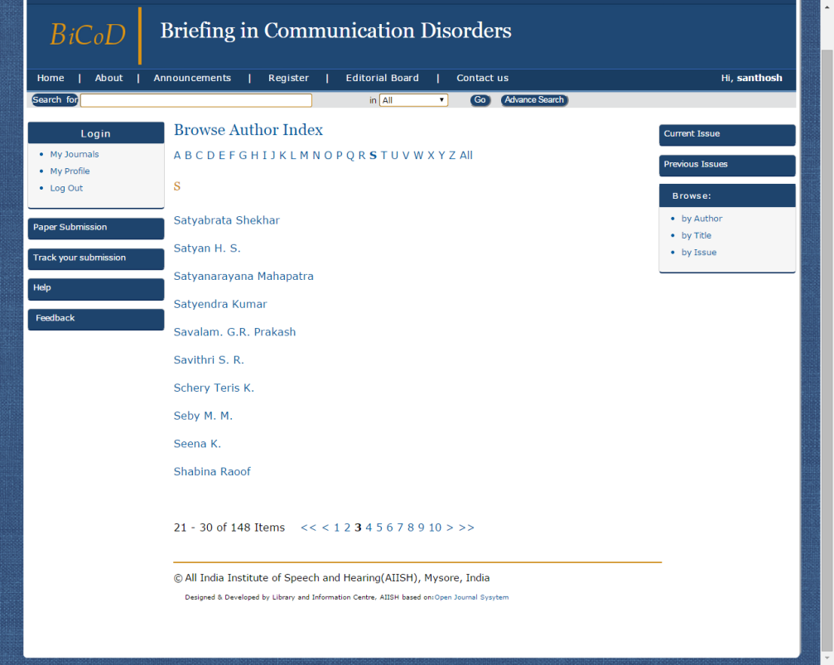
Fig. 25: Searching Interface 3

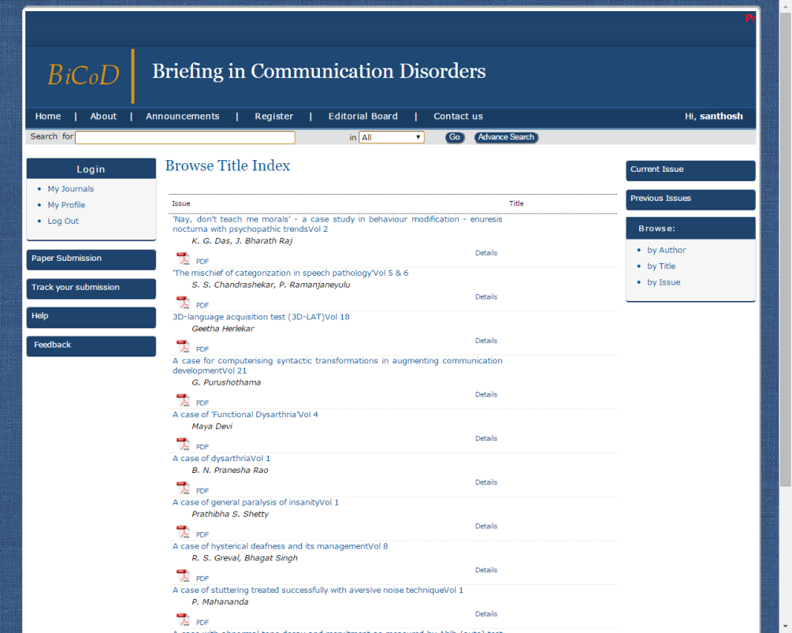
Fig. 26: Searching Interface 4

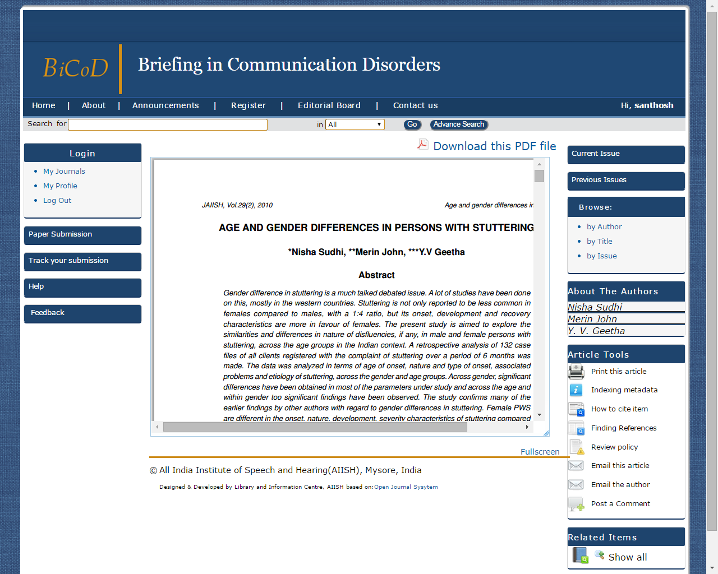
Fig. 27: Searching Interface 5

Prototype for the Student Research at AIISH
Setup has been made for publishing the Student Research at AIISH as three separate journals as shown in figure 28.
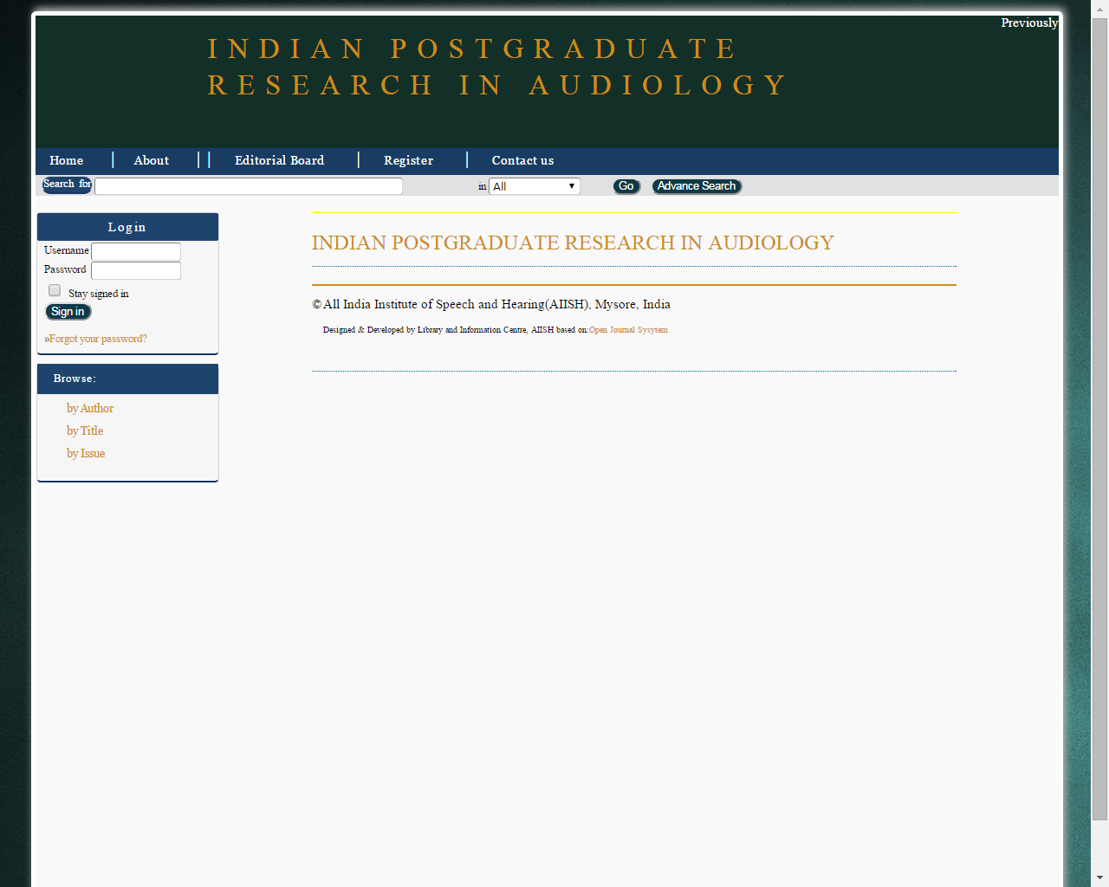
Fig.28: Interface for Student Research at AIISH journal
Trial Run and Rectification of the System
A trial run of the workflow of the system developed has been carried out with six paper submissions. The trial run identified the following drawbacks/ shortcomings which have been rectified.
- Submission acknowledgement was not always getting on the author’s e-mail. The issue has been rectified by creating an e-mail template and saving onto the system.
- There was a failure in bulk importing of archival issues. The issue has been rectified by writing an XML code.
- Reviewer comments from the Review Form was not importing to the e-mail to Author when using ‘Import Peer Review’. The issue has been rectified by checking the ‘notify author’ provision in the form item configuration.

Concluding Remarks
The present project developed web based platforms for the Journal of All India Institute of Speech and Hearing and the Student Research at AIISH towards getting them global visibility and readership. The system developed facilitates the entire processes of journal publishing online from the manuscript submission, peer reviewing, editorial activities to the final publishing of the journals. Also, it offers a wide range of features and functionalities including reading tools and searchable online archives of previous issues. The major advantages of the proposed publishing system are that it is less expensive and the operation is simple and its launch will benefit the professional community across the world.

Appendix-I
List of Speech and Hearing Journals on Open Journal System
- Audiology Research
http://www.audiologyresearch.org/index.php/audio/index

- JOURNAL OF INTERACTIONAL RESEARCH IN COMMUNICATION DISORDERS
https://journals.equinoxpub.com/index.php/JIRCD/index

- INTERNATIONAL JOURNAL OF SPEECH LANGUAGE AND THE LAW
https://journals.equinoxpub.com/index.php/IJSLL

Bibliography
Atkins, D., & Wright, M.H. (2003). Revolutionizing science and engineering through cyber infrastructure: Report of the National Science Foundation Blue-Ribbon Advisory Panel on Cyber infrastructure. Washington DC: National Science Foundation.
Bergstrom, T. C. (2001). Free labor for costly journals? Journal of Economic Perspectives. 15, 183-98. http://www.econ.ucsb.edu/~tedb/Journals/jeprevised.pdf, accessed November 25, 2012.
Björk, B-C., Roos, A., &Lauri, M. (2009). Scientific journal publishing: yearly volume and open access availability. Information Research, 14(1) paper 391. Available from 12 January, 2013 at http://InformationR.net/ir/14-1/paper391.html.
Clarke R (2010). The cost profiles of alternative approaches to journal publishing. First Monday.;12(12). Available at www.uic.edu/htbin/cgiwrap/ bin/ ojs/index.php/fm/article /view/2048/1906.
Cyzyk, M. & Choudhury, S. (2008). A survey and evaluation of open-source electronic publishing systems. Unpublished paper, Sheridan Libraries, Johns Hopkins University, Baltimore, MD. https://wiki.library.jhu.edu/display/epubs/.
Jayaram , M. & Savithri, S.R. (2005) . Foreword. In Jayaram, M & Savithri S.R (Ed.) Research at AIISH: Dissertation Abstracts,V.2.
Mary M. C. & Nancy R. J. (2007). Publishing journals @ UIC. Association of Research Libraries Journal, June-August.
Prabha, C. (2007). Shifting from print to electronic journals in ARL university libraries. Serials Review, 33(1), 4-13
Vijayalakshmi, B. (2008). Foreword. In Vijayalakshmi, V (Ed.) Student Research At AIISH: Articles Based on Dissertations Done at AIISH,V.1: 2002-03.
Willinsky, J. (2005). Open Journal Systems: An example of Open Source Software for journal management and publishing. Library Hi Tech, 23(4).
Willinsky J. (2007). Open access on a zero budget: A case study of postcolonial text. Information Research.V.12(3).
URL’s
http://www.ambraproject.org/
https://confluence.cornell.edu/display/dpubs
https://www.drupal.org/
https://pkp.sfu.ca/ojs/
http://www.iso.org

