Speech development patterns and phonological awareness in preschool children

Project funded by All India Institute of Speech and Hearing Research Fund (ARF)

Sanction Numbers: 1. SH/CDN/ARF-30/2015-16 dated 05.10.2015
2. SH/CDN/ARF-30/2015-16 dated 10.01.2017
Total grants: Rs. 4,50,000
Total Duration of the project: 18 months

Principal Investigator
Dr. Pooja R.
Lecturer in Speech Sciences
Department of Speech-Language Sciences

Co-Investigator

Dr. Ajay S.
Associate Professor
Department of Audiology

Project Staff

Ms. Suma V.
Research Officer

All India Institute of Speech and Hearing
Manasagangothri, Mysore-570006

Acknowledgements

The investigator would like to thank The investigator would like to thank The investigator would like to thank The investigator would like to thank The investigator would like to thank.

The investigator would like to thank The investigator would like to thank The investigator would like to thank. The investigator would like to thank The investigator would like to thank The investigator would like to thank The investigator would like to thank The investigator would like to thank
The investigator would like to thank The investigator would like to thank The investigator would like to thank

Dr. Pooja R.
Principal Investigator

TABLE OF CONTENTS

Chapter | Title | Page No.
I | Introduction | 1
II | Review of Literature | 5
III | Methods | 30
IV | Results | 45
V | Discussion | 70
VI | Summary and Conclusions | 79
VII | References | 81
Appendix I Appendix II
Glossary

LIST OF TABLES

Table No | Title | Page No
3.1 | Stimulus and acquisition parameters used to record click evoked  ABR and ALLR | 36-37
3.2 | Summary of acoustic parameters measured | 39-41
4.1 | Median and range of SIS (in quiet as well as in noise) and GDT  obtained in ANSD and NAA groups | 46
4.2 | Results of Mann-Whitney U test comparing the ANSD and NAA  groups in terms of their SIS (in quiet as well as in noise) and GDT | 46
4.3 | Mean and standard deviation (SD) of the acoustic parameters of  vowels in the two study groups | 48
4.4 | Results of independent t-test comparing two genders for their vowel  production characteristics | 49
4.5 | Results of independent t-test comparing NAA and ANSD groups for  their vowel production characteristics, in the two genders | 50
4.6 | Mean and Standard Deviation (SD) of the acoustic parameters  measured in plosives, in the two study groups | 51-52
4.7 | Results of independent t-test comparing two groups for the  production characteristics of plosives | 53
4.8 | Mean and Standard Deviation (SD) of the acoustic parameters  measured in fricatives, in the two study groups | 54
4.9 | Results of independent t-test comparing two groups for the  production characteristics of fricatives | 55
4.10 | Median and range for CAPE-V perceptual rating scale in the two  study groups | 55
4.11 | Results of Mann-Whitney U test comparing two groups for their  perceptual rating of voice using CAPE-V | 56
4.12 | Distribution of participants of ANSD group across the different  degrees of perceptual deviance as rated on CAPE-V scale | 57
4.13 | Median and range for acoustic parameters extracted from Vagmi in  the two study groups | 58

LIST OF FIGURES

Figure  No | Title | Page  No
3.1 | Representation of temporal measures considered in the study | 42

CHAPTER 1

INTRODUCTION

The disorder of auditory dys-synchrony (AD) is characterized by the absence

of auditory brainstem responses despite otoacoustic emissions and/or cochlear

microphonics being present (Sininger & Oba, 2001; Starr, Picton, Sininger, Hood, &

Berlin, 1996). At first, the disorder was termed as auditory neuropathy as majority of

the affected individuals were reported to have associated peripheral neuropathy. Later,

in view of the lesion being restricted to inner hair cells in some of the cases

(Miyamoto, Kirk, Renshaw, & Hussian, 1999), the term auditory dys-synchrony was

suggested (Berlin, Hood, Morlet, Rose, & Brashears, 2003). Hayes, Sininger and Starr

(2012) suggested the term auditory neuropathy spectrum disorder (ANSD)

considering that the site of damage is not confined to a particular locus in most of

these persons. Rather, there are different affected loci. Henceforth in this study, the

condition will be uniformly referred to as ANSD.

Speech identification abilities of individuals with auditory dys-synchrony are

disproportionate to the degree of their hearing loss (Starr et al., 1996; Zeng & Liu,

2006) and are the cardinal characteristics of persons with ANSD. Unlike cochlear

hearing loss, speech perception abilities in these individuals is believed to vary based

on the extent of distortion of temporal cues at suprathreshold levels rather than access

to speech spectrum (related to audibility), (Zeng, Oba, Garde, Sininger, & Starr, 1999;

Zeng et al., 2005). The psychoacoustical, neurophysiological and perceptual aspects

of individuals with ANSD are well established (Kumar & Jayaram, 2006; Norton &

Widen, 1990; Sininger, Hood, Starr, Berlin, & Picton, 1995; Sininger & Oba, 2001).

1.1 Justification for the Study

Speech characteristics of adults with ANSD have not been systematically

explored in any of the earlier western studies. However, Dayal and Maruthy (2009)

found that speech of ANSD is perceptually abnormal, more so in its prosody. They

also reported a significant high correlation between deficits in speech production and

speech perception scores. However, it was only a preliminary attempt and did not

include detailed evaluation of articulation, voice and fluency.

Detailed evaluation of speech characteristics will help enhance our

understanding of the influence of long term disruption in the temporal characteristics

of the input auditory signal, if any, on speech production in ANSD. This would

further help in verifying the Direction into velocities of articulators (DIVA) model of

speech production and will validate the findings of Dayal and Maruthy (2009). If

speech is found to be deviant, it will further stress on the need for early identification

and rehabilitation of speech related deficits of ANSD. The specific deviant

characteristics will guide us in understanding the auditory cues to speech production

relationship in a better way. These would further aid us to develop better management

strategies, thus improving the quality of life of individuals with ANSD.

1.2 Objectives of the Study

The objectives of the present study were:

1. To characterize speech production of individuals with ANSD in terms of

segmental and suprasegmental features.

2. To assess the relationship across auditory processing deficits, speech

perception deficits and speech production in individuals with ANSD.

CHAPTER 2

REVIEW OF LITERATURE

Auditory neuropathy spectrum disorder (ANSD) is a clinical syndrome in

which outer hair cell function is spared, but afferent neural transmission is disordered

(Starr et al., 1996). The VIII cranial nerve that carries electrical signals to the brain is

known to have electrical discharges that are dyssynchronous in individuals with

ANSD. It indicates the disruption in the smooth and consistent transition of

information from cochlea to the brain. The amount of dyssynchrony can vary from

person to person and can fluctuate in an individual over time. Some cases are transient

or intermittent, others change little over time and may even worsen.

2.1 Audiological Profile in ANSD

2.1.1 Hearing sensitivity

The hearing thresholds in individuals with ANSD could vary from normal

hearing to severe degree of hearing loss (Rance et al., 1999; Zeng et al., 2005).

Configuration of hearing loss could be either typical rising (Hood, 1998; Rance et al.,

1999; Sininger & Starr, 1997), rising with peak at 2 kHz (Kumar & Jayaram, 2005) or

flat in nature. Persons with ANSD having peaked audiogram are reported to have

better speech discrimination abilities compared to other configurations (Jijo &

Yathiraj, 2012; Kumar & Jayaram, 2005).

2.1.2 Middle ear muscle reflexes (MEMRs)

MEMRs are known to be present in only a few persons with ANSD. Starr et

al. (2000) found the presence of MEMRs in only 7% of persons with ANSD tested.

CHAPTER 3

METHODS

The study aimed to assess the speech production characteristics of individuals

with auditory neuropathy spectrum disorder (ANSD) and correlate these with their

auditory profile. The study used a standard group comparison research design and was

executed in two phases. Phase I comprised of preparation and compilation of test

stimuli, while Phase II involved data collection and analyses.

3.1 Participants

The study included two groups of participants; individuals with ANSD and

individuals with normal auditory abilities (NAA). The ANSD group had 30

participants in the age range of 18 to 40 years (Mean age: 26.03 years) and had visited

the department of Audiology, All India Institute of Speech and Hearing (AIISH),

Mysore, once earlier. They were contacted through letters and calls and were

requested to visit AIISH for a follow-up evaluation. ANSD was diagnosed by

qualified audiologists based on the criteria recommended by Starr et al. (2000). All of

them had sensorineural hearing loss, and the degree of hearing loss ranged from

minimal to profound hearing loss.

The speech identification scores of participants with ANSD in quiet ranged

from 0% to 96% in the two ears (Right ear: Mean = 44.82%, SD = 34.80 and Left ear:

Mean = 43.17%, SD = 34.87). The minimum duration of ANSD in these participants

was five years, and the maximum duration was up to 20 years. All of them had

acquired ANSD post-lingually.
Table 3.1
Stimulus and acquisition parameters used to record click evoked ABR and ALLR

Stimulus Parameters |  | Acquisition Parameters
ABR LLR |  | ABR LLR
Stimulus  Polarity  Level  Duration  Number of sweeps  Rate  Artifact rejection Transducer | 500 Hz Tone  Clicks Burst & /da/ of 40ms  Rarefaction Alternating  90 dB nHL 80 dB nHL  100 μs 60 ms  2000 500  11.1/s and 1.1/s 90.1/s  +/- 22 μV +/- 30μV  ER 3A Inserts ear phones | Filter Window Montage | 100- 3000 0.1-  Hz 100Hz  10.6 ms 533  ms  Cz-M1 and Cz- M2, Nasion-ground

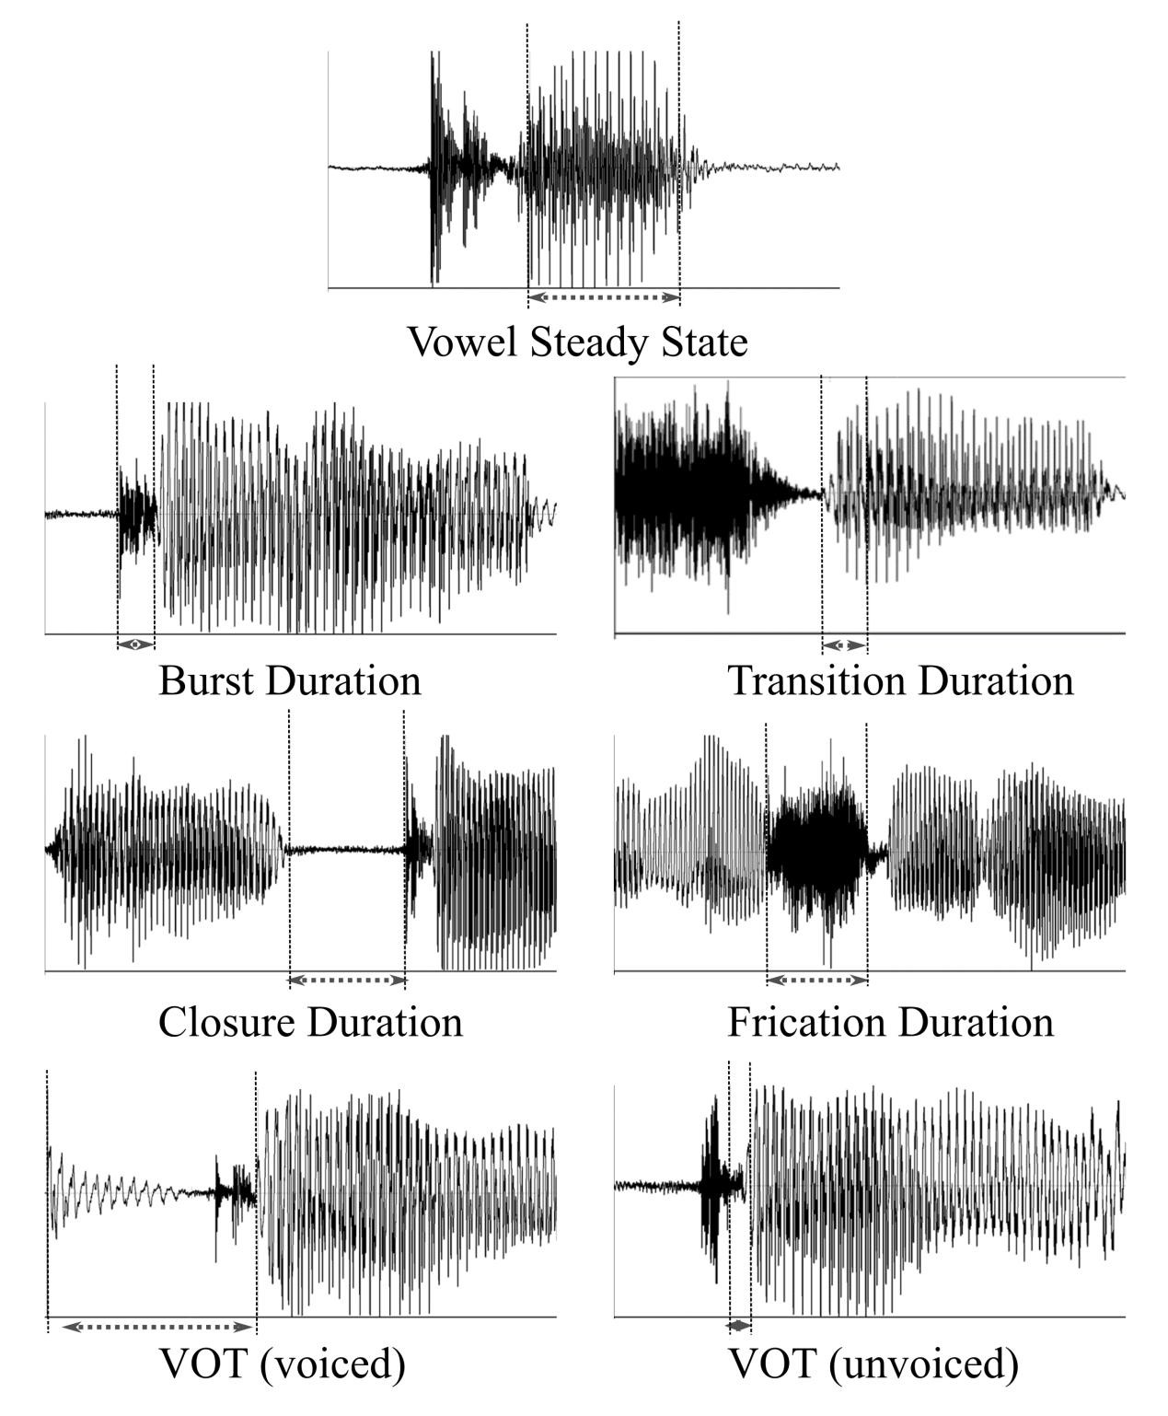
Figure 3.1: Representation of temporal measures considered in the study

CHAPTER 4

DISCUSSION

Auditory Neuropathy Spectrum Disorder (ANSD) is known to result in

distortion of the auditory feedback owing to its temporal processing and speech

perception deficits. Based on the available literature in sensorineural hearing loss, one

can expect individuals with long-standing ANSD to show deviations in their speech

production characteristics. Therefore, in the present study, it was attempted to study

the characteristics of speech production in individuals with long-standing ANSD.

Attempt was also made to study the relationship between their speech production

characteristics and the auditory abilities. Overall, the results support presence of

deviations in speech production which appear to relate to their temporal processing

deficits. The specific findings are discussed under the following headings:

5.1 Auditory abilities of individuals with ANSD

5.2 Speech production of individuals with ANSD

5.3 Relationship between auditory abilities and speech production in individuals

with ANSD

4.1 Auditory abilities of individuals with ANSD

Speech perception and the gap detection thresholds (GDTs) were assessed in

the study. It was found that individuals with ANSD performed significantly poorer

compared to individuals with normal auditory abilities (NAA) in both these measures.

Reduced speech perception, both in quiet and in noise, is known to be characteristic of

ANSD and is primarily the result of a deficit in temporal processing (Zeng et al.,

1999; 2005). GDTs reflect temporal resolution abilities of an individual, and it was

CHAPTER 5

SUMMARY AND CONCLUSIONS

Individuals with Auditory Neuropathy Spectrum Disorders (ANSD) are

known to have speech perception poorer than what could be accounted by their

hearing sensitivity. Deficits in temporal processing are known to be the primary

reason for their poor speech perception. Therefore, one can expect speech production

characteristics to be deviant and unique in these individuals compared to those with

adventitious cochlear hearing loss. Hence, the primary aim of the study was to profile

the speech production characteristics of individuals with ANSD, and assess its

relationship with their auditory abilities.

Thirty individuals diagnosed to have ANSD participated in the study. They

were assessed for their auditory abilities in terms of hearing sensitivity, speech

perception (in quiet & in noise), gap detection thresholds, and late latency responses.

Their speech production characteristics were profiled in terms of segmental and

suprasegmental aspects. Segmental aspects included acoustic analysis of vowels,

plosives, fricatives, and voice characteristics while suprasegmentals included

emphasis, rhythm, and intonation. The auditory abilities and the speech characteristics

of individuals with ANSD were compared with those of individuals with normal

auditory abilities (NAA). Attempts were also made to statistically analyze the

relationship between auditory abilities and speech production characteristics of

individuals with ANSD.

REFERENCES

Abdala, C., Sininger, Y. S., & Starr, A. (2000). Distortion product otoacoustic
emission suppression in subjects with auditory neuropathy. Ear and
hearing, 21(6), 542-553.

Alvarenga, K. F., Amorim, R. B., Agostinho-Pesse, R. S., Costa, O. A., Nascimento,
L. T., & Bevilacqua, M. C. (2012). Speech perception and cortical auditory
evoked potentials in cochlear implant users with auditory neuropathy spectrum
disorders. International Journal of Pediatric Otorhinolaryngology, 76(9), 1332-
1338.

American Speech-Language-Hearing Association. (2002). Consensus Auditory
Perceptual Evaluation of Voice (CAPE-V): ASHA Special Interest Division 3,
Voice and Voice Disorders. Rockville, MD: Author. Retrieved
from http://www.asha.org/uploadedFiles/members/divs/D3CAPEVprocedures.p
df

Angelocci, A. A. (1962). Some observations on the speech of the deaf. Volta
Review, 64(7), 403-405.

Angelocci, A. A., Kopp, G. A., & Holbrook, A. (1964). The vowel formants of deaf
and normal-hearing eleven-to fourteen-year-old boys. Journal of Speech and
hearing Disorders, 29(2), 156-170.

Arslan, E., Turrini, M., Lupi, G., Genovese, E., & Orzan, E. (1997). Hearing threshold
assessment with auditory brainstem response (ABR) and ElectroCochleoGraphy
(ECochG) in uncooperative children. Scandinavian audiology.
Supplementum, 46, 32-37.

Barman, A. (2007). Psychoacoustical profile in normals and individuals with auditory
dys-synchrony. Unpublished doctoral thesis, University of Mysore.

Basavaraj, V., & Venkatsan, S. (2009). Ethical guidelines for bio-behavioral research
involving human subjects. All India Institute of Speech and Hearing, Mysore.
Retrieved from http://www.aiishmysore.in/en/pdf/ethical_guidelines.pdf

Berlin, C. I., Hood, L. J., Cecola, R. P., Jackson, D. F., & Szabo, P. (1993). Does type
I afferent neuron dysfunction reveal itself through lack of efferent suppression?
Hearing Research, 65(1-2), 40-50.

APPENDIX I

TEST STIMULI

- Segmental aspects of speech

Wordlist to assess the acoustic characteristics of vowels

Sl. No. | Target word | IPA
1. | PÀ§Äâ | /kəbbʊ/
2. | zÀ¥Àà | /d̪ əppa/
3. | ¸ÀgÀ | /səra/
4. | Q« | /kɪvɪ/
5. | ¢A§Ä | /d̪ ɪmbʊ/
6. | ¹» | /sɪhɪ/
7. | PÀÄj | /kʊrɪ/
8. | zÀÄA© | /d̪ ʊmbɪ/
9. | ¸ÀÄR | /sʊkha/

Glossary

Abbreviation | Expansion
ABR | Auditory brainstem response
AD | Auditory Dys-synchrony
ALLR | Auditory late latency response
ANSD | Auditory neuropathy spectrum disorder
ASHA | American Speech-Language and Hearing Association
BD | Burst duration
CAEP | Cortical auditory evoked potential
CAPE-V | Consensus Auditory–Perceptual Evaluation of Voice
CD | Closure duration
D0 | Mean duration
DIVA | Direction into velocities of articulators
DPOAE | Distortion product otoacoustic emission
EcochG | Electrocochleography
EMS | Envelope modulation spectra
EoT | Extent of transition
F0 | Mean fundamental frequency
F1 | First formant
F1BW | First formant bandwidth
F2 | Second formant
F2BW | Second formant bandwidth
FD | Frication duration
FRDA | Friedrich's ataxia
GDT | Gap detection threshold
I0 | Mean intensity
IHC | Inner hair cells
JND | Just noticeable difference
MEMR | Middle ear muscle reflex
NAA | Normal auditory abilities

