**What is a Press Release?**

A press release is a brief document that shares a piece of news about your company or business with press and media outlets.

It is usually sent to journalists and editors who may use the information to [write a news article](https://blog.justreachout.io/pr-hacks/).

*Note:* A press release is accompanied by the email pitching the story to the journalist – a sort of covering letter. Know all about it in [How To Write A Press Release Email [2019 Update]](https://www.criminallyprolific.com/press-release-email/)

**Remember:** A press release usually mimics a news article format, so you need to put the most important information **first**, don’t bury the good stuff.

In short: press release is the most important 400 words you are going to write about your business.

**A Peek At Press Release Format**

While you always want to stand out amongst your competitors, with press releases, you also want to fit within a standard format.

If your press release conforms to a format that a journalist is familiar with, your odds of getting published are higher.

Here’s a typical press release format:

* **Headline:** A title that clearly explains what the release is about – Is it a [product launch](https://blog.justreachout.io/how-to-write-press-release-for-product/)? A new development? A corporate restructuring?
* **Location:** Where you are and where the news is taking place
* **Lead:** The first paragraph that summarizes the most important information about your story
* **Body:** Detailed information provided in decreasing levels of importance
* **Boilerplate:** A few words describing your company
* **Press Contact:** Name and contact details of your media coordinator or communications executive. Typically, anyone who the reporter can get in touch with to get more information.

Here are few examples of actual press releases:

**Product Releases**

[Bain & Company Launches NPS Prism, A New Business To Help Companies Create Game-Changing Customer Experiences](https://www.prnewswire.com/news-releases/bain--company-launches-nps-prism-a-new-business-to-help-companies-create-game-changing-customer-experiences-300807982.html)

[Marathon Brewing Releases Signature Beer, 26.2 Brew, Nationwide](https://www.prnewswire.com/news-releases/marathon-brewing-releases-signature-beer-26-2-brew-nationwide-300807723.html)

**Partnerships**

[Curacity Partners with CitizenNet to Turn Instagram into a Measurable, Revenue-Driving Platform for Hotels](https://www.prnewswire.com/news-releases/curacity-partners-with-citizennet-to-turn-instagram-into-a-measurable-revenue-driving-platform-for-hotels-300807769.html)

[Waterford Hotel Group and Waterton Forge Partnership to Grow Hospitality Footprint](https://www.prnewswire.com/news-releases/waterford-hotel-group-and-waterton-forge-partnership-to-grow-hospitality-footprint-300807968.html)

**Awards**

[Autosoft Recognized as a Best Place to Work in Pennsylvania Five Years Running](https://www.prnewswire.com/news-releases/autosoft-recognized-as-a-best-place-to-work-in-pennsylvania-five-years-running-300807928.html)

[American Management Association (AMA) Named to 2019 Training Industry’s Top 20 Leadership Training Companies List](https://www.prnewswire.com/news-releases/american-management-association-ama-named-to-2019-training-industrys-top-20-leadership-training-companies-list-300807641.html)

**New Hires**

[PolyOne Board Elects Dr. Patricia Verduin as Director](https://www.prnewswire.com/news-releases/polyone-board-elects-dr-patricia-verduin-as-director-300808065.html)

[ICF Appoints Mark Lee to Lead Public Sector Group](https://www.prnewswire.com/news-releases/icf-appoints-mark-lee-to-lead-public-sector-group-300807817.html)

**Technical Releases**

[ProcessPro ERP Releases New Cultivation Management System](https://www.prnewswire.com/news-releases/processpro-erp-releases-new-cultivation-management-system-300807093.html)

[Collateral Analytics Launches A New Commercial Automated Valuation Model](https://www.prnewswire.com/news-releases/collateral-analytics-launches-a-new-commercial-automated-valuation-model-300807992.html)

**Writing a Press Release in 7 Simple Steps**

Now that you know how to format a press release correctly, we can move on to mastering the art of press release writing.

Here’s your step-by-step guide on how to craft a well-written press release:

**1. Find Your Angle: Data, Newsjacking or Emotional**

Even in the world of press releases, content is king.

However, before crafting your content, it’s a good idea to pay attention to what your audience wants.

In this case, you’ll be pitching to journalists so create the content of your press release with that in mind.

A [Frac.tl study](https://blog.justreachout.io/pr-outreach/) showed that these were the types of content that journalists wanted in a press release:

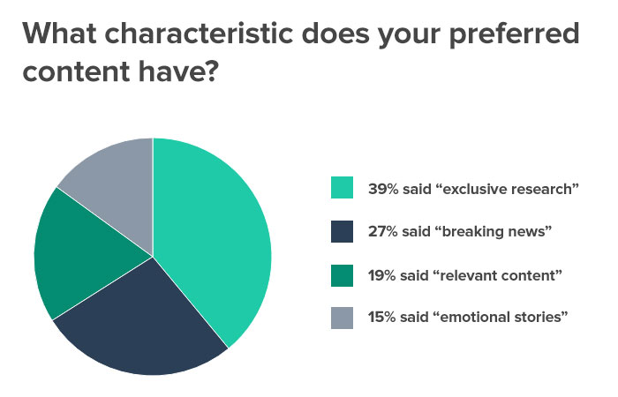

There are quite a few ways of doing this:

**Pitch Angle: Exclusive Data or Research**

Journalists love anything exclusive. They also happen to love facts. Giving them exclusive research is a good way of offering both.

If you have the ability to complement your product with original research and (hopefully) surprising results, you may have hit the press release jackpot.

These are the two types of research that usually do well:

**Surveys and Polls**

This is pretty self-explanatory – conduct surveys and polls and share the outcomes with journalists to [get a mention](https://www.criminallyprolific.com/pr-for-startups/). When I was heading growth at Polar, I used this method several times to get into major publications.

At the time, we conducted a poll on people’s preferences for iOS 6 vs iOS 7. That finding got published in TechCrunch.

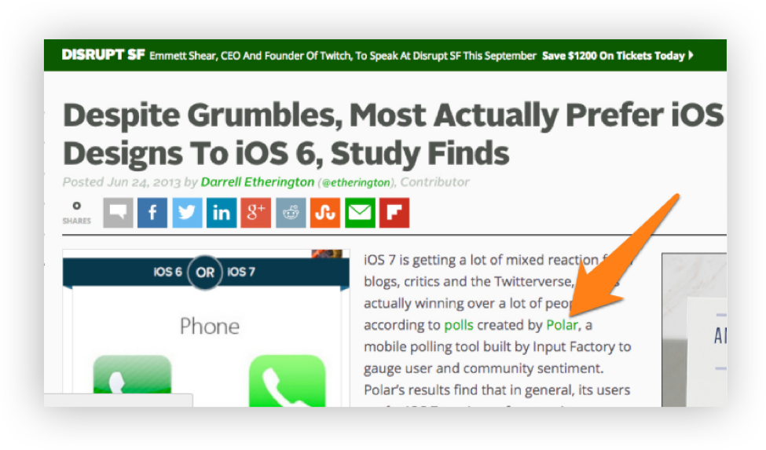

**Exclusive Data**

The idea here is simple, you provide journalists with some exclusive data and it’ll probably get a mention.

This technique is especially useful to any company that has access to factual data like customer behavioral patterns.

This is insightful information that media sites love – don’t forget to use it.

**Pitch Angle: Newsjacking**

Coming back to the Frac.tl study, we can see that 27% of the respondents preferred breaking news.

While you may not be able to provide them with your own breaking news every time, you can certainly use a current news story that’s getting press coverage to your advantage.

In other words, you can use a marketing process called newsjacking.

Simply put, newsjacking is the process of injecting your brand into current news stories to make it more relevant and eye-catching.

All you need to do is find a way to connect your company to a news story.

* Is your company a solution to the issue?
* Do you have exclusive data that could prove relevant to the story?
* Is your brand’s top executive an expert in the field concerned?

Find your connection to the news story and run with it.

There are a few things to keep in mind when using newsjacking though:

**Be Aware of Latest News**

You want to be in touch with the news that’s going on at the moment if you want to attach your brand to it.

It’s also a good idea to only latch on to news that’s relevant to your target audience.

For example, if your target audience is heavily into certain social media influencers, it then makes sense to keep track of the influencer’s social media accounts. See what they’re up to on their social media networks.  You can then try and link your brand to what they’re doing on your own social media channels and send a press release based on this connection.

It’s public relations 101.

**Be Cautious**

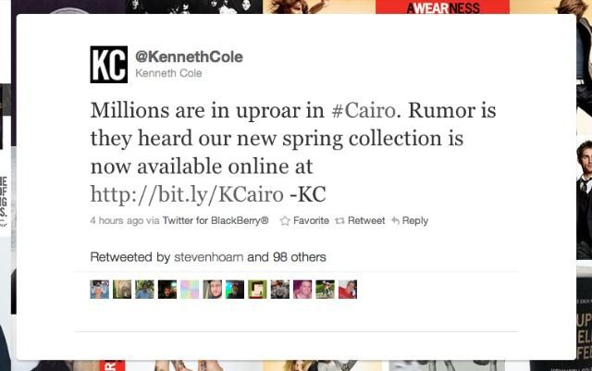

Source [Mashable](https://mashable.com/2011/02/03/kenneth-cole-egypt/#BCbR0PddT5qC)

It can be tempting to jump on to whatever is taking the world by storm at the moment, but there are instances when newsjacking isn’t an appropriate option.

Using natural disaster, civilian unrest or the death of a celebrity is not a good way to go about this.

Take what fashion house Kenneth Cole [did](https://money.cnn.com/2011/02/03/news/companies/KennethCole_twitter/index.htm) during the protests in Egypt: that’s a textbook example of what *not* to do.

**Be Fast**

As you’re dealing with breaking news, you want to capitalize on it while it’s still fresh in the reader’s minds.

You don’t want to link your brand to an event that’s been done and dusted for quite some time.



**Dmitry's take**

Aligning your pitches to developing trends in your industry is a good way to make them more attractive.

One easy way to spot these trends is to see what top journalists in your industry are writing about. Just search for your keyword on [JRO](https://justreachout.io/) to see a list of target journalists and their recent articles.

When you use these trends in your pitch while still creating evergreen content, they will rarely be rejected.

**Implement this tactic right now with our software.**

**Implement this tactic right now with our software.**

[**Give It a Try Now!**](https://justreachout.io/)

**Pitch Angle: Find an Emotional Connection**

The study showed that 15% of journalists wanted pitches with an emotional story attached to them.

Why?

It’s simple.

Stories with an emotional connect resonate better with audiences and lead to more social traction.

If you can get people emotionally invested in your brand, chances are they might be willing to give it a shot.

Take this example of a founder’s email pitch about how he slept in a car when he was trying to raise capital.

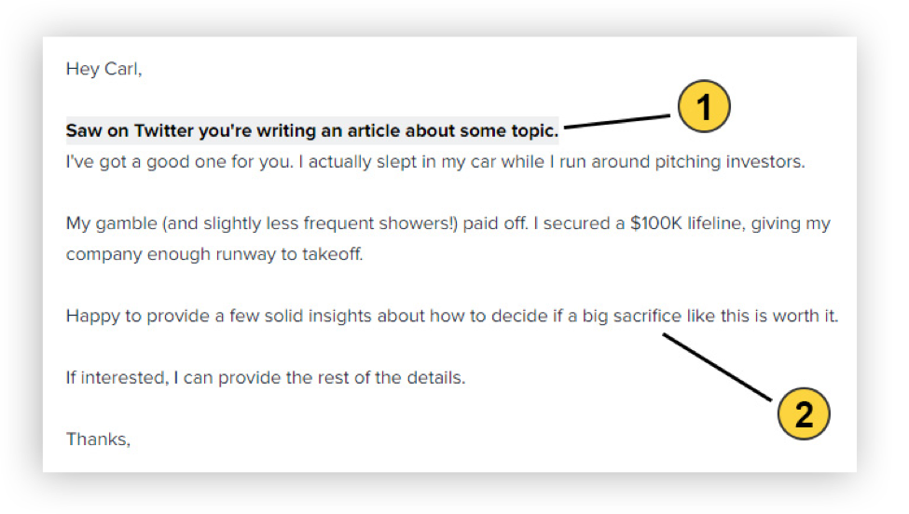There are two key points here:

1. You need to show the journalist that you’ve been keeping up with what they’ve been doing. Firstly, this gives you a better idea of what they’re looking for at the time. Secondly, by doing so, you give them the impression that you’re interested in their work.
2. The emotional kicker at the end. It’s a definitive statement that summarizes the affecting aspect of the story. It’s bound to evoke an emotional response.

Now the key with all these points is finding the one that works for you.

Remember it’s *your* angle after all.

Do your research and come to a conclusion that fits best and craft your press release based on that.

**2. Write Your Headline**

I’ve already explained the importance of writing a press release headline. It’s the first thing anyone’s going to see, so you have to make sure it’s perfect.

Here are a few things to keep in mind when trying to craft a press release headline:

**Take Your Time**

Most people think headlines are simple one-line statements that don’t deserve more than five minutes of your time.

Wrong.

Spend as much time on your headlines you would on the lead of your press release.

Take your time with it.

Run through multiple different alternatives before settling on one.

Remember, journalists are swamped with hundreds of pitches every day, they don’t have time to go through each and every one of them.

Whether or not a journalist decides to give your pitch a chance is highly dependent on your headline, so give it the attention it deserves.

Remember, a successful press release always begins with a good headline.

**Keep it Short, Direct and Simple**

The goal of your headline is to get in, impress the journalist, and get out.

That’s it.

No need to beat around the bush and try and draw the reader in.

Journalists don’t have time for that. Give them the information they need as simply and concisely as possible.

You also want to ensure that it describes your press release really well.

Remember, the journalist is making a decision about your entire press release based on this headline, so it better speak for the entire release too.

The idea here is simple – make their job easier for the journalist, and they’ll be more likely to help you out in return.

Let’s look at this headline:

*XYZ Inc. Makes a Management Change*

Yes, it’s simple. But it’s also vague.

You don’t know who has been appointed, what their position is or where the management change is happening.

A better headline would be:

*XYZ Inc. Appoints Dmitry Dragilev as the new CEO for North American Operations*

It’s far more detailed while still remaining simple. This way, the journalist has all the details they need right from the headline itself.

Remember, the three core tenets of writing a good headline are:

* Use action verbs
* Be direct
* Be comprehensive

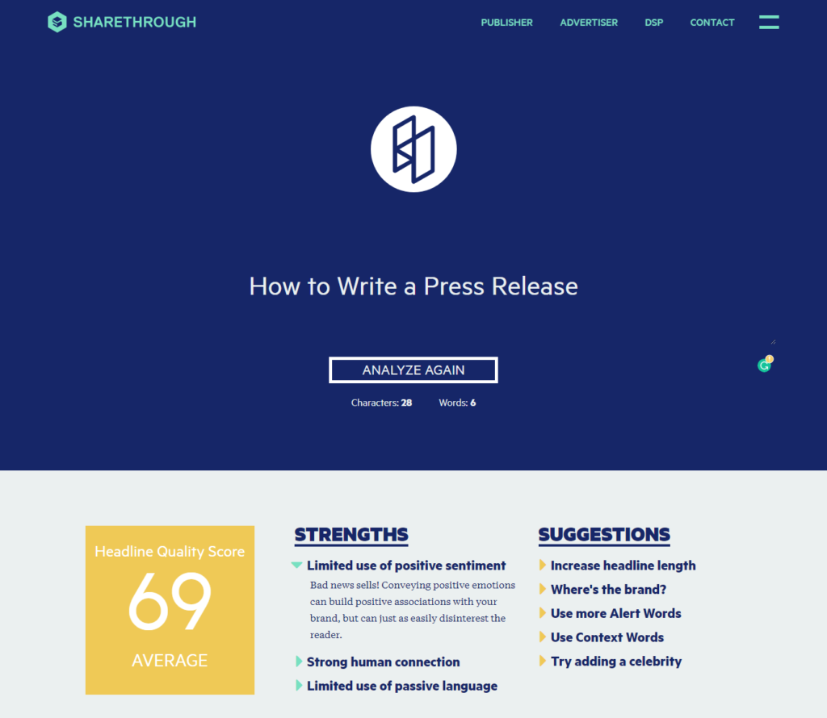

If you’re still struggling, you could always try a [headline analyzer](https://headlines.sharethrough.com/) to give you an idea of where you stand.

**Step 3 : Write your lead**

Your lead is the first paragraph in your press release.

Usually consisting of 35 to 45 words, it summarizes the most critical parts of your press release.

Much like the headline, your lead distills your entire press release into a few informative sentences.

It’s a platform to answer the “5 Ws” as concisely as possible.

Who: Who’s involved in the article? Which person or company is involved?  
What: What’s happening? What’s it about?  
When: When did this happen? When is it going to happen?  
Where: Where did this take place?  
Why: Why is this information relevant to the reader of a media outlet?

There’s a lot running on your lead. If it doesn’t clarify what’s going on, most journalists won’t bother going through the rest.

You can get into the details later, but for now, you need the journalist to know all the core facts that they need.

Here’s an example of a good lead from JA Solar Holdings.

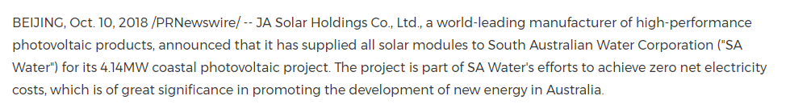

Source: [PRNewswire](https://www.prnewswire.com/news-releases/ja-solar-further-promotes-new-energy-development-in-australia-300728417.html)

Let’s see how this checks all the right boxes:

* It starts off by describing who JA Solar Holdings are – they’re the leading manufacturer of high-performance photovoltaic products. From the start, you already know *who’s* involved.
* Next, it clearly identifies the *what*. We know that they have supplied all the solar modules to the South Australian Water Corporation for their coastal photovoltaic project. You also get an idea of *where* the impact is going to be felt from this statement as well.
* Lastly, it comes to the *why*. The added advantage here is that the *‘why’* element gives the journalist and potential readers a reason to care. By contributing to a cause aimed at promoting new energy in Australia, readers have a reason to care about this news.

The lead is simple, concise and avoids jargon.

It gives the journalist a good idea of what the article is about and why it’s important – all in just four simple lines.

**Step 4: Write Your Body Paragraphs**

Your body is where you can finally get into the story.

The goal of the body is to describe all the relevant details of the story and your brand’s involvement in it.

The key word here is *relevant*. It’s easy to go overboard here since you have to note down details, but try to be concise here too.

The way you go about writing your body is to use the inverted pyramid formula.

You include the most pertinent details right at the top and then get into the less vital aspects as you go on.

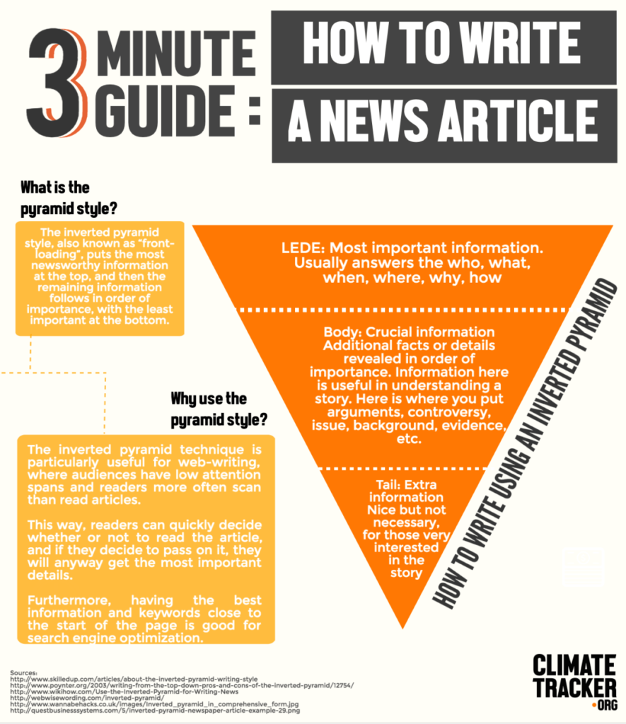

Note that less vital doesn’t mean irrelevant.

It simply means that while they’re valuable additions, you’ve already established the core of the story before including them.

A good way to go about this is to think like the reader – anticipate the questions they may have after each section and address them as you go along.

**Step 5: Include Useful Quotes**

Including quotes is a good way to boost the credibility and personality of your press release.

A good press release has at least one quote. If you have multiple ones, ensure they’re all relevant.

A good public relations manager usually writes the quotes and sends it to the concerned executives for approval.

The major benefit of this is being able to tailor the quote to fit in perfectly with what you’ve written in the press release.

However, it’s always good to ensure that your constructed quote fits in with how the individual speaks in real life.

You don’t want a situation where your quote can easily be seen as constructed – that ruins the purpose of including quotes in the first place.

Here’s an example of a quote adding value to a press release –

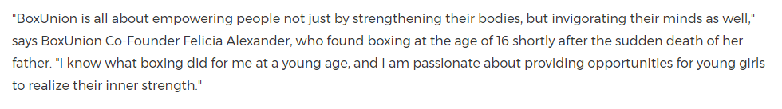Source: [PRNewswire](https://www.prnewswire.com/news-releases/boxunion-launches-be-empowered-series-to-boost-confidence-of-tween-girls-300728292.html)

BoxUnion is a premium fitness studio in Santa Monica, CA and they were launching a campaign to empower young girls through boxing.

The quote here works because of the following reasons:

* *The quote was from the co-founder.* Quotes from higher-ranking officials often hold a lot more weight and credibility than statements from other members
* *It was clearly related to the topic at hand.* The quote was in no way irrelevant –  the founder talked about the impact boxing had on her and how she wants to help young girls in the same way

Including quotes is a good way to add personality and a human touch to your press release. You can strike an emotional chord with the reader through it. This quote manages to do that.

**Step 6 : Write Your Boilerplate**

As mentioned earlier, your boilerplate is a standardized copy of what your organization is and stands for.

In my detailed article on [how to write a company boilerplate](https://www.criminallyprolific.com/company-boilerplate/) I share a great example of what one looks like from the bottom of [this](https://www.apple.com/in/newsroom/2018/01/app-store-kicks-off-2018-with-record-breaking-holiday-season/) press release by Apple about the iMac Pro:

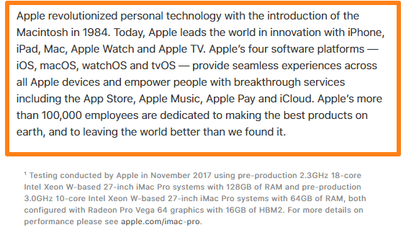

When you write a boilerplate, you are essentially condensing factual data, business aspirations and marketing goals – all into one paragraph.

There are a few things to keep in mind when you’re writing it:

**Be Specific and Simple**

You’ll want to be very specific when you’re describing your company in the boilerplate. If you’re a company that specializes in web development, mention that instead of just specifying that you’re just an ‘I.T’ company.

Also, remember that the journalists reading your press release aren’t experts in your field, so keep the technical jargon to a minimum.

**Use Data**

A vital ingredient to any good boilerplate is factual data. Aspects like when the company was formed, where it’s headquartered, its revenue – are all good ways of giving the journalist a more holistic idea of what your company is.

**Be Concise**

At times, a boilerplate can look like bragging. That’s because you’re essentially listing out all your company’s achievements. That’s why it’s easy to go overboard when you’re writing one.

Remember that this is supposed to be a *brief* distillation of what your organization is –  not a focus piece on how great it is. You should aim for anything below 120-150 words for an effective boilerplate.

Here’s an example of a good boilerplate from smartphone company OnePlus:

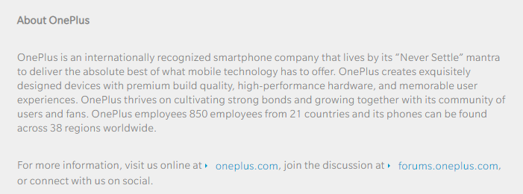

Source: [OnePlus](https://www.oneplus.in/press-releases/android-p-beta-announced-for-oneplus-6-ahead-of-phone-s-launch)

Not only does it outline the core value of the organization in the opening line itself, but also notes what they’re committed to doing. They note down what they do and include some data figures regarding their size and reach.

This boilerplate avoids any jargon and concisely explains what the organization does and strives to be. In short – it’s an ideal boilerplate.

For a more in-depth look at how to write the perfect boilerplate, click [here](https://www.criminallyprolific.com/company-boilerplate/).

**Step 7: Put Media Contact Details**

You’ll want to include your contact details for journalists to get in touch with you. It’s a good idea to include your name and designation along with your phone number and email address.

This helps give them a point of contact when they want to reach out to you.

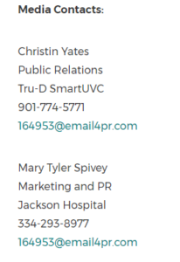

Source: [PRNewswire](https://www.prnewswire.com/news-releases/first-tru-d-smartuvc-disinfection-robot-deployed-in-montgomery-300476517.html)

**Examples of Effective Press Releases**

Here are a few press release examples and why they have nailed it.

**Product Launch Press Release**

Take a look at [this PR Release from Apple](https://www.apple.com/newsroom/2018/10/all-new-macbook-air-takes-flight/).

**The Headline**



It’s clear, concise and simple. It’s also attention grabbing – something that’s bound to attract reporters.

**The Lead**

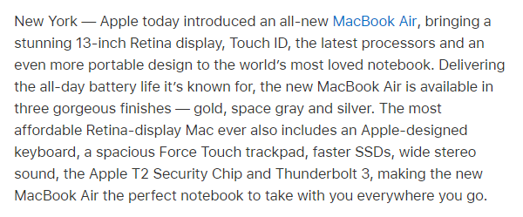

It continues in the same vein as the title. The journalist right away knows that this is a new product release. They’re also made aware of the various features that make this laptop so impressive.

Notice how just from the lead, the journalist already has enough information to thoroughly describe what’s happening quite easily.

**The Body Copy**

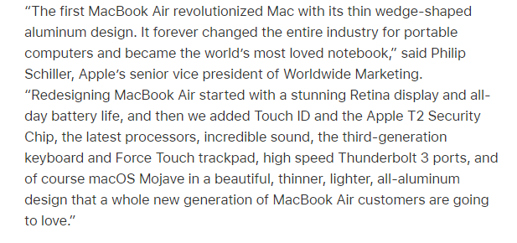

It follows the inverted pyramid format to a tee. It starts off by including a quote from a senior ranking official describing why this new release is a huge achievement for Apple.  This helps establish a human element to this otherwise technical release.

It’s only after giving the reader a brief overview of the features offered and a useful quote, that the press release proceeds on to detail each feature.

This way, all the details make far more sense to the reader as they already have a good understanding of the product.

Also, seeing as this is a new release, Apple has also included the pricing at the end of the article along with where it will be available to purchase.

**The Boilerplate**

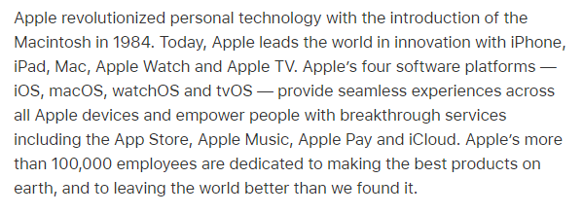

There’s a reason why the Apple boilerplate is a frequently used example for what a boilerplate should look like in marketing circles. It’s clear, avoids jargon, lists out all their offerings, includes data and notes down what they strive to do.

**The Media Contact**

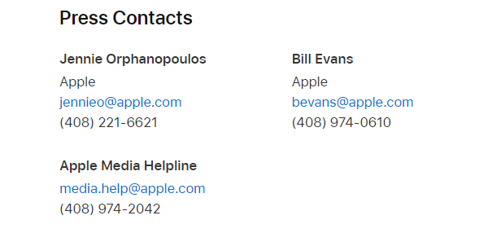

Not only does it mention the contact details of the PR agents, but also of the company’s media helpline.

**New Research Findings Press Release**



Source: [PRNewswire](https://www.prnewswire.com/news-releases/first-tru-d-smartuvc-disinfection-robot-deployed-in-montgomery-300476517.html)

There are a lot of things this press release example does well.

Starting with the title – it’s descriptive and distills what the essence of the article is about.

The first paragraph clearly describes what the robot does and where it’s going to be used.

It has useful quotes from the two CEOs concerned and includes the boilerplate of both the hospital and the technology provider.

But that isn’t what’s great about this press release.

Remember how I told you to avoid technical jargon? Well, sometimes, especially when it comes to the medical and technology industry, you can’t avoid including those details. However, you *can* minimize how much it affects the legibility of the entire press release.

Note how the press release follows the inverted pyramid formula to a tee. At the start of the article, it distills the purpose of the robot into very easily understandable terms  – it’s a UV disinfection robot that kills 99.9 percent of the harmful germs in healthcare environments.

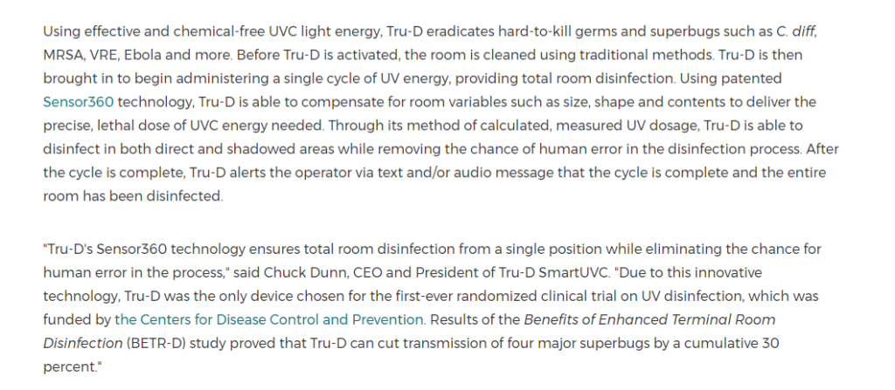

It’s only towards the end of the article after you’ve got a good idea of what the robot is, does it go into the technical facts of its operation.

The two quotes present mirror this  – the first is a more general summation of why the hospital has it, and the second details its prowess.

**Emergency Announcement Press Release**

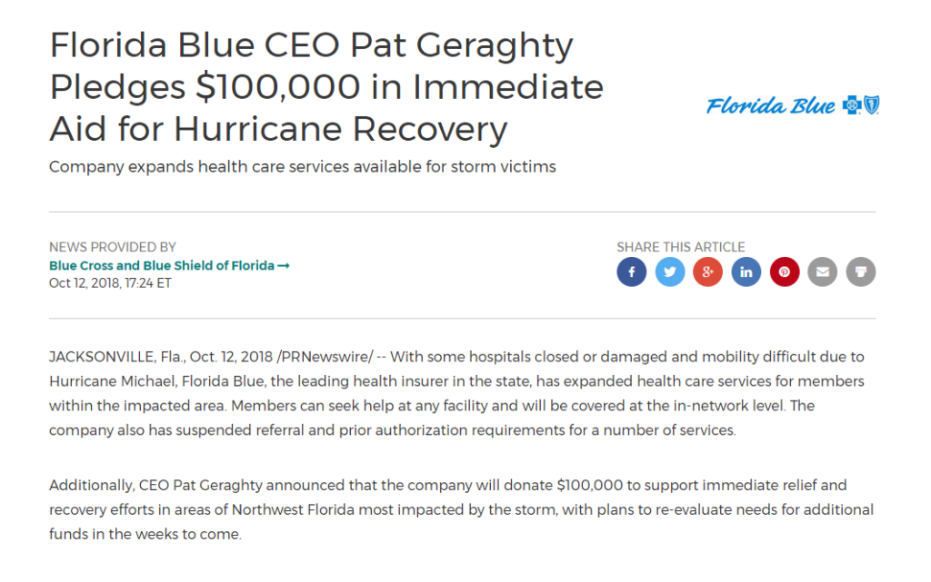

Source: [PRNewswire](https://www.prnewswire.com/news-releases/florida-blue-ceo-pat-geraghty-pledges-100-000-in-immediate-aid-for-hurricane-recovery-300730412.html)

The first thing that strikes you about this press release example is how it’s about something urgent – it focuses on something that’s currently going on. It also focuses on something with an obvious social and emotional impact for readers.

The title of this press release is clear, concise and expresses the urgency and necessity of its content.

The body follows the inverted pyramid formula and includes a relevant quote as well. It first states that Florida Blue will be expanding health care services for affected areas. It’s only later that they go into the details of this at the end of the body.

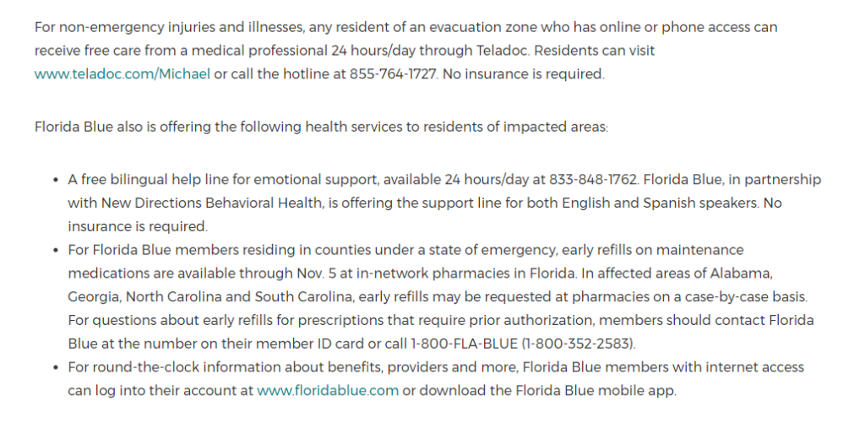

What this press release does differently, is include contact information within the body itself. In addition to very short paragraphs, there’s a subhead accompanied by bulleted lists.

Usually, this break in structure wouldn’t fit very well, but with the topic at hand, this is important information that deserves to be present higher up in the press release.

Remember that in an emergency announcement press release, your main aim should be to get to the crux of the article as fast as possible – you want to make the issue you’re addressing very clear and provide your solution to it immediately.

**New Hire Press Release**

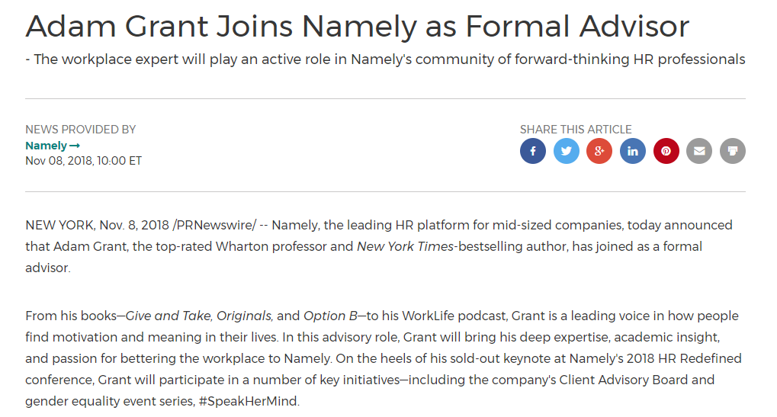

Source: [PRNewswire](https://www.prnewswire.com/news-releases/adam-grant-joins-namely-as-formal-advisor-300746623.html)

Even though each context needs its own personal touches, they’re all based on a similar blueprint.

This press release is a good example of this. See how even as it’s about a new hire, it’s not too dissimilar from the Apple laptop launch example earlier:

* Has a concise headline
* Mentions the core of the article in the lead itself
* Includes relevant quotes from important individuals

One important thing to keep in mind when crafting new hire press release is that you mention the name of the individual and the designation they hold in the title itself.

This is especially important as the core of the article is condensed into those two points:

* Who is being hired?
* What’s their role going to be?

Using the lead to note down the qualifications and past achievements of the individual is also a good idea. It gives reporters a better understanding of the individual’s background and why this hire is noteworthy.

**Award Announcement Press Release**

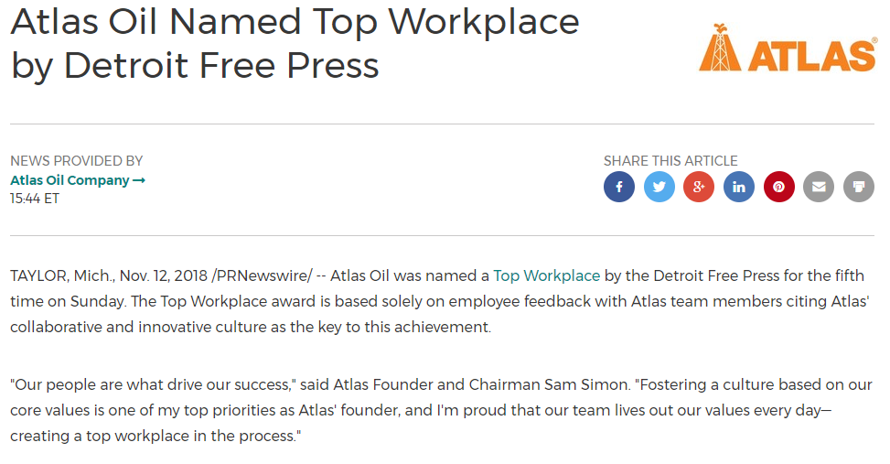

Source: [PRNewsWire](https://www.prnewswire.com/news-releases/atlas-oil-named-top-workplace-by-detroit-free-press-300748573.html)

When it comes to awards there are three key aspects:

* Who won?
* What was the award?
* Who gave the award?

Any press release that’s about awards should keep these three aspects front and center.

Ideally, all three of those components should be answered by the time the lead is up, as is done in this press release.

A journalist reading the lead would know that Atlas Oil was awarded the “Best Workplace” award by the Detroit Free Press. They’d also know that the award was based on employee feedback.

Another important thing that this press release example does is include a quote from a senior ranking official – because what are award ceremonies without acceptance speeches right?

**Tips for Writing an Effective Press Release**

Now that you have the tools to craft a great press release at your disposal, I want to go over some key things you’ll want to keep in mind during the actual process of writing press releases.

**Define Your Goals**

This must always be your first step before drafting a press release.

You want to identify why you’re creating one in the first place.

Ask yourself – *“What am I trying to achieve out of this?”*

Is it gaining more customers? Building brand awareness? Tapping into local media?

Remember, a product press release and a non-profit press release are going to look very different and require different approaches.

It’s important to identify this at the start because, in order to reach each of these goals, you’ll have to adopt different strategies.

Let’s see a few content strategies based on different goals:

**Getting More Customers**

If your goal is to get more customers, you’ll want to reach the right audiences. While targeting big publications is a great way to get your brand’s name out there, it’s not a great way to target specific demographics.

Think about it.

Big publications reach millions of people – each with different interests and desires. Of the people that these publications reach, only a small chunk may be interested in what you’re offering.

That’s why targeting a smaller, niche website that appeals to your target demographic is a better solution. This way you’re only appealing to the people that are potential customers.

**Building Brand Awareness**

Big publications like Forbes and WSJ won’t link back to your site. Nor will they only reach audiences that fit your target demographic.

What they will do is reach people. A lot of people.

This is why, if you’re simply looking to build brand awareness, getting media coverage from these publications is a great option.

**Search Engine Optimization (SEO)**

Another goal could be to improve your SEO. By improving your SEO, your brand has a higher chance of popping up on search engines every time an individual searches for a term that you rank for.

There are multiple ways to do this – one of them is getting high-quality backlinks. This refers to a big website linking back to your own page for a particular term.

If WSJ just cited some research you did and linked back to your company’s website, your website’s SEO will shoot up.

So when you’re looking to improve the SEO of your website, approaching these bigger media outlets makes sense. Remember though, getting backlinks from them can be very hard, so you’ll have to play your cards right.

**Crowdfunding**

Press releases can also be a good platform to start a crowdfunding campaign to get traction for your organization. Using a crowdfunding press release is a very commonly used method for small startups these days.

When you’re looking to crowdfund with your press release you’ll want to approach crowdfunding platforms like Kickstarter.

You also want to make sure your press release is geared towards the customers rather than journalists. Remember they’ll be the ones funding you – not the media channels.

These are just four of the many objectives you could be looking at.

Just remember that different objectives require different approaches. Find an approach that suits your goals and you’ll exponentially increase your chances of getting a mention in a news release.

**Put Yourself In Their Shoes**

Remember, you’re writing for journalists. So when you’re writing a press release, you’ll have to adopt a journalistic style of writing.

How do you do that?

By thinking like one.

Ask yourself –*“What would a journalist want in a press release?”*

**They’d want relevant information to be easily accessible**

Journalists go through hundreds of pitches every day. The last thing they want to do is sift through tons of sentences to find out if it’s relevant.

If relevant information is easily accessible in the title and lead, they’re more likely to give it a chance.

**They’d want it to be simple**

No journalist likes going through complicated sentences and metaphors to understand what’s going on. Make your press release easy to understand.

This way, journalists will waste less time trying to decipher what you’ve sent, and more time creating a media release for it.

**They’re not PR professionals**

Remember that press releases are news stories –  not blatant public relations pieces. So keep the self-praise to a minimum.

Limit mentioning how your brand is the best, or how it’s doing something great for mankind.

Keep your press release factual and informative.

Press releases can be a useful PR tool, but remember that journalists aren’t PR pros.

**Target the Right Beat**

I cannot stress how important this is.

You could have the greatest press release ever, but if your sales pitch goes to the wrong journalists, you’re going to go nowhere.

There are two things to keep in mind when you’re about to pitch your press release:

* Whether the journalist or publication you’re pitching to covers the area that your organization or product is involved in
* Whether their viewership aligns with your target demographic

Only when both of these conditions are met, will your story be meaningful enough for editors to publish it.

You can find out more about how to pitch to the right journalists [here](https://blog.justreachout.io/media-pitch/).



**Dmitry's take**

To find high quality prospects easily, use JustReachOut as it gives you a list of journalists who have written about your specific topic, not just publishers.

When you search for your target keyword in [JRO](https://justreachout.io/), the software shows a list of journalists and bloggers along with their contact details.

You can then send them an email pitch directly through JustReachOut.

**Implement this tactic right now with our software.**

**Implement this tactic right now with our software.**

[**Give It a Try Now!**](https://justreachout.io/)

So now that you know what to keep in mind when writing a press release, we can address when it’s a good idea to send them.

**When do you Need a Press Release?**

Before you can publish a press release, you first need to know when you can use them.

Even though they may seem like a tempting tool to get free press for your brand, press releases aren’t applicable to all situations.

Using it as a one-size-fits-all approach to your public relations needs isn’t the wisest solution.

Ideally, a press release is a viable outlet whenever you want to share something newsworthy.

The obvious question now is –*“How do I know that something is newsworthy?”*

For something to be considered newsworthy, there are a few factors that you need to take into consideration:

**Impact**

The first question that should run past your mind is – *“Who is going to be affected by this information?”*

If a large number of people are impacted by this official announcement, the higher your chances are of a journalist taking it up.

**Immediacy**

Another thing to keep in mind is the timeliness of the information. Is your news relevant to what’s happening now? Usually, the more current your news is, the better chance it has of being published.

**Recognition**

Big names bring big views. If your piece involves someone or something that’s very well known and reputed, issuing a press release would be an ideal option.

So now that you know what’s newsworthy, here are a few compelling situations where a press release is ideal:

* Product launches
* Upcoming events
* Big name hires
* Partnerships
* Awards
* New research findings

This list isn’t exhaustive by any measure, but it gives you a better idea of situations that fulfill the criteria of newsworthy content.

Remember people use press releases for all kinds of events – there are book press releases, nonprofit press releases, sports press releases – there’s nothing that’s off bounds. It’s just that certain events are more suited to news coverage than others are.

**Why do You Need a Press Release?**

A marketing strategy without a press release is like taking on the Death Star without the Millenium Falcon.

You could try, but you’d be working harder, not smarter.

Here are the top reasons why you need to write a press release:

**Garners attention and awareness**

This is the most straightforward reason to write a press release. It’s a good way to get your brand’s name and achievements into the public. Journalists and media outlets have far more reach than your business alone, so it makes sense to use that fact to your advantage

**Helps build relationships**

Sending press releases is a mutually beneficial exercise. Journalists live and breathe content – they’re always looking for compelling stories. If you can help them out with a relevant story that they’re willing to publish, it could be the start of a valuable relationship with someone in the media industry.

**Improves your SEO**

A lot of this depends on how well you write your press release. If you can incorporate keywords efficiently, your rank for those keywords on search engines can shoot up. As will getting mentions from top online press. Also, in the event that a journalist uses your insight or contributions for an article, it’ll be a good way to gain backlinks from reliable sites.

**You can manage your image**

Press releases are a good way to control how your business is viewed. You can build brand image and shape public perception through factual, informative messages to counter any negative publicity. Most importantly, it’s also a good way to build a respectable image for your brand by being featured on reputed publications.

**How to Distribute Your Press Release**

There are two routes you can take when it comes to the distribution of your press release  – personally sending it to journalists and news outlets, or using press release distribution services.

Distribution by yourself is always a good start, but in the event that you’re having difficulty getting traction, using a syndication service is a great way to give it the widest coverage possible.