**Prepare a model press release**

**A Handy Guide on: How to Write A Press Release**

A press release can either be the cause of your news channel’s doom or rise. It creates the first impression and indicates how professional a news channel is. From headlines, to opening phrases, to the selection of the words, all depend on how creative your channel can be.

**What is a press release?**

Before getting into how to write a press release, you must know an actual press release definition. To answer that,

a press release is basically a short news story. It serves as an official voice and is written for making statements on the record.

While writing a press release, keep in mind that you are targeting journalists and professionals in you rniche. So, make sure you write in the third person voice. There is some detail on this a little later on in this write-up.

A press release should contain all the necessary information a journalist would need in order to create an original story. In this article, you will be able to see a sample press release, which will improve your understanding regarding how exactly a press release should be written.

**Tips how to write a press release**

**In order to write an effective press release, here are some tips that might come in handy if you are a beginner at it:**

1. **Make the headline stand out:**A heading that grabs attention has true potential. Use the 5 Ws in the when making your headline. A headline beginning with What, Why, Where, When, Who and even How can bring you a wide audience.
2. **To the point:**Make sure the body/description of your press release is to the point. Don’t brag about stuff that is not important. Also, don’t give away too much information. The press release should be crisp and neat, without any misconceptions or confusions.
3. **Use catchy phrases:**Use of catchy phrases will not only attract more readers to your news but will definitely make readers remember your news. Once they remember what your news was about, they will surely pass it on to other people they meet throughout their day.
4. **Grammatically flawless:**Make your press release grammatically flawless, as poor grammar is such a turn off for people reading your news. Also, a lot of the time people read news-related articles or watch CNN to improve their spoken English skills. So, make sure your press release is error free.
5. **Less is more:**Write no more than 1 page or maximum 2 pages. Lengthy press releases tend to bore a person reading or listening to it. So, always remember this basic rule while writing your press release: less is more.
6. **Use an active voice:**The use of a passive voice may not prompt your readers to make a move. To put it in simpler terms, a passive voice in a press release would be less appealing. On the other hand, if you use an active voice, your readers or listeners will feel more connected with you.

**Simple procedure of writing a press release**

1. **Write as if it’s front page news:**Be it front page or second, you have to give it your best shot and write as if it is the headline of the front page of the biggest newspaper in your city.
2. **Provide correct facts and figures:**Don’t make your press release vague. Providing accurate facts and figures will give your news a strong ground.
3. **Answer the possible questions:**Answering the possible questions before they arrive in the audience’s mind is always better. It is going to make your press release more effective and catch your target audience’s easily. So, make sure you answer all the 5W questions including ‘how’ as well.
4. **Leave the headline for the end:**What we suggest is that you leave the headline for the last and don’t waste your time thinking about it at the beginning of your write-up. It is much easier to come up with a headline once you are done with the complete article.
5. **Don’t forget to conclude:**Concluding your press release might not be that valuable for you, but for the readers or listeners, it’s very important. It will give them a final verdict in your press release.
6. **Don’t forget the contact information:**Contact information is crucial. The publication that you have sent your press release to might have some questions regarding the content in it. So make sure you have included all the contact information. Usually this part goes at the top of the press release.
7. **Add quotes:**Adding relevant quotes will make your press release more interesting for listeners or readers. These quotes will acknowledge the CEO or sponsors of the press release.Just make sure you are not using overrated quotes like “we are pleased”, “with pleasure,” and other similar ones.
8. **Write in the third person voice:**Always write your press release in the third person voice, because you would not be targeting your audience directly. For example: “XYZ company has signed a deal worth $5 million dollars with ABC.” You are not at all going to write like: “We have signed a deal with so and so company.”
9. **Inverted pyramid structure:**This has made press release writing even easier and audience-friendly. This template gives the most important information first. The world doesn’t want to know why the new technology is here they are just interested in knowing if it’s going to make life simpler for them or not.
10. **Keep the target audience in mind:**Just like blog posts, you have to keep the target audience in mind when you are writing a press release. When writing a press release for a publication, your target audience would be journalists, editors or broadcaster. Your press release is not directly written for the audience.

**Using press release format**

The format of your press release should be crisp and correct. To make it easier for you, here is a step-by-step guide for a press release format:

1. **Company logo:**First things first, it is very important to include your company’s logo at the center of the page. Doing so will make your brand/company name more prominent.
2. **Contact information:**After the logo, you will put your contact information on the right margin. As discussed before, this will let the people to contact you for queries. Sometimes, companies put their contact information after the body paragraph. However, when you add your company’s contact information, make sure it looks like this:

Contact: Philip Williams

Phone: (000) 123 457 7-9

Email: philip.william@email.com

1. **Release date:**It is not mandatory to include a release date for your press release. But in case you want it to be done earlier do include one so the publications take action accordingly. Add the date below your company’s logo on the left margin. It should read like, either “For immediate release” or “Release on (date) at (time)”.
2. **Headline: The**Headline is what creates interests for the reader. Make sure you have a strong and unique headline that keeps your audience glued to your press release. The headline should be centered and in bold letters with the font size at 14.
3. **The deck:**Also known as sub headings, these give your press release more substance with more insights to your story. Always make sure the sub headings do not repeat the information already provided before.
4. **Dateline:**This is basically the beginning of the body paragraph. The date and location is part of the dateline. It is supposed to be separated from the body paragraph by a dash. The location should be written in capitals.

* NEW YORK CITY, USA, November 16 – (body paragraph)

1. **First body paragraph:**The first body paragraph should contain the answers to the Who, Why, What, When, Where and How questions. It should be more focused on stating the facts about your product rather than hyping it up.

**The format of the body paragraph is non-bold with font size at 12.**

1. **Remainder body paragraph:**This paragraph will sum up the headline and story that you have introduced in your first paragraph. If possible, try to write this in a journalistic tone, so that the media can us your text as it is. You can add media, hyperlinks and quotes to this paragraph to enhance the content.

* **Media content:**You can also include media files to your press release or article such as images, video clips or audios to make it look more fascinating to readers or listeners.
* **Quotations:**Adding quotes to your press release will give you another person’s perspective other than the writer’s. And as we all know, a second opinion is always a better idea.

1. **Boilerplate:**This paragraph should contain factual information of your company; what your company is and what it does. The phrasing of this paragraph isn’t that creative and can be used repeatedly for different press releases**.**

**Final note:**Adding a final note is very helpful for publication companies, as it gives them an extra ounce of information for contacting you. The final note can read: “If you want more information on this topic, feel free to contact at (name), (contact number and (email).

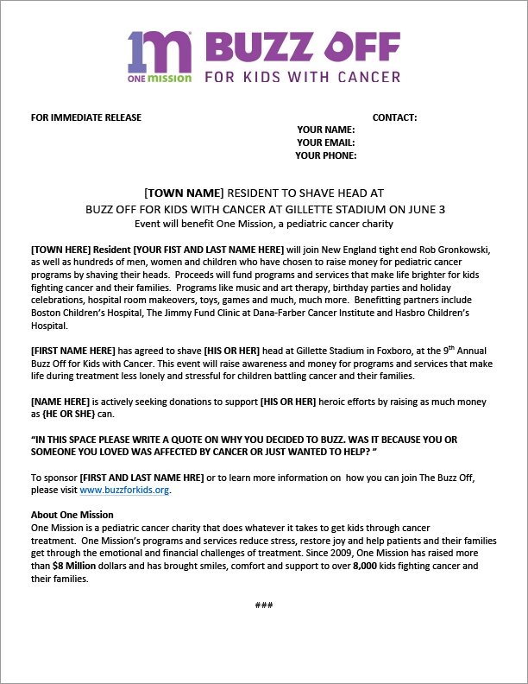

This press release template explains it way better and in an easily discernable way, making it simpler for you to write a press release. Follow this format, and your press release will reach audiences that you desire.

**Some useful press release examples**

It’s a good idea to take a look at a press release example so that you get an idea of the formats being used currently. It might also assist you in writing one.

**Product Launch Apple – iPhone X**

NYC, United States – Apple is launching a new iPhone to its range of smart phones and this one promises to be different in every way from the previous ones. The new iPhone X is has wider screen and sleek design. Based on the latest iOS 11 this smart phone has the best graphics compared to the previous ones. The hexa core processor makes it extremely fast and prevents from hanging now and then. Equipped with face time, finger print locking system and 7 megapixel HDR front camera, this iPhone has all a smart phone user looks for.

The most powerful feature of iPhone X is its graphics. The colors are so vibrant and bold that it is hard to take your eyes of the screen. Secondly, its 12 megapixel autofocus camera that clicks HD pictures giving the result of DSLR. IPhone X is like an all in one kind of smart phone. If you own one you don’t need a DSLR and you can easily watch your favorite YouTube videos on its wide screen.

Above is perhaps one of the best examples of writing a press release. All the required features are included in it. The first body paragraph has all the things to stir the reader’s interest. This will eventually compel the reader to continue reading.

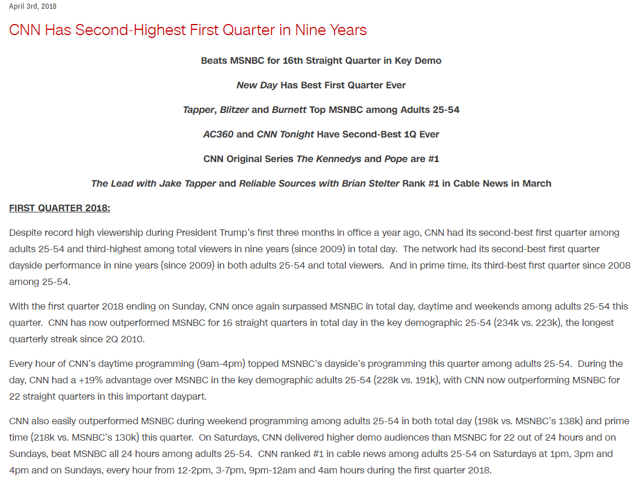

Take a look at this press release by CNN. You can clearly get an idea from the heading and first body paragraph about the main subject of the press release. The last paragraph sums up the entire press release. So, just by reading the headline with the first or last paragraph, you can get an idea of what the press release is about.

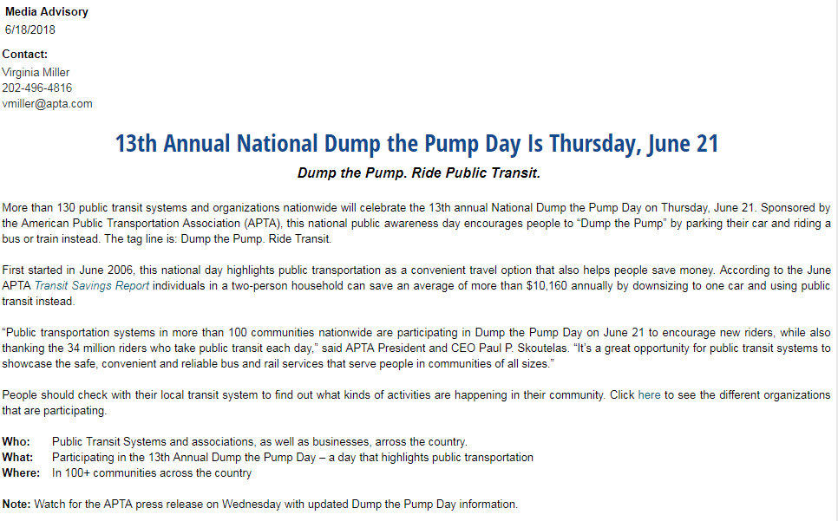

The format of this press release is even better than the previous ones. It has the date and contact information, and the title is center-aligned, which is just what a press release requires for grabbing attention of a target audience. The tagline underneath the title creates more excitement in the reader through which the reader will obviously continue reading.

Also, you can clearly see the answers to all the questions that might enter a reader’s mind at the end of the article. This couldn’t have been done better.

This article focuses on core features of writing a press release. If you choose to follow these steps when writing a press release, you can very easily achieve your targets and goals. It will be easier to reach your audience with these straight forward techniques