Generally, whether in a news agency, television or radio station, newspaper or magazine, the structure is similar and a typical day is identical in content. There are several departments in every media organization - administration, engineering, commercial/advertising, editorial. For the purpose of your communication campaign, the editorial may be the only important department because it is this department that is directly responsible for what is read, heard or seen on the media. It is the department whose partnership is important for the successful construction of public goodwill and support for the vaccine trial. It is therefore useful that you have a sense of the structure of each media organization. Here we offer a general picture of a typical newspaper/news agency, news magazine, radio station and television station.

**Structure of a Typical Newspaper/News Agency**

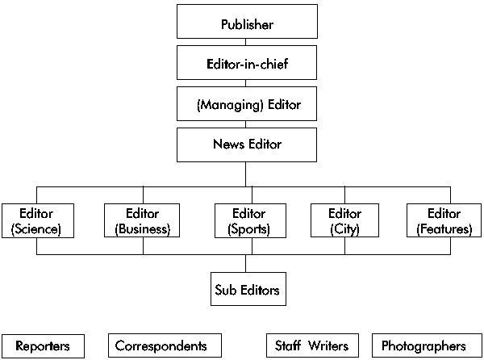  
Structure of a Typical Newspaper/News Agency

A Media Handbook for HIV Vaccine Trials for Africa (UNAIDS, 2001, 45 p