**Communication Models**

A model is widely used to depict any idea, thought or a concept in a more simpler way through diagrams, pictorial representations etc. Models go a long way in making the understanding of any concept easy and clear. Through a model one can easily understand a process and draw conclusions from it. In simpler words a model makes the learning simple.

Communication models are systematic representations of the process which helps in understanding how communication works can be done. Models show the process metaphorically and in symbols. They form general perspectives on communication by breaking communication from complex to simple and keeps the components in order. Communication models can sometimes encourage traditional thinking and stereotyping but can also omit some major aspects of human communication.

Models are used by business companies and other firms to foster their communication, explore their options and to evaluate their own situations. It is also used to understand how the receivers will interpret the message.

Methods and channels of communication to be used and the purpose of communication, must be considered before choosing a specific communication model.

**Types of Communication Models**

# **Aristotle Model of Communication**

Aristotle was the first to take an initiative and design the communication model. According to this model, the **speaker plays a key role in communication**. He is the one who takes complete charge of the communication. The sender first prepares a content which he does by carefully putting his thoughts in words with an objective of influencing the listeners or the recipients, who would then respond in the sender’s desired way. No points in guessing that the content has to be very very impressive in this model for the audience or the receivers to get convinced. The model says that the speaker communicates in such a way that the listeners get influenced and respond accordingly.

In a political meeting, the prospective leader delivers speech to the audience urging for more votes from the constituency. He tries to convince the crowd in the best possible way he can so that he emerges as a winner. **What is he actually doing ?**

He is delivering his speech in a manner that the listeners would get convinced and cast their votes only in his favour, or in other words respond in the same manner the speaker wanted to. Here the leader or the speaker or the sender is the centre of attraction and the crowd simply the passive listeners.

# **Shannon and Weaver Model of Communication**

Shannon and Weaver model is the most popular model of communication and is widely accepted all over the world. Shannon and weaver model simply proposes that a message actually originates from the person who gets the thought or has the information. The sender is also called the Source of information or the Information Source. The information then gets transmitted from the brain to the mouth and comes out as a signal which then reaches the recipient after joining hands with several noises and other disturbances. The recipient then further passes on the message to its final destination or other minds of other individuals.

In 1948, Shannon was an American mathematician, Electronic engineer and Weaver was an American scientist both of them join together to write an article in “Bell System Technical Journal” called “A Mathematical Theory of Communication” and also called as “Shannon-Weaver model of communication”.

This model is specially designed to develop the effective communication between sender and receiver. Also they find factors which affecting the communication process called “Noise”. At first the model was developed to improve the Technical communication. Later it’s widely applied in the field of Communication.

The model deals with various concepts like Information source, transmitter, Noise, channel, message, receiver, channel, information destination, encode and decode.

[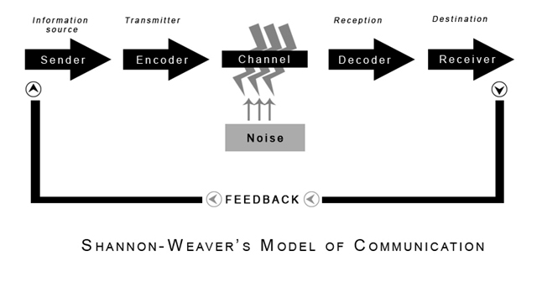](https://www.communicationtheory.org/wp-content/uploads/2011/06/shannon_weaver_model.jpg)

**Sender**:  The originator of message or the information source selects desire message

**Encoder** : The transmitter which converts the message into signals

**Note**: The sender’s messages converted into signals like waves or Binary data which is compactable to transmit the messages through cables or satellites. For example: In telephone the voice is converted into wave signals and it transmits through cables

**Decoder**: The reception place of the signal which converts signals into message. A reverse process of encode

**Note**: The receiver converts those binary data or waves into message which is comfortable and understandable for receiver. Otherwise receiver can’t receive the exact message and it will affect the effective communication between sender and receiver

**Receiver**: The destination of the message from sender

**Note**: Based on the decoded message the receiver gives their feed back to sender. If the message distracted by noise it will affect the communication flow between sender and receiver

**Noise**:  The messages are transferred from encoder to decoder through channel. During this process the messages may distracted or affected by physical noise like horn sounds, thunder and crowd noise or encoded signals may distract in the channel during the transmission process which affect the communication flow or the receiver may not receive the correct message

**Note**: The model is clearly deals with external noises only which affect the messages or signals from external sources. For example: If there is any problems occur in network which directly affect the mobile phone communication or distract the messages

**Practical Example of  Shannon-Weaver model of communication** :

Thomson made call to his assistant “come here I want to see you”.  During his call, noise appeared (transmission error) and his assistant received “I want” only. Again Assistant asked Thomson (feedback) “what do you want Thomson”.

Sender       :   Thomson

Encoder     :   Telephone (Thomson)

Channel     :   Cable

Noise          :   Distraction in voice

Reception  :   Telephone (Assistant)

Receiver     :   Assistant.

Due to transmission error or noise, Assistant can’t able to understand Thomson’s messages.

*The noise which affect the communication flow between them.

**Criticism of Shannon-Weaver model of communication** :

1.       One of the simplest model and its general applied in various communication theories  
2.       The model which attracts both academics of Human communication and Information theorist to leads their further research in communication  
3.       It’s more effective in person-to-person communication than group or mass audience  
4.       The model based on “Sender and Receiver”. Here sender plays the primary role and receiver plays the secondary role (receive the information or passive)  
5.       Communication is not a one way process.  If it’s behaved like that, it will lose its strength. For example: Audience or receiver who listening a radio, reading the books or watching television is a one way communication because absence of feedback  
6.       Understanding Noise will helps to solve the various problems in communication

|  |
| --- |
| **Information Source (Thought / message)** |
| **↓** |
| **Transmitter (Brain to mouth) [Along with noise and distractions-external barriers]** |
| **↓** |
| **Signal** |
| **↓** |
| **Recipient (Receives the signal)** |
| **↓** |
| **Final Destination (Finally gets the message)** |

**Osgood-Schramm Model of Communication**

[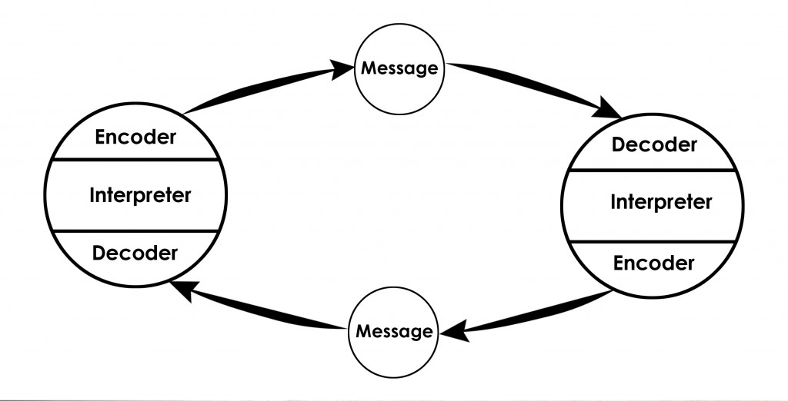](https://www.communicationtheory.org/wp-content/uploads/2010/01/Osgood-Schramm-model-of-communication1.jpg)

The Osgood-Schramm model of communication is a communication theory. It explains how we communicate with one another, mainly though speech, writing and discourse.

**Encoder**– Who does encoding or Sends the message (message originates)

**Decoder** – Who receives the message

**Interpreter** – Person trying to understand (analyses, perceive) or interpret

It emphasizes four key principles:

1. That communication is circular, not linear. The listener can both receive and send messages (in most instances).
2. That communication is usually equal and reciprocal
3. That there is a lot of interpretation involved when receiving a message
4. That all communication requires three steps: encoding, decoding and interpreting a message

### Principle 1: Circular Communication

The image above shows how the Osgood-Schramm model works. It involves circular communication between two people. Each person is both a sender and a receiver. They are therefore able to communicate to one another, rather than only in one direction.

This circular feature of the model is very different from other liner models of the time like the Shannon-Weaver model or [Lasswell’s model of communication](https://helpfulprofessor.com/lasswell-model-of-communication/).

When critiquing linear or ‘transmission’ models such as the Shannon-Weaver model, Schramm argued:

“In fact it is misleading to think of the communication process as starting somewhere and ending somewhere. It is really endless. We are really switchboard centers handling and re-routing the great endless current of information.” (Schramm, 1955)

### Principle 2: Communication involves Interpretation

Schramm was insistent that communication is not simply the passing of a packet of information from a sender to a receiver. Instead, he saw that messages must be interpreted in order for them to be understood.

In the process of interpretation, however, a lot of meaning can be lost. We call the lost or misinterpretation of information “semantic noise” caused by “semantic barriers”. Semantic barriers are specifically the values, beliefs and background knowledge that impact how someone sends and how someone receives messages.

As two-way communication keeps on going in its circular pattern, the semantic noise is ideally reduced because the two communicators can come to shared meaning and give one another further clarification on what they actually mean.

**Note:**Some people call semantic noise a weakness of this model. However, this model simply shows that semantic noise is possible – so it’s not a weakness. If anything, it’s *good* that the authors have shown us what it is and how it works.

### Principle 3: Communication requires Encoding, Decoding and Interpreting

You can see in the image above that each actor in the communication sequence has three roles: encoding, decoding and interpreting.

Here’s how each step works:

* **Encoding:** When we want to send a message, we need to think about how to craft it to get our message across clearly. We need to think of the right words to say and in what order we should send our messages to communicate our ideas to the message receiver.
* **Decoding:**When we receive a message, we need to decode it. A message may be packaged as text, image, advertisement, speech, etc. When receiving a message, we need to use our reading skills, listening skills, etc. to decode the message so it makes sense to us. Sometimes someone may ‘mishear’ or ‘misread’ a message (perhaps if it were mumbled or written by someone who is not a native speaker), which will interfere with their interpretation.
* **Interpreting:**>Now that we understand the medium of communication, we can go about interpreting the message. What does it mean to you? One person may interpret the message in a totally different way to someone else. Or, they may not understand it the same way as the encoder, meaning they have ‘misinterpreted’ the text.

Once someone has decoded and interpreted a message, they can then go about encoding their own message to send back to the original sender. They would in turn go about decoding and interpreting. The cycle continues!

### Principle 4: Equal and Reciprocal Communication

Because both members of the communication have the capacity to encode, decode and interpret, this model views the two members of the conversation as equal participants. This model therefore works very well to understand a face-to-face conversation or text message exchange, for example, where both members of the conversation will have a back-and-forth discussion.

This equal communication model is very different to many others, which see communication as a one-way street where people take the role of either ‘sender’ or ‘receiver’. By contrast, Schramm’s model sees the participants as both sender and receiver of messages

## What are the Pros and Cons of the Osgood-Schramm Model?

### Benefits / Strengths in the Osgood-Schramm Model

* **Shows how feedback can work:**This model works well for explaining cyclical feedback. Other models see communication as being a one-way street, which fail to account for feedback and dialogue. In this model, the speaker can get feedback about their language, jokes, choice of words, etc. so they can try to communicate more and more clearly as the cycle continues.
* **Recognizes that communication is complex:**By accounting for encoding, decoding and interpretation, this model shows how sometimes we can mishear and misinterpret information.
* **Sees us as active communicators:**While other models see people receiving information as passive recipients, this one shows how we’re active in interpreting information we receive.

### Disadvantages / Weaknesses in the Osgood-Schramm Model

* **Doesn’t recognize that communication can be unequal:**There are many circumstance where communication may involve one authority figure talking and one (or many) listeners trying to interpret the message. In such instances, communication is much less equal than in Schramm’s model. Therefore, this model doesn’t tend to work in situations where power balances exist. In fact, this model does a poor job overall of understanding how power functions in communication.
* **Doesn’t work for mass communication:**This is another time communication is unequal. One person communicating to many looks very different to the circular one-to-one model proposed in the Osgood-Schramm approach (for a more appropriate approach for mass media, try the Westley-Mclean model or [Lasswell’s model of Communication](https://helpfulprofessor.com/lasswell-model-of-communication/)).

**Advantage of Osgood- Schramm model of communication**

1. Dynamic model- Shows how a situation can change
2. It shows why redundancy is an essential part
3. There is no separate sender and receiver, sender and receiver is the same person
4. Assume communication to be circular in nature
5. Feedback – central feature.

**Disadvantage of Osgood- Schramm model of communication**

This model does not talk about semantic noise and it assume the moment of encoding and decoding.

Definition: The Osgood-Schramm model of communication is defined as a circular model that shows that messages go in two directions. The model has four key principles: (1) Communication is circular not linear; (2) Communication is usually equal and reciprocal; (3) Messages require interpretation; (4) there are three steps for communicating: encoding, decoding and interpreting.

**New Comb’s model of communication**

Theodore M Newcomb was a great pioneer in the field of social psychology. Merely 50 years he worked for the improvement of human motivation, perception and learning to shape the deep understanding of social process. He published a new social approach in field of communication which is called “ABX” system. Later it became Newcomb’s model.

The main purpose of this model was to introduce the role of communication in a social relationship (society) and to maintain social equilibrium within the social system.

He does not include the message as a separate entity in his model. He concentrates on the social purpose of communication, showing all communication as a means of sustaining relationships between people.

[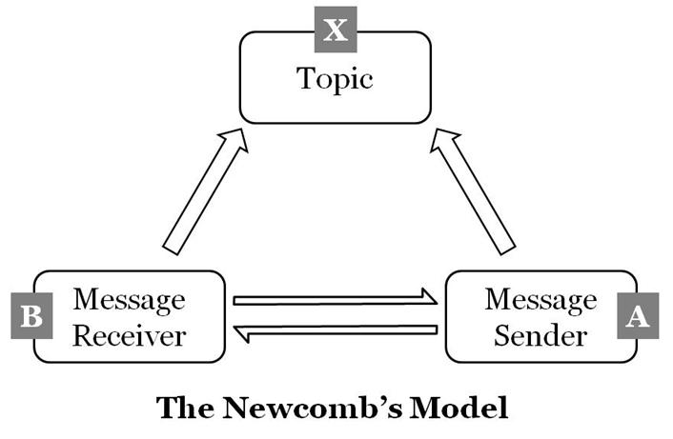](https://www.communicationtheory.org/wp-content/uploads/2011/09/the-newcombs-model-diagram.jpg)

The Newcomb’s model works in a triangular format or A-B-X system

A – Sender

B – Receiver

X – Matter of Concern

The relationship between A and B is like student and teacher, government and public or newspaper and readers. Sender and Receiver may work in a same flow but the same time some factor like “X” may affect their flow of relationship.  “X” it may be third persons, issue, topic or policy.

**For Example**:

Teachers introduce a new policy to increase the college timing from 6 hours to 8 hours.

A – Teachers     B – Students    X – Policy or issue  
If both students and teachers are satisfied with this policy then the communication maintains its equilibrium status between them. Otherwise the flow of communication between “A” and “B” becomes trouble in the social system. If “A” or “B” is not ready to accept the policy then it will directly affect the social system and can’t maintain the equilibrium status. So Teachers”A” can convince students “B” as much as possible. Otherwise they have to make some adjustments in the Policy “X” and convince them towards the policy.

**Harold Lasswell Model**

Lasswell’s communication model was developed by communication theorist Harold D. Lasswell (1902-1978) in 1948. Lasswell’s model of communication (also known as action model or [linear model](https://www.businesstopia.net/communication/linear-model-communication) or one way model of communication) is regarded as one the most influential [communication models](https://www.businesstopia.net/communication).

We consider it to be one of the first simple models of mass media communication. He himself said that the communication process can be best explained in a simple statement: “Who says what to whom in what channel with what effect.“ Who Says What To whom In what Channel With what Effect? Same as Aristotle, Lassell focuses on the oral message emphasising the terms such as speaker, message and audience, even though he uses different terminology and sees also communication as a unidirectional process in which the individual influences the others with his or her message.

### **Components of Lasswell’s Communication Model**

Who? (speaker) What? (message) Channel? (medium) To whom? (listener) Effect (effect) Lasswell’s communication model has 5 components which is used as an analysis tool for evaluating the communication process and components. The components are **the questions to be asked** to get the answers and keep communication going.

| Components | Meaning | Analysis |
| --- | --- | --- |
| **Who** | the communicator or sender or source of message | Control Analysis |
| **Says What** | the content of the message | Content Analysis |
| **In Which Channel** | the medium or media | Media Analysis |
| **To Whom** | the receiver of the message or an audience | Audience Analysis |
| **With What Effect** | the feedback of the receiver to the sender | Effect Analysis |

### **Explanation of different Components of Lasswell’s Model**

* **Control analysis** helps the sender to have all the power.
* **Content analysis**is associated to stereotyping and representation of different groups politically. It is also related to the purpose or the ulterior motives of the message.
* **Media analysis**represents which medium should be used to exercise maximum power against the receivers.
* **Audience analysis**shows who are the target population to be manipulated or brain-washed.
* **Effect analysis** is done before the process starts. It is used to predict the effect of message over the target population to be exploited.

### **Explanation of Lasswell’s Communication Model**

Though Lasswell’s model was developed to analyze [mass communication](https://www.businesstopia.net/mass-communication), this model is used for interpersonal communication or group communication to be disseminated message to various groups in various situations.

Lasswell’s model was developed to study the media propaganda of countries and businesses at that time. Only rich people used to have communication mediums such as televisions and radios back them. It was made to show the mass media culture.

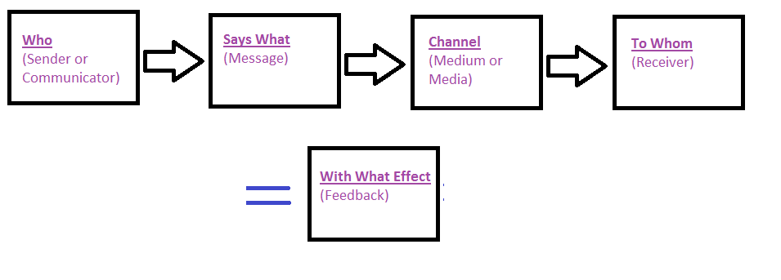

Lasswell also brought the concept of **Effective Communication Process**. He talked about the relation between presentation of facts and how it generates different effects. The use of the concept of effect makes Lasswell’s model non-linear unlike it’s name. It’s because effect can also be taken as feedback

Though, generally, the component of effect was made to be more about outcome of the message, the model is applied in different medias and fields despite being developed specifically for mass communication.

This model is similar to the [communication model proposed by Claude Shannon and Warren Weaver](https://www.businesstopia.net/communication/shannon-and-weaver-model-communication). Their model is more graphical than Lasswell’s. George Gerbner who is the founder of the cultivation theory, expanded Lasswell’s model and included the concept of reaction of the receiver.

### **Disadvantages and Criticisms of Lasswell’s Model**

The major criticism of Lasswell’s Model is that it does not include feedback and it ignores the possibility of noise. Without feedback, a communication process can not be fruitful. Lasswell’s model is very linear and does not consider [barriers in the communication process](https://www.businesstopia.net/communication/physical-barriers).

The model is also criticized for being very general and only including very traditional topics. The model is very simplistic. The model is said to be propaganda based as it is more focused on the resulting outcome and generally used for media persuasion.

# **Berlo’s Model of Communication**

While the Aristotle model of communication puts the speaker in the central position and suggests that the speaker is the one who drives the entire communication, the Berlo’s model of communication takes into account the emotional aspect of the message. Berlo’s model of communication operates on the SMCR model.

In the SMCR model

* S - Stands for **Source**
* M - **Message**
* C - **Channel**
* R – **Receiver**

### S - Source

The source in other words also called the sender is the one from whom the thought originates. He is the one who transfers the information to the receiver after carefully putting his thoughts into words.

### M - Message

When an individual converts his thoughts into words, a message is created. **The process is also called as Encoding**

### C - Channel

Channel - Channel actually refers to the medium how the information flows from the sender to the receiver.

### R - Receiver

When the message reaches the receiver, he tries to understand what the listener actually wants to convey and then responds accordingly. **This is also called as decoding**.

There are several loopholes in the Berlo’s model of communication. According to the berlo’s model of communication, the speaker and the listener must be on a common ground for smooth conversion which is sometimes not practical in the real scenario.

# **Schramm’s Model of Communication**

Schramm’s model of communication which has its roots from the Shannon weaver model itself.

Wilber Schramm proposed the model of communication in 1954.

Information is of no use unless and until it is carefully put into words and conveyed to others. Encoding plays a very important role because it initiates the process of communication by converting the thought into content. When the information reaches the recipient his prime responsibility is to understand what the speaker intends to convey. Unless and until the second party is able to understand or decode the information what the sender wants to communicate, the message is actually of no use. Thus encoding and decoding are two most important factors of an effective communication without which information can never flow between two individuals. Schramm’s model also revolves around the above principle. According to the Schramm’s model, coding and decoding are the two essential processes of an effective communication.

He also emphasizes that the communication is incomplete unless and until the sender receives a feedback from the recipient. Imagine a person sharing his thoughts with his friend and his friend not responding to him. Is the communication complete? NO.Schramm believed that communication is actually a two way process between the first party and the second party.

|  |
| --- |
| **Sender** |
| **M↓ ↑M** |
| **Receiver** |

**M** - *Stands for message*

Schramm believed that an individual’s knowledge, experience and cultural background also play an important role in communication. Individuals from diverse cultures, religion or background tend to interpret the message in different ways.

To conclude according to this model of communication when a sender passes on the information to the receiver, the receiver must interpret it in the desired form the sender wants and give him the feedback or respond accordingly. Any communication where the sender does not get the feedback, the communication is not complete and thus ineffective.