**WHAT IS MENDELEY?**

Mendeley is a free citation manager and academic social network.  In addition, Mendeley allows you to:

* Full-text search across papers
* Annotate and highlight within PDFs
* Organize PDFs and other documents
* Sync across multiple platforms: desktop, web and mobile devices
* Create citations and bibliographies in Word, OpenOffice and LibreOffice
* Collaborate with private groups, public groups and the built-in Mendeley social network

The free version of Mendeley limits you to:

* 2 GB of personal web storage
* 1 Private group of up to 3 people
* 100 MB of group web storage

The Mendeley Web Importer allows you to save references directly to your Mendeley account.  This methods works for databases, such as PubMed and Google Scholar, JumboSearch ([http://tufts.summon.serialssolutions.com/)](http://tufts.summon.serialssolutions.com/), where you can find books and other resources in the Tufts Libraries collection, and publisher websites.

To install the web importer, choose **Tools > Install Web Importer** from the menu bar in Mendeley Desktop.  On the webpage that opens, follow the installation instructions for your browser.

Once the web importer has been installed, click the **Save to Mendeley** button or icon  when viewing a list of results in a database or JumboSearch, or an article on a publisher's website.

Sign in to your Mendeley account, select the references that you want to add to your Mendeley library by checking the box next to each reference or Save all.  If you wish, use the search box at the top of the pop-up box to designate the folder to which you would like the references to be added.  The references will be added to your Mendeley Web account.

In Mendeley Desktop, click the **Sync** button to bring the new references into your desktop library.

Mendeley web importer window

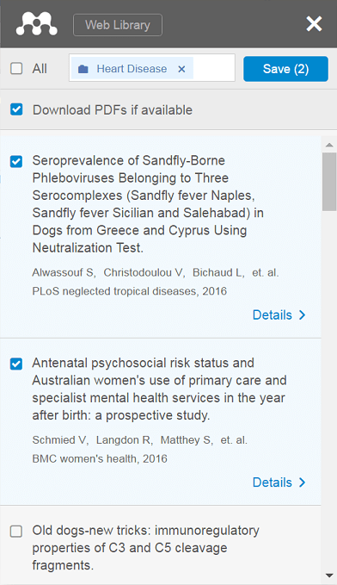

## From Ovid Databases

The Mendeley Web Importer (see box above) does not detect complete citation information for a list of results in some databases, so other methods are necessary when you wish to add multiple references to Mendeley from these databases.

#### OVID DATABASES (MEDLINE, CAB ABSTRACTS, GLOBAL HEALTH, ETC.)

Check the boxes next to the references that you wish to send to Mendeley.  If you wish to send a large set of results, then enter a range in the box at the top of the results (you can export up to 1,000 results at a time from Ovid databases).  Next, click **Export** in the toolbar at the top of the results.

Export results from Ovid

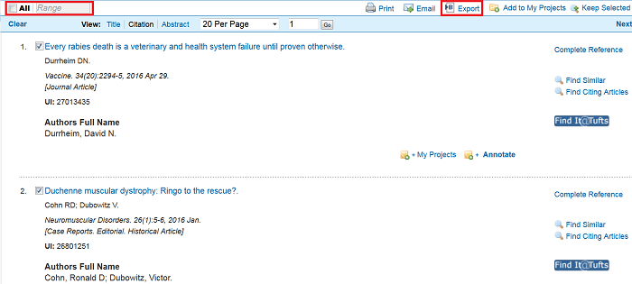

In the box that opens, choose **RIS** from the **Export To** dropdown menu.  Select which fields you would like included in the references, then click **Export Citations**.

In the box that opens, choose the **Open with** radio button and select Mendeley from the drop-down menu.  If you do not see Mendeley in the list of options, then select **Other** and find Mendeley.  Click **OK**.  The references will appear in Mendeley Desktop.

Choose RIS format

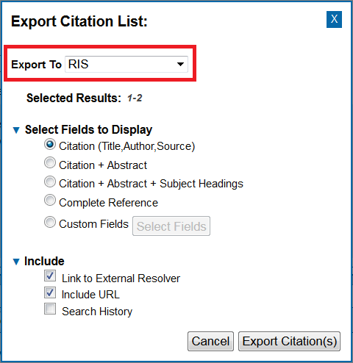

## From Web of Science Databases

The Mendeley Web Importer (see box above) does not detect complete citation information for a list of results in some databases, so other methods are necessary when you wish to add multiple references to Mendeley from these databases.

#### WEB OF SCIENCE DATABASES (CORE COLLECTION, BIOSIS, FSTA)

Check the boxes next to the references that you wish to save.  Scroll to the **Save to** menu at the top of the search results page.  Choose **Save to Other File Formats**.  In the box that opens, select **BibTeX** from the **File Format**drop-down menu.  Click **Send**.

In the box that opens, choose the **Open with** radio button and select Mendeley from the drop-down menu.  If you do not see Mendeley in the list of options, then select **Other** and find Mendeley.  Click **OK**.  The references will appear in Mendeley Desktop.

Save to Other File Formats in Web of Science

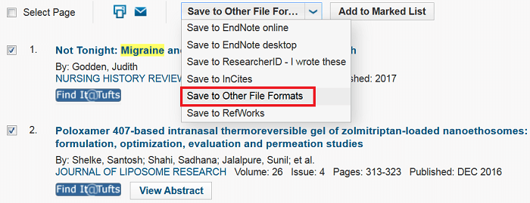

## From a File or Folder

This method of adding references to Mendeley works best for **PDF files**.  Mendeley can extract data from a PDF file to create a new reference.  Always review the reference to ensure that the citation information has been added correctly.

There are three ways to create a reference from a file or folder:

* **Drag and Drop**: Drag and drop a PDF file, or an entire folder of PDF files, from your computer to the center panel in Mendeley Desktop.
* **Add Files**: In Mendeley Desktop, click the **Add Files** button Add File in the upper left corner of the toolbar.  Select the file that you wish to add and click **Open**.
* **Watch Folder**: Files added to a Watch Folder will automatically be imported into Mendeley.  To designate a Watch Folder, choose **File > Watch Folder...** from the menu bar (Note: you can also choose Watch Folder from the **Add Files** dropdown menu in the upper left corner of the toolbar).  Navigate to a folder, check the box next to the folder(s), click **Apply,**then **OK.**

## Manually

If you need to add a reference manually, for example a government document or policy report, then choose **File > Add Entry Manually** from the menu bar (Note: you can also choose Add Entry Manually from the **Add Files** dropdown menu Add Filesin the upper left corner of the toolbar).

Select a reference type from the dropdown menu.  Enter the citation information for your reference, as completely as possible, in the fields provided.  Click **Save**

## Viewing and Editing References

When you click on a reference in Mendeley Desktop, the details for that reference will be displayed in the right-hand panel.  From this panel, you can edit any field (Title, Author, Tags, etc.) or attach a file to the reference.  Whenever you import new references into Mendeley, it is a good idea to review these details to ensure the information is correct.

Click the **Notes**tab at the top of the panel to add notes and view annotations on attached documents.  You can search the notes fields by selecting Notes from the dropdown menu in the search box in the upper right-hand corner of Mendeley Desktop.

Reference panel in Mendeley

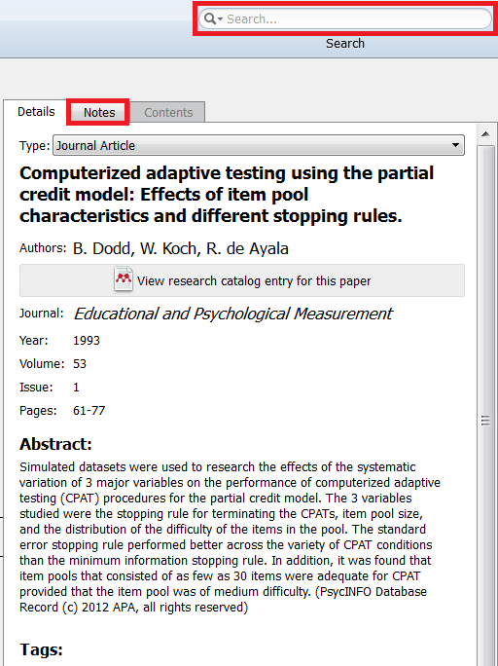

## Creating Folders and Subfolders

Folders are displayed in the left-hand panel of your Mendeley library.  Folders are used to categorize and organize references. Certain folders are always present in your Mendeley library:

* **All Documents**: All references in your library.
* **Recently Added**: References recently added to your library will remain in this folder for 3 weeks.
* **Recently Read**: PDF files that you have recently opened.
* **Favorites**: References that you have starred.
* **Needs Review**: Imported references that require attention.  References in this folder will automatically be removed once they have been reviewed.
* **My Publications**: Add references that you have authored in this folder.  References in this folder will be displayed in your online Mendeley profile.
* **Unsorted**: References not in a folder.

Create your own folders and subfolders to organize your references.  To do so, click **Create Folder...**in the left-hand panel of your Mendeley library.  To create a subfolder, right-click on the folder to which you wish to add a subfolder and select **New Folder**.

[**Back to top**](https://researchguides.library.tufts.edu/c.php?g=249269&p=4031723)

## Organizing References

**Adding References to a Folder**

* Select the reference you wish to move.  Use the **Ctrl**, **Command** or **Shift** keys to highlight multiple references.
* Drag the references to a folder.

**Removing References from a Folder**

* Select the reference you wish to move.  Use the **Ctrl**, **Command** or **Shift** keys to highlight multiple references.
* Right-click and select **Remove from Folder**.
* The references will be removed from the folder.  They will not be deleted from your library.

**Deleting References from a Library**

* Select the reference you wish to move.  Use the **Ctrl** or **Shift** keys to highlight multiple references.
* Drag and drop the references to the **All Deleted Documents** folder under **Trash** in the left-hand panel of your Mendeley library.  Alternatively, right-click and select **Delete Documents**.
* To remove references from the **All Deleted Documents** folder, drag and drop the references to another folder, or right-click and select **Restore Documents**.
* To permanently delete references from your library, right-click on the **All Deleted Documents** folder and select **Empty Trash.**Alternatively, choose **File > Empty Trash** from the menu bar.

[**Back to top**](https://researchguides.library.tufts.edu/c.php?g=249269&p=4031723)

## Removing Duplicates

To check for duplicate references in your Mendeley library, select All Documents in the left-hand panel.  Then, select **Tools > Check for Duplicates** from the menu bar.

A list of duplicate references will be displayed.  Review the references and choose the details that you would like to keep from each reference by selecting the check box next to each field.  Once you have reviewed all the field, click the **Merge Documents** button.

## Attaching and Annotating PDFs

**Attaching Documents**

There are a few ways in which a document can be attached to a reference in your Mendeley library:

* **Create reference from PDF**: If you create a reference by dragging and dropping a PDF into Mendeley, or via Add Files, then the PDF will automatically be attached to the reference in your library.
* **Mendeley Web Importer**: When you use the web importer to add references to your library, PDFs for articles that are freely available (for example from an open access journal) will automatically be downloaded and attached to the reference.
* **Manually**: You can manually attach files, including PDFs, Word documents or images, to references.  In your Mendeley Desktop library, select the reference to which you wish to attach a file.  In the reference details panel on the right side of your library, scroll to the **Files**field and click **Add Files**.

**Annotating PDFs**

You can read and annotate PDF documents in Mendeley on your computer, mobile device, or online (see [Additional Topics](https://tufts.libapps.com/libguides/admin_c.php?g=249269&p=4048271) for more information on Mendeley Web and apps).

Once a PDF has been attached to a reference, a PDF icon will appear next to that reference, and in the Files field of the reference details.  Click this icon to open the article in the Mendeley PDF reader, where you can read, highlight and add notes to the file.

Reference with PDF attached

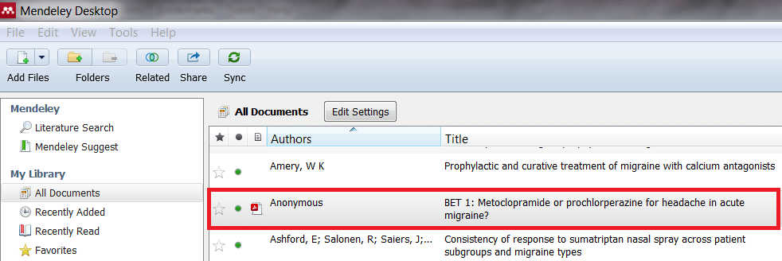

Mendeley PDF reader

