**BigBlueButton Manual**

1. **Enter the website** [**www.aiishpress.ac.in**](http://www.aiishpress.ac.in)
2. **Enter your name**
3. **In the resulting window, select**

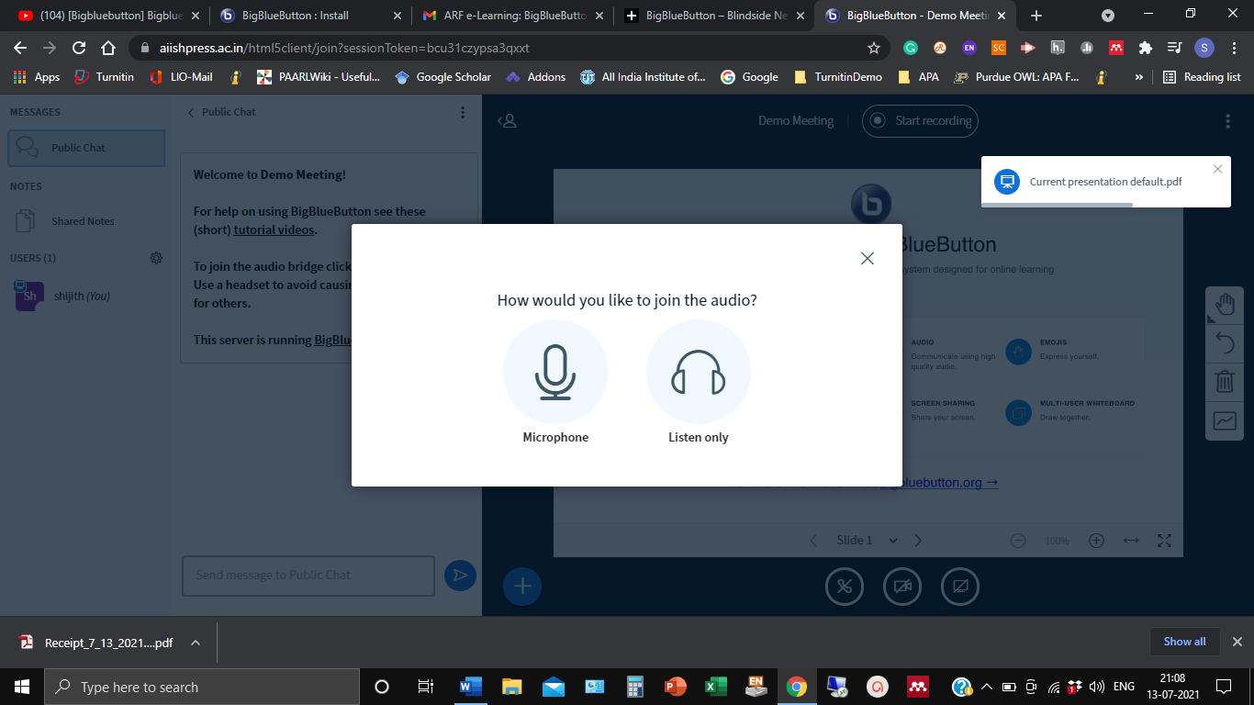

1. **The resulting page has three sections/ parts: (a) Right side presentation area (b) Middle Public chat and (c) left side Participants bar**

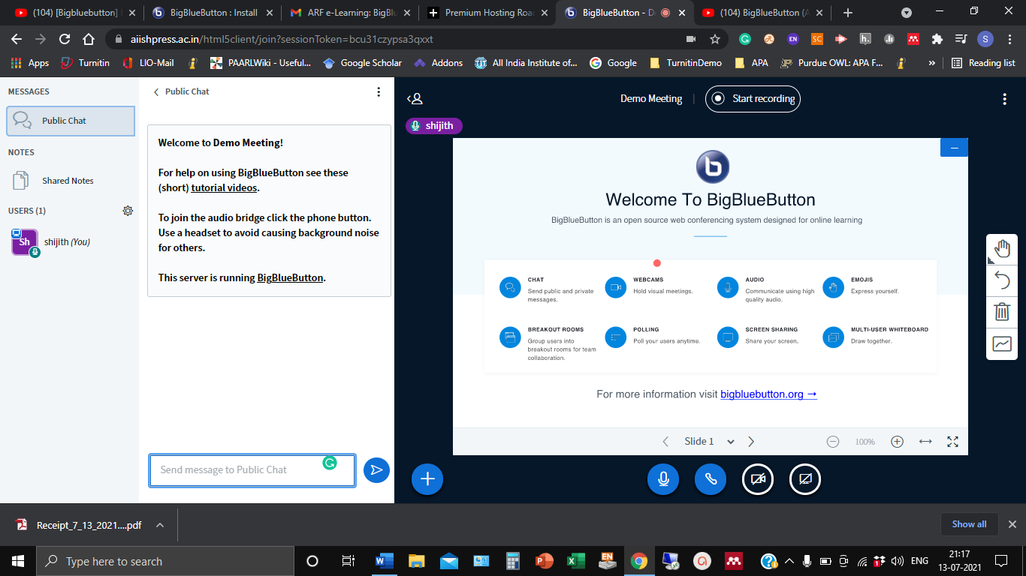

1. **The teacher will have a square icon and the students round icon**