**Biodiversity of Uttarakhand**

**Endangered Species of Uttarakhand**

1. **Introduction**

Biodiversity is the very basis of life on Earth. Biodiversity is extremely complex, dynamic and varied. The state of Uttarakhand is a part of Indian Himalayan System (IHM) which is very rich in biodiversity and is a storehouse of enumerable rare, endangered and endemic floral and faunal species.

An endangered species is a species that is very likely to become extinct in the near future, either worldwide or in a particular political jurisdiction. Endangered species may be at risk due to factors such as habitat loss, poaching and invasive species.

A brief description of five endangered flora species and five endangered fauna species in the state of Uttarakhand is given below.

1. **Endangered Flora**
   1. Aconitum balfourii

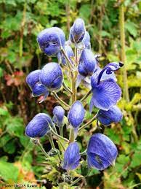

Scientific Name : Aconitum balfourii Stapf

Common name: Mitha/vish

Local Name: Mitha/Banwa

Threats: Over exploited species due to ready market for tubers which are used in ayurvedic medicine

**1.2 Aconitum heterophyllum**

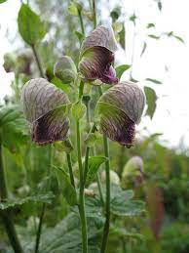

Scientific Name : Aconitum heterophyllum Wall.ex Royale.

Common name : Atis/Patis/Ativish/Atvika

Local Name : Phataki/Atis

Threats: Over exploitation for medicine and due to degradation it has become one of the most highly threatened medicinal plant species that is showing a steady decline.

**1.3 Phaius tancarvilleae**

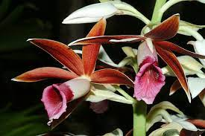

Scientific Name : Phaius tancarvilleae Blume

Common name : Nun’s Orchid, Nun’s Cap Orchid, Chinese Ground Orchid

Local Name : camel's foot, Venus boot

Threats: Extraction from wild for ornamental purpose and trade

**1.4 Pecteilis gigantean**

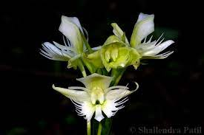

Scientific Name : Pecteilis gigantea Rafi n

Common name : Butt erfl y Orchid, Lady Susan’s Orchid,

Local Name: Waghchora

Threats: Extraction from wild for aesthetic value and trade, habitat degradation.

**1.5 Trachycarpus takil**

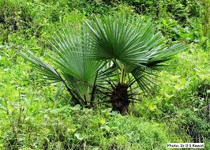

Scientific Name : Trachycarpus takil Becc.

Common name : Thakal

Local Name: Jhagerau

Threats: Extremely poor regeneration and habitat degradation.

1. **Endangered Fauna**

**2.1 Gyps bengalensis**

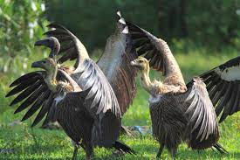

Scientific Name : Gyps bengalensis

Family : Accipitridae

Common name : White-rumped Vulture, Asian White-backed Vulture

Threats: changes in human consumption and processing of dead livestock, and poison and pesticide use

**2.2 Tragopan melanocephalus**

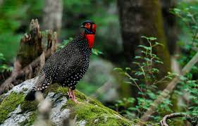

Scientifi c Name : Tragopan melanocephalus

Family : Phasianidae

Common name : Western Tragopan

Vernacular name : Jujurana , Fulgar

Threats: The degradation of the alpine habitat of the Western Tragopan as a result of intensive grazing by livestock has lead to its decline in numbers

**2.3 Ophrysia superciliosa**

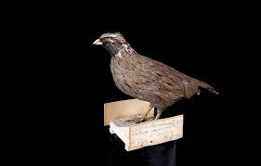

Scientific Name : Ophrysia superciliosa

Family : Phasianidae

Common name : Himalayan Quail

Vernacular Names : Chota kala teetar

Threats: Degradation of habitat is a serious threat to this species.

**2.4 Moschus chrysogaster**

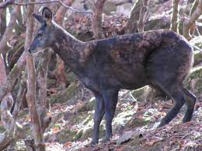

Scientific Name : Moschus chrysogaster

Family : Moschidae

Common name : Himalayan Musk Deer

Local name : Kasturi mrig

Threats: Poaching for musk, and extensive habitat degradation, have led to the decline of musk deer populations and local extinctions

**2.5 Ursus arctos isabellinus**

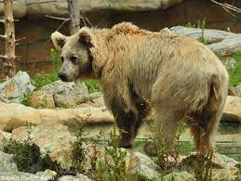

Scientifi c Name : Ursus arctos isabellinus

Family : Ursidae

Common Name : Himalayan brown bear

Local name : Lal bhalu or Burra bhalu

Threats: Poaching for bear parts (gall bladder, bear paws) and retaliatory killings to reduce livestock depredation by herders

**Conclusion**

Endemism is very high in the species found in Uttarakhand also there are other species which has a high threat status. If proper policies and strategies are not formed and proper action is not directed towards the conservation and preservation of these species, then there is every likelihood of these species becoming extinct.

**References**

1. [**http://www.wiienvis.nic.in/Database/uttara_biodiversity_8417.aspx**](http://www.wiienvis.nic.in/Database/uttara_biodiversity_8417.aspx)
2. [**https://sbb.uk.gov.in/files/books/Threatened_Species_Book-CTP.pdf**](https://sbb.uk.gov.in/files/books/Threatened_Species_Book-CTP.pdf)