**Nationalism in India**

1. **Why growth of nationalism in the colonies is linked to an anti-colonial movement?**

People began discovering their unity in the process of their struggle with colonialism. The sense of being oppressed under colonialism provided a shared bond that tied many different groups together. But, in India, each class and group felt the effects of colonialism differently, their experiences were varied, and their notions of freedom were not always the same. The Congress under Mahatma Gandhi tried to forge these groups together within one movement.

1. **Explain the new economic and political situation developed in India due to World War I**

**OR**

**How the First World War help in the growth of the National Movement in India?**

The First World War created a new economic and political situation as mentioned below

1. The defense expenditure had increased.
2. War loans were taken and more taxes were imposed.
3. Custom duties were raised.
4. Income tax was introduced.
5. The rise in prices led to extreme hardships for the people.
6. There was widespread discontentment in the rural area due to forced recruitment of soldiers.
7. In 1918-19 and 1920-21 crops failed in many parts of India resulting in acute shortages of food.
8. Many people died due to the influenza epidemic.

People thought that their hardships and suffering would come to an end after the war but that did not happen. That led the people to support National Movement in India and its growth.

1. **How did the first World War affected the Indians?**

**OR**

**Describe the hardship caused by the First World War on Indians**

The war created a new economic and political situation in the country. In order to meet the war expenses, the British government introduced war loans, increased the existing taxes and introduced income tax. The customs duties on goods were raised. During the war period between 1913 and 1918 the prices doubled. This brought extreme hardship for the common people. The Indian village people were recruited to the military services forcefully which caused widespread anger. Then in 1918-19 and 1920-21, crops failed in many parts of India, resulting in acute shortages of food. This was accompanied by an influenza epidemic. 12 to 13 million Indians died as a result of famines and the epidemic during this period.

1. **Describe the novel method of mass agitation that Mahatma Gandhi used for fighting the racist regime in South Africa**

OR

**Explain the idea behind Satyagraha**

**OR**

1. **Describe the concept of Satyagraha**

In South Africa, Mahatma Gandhi successfully fought the racist government with a novel method of mass agitation, which he called satyagraha. The idea of satyagraha emphasised the power of truth and the need to search for truth. It suggested that if the cause was true, if the struggle was against injustice, then physical force was not necessary to fight the oppressor. Without seeking vengeance or being aggressive, a satyagrahi could win the battle through non-violence. This could be done by appealing to the conscience of the oppressor. People – including the oppressors – had to be persuaded to see the truth, instead of being forced to accept truth through the use of violence. By this struggle, truth was bound to ultimately triumph. Mahatma Gandhi believed that this dharma of non-violence could unite all Indians.

1. **Why did Gandhijith travel to Champaran, Bihar in 1916 ?**

Gandhiji travelled to Champaran, Bihar in 1916 to inspire the peasants to struggle against the oppressive plantation system.

1. **Why did Gandhiji organise satyagraha in Kheda district of Gujarat?**

In 1917, Gandhiji organized a satyagraha to support the peasants of the Kheda district of Gujarat. Affected by crop failure and a plague epidemic, the peasants of Kheda could not pay the revenue, and were demanding that revenue collection be relaxed.

1. **Explain the three satyagrahas organized by Gandhiji**
2. In 1916 Gandhiji went to Champaran, Bihar and inspired the peasants to struggle against the oppressive plantation system.
3. In 1917, Gandhiji organised a satyagraha to support the peasants of the Kheda district of Gujarat who were affected by crop failure and a plague epidemic. They could not pay the revenue, and were demanding that revenue collection be relaxed.
4. Mahatma Gandhi organised a satyagraha movement amongst cotton mill workers of Ahmedabad in 1918.
5. **Explain the Rowlatt Act (1919)**

**OR**

**Why were Indians outraged by the Rowlatt Act ?**

The Rowlatt Act was an Act passed by the Imperial Legislative Council in 1919. Indians were outraged by the Act, as it gave the government a lot of powers to repress political activities and allowed the detention of political prisoners without trial for two years. The Rowlatt Act was passed quickly although the Indian members in the Legislative Council unitedly opposed it.

1. **Explain the Jallianwalla Bagh incident**

Martial law was imposed in Amrithsar, Punjab on 10th April 1919 to control people who were protesting against Rowlatt Act. On 13 April 1919, a large crowd gathered in the enclosed ground of Jallianwalla Bagh in Amrithsar. Some came to protest against the government’s new repressive measures like the Rowlatt Act. Others had come to attend the annual Baisakhi fair. Being from outside the city, many villagers were unaware of the martial law that had been imposed. The British General Dyer entered the area, blocked the exit points, and opened fire on the crowd, killing hundreds.

1. **Explain the effects of Jallianwala Bagh massacre**
2. After the Jallianwala Bagh massacre crowds took to the streets in many north Indian towns. There were strikes, clashes with the police, and attacks on government buildings.
3. The government, on the other hand, followed a policy of repression.  
   (a) They humiliated and terrorized people.

(b) Satyagrahis were forced to rub their noses on the ground.  
(c) They were forced to crawl on the streets and salam all sahibs.

(d) People were flogged.

(e) Some villages around Gujranwala in Punjab were bombed. As the violence spread, Gandhiji called off the movement.

1. **Why did Mahatma Gandhi withdraw the non-violent civil disobedience against the Rowlatt Act?**

A series of violence irrupted in the country following the Jallianwalla Bagh incident on 13 April 1919. The crowds took to the streets in many north Indian towns. There were strikes, clashes with the police, and attacks on government buildings. The government responded with brutal repression, seeking to humiliate and terrorize people: satyagrahis were forced to rub their noses on the ground, crawl on the streets, and do *salaam* (salute) to all sahibs; people were flogged and villages around Gujranwala in Punjab,( now in Pakistan) were bombed. Seeing violence spread, Mahatma Gandhi called off the civil disobedience movement against the Rowlatt Act.

1. **Explain the Khilafat movement**

The First World War had ended with the defeat of Ottoman Turkey. And there were rumors that a harsh peace treaty was going to be imposed on the Ottoman emperor, i.e. the spiritual head of the Islamic world (the Khalifa). To defend the Khalifa’s temporal powers, a Khilafat Committee was formed in Bombay in March 1919. A young generation of Muslim leaders like the brothers Muhammad Ali and Shaukat Ali were the leaders of the Khilafat Movement. Gandhiji saw this as an opportunity to bring Muslims under the umbrella of a unified national movement and started a non-cooperation movement in support of Khilafat as well as for swaraj.

1. **Gandhiji saw this as an opportunity to bring Muslims under the umbrella of unified** **national movement” Can you explain that opportunity.**

That opportunity was ‘Khilafat Issue’. The First World War ended with the defeat of Ottoman Turkey. And there were rumours that a harsh peace treaty was going to be imposed on the ottoman emperor-the spiritual head of the Islamic world (the Khailifa). To defend the khalifa’s temporal power, a khilafat committee was formed in Bombay in March 1919. A young generation of Muslims leaders likes the brothers Muhammad Ali and Shaukat Ali, Began discussing with Mahatma Gandhi about the possibility of a united mass action on the issue. Gandhiji saw this as an opportunity to bring Muslims under the umbrella of unified national movement.

1. **What was Gandhiji’s idea behind starting Non-cooperation movement?**

**OR**

**Why did Gandhijit start Non-cooperation movement?**

Mahatma Gandhi declared that British rule was established in India with the cooperation of Indians, and had survived only because of this cooperation. If Indians refused to cooperate, British rule in India would collapse within a year, and swaraj would come. Hence, Gandhiji started **Non-cooperation movement**

1. **What were the main ideas of Gandhiji behind ‘Non Co-operation’?**

**Ans.**Gandhiji in his famous book Hind Sawraj declared that British Rule was established in India with the cooperation of Indians, and successful only because of our cooperation.If Indians refused to cooperate, British rule in India would collapse within a year and swaraj would come. According to Gandhiji it should begin with the surrender of titles that the British government awarded, and a boycott of civil services, army, police, courts and legislative councils, schools and foreign

1. **What were three proposals regarding Non- Cooperation movement, as suggested by** **Mahatma Gandhi?**

1. The movement was to be unfolded in stages.

2. It should begin with the surrender of titles awarded by the government and boycott of civil services, army, police, courts, legislative council, schools and foreign goods.

3. Then, In case the government used repression, a civil disobedience movement would be launched.

1. **How did congress party react to Gandhiji’s proposal for the Non- Cooperation movement?**

**OR**

**Can you explain why some congress leaders were reluctant to boycott the council** **elections of November 1920?**

Many within the congress were, concerned about the proposals given by Gandhiji. They were reluctant to boycott the council elections of November 1920 because they feared that the Movement might lead to popular violence. In the months between September and December, there was an instance tussle within the congress. For a while, there seemed no meeting point between the supporters and the opponents of the movement. Finally, at the Congress session at Nagpur in December 1920, a compromise was worked out and the Non cooperation program was adopted.

1. **The effects of non-cooperation on the economic front were more dramatic. Explain.**

**OR**

**Highlight the effects of Non Cooperation movement on the economy of India.**

The non-cooperation movement had a major impact on economic matters of the country. People boycotted foreign goods, picketed liquor shops, and foreign cloth burnt in huge bonfires. As a result, the import of foreign cloth halved between 1921 and 1922, its value dropping from Rs 102 crore to Rs 57 crore. In many places, merchants and traders refused to trade in foreign goods or finance foreign trade. As the boycott movement spread, and people began discarding imported clothes and wearing only Indian ones, production of Indian textile mills and handlooms went up.

1. **Explain the reasons for the gradual slow down of non-cooperation movement in the cities?**

The non-cooperationmovement in the cities gradually slowed down for a variety of reasons. Khadi cloth was often more expensive than mass-produced

mill cloth and poor people could not afford to buy it. Hence, they could not boycott mill cloth for a longer period. Similarly the boycott of British institutions posed a problem. For the movement to be successful, alternative Indian institutions had to be set up so that they could be used in place of the British ones. These were slow to come up. So students and teachers went back to government schools and lawyers joined back work in government courts run by the British.

1. **Explain the ups and downs of non-cooperation movement in Indian cities**

**OR**

**How had non-cooperation spread in cities ? Explain. Why did it gradually slow down ?**

**OR**

**Explain how the middle-class participated in the** **non-cooperation movement in the cities**

The movement started with middle-class participation in the cities. Thousand of students and teachers left the British-run schools and lawyers gave up their practices. The council elections were boycotted in most provinces except Madras. On the economic front, foreign goods were boycotted, liquor shops picketed, and foreign cloth burnt. The import of foreign cloth and its value dropped considerably. People discarded imported clothes and wore only Indian ones, resulting in increased production in Indian textile mills and handlooms. Merchants and traders refused to trade in foreign goods or finance foreign trade.

The non-cooperationgradually slowed down. The Khadiclothes were expensive and hence, ordinary people were forced to purchase the cheap mill-made foreign clothes. Similarly, though the people were ready to boycott of British institutions forever, enough Indian institutions were not available to complete their education or to get employed. So, the students and teachers went back to government schools and lawyers joined back work in courts governed by the British.

1. **Explain the Economic effects of the Non-Cooperation Movement**

The Economic effects of the Non-Cooperation Movement were as given below.

* + 1. The import of foreign cloth decreased from Rs. 102 crores to Rs. 57 crore between 1921 and 1922
    2. In many places merchants and traders refused to trade in foreign goods or finance foreign trade.
    3. People discarded foreign clothes and started wearing only Indian clothes. This led to increased production by the Indian textile mills and handlooms.

1. **Why did the non-cooperation movement in the cities gradually slowed down?**

The non-cooperation movement in the cities gradually slowed down for the reasons given below :

1. Khadi was often more expensive than mass-produced mill cloth and poor people could not afford to buy it.
2. Similarly the boycott of British institutions failed because to be successful alternative Indian institutions could not be set up in place of the British ones. As a result of it, students and teachers began to go back to government schools.
3. The lawyers too joined back work in government courts.
4. **Write a note on Awadh Peasant Struggle**

**OR**

**What were the methods used by peasants of Awadh to achieve their goal? Explain.**

**Problems faced by the peasants in Awadh**

1. In Awadh, the talukdars and landlords extracted very high rents and a variety of other cesses from the peasants.

2. The peasants also had to do ‘begar’ labour for the landlords and work on their farms without any remuneration.

3. There was no security of tenure and peasants were often evicted, in order to deny any opportunity for them to develop a right over the land they cultivated

**Mode of protest by Peasants in Awadh**

* 1. In many places **nai-dhobi bandhs** were organized by panchayats to deprive landlords of the service of even barbers and washer men.
  2. The peasant movement demanded reduction of revenue, abolition of beggar and social boycott of oppressive landlords.
  3. Some peasants denied doing beggar-work without at landlords’ farms without any payment.
  4. Oudh Kisan Sabha was set up headed by Jawaharlal Nehru, Baba Ramchandra and a few others with over 300 branches.
  5. As the movement spread in 1921, the houses of talukdars and merchants were attacked, bazaars were looted.

Baba Ramchandra, a sanyasi coordinated the peasants’ strike in Awadh.

1. **Explain the strike of tribal peasants in Gudem Hills of Andhra Pradesh**

**OR**

**The message of Mahatma Gandhi and the idea of swaraj were interpreted in different ways by people. Justify the statement with the tribal peasant strike in Gudem Hills of Andhra Pradesh.**

In the Gudem Hills of Andhra Pradesh, the British government prevented the tribal people from entering the forest to graze their cattle, and to collect fuelwood and fruits. In addition, the government forced them to contribute *beggar* for road building. The tribals felt that their rights were denied and hence, protested against the government under the leadership of Alluri Sitaram Raju. Alluri Sitaram Raju made the illiterate tribals believe that he had special powers, make correct astrological predictions and heal people, and he could survive even bullet shots. Inspired by Gandhiji and the Non-Cooperation Movement, Raju persuaded people to wear *khadi* and give up drinking. However, he asserted them that liberation of India from the British is only possible using force, not non-violence. The tribals believed Raju as an incarnation of God. They obeyed him and attacked police stations, attempted to kill British officials and carried on guerrilla warfare for achieving swaraj. Raju was captured and executed in 1924, and over time became a folk hero.

1. **Explain the character of Alluri Sitaram Raju, the tribal leader of Gudem Hills of Andhra Pradesh.**

Alluri Sitaram Raju was a person with a unique character. He led a militant guerrilla movement against the colonial government by coordinating with the tribal people of Gudem Hills of Andhra Pradesh. The tribals were unsatisfied with the British Government’s prevention of them from entering forest, collecting fruits and grazing cattle. Alluri Sitaram Raju made the illiterate tribals believe that he had special powers, make correct astrological predictions and heal people, and he could survive even bullet shots. Inspired by Gandhiji and the Non-Cooperation Movement, Raju persuaded people to wear *khadi* and give up drinking. However, he asserted them that liberation of India from the British is only possible using force, not non-violence. The tribals believed Raju as an incarnation of God. They obeyed him and attacked police stations, attempted to kill British officials and carried on guerrilla warfare for achieving swaraj. Raju was captured and executed in 1924, and over time became a folk hero.

1. **The message of Mahatma Gandhi and the idea of swaraj were interpreted in different ways by people. Justify the statement with the plantation workers in Assam**

The plantation workers in Assam were not permitted to leave the tea gardens without permission under the Inland Emigration Act of 1859. They used the non-cooperation movement as an opportunity and thousands of workers left the plantations and moved to their homes. They believed that Gandhi Raj was coming and everyone would be given land in their own villages. However, before reaching home, they were caught by the police and brutally beaten up.

1. **Non-Cooperation Movements in the countryside were not as defined by the Congress programme. Even then, they contributed to India’s independence. Explain**

It is true that many of the strikes taken place in country side were not as defined by the Congress programme. The people involved in these movements interpreted the term *swaraj* in their own ways, imagining it to be a time when all suffering and all troubles would be over. Yet, when the tribals, plantation laborers, and peasants chanted Gandhiji’s name and raised slogans demanding ‘*Swatantra Bharat’*, they were also emotionally relating to an all-India agitation. When they acted in the name of Mahatma Gandhi, or linked their movement to that of the Congress, they were identifying with a movement that went beyond the limits of their immediate locality.

1. **Why did Mahatma Gandhi decide to withdraw from the Non-Cooperation Movement?**

**Non-Cooperation Movement** was turning violent in many places. At  **Chauri-Chaura** in Gorakhpur in Uttar Pradesh, a peaceful demonstration in the bazaar turned into a violent clash in which more than 20 policemen were killed. Gandhiji felt that the satyagrahis needed to be properly trained before they would be ready for mass struggles. Hence, in February 1922, he decided to withdraw from the Non-Cooperation Movement.

1. **Explain the factors that led to the withdrawal of Non-Cooperation Movement**

Gandhiji felt the movement was turning violent in many places and satyagrahis needed to be properly trained before they would be ready for mass struggles.

Within the Congress, some leaders were by now tired of mass struggles and wanted to participate in elections to the provincial councils that had been set up by the Government of India Act of 1919. They felt that it was important to oppose British policies within the councils, argue for reform and also demonstrate that these councils were not truly democratic. C. R. Das and Motilal Nehru formed the Swaraj Party within the Congress to argue for a return to council politics.

1. **Elaborate on the internal debate and dissension that shaped Indian politics towards the late 1920s.**

Within the Congress, some leaders were tired of mass struggles as a part of non-cooperation movement and wanted to participate in elections to the provincial councils that had been set up by the Government of India Act of 1919. They felt that it was important to oppose British policies within the councils, argue for reform, and also demonstrate that these councils were not truly democratic. C. R. Das and Motilal Nehru formed the Swaraj Party within the Congress to argue for a return to council politics. However, younger leaders like Jawaharlal Nehru and Subhas Chandra Bose pressed for more radical mass agitation and for full independence.

1. **Why did the Simon** **Commission constitute?**

The new Tory government in Britain constituted a Statutory Commission under Sir John Simon in 1928 in response to the nationalist movement in India. The commission was to look into the functioning of the constitutional system in India and suggest changes. The problem was that the commission did not have a single Indian member. They were all British.

1. **Simon Commission was greeted with slogan “Go Back Simon” at arrival in India. Support this reaction of Indians with arguments.**
   * + 1. In 1928, Simon Commission was constituted by the Tory government in Britain in response to the nationalist movement.
       2. The object of the Commission under Sir John Simon, was to look into the functioning of the constitutional system in India and suggest changes. But the problem was that the commission did not have a single Indian member. All the members were British.
       3. It was under these circumstances that the Indians decided to boycott the commission. So when the commission arrived in India in 1928, it was greeted with the slogan ‘Go back Simon’. All parties including the Congress and the Muslim League, participated in the demonstrations.
2. **Describe the main events leading to Civil Disobedience Movement or Salt- Satyagraha in 1930.   
                                     Or  
   Describe the different factors that shaped the political situations in the late 1920s.**  
   The main events/factors that led to start of Salt Satyagraha were as mentioned below:
3. Boycott of Simon Commission.
4. Announcement of Lord Irwin in October 1929.  
   **(a)** In October 1929 in order to win over Congress and the Muslim League, Lord Irwin Viceroy made an offer of ‘dominion status’ for India in an unspecified future.  
   **(b)** He also stated that a Round Table Conference would be held to discuss a future constitution for India.
5. These actions of Lord Irwin could not satisfy the radicals within the Congress.
6. Subash Chandra Bose and Jawaharlal Nehru became more assertive.
7. The liberals and moderates who were demanding constitutional system within the frame work of British dominion lost their influence.
8. Under these circumstances, Congress Session at Lahore was held in December 1929, under the presidency of Jawaharlal Nehru.
9. At Lahore session, Congress passed a resolution for ‘Purna Swaraj’ or full independence for India. It was declared that 26 January, 1930 would be celebrated as Independence Day and people were to take a pledge to struggle for independence. Thus, the stage was ready for next part of struggle against the British government
10. **What were the main demands put forward by Gandhiji in his letter dated 31st January 1930 to Viceroy? What was the object and importance of Salt Tax?**  
    **(a)** At the Lahore session of Congress, ‘Purna Swaraj’ was passed and it was decided to celebrate 26 January 1930 as Independence Day. The congress authorized Gandhiji to start a movement. Before starting a movement, Gandhiji wrote a letter on 31st January 1930 stating 11 demands which were wide ranging.

**(b)** The abolition of Salt Tax was the most important demand because salt was consumed by the rich as well as poor. It was one of the most essential items of food. The monopoly of the government over its production revealed the most oppressive policy of the British government. , So to attract each and everyone into the movement, Gandhiji included abolition of salt tax in his  
eleven demands. The demands were, however, not accepted by the Viceroy. Hence, the congress and Gandhiji started the Civil Disobedience Movement including Salt Satyagraha.

**36. Explain the Dandi March**

Mahatma Gandhi found in salt a powerful symbol that could unite the nation. Salt was something consumed by the rich and the poor alike, and it was one of the most essential items of food. According to Gandhiji, the tax on salt and the government monopoly over its production are the evidences of oppressive face of British rule. On 31 January 1930, he sent a letter to Viceroy Irwin stating eleven demands. Of these, the most important demand was to cancel the tax on salt. Since the British government rejected Gandhiji’s demand, he started the famous salt march accompanied by 78 of his trusted volunteers from Sabarmati ashram to the Gujarati coastal town of Dandi. On 6 April he reached Dandi, and ceremonially violated the law, manufacturing salt by boiling sea water.

1. **How as the Civil obedience Movement different from Non Cooperation Movement?** **State any three points of difference.**

i) Non-cooperation Movement was launched in 1920 to 1922, while the Civil Disobedience Movement continued from 1929 to 1934.

ii) The Non-cooperation Movement was launched because of the anger of Jallianwala Bagh and against Rowlett Act, while Civil Disobedience movement was launched against the arrival of Simon Commission.  
iii) The Idea of Non-Cooperation includes that if the Indians refused to cooperate, British rule in India will collapse within a year and swaraj would come. But the idea of Civil Disobedience Movement includes breaking **and** disobeying colonial rules.

1. **How did the rich peasants react to the civil disobedience movement?**

**OR**

**Why did the Rich peasant communities become active in the Civil Disobedience** **Movement?**

The rich peasant communities such as Patidars of Gujarat and the Jats of Uttar Pradesh actively participated in the civil disobediencemovement. They were the producers of commercial crops. With the trade depression and falling price of crops, they were at loss and found it impossible to pay the government’s revenue tax. The government refused their request to reduce the tax demand made them very unhappy. Thus, the rich peasants enthusiastically supported the Civil Disobedience Movement and encouraged their community members to participate in the boycott programs. For them, the fight for swaraj was a struggle against high revenues. But, the rich peasants become disappointed when the civil disobediencemovement was called off in 1931 without reducing the revenue tax. So, when the movement was restarted in 1932, many of them refused to participate.

1. **How did the poor peasants react to the civil disobedience movement?**

The poorer peasants were interested in lowering the revenue tax. Also, many of them were small tenants cultivating land they had rented from landlords. As the trade depression continued and cash incomes reduced, they found it difficult to pay their rent. They joined a variety of radical movements, often led by socialists and communists, and carried out ‘no rent’ campaigns. The congress party did not support the poorer peasants’ strike against the landlords, thinking that it will upset the relationship between the party and rich peasants and landlords. As a consequence, the Congress lost the support of the poor peasants.

1. **How did the business class people relate to the civil disobedience movement?**

The First World War made the Indian merchants and industrialists rich and powerful. They wanted changes in the colonial business in their favour. The demands of Indian businessmen include protection against imports of foreign goods, and a rupee-sterling foreign exchange ratio that would discourage imports. To strengthen their activities, the Indian business men organized the Indian Industrial

and Commercial Congress in 1920 and formed the Federation of the Indian Chamber of Commerce and Industries (FICCI) in 1927. The Indian industrialists and businessmen led by prominent industrialists like Purshottamdas Thakurdas and G. D. Birla, supported the Civil Disobedience Movement and attacked colonial control over the Indian economy. They also gave financial assistance to the movement and refused to buy or sell imported goods. They thought, with *swaraj* colonial restrictions on business will end and trade and industry would flourish without constraints. But

the failure of the Round Table Conference, spread of militant activities, prolonged

disruption of business and the growing influence of socialism amongst the younger members of the Congress made them unhappy and less enthusiastic towards the Civil Disobedience Movement.

1. **How did the industrial working class people (industrial labourers ) react to the civil disobedience movement?**

The industrialist and landlords were close to congress party. Because of this, the industrial workers stayed away from congress party and did not participate in Civil Disobedience Movement in large numbers, except in Nagpur. However, a few of them selectively participated in the movement by adopting some of the ideas of the Gandhian programme, like boycott of foreign goods, as part of their own protest against low wages and poor working conditions.

Thousands of tin mine workers in Chotanagpur wore Gandhi caps and participated in protest rallies and boycott campaigns in 1930. Similarly, railway workers in 1930 and dockworkers in 1932 participated in the strike. But the Congress did not include the demands of the workers in their program of struggle as the party felt that such a move will spoil the relationship with the industrialists thereby dividing the anti-imperial forces.

1. **Explain the role of women in the civil disobedience movement**

The large-scale participation of women was an important feature of the Civil Disobedience Movement. Thousands of women came out of their homes to listen to Gandhiji during his salt march. They participated in protest marches, manufactured salt, and picketed foreign cloth and liquor shops. Many went to jail. The women from the high-caste families in urban areas and rich peasant households of rural areas participated in the movement. They were motivated by Gandhiji’s words and considered the service to the nation as a sacred duty.

However, the increased public role did not change the position of women in the family, and society. According to Gandhiji it was the duty of women to look after home and hearth, be good mothers and good wives. Moreover, for a long time , the congress party did not to allow women to hold any position of authority within the party and the presence of women in the party was just symbolic.

1. **Discuss the Limits of Civil Disobedience**

When the Civil Disobedience Movement started there was thus an atmosphere of suspicion and distrust between communities in the country. They did notmove by the abstract concept of swaraj.

One such group was the nation’s ‘untouchables’ or Dalit or oppressed. The Congress, most of the time ignored the Dalits to ensure the support of the conservative high-caste Hindus. Gandhiji, on the other hand, declared that swaraj would not come for a hundred years if untouchability was not eliminated.

But many Dalit leaders believed that political empowerment, would resolve the problems of their social disabilities. Dalit participation in the Civil Disobedience Movement was therefore limited, particularly in the Maharashtra and Nagpur region where their organization was quite strong Dr. B.R. Ambedkar, who organized the Dalits into the Depressed Classes Association in 1930, clashed with Mahatma Gandhi at the second Round Table Conference by demanding separate electorates for Dalits.

Some of the Muslim political organisations in India were also lukewarm in their response to the Civil Disobedience Movement. After the decline of the Non-Cooperation-Khilafat movement, a large section of Muslims felt alienated from Congress. From the mid-1920s, Congress came to be more visibly associated with openly Hindu religious nationalist groups like the Hindu Mahasabha. As relations between Hindus and Muslims worsened, each community organized religious processions with militant fervor, provoking Hindu-Muslim communal clashes and riots in various cities. Every riot deepened the distance between the two communities.

1. **Why did the political leaders differ sharply over the question of separate electorates**

In a system of separate electorates, people of one religion or community only vote for a candidate of their own religion or community.

The different political leaders differed over the question of separate electorates because of the following reasons:

1. The Congress leaders opposed the policy of the British Government in instigating different peoples in demanding a separate electorate. They knew well that the British Government was encouraging different communities and groups to ask for separate electorates because such a policy would weaken the national movement, and prolong Britishers’ stay in India. Hence, the Congress leaders were in favor of joint electorates.
2. The Muslim leaders, like Muhammed Iqbal and Mr Jinnah asked for separate electorates for the Muslims to safeguard the political interests of Muslims. In their opinion, the majority of the people were Hindus, and so in the case of joint electorates, the Muslims would have little chance of winning the seats. As such, they would always be at the mercy of the Hindus.
3. The leaders of the Depressed or Dalits like, Dr. B.R. Ambedkar, also asked for separate electorates because, in the joint electorates, he feared the dominance of the upper caste Hindus in the elections. By the Poona Pact he, however, agreed to have joint electorates with the Hindus, provided the seats for the Depressed Classes were fixed or reserved in the Provincial and Central Legislative Councils.
4. **What is a separate electorate? Why do you think Gandhiji was against the demand of** **separate electorate by B R Ambedkar?**

In a system of separate electorates, people of one religion or community only vote for a candidate of their own religion or community. A separate electorate for Dalits means that Dalits will choose their representative from among the Dalit voters in a constituency.

Gandhiji was against the demand of a separate electorate of Dr B R Ambedkar because he believes that separate electorates for Dalits would slow down the process of their integration into society.

1. **Explain the views and efforts of Gandhiji to eradicate untouchability**

According to Gandhiji, swaraj would not come for a hundred years if untouchability was not eliminated. He called the ‘untouchables’ or Dalits using the Sanskrit ‘harijan’ which means the children of God. Gandhiji organised satyagraha to secure Dalits’ entry into temples, and access to public wells, tanks, roads, and schools. He himself cleaned toilets to dignify the work of the bhangi (the sweepers), and persuaded upper castes to change their hearts and give up ‘the sin of untouchability’.

However, Dr B.R. Ambedkar, the most prominent Dalit leader in the country, clashed with Mahatma Gandhi at the second Round Table Conference by demanding separate electorates for Dalits. When the British government conceded Ambedkar’s demand, Gandhiji began a fast unto death. He believed that separate electorates for Dalits would slow down the process of their integration into society. Ambedkar ultimately accepted Gandhiji’s position and as a result, reserved seats were allotted for the Depressed Classes (later to be known as the Scheduled Castes) in provincial and central legislative councils, but they were to be voted in by the general electorate.

1. **Which political solutions were adopted by Dalits leaders to the problems of their** **community?**  
   i) Many Dalits leaders believed that issue of untouchability and other problems faced by the Dalits could be better solved by political means.

ii) They began organizing themselves and demanding reserved seats in elections

iii) They also asked for separate electorate that would choose Dalits members for legislative councils.

iv) Dr B R Ambedkar organized the Dalits and formed a Depressed classes Association in 1930s.

v) These voluntary organizations also receive financial support from the government for creating awareness among people.

1. **Describe Poona Pact of September 1932.**

When the British government conceded Ambedkar’s demand for a separate electorate for the Dalits, Gandhiji began a fast unto death. Gandhiji believed that separate electorates for Dalit would slow down the process of their integration into society. Ultimately, Poona Pact was signed in September 1932. This gave the Depressed Classes reserved seats in provincial and central legislative councils. They were, however, to be voted in by the general electorate be., by all the voters in a constituency.

1. **Explain different ways adopted to spread nationalism during the pre-independence period in India**

Nationalism spreads when people begin to believe that they are all part of the same nation when they discover some unity that binds them together. History and fiction, folklore and songs, popular prints and symbols, all played a part in the making of nationalism. In India, the nationalism spread in the following ways:

1. **Image of Bharat Mata:** The identity of India was visualized with the image of Bharat Mata, an imaginary mother figure. Devotion to mother figure was treated as evidence of one’s nationalism. Bharat Mata was first created by Bankim Chandra Chattopadhyay who wrote the hymn Vande Mataram’ meaning “Mother, I bow to thee”. Later it was included in his novel *Anandamath* and widely sung during the Swadeshi movement in Bengal. Abanindranath Tagore, the nephew of Rabindranath Tagore painted an image of Bharat Mata. In this famous painting, Bharat Mata is portrayed as an ascetic figure with a calm, composed, divine and spiritual look. Later, the image of Bharat Mata was painted in many different forms by artists and circulated in prints and other media
2. **Revival of Indian folklore**: In the late nineteenth century, the revival of folklore helped in the development of nationalism. Folk songs and legends, gave a true picture of traditional Indian culture. However, they were destroyed by the outside forces. The nationalists tried to collect and preserve the folk literature and tradition so that people will discover their national identity and restore a sense of pride in one’s past.
3. **Icons and symbols**: Icons and symbols helped in unifying people and inspiring in them a feeling of nationalism. A tricolor flag was designed in Bengal with eight lotuses representing eight provinces of British India, and a crescent moon, representing Hindus and Muslims. Gandhiji also designed a tricolor Swaraj flag in 1921 with a spinning wheel in the centre, Carrying the flag, holding it aloft, during marches became a symbol of defiance.
4. **Interpretation of history**: The interpretation of history also helped in raising the sense of nationalism among the Indians. Nationalist leaders felt that the people should be taught and make aware of India’s glorious ancient history, because, the British saw Indians as backward and primitive, incapable of governing themselves. Hence, the nationalists wrote about the art and architecture, science and mathematics, religion and culture, law and philosophy, crafts and trade that flourished in ancient India, and declined during the British rule.

MAPS

1. **A. Two features A and B are marked in the given political map of India. Identify these features with the help of the following information and write their correct names on the lines marked on the map.  
   1. The Satyagraha of the peasants  
   2. Place where Gandhiji violated the Salt Law.**  
   **B. Locate and Label Nagpur session 1920 with appropriate symbols on the same map given for identification**  
   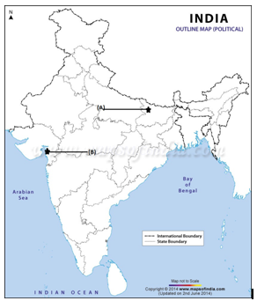  
   **Ans.**  
   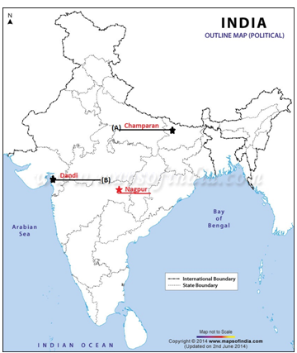
2. **On the given political outline map of India locate and label the following places of national movement:** Champaran, Kheda, Amritsar, Chauri-Chaura, Lahore, Bardoli

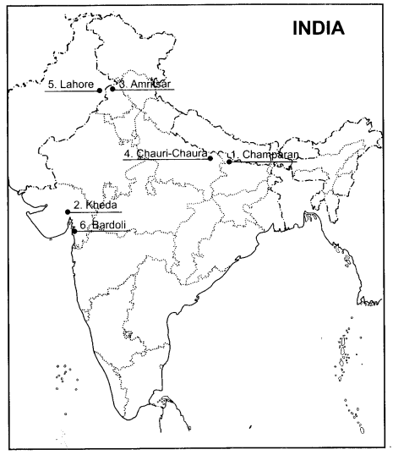

Locate and label the following Indian National Congress Sessions on the given political outline of India with appropriate symbols:  
(i) Calcutta Session (Sept. 1920)  
(ii) Nagpur Session (Dec. 1920)  
(iii) Madras Session (1927)  
(iv) Lahore Session (1929)

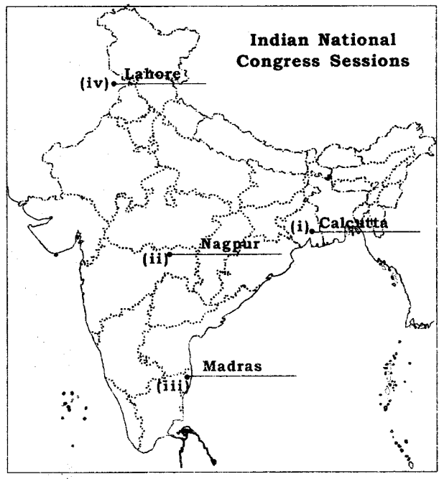

Locate and level the following important centres of Indian National Movement.  
(i) Champaran – Movement of Indigo Planters.  
(ii) Kheda related to Peasant Satvagraha.  
(iii) Ahmedabad centre of Cotton Mill Workers Satyagraha  
(iv) Amritsar related place to Jallianwala Bagh Incident  
(v) Chauri Chaura – Calling off the Non-Cooperation Movement.  
(vi) Dandi Starting place of Civil Disobedience Movement.  
Answer  
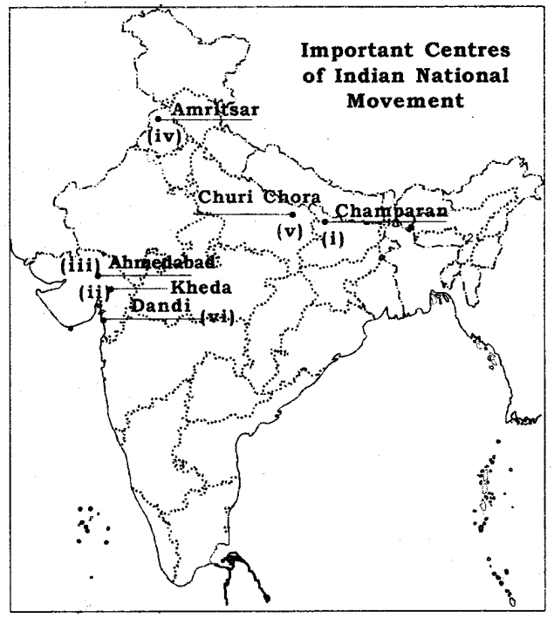

Question 3.  
On the given political outline map of India, the India National Congress Sessions are marked as by A, B, C and D. Identify the centres of these sessions, and write their correct names on the lines drawn near them.  
Answer  
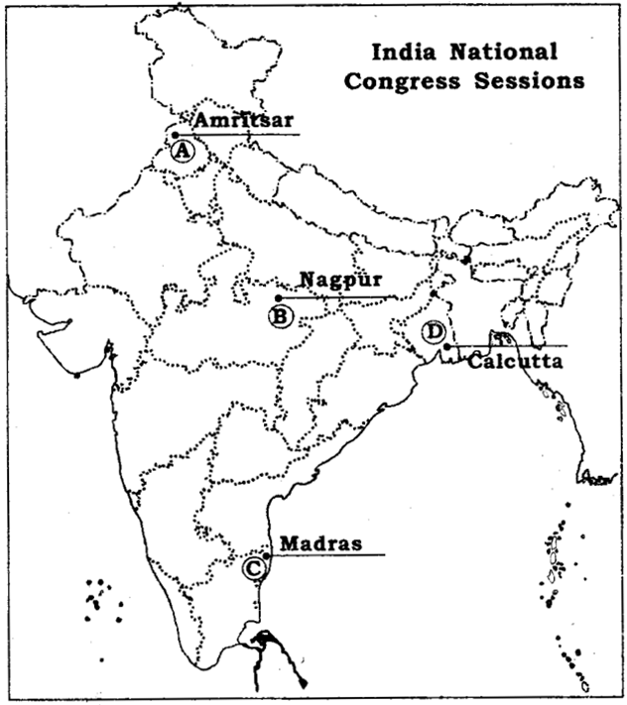

Question 4.  
On the given political outline map of India, the important centres of National Movements are marked as by A, B, C, D, E and F. Identify these centres with the help of the following information and write their correct names on the lines drawn near them.  
A. Satyagraha Centre of Indigo Planters  
B. Peasants Satyagraha Centre in Gujarat  
C. Satyagraha Centre of cotton mill workers  
D. The place related to calling off the Non Cooperation Movement  
E. The Starting place of Civil Disobedience Movement  
F. The related city to Jallianwala Bagh Incident.  
Answer  
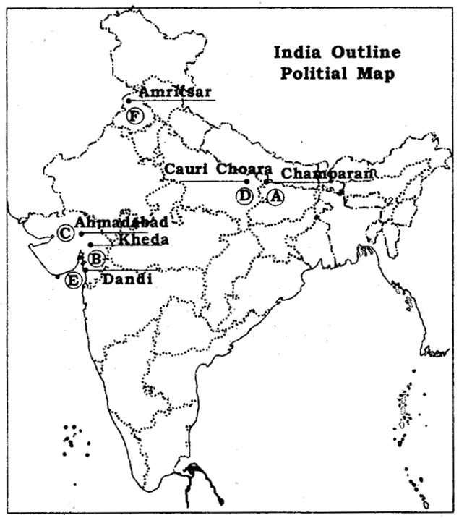

Question 5.  
Locate and label the following dams on the given political outline map of India with appropriate symbols:  
(A) Salal  
(B) Bhakra Nangal  
(C) Tehri  
(D) Rana Pratap Sagar  
(E) Sardar Sarovar  
(F) Hirakud  
(G) Tungabhadra  
(H) Nagarjuna Sagar.  
Answer  
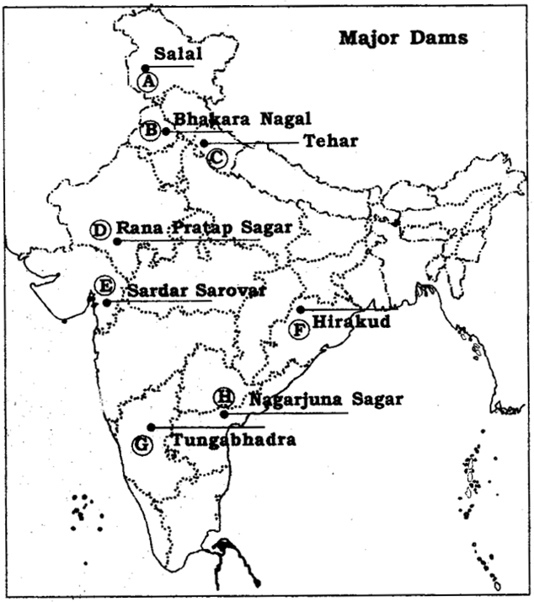

Question 6.  
Identify the largest producer states of the following Crops and write their names on the lines marked.  
1. Sugarcane  
2. Tea  
3. Coffee  
4. Rubber  
5. Cotton  
6. Jute  
Answer  
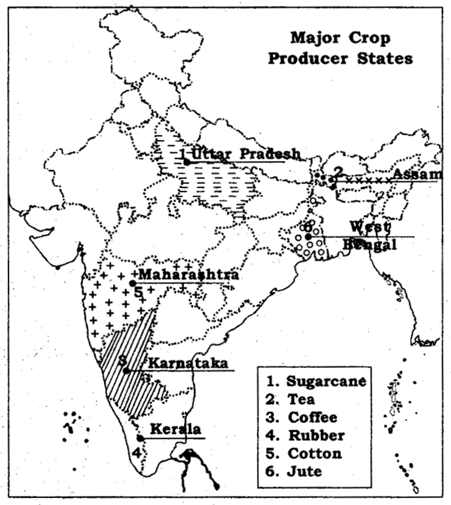

Question 7.  
Identify the iron-ore mines marked on the given political outlines map of India by social number 1, 2, 3, 4, and 5 and write their correct names on lines drawn on the map.  
Answer  
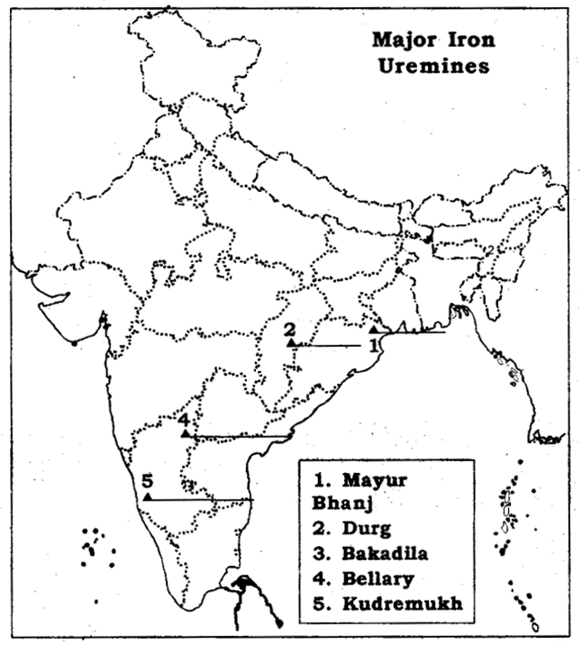

Question 8.  
Identify the following mica mines marked by the numbers 1, 2, 3, 4 and 5 on the given political outline map of India and write their correct names on the lines drawn on the map.  
Answer  
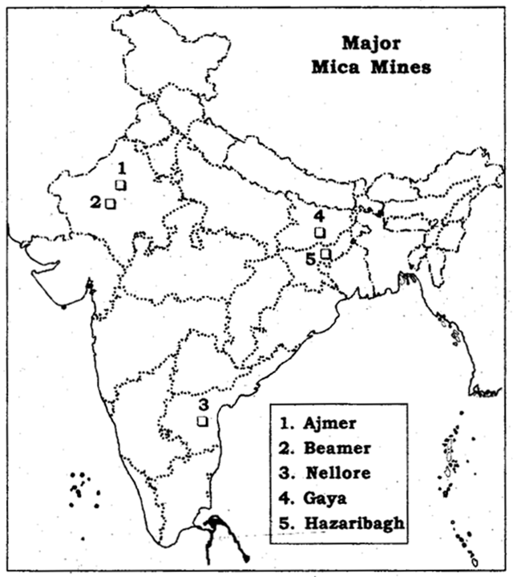

Question 9.  
Identify the following Coal mines marked by the numbers 1, 2, 3, 4, 5, 6, 7 and 8 on the given political outline map of India and their correct names on the lines drawn near them on the map.  
Answer  
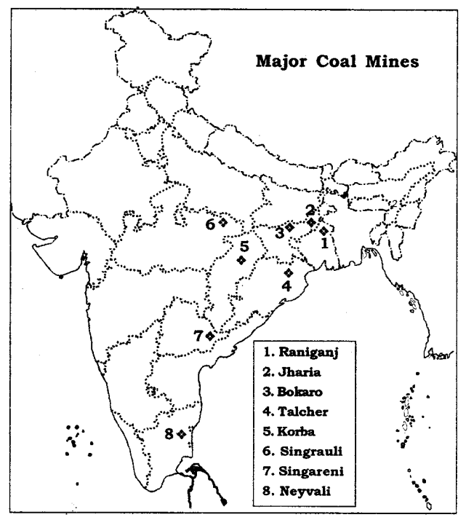

Question 10.  
Identify the Oil fields as marked by the numbers 1, 2, 3, 4, 5 and 6 on the given political outline map of India and write their correct names on the lines drawn near them.  
Answer  
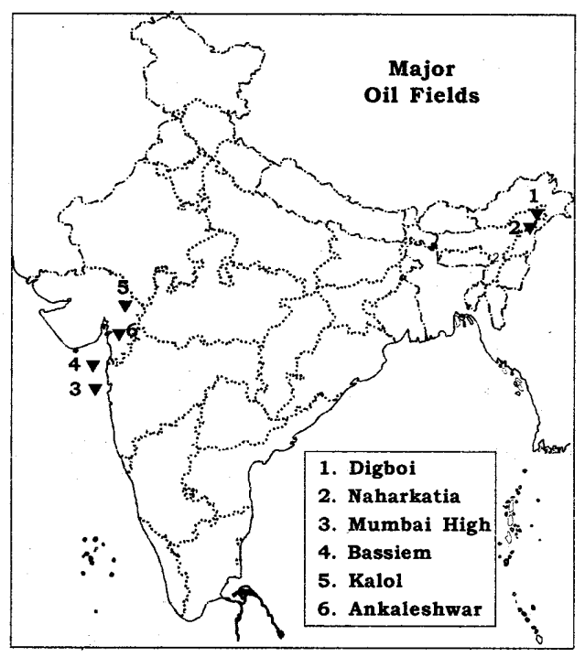

Question 11.  
Identify the Bauxite deposits as marked by 1, 2, 3 and 4 on the given political outline map of India and write their correct names on the lines drawn near them.  
Answer  
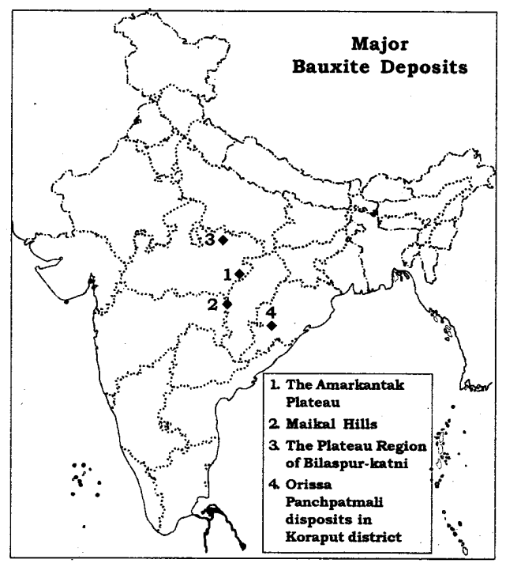

Question 12.  
Locate and label the following Thermal Power Plants on the given political outline map of India, with appropriate symbols :  
(i) Namrup  
(ii) Talcher  
(iii) Singrauli  
(iv) Harduaganj  
(v) Korba  
(vi) Uran  
(vii) Ramagundam  
(viii) Vijaywada  
(ix) Tuticorin.  
Answer  
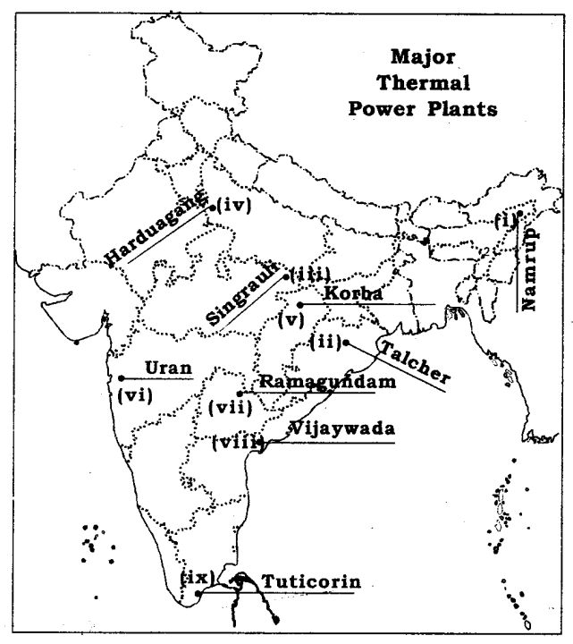

Question 13.  
Locate and label the following Nuclear Power Plants on the given political outlines map of India with appropriate symbols.  
(i) Narora  
(ii) RawatBhata  
(iii) Kakrapara  
(iv) Trapur  
(v) Kaiga  
(vi) Kalpakkam  
Answer  
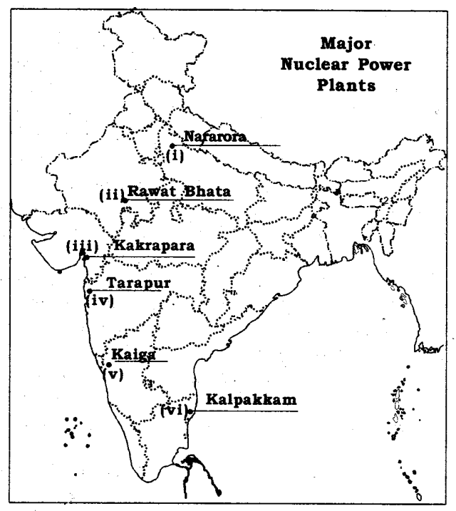

Question 14.  
Locate and label the following Cotton Textile Centres on the given political outline map of India with appropriable symbols :  
(i) Mumbai  
(ii) Indore  
(iii) Ahmedabad  
(iv) Surat  
(v) Kanpur  
(vi) Coimbatore  
(vii) Madurai  
Answer  
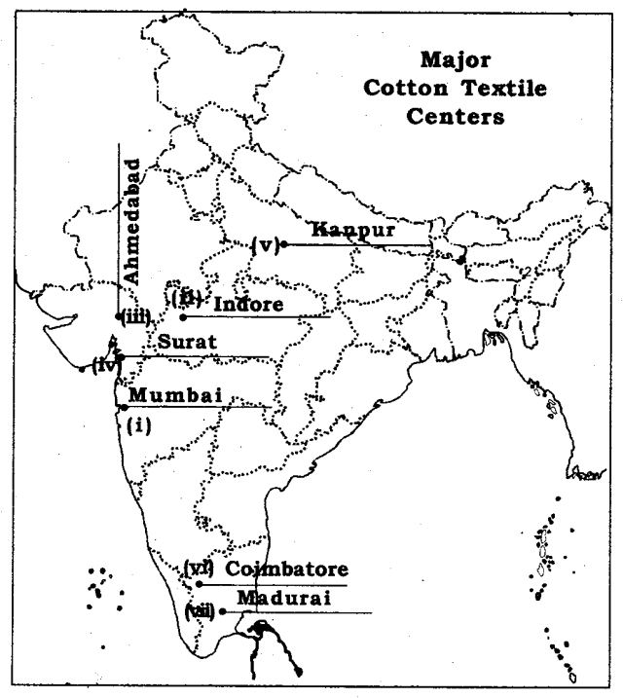

Question 15.  
Locate and label the following Iron and Steel centres on the given political outline map of India with appropriate symbols :  
(i) Bampur  
(ii) Durgapur  
(iii) Bokaro  
(iv) Jamshed pur  
(v) Raurkela  
(vi) Bhilai  
(vii) Vijay nagar  
(viii) Bhadravati  
(ix) Vishakhapatnam  
(x) Salem.  
Answer  
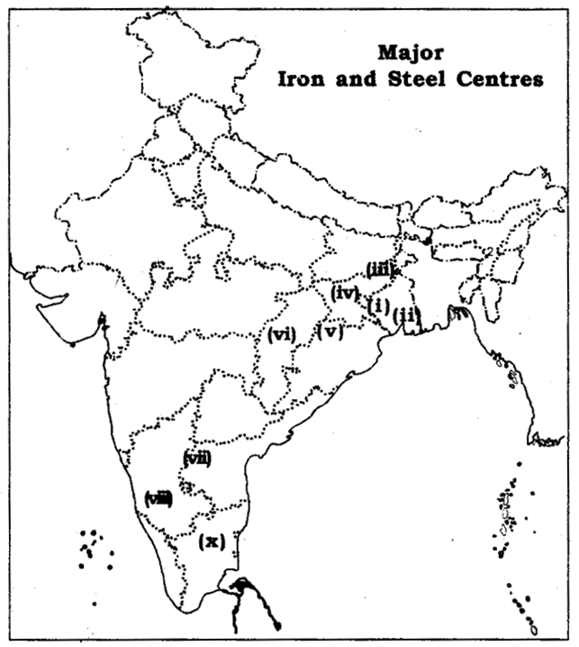

Question 16.  
Locate and label the following Software Technology parks. On the given political outline map of India with appropriate symbols.  
(i) Mohali  
(ii) Noida  
(iii) Jaipur  
(iv) Gandhi nagar  
(v) Indore  
(vi) Mumbai  
(vii) Pune  
(viii) Kolkata  
(ix) Bhubaneshwar  
(x) Vishakhapatnam  
(xi) Hyderabad (xii) Bangalore  
(xii) Mysore  
(xii) Chenna  
(xiii) Thiruvanatapuram  
Answer  
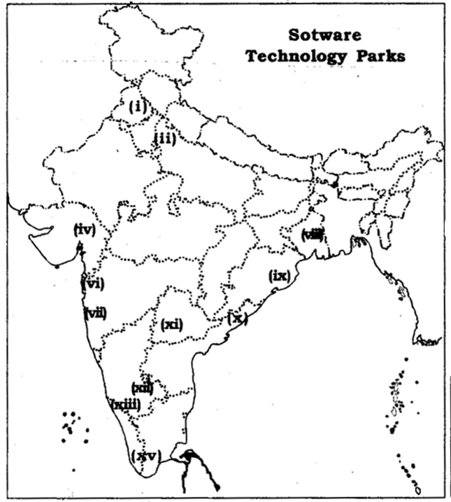

Question 17.  
Locate and label the following major Ports on the given political outline map of India with appropriate symbols:  
(i) Kandla  
(ii) Mumbai  
(iii) Jawahar Lai Nehru  
(iv) Marmagao  
(v) New Mangalore  
(vi) Kochi  
(vii) Tuticorin  
(viii) Chennai  
(ix) Vishakhapatnam  
(x) Paradip  
(xi) Haldia  
(xii) Kolkata  
Answer  
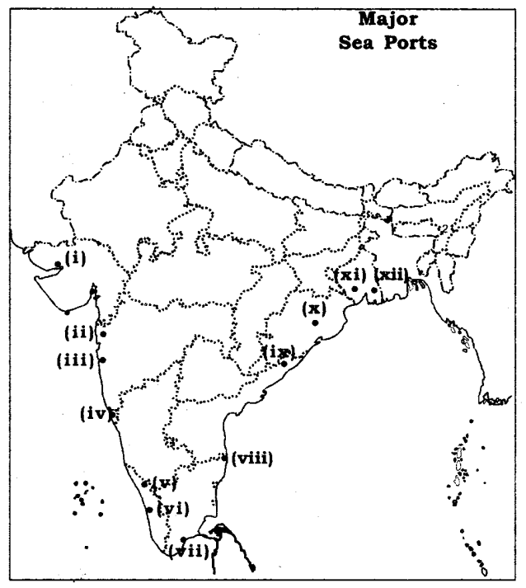

Question 18.  
Locate and label the following International Airports. On the given political outline map of India with appropriate symbols:  
(i) Amritsar (Raja Sansi).  
(ii) Delhi (Indira Gandhi International).  
(iii) Mumbai (ChhatrapatiShivaji).  
(iv) Chennai (Meenam Bakkam).  
(v) Thiruvanatapuram (Nedim Bacherry).  
(vi) Kolkata (Netaji Subhash Chandra Bose)  
(vii) Hyderabad (Rajiv Gandhi).  
Answer  
