This map shows the Important Sessions of Indian National Congress from 1885 to 1947.  
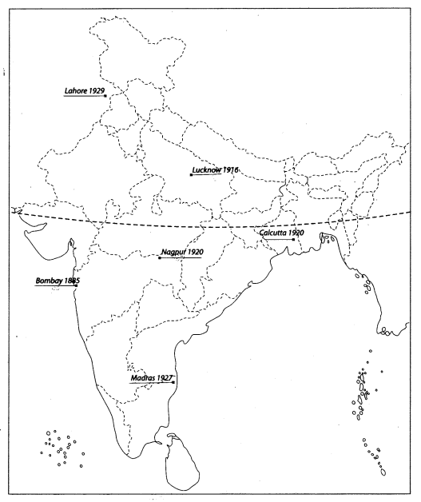

**Important Centres of Freedom Movement in India**

This map shows the important centres of the freedom movement in India from 1857 to 1947.  
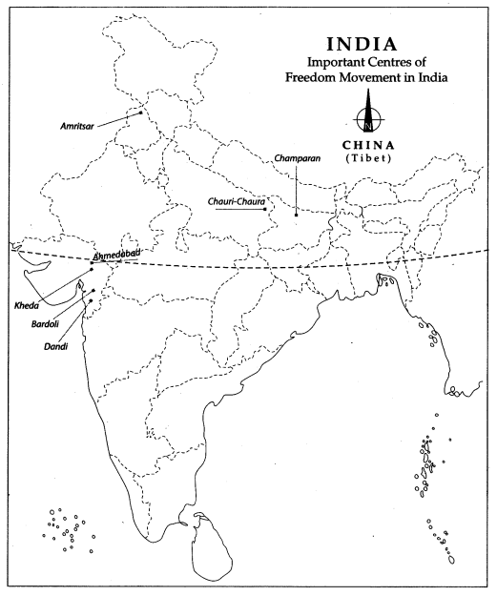

Question 1.  
On the given political map of India, name and locate the following.  
1. The place where the first Session of Indian National Congress was held in 1885  
2. The place where the Indian National Congress Session was held in 1929.   
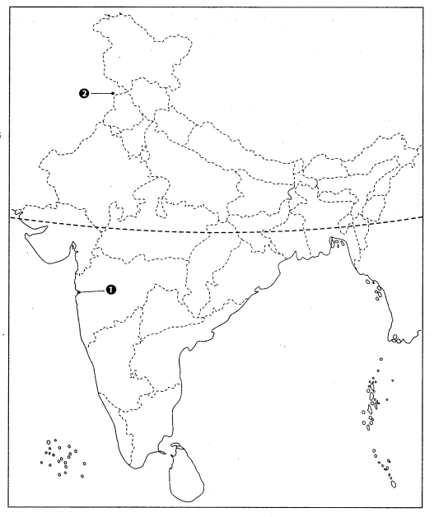  
Answer1. Bombay 2. Lahore  
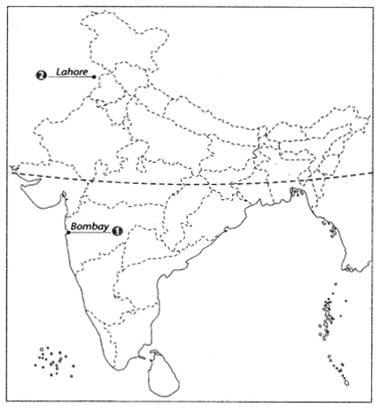

Question 2.  
Locate and label the following items on the given map.  
1. Lucknow 1916  
2. Nagpur 1920  
3. Calcutta 1920  
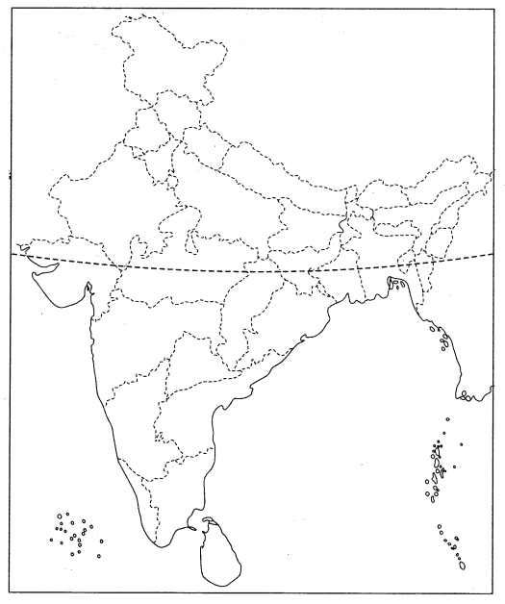

Answer  
1. Calcutta 1920  
2. Nagpur 1920  
3. Lucknow 1916  
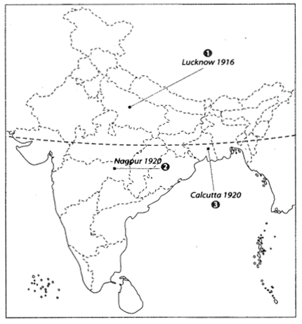

Question 3.  
Features are marked by numbers in the given political map of India. Identify these features with the help of the following information and write their correct names on the lines marked in the map.  
1. The centre/place of calling off/withdrawing of the Non-Cooperation Movement. **[CBSE 2013]**  
2. The place is known for the movement of Indigo peasants during the British Period. **[CBSE 2016]**  
3. The place where Gandhiji started the Satyagraha in favour of cotton mill workers.**[CBSE 2012, 13]**  
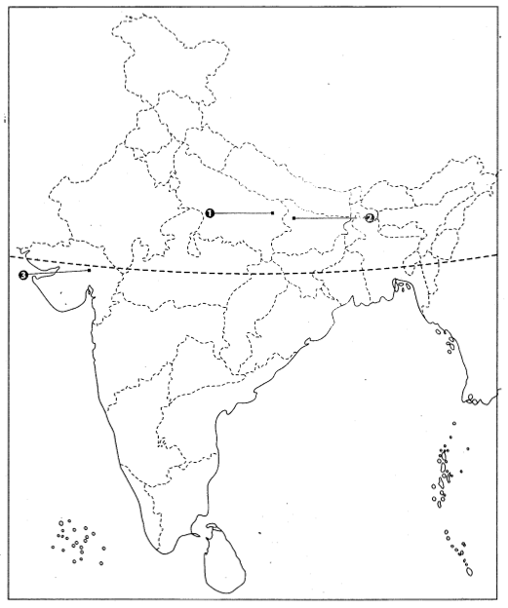  
Answer  
1. Chauri-Chaura  
2. Champaran  
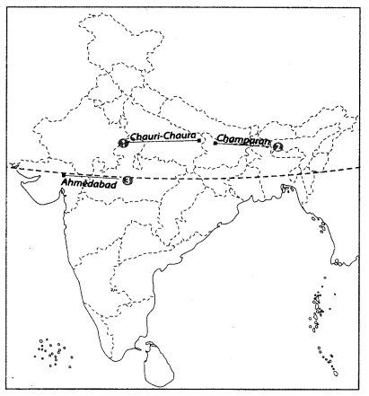

Question 4.  
On the given political map of India, name and locate the following.  
1. The place where Gandhiji started the Satyagraha in support of the peasants of Gujarat in 1917.**[CBSE 2012]**  
2. A place associated with the ‘No Tax Campaign’. **[CBSE 2016, 12]**  
3. The place from where the Civil Disobedience Movement/ Salt Satyagraha was started. **[CBSE 2012]**  
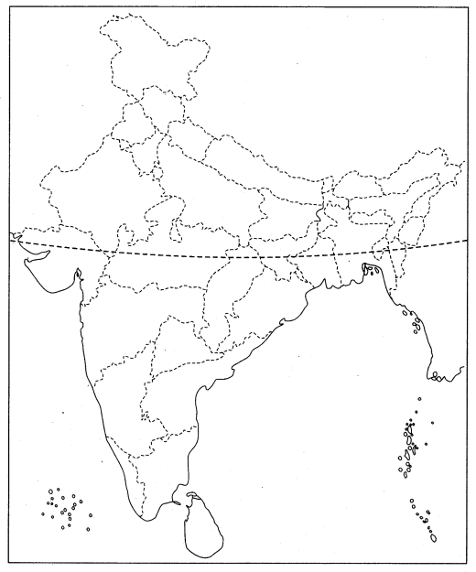  
Answer  
1. Kheda  
2. Bardoli  
3. Dandi  
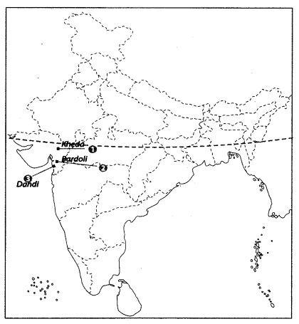

Question 5.  
On the given political map of India, name and locate the following:  
1. The state to which the Gudem rebels belonged. **[CBSE 2014]**  
2. The place where the session of the Indian National Congress was held in December 1920.  
3. The place where Gandhiji started Satyagraha in favour of cotton mill workers.  
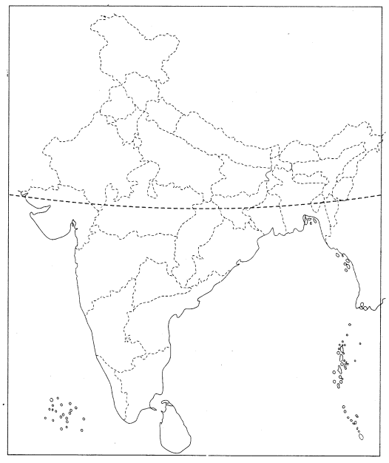  
Answer  
1. Andhra Pradesh  
2. Nagpur  
3. Ahmedabad  
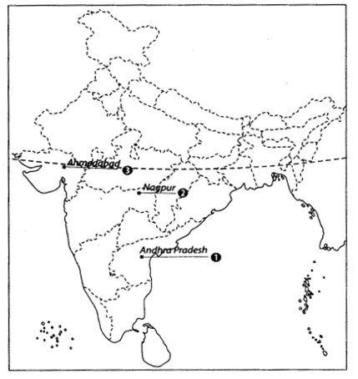

Question 6.  
Features are marked in the given political map of India. Identify these features with the help of the following information and write their correct names on the lines marked in the map.  
1. The place where the Indian National Congress Session of September 1920 was held **[CBSE 2012]**  
2. The place where the Indian National Congress Session was held in 1927 **[CBSE 2016]**  
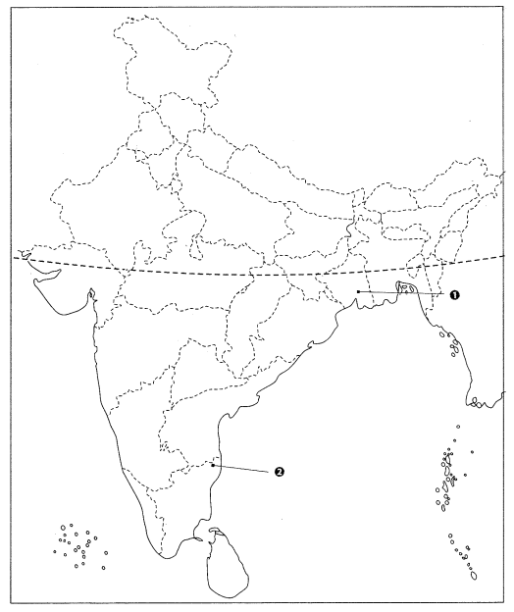  
Answer  
1. Calcutta (Now Kolkata)  
2. Madras (Now Chennai)  
