**India: Textile Industry of India**

This map shows the cotton, woolen, and silk textile industries of India.  
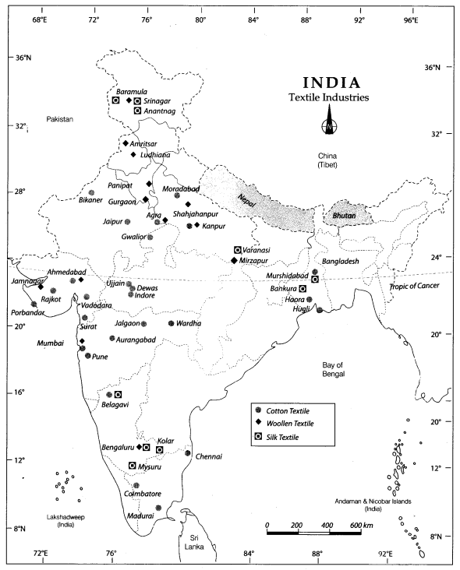

**India: Iron and Steel Industry of India**

This map shows the Iron and Steel Plants of India. Iron and Steel is a heavy industry because all the raw materials, as well as finished goods, are heavy and bulky.  
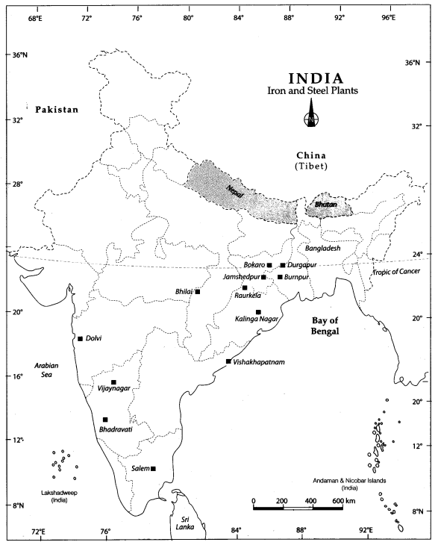

**India: Software Technology Park of India**

This map shows the software technology parks in India. Bengaluru is known as the electronic capital of India.  
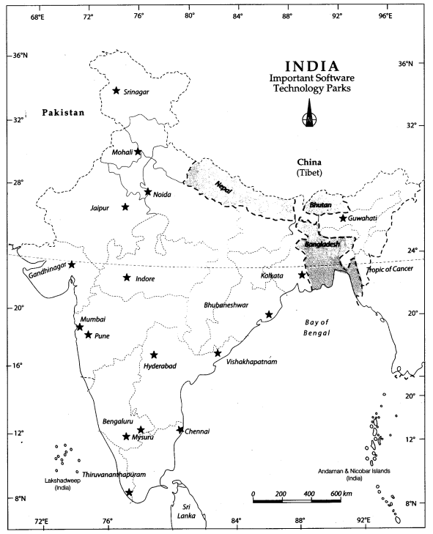

Question 1.  
Locate and label the following items on the given map with appropriate symbols.  
1. Silk industry – Mysuru, Kolar and Srinagar  
2. Cotton textile industry – Ahmedabad, Surat, and Kanpur  
3. Woolen industry – Ludhiana, Panipat, and Amritsar  
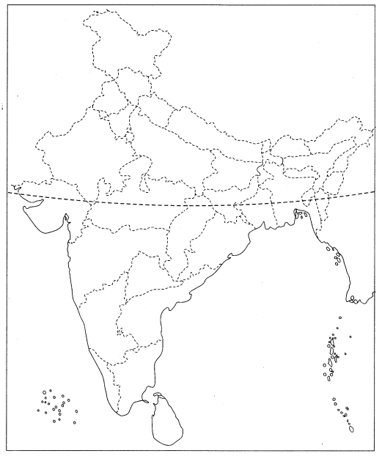  
Answer  
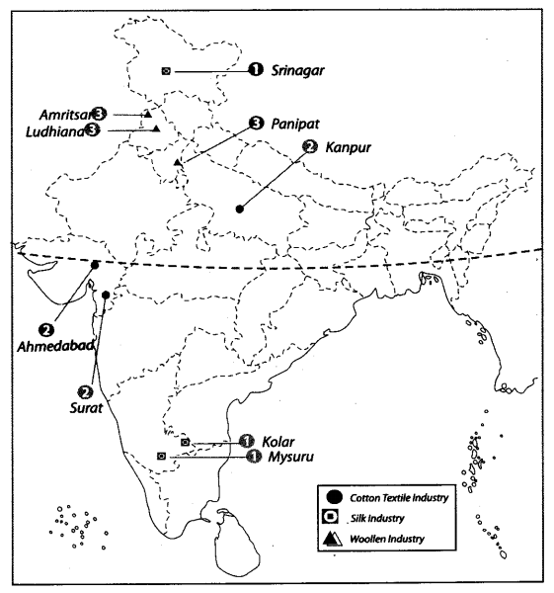

Question 2.  
Features are marked by numbers in the given political map of India. Identify these features with the help of the following information and write their correct names on the lines marked in the map.  
1. Cotton textile industry  
2. Woolen industry  
3. Silk industry  
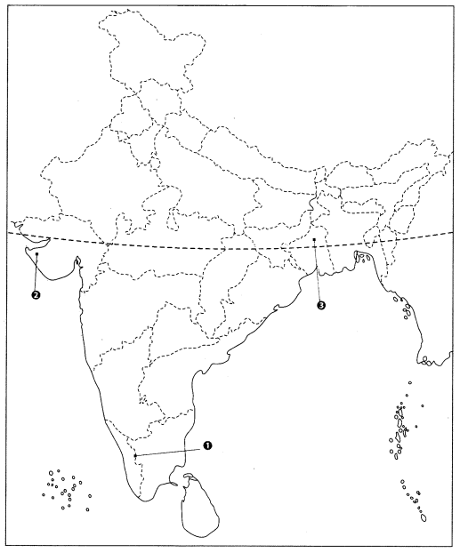  
Answer  
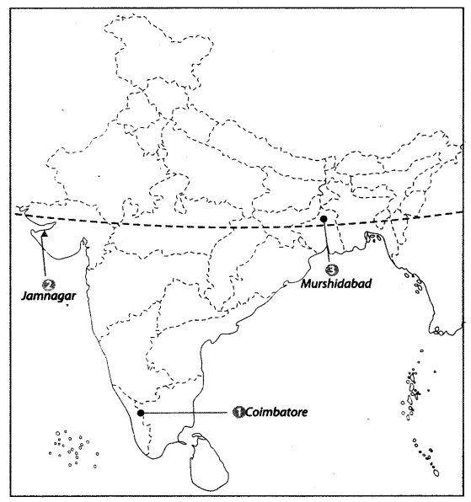

Question 3.  
Locate and label the following items on the given map with appropriate symbols.  
1. Jamshedpur  
2. Raurkela  
3. Salem  
4. Bokaro  
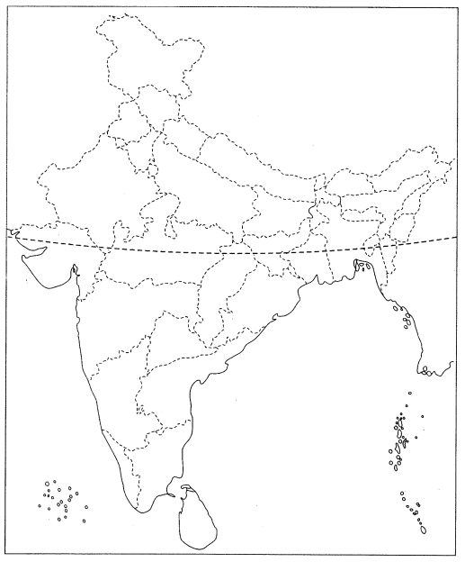  
Answer  
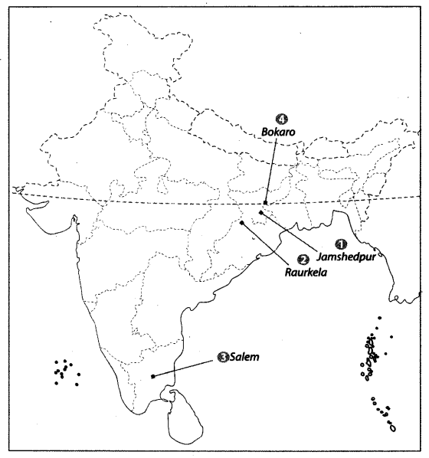

Question 4.  
Features are marked by numbers in the given map of India. Identify these features with the help of the following information and write their correct names on the lines marked in the map.  
1. An Iron and Steel Plant  
2. Iron and Steel Plant in Odisha  
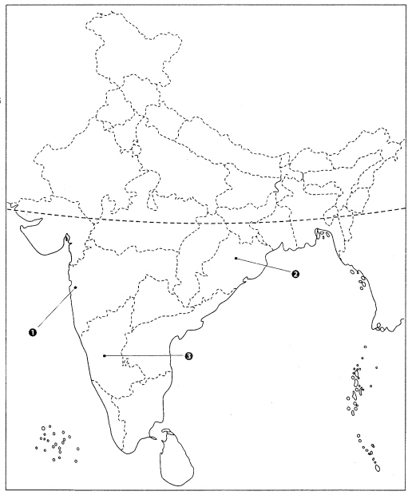  
Answer  
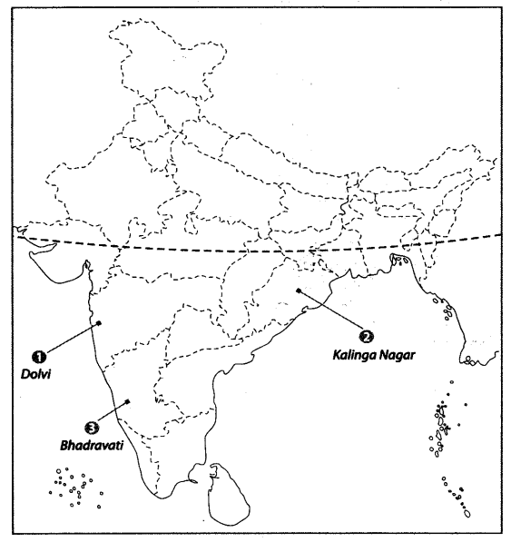

Question 5.  
Locate and label the following items on the given map with appropriate symbols.  
1. Kolkata  
2. Guwahati  
3. Indore  
4. Jaipur  
5. Bengaluru  
6. Noida  
7. Pune  
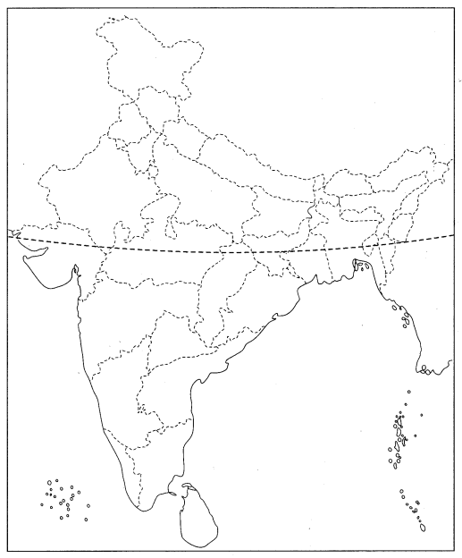  
Answer  
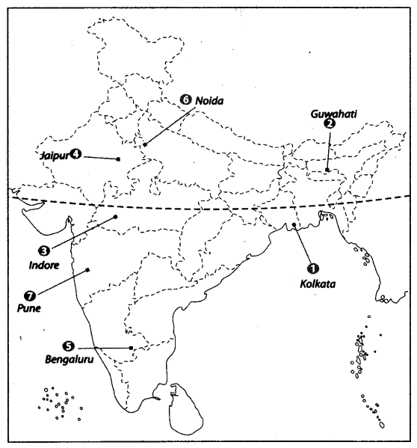

Question 6.  
Features are marked by numbers in the given map of India. Identify these features with the help of the following information and write their correct names on the lines marked in the map.  
1. A Software Technology Park  
2. Technology Park in Odisha  
3. Technology Park dedicated to electronics, software and other Information Technology ventures.  
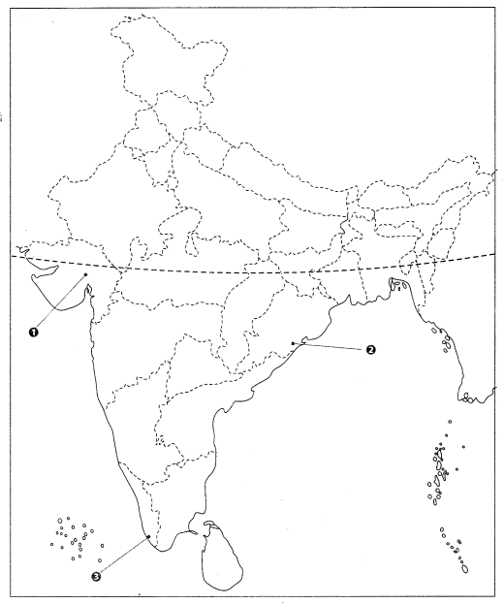  
Answer  
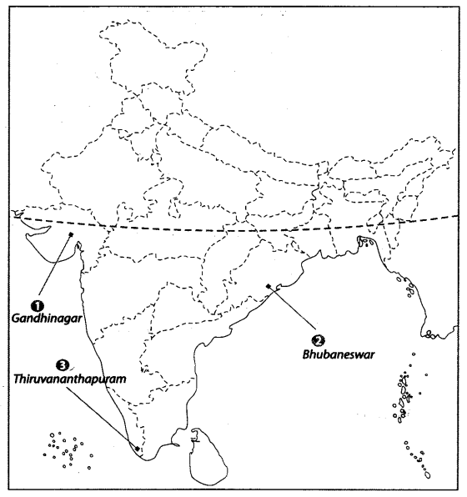

Question 7.  
Locate and label the following items on the given map with appropriate symbols.  
1. Bhadravati iron and steel plant  
2. Chennai software technology park  
3. Indira Gandhi International airport  
4. Beawar mica mines  
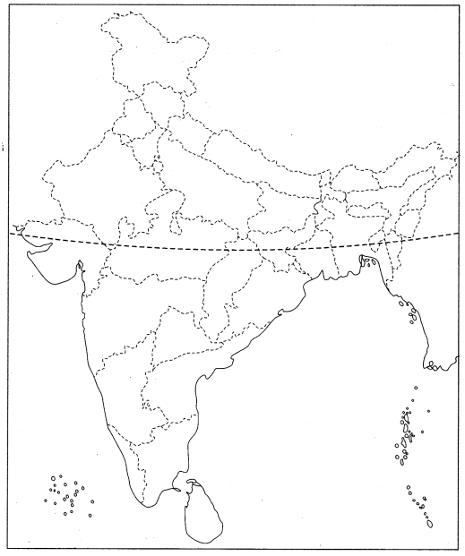  
Answer  
