**Step by Step Procedures for Reviewing and Editorial Processes**

**Managing Editor (ME)**

1. Receiving of a copy of the system generated acknowledgement e-mail to an author (in the name of the Chief Editor) upon submission of a manuscript to the journal, along with the submission link.

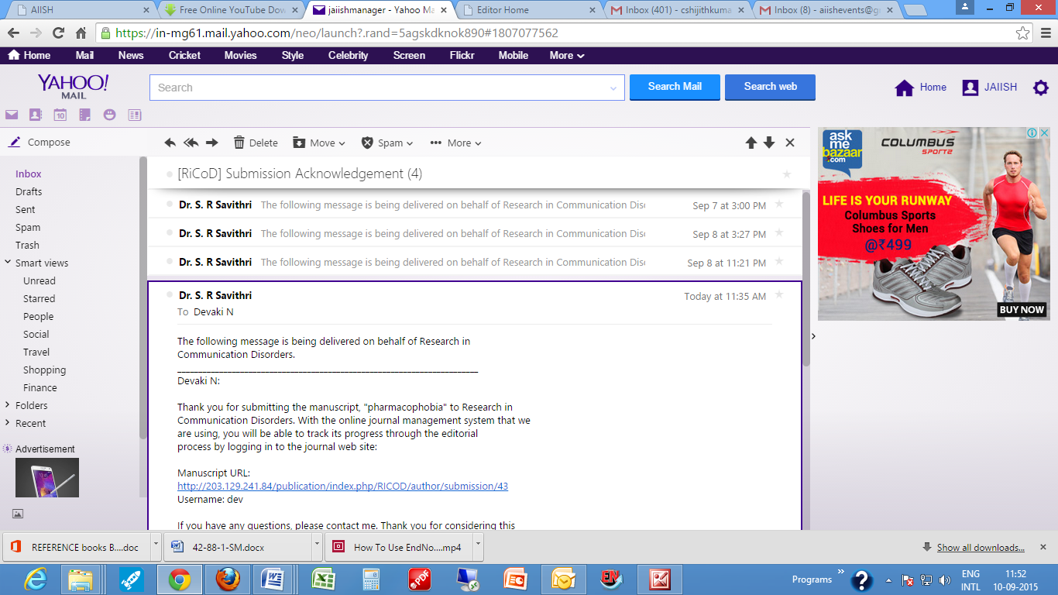

**Note**

* At the end of the link there will be a system generated unique Identification number which is assigned automatically to all the manuscripts submitted to the journal.

<http://203.129.241.84/publication/index.php/RICOD/sectionEditor/submissionReview/41>

1. Login to the Journal website

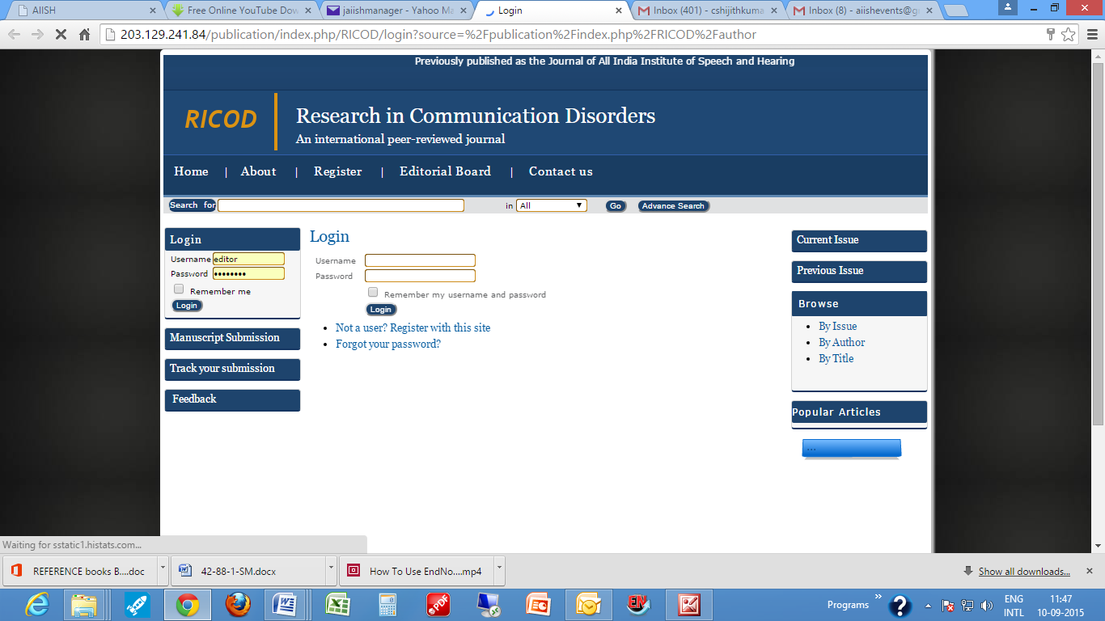

**Note**

* The ME can login to the journal website in either of the following two ways.

Upon receiving an e-mail notification about the submission of a new manuscript, as stated above, he can follow the submission link received through the e-mail message. This will first take him to the journal login page, and then upon entering his User Name and Password to the Summary page of the manuscript. (Please note that the system generated unique id of the manuscript will be prominently displayed along with the heading ‘Summary’)

**OR**

The ME can also login to the journal website by directly keying in the Journal URL on a Web browser. In this case, he will be taken to his home page called **Editor Home** on the journal website.

* The ME’s home page contains 3 parts. A top portion named **Submissions**. A middle search frame which is unnamed and a bottom portion named **Issues**.

### 

### The submission portion provides the status of all the manuscripts submitted to the journal which are in different stages with numbers in brackets. The stages are: [Unassigned](http://203.129.241.84/publication/index.php/RICOD/editor/submissions/submissionsUnassigned) , [In Review](http://203.129.241.84/publication/index.php/RICOD/editor/submissions/submissionsInReview) , [In Editing](http://203.129.241.84/publication/index.php/RICOD/editor/submissions/submissionsInEditing) , [Archives](http://203.129.241.84/publication/index.php/RICOD/editor/submissions/submissionsArchives). (E.g. An Editors Home Page with Unassigned (2), In Review (0), In Editing (1) and Archives (5) means that 2 manuscripts submitted to the journal for publication are awaiting the Editor’s action in processing them, no manuscripts are under review, 1 is under editing stage and five are in Archives i.e. decided whether they should be published or not.

* The search frame helps the Editor in searching the details of manuscripts submitted to the journal using various search terms. This will be a really useful and time saving tool when the numbers of submissions are more.
* The **Issues** Section deals with the journal issues and consists of 4 portions: [**Create Issue**](http://203.129.241.84/publication/index.php/RICOD/editor/createIssue), [**Notify Users**](http://203.129.241.84/publication/index.php/RICOD/editor/notifyUsers), [**Future Issues**](http://203.129.241.84/publication/index.php/RICOD/editor/futureIssues) and [**Back Issues**](http://203.129.241.84/publication/index.php/RICOD/editor/backIssues). The **Create Issue** is to set up a new issue for the journal, **Notify Users** is to inform the user about the publication of a new issue through their e-mail ids registered with the website, **Future Issues** is to set up a few future issues and the **Back Issues** is to manage the already published journal issues on the website.

1. Once the ME logon to the system and accessed the Manuscript submitted as per the e-mail intimation, he
2. The **Unassigned** link under **Submission** (This is the first step he has to do upon getting e-mail intimation of a new submission each time. The **Unassigned** page consists of three parts:
3. A menu bar with the options: [**Unassigned**](http://203.129.241.84/publication/index.php/RICOD/editor/submissions/submissionsUnassigned)**, ,**[**In Review**](http://203.129.241.84/publication/index.php/RICOD/editor/submissions/submissionsInReview)**,** [**In Editing**](http://203.129.241.84/publication/index.php/RICOD/editor/submissions/submissionsInEditing) **,** [**Archives**](http://203.129.241.84/publication/index.php/RICOD/editor/submissions/submissionsArchives). which helps the ME to navigate through other activities in the journal work flow such as **In** **Review, In Editing** and **Archives**
4. A search frame to search for a particular Unassigned Manuscript (This will be useful when there are more no. of unassigned submissions)
5. A list of all the Unassigned manuscripts with an automatic submission id, date of submission, Section under which it is submitted, title with hyperlink, and the last name(s) of the Author(s). The entries in the list will be arranged according to the date of submission.

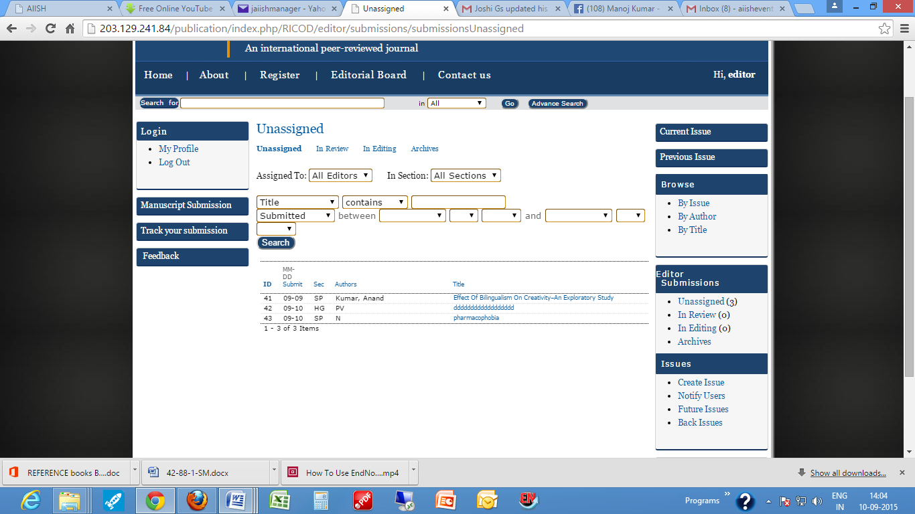

1. The ME has to click the hyperlinked title of any of the unassigned manuscript to initiate its processing. Clicking on the hyperlinked title will open a web page pertaining to that particular manuscript which consists of the following parts:

### Submission which provides the details of the submitted manuscript such as its author, title, date of submission, section to which it is submitted, name of the submitter along with links to the Original Manuscript (original file) and the Supplementary File(s) if any.

### Plagiarism Checking, an option for checking plagiarism in the submitted manuscript by requesting the Technical Support Team.

### Editors, an option for assigning the manuscript to the concerned Associate Editor

### Metadata, containing the metadata elements of the manuscript submitted such as Author(s), title, keywords, Abstract and References.

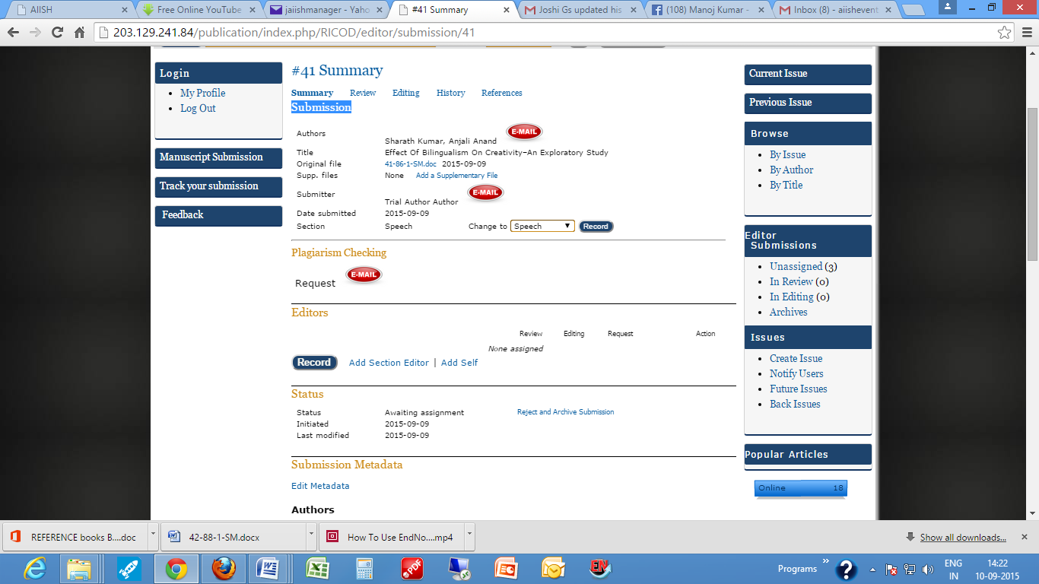

1. Upon opening an unassigned submission, the ME can verify the submission details including metadata and do the following. **If necessary**
2. Reject and archive submission if the manuscript does not fit for the journal in which case an automatic e-mail will send by the System to the Author intimating him that the paper cannot be accepted and to try elsewhere.
3. Edit metadata, correct the details, and supplement
4. Request for plagiarism Checking
5. Request to the Author to revise the paper
6. The revised paper can be collected from the Author in any one of the following ways.
7. Request him to re-submit the manuscript ( As the software at present does not have a re-submit option, in effect he has to resubmit the paper as a new submission by following the 5 step procedures.
8. In case only minor changes are required the changed portions can be received through an e-mail attachment and the ME himself can upload the paper at the Review Section
9. The first activity that the ME has to do (only during the initial login) is the Creation of Issues. It consists of two parts: Identification in which the ME has to enter the Volume & Issue nos, year, title if any for the issue being created (such as special topic) and Cover to insert the cover design (an image already made available, if any).

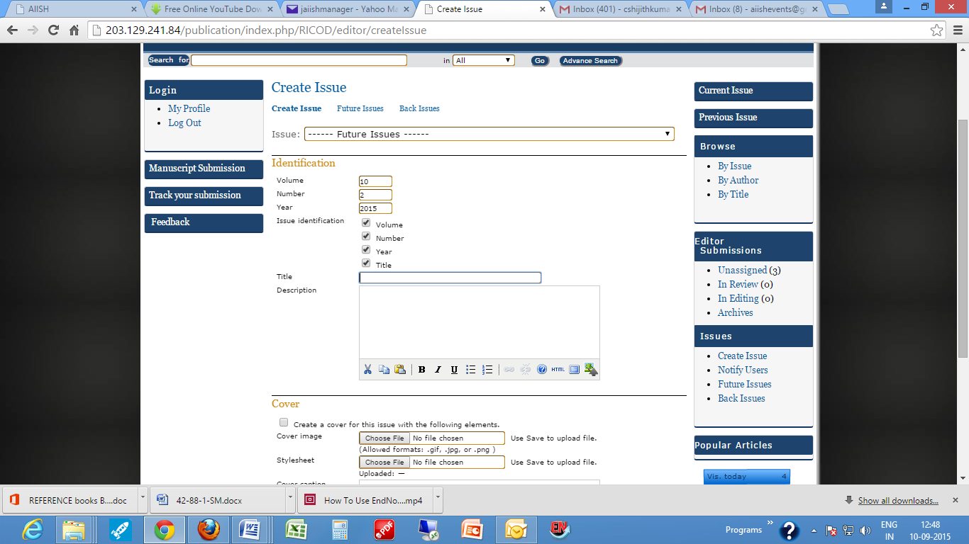

1. Once the Issue has been created the ME can go back to his home page by clicking the **Manuscript Submission** button on the left side menu.

**Associate Editor (AE)**

The AE is responsible for coordinating and supervising peer reviewing and editorial processing of the manuscript(s) assigned to him by the Chief/ Managing Editor. The activities that are to be carried out by the AE are:

1. Download the manuscript assigned to him by the Chief/ Managing Editor
2. Remove the personal identification marks from the manuscript, if any, such as Author(s) name, Affiliating Institution(s), Funding Agency, Acknowldgement etc.
3. Identify suitable reviewers based on the topic covered in the manuscript, from the Reviewer database provided on the Journal Website OR by searching on the bibliographic databases (links to the databases in the field are provided on the journal website).
4. Assign the Reviewers(s) and make request using the prepared e-mail available on the journal website.
5. In case a Reviewer rejects a request send the request to another one following the same procedures above.
6. Receive the comments from the Reviewer (s) through: Balloon Comment Box/ Reviewer Form/ Reviewed Manuscript.
7. Intimate the Chief Editor regarding the posting of Reviewers comments on the website and request to take a decision regarding the acceptance/rejection/revision & acceptance of the manuscript
8. Record the decision on the website based on the input from the Chief Editor
9. Intimate the Author in case the decision is to reject the manuscript
10. Intimate the Author and get the manuscript revised in case the decision is revision & acceptance of the manuscript
11. Send the revised manuscript for plagiarism checking if required
12. Take the finally accepted manuscript for editing
13. Check the paper for textual and bibliographic style, grammar and punctuation
14. Assign the layout Editing to the Layout Editor
15. Intimate the Chief/Managing Editor regarding the completion of editing work

The steps by step procedures which are to be carried by the AE are given below along with brief notes.

1. Receiving of a system generated e-mail notification in the name of Chief Editor with the subject **Editorial Assignment** intimating the assignment of a submitted manuscript to the journal and requesting the AE to take it through editorial process The e-mail will have a direct link to the manuscript submitted.

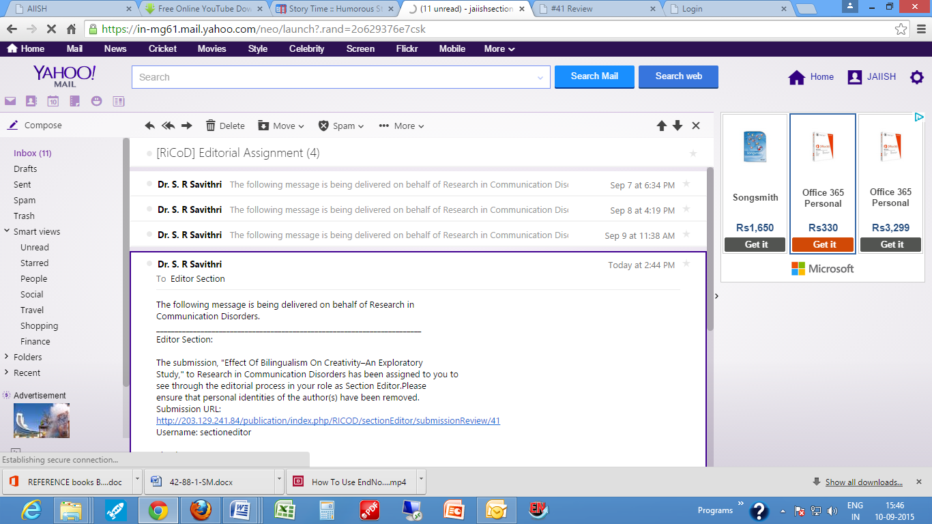

**Notes**

* Kindly note the number provide at the end of the link. This is the system generated id for the manuscript. This is a unique id assigned automatically to all the manuscripts submitted to the journal online.

 <http://203.129.241.84/publication/index.php/RICOD/sectionEditor/submissionReview/41>

1. Login

**Note**

* AE can login to the Journal website in two ways.
* One way is by following the submission link received through the e-mail message sent by the Chief/Managing Editor, which will lead to the journal site and then, upon entering the user name and password directly to the **Review** web page of the manuscript assigned to him/her.

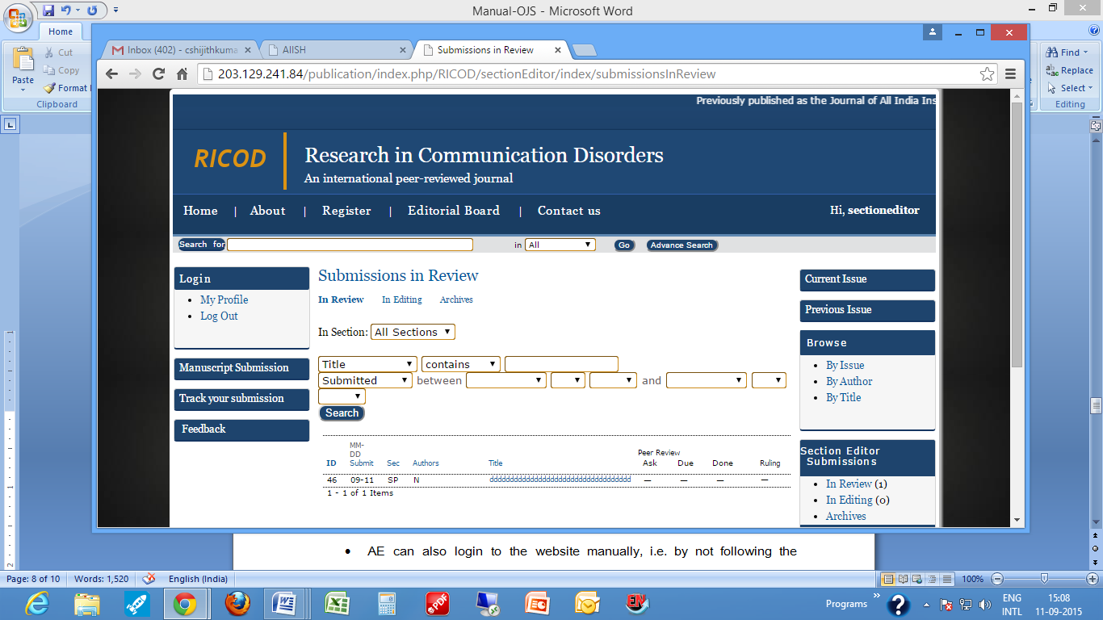

* AE can also login to the website manually, i.e. by not following the hyperlink in the e-mail, in which case he/she will be taken to the AEs home page on the journal website as given below.

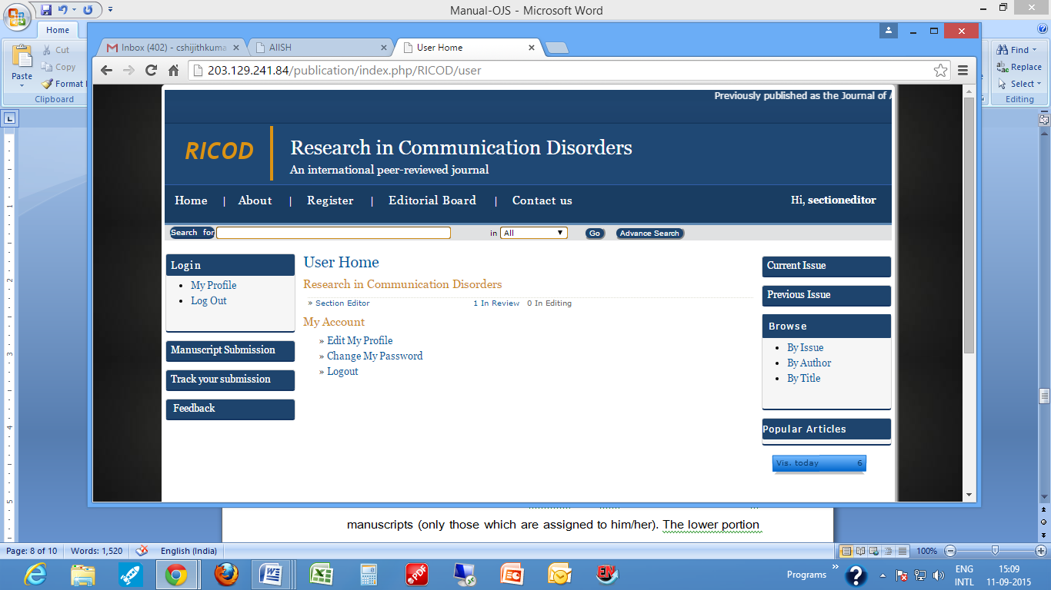

* In addition to the features, **Edit My Profile, Change My Password** and **Logout** the home page of AE provides two hyperlinks titled **In Review** and **In Editing** with prefixed numbers. This indicates the number of manuscripts (which are assigned to him/her) in Review/Editing.
* Clicking **In Review** link will lead to a web page with all his/her Assigned Submissions under Review (This includes the manuscripts waiting for assigning Reviewer(s) by the AE as well as those are under Review.). The page has 3 portions: (a). On the top, a menu with hyperlinks to **Review** (current page),Editing and **Archive** pages. The menu portion will help the AE to navigate through the Review, Editing and Archive pages. (b) In the middle, a search frame with various search options which will help the AE to search for a particular manuscript when the manuscripts submitted are more in number. (c) A bottom portion listing all the manuscripts waiting for assigning Reviewer(s) by the AE or under Review.

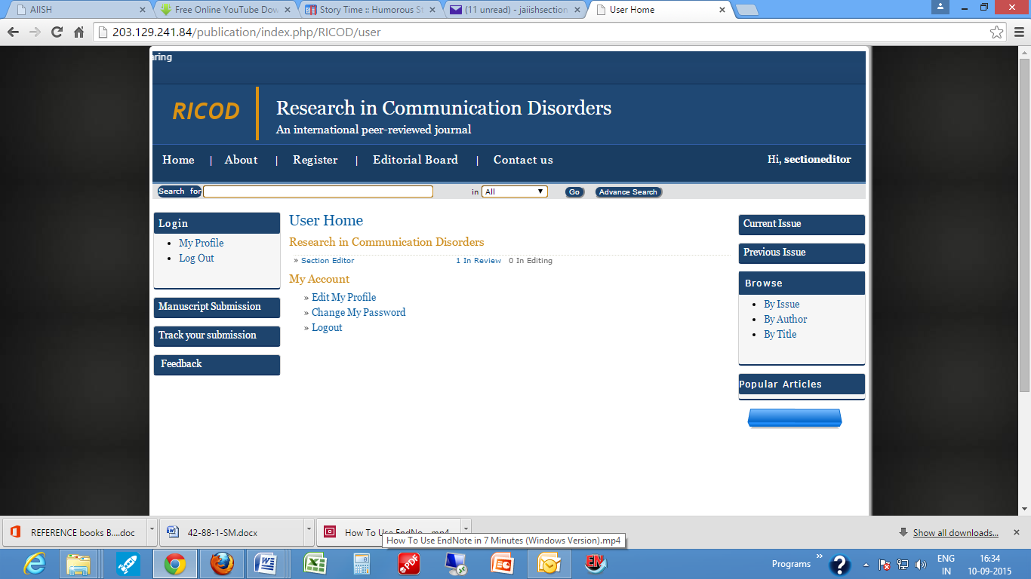

1. Upon login and reaching the Review page, AE has to open the manuscript assigned to him by clicking the hyperlinked title of the manuscript.

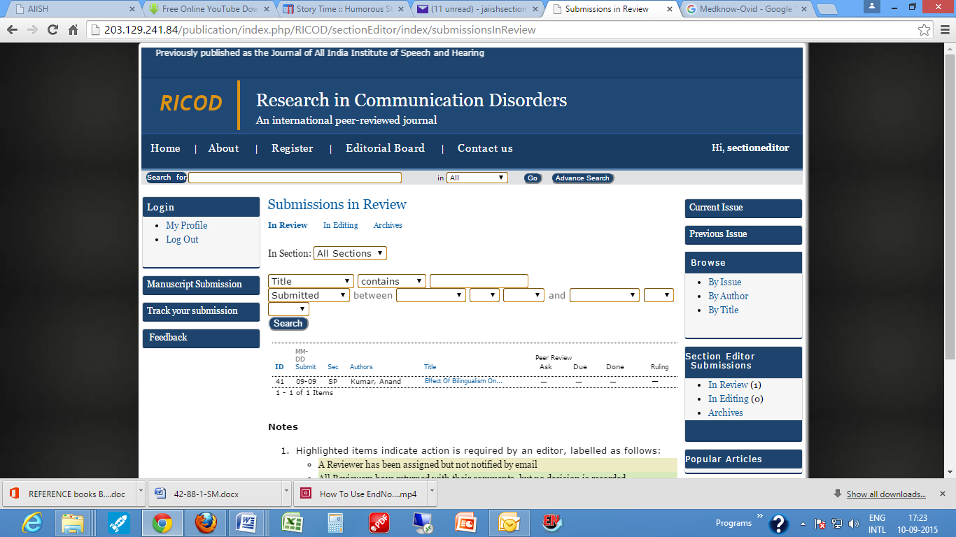

**Note**

This will open the actual **Review** page of the manuscript with a main heading ‘Review’ along with the id no. of the paper. (Eg. #46 Review). This page is divided under the following headings: 1. Submission, 2. Peer Review, 3. Request for the Comments from the Chief Editor, 4. Comments by the Chief Editor, 5. Editor Decision.

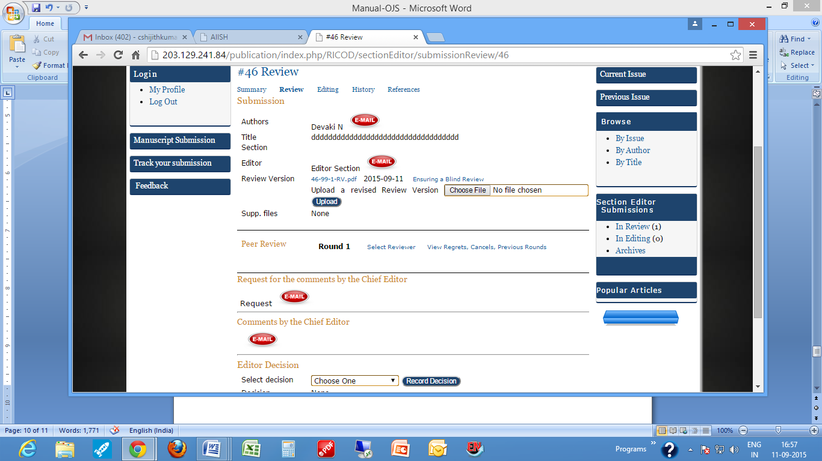

1. Upon accessing the page the AE has to download the manuscript form the **Submission** section at **Review Version,** remove thepersonal identification information, if any, on it such as Author(s), affiliating Institution(s), Funding Agency, Acknowledgement etc. and also remove the personal identification information from the MS WORD document property by following the instructions given in the **Ensuring Blind Peer Review** document available in the **Submission** Section.
2. Upload the revised manuscript at the **Upload a revised Review Version** part.
3. Go to the **Peer Review** Section
4. Click on [**View Regrets, Cancels, Previous Rounds**](http://203.129.241.84/publication/index.php/RICOD/sectionEditor/submissionRegrets/46) link. This is to know the reviewers who have denied / cancelled the review request from the journal when approached previously.

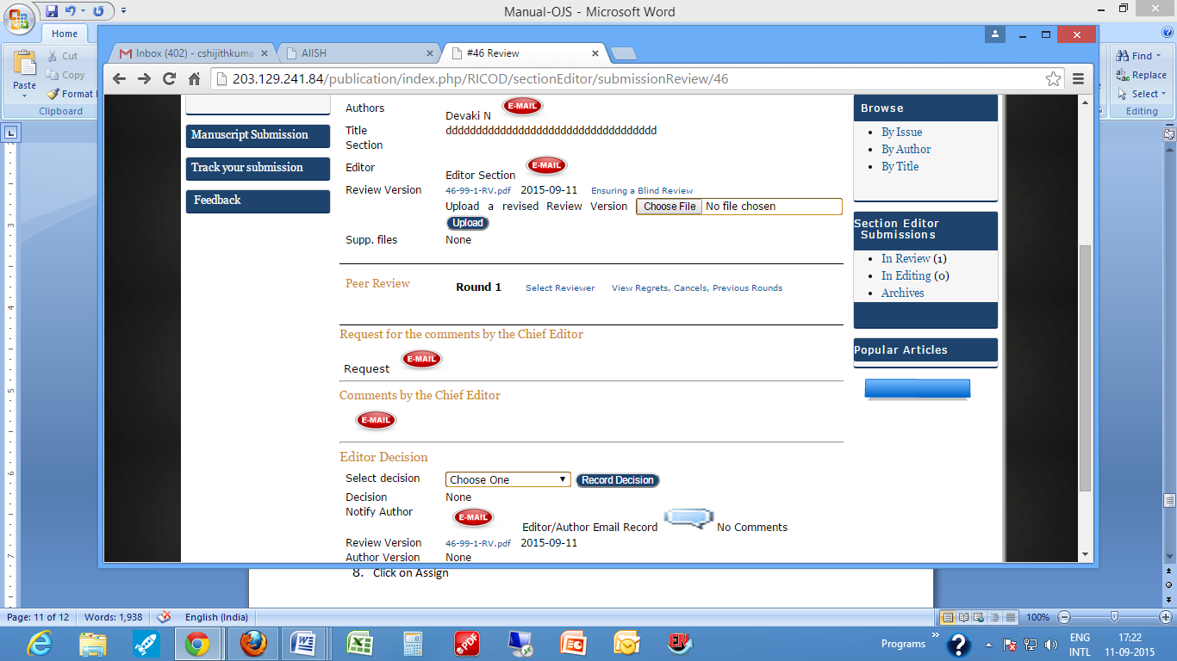

1. Click on **Select Reviewer** option which will open a database of already enrolled Reviewers on the Journal website with provision for [**Enroll an Existing User As Reviewer**](http://203.129.241.84/publication/index.php/RICOD/sectionEditor/enrollSearch/46)**,** [**Create New Reviewer**](http://203.129.241.84/publication/index.php/RICOD/sectionEditor/createReviewer/46) and to select and add reviewers by searching **COMDIDOME**, LLBA and **PubMEd** databases.
2. Once a Reviewer is selected, click on **Assign**
3. This action will lead to the main Review page of the manuscript again which now will have a new section for **Reviewer**.
4. Click on the E-mail button near the **Request**
5. Ignore the **Editor To Enter** step. This is applicable only cases where the AE receives the Reviewers’ comments without using the automated system on the journal website. Say for e.g. ‘No’ answer as a reply to the e-mail request in the same mail. In that case, the AE has to record it on the journal site and request the next Reviewer.
6. Repeat the step 8 to 12 for the next reviewer also
7. Wait for the peer reviewing

**\*\*\*\* **** **** \*\*\*\***

1. Upon getting an automatic e-mail intimation from the Reviewers(s) regarding the completion of peer-reviewing log on to the Journal Website and see the comments made by the Reviewer(s) at the **Peer Review** Section at the name of the Reviewer.
2. Go to the Section **Request for the Comments from the Chief Editor** and click on E-mail icon. Send the mail to the Chief Editor
3. Upon receiving the comments from the Chief Editor move on to **Editor Decision** and record the decision taken button. The decision can be any one of the following: **Accept Submission**; **Revision Required**; **Resubmit for Review**; **Decline Submission**.

**Accept Submission**

In case the decision is **Accept Submission** i.e. to accept the manuscript without any revision:

1. Record the decision by clicking the button

**Record**

1. Inform the decision to the Author by clicking the automatic e-mail icon and select the bullet against the Review Version (preferably) of the file and then click button.

**Send to copyediting**

**Revision Required**

In case the decision is **Revision Required** i.e.theAuthor has to revise the manuscript**:**

1. Record the decision by clicking the button

**Record**

1. Inform the decision to the Author by clicking the automatic E-mail icon and wait for the author revision.
2. Once E-mail intimation is received from the Author regarding the completion of revision and uploading of the revised manuscript on to the journal website, logon to the site and, ensure that the Author revised file is now displaying at ‘**Author Version**’.
3. Download the file revised by the author, verify it and make sure that the Author has been carried out the necessary revision.
4. Send the file as an e-mail attachment to the Technical Support Team ([lio@aiishmysore.in](mailto:lio@aiishmysore.in)) for plagiarism checking, if desired. Then inform the Chief Editor regarding the revision carried out by following the procedure mentioned above.
5. Then take the manuscript for copyediting by checking the bullet button against the Author Version OR the one against the Editor Version (in case the AE made some changes in the file after Author’s revision/re-submission) and click the button.

**Send to copyediting**

**Resubmit for Review**

In case the decision is **Resubmit for Review i.e**.to re-submit to the same Reviewer for peer reviewing after making necessary corrections:

1. Record the decision by clicking the button

**Record**

1. Inform the decision to the Author by clicking the automatic E-mail icon and wait for the author revision.
2. Once E-mail intimation is received from the Author regarding the completion of the revision and uploading of the revised manuscript on to the journal website, logon to the site and make sure that the file has been revised by the author and uploaded at ‘**Author Version**’.
3. Now, click the button provided at the **Resubmit selected file for peer review**

**Resubmit**

1. The go to the **Peer Review** Section and once again send a request E-mail to the same Reviewer who did the first review and instructed for resubmission.
2. This will pop-up an e-mail to the Reviewer mentioning his previous mail for re-submission.
3. Wait for the Reviewer e-mail and follow the appropriate procedures discussed already such as intimating the Chief Editor and sending for plagiarism check
4. Select the final version for copy editing by checking the bullet button and clicking the button

**Send to copyediting**

. **Decline Submission**

In case the decision is **Resubmit for Review i.e**.to reject the manuscript,

1. Record the decision by clicking the button

**Record**

1. Inform the Author about the rejection of the manuscript by clicking the E-mail button.
2. Copy edit the manuscript by checking it for grammar, textual and bibliographic styles and punctuation.
3. Upon clicking the **Send to copy Editing** button, the Editing page of the manuscript will open.

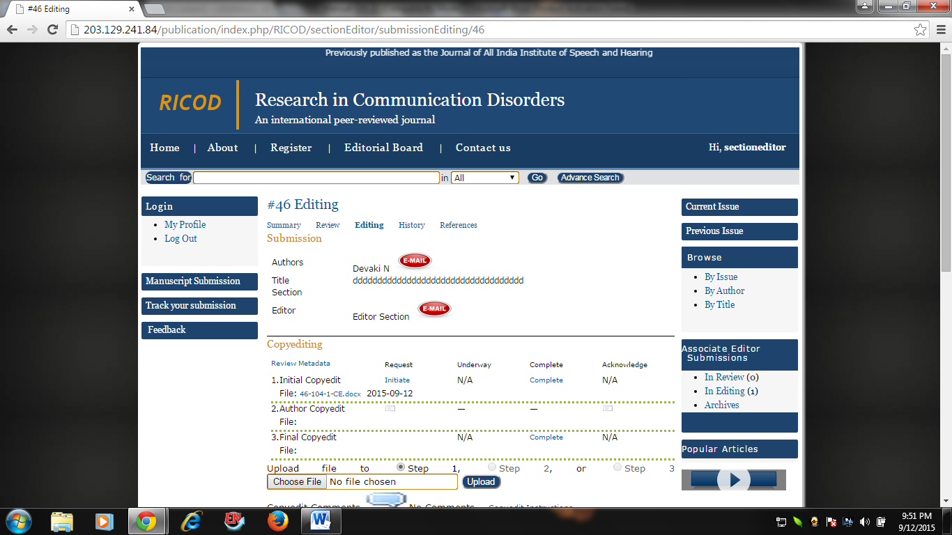

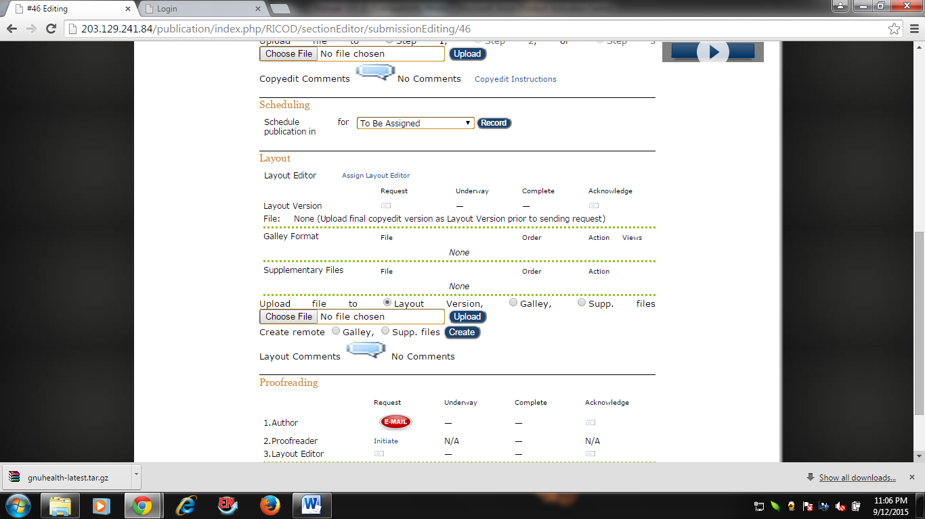

**Note**

The editing page of the manuscript consists of 4 portions. **Submission** which gives a summary of the paper such as Author, Title and Section Editor E-mail facility; **Copyediting** which contains **Initial Copy Edit, Author Copy Edit and Final Copy Edit ; Scheduling for publication** to include the manuscript in an issue; **Layout Section; Proofreading Section.** Of these, AE will not use the **Copyediting** portion.

1. Upload the Copyedited manuscript at the end of the **Layout** portion along the **Upload file** **to Layout Version (with the bullet checked at Layout version, which is default)**
2. Now, assign the Layout Editor for the manuscript by moving to the top portion of the **Layout** section and click on Assign Layout Editor. Select the Layout Editor from the resulting list of Layout Editor(s) and click Assign there.

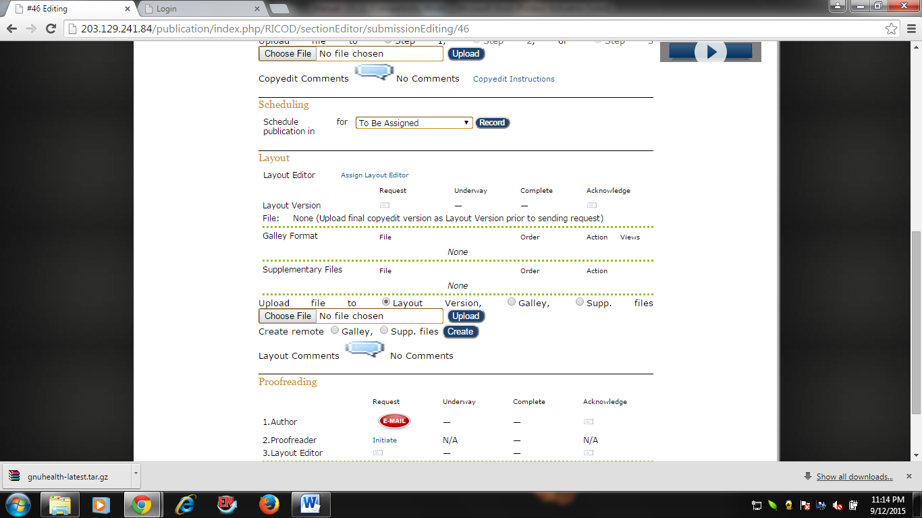

1. Click on the E-mail button with request
2. Wait till the completion of Layout Editing

*********** ******************** ********************* ***********************

1. Receive the e-mail intimation from the LE regarding the completion of layout Editing
2. Login to the journal website and view the proof at the **Layout** section.
3. Go to the **Proofreading** Section.
4. Request the Author to proofread by clicking the e-mail icon

************** ************************** ****************************

1. Receive the e-mail intimation from the Author regarding the completion of Author proofreading
2. Acknowldge the Author by sending e-mail
3. Request the LE to check the Author comments and revise the galley if desired

*** *******************

1. Receive the e-mail intimation from the LE regarding the completion of the work
2. Schedule publication

### Layout Editor (LE)

### The LE has to do the following activities

### Preparation of the manuscript in the format in which (galley formation) it is published in the Journal

### Proofread the manuscript

### Make necessary changes in the proof after getting suggestion from the Author

### Upload the revised galley

### The step by step procedures in layout editing are the following:

### Receiving of e-mail intimation from the AE regarding the assignment of a manuscript for Layout Editing

### Login to the Journal website and access the Layout Editing page of the manuscript.

### Note

### The LE can login to the journal website in two ways:

### By following the manuscript hyperlink received through e-mail from the AE. In this case the LE will be first taken to the login page of the journal website and from there upon entering the Username and Password directly to the Layout Page of the manuscript.

### Manually accessing the website and entering the User name and Password. In this case, the LE will be taken to his/her home page on the journal website. From here, the Active button under Submission has to be clicked which will lead to a list of manuscripts awaiting action by the LE, depending upon the assignment by the AE. From here the LE has to click the title of the manuscript assigned to him by the AE through the previously mentioned e-mail. Upon clicking the title he will reach the Layout Page of the manuscript

### 

### 

### Download the manuscript in the required format of publishing the journal and upload at Upload file to option under Layout by changing the bullet option to Galley.

### 

### This will result in another window with the heading Galley. Verify the details and click the Save button of the window.

### This will take back to the Editing page. Click on the E-mail icon near the complete icon at the Layout to intimate the AE regarding the completion of layout Editing.

### ********** ********************* *************

### Receive e-mail intimation from the AE regarding the Author Proofreading and revise the galley, if needed.

### Login to the site and do the needful

### Intimate the AE regarding the completion of the work

### Submission which provides the details of the submitted manuscript such as its author, title, date of submission, section to which it is submitted, name of the submitter along with links to the Original Manuscript (original file) and the Supplementary File(s) if any.