ALL INDIA INSTITUTE OF SPEECH AND HEARING

**Briefing in Communication Disorders**

Instructions to the Managing Editor

The Managing Editor is assigned with the following responsibilities.

1. Preliminary reviewing of the manuscript submitted to the journal for publication
2. Assign the paper to the concerned Section Editor to see through the Peer reviewing and Editorial proceses in case the manuscript content matches with the subject coverage of the journal.
3. Reject the paper and inform the author by e-mail in this regard

Chief / Managing Editor Home page

To perform his duties as the The Managing Editor he has to access his **homepage**  on the journal websiteee by **login**

This will take him to the interface given below.

Figure …. Managing Editor’s Home Page

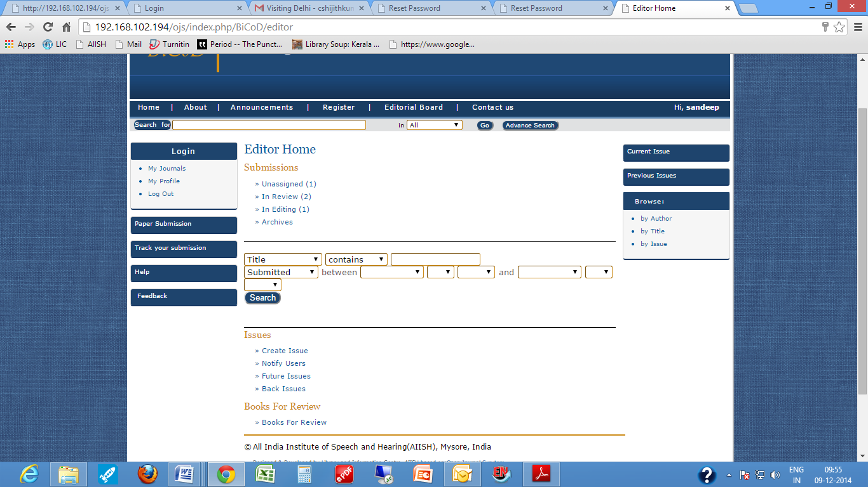

The Managing Editor’s Home Page (figure …. ) consists of four major sections: 1. Submissions 2. Search and 3. Issues 4. Book Review

Clicking on unassigned will take you to the summary page of the unassigned paper which consists of 4 sections.

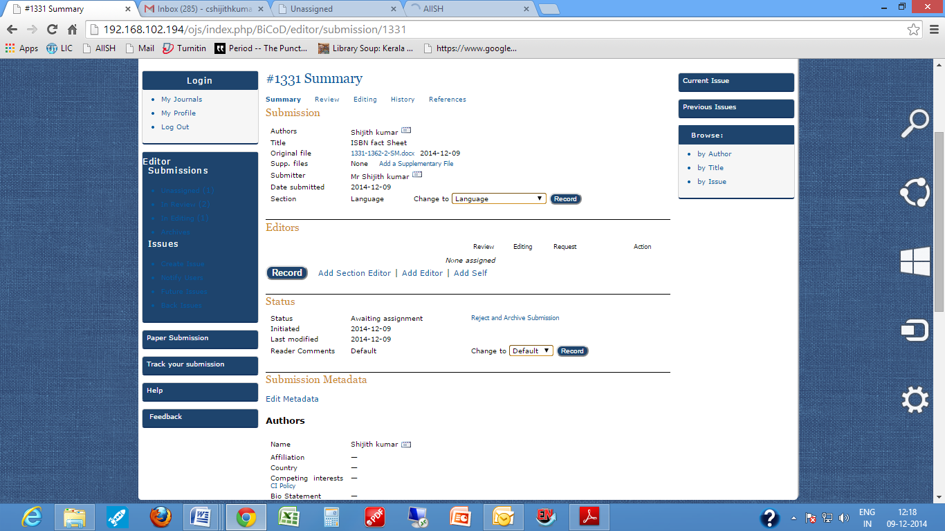

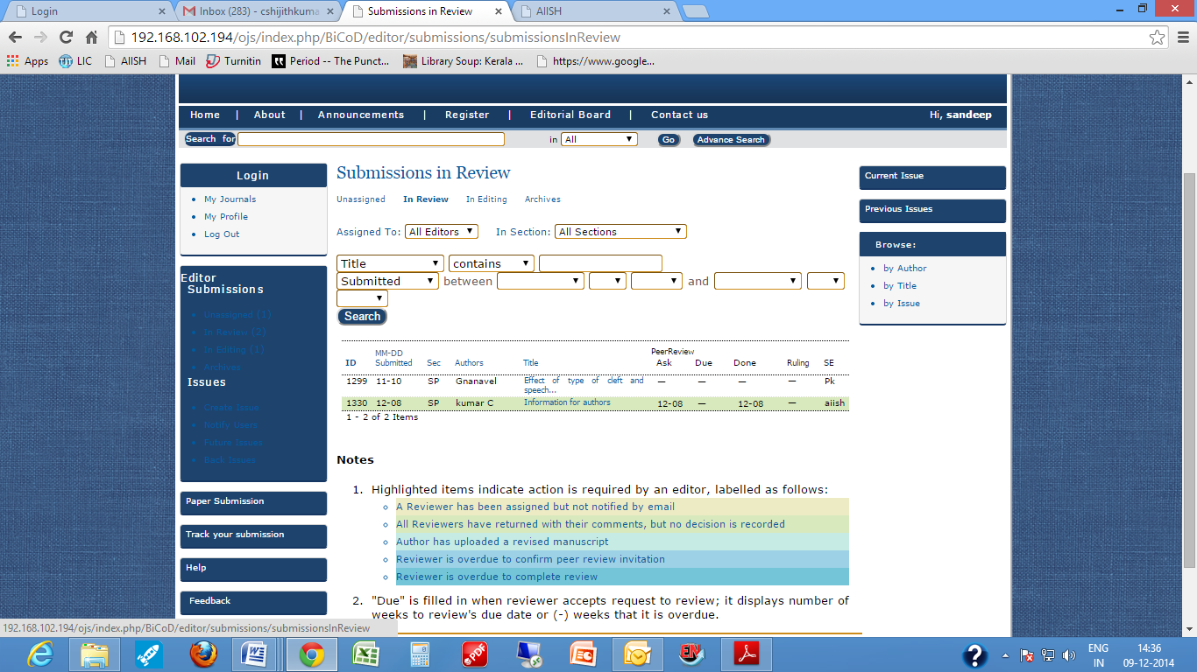

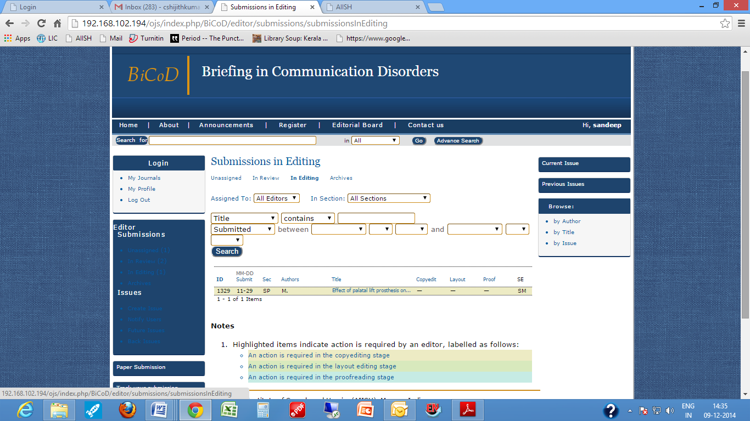

==

Mr Varun U:

I would ask that you undertake the copyediting of "ISBN fact Sheet" for Briefing in Communication Disorders by following these steps.

1. Click on the Submission URL below.

2. Log into the journal and click on the File that appears in Step 1.

3. Consult Copyediting Instructions posted on webpage.

4. Open the downloaded file and copyedit, while adding Author Queries as needed.

5. Save copyedited file, and upload to Step 1 of Copyediting.

6. Send the COMPLETE email to the editor