“Web 2.0, Social Media and Libraries: Role of social media in promoting library and information services in an academic setting: with special reference to University of Bolton (UoB), Academic Centre Sri Lanka Library”.
By Lionel R. Amarakoon, FCILIP (UK); FLA (S.L.); MITD; PGD; Dip in HRD (India)
Librarian, University of Bolton, Academic Centre Sri Lanka
E-mail: lra1ext@bolton.ac.lk
Ruwani S. Kumari Amarakoon, B.Sc (Special) Hon. Information Technology Management
M.Sc in Information Systems Management (Reading) at University of Greenwich, London
E-mail: ruwani@gmail.com
Abstract
Web 2.0 and Social media networking tools are now being used by number of academic libraries in Sri Lanka in order to enhance service delivery to library clientele. The paper attempts to explore the different applications of social media for promoting of library and information resources and services in an academic setting. Author recommends the use of social media such as Facebook, Wikis, LinkedIn, Blogging, YouTube and online groups etc., for marketing different library services. Author attempts to assess the effectiveness of social media in promoting library services too.
Author indicates that inadequate training opportunities, lack of knowledge, privacy and identity theft, slow speed of internet and electricity failure are the problems for applying social media in libraries of Sri Lanka for promoting library resources and services. They needed trainings on social media usage and suggested that libraries should adopt social media for maximum exploitation of library services. Author recommends that library and information resource centers should develop their marketing plan with incorporating social media for news, service alerts and quick updates to online users and fund raising. They argue that the use of social media is important to capture the attention of online users and which will help in distance learning and knowledge sharing.
Key words: Web 2.0; Social Media; Library Publicity; library marketing, Facebook, Google, Twitter, Skype

Preamble
Web definition(s) of Social Media
- This is comprised primarily of internet based tools for discussing and sharing information on both personal and business levels. Some popular social media platforms include Twitter, Facebook, MySpace, and Flickr.
www.stepforth.com/resources/web-marketing-glossary

- A term often used interchangeably with term "user-generated content" or "Web 2.0" to refer to online content and tools that allow anyone to create, share and collaborate about content and information. ...
www.dbcde.gov.au/digital_economy/what_is_the_digital_econo…

Hence, a social network is a network of users that are linked together either through similar interest of who one may know in real life or virtually. Joining a social network involves creating an online profile with your personal information and gaining friends. One can gain friends either through joining similar online interest groups or through requesting persons, with whom you interact with, to join your network.

Purposes of social networking

Social networking is a way for people to connect and share information with each other online.
Millions of people worldwide regularly access these types of services from mobile devices,
applications, and websites. According to statistics published by some of the most well-known
social networking services, there are more than 500 million active users on Facebook1, 175
million registered users on Twitter2, more than 100 million users on MySpace3, and more than 80 million members on LinkedIn4.

The reason that information professionals should engage in active use of social networking tools is to attract their library users to the library by existing in the same online space as their patrons. World over several library systems have taken steps to develop an online presence on the most popular social networking sites. The National Library and Information Systems Authority in Trinidad and Tobago provide links to its Facebook, Twitter and YouTube content via its homepage and Halifax Public Libraries on its teen page provides a link to its teen Face book page. There is, however, a disturbing trend that in spite of the library’s presence on social networking sites, these library pages are not well subscribed to. For example, though Halifax Public Library serves a large community their teen Face Book page has a mere 102 fans. What could be accounting for the low numbers, despite these institutions engaging in technological innovation and existing in the same digital space as their clientele? The new generation of library users will not simply come to the library’s Facebook page but rather the library has to actively engage the user. Being information professional involves proactive in connecting to your users, and that means being as dynamic and outgoing digitally as the users with whom you are trying to interact.

Social media marketing of libraries

Social media marketing of libraries is the way of advertising library, its brand product and services via web 2.0 technologies. By using social media libraries can engage with their clienteles and enable them to participate in the production of library products. Social media includes networking web sites like Face book, MySpace, micro blogging web sites like Twitter and other media like blogs, podcasts, photos and videos. By posting library material via social media on library page, it can be used by the variety of locations on the Web (Tuten, 2001).

The shift of paradigm from Web 1.0 to Web 2.0 is offering new challenges for libraries that how to capture the attention of remote users who are engaged in social media activities. Different applications of Web 2.0 in form of social media are being used by millions of people in the world. Social media is an instrument on communication. It is a broad term and covers a large range of web sites which enable people to interact with other visitors. These media are Social news (Dig, Propeller), Social Bookmarking (Del.lcio.us, Simpy, Blinklist), Social Networking (Facebook, Myspace, LinkedIn), Social Photo and Video Sharing (YouTube, Vimeo, Flickr) and Wikis (Wikipedia, 2011). According to the statistics of July 2011, it has been reported that there are 750 million users of Facebook around the world. Twitter is being used by 250 million users worldwide., 115 million people use LinkedIn, MySpace is being used by 50 million users and the users of Google Plus are 25 million (Googlefan, 2011).
Social media provides more opportunity to reach your community, target specific audiences, and give them a chance to interact with your library. Statistics of Social media usage shows that there are nearly 700 million active Facebook users, over 100 million LinkedIn members, 5 billion+ images on Flickr, 24 million pages on Wikipedia, 300 million Twitter users posting over 7,000 tweets per second, over 2.9 billion hours of YouTube watching per month (Tortorella, 2012). The whole business of libraries is about connecting people with information and this is what social media is really all about. Social media helps in reaching out to our communities and providing them information that they need in a very accessible way. There are number of libraries that used Wikis, Flickr, or Blogs for publishing historical photos and ask people to identify people, places, or events pictured. Different libraries use Wikis for content creation and to create a collaborative relation between library and the community. Hence IM (Instant Messaging), SMS, Twitter and email are being for answering questions (Convertive, 2011).
Literature review

In developed countries libraries are using latest trends to market their services. U.S. libraries of all types are increasingly using social media tools and Web 2.0 applications to connect with library users and to make library programs and services accessible (ALA, 2001). Library of Congress is also utilizing social media for marketing its services and to interact with its online users. Library uses Blogging, Flickr, YouTube, Social Networking, iTunes and Twitter for its different services (Braziel, 2009). National library of Australia has embraced the use of social media as a corporate communications and community building tools. Library supports every employee to have the opportunity to communicate online via social media, professional networking sites, blogs and personal web sites (NLA, 2010). The National Library of Australia uses a variety of social media for notifying news, relevant items from collection and library events.

Facebook is used by the library to inform the library users about major events, activities and recent acquisitions through posting photos, videos and links to resources about the library. Library uses YouTube for sharing videos of many of the events held at the library. Presentations and talks organized on different topics by the library are disseminated via podcasts (NLA, n.d). Hendrix and Zafron (2009) found that the main purpose of using Facebook in libraries is to market the library and push out announcements to library users for promotional purpose. In order to have a presence in the social network, libraries post photos and provide chat reference service.

Studies conducted at International level show positive results regarding the use of social media in libraries to market their products and services. According to the survey report conducted by the South Carolina State Library, it was observed that majority of respondents (92.2 %) considered Web 2.0 tools important for marketing and promoting library services (ALA, 2001). Similarly, Burkhardt (2009) identified that library can market its services and events by using fliers, bookmarks, announcements in calendars of events, newspaper ads, press releases. Rogers (2009) reported that many public libraries in America are embracing social networking tools to promote library marketing services for library patrons. Internet based social media tools like blogs, podcasts, online videos and social networks are giving voice to the opinions of millions of online users. Mickiernan (2009) stressed that libraries should think to fulfill the need of online users i.e. professors, librarians or parents who are in social space. It was found that students were willing to access the library through this unique plate form in the right circumstances.
Different studies have shown that social media tools are much popular among new users' generations. As they are growing up with modern information technologies, they rely on social media and use it as a tool for communication, information sharing and discussions. Bart (2010) studied the social media usage among college faculty. It was found that 80% of the respondents had at least one social networking account. They used it for professional purpose. Facebook, Twitter and YouTube were found as most recognizable names among more than 90% of the faculty. It was found that teachers used Facebook, LinkedIn, Skype and YouTube for communicating with peers and students. It was appeared that social media use is more among faculty in the Humanities and Social Sciences than those in Mathematics, Science, Business and Economics. Like Bart (2010), Kamdani and Kumbar (2006) also found that majority of the respondents visit institutional web site regularly. It was observed that respondents agreed that libraries should maintain the portal by hosting the Web OPAC. Library portal should provide facility to the users to access library databases. It was concluded that libraries should provide web-based services to their user. Suraweera et al. (n.d.) explored that social networks are being used by teachers, lectures and students as a communication tool. Many students are using this tool in a very wide range. Teachers, lecturers and professors are using this tool for discussions to post assignment, tests and quizzes. Social networking sites are being used to foster the communication between teachers and parents. Chand, Suman and Nirmalendu (2008) concluded that adding Web 2.0 studies to the curriculum may also serve to improve the position of LIS programmes. RSS is also very useful to library and information science education and research purpose. With the help of RSS library science students can monitor high school and college scholarship opportunities by using RSS feeds. Library and information science department can also use RSS to communicate departmental news with their students, announcing staff changes, new courses or any other news that is relevant and of interest to the student population.

Problem Statement

Increasing use of social media by the Internet users is offering new challenges for libraries to keep their image alive into the minds of community that work in virtual environment. Statistics have shown the tremendous use of social media sites by the users all around the world. In Sri Laka, the use of Internet by the community is increasing day by day.

The Internet users in Sri Lanka were last reported at 2503193.88 in 2010, according to a World Bank report published in 2012. Internet users are people with access to the worldwide network. In spite of years of civil war, the country has recorded strong growth rates in recent years. The main sectors of the Sri Lanka's economy are tourism, tea export, apparel, and textile and rice production. Remittances also constitute an important part of country's revenue. Computer literacy is very high in Sri Lanka when compared to other countries in South and Central Asia.

In countries with developed education and library systems, libraries are utilizing contemporary trends for marketing their library and information products and services for their remote users. On the other hand, review of the literature shows that in Sri Lanka, no study has been conducted so far to investigate the ways for libraries to market their products and services among the users in online social space. Research should be conducted in Sri Lanka (keeping in view the typical problems and challenges being faced by Libraries in Sri Lanka), to investigate the attitude of LIS professionals towards the use of social media in marketing of library resources and services and to find out the ways for optimum utilization of social media tools for marketing the library services.

Objectives of the Study
The study seeks to achieve the following objectives: to explore the different applications of social media for promoting of library and information resources and services in an academic setting.
To explore whether inadequate training opportunities, lack of knowledge, privacy and identity theft, slow speed of internet and electricity failure are the problems for applying social media in libraries of Sri Lanka for promoting library resources and services.
In countries with developed education and library systems, libraries are utilizing contemporary trends for marketing their library and information products and services for their remote users. On the other hand, review of the literature shows that other than in Pakistan, in Sri Lanka no study has been conducted so far to investigate the ways for libraries to market their products and services among the users in online social space.
Research should be conducted in Sri Lanka in future, keeping in view the typical problems and challenges being faced by Sri Lankan libraries, to investigate the attitude of Library and Information Science professionals towards the use of social media in marketing of library resources and services and to find out the ways for optimum utilization of social media tools for marketing the library and information products and services. (This can be examined at the 2nd stage of the current ongoing study (planned).
Social Media Marketing in Sri Lanka
Social Media Marketing in Sri Lanka is gaining momentum every day. Not only some of the popular brands; but also we can see some artists, politicians, celebrities, photographers and even some religious organizations are trying to make their presence on social media tools like Face book and other social media channels to carry out their marketing efforts. Among many other sources, Face book remains the most popular Social Media Marketing tool for Sri Lankan businesses. Face book advertising is more popular in Sri Lanka, than advertising on Google Adwords. However, I have met several Sri Lankans, who keep asking me “what is this all the buzz about Face book marketing?” In Sri Lanka, the internet penetration is very low and as a result some companies don’t see it as important to get a social media or Face book marketing campaign going on. Meanwhile, the traditional consultants and advertising agencies in Sri Lanka are also don’t know much about these latest trends in social media marketing and online media. Companies and businesses in Sri Lanka find it much difficult task to figure out how to do marketing on Face book, or how to use the social media channels like YouTube, Twitter and other tools to promote their brands in Sri Lanka. We can see a clear gap of expert knowledge about these new social media marketing channels in Sri Lanka. This blog will focus on keeping you up to date with latest Social Media trends in Sri Lanka.

Social Media Marketing in Libraries in Sri Lanka

After an academic institute creates a Face book page, users can “Like” the page to become a fan, and updates and messages about the library will then appear in their newsfeeds. We at University of Bolton, Academic Centre, in Sri Lanka has created a page for its library and information resource centre (LIRC).
Previously, the two face book pages we continued to maintained here at WCMT were sort of insipid Face
book pages. Since we needed more effective social media marketing program the challenge we facedwas
how to make them into a dynamic and engaging platform for our target audiences. On the other hand we
need to develop a stronger “Reference Market” to be the flagship for our marketing campaign(s). Hence
we made a face book which is unique and stand out from the rest in the market. We thought that we need
to educate our users, provide them assistance if needed, provide them resources and disseminate
Information which might be useful for their programs and projects in hand. Hence we convert our pages
from generic landing page(s) into pages specifically tailored for them. We give a little background
about our organizations, and convince them with great reasons why they should join our page(s).

We thought that our die-hard followers (current student population) won’t need any reason for joining in
our page. But if WCMT wants to grow our FB presence, we need to give something back to them. Thus
we commenced to provide resources, helping them to solve problems and even guiding them.
We all know that people on FB want to see variety of photographs. It is no doubt that FB is the biggest photo sharing site on the web. We made a large photo of our campus, the brand and our vision and mission statements etc., as our profile picture. These will help us with branding and adds trust to WCMT profile.
We were really keen on getting the number of fans increased and hence we started tagging the fans on our photo albums. Therefore it is important that you tag your fans in photos. We have taken number of pictures at the events took place at the WCMT premises and at various exhibitions we participated. But we have failed to tag the people in those pictures earlier. Usually many people have Face book notifications that alert them when they have been tagged in photos, and this will bring them back to our page(s) and that is how we gradually build a “Reference Market” for our products and WCMT as a whole. Do not forget that our target audiences also have the ability to upload photos as well. Surely, this might require some moderation on our part in order to avoid spam etc. The beauty of the FB is that by allowing our fans (target audience) to upload and tag themselves and friends in our pages automatically add a nice social “hook” to our pages. Not only have we given back by adding photos, we also keeping our brand planted firmly in the mindset of our target audience. Contents are great way to make our pages more engaging and they also give incentive for potential fans to join in. We can use multiple Face book applications to pull in our other already existing accounts from other social networking sites. We need to tryout to pull in LinkedIn, Twitter, Flicker, YouTube and many other fairly quickly. Do not forget to thank people for becoming our fans. When someone becomes a fan on FB, we need to thank them immediately. It is absolutely necessary for us to give them something in return, such as an e-newsletter, e-resource etc or at least send them a quick “thanks” message.
Some proactive information professionals may wish to create an individual profile page. This page is professional in nature and is separate from any personal Face book page that an information professional may have. This is a good idea as some library users may not wish to be a fan of the library as an organization, but if they choose to be friends with the librarians, they may gain access to updates and information in this manner.

All these different Face book presences are used with varying degrees of success. Organization Page works well with a large library system that seek to have a wide reach. However, groups work well with smaller, close-knit libraries where the information displayed would be relevant to only certain people, rather than the wider public. Individual profile pages are also a good idea, since they have the effect of personalizing the library’s connection with the library users.
Miller and Jensen (2007) offer some suggestion on how to connect with your patrons. In spite of their focus on the high school library, some of their suggestions may be applied to public libraries and even academic libraries as well.
Libraries can create three types of Face book presence:
Organization/business page
Face Book Groups
Profile Page for Individual Librarians

Librarians becoming Face book fiends of all the users of a library are good ideas. Then you can send the suggestion to join the library’s Face Book page or group. Also, encourages student members to tell their friends to also join the library group or page as well.

Conclusions

Our observations revealed that although few librarians have commenced to use social media such as, Face Book in their library promotion in Sri Lanka, still they need proper orientation on how to make their Library Face Book more dynamic and engaging. Without such training on how to use social media more effectively, the Library Face Books will not serve its purpose, i.e. “the role of effective library promotion”.

Inadequate training opportunities, lack of knowledge, privacy and identity theft, slow speed of internet and electricity failure are the problems for applying social media in libraries of Sri Lanka for promoting library resources and services. Librarians needed trainings on social media usage and suggested that libraries should adopt social media for maximum exploitation of library services. We recommend that library and information resource centers should develop their marketing plan for utilizing social media for news and service alerts and quick updates to online users. The use of social media is important to capture the attention of online users and helps in distance learning and knowledge sharing.

WCMT before making its FB more dynamic was like this:
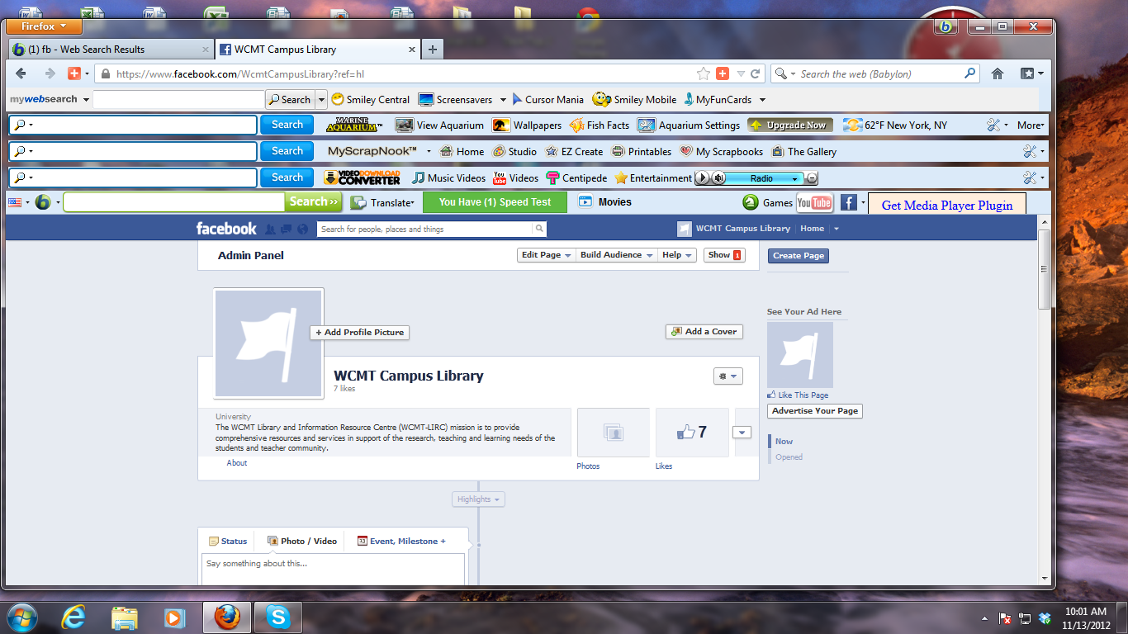
Figure - 1
After adopting the tips for creating a more dynamic Face Book page for WCMT Campus Library is given below:
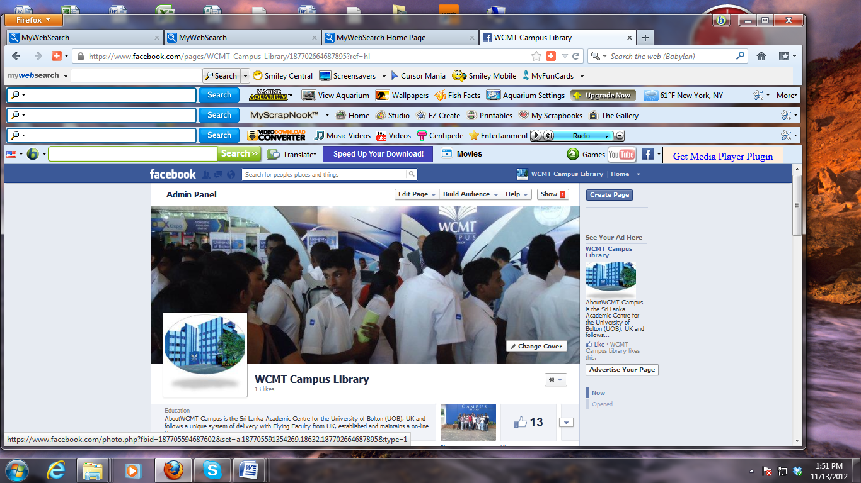
Figure – 2
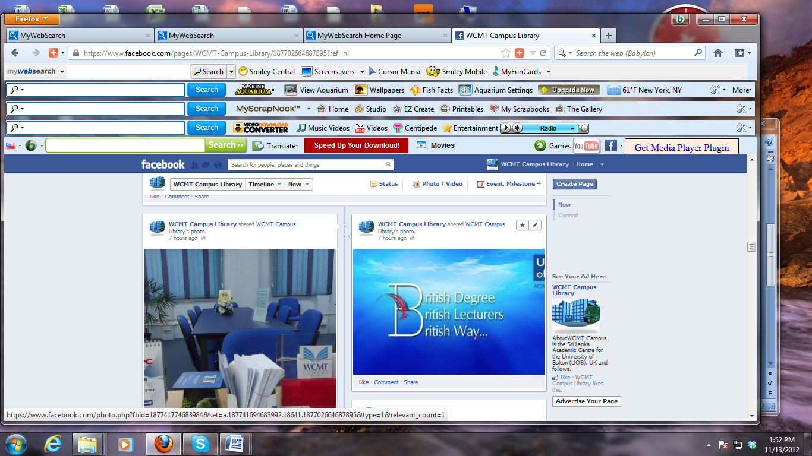
Figure – 3
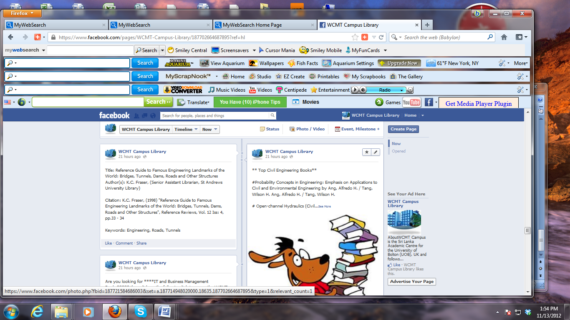
Figure – 4
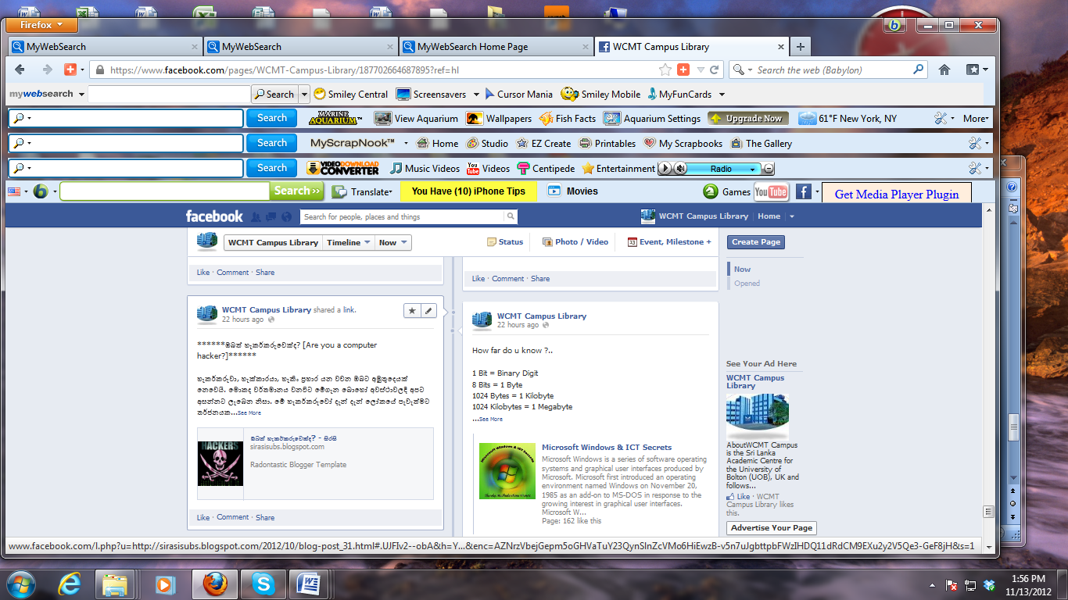
Figure - 5 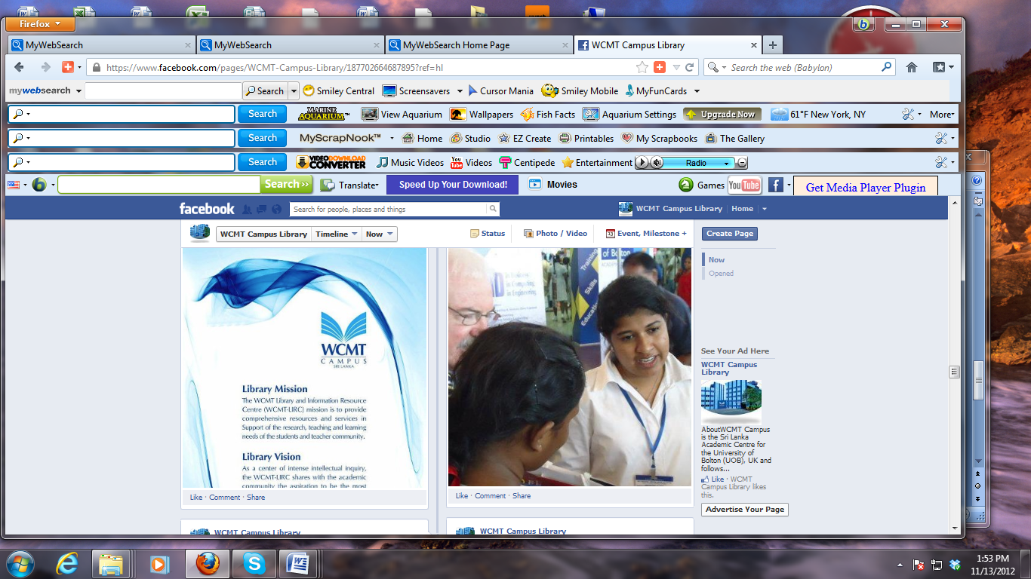
Figure - 6

References
- ALA (2001). Libraries making good use of social media and Web 2.0 applications. Retrieved May 9, 2012, from http://www.ala.org/news/mediapresscenter/americaslibraries/socialnetworking
- Bart, M. (2010). Social media usage among college faculty. Retrieved May 9, 2012, from http://www.facultyfocus.com/articles/trends-in-higher-education/social-media-usage-among-college-faculty/
- Braziel, L. (2009). Social media marketing example #12: Library of Congress. Retrieved May 9, 2012, from http://www.ignitesocialmedia.com/social-media-examples/social-media-marketing-example-library-of-congress/
- Burkhardt, A. (2009). Four reasons libraries should be on social media. Retrieved May 9, 2012, from http://andyburkhardt.com/2009/08/25/four-reasons-libraries-should-be-on-social-media/
- Chand, S.N., Suman, D., & Nirmalendu, P. (2008). Application of Web 2.0 in library and information science: With special reference to RSS. Retrieved May 9, 2012, from http://ir.inflibnet.ac.in/dxml/handle/1944/1157
- Convertive (2011). Using social media in major library systems. Retrieved May 9, 2012, from http://www.convertiv.com/using-social-media-in-a-major-library-system/
- Googlefan (2011). Social network user statistics as of July 2011. Retrieved May 9, 2012, from http://google-plus.com/598/social-network-user-statistics-as-of-july-2011/
- Hendrix, D., & Zafron, M.L. (2009). Use of Facebook in academic health sciences libraries. Journal of Medical Library Association, 97(1), 44-47.

Khan, Shakeel Ahmad, & Bhatti, Rubina (2012). "Application of social media in marketing of library and information services: A case study from Pakistan." Webology, 9(1), Article 93. Available at: http://www.webology.org/2012/v9n1/a93.html
- Tortorella, D. (2012). Library marketing and promotion via social media. Retrieved May 9, 2012, from http://infopeople.org/training/library-marketing-and-promotion-social-media
- Mickiernan, G. (2009). Friends: Social networking sites for engaged library services. Retrieved May 9, 2012, from http://onlinesocialnetworks.blogspot.com/
- Rogers, C.R. (2009). Social media, libraries, Web 2.0: How American libraries are using new tools for public relation and to attract new users. Retrieved May 9, 2012, from http://themwordblog.blogspot.com/2009/06/social-media-libraries-and-web-20-how.html
- Suraweera, N., et al. (2011). Value of social networking in libraries and information organizations in Asia and Oceania. Retrieved May 9, 2012, from http://www.ifla.org/files/hq/papers/ifla76/145-suraweera-en.pdf
- Tuten, T.L. (2001). Advertising 2.0 - Social media marketing in a Web 2.0 World. Book review. Retrieved May 9, 2012, from http://blogcritics.org/books/article/book-review-advertising-20-social-media/
- Wikipedia (2011). Social media. Retrieved May 9, 2012, from http://en.wikipedia.org/wiki/Social_media

