# Day 1 Using electronic resources

# Unit 1.3: Effective searching of e-resources

## Handout 1.3.4 How to search on Google

<https://support.google.com/websearch/answer/134479?hl=en>

### Tip 1: Keep it simple

No matter what you're looking for, try to start with a simple search. Add a few descriptive words if necessary. If you're looking for a place or product in a specific location, add the town or zip code.

Try it out: [**where's the closest airport**]

Tired of typing? If you’re using Google Chrome, click the https://storage.googleapis.com/support-kms-prod/SNP_326FA07D5EB88DFE60A02D12B2E46B870C2D_3407081_en_v0microphone icon in the search box and [search by voice](https://support.google.com/chrome/answer/1331723).

### Tip 2: Use web friendly words

Use words that are most likely to appear on websites. For example, instead of saying [**my head hurts**], say [headache], because that’s the term a medical site would use.

### Tip 3: Don’t worry about the little things

* **Spelling.** Google's spell checker automatically uses the most common spelling of a given word, whether or not you spell it correctly.
* **Capital letters.** A search for [**New York Times**] is the same as a search for [**new york times**].
* **Punctuation.** Most punctuation, like ?!,.%^*()[]\, is ignored when you search.

### Tip 4: Find quick answers

For many searches, Google will do the work for you and display an answer right on the search results page immediately after you type it. Try some of the searches below either by typing or searching by voice:

Some features, such as information about sports teams, are not available in all regions.

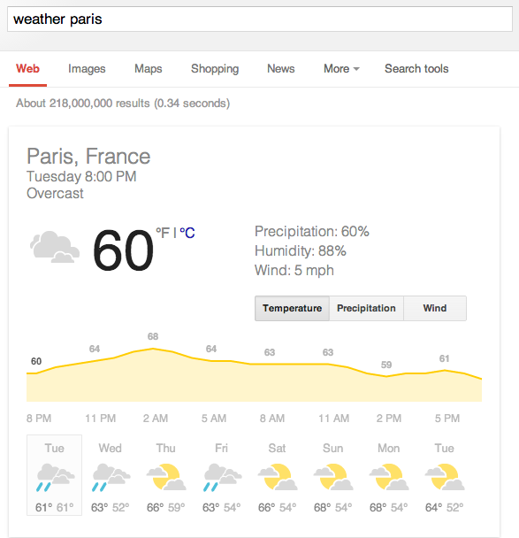

* **Weather.** Search [**weather**] to see the weather in your location or add a city name after weather to find weather in that area.
* **Dictionary.**Put [**define**] in front of any word to see its definition.
* **Calculations.** Enter a math equation like [**3*9123**] to see the answer, along with a calculator to solve more problems, even graphing equations.
* **Unit conversions.** Enter any conversion, like [**3 dollars in euros**].
* **Sports.** Search for the name of your team to see a schedule, game scores and more.
* **Quick facts.** Search for the name of a celebrity, location, movie, or song, and see quick information on the right side of the page.

### Tip 5: Become a search expert

Want more tips and tricks to help you search like a pro? Check out the links below to learn more advanced search techniques.

* [Advanced Search](https://support.google.com/websearch/answer/35890)
* [Image search](https://support.google.com/websearch/answer/1325808)
* [Search operators](https://support.google.com/websearch/answer/136861%20)
* [Search tools and filters](https://support.google.com/websearch/answer/142143%20)
* [Punctuation and symbols in search](https://support.google.com/websearch/answer/2466433%20)

# <https://support.google.com/websearch/answer/136861>

# Search operators

Narrow down your search results by adding symbols and words to your search called search operators. Don’t worry about memorizing every operator - you can also use the [Advanced Search](http://www.google.com/advanced_search) page to create these searches.

When you search using an operator, don't add any spaces between the operator and your query. A search for **site:nytimes.com** will work, but **site: nytimes.com** will not.

|  |  |
| --- | --- |
| **Search for an exact word or phrase**  **"search"** | Use quotes to search for an exact word or set of words on a web page. This is helpful when searching for song lyrics or a line from a book. But only use this if you're looking for an exact word or phrase, otherwise you'll exclude many helpful results by mistake.  **"imagine all the people"** |
| **Exclude a word**  **-search** | Add a dash (**-**) before a word or site to exclude all results that include that word. This is especially useful for words with multiple meanings, like Jaguar the car brand and jaguar the animal.  **jaguar speed -car**  **pandas** **-site:wikipedia.org** |
| **Search within a site or domain**  **site:** | Get results only from certain sites or domains. For example, you can find all mentions of "olympics" on the NBC website, or any .gov websites.  **olympics site:nbc.com**  **olympics site:.gov** |
| **Search for pages that link to a URL**  **link:** | Find pages that link to a certain page. For example, you can find all the pages that link to google.com.  **link:google.com** |
| **Search for pages that are similar to a URL**  **related:** | Find sites that are similar to a URL you already know. If you search for related sites to the Time.com, you'll find other news publication sites you may be interested in.  **related:time.com** |
| **Fill in the blank**  **\*** | Add an asterisk within a search as a placeholder for any unknown or wildcard terms. Use with quotation marks to find variations of that exact phrase or to remember words in the middle of a phrase.  **"a * saved is a * earned"** |
| **Search for either word**  **OR** | If you want to search for pages that may have just one of several words, include **OR** (capitalized) between the words. Without the **OR**, your results would typically show only pages that match both terms.  **world cup location 2014 OR 2018** |
| **Search for a number range**  **..** | Separate numbers by two periods without spaces (**..**) to see results that contain numbers in a given range of things like dates, prices, and measurements.  **camera $50..$100** |
| **Find information about a site**  **info:** | Get information about a URL, including the cached version of the page, similar pages, and pages that link to the site.  **info:google.com** |
| **See a cached version of a site**  **cache:** | See what a page looks like the last time Google crawled the site.  **cache:washington.edu** |

### Punctuation

When you search, most punctuation and special characters are ignored. However, there are some [punctuation and symbols](https://support.google.com/websearch/answer/2466433) that work in searches.