Why evaluate?

It is always important to evaluate the information sources you use in your academic work. However, it is particularly important to critically examine the information you locate in when searching... [select below]

 (required)



Google



your campus library



Exeter's digital library resources

Correct! While it's always important to evaluate your sources, it is important to be especially vigilant when searching for information online. Google is a great tool that provides free and easy access to a vast amount of information. However, the sheer amount of information available means that source quality can vary considerably. For example, expertly written, peer-reviewed articles from academic journals can appear in your results alongside personal blogs, social media posts, satire and propaganda.

Before we look at some of the criteria that you can use to evaluate your information sources, the activity below allows you to test your current judgment by giving you the opportunity to rank three different sources on their academic quality

For the purpose of this activity, the topic being researched is:

***The effects of regular coffee consumption on long-term health in adults.***

Researching a topic such as this would require an extensive search for any relevant literature that already exists on the subject.

## Activity: assessing source quality

The academic quality of information available online can vary significantly. Searching for information on the above research topic brings up a wide range of search results, including the three articles below:

**Source 1**: [A research project published in the British Medical Journal, evaluating evidence on the effects of coffee consumption on a range of health outcomes.](https://doi.org/10.1136/bmj.j5024)

**Source 2**: [An article from the Express Online outlining aspects of human health that can be detrimentally effected by excessive caffeine consumption.](https://www.express.co.uk/life-style/health/882502/diet-cold-coffee-ill-immune-system-tired-vitamin-deficiency)

**Source 3**: [A news item from the University of Southampton highlighting the relationship between coffee drinking and a reduced risk of liver cancer.](https://www.southampton.ac.uk/news/2017/05/coffee-liver-study.page)

Take a look at each of these articles, then complete the activity in the next box, where you can rank each article by its academic quality

# Activity: Assessing source quality

Have a look through the three sources in the box on the **left**and think about the quality of each one in relation to the research topic. Rank them in order of quality by selecting their most appropriate position in the grid on the next page.

**Highest Quality: Source 1**

Of the three sources, Source 1 would rank highest. It is a recently published academic article which directly addresses the research topic. It is published in a leading academic journal and is written by expert figures from the field of health research. They are also clear in outlining the methods used to conduct the project and provide clear references to over 130 sources used to support the research.

**Source 3**

This is also a good quality source. The source summarises the findings from research carried out by academics from the University of Southampton. The research itself was an extensive academic study that was published in a leading peer-reviewed publication. The article was written in 2017, so it likely remains relevant, while it is also posted on a university website, which can often indicate a good level of academic reliability. While you should take care to note that this is only a brief summary of a larger project, drawing attention to selected findings; the article provides a link to the original research paper, which you could read to gain a more complete insight into the study.

**Lowest Quality: Source 2**

Despite being related to the research topic, offering different perspective to the other articles and being published relatively recently, Source 2 is bottom of the list. As a tabloid article, its main function is to appeal to the general public, rather than students or researchers. This is particularly the case with online articles, where headlines are designed to generate clicks. Though the author has written on health issues before, a quick search for her name highlights that rather than being an expert in the subject matter, she also writes on a range of additional topics, including ‘style’, ‘travel’ and ‘showbiz’. There are also issues with the content of the article. Rather than pointing to academic research, the author quotes the views of a “sleep expert”, who is not a medical professional or researcher. The ‘expert’ proceeds to recommend readers use an alternative product, of which he is a brand ambassador, displaying a rather transparent conflict of interest.

**Evaluation criteria: using the CRAAP test**

There are a number of different criteria and models that you can use to evaluate information sources. This tutorial will focus on the CRAAP test, one such model that you can apply. The CRAAP test consists of five main criteria that you can use to judge the academic quality of information:

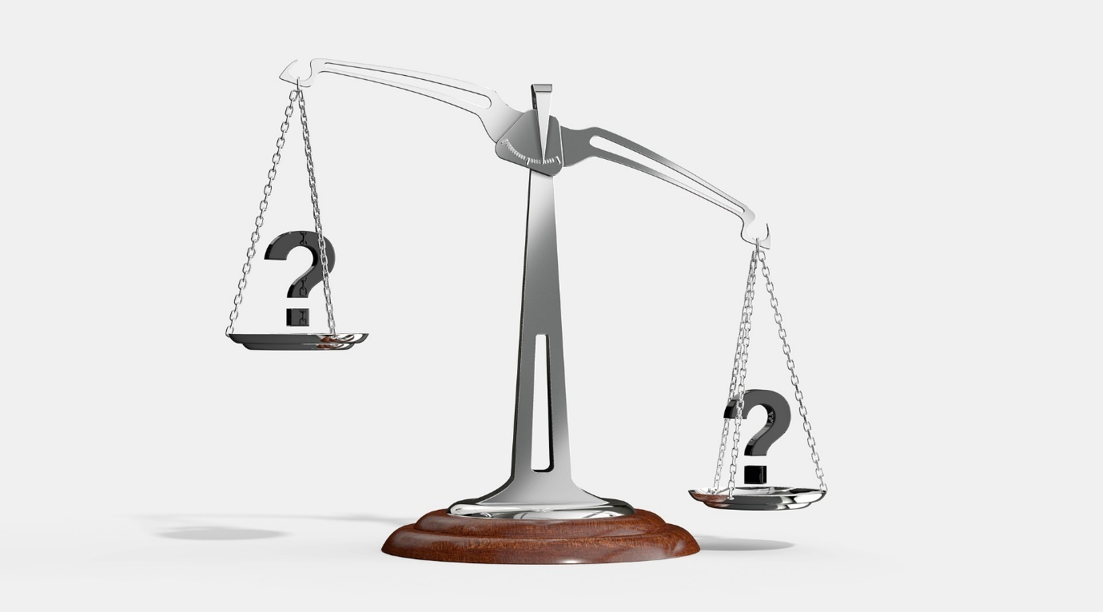

- **C**urrency

- **R**elevancy          ​

- **A**uthority

- **A**ccuracy

- **P**urpose

Each criteria encourages you to ask a series of questions of your sources to help you determine if they should play a role in informing your work. This process does not need to be taxing or time consuming; indeed many of these checks can be completed without having to read the article or source you find in full.

## Activity: applying evaluation criteria

This activity provides an opportunity for you to put the CRAAP test into practice.

Bearing in mind the previous research topic:

***The effects of regular coffee consumption on long-term health in adults.***

Take a look at the source below and consider some of the key questions from the CRAAP test when answering the questions in the box on the right.

**Source**: [Coffee A–Z: A Guide to the History, Types, Benefits, and Risks of the Buzzy Drink​](https://www.everydayhealth.com/diet-nutrition/diet/coffee-healthy-caffeine-content-nutrition-benefits-risks/)

# Activity: Evaluation criteria

Use the following questions to apply the CRAAP test criteria to the article on the left of the page: 'Coffee A–Z: A Guide to the History, Types, Benefits, and Risks of the Buzzy Drink​'.

Activity: Evaluation criteria

**Currency:**  
Does the article provide a clear publication date?



Yes



No

**Currency Feedback -**

**No**, the original publication date is not shown. Although it is not displayed very clearly, you can see that the article was recently updated in May 2018. However, some of the academic articles and web pages that the article links to are much older, with some examples being 10, 20 and even 30 years old. It is important that when researching a subject such as this, that you are drawing on the most up to date evidence. As the author does not present a methodology of how they have selected their articles, it is difficult to know if this is the most current evidence available.

**Relevancy:**  
Do you think this article is relevant to the research topic?



Yes



No

**- Relevancy -**

The article is partly, but not entirely relevant to the example research project. It highlights some of the potential 'benefits' and 'risks' of coffee drinking, but it also dedicates considerable space to other areas, such as history, production and varieties of coffee.

**Relevancy:**  
Who is the target audience for the article?



Business



Academics, students, researchers



General public



The media

**- Relevancy -**

**The general public.**The website's aim is to make health information available and accessible for the general public, so the article is written with a more general audience in mind. Signs of this include the writing style, including the use of slang terms ("'buzzy drink"; "cup of Joe" etc.) and contractions, which are not traditionally used in academic writing. The key points around the health effects of coffee are also presented in short bite-sized chunks, rather than through detailed analysis. When producing academic work, the most relevant secondary sources are often those written with students and academics as the target audience.

**Authority**:  
In the box below, note the following:

* Who is the author / who produced the information?
* Do they / their organisation have expertise to write with authority in this area?
* ***- Authority Feedback -***
* The article is written by Valencia Higuera, who's profile does not indicate a particular expertise in this area. While writing on' health' subjects, she also writes for various publication in the fields of 'lifestyle' and 'personal finance'. The website, 'Everyday Health', specialises in providing health content for the general public via articles, newsletters and other services. Its senior editorial staff are experienced health writers or have had careers in the health industry, indicating a level of authority for the organisation as a whole.

**Accuracy**:  
In the box below, note the following:

* Is the information supported by evidence (e.g. references, research data)?
* Is there evidence that the article has gone through a quality-checking process?
* ***Accuracy Feedback -***
* Though not presented in an academic style, the article does include links to supporting sources throughout and provides a full reference list of the 36 sources used at the end of the article ('Editorial sources and fact checking'). The quality of these sources appears to be mixed. Some are direct links to peer-reviewed academic research, while others are to websites or lifestyle pages, which will themselves be 1-2 steps removed from the original data and research.
* The website are keen to highlight that most of their articles, including this one, go through a 'medical review' process to provide an extra layer of authority. This article was reviewed by Kelly Kennedy, a registered dietitian, who is one of a number of health professionals affiliated with the site. The website is also shown to be in compliance with the HONcode (Health on the Net Foundation);  an industry code of conduct that aims to ensure the reliability and credibility of health information online

**Purpose:**  
What is the purpose of this article? [select all that apply]

***- Purpose -***

**Inform + Sell**

At first look, the purpose seems to be aligned with the stated aims of the website, to inform the public about the nature of coffee and its possible health implications. However, note that the website, 'Everyday Health'  is a business trying to make money. The headline, writing style and article structure are designed to draw readers in, keep them on the site and expose them to adverts. An exploration of the website also highlights that they produce sponsored content, developed alongside their commercial partners. While Everyday Health stress that they maintain editorial control to ensure "accuracy, objectivity and balance", in reality this content is difficult to distinguish for the website's own articles.

**Not entirely appropriate for academic work**

Applying the CRAAP test to this article reveals that it is mixed and inconsistent in its level of academic quality. For each criteria there are some positive aspects as well as drawbacks:

**Currency:**The article was updated this year, but in some cases is basing its points on decades old research.

**Relevancy:**The article relates to our research topic, but is written for a general, rather than academic audience and is not presented in an academic style.

**Authority:**The website is run by experienced health journalists supported by healthcare professionals, but the author of the article is not herself a health expert.

**Accuracy:**The article has gone through an internal 'review' process and the organisation subscribe to a set of professional information standards; but there is no original data, and the article's references are mixed in terms of their own academic quality.

**Purpose:**The author appears genuine in their intention to inform the public of the benefits and risks of coffee drinking, but the website itself is a business trying to keep readers on their website and generate advertising revenue.

**Overall**, this reveals that while the article does offer some evidence-based insight into the research topic, it cannot itself be described as an academic source. If you were to come across a source like this during your searching process, it may be best to neither discount it entirely, or to cite it in your assessment. Instead, note down some of the key points raised in the article and look for **academic**articles in these areas. You could also head directly to some of the academic journal articles cited in the article and deal with the information at its **source**.

# Activity: types of resources

Which type of resource is most likely to provide up-to-date information?



Newspaper article



Textbook



Journal article

That's correct! Most major newspapers are published on a daily basis, so should be some of the most up-to-date sources of information. However, this does not mean they will carry the most academic authority. They will be written in a journalistic, rather than academic style and may not be in a position to provide the detailed academic analysis of subjects that later publications can do.

# Activity: types of resources

Which type of resource is most likely to be written by a subject expert?



Journal article



Personal blog



Newspaper article

That's correct! While any of these resources could be produced by subject experts, academic journals, with their strong peer-review processes, are most likely to have contributions from scholars who are established experts in their fields.

Which type of resource is *most likely* to include academic references and evidence to support the authors' arguments.



News articles



Websites



Textbooks

That's correct! Although newspapers and websites will often provide links to relevant supporting content, including academic research, textbooks are the most likely to include scholarly citations and references in an academic style.

Which type of resource is *most likely*to have been created with an academic audience in mind?



Conference papers



Podcasts



Government reports

That's correct! Of the three resources, conference papers are the most likely to have students, academics and researchers as their target audience. While podcasts and government reports may be useful sources to use in your project, they are generally produced with broader audiences in mind. For example, government reports may be targeting other politicians, the media, the public, business, the charity sector and financial markets, as well as academics.

Evaluating your information sources and selecting good quality academic information can...[select all that apply].



...give your work and arguments greater authority.



...help you avoid misinformation and fake news.



...help to improve your grades.

That's correct! Taking the time to critically evaluate the information you find while searching can help you in all of these areas.

While searching for information on a project, how would you select which source to read in more detail?



I would check who produced the source.



I would check if it is relevant to my project then use it.



I focus on only using books, because if they have been published they will be OK to use in my work.



I would check if it is relevant, then who produced the source and the date that it was produced.

This is the correct approach. As well as checking if a source is relevant to your project, you should also at least check who has produced it and when it was produced.

Which of  these sources is more likely to be effected by personal biases?



Academic journal article



Newspaper column



Conference presentation

That's correct. Newspaper columns are more likely to be effected by personal biases, as columnists are paid to write about their interpretation or views an issue. Because of this, columns are sometimes referred to as 'opinion' articles.

While you should evaluate each source individually, the best place to search for high quality academic information for most topics is...



...Google.



...Exeter's digital library resources.



...your campus library.