**PUBLIC EDUCATION**

The Institute has been taking various steps to make the common man aware of communication disorders, educate them on prevention of the disorders and provide guidance and counselling to persons suffering from such disorders. The major public education activities carried out during the reporting year are the following.

**Monthly Public Lectures**

In order to create public awareness on various aspects of communication disorders such as causes, identification and prevention hearing loss, voice disorders, speech and language disorders, the institute organized monthly public lectures tailored for common man during which the expert professionals working in the institute delivered lectures followed by question and answer session with the audience. The details of the lectures organized during the reporting year are given in table 1.

Table 1: Monthly Public Lectures

|  |  |  |  |
| --- | --- | --- | --- |
| **Date** | **Topic** | **Resource Person** | |
| 27.02.2019 | 1. Overview of the Activities of the institute 2. Communication Disorders: An Overview 3. Hearing Impairment: An overview 4. Communication disorders and educational needs of children with communication disorders | Ms. Lakshmi Prabha, J.K.  Ms. Sangeetha Mahesh  Dr. Prashanth Prabhu  Ms. Ramanakumari P V |
| 27.03.2019 | 1. Overview of the Activities of the institute 2. Communication Disorders: An Overview 3. Hearing Impairment: An overview 4. Consanguinity , genetic disorders and communication disorders | Ms. Lakshmi Prabha, J.K.  Ms.Prathima S  Dr.Ganapathy M K  Dr.Priya M B |
| 24.04.2019 | 1. Overview of the Activities of the institute 2. Communication Disorders: An Overview 3. Hearing Impairment: An overview 4. Quality of life of persons with communication disorders | Mr. Prashanth R  Dr. Priya M B  Dr. Sharath Kumar, K.S  Dr.G.Y.Yashodhara |
| 29.05.2019 | 1. Overview of the Activities of the institute 2. Communication Disorders: An Overview 3. Hearing Impairment: An overview 4. a Autism   b. Voice Conservation | Mr. Keerthi A.R  Dr.Sangeetha Mahesh  Dr. Prashanth Prabhu  Ms.Gayathri Krishnana & Dr.T.Jayakumar |
| 26.06.2019 | 1. Overview of the Activities of the institute 2. Communication Disorders: An Overview 3. Hearing Impairment: An overview 4. Improving Quality of Life through Yoga/ meditation/ mindfulness and lifestyle management | Ms.Lakshmi Prabha J.K  Dr. Priya, M.B  Dr. Ganapathy M.K  Mr.Arun Raj |
| 31.07.2019 | 1. Overview of the Activities of the institute 2. Communication Disorders: An Overview 3. Hearing Impairment: An overview 4. Alternative and augmentative services for the rehabilitation of persons with communication disorders | Mr. Prashanth R  Ms.Prathima S  Dr. Sharath Kumar K.S  Ms.Aruna Kamath/Ms.Deepa Anand |
| 28.08.2019 | 1. Overview of the Activities of the institute 2. Communication Disorders: An Overview 3. Hearing Impairment: An overview 4. Role of rehabilitation Specialist in the field of Communication Disorders | Mr.Keerthi A.R.  Dr.Sangeetha Mahesh  Dr. Prashanth Prabhu  Ms.Geetha, M. P. |
| 25.09.2019 | 1. Overview of the Activities of the institute 2. Communication Disorders: An Overview 3. Hearing Impairment: An overview 4. Role of Caregivers in alleviating the quality of life of persons with communication disorders | Ms.Lakshmi Prabha J K  Dr. Priya, M.B  Dr. Ganapathy M.K  Ms.Rathna Shetty-Special Educator |
| 23.10.2019 | 1. Overview of the Activities of the institute 2. Communication Disorders: An Overview 3. Hearing Impairment: An overview 4. Advances in the rehabilitation of the hearing Impaired individuals | Mr. Prashanth R  Ms.Prathima S  Dr. Sharath Kumar K.S  Dr.Prashanth Prabhu |
| 27.11.2019 | 1. Overview of the Activities of the institute 2. Communication Disorders: An Overview 3. Hearing Impairment: An overview 4. UNCRPD and AIISH | Mr.Keerthi A.R.  Dr.Sangeetha Mahesh  Dr. Prashanth Prabhu  Mr.Prashanth R |
| 17.12.2019 | 1. Overview of the Activities of the institute 2. Communication Disorders: An Overview 3. Hearing Impairment: An overview 4. Cerebral palsy and other Childhood communication disorders | Ms.Lakshmi Prabha J K  Dr. Priya, M.B  Dr. Ganapathy M K  Ms.Prathima S |
| 29.01.2020 | 1. Overview of the Activities of the institute 2. Communication Disorders: An Overview 3. Hearing Impairment: An overview 4. Rights and Acts to protect the privileges of Persons with Special Abilities | Ms.Prashanth R  Ms.Prathima S  Dr. Sharath Kumar K.S  Mr.G.Y.Yashodhara Kumar |
| 27.02.2020 | 1. Overview of the Activities of the institute 2. Communication Disorders: An Overview 3. Hearing Impairment: An overview 4. Rights and Acts to protect the privileges of Person with Special Abilities | Ms. Lakshmi Prabha, J.K.  Ms. Prathima, S  Dr. Sharath Kumar, K.S  Mr. Prashanth, R. |

**Preparation and Dissemination of Information Resources**

The Institute developed and disseminated a variety of information resources on communication disorders in different media formats. The details are given in table 2.

Table 2: Information Resources

|  |  |  |
| --- | --- | --- |
| **Sl.No.** | **Title** | **Language** |
| 1 | Articulation Disorders | Kannada |
| 2 | Fluency disorders | Kannada |
| 3 | Communication disorders in elderly | Kannada |
| 4 | Stuttering | Kannada |
| 5 | Learning Disability | Kannada |
| 6 | Cleft lip and palate | Malayalam |
| 7 | Articulation Disorders | Malayalam |
| 8 | Frequently asked questions in NIHL | Tamil |
| 9 | Fluency disorders | Tamil |
| 10 | Ear Discharge | Tamil |
| 11 | Laryngectomy | English |

**Camp-based Awareness Activities**

The institute organized communication disorder screening camps in different localities in the state and other parts of the country. As a part of the camps, extensive awareness programmes were conducted to educate the public on the prevention and management of communication disorders. Totally, eight camps were conducted and around thousands of general public were educated on communication disorders.

**Street Plays and Rally on Prevention and Awareness of Communication Disorders**

The Institute, under the aegis of the Department of Prevention of Communication Disorders conducted rallies and created street plays on various aspects of communication disorders and related topics, and performed before the public in different localities. The details are given in table 3.

Table 3: Street Plays/ Rallies

|  |  |
| --- | --- |
| **Theme/Topic** | **Place of performance** |
| Jatha/Prevention and early identification of communication disorders | KR Nagar |
| KR Nagar |
| KR Nagar |
| Chikmangalore |
| Chikmangalore |
| Chikmangalore |
| Hole Narsipura |
| Sakaleshpura |
| Sakaleshpura |
| World Cerebral Palsy Day | Chikmanagaluru |
| Different speech and hearing disorders | Holenarasipura |
| Sakleshpur |
| Glimpses of street play performances by BASLP students | Netaji Subash Chandra Bose Memorial Medical College and Hospital Jabalpur |
| Hearing care and importance of world hearing day | Madikkeri |
| Walkathon | Mysuru |

**Public Orientation/Sensitization Programmes**

In addition to the monthly public lecture series conducted at the campus, the institute organized orientation lectures / sensitization programs on prevention of communication disorders in AIISH and various other localities in Mysore and nearby districts under the aegis of the Department of Prevention of Communication Disorders. Totally, 7941 persons including senior citizens, students, industry workers, and teachers benefitted from 11 orientation programmes conducted at AIISH and 10 programmes at the NBS and OSCs centres during the reporting year, the details are given in table 4 & 5.

Table 4 : Public Orientation/Sensitization Programmes, AIISH

|  |  |  |  |  |
| --- | --- | --- | --- | --- |
| **Sl. No** | **Target group** | **Male** | **Female** | **Total** |
|  | School Students | 2354 | 2456 | **4810** |
|  | School Teachers | 362 | 458 | **820** |
|  | General Public | 420 | 450 | **470** |
|  | Expectant Mothers | 00 | 49 | **00** |
|  | B.Ed. Students | 20 | 75 | **95** |
|  | Ladies Association | 00 | 50 | **50** |
|  | Yoga Practitioners | 30 | 35 | **65** |
|  | Security and Housekeeping Staff | 30 | 45 | **75** |
|  | Administrative Staff | 19 | 20 | **39** |
|  | Ayurveda Doctors | 15 | 24 | **39** |
|  | Parents of children with communication disorder | 04 | 76 | **80** |
| **Total** | | **3254** | **3738** | **6543** |

Table 5: Public Orientation/Sensitization Programmes, NBS and OSC centres

|  |  |  |  |  |
| --- | --- | --- | --- | --- |
| **Sl.**  **No.** | **Target group** | **Gender** | | **Total number of Participants** |
| **Male** | **Female** |
| 1. | School students | 190 | 200 | **390** |
| 2. | School teachers | 19 | 72 | **91** |
| 3. | General public | 07 | 06 | **13** |
| 4. | Doctors | 10 | 25 | **35** |
| 5. | Medical Students | 138 | 140 | **278** |
| 6. | Parents of children with communication disorder | 76 | 229 | **305** |
| 7 | Individual with Hearing impairments | 72 | 66 | **138** |
| 8 | Hospital staff | 12 | 13 | **25** |
| 7. | Nurses | 08 | 15 | **23** |
| 8 | Paramedical students | 12 | 38 | **50** |
| 9. | BASLP students | 06 | 24 | **30** |
| 10 | Post-partum Mothers | 00 | 20 | **20** |
| **TOTAL** | | **550** | **848** | **1398** |

**Resource Exchange and Education through Care and Hope** (REACH)

The Department of Clinical Services conducted 12 orientation lectures under the REECH programme during the reporting year and created awareness among parents/caregivers on management of individuals with communication disorders. The details are given below.

|  |  |  |  |
| --- | --- | --- | --- |
| **Sl.**  **No.** | **Resource Person** | **Topic** | **Date** |
|  | Ms. Akriti  SLP Gr. I | Speech-Language Stimulation Activities & Reinforcement for Home Training for Spoken Language Disorders (ID, CP, DD) | 21.08.2019 |
|  | Ms. Malini L  Clinical Supervisor | Speech-Language Stimulation Activities & Reinforcement for Home Training for Spoken Language Disorders (ID, CP, DD) | 23.08.2019 |
|  | Mr. Prashanth R  MSW | Concession and facilities available for individual with Cerebral Palsy | 29.08.2019 |
|  | Ms. Yashaswini R | Tele-rehabilitation Services for Person with Communication Disorders (Age group – Children) | 18.09.2019 |
|  | Dr. Malar G, Special Educator | Curricular development & adaptation for children with communication disorders | 25.09.2019 |
|  | Mr. Jagadisha S R, AMRO | Importance of Medical records to general public | 27.09.2019 |
|  | Ms .Divyashree K .N SLP Gr.I | Home training activities for improving phonological skills in children with communication disorders | 26.11.2019 |
|  | Ms. P. Meela  Occupational Therapist | Sensory diet to the children with autism | 27.11.2019 |
|  | Ms .Rubby  Sign Language Teacher | Use of sign language in children with hearing impairment | 28.11.2019 |
|  | Ms Pooja C  SLP Gr. II | Clarity of speech in Children with Hearing Impairment in Kannada | 29.01.2020 |
|  | Ms. Anusmitha Mathew  SLP Gr. II | Clarity of speech in Children with Hearing Impairment in Malayalam. | 30.01.2020 |
|  | Ms. Meela  Occupational Therapist | Pre writing skills in children with Autism | 31.01.2020 |

**Observation of Commemorative Days**

The following commemorative days associated with speech and hearing and allied fields were observed at the institute to raise awareness, and hundreds of people from different walks of life attended them.

1. International Yoga Day on 21st June 2019
2. International Day of Sign Languages on 23rd September 2019
3. World Cerebral Palsy Day on 6th October 2019
4. International Day for Persons with Disabilities on 18th December 2019
5. World Hearing Day on 3rd March 2020

**Mass Media based Public Education**

1. Dr. Jayashree C Shanbal delivered a radio talk (AIR) on Early Identification of Learning Disability as a part of Learning Disability Awareness Day.
2. An article titled ‘Ee shravana samasye nimagoo ideya, pareekshisi’, written by Mrs. Nithyashree, R., Junior Technical Writer was published in Kannadaprabha’ the Kannada Daily on 6th May 2019.
3. An article titled ‘Kiwi melondu kannidi’, written by Mrs. Nithyashree, R. Junior Technical Writer was published in ‘Kannadaprabha’ , the Kannada Daily on 8th July 2019.
4. Rehabilitation services available at AIISH, Mysuru. A Radio Acitva ((90.4MHz), Bangaluru on 16th September 2019.
5. Hearing and hearing health care. Radio Activa (90.4MHz), Bengaluru on 24.10.2019.
6. Introduction on communication disorders and cleft lip and palate. All India Radio, Mysore on 2.03.2020.
7. Ear and Hearing care. All India Radio, Mysore on 2.03.2020.
8. An article written by Prof. M. Pushpavathi, Director, AIISH on the development of ear, different types of superstitious beliefs on ear and hearing, care about ear and hearing, benefits of using hearing aids and the importance of world hearing day 2020 was published in Vijaya Karnataka, the leading Kannada daily on 28th February 2020.
9. A short radio narrative of about 4-5 minutes on the frequently asked hearing disorders related questions (FAQs) and its management options were broadcasted from the ommunity radio station, Sarguru as a conversation between a child and her elder sister. Baby Shivaali, a 3rd standard studentat Viveka School of Excellence, Saragur performed the role of the child and Ms Arpitha V , SLP, OSC-AIISH, Saragur as the elder person. This was broadcasted as a promotion advertisement for free hearing screening camp in the community radio station (CSR) Janadhwani (90.8 MHz), several times in a day, throughout the week.

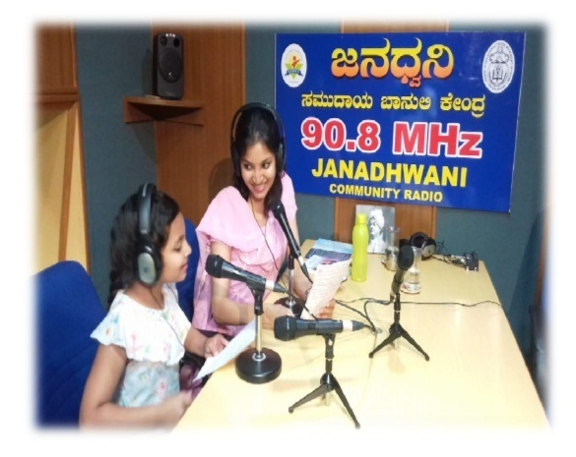

1. A radio talk on the Cause and Cure of various hearing disorders by Dr Prashanth Prabhu P, Assistant Professor, Department of Audiology, AIISH, Mysuru was broadcasted from Janadhvani (90.8MHz) a Communit Radio Station, Sarguru.
2. A 13 episode serial programme on communication disorders was broadcasted by the All India Radio, Mysuru (100.06 MHz) with expert talks by Dr. H. Sundararaju, Dr. Ajith Kumar U., Dr. K. Rajalakshmi and Mr. K. Arunraj on various topics on Hearing impairment as a part of World Hearing Day 2020 celebration.

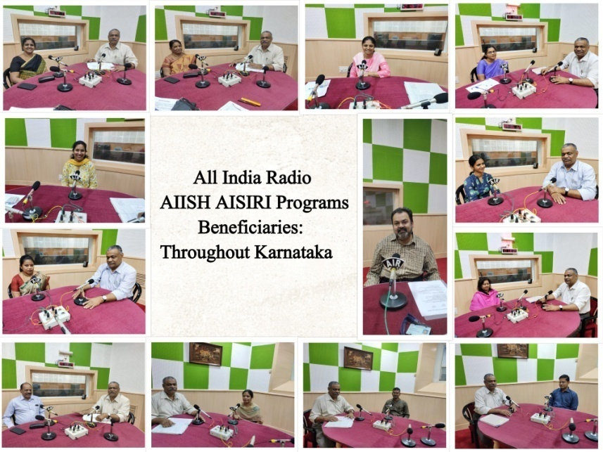

1. An Interview program of Dr. M. Pushpavathi, Director, AIISH and Dr. Sandeep M., Associate Professor in Audiology was telecasted in TV-9, a regional TV channel on 2nd 6th February and 2nd March 2020.

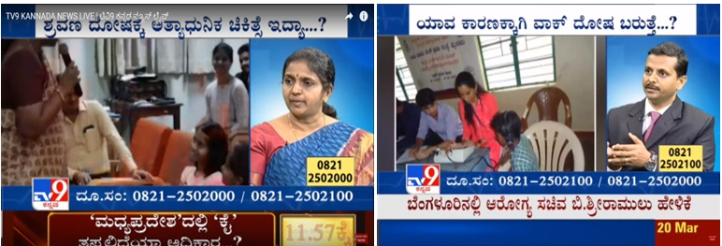

1. A live phone-in program in collaboration with Vijaya Karnataka, the leading Kannada daily was conducted and the same was published in the daily on 3rd March 2020. Prof. M. Pushpavathi, Director, AIISH, Mysuru; Dr. N. Sreedevi, Head, Dept of POCD, Dr. M. Sandeep, Associate Professor in Audiology and Mr. Arunraj, Audiologist participated in the program.
2. Dr. Venkatesan S., delivered a 20-minute radio talk on psychological problems in children and parents at All India Radio, Mysuru (10.6MHz) ,
3. Radio Talk (All India Radio) on “Namma Arogya Program -Cerebral palsy” on 24.9.2019 at 3.00 pm, time of broadcast 6.10.2019 at 9:05 am.

1. Dr. Rajalakshmi K delivered talk Ras a part of All India Radio (AIR) Program on 24.02.2020.