**Promotion of Academic Integrity and Prevention of Plagiarism: Challenges for Indian Higher Educational Institions**

1 Shijith Kumar C

[1cshijithkumar@gmail.com](mailto:1cshijithkumar@gmail.com). Library and Information Officer, All India Institute of Speech and Hearing, Mysuru, 570006

This paper addresses the challenges faced by the

**Keywords:** *Ethics in Education, Academic Dishonesty, UGC Regulations*

# **INTRODUCTION**

Plagiarism, the act of presenting other’s scholarly work as one’s own is considered as the highest form of dishonesty in academic world. In view of the alarming rise in plagiarism and other forms of academic dishonesty, western higher educational institutions have implemented policies and procedures for preventing these offences long back. The University Grants Commission (UGC), the apex body of higher education in India, took a significant step by enacting comprehensive regulations for maintaining and fostering academic integrity. The regulations known as Promotion of Academic Integrity and Prevention of Plagiarism in Higher Educational Institutions was came into force with its gazette notification on 31st July 2018. This paper reviews the major recommendations of the UGC as mentioned in the regulations and challenges in implementing them by the higher educational institutions (HEI) in the country.

The need for academic integrity education on campuses has been well documented (Bertram Gallant, 2008, 2016; Bertram Gallant & Drinan, 2006; Liebler, 2009; McCabe, Butterfield, & Trevino, 2004)

Academic integrity receives a great deal of attention in institutions of higher education. Universities and colleges

--have administrative units to promote

-- contextualizing academic integrity to the personal lives and professional expectations of students

* **We found that academic dishonesty in Canada, as in other countries, is widespread among students and faculty, while policies and their implementation are often inconsistent. Calls for clearer guidelines and greater support for students and faculty resound as a consistent theme in the literature**
* **Text-matching (also known as plagiarism detection) software is becoming more common, but there are concerns about its cost to institutions, the intellectual property rights of students whose papers are uploaded to a third party, and the fact that most programs cannot deal with non-text materials.**
* There is no common framework for academic integrity in higher education across Canada.
* There should be a greater focus on educating students about rather than punishing them for academically dishonest behaviours
* **Teach Us How to Do It Properly!" An Australian Academic Integrity Student Survey**
* Bretag, Tracey; Mahmud, Saadia; Wallace, Margaret; Walker, Ruth; McGowan, Ursula; East, Julianne; Green, Margaret; Partridge, Lee; James, Colin

*Studies in Higher Education*, v39 n7 p1150-1169 2014

The results of a large online student survey (n?=?15,304), on academic integrity at six Australian universities, indicate that a majority of respondents reported a good awareness of academic integrity and knowledge of academic integrity policy at their university and were satisfied with the information and support they receive. Response varied across cohorts, with international students expressing a lower awareness of academic integrity and academic integrity policy, and lower confidence in how to avoid academic integrity breaches. Postgraduate research student respondents were the least satisfied with the information they had received about how to avoid an academic integrity breach. The results from this survey provide an opportunity to explore the student perspective and inform the higher education sector in relation to communicating with and educating students about academic integrity. The students have indicated that Australian universities need to move beyond the mere provision of information to ensure a holistic approach that engages students about academic integrity.

* we find that students are more likely to cheat when they have previous misconduct records, when they perceive academic integrity policy as being poorly enforced, and when they perceive that instructor tolerance toward misconduct incidents is high.// Rationality and Students’ Misconduct at University: Empirical Evidence and Policy Implications/ Jocelyn Grira1 & Louis Jaeck// International Education Studies; Vol. 12, No. 3; 2019. Consistently with the literature (Dee & Jacob, 2012), we concluded that universities should increase student awareness about academic ethics and should clarify the boundaries between what is acceptable among scholars and what is not.
* Galles et al. (2003) show that reducing the tolerance toward cheating is more efficient than increasing the harshness of policies of academic integrity is.

# **Student Dishonesty and Its Control in College**



1. **Major recommendations of the UGC and their implementation challenges**

The major recommendations of the UGC to promote academic integrity and prevent plagiarism in HEIs are summarised below along with their implementation challenges.

**2.1 Instructional Programmes**

The UGC directs the HEIs in the country to conduct a variety of instructional programmes towards achieving an academically integrated community among the students, faculty, research scholars and staff covering various aspects of academic integrity as detailed in table 1.

**Table1: Instructional strategies and topics**

|  |  |
| --- | --- |
| **Type of Instructional strategies** | **Topics of Instruction** |
| Awareness and sensitization Programmes |  |
|  |  |
|  |  |
|  |  |
|  |  |
|  |  |

1. Awareness

awareness, and sensitization programmes, afollowing instructional strategies for prmoting

Many studies have reported that

Selecting the right technology for monitoring online exams can be challenging. Depending on the level of security

desired, the cost increases. No single academic integrity solution can address all the possible needs for the various

content areas. Selecting only one product for an institution can be difficult based upon the variety of content areas or

types of tests required by the institution. In those situations, providing a range of products allows for flexibility in

choosing the approach that is best for their situation. Below are factors that can impact the selection of a proctoring

service.

Another concern revolving around the selection of the technology used in proctoring online exams is the comfort level

with the technology by both the faculty and students. Students may be concerned about their privacy and not want to

be observed as they are taking the exam (Educause Learning Initiative, 2016). Faculty may be concerned about the

window that is created into the students’ private home settings. Involving the faculty in the selection of the proctoring

tools is helpful in determining the comfort level with the technology.

**Universities and colleges provide specific honor codes or have administrative units to promote good behaviors and resolve dishonesty allegations**

Institutions of higher education must focus on developing a culture of academic integrity that permeates entire organizations. A holistic approach that incorporates both strategic culture building activities with operational training tools, such as RAISE (Cronan et al., 2016), and detection tools, such as Turnitin, within multistakeholder environments appears to be a good approach [[[Journal of Information Systems Education, Vol. 27(3) Summer 2016 153// Academic Integrity: Information Systems Education Perspective/// Roger McHaney// Timothy Paul Cronan David E. Douglas]]]

Poor English language skills may contribute to a student plagiarizing either inadvertently through misunderstanding or simply because there is no other way to pass the unit. The relationship between English language proficiency (as part of a ‘cultural influence’ construct) and student self-reported plagiarism was verified by Guo (2011) and has been reported by others (Le Masurier, 2009). [[[Journal of Information Systems Education, Vol. 27(3) Summer 2016 197// Ten Years in the Academic Integrity Trenches: Experiences and Issues// Doug Atkinson S. Zaung Nau Christine Symons]]] Detecting insufficient levels of English language and recommending and providing language support services is one measure that can reduce its influence in plagiarism.

## **2.1 Subsection headings (Heading 2)**

Subtitle headings are left-justified, 12-pt.. Capitalize the first word, acronyms, and proper nouns.

**2.2 Other instructions (Heading 2)**

The organizing committee reserves the right to edit the paper for clarity or correctness of English but will consult the author if any significant changes are needed. Please save your file and rename it with lead presenter’s full name. Submit your full paper to ngl2019.india@gmail.com on or before 06th September 2019. The template will be used to format your paper.

# **figures and tables (Heading 1)**

Insert all figures and tables with center align, size to fit in the main body. Give the figure number (Figure 1) and Table number (Table 1). Please cite the figure in the text first and then insert the image. Figure captions should be placed below the figure.

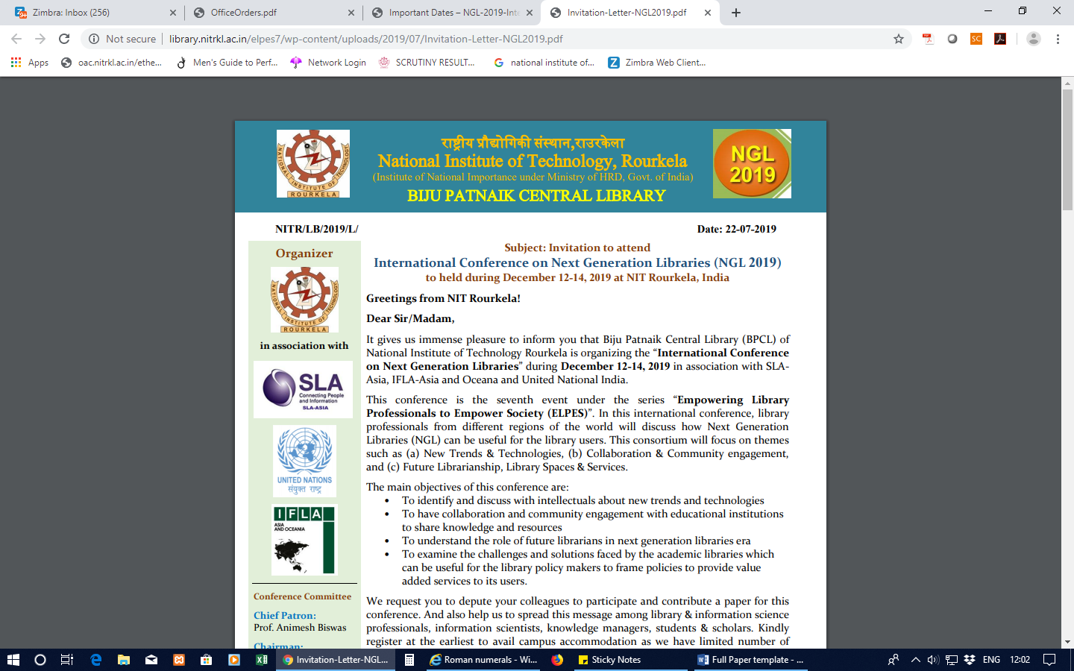

Figure 1 Example of the figure.

Give the Table captions should be placed at the top of the table, center align the table. Please cite the table in the text first and then insert the table at an appropriate place. Fit the manuscript in one column format.

# Table 1 Heading of Table

|  |  |  |
| --- | --- | --- |
| **Heading** | **Heading** | |
| ***Subheading*** | ***Subheading*** |
| A | 0.00 | 0.00 |
| B | 0.00 | 0.00 |
| C | 0.00 | 0.00 |

## **Abbreviations and Acronyms**

You may use abbreviations and acronyms. Please define all abbreviations and acronyms for the first time they are used in the text. Please try to avoid abbreviations in headings and titles. You may add a list of symbols/abbreviations/acronyms/ notations if required.

##### **References**

Use the APA style. You may use online citation generator, or else citation management tools (Zotero, Mendeley etc.) to get the APA style (6th ed.) reference format.

Example:

*Journal*

Das, K., & Mahapatra, R. (2018). Collaboration and Knowledge Sharing via Facebook Groups: Analysis of Postings of Library and Information Science Community. DESIDOC Journal of Library & Information Technology, 38(2), 95-101. <http://publications.drdo.gov.in/ojs/index.php/djlit/article/view/10949>

*Book Chapter*

Das, K., Behera, S. K. and Gunjal, B. (2017). Enhancing Library Services through Subject Guide: A Case Study of NIT Rourkela. In V. K. Singh and A. Kumar (Author), Librarianship in New Millennium (pp. 73-84). New Delhi: Today and Tomorrow’s Printer and Publishers.

*Webpage*

Bergdahl, E. (2017, January 15). A Brief History of the Wiki—and Where It Might Be Going Next. Retrieved December 17, 2018, from <http://mentalfloss.com/article/90598/brief-history-wiki-and-where-it-might-be-going-next>

*Conference Paper*

Lambert, J., & Fisher, J. (2009). Community Building in a Wiki-Based Distance Education Course. *Proceedings of ED-MEDIA 2009--World Conference on Educational Multimedia, Hypermedia & Telecommunications*, 1527–1531. <https://www.learntechlib.org/primary/p/31679/>