Academic Integrity Tutorial accessibility document

Recycle & Clone module

Use this document as an alternative to the online interactive tutorial

Contents
Academic Integrity Tutorial accessibility document 1
Recycle & Clone module 1
Use this document as an alternative to the online interactive tutorial 1
Screen 1 – Title – Recycle & Clone 2
Screen 2 - Introduction 2
Screen 3 – Recycle & Clone plagiarism 3
Screen 4 – Example 2: Recycle & Clone plagiarism 4
Screen 5 – What is Recycle & Clone plagiarism? 4
Screen 6 – What causes Recycle & Clone plagiarism? 5
Screen 7 – What could the student have done? 6
Screen 8 - Conclusion 7
Screen 9 – Additional resources 8
Appendix 10

Screen 1 – Title – Recycle & Clone

Title slide image showing recycling logo and laboratory equipment.

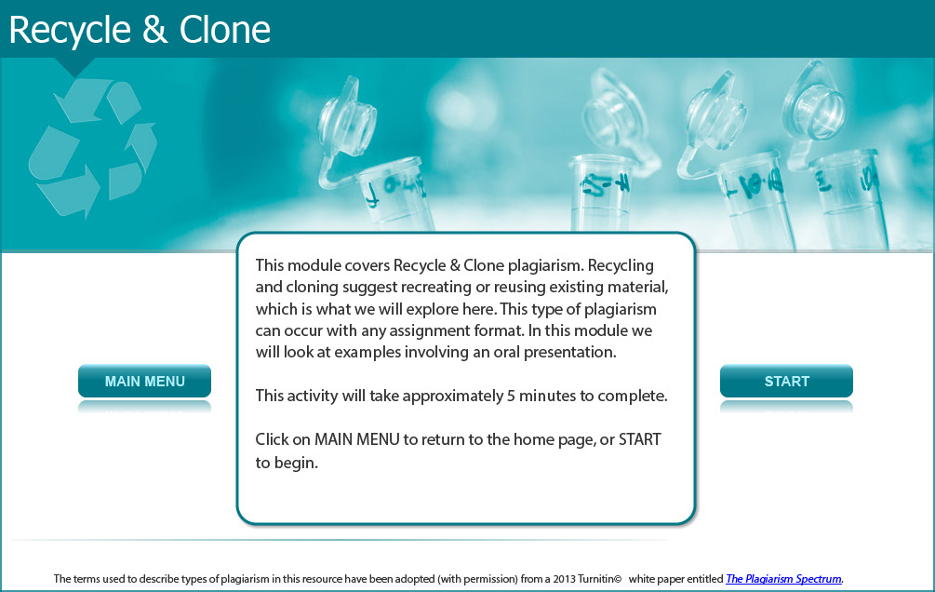

This module covers Recycle & Clone plagiarism. Recycling and cloning suggest recreating or reusing existing material, which is what we will explore here. This type of plagiarism can occur with any assignment format. In this module we will look at examples involving an oral presentation.

This activity will take approximately 5 minutes to complete.

Screen 2 - Introduction

Image of a female student pointing to two presentations.

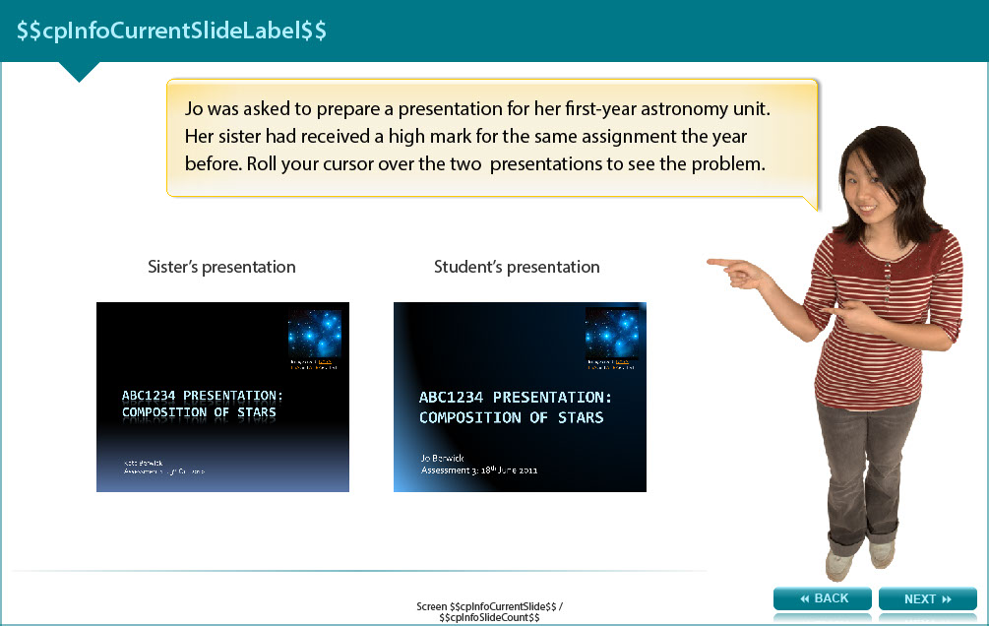

Jo was asked to prepare a presentation for her first-year astronomy unit. Her sister had received a high mark for the same assignment the year before. The user is required to roll the cursor over the two images to see two examples, one the student’s presentation and the other her sister’s presentation. These two presentation are very similar.

Screen 3 – Recycle & Clone plagiarism

Image of female student with open palms asking a question.

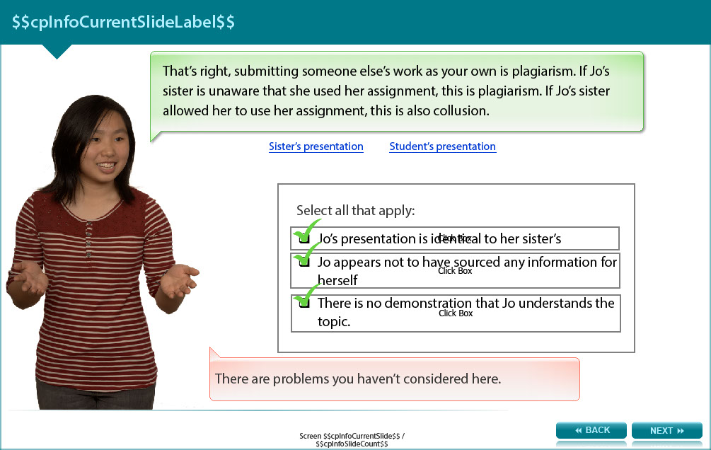

Roll your cursor over the two presentations to compare them again.
What are the problems with the student’s presentation? Select all the answers that apply:

- Jo’s presentation is identical to her sister’s (feedback: That’s right, submitting someone else’s work as your own is plagiarism. If Jo’s sister is unaware that she used her assignment, this is plagiarism. If Jo’s sister allowed her to use her assignment, this is also collusion.)
- Jo appears not to have sourced any information for herself (feedback: Yes, searching for information yourself is one of the best ways to learn about the topic.)
- There is no demonstration that Jo understands the topic (feedback: Correct. If Jo has simply copied her sister’s assignment, she may not have learnt the material.)

Screen 4 – Example 2: Recycle & Clone plagiarism

Image of female student in thinking pose with her one hand on her chin.

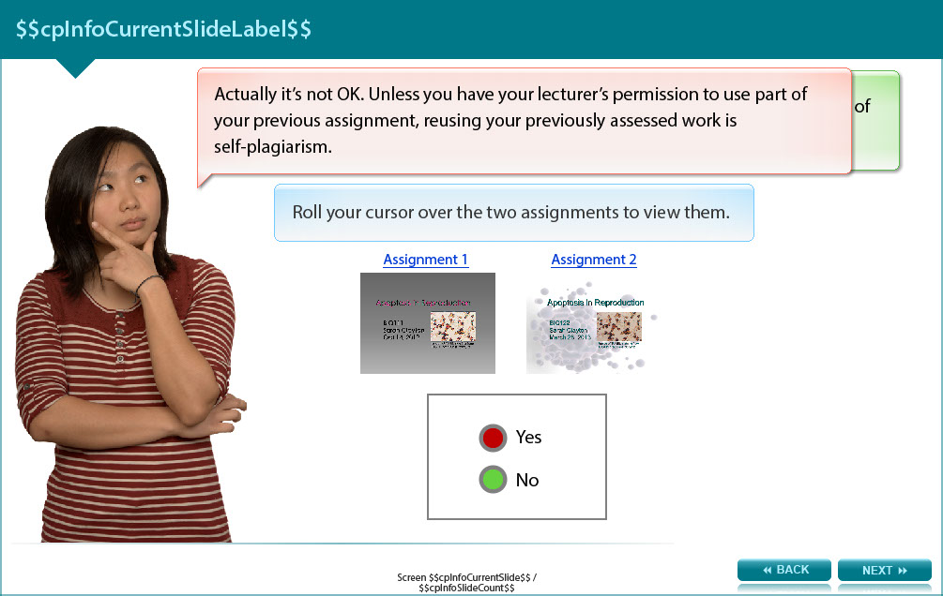

So if copying from your sister is not OK, what if you recycle your own assignment for a different unit? Is this OK?

The screen shows images of two example assignments followed by the answer options to the question.

Answers (see the appendix for the correct answer and feedback)
- Yes
- No

Screen 5 – What is Recycle & Clone plagiarism?

Image of a female student with palms up asking a question.

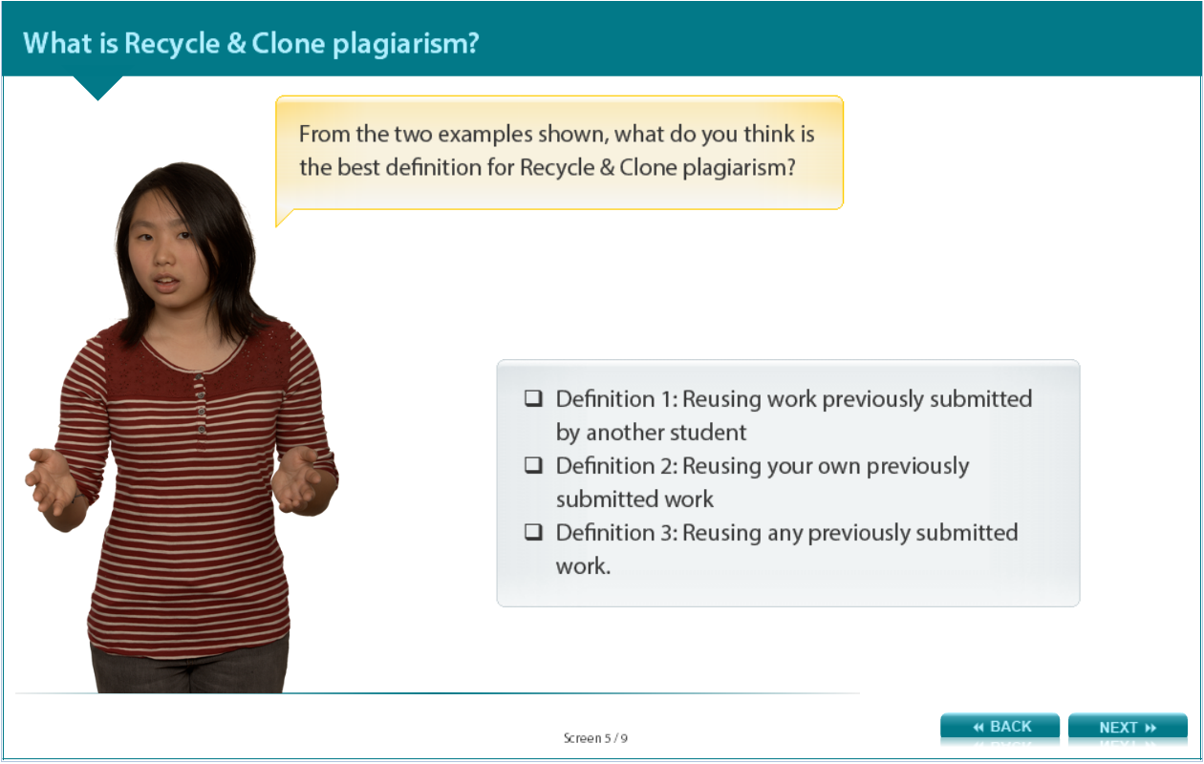

From the two examples shown, what do you think is the best definition for Recycle & Clone plagiarism?

Answers (see the appendix for the correct answer and feedback)
- Definition 1: Reusing work previously submitted by another student
- Definition 2: Reusing your own previously submitted work
- Definition 3: Reusing any previously submitted work

Screen 6 – What causes Recycle & Clone plagiarism?

Image of a female student holding up a board with reasons why plagiarism occurs.

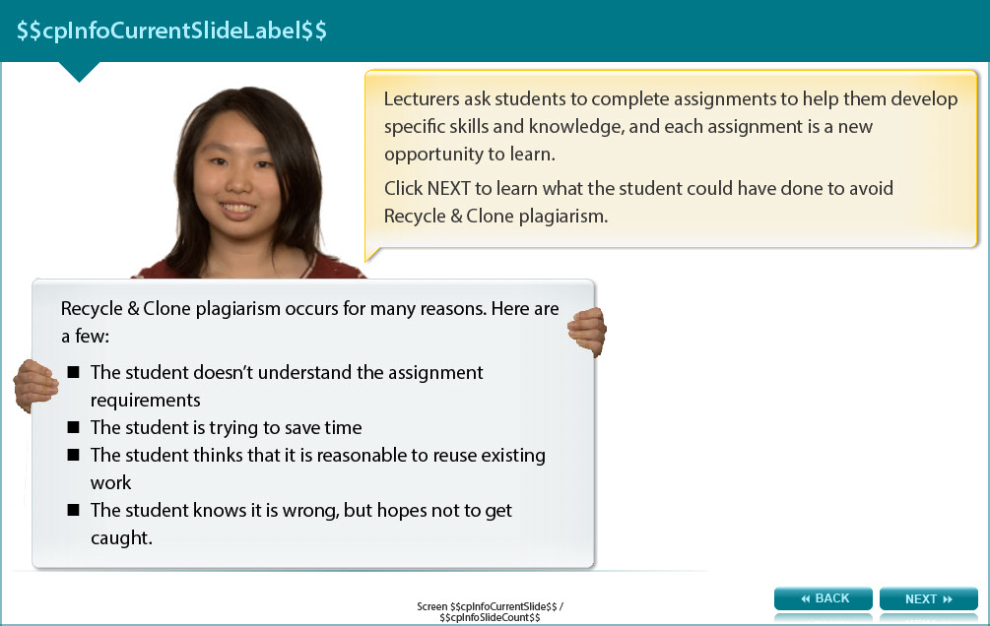

Recycle & Clone plagiarism occurs for many reasons. Here are a few:

- The student doesn’t understand the assignment requirements
- The student is trying to save time
- The student thinks that it is reasonable to reuse existing work
- The student knows it is wrong, but hopes not to get caught.

Lecturers ask students to complete assignments to help them develop specific skills and knowledge, and each assignment is a new opportunity to learn.

Read the next screen to learn what the student could have done to avoid Recycle & Clone plagiarism.

Screen 7 – What could the student have done?

Image of female student holding hands out with palms up asking a question.

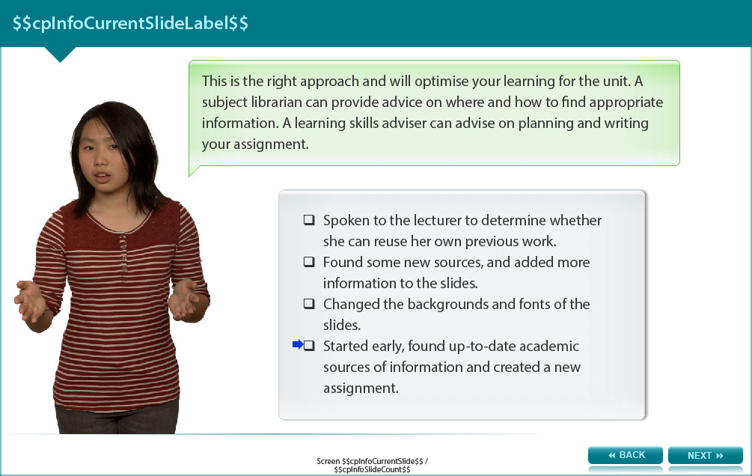

What could the student have done to avoid Recycle & Clone plagiarism? Select from the answers below.

Answers (see the appendix for the correct answers and feedback)

- Spoken to the lecturer to determine whether she can reuse her own previous work.
- Found some new sources, and added more information to the slides.
- Changed the backgrounds and fonts of the slides.
- Started early, found up-to-date academic sources of information and created a new assignment.

Screen 8 - Conclusion

Image of a female student holding a board with one hand and pointing to the board with the other. A number of bullet points are listed on the board. Read text below to see what they are.

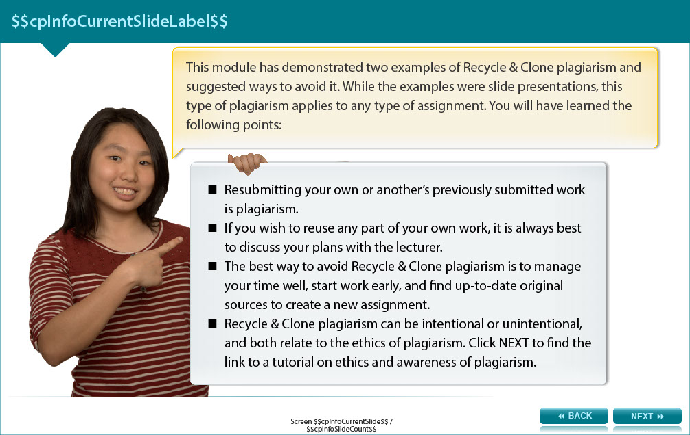

This module has demonstrated two examples of Recycle & Clone plagiarism and suggested ways to avoid it. While the examples were slide presentations, this type of plagiarism applies to any type of assignment. You will have learned the following points:

- Resubmitting your own or another’s previously submitted work is plagiarism.
- If you wish to reuse any part of your own work, it is always best to discuss your plans with the lecturer.
- The best way to avoid Recycle & Clone plagiarism is to manage your time well, start work early, and find up-to-date original sources to create a new assignment.
- Recycle & Clone plagiarism can be intentional or unintentional, and both relate to the ethics of plagiarism. Read the next screen to find the link to a tutorial on ethics and awareness of plagiarism.

Screen 9 – Additional resources

Image shows titles and icons of related resources.
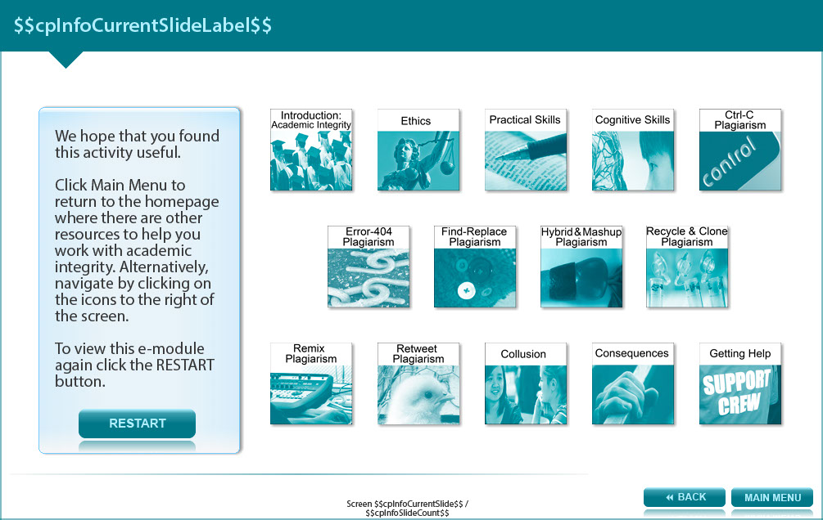

We hope that you found this activity useful.

Click the links below to view other modules in this academic integrity tutorial:

- Introduction: Academic integrity (http://www.monash.edu/rlo/research-writing-assignments/referencing-and-academic-integrity/academic-integrity/introduction)
- Ethics (http://www.monash.edu/rlo/research-writing-assignments/referencing-and-academic-integrity/academic-integrity/ethics)
- Practical skills (http://www.monash.edu/rlo/research-writing-assignments/referencing-and-academic-integrity/academic-integrity/practical-skills)
- Cognitive skills (http://www.monash.edu/rlo/research-writing-assignments/referencing-and-academic-integrity/academic-integrity/cognitive-skills)
- Ctrl-C plagiarism (http://www.monash.edu/rlo/research-writing-assignments/referencing-and-academic-integrity/academic-integrity/ctrl-c)
- Error-404 plagiarism (http://www.monash.edu/rlo/research-writing-assignments/referencing-and-academic-integrity/academic-integrity/error-404)
- Find-Replace plagiarism (http://www.monash.edu/rlo/research-writing-assignments/referencing-and-academic-integrity/academic-integrity/find-and-replace)
- Hybrid & Mashup plagiarism (http://www.monash.edu/rlo/research-writing-assignments/referencing-and-academic-integrity/academic-integrity/hybrid-mashup)
- Recycle & Clone plagiarism (http://www.monash.edu/rlo/research-writing-assignments/referencing-and-academic-integrity/academic-integrity/recycle-and-clone)
- Remix plagiarism (http://www.monash.edu/rlo/research-writing-assignments/referencing-and-academic-integrity/academic-integrity/remix)
- Retweet plagiarism (http://www.monash.edu/rlo/research-writing-assignments/referencing-and-academic-integrity/academic-integrity/retweet)
- Collusion (http://www.monash.edu/rlo/research-writing-assignments/referencing-and-academic-integrity/academic-integrity/collusion)
- Consequences (http://www.monash.edu/rlo/research-writing-assignments/referencing-and-academic-integrity/academic-integrity/consequences)
- Getting help (http://www.monash.edu/rlo/research-writing-assignments/referencing-and-academic-integrity/academic-integrity/getting-help)

Appendix

Screen 4 – Example 2: Recycle & Clone plagiarism answers

- Yes (Feedback: Actually it’s not OK. Unless you have your lecturer’s permission to use part of your previous assignment, reusing your previously assessed work is self-plagiarism.)
- No (Feedback: Well done. This is self-plagiarism. You need the lecturer’s permission to reuse parts of your assignments.)

Screen 5 – What is Recycle & Clone plagiarism? Answers

- Definition 1: Reusing work previously submitted by another student (Feedback: This is a good partial definition, but there’s more to it.)
- Definition 2: Reusing your own previously submitted work (Feedback: This is a good partial definition, but there’s more to it.)
- Definition 3: Reusing any previously submitted work (Feedback: Well done. Recycling and resubmitting previous work, whether another student’s or your own, is plagiarism.)

Screen 7 – What could the student have done? Answers

- Spoken to the lecturer to determine whether she can reuse her own previous work. (Feedback: This is a good idea. Unless you have permission, you shouldn’t reuse your own previously submitted work. Your lecturer may offer good ideas on how to build on that work.)
- Found some new sources, and added more information to the slides. (Feedback: Minor additions would not change the fact that this is self-plagiarism. Significant additions and reworking would be required, and you would need to discuss your plans with the lecturer.)
- Changed the backgrounds and fonts of the slides. (Feedback: Making a few minor changes would not change the fact that this is self-plagiarism.)
- Started early, found up-to-date academic sources of information and created a new assignment. (Feedback: This is the right approach and will optimise your learning for the unit. A subject librarian can provide advice on where and how to find appropriate information. A learning skills adviser can advise on planning and writing your assignment.)

