Academic Integrity Tutorial accessibility document

Introduction module

Use this document as an alternative to the online interactive tutorial

Contents
Academic Integrity Tutorial accessibility document 1
Introduction module 1
Use this document as an alternative to the online interactive tutorial 1
Screen 1- Title – Introduction: Academic Integrity 2
Screen 2 – Welcome: Professor Darrell Evans 2
Screen 3 – Introduction 3
Screen 4 – How can I study with integrity? 4
Screen 5 – Avoiding Plagiarism 5
Screen 6 – Some Other Things to Think About 6
Screen 7 – One Other Thing 7
Screen 8 – Over To You 8
Screen 9 – Additional Resources 9
Appendix 1 - Answers 10

Screen 1- Title – Introduction: Academic Integrity

Title slide image showing students wearing graduation caps.

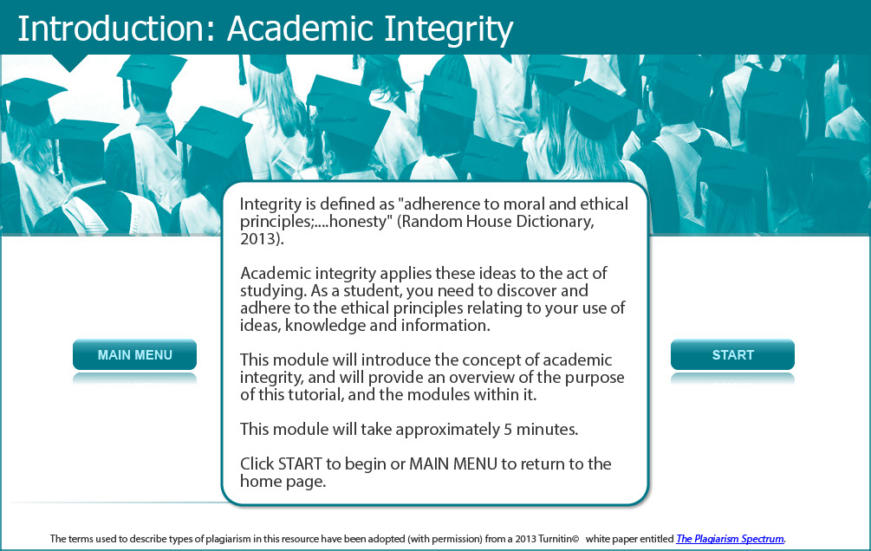

Integrity is define as “adherence to moral and ethical principles;……..honesty” ( Random House Dictionary, 2013 ).

Academic integrity applies these ideas to the act of studying. As a student, you need to discover and adhere to the ethical principles relating to your use of ideas, knowledge and information.

This module will introduce the concept of academic integrity, and will provide an overview of the purpose of this tutorial, and the modules within it.

This module will take approximately 5 minutes.

Screen 2 – Welcome: Professor Darrell Evans
Introductory screen image showing Professor Darrell Evans in YouTube video

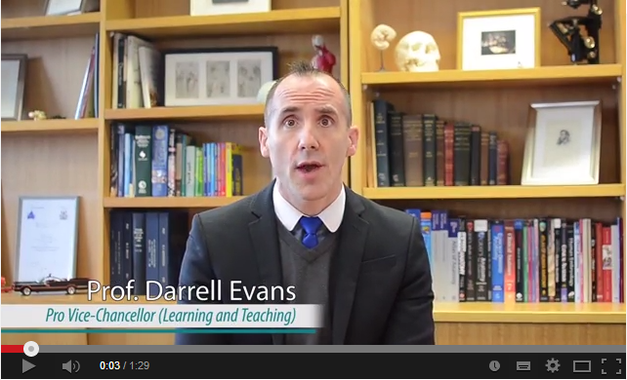

Script of the video
"Welcome to our Monash University tutorial on academic integrity. ‘What is academic integrity?’ you might ask … and it’s a fair question. At Monash we consider academic integrity as showing honesty and responsibility in your approach to your university studies, and later in your professional pursuits. It encompasses a whole range of things. For example, being original in the work you produce, appropriately acknowledging the use of others’ ideas, developing good judgement about the ideas you do use, being truthful about your individual contribution to work, and most importantly, leading your peers to display the same honesty.
This tutorial explores a range of ethical dilemmas and different scenarios which dare you to consider what is right and wrong, and whether blunders are intentional or unintentional. You are challenged to determine the types of skills required in different situations, and links are provided to sites where you may work on developing these skills, or find help for urgent issues.
We recognise that developing the skills required to produce high level academic or professional work takes time. What we hope you will achieve in doing all or part of this tutorial are: firstly, a better ethical awareness of issues in academic integrity; secondly, an understanding of the knowledge and the skills required to demonstrate academic integrity, and finally, a better idea of the help available and where to find it.
Good Luck! "

Screen 3 – Introduction

Image of female student considering the definition of integrity via five visual examples.

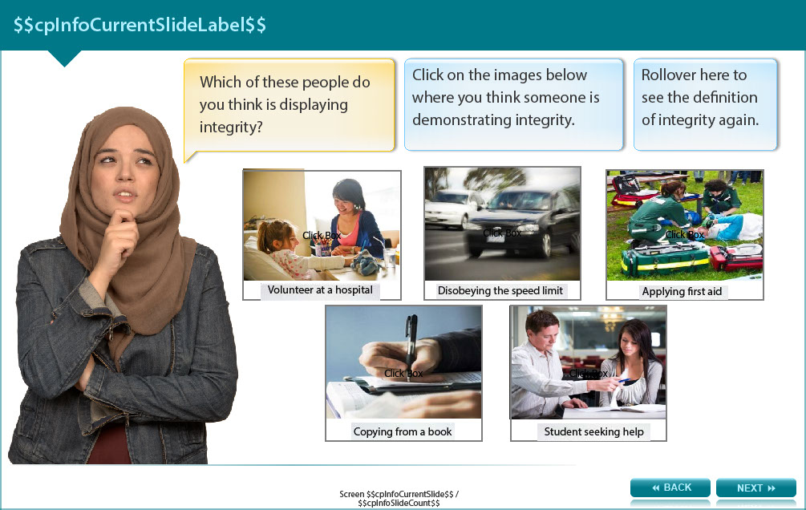

Which of these people do you think is displaying integrity?

Choose from the options below whether you think someone is demonstrating integrity.

Here to see the definition of integrity again- "adherence to moral and ethical principles;... honesty" (Random House Dictionary, 2013)

- Image one shows female volunteering at a hospital with a patient-Most people would probably agree with you.

- Image two shows car being driven by a person disobeying the speed limit-I'm not sure other people would agree with you.

- Image three shows two people applying first aid to a person-Most people would probably agree with you.

- Image four shows someone copying from a book-I'm not sure other people would agree with you.

- Image five shows a student seeking help from a professor-Most people would probably agree with you.

Answers (see the appendix for the correct answer and feedback)

Screen 4 – How can I study with integrity?

Image of female student considering the issue.

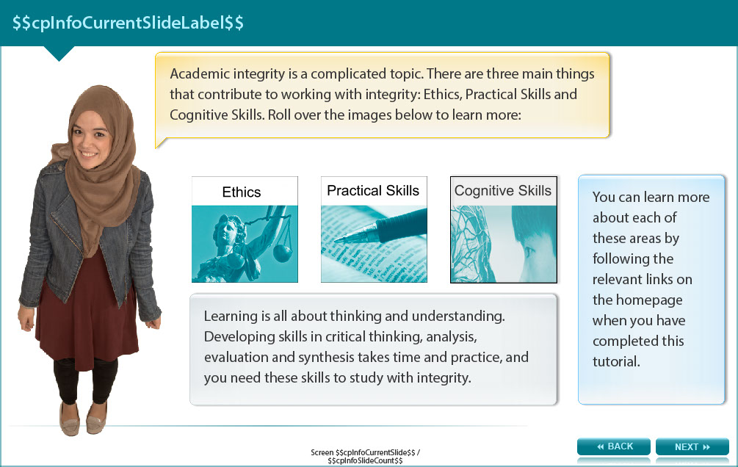

Academic integrity is a complicated topic. There are three main things that contribute to working with integrity: Ethics, Practical Skills and Cognitive Skills. User is required to roll the mouse cursor over the images to learn more:

You can learn more about each of these areas by following the relevant links on the homepage when you have completed this tutorial.

First roll over image for Ethics - Ethics are a set of rules agreed by a community that govern what is acceptable. Understanding the rules of our academic community can help you to act with academic integrity.

Second roll over image for Practical Skills - Having the skills to manage your time, find relevant resources, acknowledge creators of ideas, documents, or information, and manage your own notes carefully can all help you to maintain integrity in your studies.

Third roll over image for Cognitive Skills - Learning is all about thinking and understanding. Developing skills in critical thinking, analysis, evaluation and synthesis takes time and practice, and you need these skills to study with integrity.

Screen 5 – Avoiding Plagiarism

Image of a female student considering the issue.

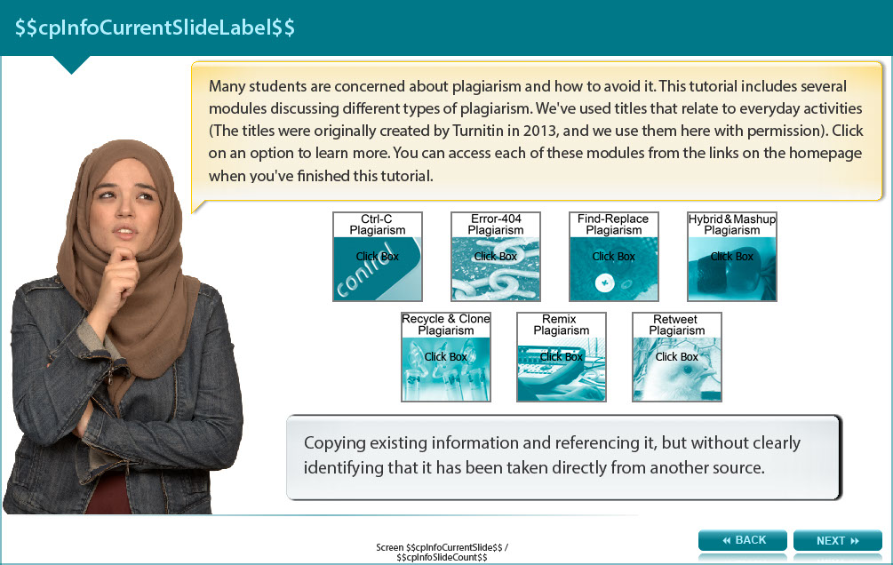

Many students are concerned about plagiarism and how to avoid it. This tutorial includes several modules discussing different types of plagiarism. We've used titles that relate to everyday activities (The titles were originally created by Turnitin in 2013, and we use them here with permission). The user is required to click on an option to learn more (see below for options). You can access each of these modules from the links on the homepage when you've finished this tutorial.

- Ctrl-C Plagiarism - Copying and pasting information without any acknowledgement of the original author.

- Error-404 Plagiarism - Work with some missing or incomplete references, so the original sources can't be found.

- Find-Replace Plagiarism - Replacing a few pieces of information in a copied piece of work, to make it look like something new (but without actually being original).

- Hybrid & Mashup Plagiarism - Combining information from a few different sources, acknowledging original creators, but with no development of new ideas.

- Recycle & Clone Plagiarism - Reusing work that has been submitted before.

- Remix Plagiarism - Combining several slightly modified works, but without acknowledging the original creators or producing anything original.

- Retweet Plagiarism - Copying existing information and referencing it, but without clearly identifying that it has been taken directly from another source.

Screen 6 – Some Other Things to Think About

Image of a female student holding up a notice board with the words getting help and consequences on it.

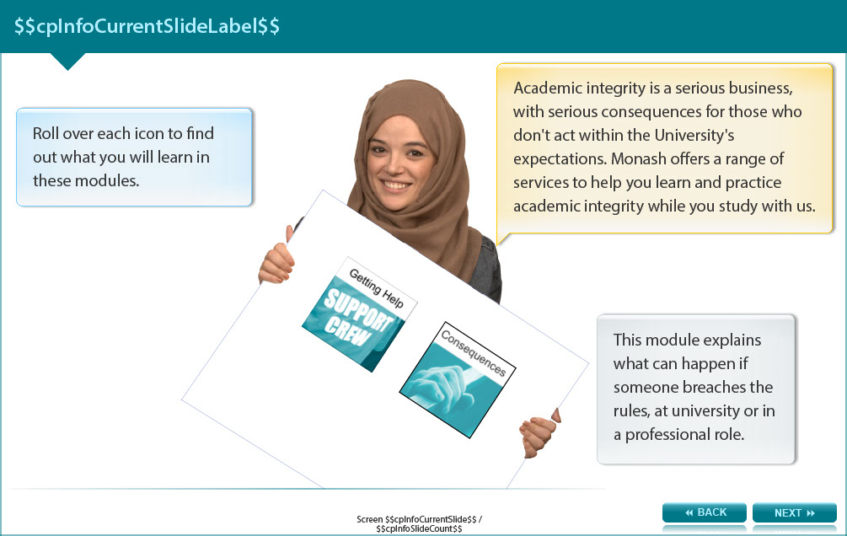

Academic integrity is a serious business, with serious consequences for those who don't act within the University's expectations. Monash offers a range of services to help you learn and practice academic integrity while you study with us.

The user is required to roll the cursor over two icons to find what will be covered in these modules.

Consequences Rollover Icon - This module explains what can happen if someone breaches the rules, at university or in a professional role.

Getting Help Rollover Icon - This module will show you where to find help in avoiding academic misconduct - or what to do if you think you've broken the rules.

Screen 7 – One Other Thing

Image showing female student pointing to collusion icon.

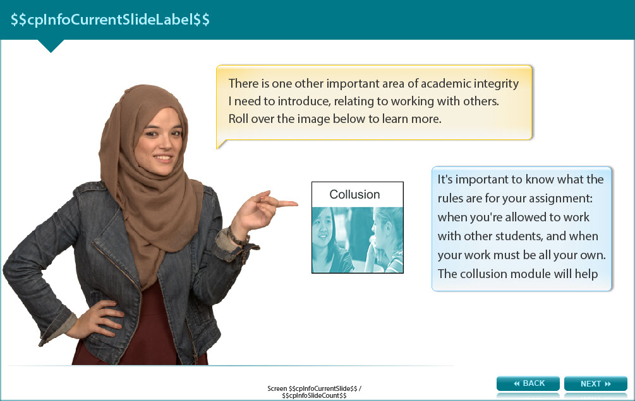

There is one other important area of academic integrity I need to introduce, relating to working with others. The user is required to roll over an image below to learn more.

Collusion Rollover Icon - It's important to know what the rules are for your assignment: when you're allowed to work with other students, and when your work must be all your own. The collusion module will help you learn more about this.

Screen 8 – Over To You

Image of female showing student with two thumbs up.

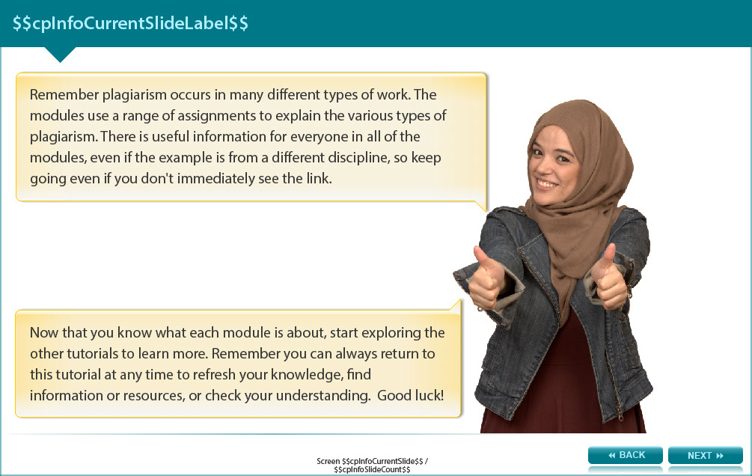

Remember plagiarism occurs in many different types of work. The modules use a range of assignments to explain the various types of plagiarism. There is useful information for everyone in all of the modules, even if the example is from a different discipline, so keep going even if you don't immediately see the link.

Now that you know what each module is about, start exploring the other tutorials to learn more. Remember you can always return to this tutorial at any time to refresh your knowledge, find information or resources, or check your understanding. Good luck!

Screen 9 – Additional Resources

Image shows titles and icons of related resources.

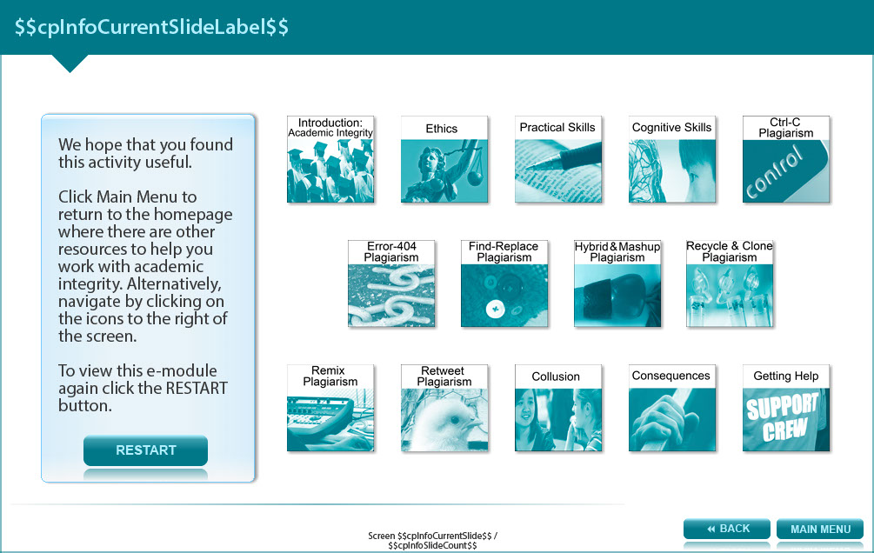

We hope that you found this activity useful.

Click the links below to view other modules in this academic integrity tutorial:

- Introduction: Academic integrity (http://www.monash.edu/rlo/research-writing-assignments/referencing-and-academic-integrity/academic-integrity/introduction)
- Ethics (http://www.monash.edu/rlo/research-writing-assignments/referencing-and-academic-integrity/academic-integrity/ethics)
- Practical skills (http://www.monash.edu/rlo/research-writing-assignments/referencing-and-academic-integrity/academic-integrity/practical-skills)
- Cognitive skills (http://www.monash.edu/rlo/research-writing-assignments/referencing-and-academic-integrity/academic-integrity/cognitive-skills)
- Ctrl-C plagiarism (http://www.monash.edu/rlo/research-writing-assignments/referencing-and-academic-integrity/academic-integrity/ctrl-c)
- Error-404 plagiarism (http://www.monash.edu/rlo/research-writing-assignments/referencing-and-academic-integrity/academic-integrity/error-404)
- Find-Replace plagiarism (http://www.monash.edu/rlo/research-writing-assignments/referencing-and-academic-integrity/academic-integrity/find-and-replace)
- Hybrid & Mashup plagiarism (http://www.monash.edu/rlo/research-writing-assignments/referencing-and-academic-integrity/academic-integrity/hybrid-mashup)
- Recycle & Clone plagiarism (http://www.monash.edu/rlo/research-writing-assignments/referencing-and-academic-integrity/academic-integrity/recycle-and-clone)
- Remix plagiarism (http://www.monash.edu/rlo/research-writing-assignments/referencing-and-academic-integrity/academic-integrity/remix)
- Retweet plagiarism (http://www.monash.edu/rlo/research-writing-assignments/referencing-and-academic-integrity/academic-integrity/retweet)
- Collusion (http://www.monash.edu/rlo/research-writing-assignments/referencing-and-academic-integrity/academic-integrity/collusion)
- Consequences (http://www.monash.edu/rlo/research-writing-assignments/referencing-and-academic-integrity/academic-integrity/consequences)
- Getting help (http://www.monash.edu/rlo/research-writing-assignments/referencing-and-academic-integrity/academic-integrity/getting-help)

Appendix 1 - Answers

Screen 3 – Introduction

- Most people would probably agree with you.

- I'm not sure other people would agree with you.

- Most people would probably agree with you.

- I'm not sure other people would agree with you.

- Most people would probably agree with you.

