Academic Integrity Online Tutorial – Error-404

Error-404 module

Use this document as an alternative to the online interactive tutorial
Contents
Academic Integrity Online Tutorial – Getting Help 1
Getting Help module 1
Use this document as an alternative to the online interactive tutorial 1
Screen 1 – Title – Getting help 2
Screen 2 – Introduction 2
Screen 3 – I want to behave with academic integrity 3
Screen 4 – I’m in trouble – what can I do? 4
Screen 5 – Conclusion 5
Screen 6 – Additional resources 6

Screen 1- Title – Error-404

Title slide image showing broken links on chain.

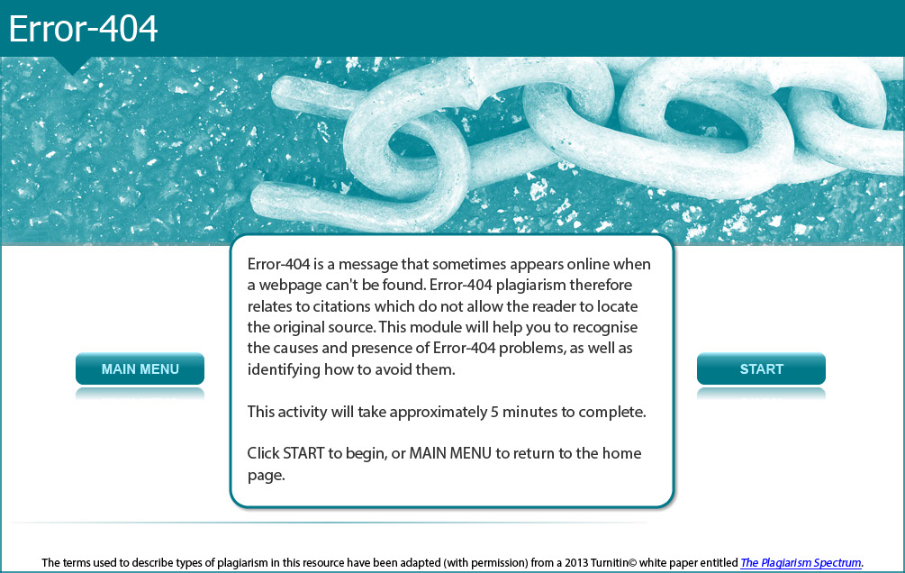

Error-404 is a message that sometimes appears online when a webpage can't be found. Error-404 plagiarism therefore relates to citations which do not allow the reader to locate the original source. This module will help you to recognise the causes and presence of Error-404 problems, as well as identifying how to avoid them.

This activity will take approximately 5 minutes to complete.

Screen 2 - Introduction

Introductory screen image showing female student pointing at text.

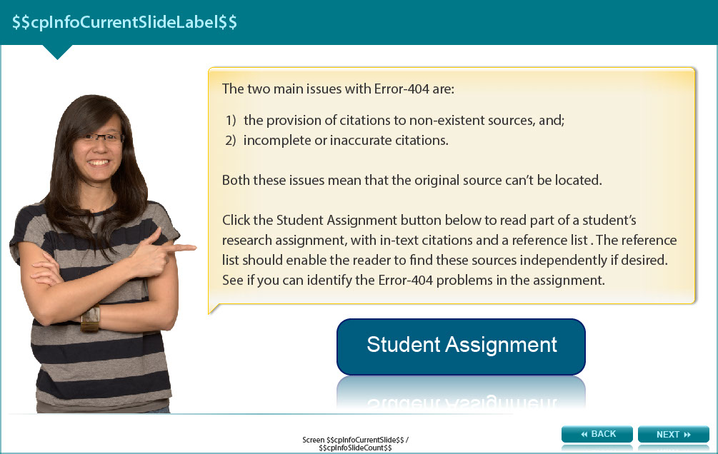

The two main issues with Error-404 are:

- the provision of citations to non-existent sources, and
- incomplete or inaccurate citations.

Both these issues mean that the original source can’t be located.

Read this part of a student’s research assignment, with in-text citations and a reference list. The reference list should enable the reader to find these sources independently if desired. See if you can identify the Error-404 problems in the assignment. The learner is asked to roll their mouse cursor over each of the references. What is seen is depicted below.

Part of an assignment follows:

Handedness, or a preference to use one side of the body for particular purposes, has been identified in many species. An observational study of parrots conducted by Brown and Magat (2011) showed a strong correlation between dominant eye and foot for 11 out of 16 parrot species. The link between handedness and eye preferences suggests that the preferred use of one side of the body could be due to use of a specific brain hemisphere. Chandler, Ford and Jansen (2010) observed wild ring-necked parakeets in Germany and found that 56% of the flock displayed left-footed preference; the remaining 44% preferred to use their right feet when eating. These two studies investigated different species. A future avenue of research would be to investigate the eye-dominance and handedness of birds within a single species, including pet, captive and wild parrots within the samples.

References
Brown, C. & Magat, M. (2011). Cerebral lateralization determines hand preferences in Australian parrots, Biology letters, 7(4), 496-498. Retrieved from http://www.ncbi.nlm.nih.gov/pmc/articles/PMC3130212/ [this resource shows an image of an online database called Biology Letters and shows the abstract and other important details about the article source]

Chandler, C., Ford, A., & Jansen, S. (2010). Handedness in parrots - a real phenomenon? Parakeet Periodicals, 33(4), 49-53. Retrieved from http://www.tandfonline.com.ezproxy.lib.monash.edu.au/doi/abs/10.1080/135763188 [this resource shows an online database resource called Taylor and Francis Online that Monash University subscribes to, but the article shows an error, saying that the article is not available]

Pretorius, L. (2013) Pet Parrots. [photograph]. Retreieved from http://www.google.com.au/imghp?hl=en&tab=wi [this resource shows the Google images search box]

Screen 3 – What is Error-404?

Image of a female student holding up a notice board with answer choices to a question.

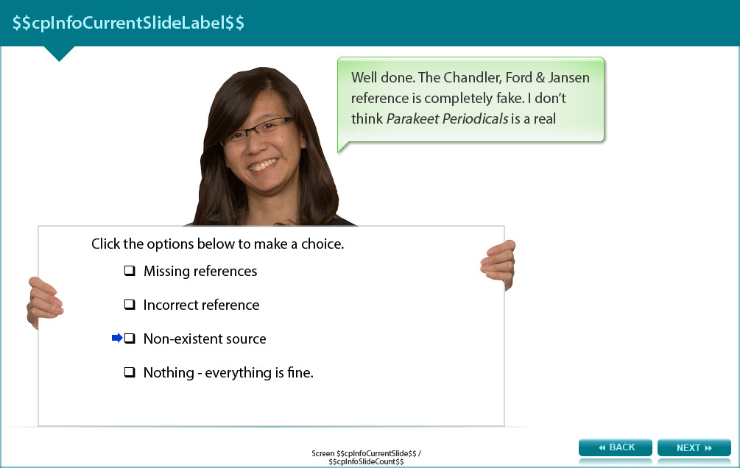

Answer the following question and check the answer in the appendix.

What were the Error-404 problems in the student assignment?

- Missing references
- Incorrect reference
- Non-existent source
- Nothing - everything is fine.

Screen 4 – What causes Error-404 plagiarism?

Image of a female student considering the issue.

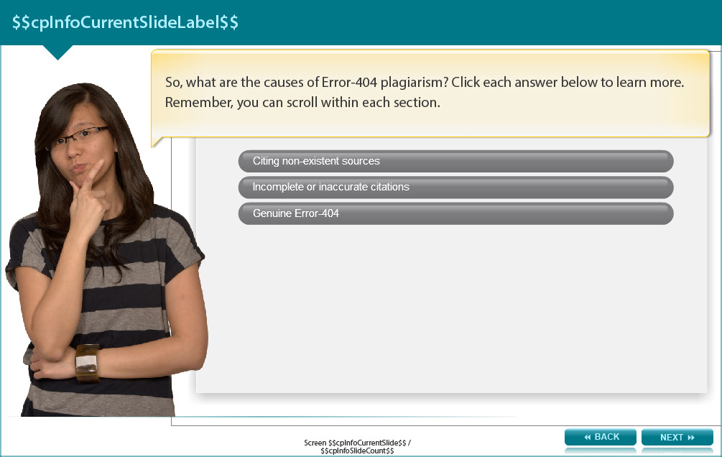

What are the causes of Error-404 plagiarism? The learner is asked to click three buttons to reveal the text below.

Citing non-existent sources.
Giving a fictional citation is a serious breach of academic integrity. Students sometimes take the risk:

- to meet the assignment requirement of consulting a certain number of sources
- to cover up the use of an unreliable or non-academic source
- because they lose their notes and cannot find the original source

However, it is always best to be honest. You are unlikely to fail the assignment for consulting eight sources instead of ten, but you will be penalised for providing false citations.

Incomplete or inaccurate citations
Error-404 can be unintentional, due to oversights or spelling mistakes in the reference list. It is important to take the time to check your citations and reference list carefully before submitting your assignment.

Genuine Error-404
In very rare cases a link to an online source of information may be broken before your assignment is marked. For this reason it is important to always record the date you viewed material online.

Screen 5 - Conclusion

Image of a female student speaking through a megaphone.

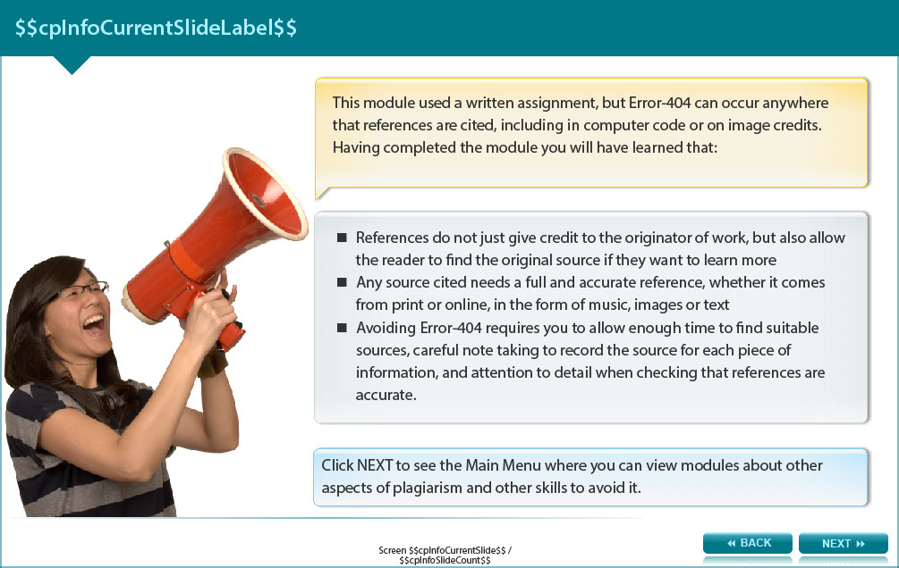

This module used a written assignment, but Error-404 can occur anywhere that references are cited, including in computer code or on image credits. Having completed the module you will have learned that:

- References do not just give credit to the originator of work, but also allow the reader to find the original source if they want to learn more
- Any source cited needs a full and accurate reference, whether it comes from print or online, in the form of music, images or text
- Avoiding Error-404 requires you to allow enough time to find suitable sources, careful note taking to record the source for each piece of information, and attention to detail when checking that references are accurate.

Screen 6 – Additional resources

Image shows titles and icons of related resources.

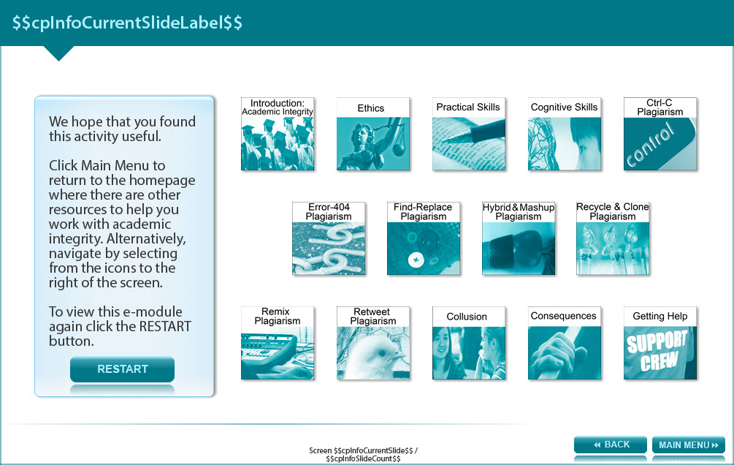

We hope that you found this activity useful.

Click the links below to view other modules in this academic integrity tutorial:

- Introduction: Academic integrity (http://www.monash.edu/rlo/research-writing-assignments/referencing-and-academic-integrity/academic-integrity/introduction)
- Ethics (http://www.monash.edu/rlo/research-writing-assignments/referencing-and-academic-integrity/academic-integrity/ethics)
- Practical skills (http://www.monash.edu/rlo/research-writing-assignments/referencing-and-academic-integrity/academic-integrity/practical-skills)
- Cognitive skills (http://www.monash.edu/rlo/research-writing-assignments/referencing-and-academic-integrity/academic-integrity/cognitive-skills)
- Ctrl-C plagiarism (http://www.monash.edu/rlo/research-writing-assignments/referencing-and-academic-integrity/academic-integrity/ctrl-c)
- Error-404 plagiarism (http://www.monash.edu/rlo/research-writing-assignments/referencing-and-academic-integrity/academic-integrity/error-404)
- Find-Replace plagiarism (http://www.monash.edu/rlo/research-writing-assignments/referencing-and-academic-integrity/academic-integrity/find-and-replace)
- Hybrid & Mashup plagiarism (http://www.monash.edu/rlo/research-writing-assignments/referencing-and-academic-integrity/academic-integrity/hybrid-mashup)
- Recycle & Clone plagiarism (http://www.monash.edu/rlo/research-writing-assignments/referencing-and-academic-integrity/academic-integrity/recycle-and-clone)
- Remix plagiarism (http://www.monash.edu/rlo/research-writing-assignments/referencing-and-academic-integrity/academic-integrity/remix)
- Retweet plagiarism (http://www.monash.edu/rlo/research-writing-assignments/referencing-and-academic-integrity/academic-integrity/retweet)
- Collusion (http://www.monash.edu/rlo/research-writing-assignments/referencing-and-academic-integrity/academic-integrity/collusion)
- Consequences (http://www.monash.edu/rlo/research-writing-assignments/referencing-and-academic-integrity/academic-integrity/consequences)
- Getting help (http://www.monash.edu/rlo/research-writing-assignments/referencing-and-academic-integrity/academic-integrity/getting-help)

Appendix

Screen 3 - What is error 404?

What were the Error-404 problems in the student assignment?

- Missing references – All the citations have a corresponding reference list entry.
- Incorrect reference – Yes, the reference for the image is incorrect because the hyperlink only takes you to a search page, not the actual image.
- Non-existent source – Well done. The Chandler, Ford & Jansen reference is completely fake. I don’t think Parakeet Periodicals is a real journal.
- Nothing - everything is fine. - Are you sure? Check the reference list again.

