Academic Integrity Online Tutorial - Consequences

Consequences module

Use this document as an alternative to the online interactive tutorial
Contents
Academic Integrity Online Tutorial - Consequences 1
Consquences module 1
Use this document as an alternative to the online interactive tutorial 1
Screen 1- Title – Consequences 2
Screen 2 – Consequences 2
Screen 3 – Consequences-Pre Quiz 3
Screen 4 – Consequences- Real Deal? Or Not Real? 4
Screen 5 – Consequences- Real Deal? Or Not Real? 5
Screen 6 – Consequences- Real Deal? Or Not Real? 6
Screen 7 – Real Deal? Or Not Real? 6
Screen 8 – Real Deal? Or Not Real? 7
Screen 9 – Real Deal? Or Not Real? 8
Screen 10 – Not Real 9
Screen 11 – Real Deal 9
Screen 12 – Real Deal? Or Not Real Deal? 9
Screen 13 – Real Deal? Or Not Real Deal? 10
Screen 14 – Real Deal? Or Not Real? 10
Screen 15 – Not Real 11
Screen 16 – Real Deal? 11
Screen 17 – Real Deal Or Not Real ? 12
Screen 18 – Why? 13
Screen 19 – Why? 13
Screen 20 –Example 14
Screen 21 – Example 14
Screen 22 – Example 15
Screen 23 –Want to find out more? 17
Screen 24 – Additional Resources 17

Screen 1- Title – Consequences

Title slide image showing hands on prison bars.

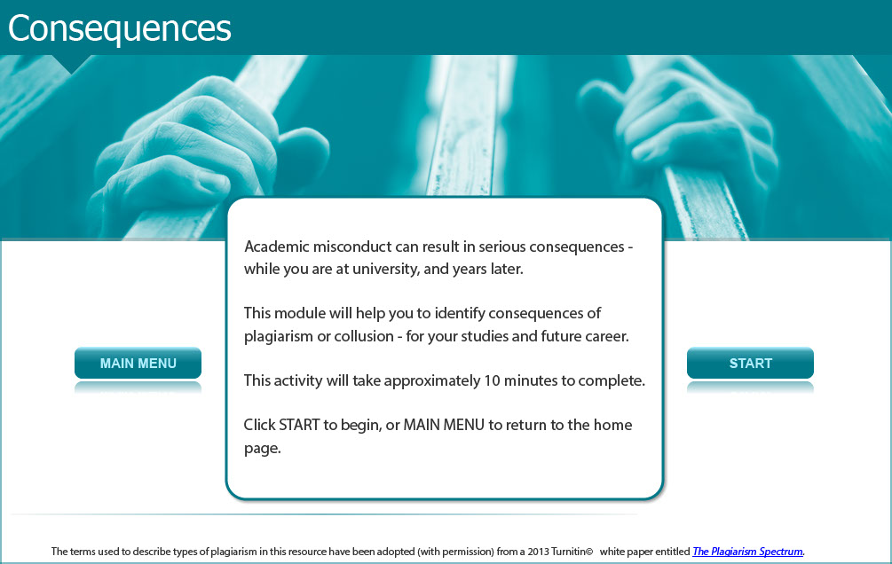

Academic misconduct can result in serious consequences - while you are at university, and years later.

This module will help you to identify consequences of plagiarism or collusion - for your studies and future career.

This activity will take approximately 10 minutes to complete.

Screen 2 – Consequences

Image of male staff member considering the issue.

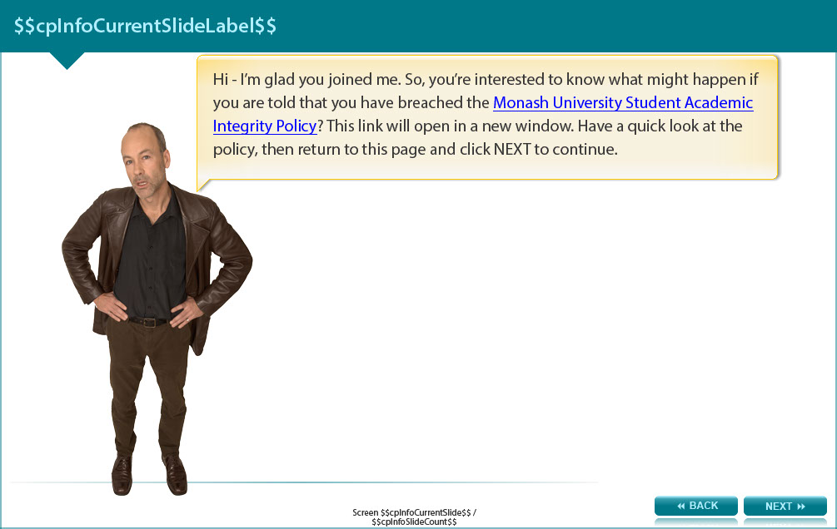

Hi - I’m glad you joined me. So, you’re interested to know what might happen if you are told that you have breached the Monash University Student Academic Integrity Policy? This link will open in a new window. Have a quick look at the policy (http://www.policy.monash.edu.au/policy-bank/academic/education/conduct/student-academic-integrity-policy.html), then return to this page and read further.

Screen 3 – Consequences-Pre Quiz

Image of male staff member holding a noticeboard with a list of options.

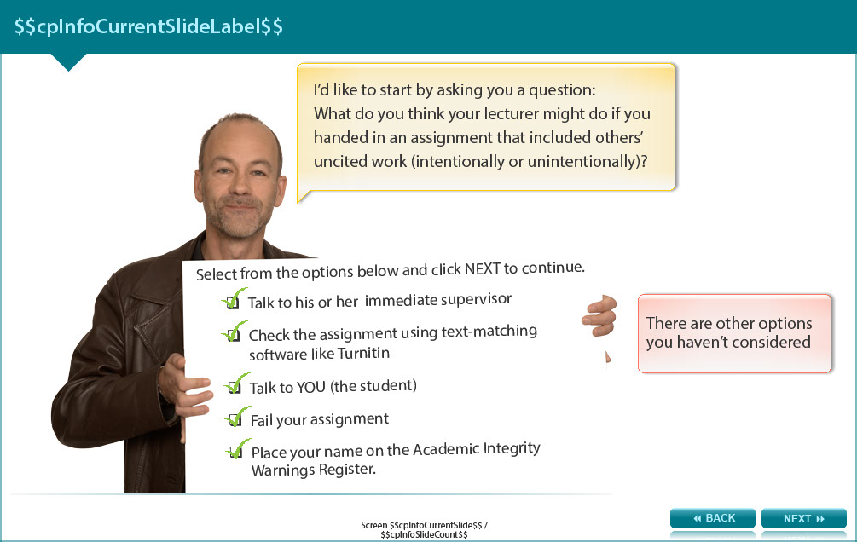

I’d like to start by asking you a question:

What do you think your lecturer might do if you handed in an assignment that included others’ uncited work (intentionally or unintentionally)?

Select from the options below and read the feedback.

- Talk to his or her immediate supervisor (feedback: Good option. Many lecturers and tutors are skilled in detecting academic dishonesty, but they still may wish to seek advice from more senior academics in some circumstances.)

- Check the assignment using text-matching software like Turnitin (feedback: This can be used to confirm whether your text is too similar to other original work.)

- Talk to YOU (the student) (feedback: Good choice. Part of an academic’s responsibility is to model, teach and uphold academic integrity in work produced by students. This presents an opportunity to teach the student about the issues identified, find out why this may have occurred, and direct the student to helpful resources.)

- Fail your assignment (feedback: This is possible. After investigating the issue, a lecturer would consider the knowledge and skill-level of the student, severity of plagiarism and whether the student has been penalised for this before, and can decide upon such a penalty.)

- Place your name on the Academic Integrity Warnings Register. (feedback: This is possible. The lecturer could place your name on the Academic Integrity Warnings Register to record that you have been warned about plagiarism or collusion (even if no formal action was taken or penalty applied) or to record that you have been penalised for breaching the University’s Student Academic Integrity Policy.)

Screen 4 – Consequences- Real Deal? Or Not Real?

Image of male staff member talking through a speech bubble.

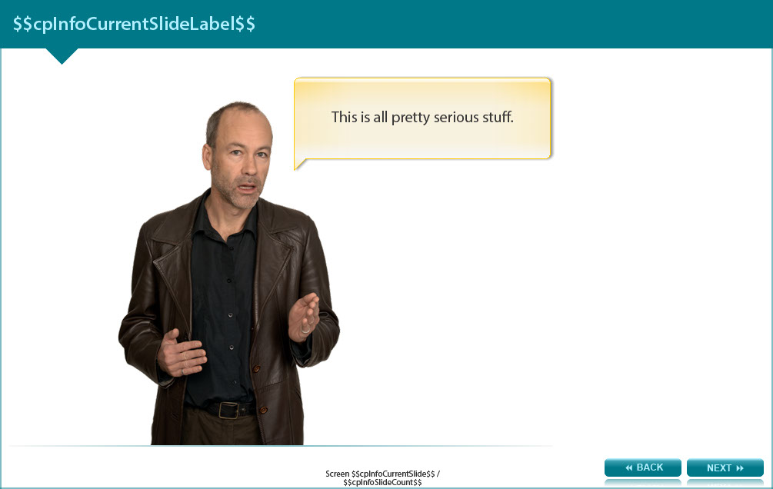

This is all pretty serious stuff.

Screen 5 – Consequences- Real Deal? Or Not Real?

Image of a male staff considering the issue.

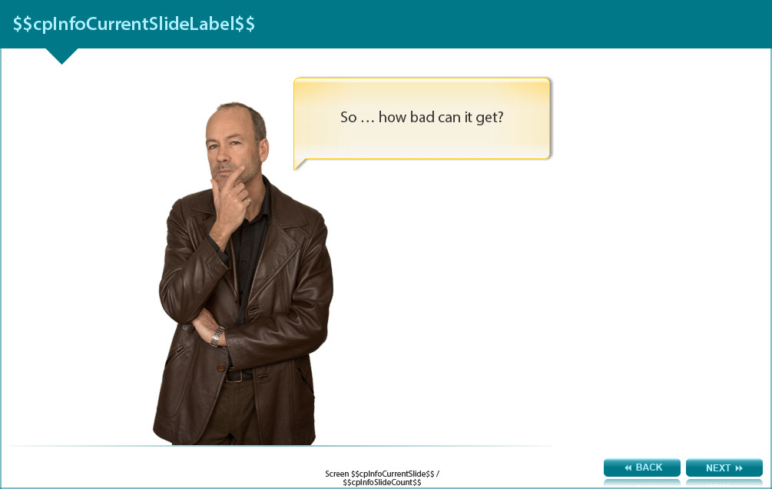

So … how bad can it get?

Screen 6 – Consequences- Real Deal? Or Not Real?

Image of a male staff member talking through a speech bubble and pointing to the words Real Deal or Not Real?

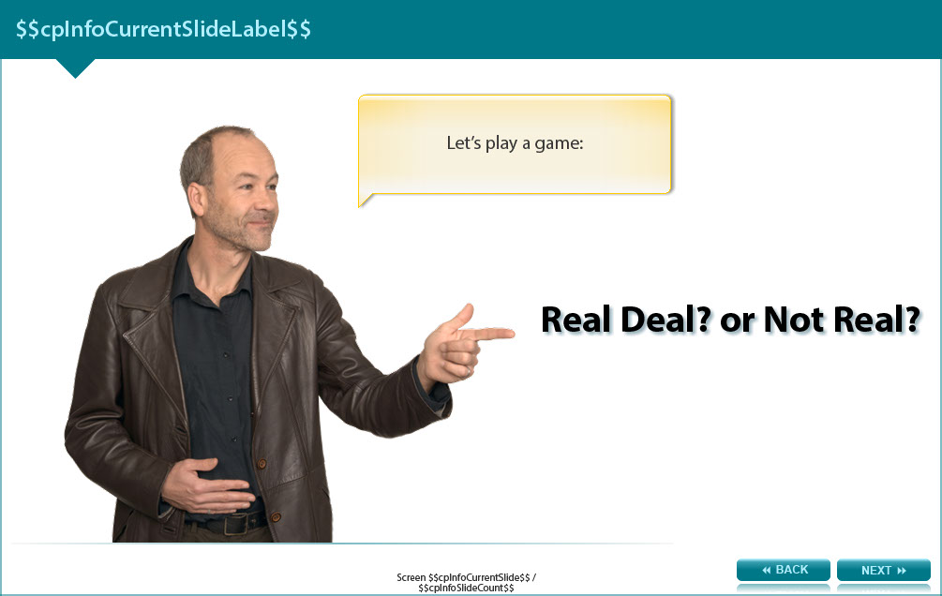

Let’s play a game:

Real Deal? or Not Real?

Screen 7 – Real Deal? Or Not Real?

Image showing a male staff member considering the issue.

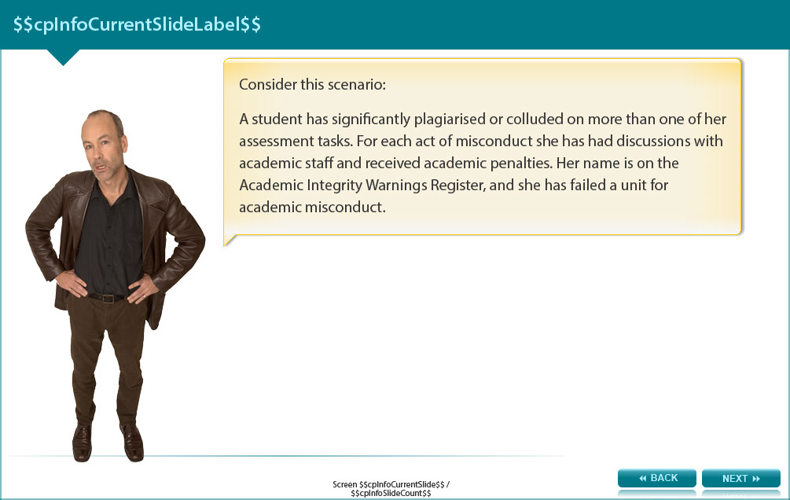

Consider this scenario:

A student has significantly plagiarised or colluded on more than one of her assessment tasks. For each act of misconduct she has had discussions with academic staff and received academic penalties. Her name is on the Academic Integrity Warnings Register, and she has failed a unit for academic misconduct.

Screen 8 – Real Deal? Or Not Real?

Image of a male staff member considering the issue.
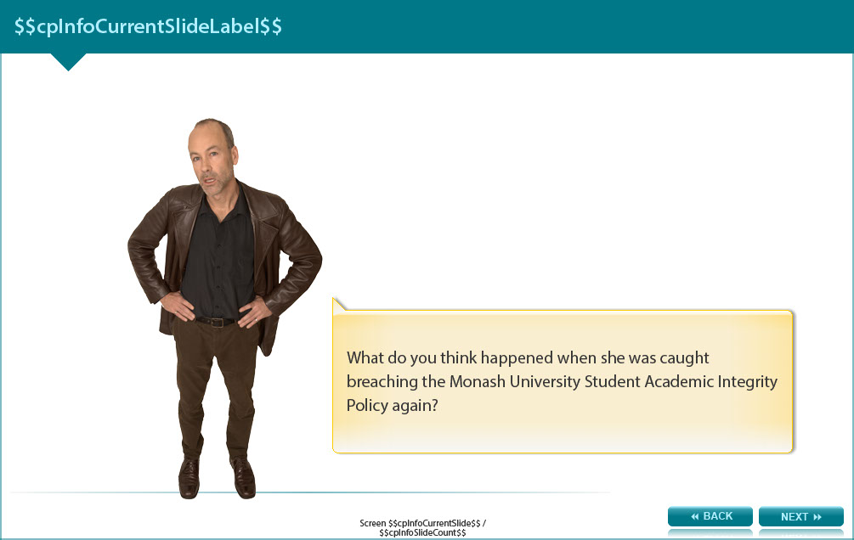

What do you think happened when she was caught breaching the Monash University Student Academic Integrity Policy again?

Screen 9 – Real Deal? Or Not Real?

Image of a male staff member speaking through a speech bubble and pointing to two briefcases, one labelled real deal and the other labelled not real.

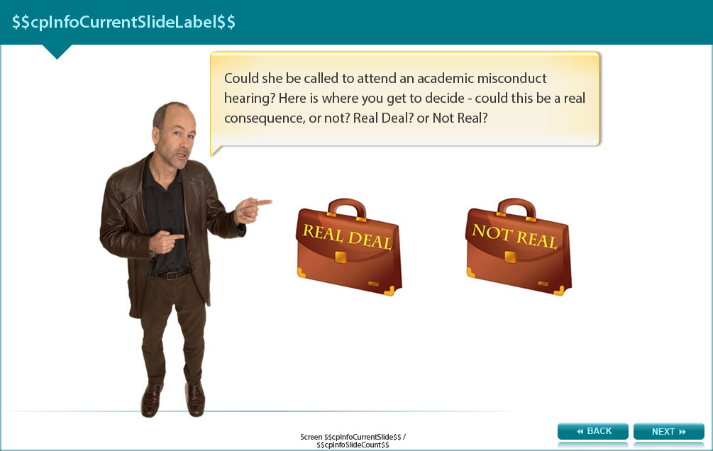

Could she be called to attend an academic misconduct hearing? Here is where you get to decide - could this be a real consequence, or not? Real Deal? or Not Real?

- Real Deal - (feedback: Real deal)
- Not Real – (feedback: Try again...)

Screen 10 – Not Real

Feedback to screen 9 (not real option)

Click BACK to try again...

Screen 11 – Real Deal

Feedback to screen 9 (real deal option). Image of a male staff member pointing to a laptop with the words real deal on the screen.

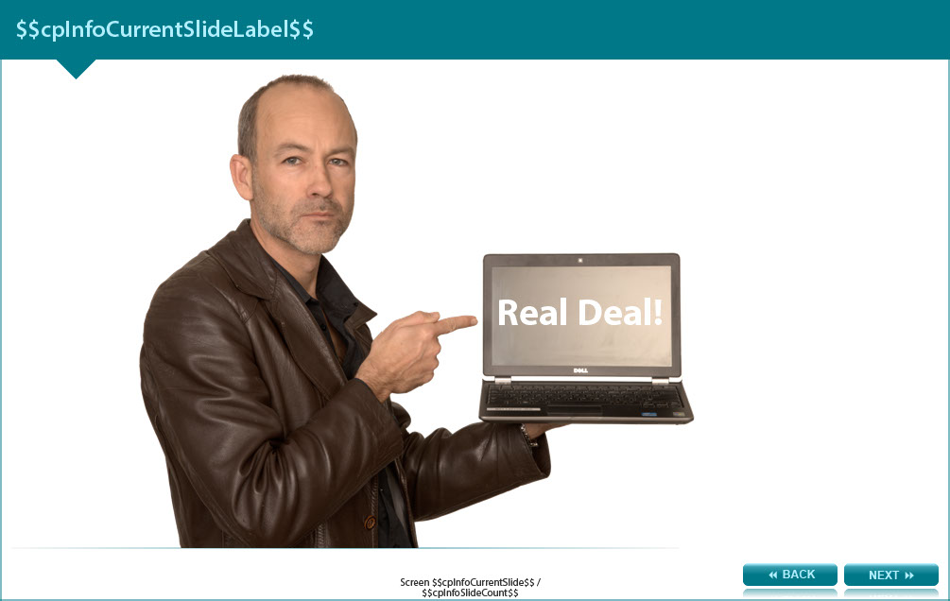

Screen 12 – Real Deal? Or Not Real Deal?

Image of a male staff member pointing to a photograph of a discipline panel.

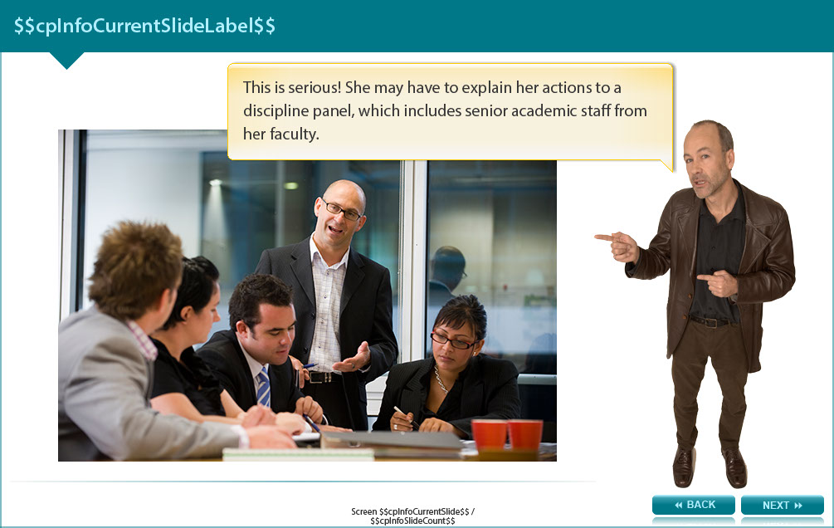

This is serious! She may have to explain her actions to a discipline panel, which includes senior academic staff from her faculty.

Screen 13 – Real Deal? Or Not Real Deal?

Image of student considering the issue.

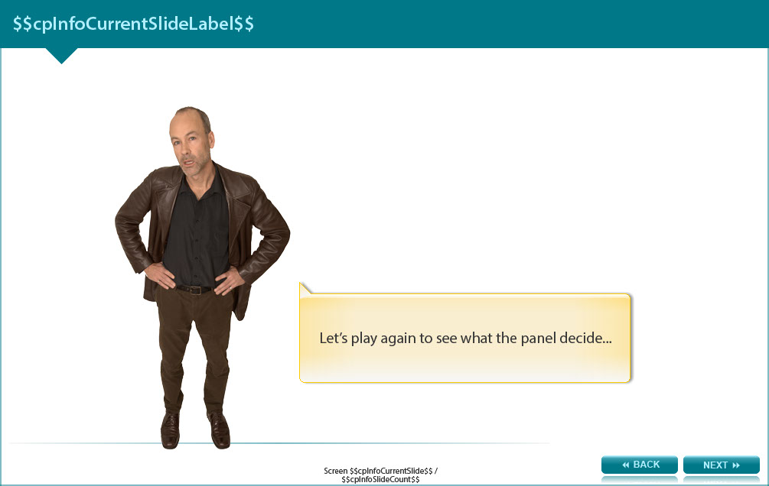

Let’s play again to see what the panel decide...

Screen 14 – Real Deal? Or Not Real?

Image of a male student speaking through a speech bubble and pointing to two briefcases, one labelled real deal and the other labelled not real.

Would they decide to exclude this student from Monash University? What do you think?

- Real Deal? – (feedback: Real deal).
- Not Real? – (feedback: Try again).

Screen 15 – Not Real

Feedback to screen 14 (not real option)

Click BACK to try again...
Screen 16 – Real Deal?

Image of a male staff member pointing to a laptop with the words real deal on the screen.

Feedback to screen 14 (real option)

Real deal.
Screen 17 – Real Deal Or Not Real ?

Image of a male staff member talking through and speech bubble and pointing to the Monash logo which has been crossed out in a red circle.

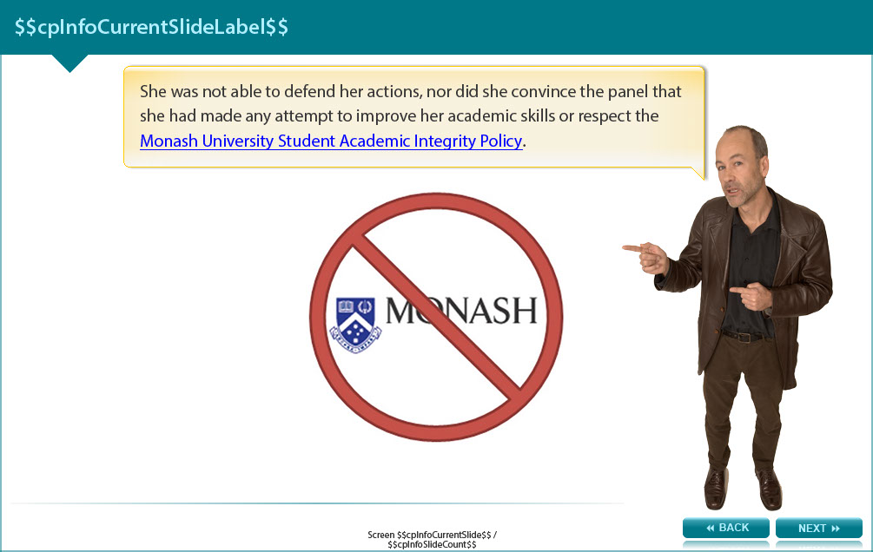

She was not able to defend her actions, nor did she convince the panel that she had made any attempt to improve her academic skills or respect the Monash University Student Academic Integrity Policy (http://www.policy.monash.edu.au/policy-bank/academic/education/conduct/student-academic-integrity-policy.html)
Screen 18 – Why?

Image of a male staff member talking through a speech bubble.

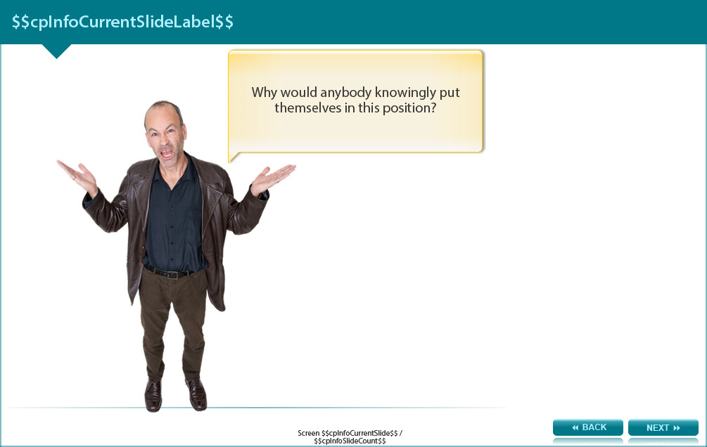

Why would anybody knowingly put themselves in this position?

Screen 19 – Why?

Image of a male staff member talking through a speech bubble and pointing to a photograph of a student and a learning skills advisor.

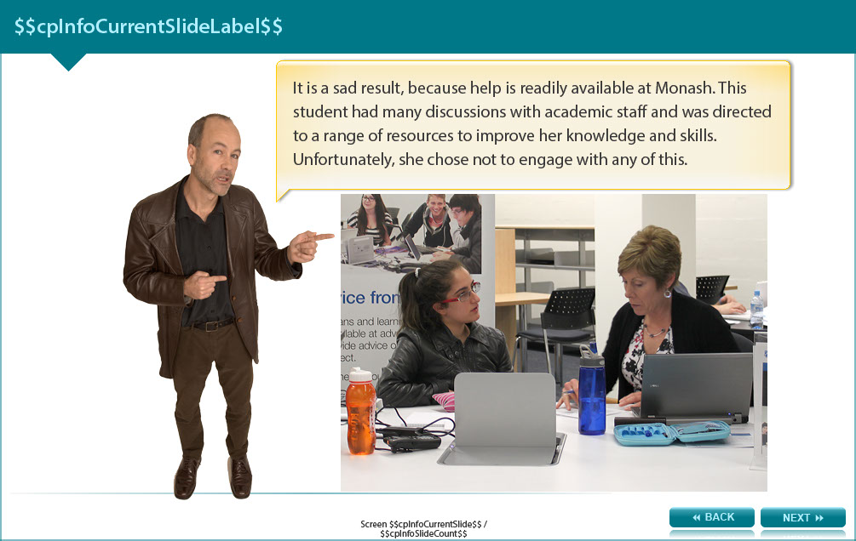

It is a sad result, because help is readily available at Monash. This student had many discussions with academic staff and was directed to a range of resources to improve her knowledge and skills. Unfortunately, she chose not to engage with any of this.

Screen 20 –Example

Image of a male staff member considering the issue.

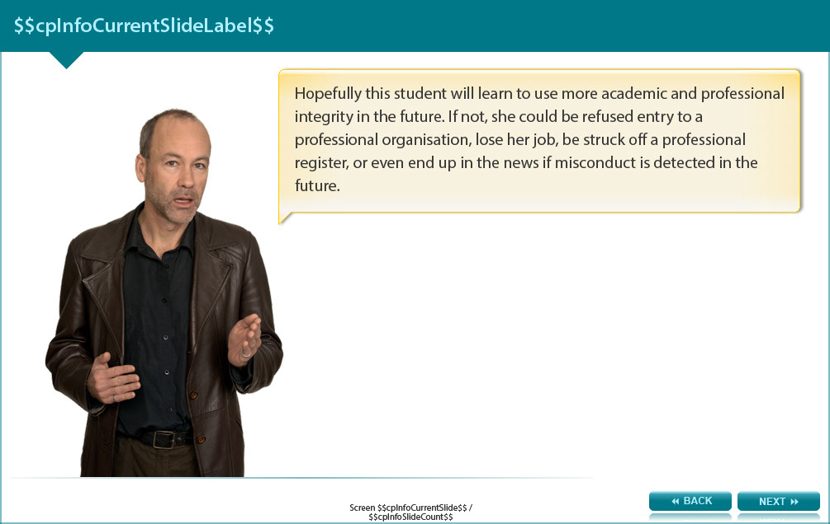

Hopefully this student will understand and apply academic and professional integrity in the future. If not, she could be refused entry to a professional organisation, lose her job, be struck off a professional register, or even end up in the news if misconduct is detected in the future.

Screen 21 – Example

Image of a male staff member pointing to an example.

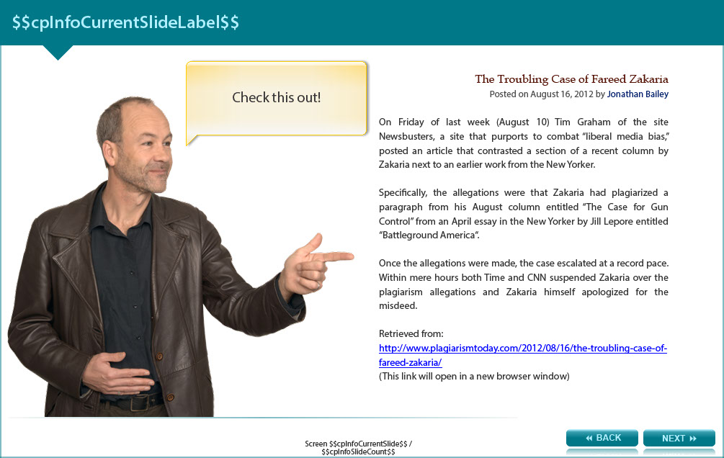

Check this out!

The Troubling Case of Fareed Zakaria
Posted on August 16, 2012 by Jonathan Bailey

On Friday of last week (August 10) Tim Graham of the site Newsbusters, a site that purports to combat “liberal media bias,” posted an article that contrasted a section of a recent column by Zakaria next to an earlier work from the New Yorker.

Specifically, the allegations were that Zakaria had plagiarized a paragraph from his August column entitled “The Case for Gun Control” from an April essay in the New Yorker by Jill Lepore entitled “Battleground America“.

Once the allegations were made, the case escalated at a record pace. Within mere hours both Time and CNN suspended Zakaria over the plagiarism allegations and Zakaria himself apologized for the misdeed.

Retrieved from: http://www.plagiarismtoday.com/2012/08/16/the-troubling-case-of-fareed-zakaria/

Screen 22 – Example

Image is showing the two articles in question side by side, highlighting the plagiarised paragraph.

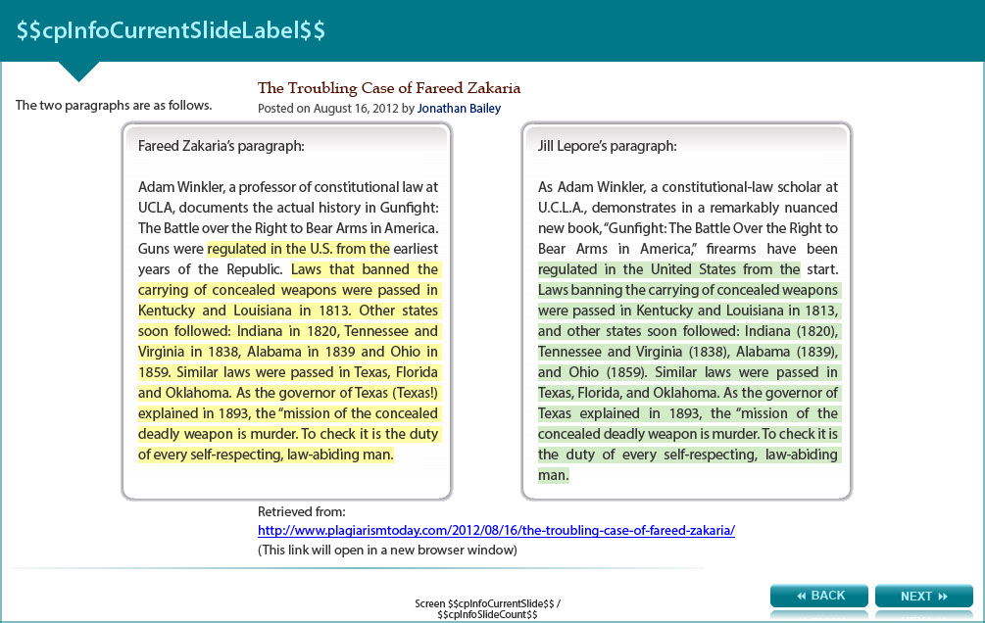

The two paragraphs are as follows with the bold sections showing the similarities.

The Troubling Case of Fareed Zakaria
Posted on August 16, 2012 by Jonathan Bailey

Fareed Zakaria’s paragraph:

Adam Winkler, a professor of constitutional law at UCLA, documents the actual history in Gunfight: The Battle over the Right to Bear Arms in America. Guns were regulated in the U.S. from the earliest years of the Republic. Laws that banned the carrying of concealed weapons were passed in Kentucky and Louisiana in 1813. Other states soon followed: Indiana in 1820, Tennessee and Virginia in 1838, Alabama in 1839 and Ohio in 1859. Similar laws were passed in Texas, Florida and Oklahoma. As the governor of Texas (Texas!) explained in 1893, the “mission of the concealed deadly weapon is murder. To check it is the duty of every self-respecting, law-abiding man.

Jill Lepore’s paragraph:

As Adam Winkler, a constitutional-law scholar at U.C.L.A., demonstrates in a remarkably nuanced new book, “Gunfight: The Battle Over the Right to Bear Arms in America,” firearms have been regulated in the United States from the start. Laws banning the carrying of concealed weapons were passed in Kentucky and Louisiana in 1813, and other states soon followed: Indiana (1820), Tennessee and Virginia (1838), Alabama (1839), and Ohio (1859). Similar laws were passed in Texas, Florida, and Oklahoma. As the governor of Texas explained in 1893, the “mission of the concealed deadly weapon is murder. To check it is the duty of every self-respecting, law-abiding man.

Retrieved from: http://www.plagiarismtoday.com/2012/08/16/the-troubling-case-of-fareed-zakaria/
Screen 23 –Want to find out more?

Image of a male staff member pointing to a list of issues that can arise through academic misconduct.

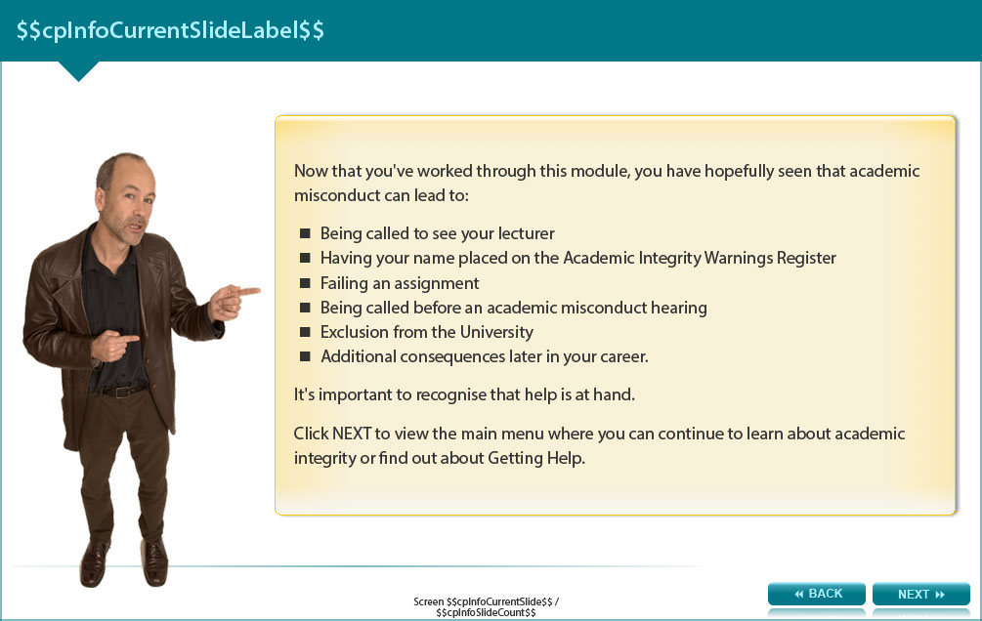

Now that you've worked through this module, you have hopefully seen that academic misconduct can lead to:

- Being called to see your lecturer
- Having your name placed on the Academic Integrity Warnings Register
- Failing an assignment
- Being called before an academic misconduct hearing
- Exclusion from the University
- Additional consequences later in your career.

It's important to recognise that help is at hand.

Read the next screen to view the links where you can continue to learn about academic integrity or find out about Getting Help.

Screen 24 – Additional Resources

Image shows titles and icons of related resources.

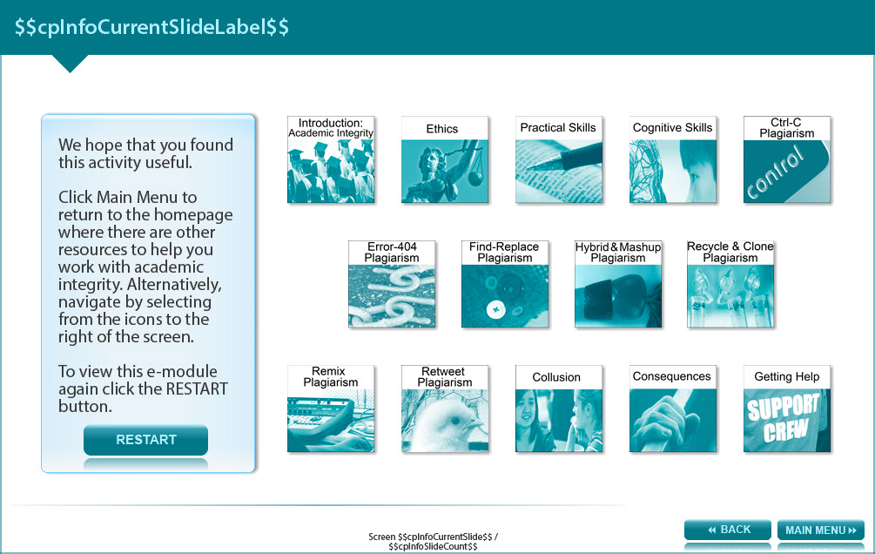

We hope that you found this activity useful.

Click the links below to view other modules in this academic integrity tutorial:

- Introduction: Academic integrity (http://www.monash.edu/rlo/research-writing-assignments/referencing-and-academic-integrity/academic-integrity/introduction)
- Ethics (http://www.monash.edu/rlo/research-writing-assignments/referencing-and-academic-integrity/academic-integrity/ethics)
- Practical skills (http://www.monash.edu/rlo/research-writing-assignments/referencing-and-academic-integrity/academic-integrity/practical-skills)
- Cognitive skills (http://www.monash.edu/rlo/research-writing-assignments/referencing-and-academic-integrity/academic-integrity/cognitive-skills)
- Ctrl-C plagiarism (http://www.monash.edu/rlo/research-writing-assignments/referencing-and-academic-integrity/academic-integrity/ctrl-c)
- Error-404 plagiarism (http://www.monash.edu/rlo/research-writing-assignments/referencing-and-academic-integrity/academic-integrity/error-404)
- Find-Replace plagiarism (http://www.monash.edu/rlo/research-writing-assignments/referencing-and-academic-integrity/academic-integrity/find-and-replace)
- Hybrid & Mashup plagiarism (http://www.monash.edu/rlo/research-writing-assignments/referencing-and-academic-integrity/academic-integrity/hybrid-mashup)
- Recycle & Clone plagiarism (http://www.monash.edu/rlo/research-writing-assignments/referencing-and-academic-integrity/academic-integrity/recycle-and-clone)
- Remix plagiarism (http://www.monash.edu/rlo/research-writing-assignments/referencing-and-academic-integrity/academic-integrity/remix)
- Retweet plagiarism (http://www.monash.edu/rlo/research-writing-assignments/referencing-and-academic-integrity/academic-integrity/retweet)
- Collusion (http://www.monash.edu/rlo/research-writing-assignments/referencing-and-academic-integrity/academic-integrity/collusion)
- Consequences (http://www.monash.edu/rlo/research-writing-assignments/referencing-and-academic-integrity/academic-integrity/consequences)
- Getting help (http://www.monash.edu/rlo/research-writing-assignments/referencing-and-academic-integrity/academic-integrity/getting-help)

