Academic Integrity Online Tutorial - Cognitive Skills

Cognitive skills module

Use this document as an alternative to the online interactive tutorial
Contents
Academic Integrity Online Tutorial - Cognitive Skills 1
Cognitive skills module 1
Use this document as an alternative to the online interactive tutorial 1
Screen 1- Title – Cognitive Skills 2
Screen 2 – Introduction 2
Screen 3 – Analysis 3
Screen 4 – Evaluating Quality of Sources or Information 5
Screen 5 – Critical Thinking 5
Screen 6 – Critical Thinking 6
Screen 7 – YouTube Clip 1 7
Screen 8 – YouTube Clip 2 8
Screen 9 – YouTube Clip 3 9
Screen 10 – YouTube Clip 4 10
Screen 11 – YouTube Clip 5 11
Screen 12 – YouTube Clip 6 12
Screen 13 – Synthesis-What does it mean? 13
Screen 14 – Synthesis-What does it mean? 14
Screen 15 – How to Synthesis? 15
Screen 16 – Synthesis Activity 16
Screen 17 – Conclusion 19
Screen 18 – Additional Resources 19

Screen 1- Title – Cognitive Skills

Title slide image showing young child staring at a model of an anatomical head.

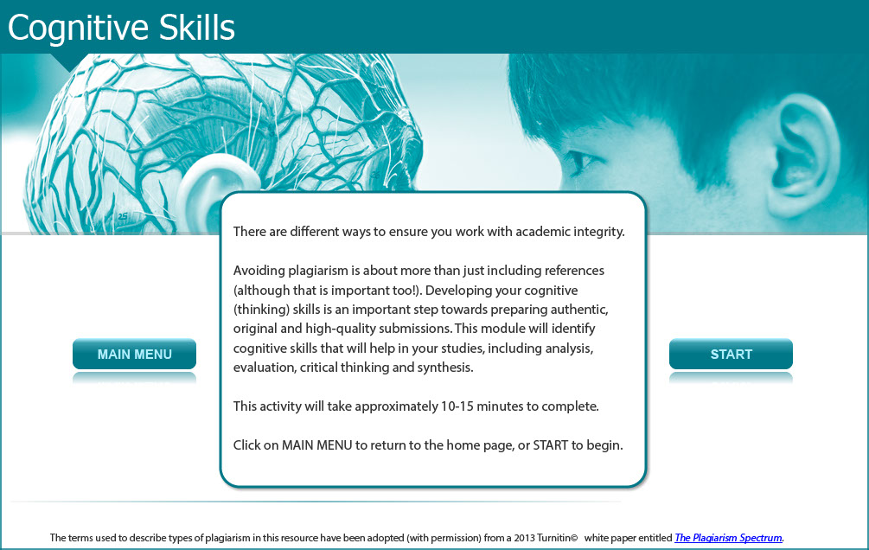

There are different ways to ensure you work with academic integrity.

Avoiding plagiarism is about more than just including references (although that is important too!). Developing your cognitive (thinking) skills is an important step towards preparing authentic, original and high-quality submissions. This module will identify cognitive skills that will help in your studies, including analysis, evaluation, critical thinking and synthesis.

This activity will take approximately 10-15 minutes to complete.

Screen 2 – Introduction

Image of a male staff member holding a noticeboard with links to specific cognitive skills.

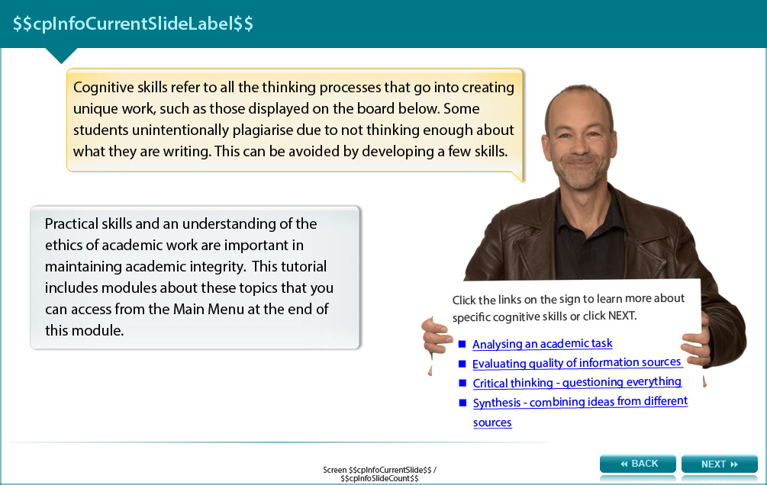

Cognitive skills refer to all the thinking processes that go into creating unique work, such as those displayed on the board below. Some students unintentionally plagiarise due to not thinking enough about what they are writing. This can be avoided by developing a few skills.

Practical skills and an understanding of the ethics of academic work are important in maintaining academic integrity. This tutorial includes modules about these topics that you can access from the Additional Resources screen at the end of this module.

The topics below are displayed as links in the online module. They jump to sections within the module. To learn more about each, simply scroll to the relevant sections.

- Analysing an academic task

- Evaluating quality of information sources

- Critical thinking - questioning everything

- Synthesis - combining ideas from different sources

Screen 3 – Analysis

Image of a male staff member talking via a speech bubble.

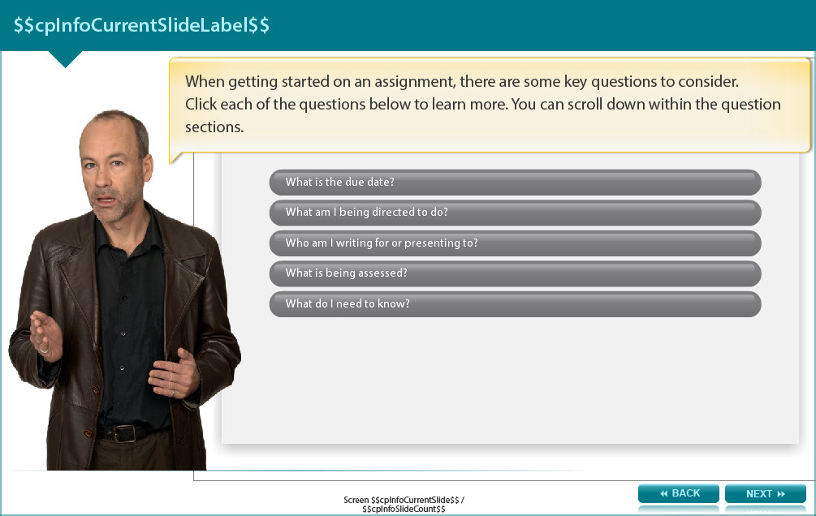

When getting started on an assignment, there are some key questions to consider.

The learner is asked to click tabs displaying each of the questions below to learn more. You can scroll down within the question sections.

When is the due date?
How long do you have to find information, read, take notes, plan, write and edit the assignment? Write the due date in your diary and set earlier deadlines for each smaller task to ensure that you devote enough time to all aspects of the assignment. Further information on this can be found in the time management section of the Practical Skills module.

What am I being directed to do?
Direction words include 'identify' (choose an appropriate option), 'discuss' (present different, supported, arguments relating to the topic and if necessary identify which is the most appropriate), 'explain' (provide reasons for something, with evidence) and 'compare' (present similarities and differences between ideas or options). These words can help you to identify what is expected in your assignment.

Who am I writing for or presenting to?
A standard essay might be targeted to a discipline-specific academic audience, which understands the terminology specific to that field. However, other tasks could be ‘Write a report for the Board of Directors of a company', or ‘Prepare a lesson plan for a Grade 3 art class’. Keep the audience in mind when preparing your response.

What is being assessed?
Check the assessment guidelines for the assignment. These will often provide details on the structure and content expected, and may emphasise particular aspects that you might not otherwise have considered (e.g. critical analysis of findings, or suggesting future directions for research in your conclusion).

What do I need to know?
By identifying the gaps in your knowledge, you are well on the way to start searching for information on the topic.

Screen 4 – Evaluating Quality of Sources or Information

Image of male staff member talking via a speech bubble.

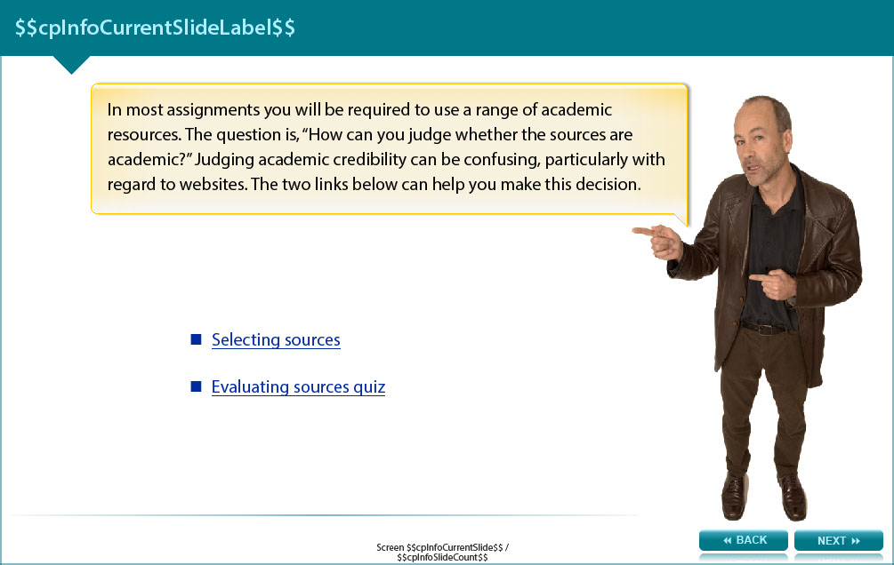

In most assignments you will be required to use a range of academic resources. The question is, “How can you judge whether the sources are academic?” Judging academic credibility can be confusing, particularly with regard to websites. The two links below can help you make this decision.

Selecting sources: http://www.monash.edu.au/lls/llonline/writing/information-technology/sources/2.1.xml

Evaluating sources quiz: https://docs.google.com/a/monash.edu/forms/d/e/1FAIpQLSdrA2xpcWSCZIUNXxjw0ihvdhwstsXxERSMT4tL5ERsBYhceQ/viewform

Screen 5 – Critical Thinking

Image of a male staff member considering the issue.

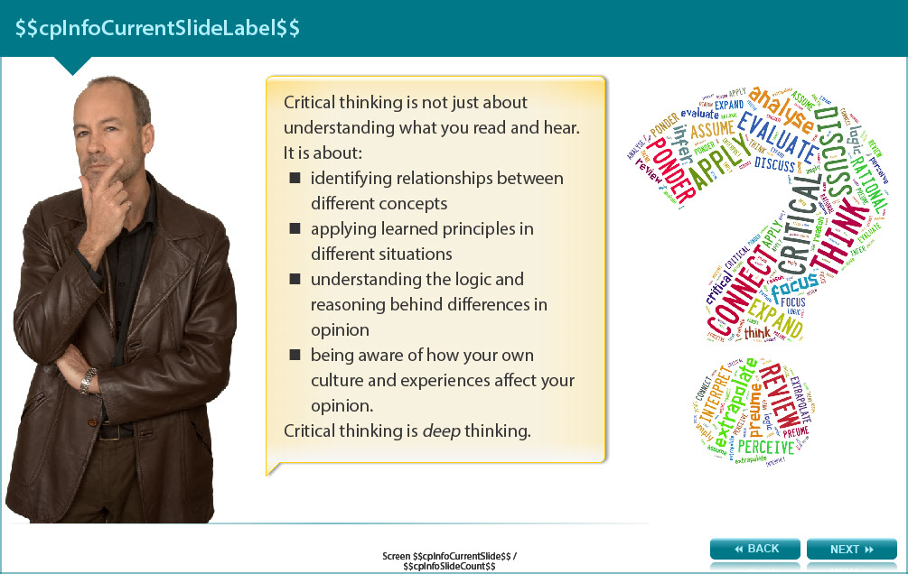

Critical thinking is not just about understanding what you read and hear. It is about:

- identifying relationships between different concepts

- applying learned principles in different situations

- understanding the logic and reasoning behind differences in opinion

- being aware of how your own culture and experiences affect your opinion.

Critical thinking is deep thinking.

Screen 6 – Critical Thinking

Image of a male staff member considering the issue.

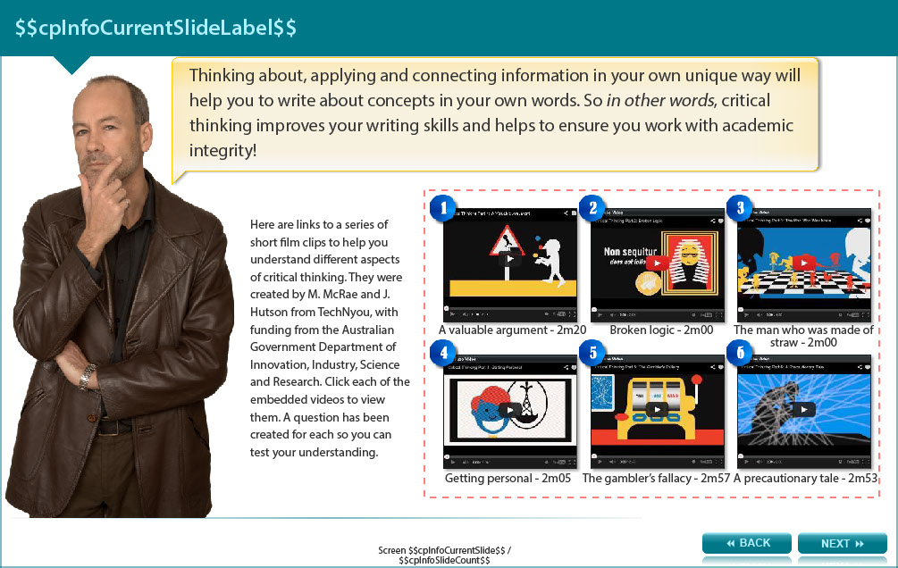

Thinking about, applying and connecting information in your own unique way will help you to write about concepts in your own words. So in other words, critical thinking improves your writing skills and helps to ensure you work with academic integrity!

Here are links to a series of short film clips to help you understand different aspects of critical thinking. They were created by M. McRae and J. Hutson from TechNyou, with funding from the Australian Government Department of Innovation, Industry, Science and Research. Click each of the embedded videos to view them. A question has been created for each so you can test your understanding.

- A valuable argument - 2m20 (http://www.youtube.com/watch?v=iSZ3BUru59A)

- Broken logic - 2m00 (http://www.youtube.com/watch?v=VRZk62QNOsM)

- The man who was made of straw - 2m00 (http://www.youtube.com/watch?v=kgdDK4XMpm0)

- Getting personal - 2m05 (http://www.youtube.com/watch?v=W_veZ24nC3g)

- The gambler’s fallacy - 2m57 (http://www.youtube.com/watch?v=K8SkCh-n4rw)

- A precautionary tale - 2m53 (http://www.youtube.com/watch?v=vjaqM4yd_RA)

Screen 7 – YouTube Clip 1

Image showing YouTube clip.

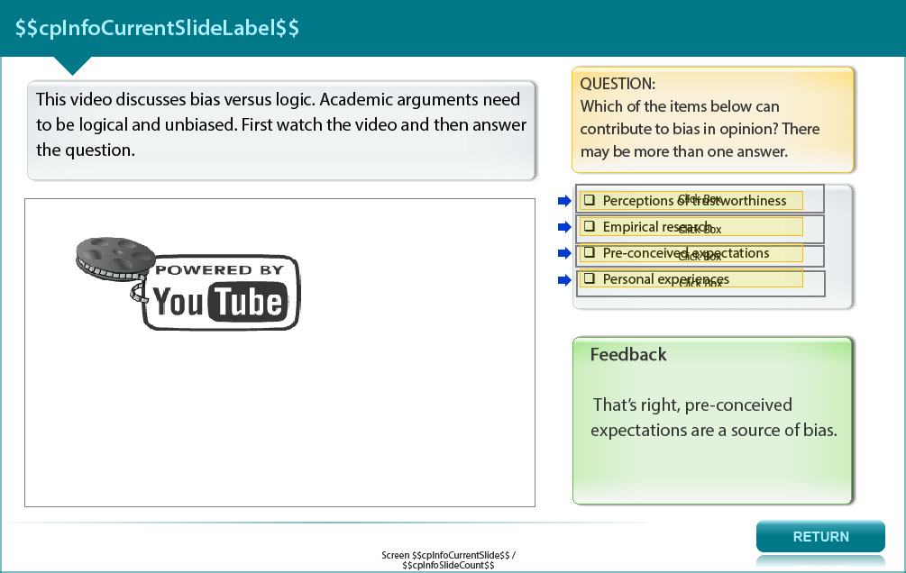

This video discusses bias versus logic. Academic arguments need to be logical and unbiased. First click (http://www.youtube.com/watch?v=iSZ3BUru59A) to watch the video and then answer the question.

QUESTION:
Which of the items below can contribute to bias in opinion? There may be more than one answer.

- Perceptions of trustworthiness (feedback: Yes, perceptions of trustworthiness is one source of bias)

- Empirical research (feedback: Empirical research is a process of applying quantitative and qualitative methods to analyse observations, using logical reasoning to explain the observations. Bias is minimised in this process.)

- Pre-conceived expectations (feedback: That’s right, pre-conceived expectations are a source of bias.)

- Personal experiences (feedback: Personal experience can be a source of bias.)

Screen 8 – YouTube Clip 2

Image showing YouTube clip.

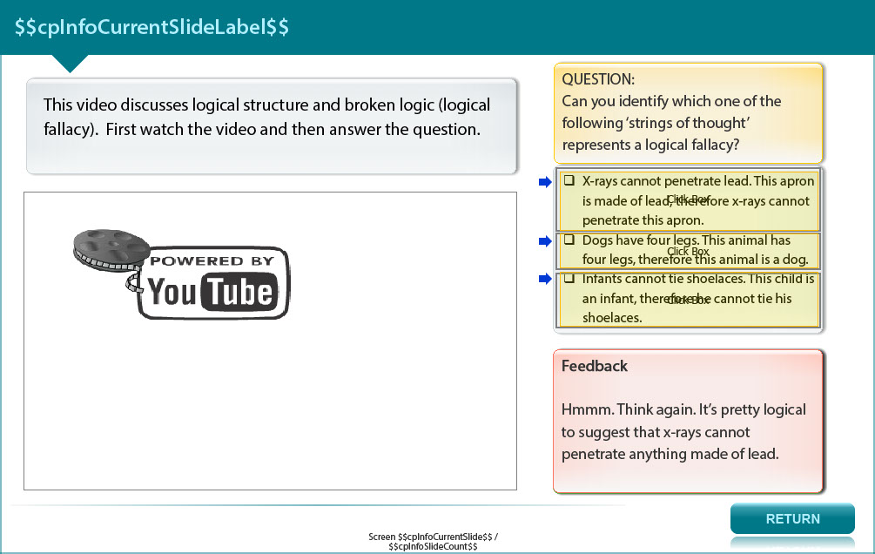

This video discusses logical structure and broken logic (logical fallacy). First click (http://www.youtube.com/watch?v=VRZk62QNOsM) to watch the video and then answer the question.

QUESTION:
Can you identify which one of the following ‘strings of thought’ represents a logical fallacy?

- X-rays cannot penetrate lead. This apron is made of lead, therefore x-rays cannot penetrate this apron (feedback: Hmmm. Think again. It is fair and reasonable logic to expect that an infant does not have the fine motor skills to tie their shoe laces.)

- Dogs have four legs. This animal has four legs, therefore this animal is a dog (feedback: Many animals have four legs - so the animal could be a cat or a horse or a deer! Well done. You have clearly understood the point about broken logic.)

- Infants cannot tie shoelaces. This child is an infant, therefore he cannot tie his shoelaces (feedback: Hmmm. Think again. It’s pretty logical to suggest that x-rays cannot penetrate anything made of lead.)

Screen 9 – YouTube Clip 3

Image showing YouTube clip.

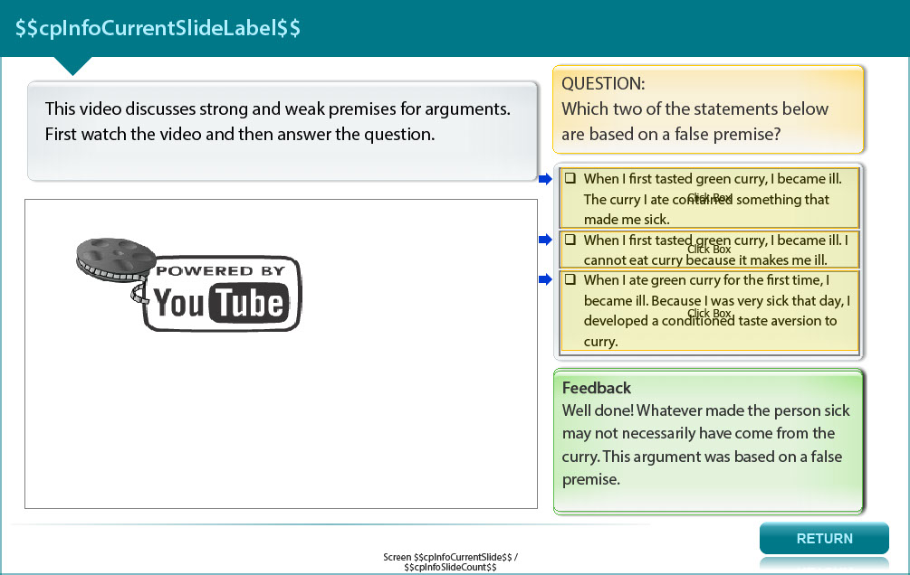

This video discusses strong and weak premises for arguments. First click (http://www.youtube.com/watch?v=kgdDK4XMpm0) to watch the video and then answer the question.

QUESTION:
Which two of the statements below are based on a false premise?

- When I first tasted green curry, I became ill. The curry I ate contained something that made me sick (feedback: Well done! Whatever made the person sick may not necessarily have come from the curry. This argument was based on a false premise.)

- When I first tasted green curry, I became ill. I cannot eat curry because it makes me ill (feedback: Well done! Even if the curry had contained the source of illness (a questionable premise), the ingredients may not be the problem. Bacterial contamination is another possibility.)

- When I ate green curry for the first time, I became ill. Because I was very sick that day, I developed a conditioned taste aversion to curry. (feedback : It is difficult to find fault with this statement. The curry is not being blamed for the cause of illness. The person recognises that whatever the source, they have associated the feeling of being ill with the taste of green curry. This is a well-researched psychological phenomenon.)

Screen 10 – YouTube Clip 4

Image showing YouTube clip.

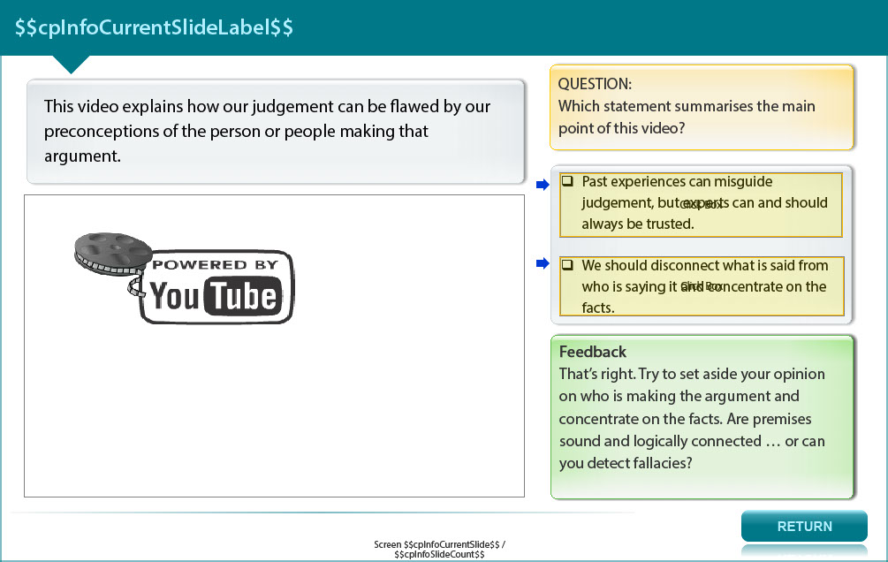

This video explains how our judgement can be flawed by our preconceptions of the person or people making that argument. First click (http://www.youtube.com/watch?v=W_veZ24nC3g) to watch the video and then answer the question.

QUESTION:
Which statement summarises the main point of this video?

- Past experiences can misguide judgement, but experts can and should always be trusted (feedback: Hmmm. Always? Even in an academic environment there are differing opinions, so whose arguments are the most logical? It’s up to you to weigh up the facts and make your own decision.)

- We should disconnect what is said from who is saying it and concentrate on the facts (feedback: That’s right. Try to set aside your opinion on who is making the argument and concentrate on the facts. Are premises sound and logically connected … or can you detect fallacies?)

Screen 11 – YouTube Clip 5

Image showing YouTube clip.

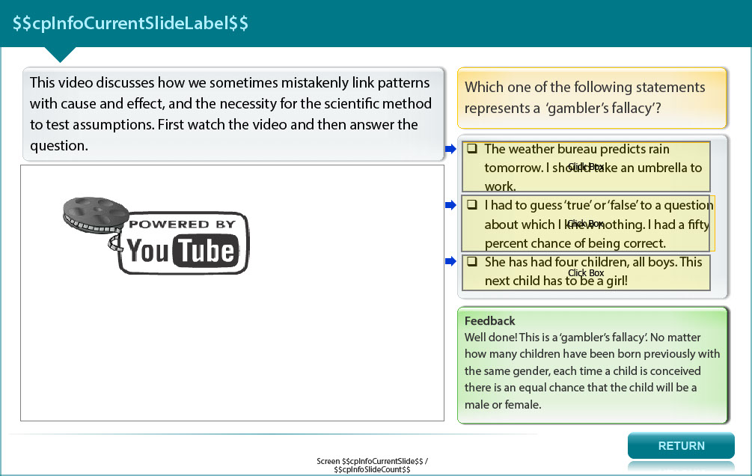

This video discusses how we sometimes mistakenly link patterns with cause and effect, and the necessity for the scientific method to test assumptions. First click (http://www.youtube.com/watch?v=K8SkCh-n4rw) to watch the video and then answer the question.

QUESTION:
Which one of the following statements represents a ‘gambler’s fallacy’?

- The weather bureau predicts rain tomorrow. I should take an umbrella to work (feedback: Whilst weather predictions are not always accurate, predictions are based on scientific method, and for the most part they are reliable. This isn’t a ‘gambler’s fallacy’.)

- I had to guess ‘true’ or ‘false’ to a question about which I knew nothing. I had a fifty percent chance of being correct (feedback: This is a true mathematical (scientific) probability calculation, so it’s not a ‘gambler’s fallacy’.)

- She has had four children, all boys. This next child has to be a girl! (feedback: Well done! This is a ‘gambler’s fallacy’. No matter how many children have been born previously with the same gender, each time a child is conceived there is an equal chance that the child will be a male or female.)

Screen 12 – YouTube Clip 6

Image showing YouTube clip.

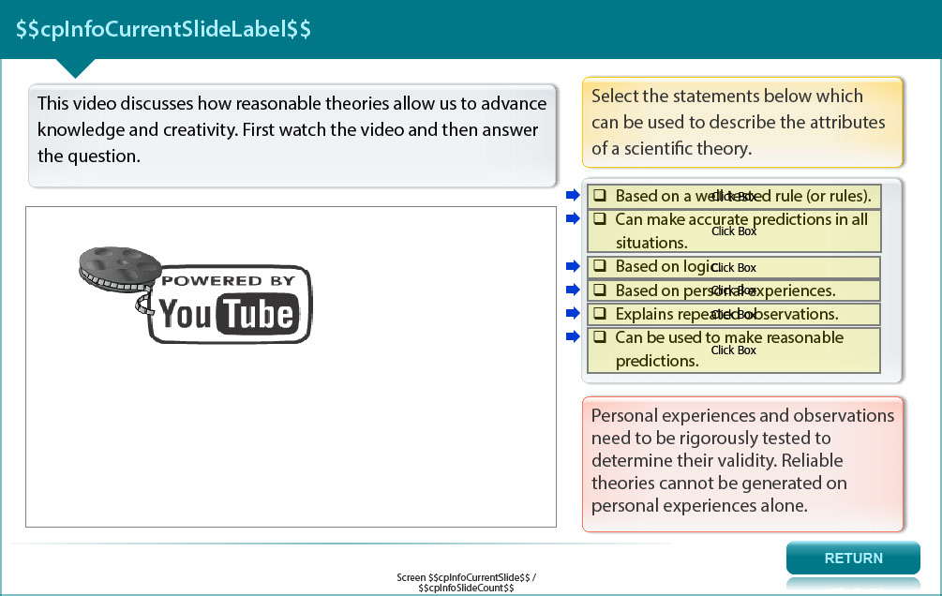

This video discusses how reasonable theories allow us to advance knowledge and creativity. First click (http://www.youtube.com/watch?v=vjaqM4yd_RA) to watch the video and then answer the question.

Select the statements below which can be used to describe the attributes of a scientific theory.

- Based on a well tested rule (or rules) (feedback: Well done.)

- Can make accurate predictions in all situations (feedback: Scientific theories can suggest reasonable predictions, but are not 100% accurate in predicting outcomes in every situation.)

- Based on logic (feedback: Absolutely.)

- Based on personal experiesnces (feedback: Personal experiences and observations need to be rigorously tested to determine their validity. Reliable theories cannot be generated on personal experiences alone.)

- Explains repeated observations (feedback: Definitely.)

- Can be used to make reasonable predictions (feedback: Yes.)

Screen 13 – Synthesis-What does it mean?

Image of male staff member considering the issue.

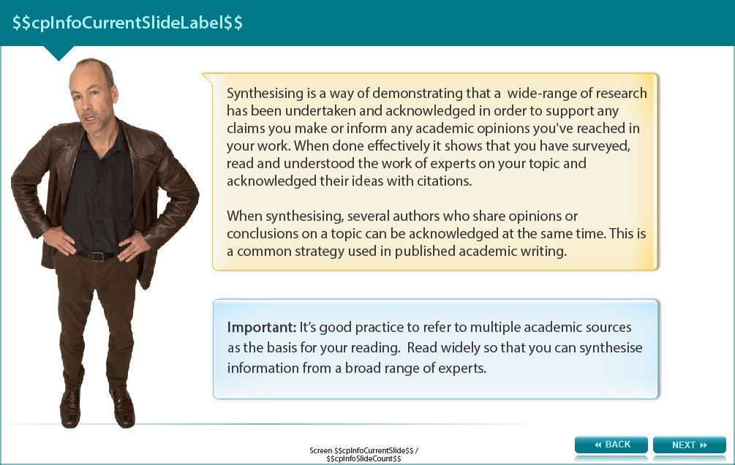

Synthesising is a way of demonstrating that a wide-range of research has been undertaken and acknowledged in order to support any claims you make or inform any academic opinions you've reached in your work. When done effectively it shows that you have surveyed, read and understood the work of experts on your topic and acknowledged their ideas with citations.

When synthesising, several authors who share opinions or conclusions on a topic can be acknowledged at the same time. This is a common strategy used in published academic writing.

Important: It’s good practice to refer to multiple academic sources as the basis for your reading. Read widely so that you can synthesise information from a broad range of experts.

Screen 14 – Synthesis-What does it mean?

Image of a male staff member considering the issue.

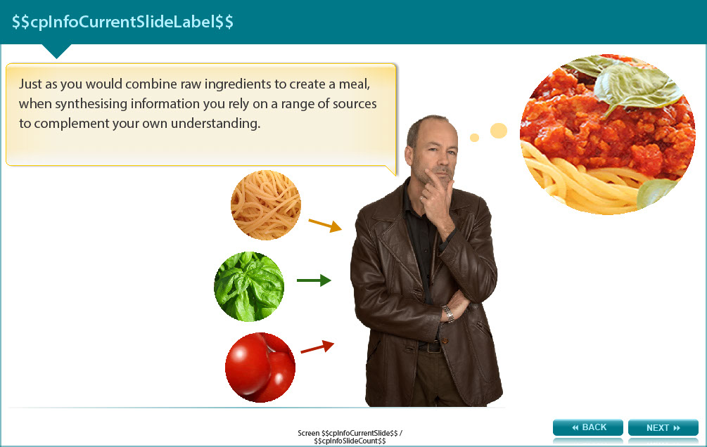

Just as you would combine raw ingredients to create a meal, when synthesising information you rely on a range of sources to complement your own understanding.

Screen 15 – How to Synthesis?

Image of a male staff member showing two thumbs up.

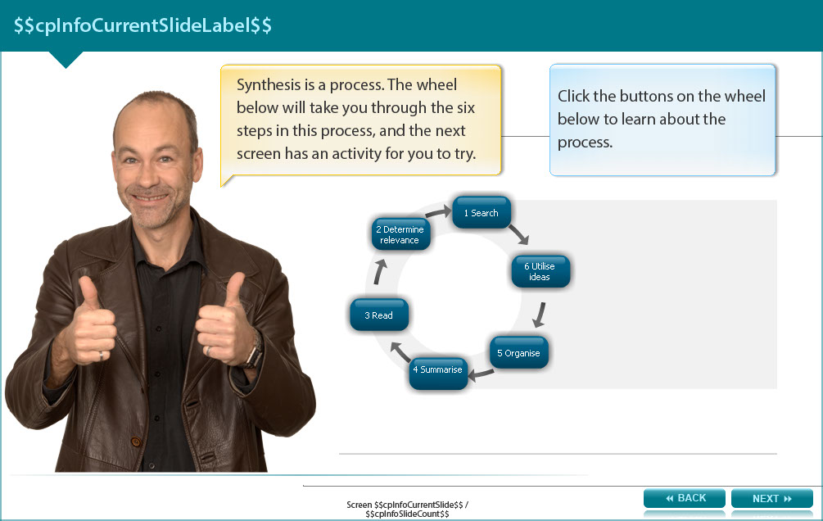

Synthesis is a process. The screen shows the six steps in this process (listed below) arranged in a circle. The next screen has an activity for you to try about synthesis.

- Search: Conduct searches to locate the academic sources you need.

- Determine relevance: Determine the relevance of several sources.

- Read: Read sources in detail, taking notes and highlighting or underlining key points that relate directly to your topic

- Summarise: Summarise these relevant points in your own words, ensuring that the original meaning is retained

- Organise: Organise source ideas into categories, e.g. ideas where they disagree, alternative ideas on the topic

- Utilise Ideas: Include the ideas or information at the appropriate point in your assignment and cite the sources

Screen 16 – Synthesis Activity

Image of a male staff member holding up a noticeboard.

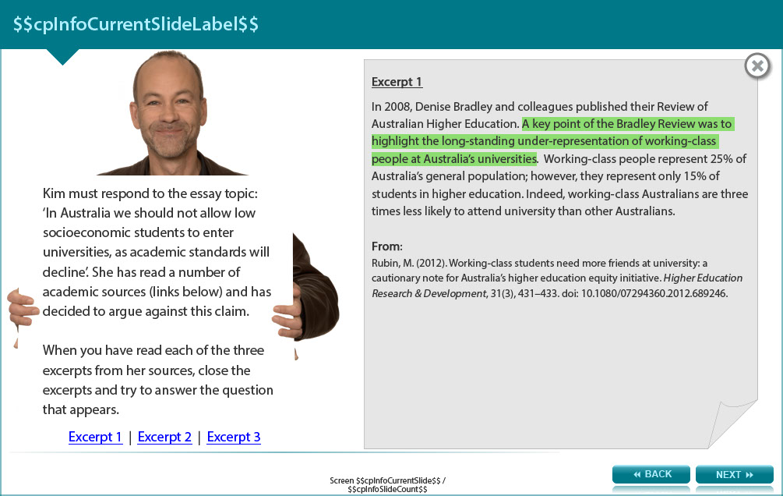

Kim must respond to the essay topic: ‘In Australia we should not allow low socioeconomic students to enter universities, as academic standards will decline’. She has read a number of academic sources (links below) and has decided to argue against this claim.

When you have read each of the three excerpts from her sources, close the excerpts and try to answer the question that appears.

Excerpt 1

In 2008, Denise Bradley and colleagues published their Review of Australian Higher Education. A key point of the Bradley review was to highlight the long-standing under-representation of working-class people at Australia’s universities. Working-class people represent 25% of Australia’s general population; however, they represent only 15% of students in higher education. Indeed, working-class Australians are three times less likely to attend university than other Australians.

From:
Rubin, M. (2012). Working-class students need more friends at university: a cautionary note for Australia’s higher education equality initiative. Higher Education Research & Development, 31(3), 431-433. doi: 10.1080/07294360.2012.689246.

Excerpt 2

Underpinning this four-point approach is a set of beliefs and principles which inform all outreach activities (QUT, 2004):

Low-SES students are chronically under-represented across Australia, although their pass rates and completion rates are reasonably close to those of other students. Making university affordable and accessible is the core challenge.

Barriers to the participation of low-income students in higher education are a complex mix of issues-affordability, cultural/family issues, awareness and achievement.

Integrated, long-term effort across is required in order to affect change.

New activities should build on the fundamentals which already exist and the aim is a sustainable, embedded, University-wide program.

An all-university partnership approach is required. For some elements, co-operative activities with other universities and with other sectors will be needed.

From:
O’Brien, G. (n.d.). Working towards social inclusion in higher education: an integrated approach to outreach and retention [PowerPoint slides]. Retrieved from http://www.fyhe.com.au/past_papers/papers09/ppts/9E.pdf

Excerpt 3

Over the past two decades, successive Australian governments have recognised the poor higher education participation rates of students from low socio-economic (LSES) backgrounds. Yet, as Devlin notes, ‘despite an expansion of participation per se, the provision of financial and other support for students, and significant target setting and monitoring of universities’ performance’ (Devlin 2008, 1), participation rates for LSES students have remained at around 15%, compared to the current 25% for the general population (Bradley et al. 2008, 28; DEEWR 2009, ii).

From:
Devlin, M., & O’Shea, H. (2012). Effective university teaching: views of Australian university students from low socio-economic status backgrounds. Teaching in Higher education, 17(4), 385-397. doi: 10.1080/13562517.2011.641006.

Question:
Which of the three examples below is the best synthesis of the author’s ideas?

- There has been long-standing under-representation of students from low socioeconomic (LSES) backgrounds at Australia’s universities, even though their academic performance is similar to students from more economically privileged backgrounds (Ruben, 2012; Devlin & O’Shea, 2012; O’Brien, n.d).

Feedback: “Hmm. The point she makes does accurately reflect points made in the excerpts…but did you notice something else? There is some exact wording from excerpts 1 and 3 in this sentence. This is a form of plagiarism. Also, only excerpt 2 made mention of low-SES representation and comparable student performance, so it’s not accurate to cite all three sources after this statement.

- For some time now students from less privileged backgrounds have been under-represented at Australian tertiary institutions (Ruben, 2012; Devlin & O’Shea, 2012; O’Brien, n.d), even though their academic performance is similar to students from more economically privileged backgrounds (O’Brien, n.d).

Feedback: Well done. The wording accurately represents the arguments made in each of the three sources, and it is written in Kim’s own words. Note that the first point was common to all sources and she correctly cites them all. The second point about LSES representation and comparible student performance was only mentioned by excerpt 2, and she accurately includes a separate citation for this statement.

- In recent times few people from working class backgrounds can be seen at Australian universities, although these people often perform as well as people from more privileged economic statuses (Ruben, 2012; Devlin & O’Shea, 2012; O’Brien, n.d).

Feedback: Hmm. Not a bad choice. It is written in Kim’s own words, but unfortunately she has changed the meaning slightly. People “seen at Australian universities” are not necessarily students. They could be staff or visitors, so original meaning has changed. Also, only excerpt 2 made mention of LSES representation and comparable student performance, so it’s not accurate to cite all three sources for this statement.

Screen 17 – Conclusion

Image of a male staff member showing two thumbs up.

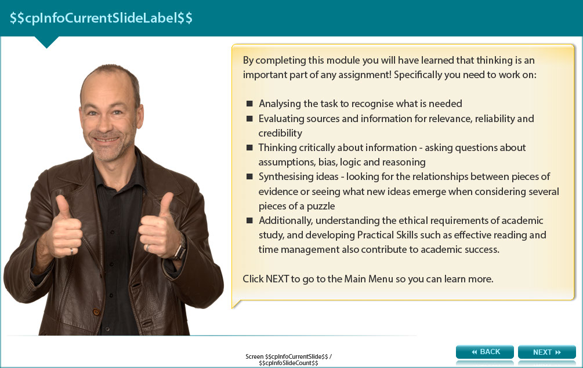

By completing this module you will have learned that thinking is an important part of any assignment!

Specifically you need to work on:

- Analysing the task to recognise what is needed

- Evaluating sources and information for relevance, reliability and credibility

- Thinking critically about information - asking questions about assumptions, bias, logic and reasoning

- Synthesising ideas - looking for the relationships between pieces of evidence or seeing what new ideas
- emerge when considering several pieces of a puzzle

- Additionally, understanding the ethical requirements of academic study, and developing Practical Skills such as effective reading and time management also contribute to academic success.

Screen 18 – Additional Resources

Image shows titles and icons of related resources.

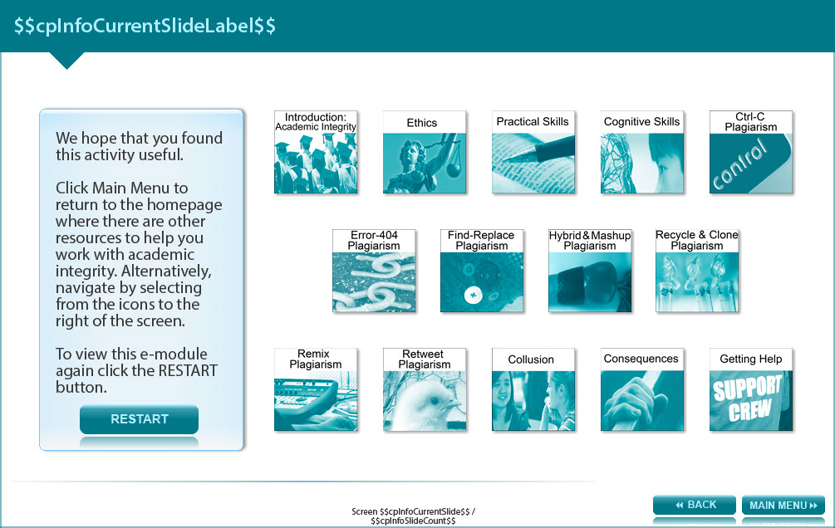

We hope that you found this activity useful.

Click the links below to view other modules in this academic integrity tutorial:

- Introduction: Academic integrity (http://www.monash.edu/rlo/research-writing-assignments/referencing-and-academic-integrity/academic-integrity/introduction)
- Ethics (http://www.monash.edu/rlo/research-writing-assignments/referencing-and-academic-integrity/academic-integrity/ethics)
- Practical skills (http://www.monash.edu/rlo/research-writing-assignments/referencing-and-academic-integrity/academic-integrity/practical-skills)
- Cognitive skills (http://www.monash.edu/rlo/research-writing-assignments/referencing-and-academic-integrity/academic-integrity/cognitive-skills)
- Ctrl-C plagiarism (http://www.monash.edu/rlo/research-writing-assignments/referencing-and-academic-integrity/academic-integrity/ctrl-c)
- Error-404 plagiarism (http://www.monash.edu/rlo/research-writing-assignments/referencing-and-academic-integrity/academic-integrity/error-404)
- Find-Replace plagiarism (http://www.monash.edu/rlo/research-writing-assignments/referencing-and-academic-integrity/academic-integrity/find-and-replace)
- Hybrid & Mashup plagiarism (http://www.monash.edu/rlo/research-writing-assignments/referencing-and-academic-integrity/academic-integrity/hybrid-mashup)
- Recycle & Clone plagiarism (http://www.monash.edu/rlo/research-writing-assignments/referencing-and-academic-integrity/academic-integrity/recycle-and-clone)
- Remix plagiarism (http://www.monash.edu/rlo/research-writing-assignments/referencing-and-academic-integrity/academic-integrity/remix)
- Retweet plagiarism (http://www.monash.edu/rlo/research-writing-assignments/referencing-and-academic-integrity/academic-integrity/retweet)
- Collusion (http://www.monash.edu/rlo/research-writing-assignments/referencing-and-academic-integrity/academic-integrity/collusion)
- Consequences (http://www.monash.edu/rlo/research-writing-assignments/referencing-and-academic-integrity/academic-integrity/consequences)
- Getting help (http://www.monash.edu/rlo/research-writing-assignments/referencing-and-academic-integrity/academic-integrity/getting-help)

