**Renal diseases in elderly population**

* Dr I G Rajiva

*“Age is an issue of mind over matter. If you don’t mind, it doesn’t matter.”*

*Mark Twain*

In the last few decades because of improved lifestyle and healthcare facilities our lifespan is improving, and we are living longer. Because of this and negative population growth-rate the elderly population (> 65 years) is increasing steadily. The elderly population was 382 million in 1980 and increased to 962 million in 2017. By 2050 elderly are likely to represent nearly 2.1 billon of total population worldwide surpassing the total children and adolescent population. In North America and Europe currently 20% of population is elderly and increase in numbers is expected to be much more significant in developed countries and by 2050, in these countries elderly population is projected to account for >35% of the total population.

India is relatively a younger country with nearly 60% of population is <35-year-old as per population census of 2020 and elderly represents 12% of total population. It is projected that by 2050, Indian population will be expected to reach 1.65 billion and 20% of Indian population will be elderly. With improvement of healthcare facilities, the life expectancy at birth in India is steadily increasing and currently it is 70.4 years.

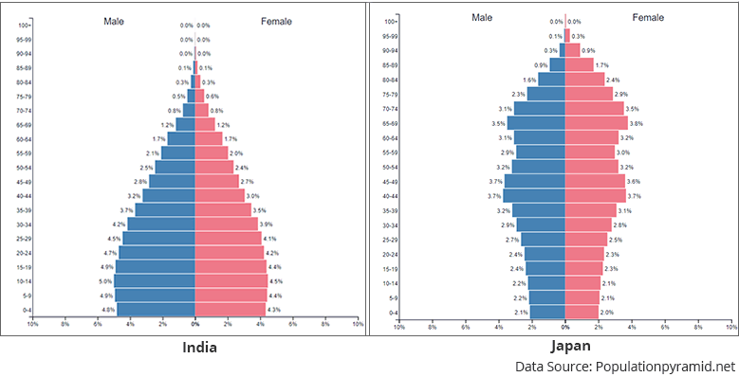 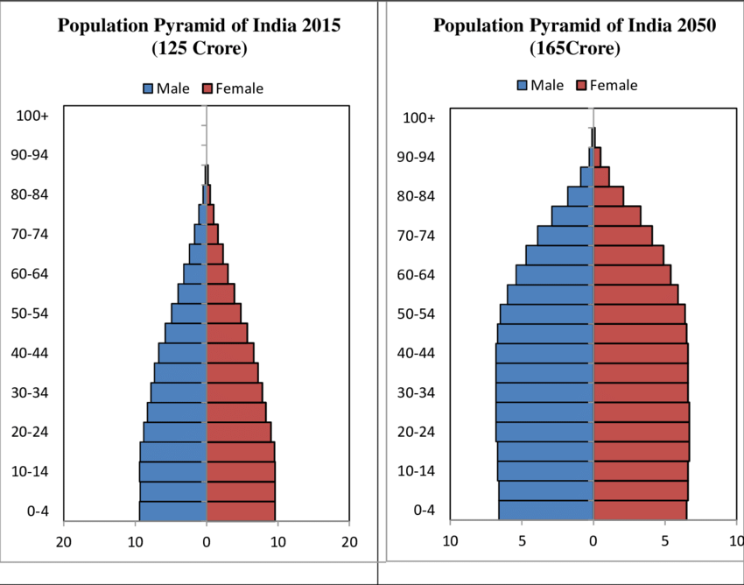

**Epidemiology of Kidney diseases:**

Most of the developed countries maintain a registry of Kidney diseases and will be able to project the numbers and prognosis based on registry data. India poses a different challenge with regards to kidney health as there is no dedicated registry database. As per one of the report the mortality secondary to Kidney diseases in India doubled from 0.59 million in 1990 to 1.18 million in 2016.

**Our Kidneys:**

Kidneys perform some of most vital functions in the body which includes removing toxic waste products generated from food and metabolic functions, control of fluid status and Blood pressure.

Kidneys work in harmony with other organs like heart, brain and liver. On average 20% of blood passes through kidney every minute and approximately 180 litres of blood is filtered each day (Glomerular Filtration Rate (GFR): approximately 120ml per min per 1.73m2 body surface area). Kidneys maintain a fine balance of fluid status and eventually our kidneys reabsorb nearly 99% of filtered water and electrolytes and we excrete 1-2 litre of urine per day (approximately 1ml/kg/hour) to remove most of the unwanted waste products.

Kidney function can be assessed by blood tests and ultrasound examination and Kidney disease is staged based on the GFR a mathematical formula based on the blood test for age specified criteria.

**Age related decline of Kidney function.**

As we get older our kidneys get old too and are partly influenced by the health of other organs, especially of the heart. Kidney function slowly reduces after the age of 40 years even in otherwise healthy adult and rate of decline is approximately 1% per year. So by the age of 65 already 25% of kidney function is lost and still person remains asymptomatic.

**Chronic Kidney disease:**

Chronic Kidney disease is a longstanding Kidney condition where kidney function deteriorates progressively and continuously with no signs of recovery.

Risk of kidney diseases increase significantly in elderly population. On average approximately 50% of people >75 years old have evidence of Chronic Kidney disease. Long standing health conditions like Diabetes and Hypertension affect kidney adversely and the kidneys function deteriorates. Other causes of Chronic Kidney disease include obstructive nephropathy (obstruction of urine passage), some medications use (commonly over the counter prescription of painkillers) and Urinary tract Infections to name a few.

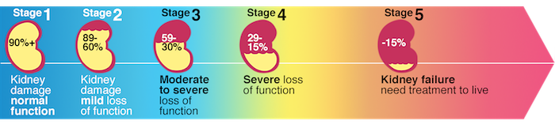

The Kidney has a great reserve and majority of patients do not manifest any symptoms of Kidney disease till very late stage of kidney damage and only evidence of kidney damage will be in form of blood test abnormalities and changes in kidney appearance in ultrasound examination.

**Symptoms at later stages of kidney disease includes**

1. Oedema (swelling of face and legs especially in early mornings),
2. Breathing difficulty (initially at exertion and progressed to breathless at lesser activity and at rest)
3. Weight gain
4. Extreme tiredness
5. Pallor (secondary to anaemia)
6. Poor appetite and weight loss
7. Nausea and vomiting
8. Itching and black pigmentation of skin.

Kidney failure can increase risk of uncontrolled blood pressure, Anaemia (lack of red blood) and bony abnormalities and these complications will need to be treated appropriately under the care of a specialist Nephrologist. When kidneys completely fail the accumulation of waste materials in the body can lead to heart failure, confusion or coma and in extreme cases can lead to patients death.

When kidneys fail completely doctors do recommend artificial means of removal of waste and water and this process is called as **Kidney Replacement Therapy**.

1. **Dialysis**: This can be performed either by blood purification (Haemodialysis) and Abdominal fluid purification (Peritoneal Dialysis)
2. **Kidney Transplantation**: (Process of healthy Kidney implantation from relative or cadaver donor): In select number of patients who are otherwise healthy and fit in absence of any other significant medical illness. The donated kidney performs all the functions of Kidney and patient can remain free of dialysis. Patient needs to take regular medications to prevent loss or damage to donated kidney.

**Diabetes Mellitus and Kidney disease.**

Diabetes Mellitus (DM) needs a special mention here. Diabetes mellitus is the commonest cause of kidney disease worldwide. This condition is usually progressive and leads to permanent kidney damage. Diabetes is associated with faster decline in kidney function compared to other conditions. Diabetes induced Kidney disease accounts for nearly 40% of patients on dialysis worldwide.

Diabetes also is associated with high blood pressure, risk of obesity, high cholesterol and leads to complications like heart disease, stroke and paralysis and infections to name a few.

The incidence of Diabetes is increasing in alarming numbers worldwide. Globally by 2019 Diabetes was prevalent in 9.3% of population and the numbers are expected to increase to 10.2% in 2030 and 10.9% in 2045. Diabetes is more prevalent in elderly and currently 19.5% of people of age group 65-79 years are diagnosed to have diabetes.

As per health statistics of 2019 India accounts for more than 77 million patients with diabetes and it is projected that by 2045 numbers are likely to double up to nearly 134 million. Nearly half of patients with Diabetes are not aware of their diabetes. Diabetes Mellitus (DM) is the most common cause of chronic kidney disease worldwide and India is no exception.

**Urinary Tract Infections**

Urinary Tract infections are fairly common as we age and its slightly more common in females compared to males. Usually patient will present with symptoms of burning urination, blood in urine and frequent urination. Some patients with severe urinary tract infections also present with fever and chills, pain over kidney site and in very severe cases with hypotension (low BP), confusion or coma. This condition is diagnosed by urine analysis and will need to be treated with appropriate antibiotics. Sometimes patient needs to be admitted to hospital for injectable antibiotics.

**Kidney stones:**

Kidney stones are also fairly common occurrence in elderly population and usually associated with dehydration and some types of diets like increased milk product or meat-based diet.

Patients present with history of pain over kidney site which is sometimes unbearable, blood in urine and difficulty to pass urine. Patient are usually very symptomatic and invariably need admission for control of pain and treatment.

Treatment will be in form of intravenous hydration and pain medications and many times the patient will be able to pass stones via urine. Rarely a patient may need a surgical treatment to remove the impacted stone. This condition can recur in later stage and the preventive measures include increased fluid intake to prevent dehydration and frequent micturition. Recurrent episodes of kidney stones is a risk factor for urinary tract infections or eventual Kidney failure.

**Prostate abnormalities**

Prostate is an organ in Males, is situated at the outlet of urinary bladder and its main function is to store the sperms in young adults. Due to hormone changes in late adulthood prostate increases in size and may obstruct urine flow. This condition is called as **Benign Prostatic Hypertrophy**. Patients present with difficulty to pass urine and frequent urination, will require clinical examination, blood test, ultrasound examination and biopsy of prostate to confirm the diagnosis. This condition needs to be treated with medications and sometimes operation to remove the prostate.

To risk of **Prostate cancer** increases with age the patients present with complaints similar to patients with Benign Prostatic Hypertrophy. Diagnostic investigations include clinical examination, blood tests, radiology and biopsy of prostate. This condition is more serious and will need to be addressed as a matter of urgency. Treatment of prostate cancer includes operation and anti-cancer medications.

**Preventive measures:**

Kidney disease is usually progressive, and requires preventive measures and control of the longstanding conditions to control progression of kidney disease.

1. Control of Diabetes and Hypertension. Aim for Blood sugar to as near to normal as possible (100-140) and Blood pressure below 130/75mm Hg.
2. Drink plenty of water, up to 2 litres (8 glasses) per day to avoid dehydration and reduce risk of Urinary tract infection or kidney stones.
3. Regular moderate exercises.
4. Healthy balanced diet.
5. Avoid smoking, alcohol in moderation and avoid use of over the counter use of medications.
6. Regular health check-up, Urine and blood tests at-least annually and medical examination.

Some of the warning symptoms which warrant early referral to physician or Kidney specialist.

1. Blood in urine.
2. Frothy urine.
3. Symptoms of pain while passing urine, pain over kidney site or over the lower part of abdomen.
4. Frequent urination and frequent night urination.
5. Difficulty to pass urine and sensation of incomplete urination.
6. Reduced amount of urine.
7. Fever and any of the above symptoms.

And to remember healthy lifestyle and regular health checkup can ensure disease free and comfortable life.

**Author**

Dr Rajiva Ibakkanavar

MBBS MD MRCP(UK) MRCP Renal Medicine

Consultant Nephrologist

Tan Tock Seng Hospital

11, Jalan Tan Tock Seng

Singapore 308433

Singapore

rajiva_ig@yahoo.co.in