**Oral Health and Hygiene**

* Dr Shruthi S Fasalkar

**Introduction**

Aging can be defined as a progressive and generalized impairment decline of function. It can be general or related to oral health. We shall discuss some of the oral changes seen with ageing, symptoms experienced due to these changes when to consult your Dentist.

The oral cavity (mouth) is made up of three main organs

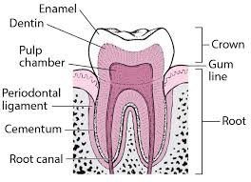

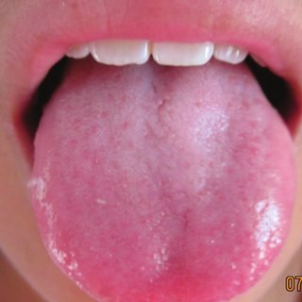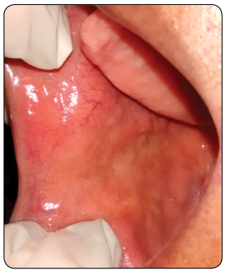

**Teeth Tongue Oral mucosa (lining of mouth)**

**Common changes in (Teeth) with ageing**

As age progresses everyday wear and tear damages the tooth layers. The outermost layer of the tooth that is Enamel chips out due to which individual can observe a change in the shape of the teeth, that is the biting surface of the teeth becomes flat and the color of the teeth becomes yellow and the patient experience sensitivity (shocking feeling in the tooth) while having cold and sour food items. If the damage to the teeth is more, then the patient may experience pain. When patient observes any of the above changes and experiences any of these symptoms they should report to the Dentist.

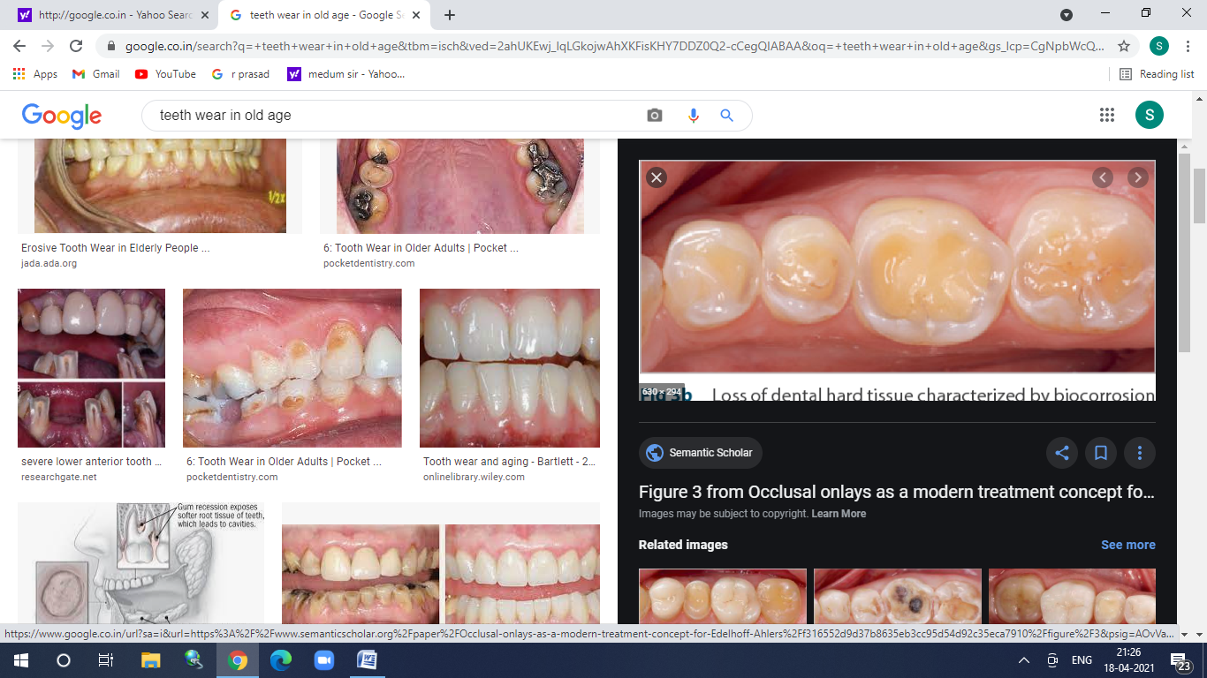

**Tooth wear**

Treatment for this depends on the degree of damage to the teeth if the damage is minimal then a normal filling is done to the damaged tooth. If the damage of tooth structure is more, then the patient is advised Root canal treatment. It is done under local anesthesia where the Dentist cleans the third layer of the tooth that is called pulp and fill the pulp canal with a filling material and fix a cap over the treated tooth. As elderly patients can’t keep their mouth open for longer time, Dentist may do it two or three appointments to complete the treatment to avoid discomfort to patients. The patient is advised to wear a night guard (flexible plastic material) that covers all the teeth, to prevent further damage to the teeth particularly for those having habit of grinding their teeth at night.

A white chalky material called (plaque) gets deposited continuously around the teeth or in between teeth and gums it is formed with the continuous deposition of a thin layer of food particles along with some content from saliva. It contains germs which slowly damages the gums around the tooth and makes the gums red, swollen and could bleed while brushing teeth. As the gums become infected it slowly detaches from teeth and moves down which further damages the jaw bone that supports the tooth due to which the tooth becomes loose and may fall. When patient observes this chalky white deposit with red swollen gums and bleeding while brushing, they should visit the Dentist and get the teeth cleaned which is not a painful procedure. Depending on the deposits on the teeth the number of appointments is fixed. After the cleaning procedure Dentist advises the proper brushing technique, flossing, type of brush to be used, and may prescribe the mouth wash. Every individual should get their teeth cleaned approximately once in 3 months to make teeth strong. It is a myth that some people have, that teeth will become loose if you get frequent teeth cleaning procedure.

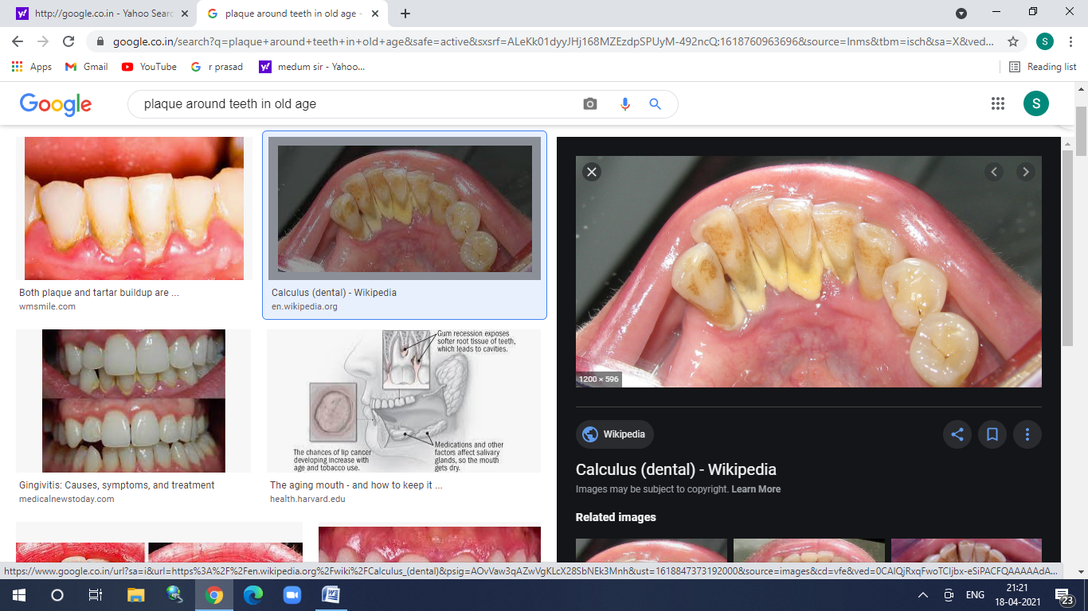

**Plaque deposit around teeth**

Root Caries (decay on root surface) root surface is that part of the tooth that is inside the jaw bone. Root Caries is more common in older people as gums move down it gets detached from the tooth and exposes the root surface. Food particles get deposited to the root surface and due to improper cleaning germs multiply and lead to root caries. When the patient observes brownish-black discoloration with a rough irregular surface on the tooth and experiences sensitivity or pain. Patients should report to the Dentist if they observe these changes.

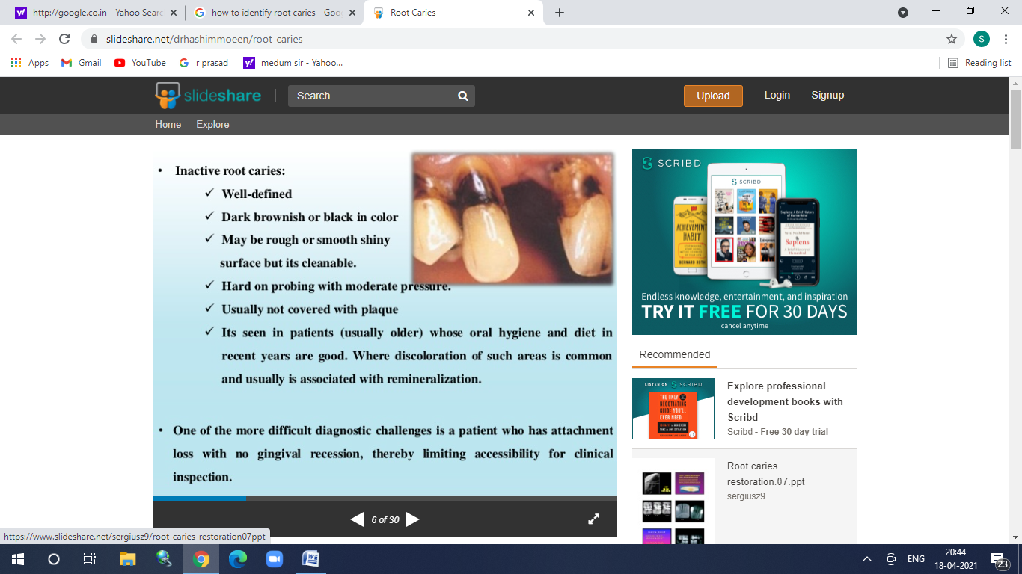

**Root caries**

Treatment depends on the extent of the tooth decay; if it's minimal then filling is done and if it is deep then Root canal treatment is advised.

**Changes observed in tongue with ageing**

A healthy normal tongue appears to be thin, pink, with a very thin white coating on it, and is usually wet. As the age progresses the tongue becomes dry, with a thick white coating on the tongue, taste alteration, and difficulty in swallowing. Sometimes tongue appears to be bald with reduced taste buds on the tongue due to deficiency of Vitamin B12, poor diet due to inability to chew the food due to loss of teeth. These changes can be related to aging which is normal or related to the medicines which they take regularly example medicines for BP, psychiatric issues, and many others. If a person is diabetic these changes are observed as there is reduced saliva flow. The patient should see their Dentist if any of the above changes observed. Even though these changes are natural with age, the Dentist may advise you to drink at least 3 litres of water per day considering your general health, and to chew sugarless chewing gums. If it is too dry then they may advise medication to increase the flow of saliva.

Alteration in taste is usually associated with regular use of BP medication, so consult your physician regarding the change of medicine. The Dentist may advise multi-vitamin tablets if there is any deficiency due to a poor diet. If white quoting on the tongue is thick then the Dentist advises and trains you on how to use a brush or the tongue scraper to clean the tongue.

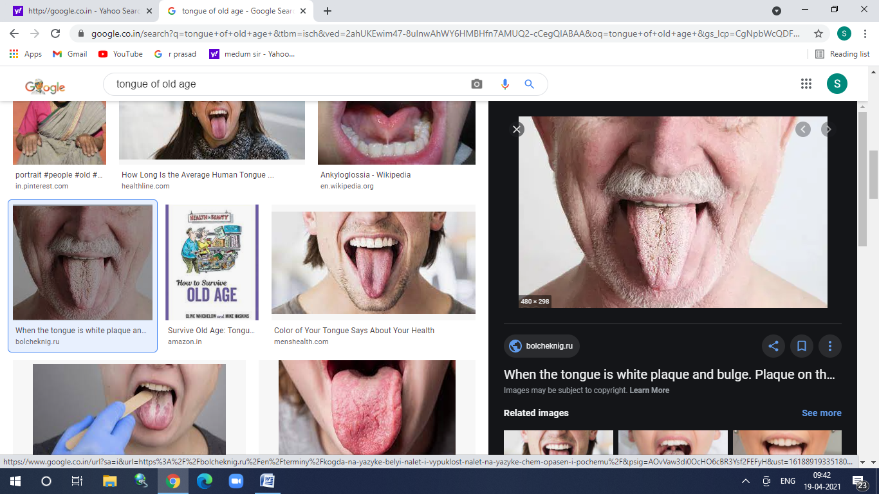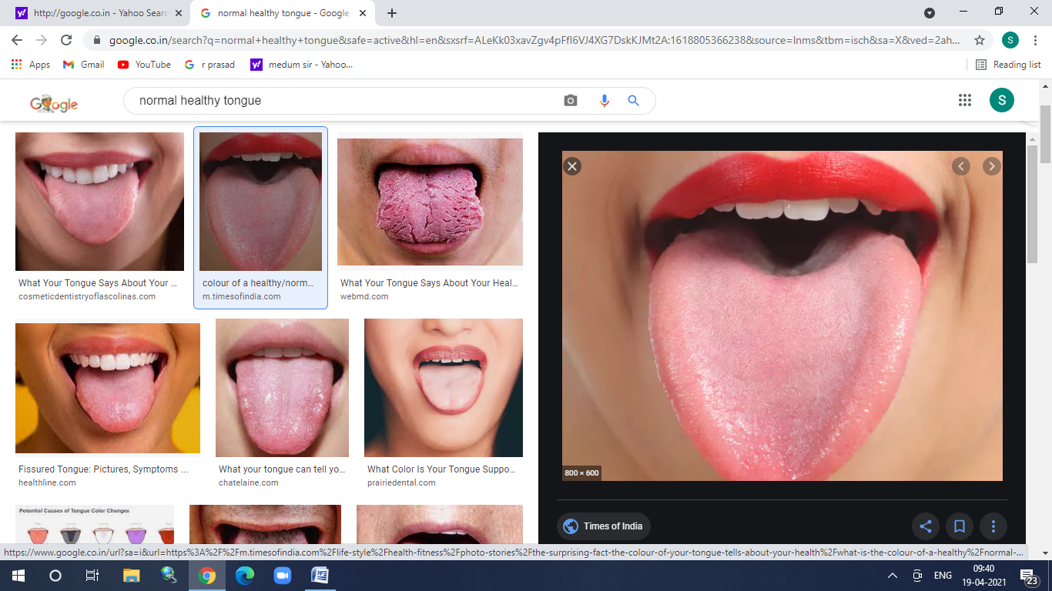

**Tongue of young adult Tongue of elderly**

**Changes observed in Oral mucosa (lining of the mouth) with ageing**

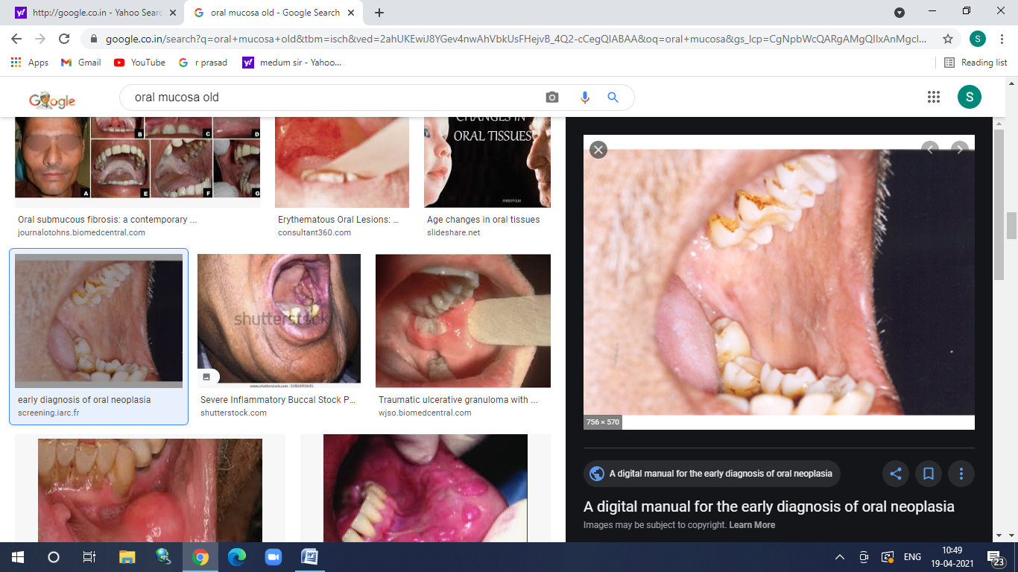

**Oral mucosa**

Due to ageing oral mucosa becomes thin, fragile, losses its elasticity (difficulty in opening the mouth), dry, and the patient experience a burning sensation in the mouth. These changes may be due to ageing, systemic disease like diabetes, intake of BP medication, improper nutritive diet, bad habits like smoking, chewing tobacco, alcohol. Also, in females when they are nearing menopause or post-menopause, due to reduced estrogen hormone which reduces saliva flow in the mouth that leads to dry mouth, thinning of lining of mouth (mucosa) and is associated with a burning sensation. When the patient observes any of these changes report to your Dentist. Dentists advise to sip water regularly, try sugarless drink, or suck ice chips, stop consumption of tobacco, alcohol, stop consumption of spicy food, If dryness is more then they advise medication to increase saliva flow. If dryness is related to menopause or post-menopause then the patient is advised Hormonal Replacement Therapy under the instruction of a gynecologist. If the burning sensation is more, then they advise an anesthetic mouth rinse to reduce the burning sensation.

**Miscellaneous**

- Due to the destruction of tooth structure, the tooth may become sharp and injure and damage oral mucosa causing (traumatic ulcers) or it may be caused due to ill-fitting dentures. When patient observes ulcer, experience pain, unable to eat hot spicy food then report to the Dentist.

- Oral cancer is unfortunately second most common cancer in India, and may be due to habits such as smoking, chewing tobacco, and consumption of alcohol. Older people are more prone to oral cancer due to less immunity. When the patient feel or see any lump, ulcer, red or white patch, difficulty in opening mouth, report to the Dentist early. Initially, it is painless but later it's very painful, patient cannot eat, speak so better to avoid such habits.

- Loss of teeth is more common in old age. In females when they attain menopause or post-menopause due to lower levels of estrogen hormone and calcium there is bone loss due to which they may lose their teeth. In males, habits such as smoking, alcohol leads to bone loss, and in turn, they may lose their teeth. In general uncontrolled diabetes, poor oral hygiene leads to bone loss and loss their teeth.

**Suggestions**

- Visit your Dentist once in 3 months

- Brush twice daily, use the brush as advised by your Dentist

- Floss daily so that it prevents root caries

- Use fluoridated toothpaste to prevent tooth decay

- Get your teeth cleaned every three months to prevent gum bleeding, loss of teeth and root caries

- Use a tongue scraper to clean your tongue which is suggested by the Dentist considering your age

- Rinse your mouth regularly

- In case of ulcers if it does not heal within 15 days then visit the Dentist

- Replace your missing teeth with a Prosthodontic appliance (artificial teeth)

- Clean your prosthodontic appliance daily with soap which is used to take bath. Place the appliance in water at night before going to bed

- If the teeth are sharp and irritate buccal mucosa (lining of the mouth) is it your dentist and get the sharp tooth smoothened or get it removed as this irritation from the sharp tooth may lead to oral cancer.

- Avoid smoking, usage of tobacco, and alcohol as these may make jaw bones weak and lead to tooth loss or may cause oral cancer

- Menopausal women and post-menopausal women are advised to visit the dentist and get the radiograph done as it suggests the bone density (bone thickness).

- Menopausal and post-menopausal women are advised to take Calcium supplements.

- If you are diabetic keep it under control, take medications regularly as diabetes may cause dry mouth, bone loss, and fungal infection

(candidiasis)

- Inform the Dentist if you have BP, diabetes, heart problem, or under any of the medication as this information helps the dentist to modify the treatment plan.

- If you are unfortunately diagnosed with Cancer and have advised radiation therapy, visit your Dentist before radiation therapy and get the emergency oral treatment before 2 to 3 weeks.

- Caregivers of the elderly persons need training in Oral Health and Hygiene

**Author:**

Dr Shruthi S Fasalkar,

BDS, MDS (Oral Med. & Rad.)

Oral Health care Dental Clinic,

RR layout, Nagadevanahalli,

Bangalore 560056

shruthijayant@gmail.com