Hearing Health in elderly
Dr S P Goswami, Chaitra V & Khyathi G Jain
Hearing is one of the important senses in humans, which paves way for effortless communication with others without us even realizing about it. Hearing sensitivity is influenced by either several factors, which can be individual specific (such as genetic factors, lifestyle habits, etc.), or environmental factors (such as exposure to loud noise).
Over 65% of adults above 60 year’s experience hearing loss: WHO
Hearing loss is the inability to hear, either partially or completely. It can be either acquired or by birth. While some types of hearing problems, such as infections, may be treatable (hearing can often return to normal), others types are more permanent in nature and cannot be reversed, such as age-related hearing loss.
Hearing loss in elderly (known as Presbycusis) is not an uncommon issue. Our hearing system is subjected to changes due to ageing like any other body part. These changes occur gradually over time, making it progressively difficult for the elderly person to hear clearly. Pre-existing conditions such as chronic ear infections, diabetes, and/or intake of ototoxic drugs (medications which particularly affect the ear) etc., might aggravate the age-related hearing loss.
How does age affect one’s hearing ability?
As we age, our auditory system undergoes many physical and functional changes. It could be as simple as the skin of the ear canal becoming loose and drooping, or more complex changes such as the deterioration (or even death) of the tiny and sensitive hair cells inside the inner ear. Deteriorations also happen at higher and central levels of the auditory system such as the nerves, which connect, to the brain. A particularly worrying aspect of the age-related hearing loss is the slow nature of the progression. This slow progression can also lead to a person suffer from dementia and is placed at high risk for it. Every 7th person who suffers from hearing loss is diagnosed with dementia i.e., memory loss. Thus, adding to co-morbidity in terms of negative outcomes such as poor quality of life and high caregiver burden.
Because of this slow progression, people often do not visit an audiologist (a qualified hearing professional) until the degree of the loss is already substantial.

How do I know if I have hearing problem?
Presbycusis can start as early as 40 years of age and slowly progress over the period. As mentioned before, the early stages of this hearing problem often go unnoticed. Therefore, awareness regarding this issue is of utmost importance so that early intervention can take place. Below mentioned are the signs and symptoms one might look out for:
- Difficulty understanding speech in presence of noise (e.g. in restaurants or function halls).
- Speech sounds muffled (you might hear them speak but do not understand them).
- Understanding someone from a distance is more difficult than before
- Possible presence of tinnitus (ringing, roaring or hissing kind of sound in the ear).
- Tendency to increase the volume of TV or radio often.
- Doorbells, bird chirping or telephone rings are not as audible.
- Difficulty in hearing a Child’s voice.
- Male’s Voice is much easier to understand compared to female voice.
- You tend to ask others to repeat what they told often.

-You tend to others to repeat what they told often
What next?
Once you have noticed that you are facing challenge with one or more of the above-mentioned scenarios, it is pertinent to consult a hearing health care professional for a detailed evaluation of your hearing. Audiological services can be obtained either in a private clinic or at government institutions. Once the severity and nature of the problem is ascertained, appropriate treatment will be suggested, which in case of age related hearing loss is usually hearing aids. Hearing aids, explained in the simplest terms, are electronic devices that amplify the sounds in order to compensate for the reduced hearing sensitivity. Hearing aids differ with respect to styles or features they incorporate. Depending on the type and severity of your problem, your audiologist will suggest the most appropriate hearing aid, which will help with your everyday listening needs.
Unaddressed hearing loss:
While being aware of the issue is the first and foremost important step, seeking immediate help is just as important. It has been a tendency of the people to wait till the problem gets worse and consult an audiologist only when their problem is substantial. Some tend to just live with it. A major issue with late consultation is that the individual is likely to receive minimal benefits with the hearing aid when the hearing loss reaches severe degree. Such minimal benefits from hearing aids not only limit the individual’s ability to communicate effectively with others, it also reduces the motivation to use the device for a sustained period. Additionally, untreated hearing loss can also lead to a variety of social, emotional and psychological issues, which not only affects the quality of your life but also of your loved ones.
Effects of hearing problem:
- Balancing problems leading to frequent falls
- Dementia
- Frustration
- Anxiety
- Low self confidence
- Depression
- Isolation

The cost of untreated hearing loss is higher than one might expect. It is, therefore, important get your hearing tested routinely just like you get your test sugar level tested. It is advised to get your hearing evaluated at least once a year once you hit your 40s, once in every six months if the loss is already detected in order to track the progress and get the hearing aid fine-tuned accordingly if necessary.
The audiologist and speech language pathologist are the right professional to approach as your one stop solution for all the problems that may occur for your hearing and communication problems.
TEAM APPROACH
Ageing in some individuals is the period when we face many health problems. It is important to connect to various professionals at right time for effective services for a better quality of life. Team members may either see the patient together or make joint recommendations or may participate as individual consultants. When participating as an individual, the team member who sees the patient initially will refer to other members of the team for assessment as needed. The various team members involved will include

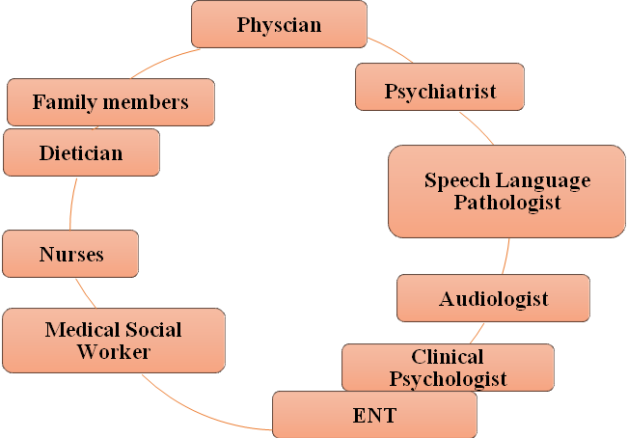

Key responsibilities of multidisciplinary care team
- Identify patients with potential problem.
- Perform an evaluation and make appropriate referrals.
- Future recommendations and management of the problem for the patient.
- Improve or prevent deterioration of the problem.
- Prevent other ageing related sequelae.
- Educate patients, care givers, and other health care providers.

GUIDE FOR ACTIVE HEALTHY HEARING DURING AGING

Aging is inevitable and everyone has to go through this phase. However, it can be made healthier by having an active hearing which facilitates social, emotional, financial and physical well-being. Given below are few tips for hearing to follow for a happy effective ageing.
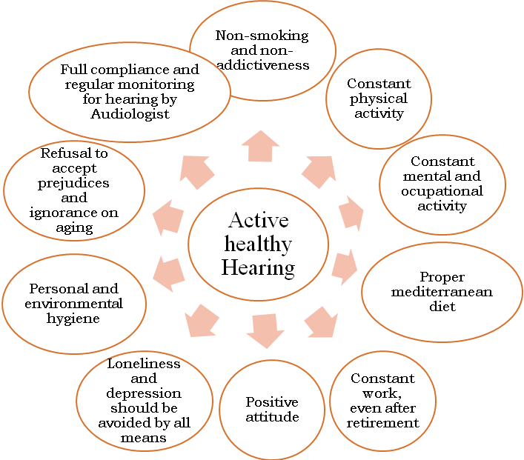

Corresponding Author:
Dr SP Goswami, PhD ( Sp. & Hg.)
Professor of Speech Pathology & Head
Department of Speech-Language Pathology
All India Institute of Speech and Hearing
Manasagangothri, Mysore-570006
Email: goswami16@gmail.com

