**Skin Ageing; Grace versus Deferment**

* Dr B S Chandrashekar & Dr Seema Manjunath*

**Introduction**

India’s ageing population is rising with increased longevity meant more older people around. Hence there is increased social pressure to look younger and to preserve youthfulness. Ageing is a multifactorial degenerative process with environmental influences which involves skin and its supportive structures like bone cartilage and subcutaneous compartments. Some changes like wrinkles, brown pigments and sagging are not acceptable to many people. However, efforts are made to look younger has led to great demand for effective cosmetic treatments for skin and facial rejuvenation.

**Causes of Ageing:**

It is the most exposed part of our body hence it is more vulnerable and noticeable. As face is the focal point of human beauty, the signs of ageing are first noticed on face. The overall thickness of skin decreases at about 6% per decade, decreasing faster in women than in men. This phenomenon occurs in all layers of the skin. It is most pronounced in exposed areas, such as the face, neck, upper part of the chest and the extensor/outer surface of the hands and forearms. In addition to the skin, underlying soft tissue and bone undergo changes leading to change in facial and body contour.

Our skin ages due to various internal and external causes. Internal causes of skin ageing are due to individual genetic make-up and cannot be altered. However, several external factors like sun exposure, pollution, xenobiotics (chemicals), smoking and unhealthy diet, can cause premature ageing of the skin. A holistic approach to lifestyle and skin care can help to reduce the visible signs of skin aging or prevent [premature skin ageing](https://int.eucerin.com/skin-concerns/aging-skin/premature-skin-ageing).

**Internal causes of skin ageing:**

Our biological age determines structural changes in the skin and the efficiency of cell functions. These slow down with each passing year.

*Cellular function:* In young skin, strong connections between the layers allow moisture and nutrients to be delivered efficiently to the visible layers. Over time these connections and systems slow down.

*Hormonal influences.* Estrogen protects skin from several contributory factors of ageing like Reactive Oxygen Species (ROS), cellular aging and DNA damage. Decreasing levels of estrogen (instruction giving hormones) result in reduced messaging between the cells.

*A poorer blood supply* to the skin means the delivery of nutrients and oxygen to the skin’s surface is impeded. The radiance that is a feature of young skin fades, and skin becomes duller.

*Genetics.*The phototype and skin type we are born with make a difference to how quickly signs of aging appear on skin’s surface.

For example: There are six skin phototypes - Indian skin falls under Phototype IV-V. This type has more melanin content and protects from accelerated aging and skin cancers. However, we are more prone to pigmentary changes.

**External causes of skin ageing**

The external factors affecting the speed with which the skin ages are all due to one process so called [oxidative stress](https://int.eucerin.com/our-research/ingredients/oxidative-stress). Oxidative stress releases molecules called Reactive oxygen species (ROS) and free radicals. These can cause premature ageing by damaging cell structures. Under normal circumstances, ROS and free radicals are neutralized by antioxidants in the skin:. However, over time, the skin’s ability to de-activate ROS decreases resulting in damage to skin cells.

Oxidative stress is triggered and accelerated by a variety of lifestyle factors:

*Sun exposure:* The Ultra violet A (UVA) from the sunlight causes imbalance between ROS and antioxidants in skin leading to damage to structure and function of skin. Skin damage caused by the sunlight is known as [photoageing](https://int.eucerin.com/skin-concerns/sun-protection/photoaging) and [uneven pigmentation](https://int.eucerin.com/skin-concerns/uneven-skin/hyperpigmentation) is often one of the first visible signs to appear.

*Pollution*

Exposure to pollution, most commonly in cities, can trigger the release of skin damaging free radicals. Pollution also worsens the effects of sun exposure accelerating [oxidative stress](https://int.eucerin.com/our-research/ingredients/oxidative-stress).

*Smoking*

The chemicals and nicotine contained in cigarettes are responsible for an upsurge in the number of free radicals in the skin causing premature ageing. It decreases hydration of skin, reduces blood flow to skin thus depletes oxygen and nutrient supply to skin. Due to decreased blood supply they also cause damage to underlying soft tissue leading to hollowing of cheeks.

*Nutrition*

Eating lots of antioxidant-rich fruits and vegetables is an important part of caring for our skin as it ages.

**Inappropriate skin care**

Skin will age more quickly if it is poorly cared for or if you use products that irritate skin. Thorough cleansing using gentle products appropriate for skin type and seasons, together with the regular application of care products targeted at skin’s primary concern, will help to care for skin. Effective sun protection is the key to preventing [premature skin ageing](https://int.eucerin.com/skin-concerns/aging-skin/premature-skin-ageing).

**Structural changes in ageing skin:**

Skin ageing takes place in every layer of the skin and shows itself on the surface.

1. **Epidermal layers**

A loss of hyaluronic acid content, slower cell turnover and reduction in sebum production on the skin’s surface makes roughness and dryness more likely. As this particular layer of the skin ages, it becomes more sensitive to the [sun’s rays](https://int.eucerin.com/about-skin/basic-skin-knowledge/sun-and-the-skin). Skin is less efficient at healing itself, and a reduced immune function can lead to an increase in skin infections together with slower wound healing.

1. **Dermal layers**

From about the age of 25, collagen, one of skin’s building blocks, decreases by 1% each year. Together with a decline in functional elastin, this leads to dermal tissue disorganization. Skin structure is compromised and [fine lines and wrinkles](https://int.eucerin.com/skin-concerns/aging-skin/wrinkles) are more likely. As our skin matures, elasticity continues to reduce and deeper [wrinkles](https://int.eucerin.com/skin-concerns/aging-skin/wrinkles) form. The production of hyaluronic acid – plentiful in youthful skin – slows down, so skin cells are less effective at binding in water and skin is prone to dryness. It also becomes weaker and more prone to damage and broken capillaries. Reduced micro-circulation means a less efficient delivery of nutrition and oxygen to the surface, which leads to a decrease in the radiance enjoyed by youthful skin.

1. **Subdermal layers**

In the deeper layers, the most notable changes are the reduction in size and number of lipid-storing cells in the adipose layer. This results in [sagging skin and a loss of volume](https://int.eucerin.com/skin-concerns/aging-skin/sagging-skin-and-loss-of-volume) and can lead to deep [wrinkles](https://int.eucerin.com/skin-concerns/aging-skin/wrinkles) and hollow temples and cheeks.

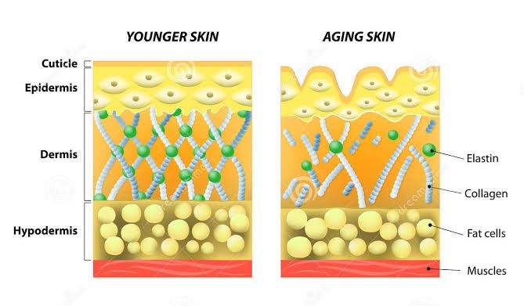

**Signs and symptoms:**

From around the age of 25 the first signs of ageing start to become apparent on the surface of the skin. Fine lines appear first followed by [wrinkles](https://int.eucerin.com/skin-concerns/aging-skin/wrinkles), [loss of volume](https://int.eucerin.com/skin-concerns/aging-skin/sagging-skin-and-loss-of-volume) and  [loss of elasticity](https://int.eucerin.com/skin-concerns/aging-skin/loss-of-elasticity) become noticeable over time. As we age, the skin thins, dries, wrinkles, and becomes unevenly pigmented. A loss of underlying fat, bone and cartilage, manifests as sagging skin and fallen nasal tips. The first signs of ageing are fine lines around eyes, mouth and forehead, greater visibility of bony landmarks, hollowing of the cheeks and perioral area and deepening nasolabial folds. This is followed by flat eyebrows, upper eyelid laxity, atrophy of lips, decent of the corners of the mouth and lower face and neck sagging. Surface changes like roughness, enlarged pores and pigmentary blemishes are also part of aging process.

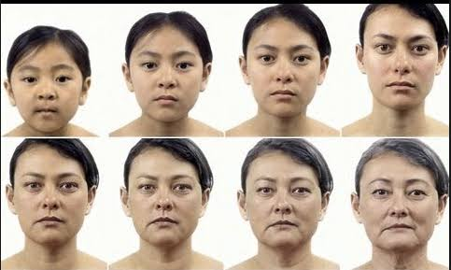

There are three main signs of skin aging and each one effects facial skin in a different way:

1. **Wrinkles**

The first noticeable signs of skin ageing are [fine lines and wrinkles](https://int.eucerin.com/skin-concerns/aging-skin/wrinkles). Small, shallow [wrinkles](https://int.eucerin.com/skin-concerns/aging-skin/wrinkles) known as laughter lines or crow´s feet tend to become noticeable at the outer corners of the eyes. These may appear around the age of 30, but we all age differently and how we age depends on our genetics and lifestyle. These fine lines are followed by wrinkles on the forehead. At first these are only visible when our skin moves as we change our facial expressions and they are known as dynamic wrinkles. As we age further they become more prominent and evolve into permanent wrinkles that are visible even when our face is static. Frowning can cause vertical lines between the brows.

1. **Loss of volume**

It can be difficult to identify a loss of volume and facial contours. The first signs of loss of volume in the lips tends to be when lipstick starts to bleed. A loss of facial volume tends to result in sagging skin, a flattening of the cheeks and the appearance of a “turkey neck”. It changes the overall appearance of the face which can look negative, sad or tired. The fold that develops between the nose and the mouth, known as the nasolabial fold, is also caused due to sagging skin and a [loss of volume](https://int.eucerin.com/skin-concerns/aging-skin/sagging-skin-and-loss-of-volume).

1. **Loss of elasticity and deep wrinkles**

As our skin matures its structure weakens and it loses elasticity and firmness. Skin also becomes drier, appears more `crepey` and loses the radiance seen in youthful skin. Again, because our skin is as individual as we are, these changes become visible at different ages but are most commonly experienced by those who are 50+.

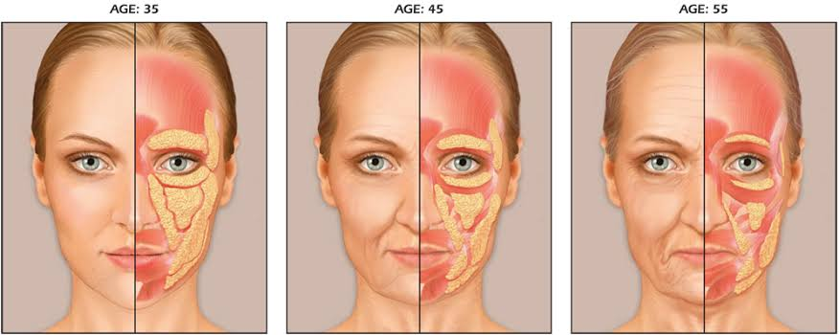

**Premature ageing:**

Premature ageing is when your skin undergoes an unnatural ageing process, such as with extreme sun exposure or living with an unhealthy lifestyle. Premature ageing manifests in earlier stages as loss of glowing complexion of skin, followed by dark eye circles, fine wrinkles around eyes, mouth, forehead and drooping skin**.**

Unnatural ageing is almost always due to poor habits as mentioned below.

1. Excessive sun exposure
2. Some medical conditions like Progeria or those taking medications that age skin.
3. Inadequate sleep
4. Rubbing and pulling the skin around their eyes can damage collagen and cause darkness and wrinkles.
5. Smoking
6. Unhealthy diet leads to weight gain, diabetes mellitus promotes premature aging of skin. Sudden weight gain or weight loss can also cause wrinkles.
7. Excessive alcohol intake interrupts the skin cell functions and cause premature aging.
8. Stressful lifestyle leads to inadequate sleep and contributes to premature aging.

**Psychosocial impact of premature ageing of skin:**

An aged appearance can have a significant psychological impact on individuals and cause sudden awareness of the stigmatization of ageing, which may manifest as amazement, despair, a disruption of sense of self and identity, or feelings of heightened vulnerability, shame, depression, a sense of diminished physical or sexual attractiveness and severe loss of self-esteem. Some of the major psychosocial factors associated with skin ageing include social anxiety, isolation, and, occasionally, a more serious emotional crisis, such as depression and may also cause discrimination at workplace.

**Graceful ageing:**

“Ageing gracefully” was being used previously for those who accept the ageing changes without undergoing any aesthetic procedures. But in today’s world, people have realized merits of aesthetic procedures which can help them maintain their youthful appearance. They can help you not only look younger, but also feel more confident.

Ageing gracefully doesn’t mean you have to wear your wrinkles with pride – instead, you need to do whatever is necessary to stride into your older years with confidence. It means taking steps to make your outside appearance look youthful and match the way you feel internally.

The following are crucial tips recommended to help in aging gracefully

1. Regular Exercise

2. Healthy diet

3. Adequate Sleep

4. Good mental health

5. Avoid alcohol and smoking

6. Adequate hydration of skin by frequent use of moisturizers.

7. Adequate use of sunscreens.

8. Regular follow-up with your dermatologist and physician.

**Management**

A holistic approach to lifestyle and skin care can help to prevent [premature skin ageing](https://int.eucerin.com/skin-concerns/aging-skin/premature-skin-ageing) and reduce the visible signs of skin ageing.

Management of ageing skin can be considered under 3 levels:

**Primary Intervention:** It involves risk factors which contribute to ageing as below;

1. Adequate use of proper sunscreen, moisturizers
2. Avoid extrinsic factors like sun exposure and environmental pollutants
3. Avoid Stress
4. Avoid excess of alcohol
5. Lifestyle:As [oxidative stress](https://int.eucerin.com/our-research/ingredients/oxidative-stress)is the primary external cause of skin ageing, lifestyle changes should focus on minimizing its effects.
6. Nutrition: A healthy diet, rich in fruits and vegetables, will ensure an intake of antioxidants that can help to limit the damaging effects of free radicals on the skin. Some foods are known to be particularly high in antioxidants and might even have a skin protecting effect like: carrots, apricots, other orange and yellow fruit and vegetables, blueberries, leafy green vegetables, bell peppers, tomatoes, beans and other pulses, oily fish (such as salmon) and nuts.
7. Smoking: Smoking accelerates aging remarkably, reducing elasticity and causing dullness. Stopping smoking will help to improve skin’s appearance.

**Skin care**

A good skin care routine is an essential part of a holistic approach to treating all signs of aging: wrinkles, loss of volume, loss of elasticity and related conditions such as age induced dryness or sensitive aging skin.

A [basic skincare routine](https://int.eucerin.com/about-skin/skin-treatment/daily-routine-for-face)should consist of three steps: cleanse, care and sun protection.

* **Cleanse** to remove make-up, dirt and chemicals from the skin. This is vital, as chemicals on the surface as a result of pollution can trigger [oxidative stress](https://int.eucerin.com/our-research/ingredients/oxidative-stress). Recommended cleansers according to season, help skin to breathe better.
* **Care**: Creams containing Hyaluronic acid, ceramides, Glycolic acid and fruit extracts can be used to replenish and hydrate skin that address your primary ageing concern.
* **Protect**: Protecting skin from the [sun’s rays](https://int.eucerin.com/about-skin/basic-skin-knowledge/sun-and-the-skin), even on cloudy days, is the most important step in preventing [premature skin ageing](https://int.eucerin.com/skin-concerns/aging-skin/premature-skin-ageing). Choose a [day cream that includes an SPF](https://int.eucerin.com/products/hyaluron-filler/day-cream-spf-30-all%20skin-types) and protects your skin from the sun or, for more intense exposure, use a dedicated [sun protection product](https://int.eucerin.com/products/sun-protection).
* **Creams with colour pigments** can also be used to even the skin tone and correct your complexion. Choose a tinted calamine containing lotions that evens skin tones for a radiant complexion

**Secondary intervention:** It involves early detection and treatment to prevent or reduce changes in the aging skin. It involves various medical therapies.

**Tertiary intervention:** It involves both medical and surgical therapy.

Successful rejuvenation of face requires proper scaling of age related counter changes (bony prominences and soft tissue changes) and textural changes (superficial and deep wrinkles, pigmentary changes and loss of skin elasticity). Based on above changes dermatologist can offer individualised treatment plan to give youthful and natural looking skin.

There are various treatment options ranging from Anti-ageing creams, Superﬁcial and Medium peels, Non-ablative facial rejuvenation, Laser and fractional resurfacing, Botulinum toxin type A injections, Fillers to new generations of cosmoceuticals.

The ageing process can have array of changes requiring combination of therapies.

1. Superﬁcial rejuvenation is by chemical peels, microdermabrasion and non-ablative lasers.
2. Deeper rejuvenation is by fractional lasers, non-ablative facial rejuvenation lasers, PRP, micro-needling, medium depth and deeper peels, HIFU, RF and thread lifts.
3. Soft tissue loss is treated safely and effectively by Fillers and fat transfer.
4. Botulinum toxin- not only corrects dynamic wrinkles but also counters and sculpts the face

With ageing, skin functions deteriorate and can results in palette of diseases like dryness, infectious diseases and benign, premalignant and malignant tumours that can jeopardise life which needs consultation by expert and appropriately treated.

Regular monitoring of aging skin and supervised treatment by a dermatologist is necessary along with adequate routine skin care.

*Acknowledgement*

Images have been taken from following websites.

1. <https://www.dreamstime.com/stock-illustration-younger-skin-older-skin-aging-elastin-collagen-diagram-aging-showing-decrease-collagen-image47370344>
2. <https://youtu.be/uBiAq6uO7J8>.
3. <https://grossepointedermatology.com/conditions-treatment/anatomy-of-facial-aging-2/aging-04-big/>

**Authors:**

Dr B S Chandrashekar (Founder & Chief Dermatologist)

And

(*Corresponding Author)

Dr Seema Manjunath (Consultant Dermatologist)

Cutis Academy of Cutaneous Sciences, Vijayanagar, Bangalore

Email: cutisclinic@gmail.com