JOURNAL IMPACT

Journal impact metrics attempt to quantify the importance of a particular journal in its field, usually via an algorithm that takes into account the number of articles published per year and the number of citations to articles published in that journal.  Like author impact measurements, journal impact measures have limitations. Dissatisfaction with existing metrics has contributed to the development of new metrics such that there are now quite a few. While these metrics do tell us something, researchers in a discipline will have the best sense of the top journals in their field.

**Journal Citation Reports via Web of Science**

InCites Journal Citation Reports

You can access Journal Citation Reports (JCR), a product of Thomson Reuters, via [Web of Science](http://webofknowledge.com/WOS) (look for the link JCR link at the top of the page). Published annually, JCR provides a number of journal impact measurements for journals in the sciences and social sciences. Reported metrics include Impact Factor, 5-year Impact Factor, Immediacy Index, and others. Since 2007, JCR has also included Eigenfactor Metrics.

Learn more:

* [Journal Citation Reports Training Videos and Quick Reference Cards](http://wokinfo.com/training_support/training/journal-citation-reports/)

Brief videos and information sheets - both available in multiple languages. There is also a link to live and recorded trainings.

**CiteScore journal metrics from Scopus**

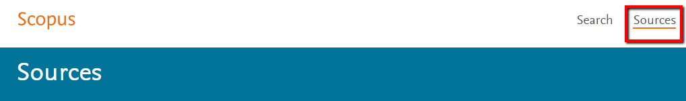

The [Sources tab](https://www.scopus.com/sources) is available via the top menu bar in Scopus. You can search for a particular journal, or browse sources alphabetically or by subject.



Available metrics are CiteScore, SJR, and SNIP.

* [Tutorial on Analyzing Journals in Scopus](http://help.elsevier.com/app/answers/detail/a_id/3704/p/8150/c/8270)

How to get information and metrics about a journal using the Browse Sources interface.

**Google Scholar Metrics**



[Google Scholar Metrics](https://scholar.google.com/intl/en/scholar/metrics.html) includes a top 100 list of journals for particular subject fields ranked using their 5-year h-index. You can look at top journals in particular subject categories and sub-categories. The underlying data come from Google Scholar. Sections on [Metrics](https://scholar.google.com/intl/en/scholar/metrics.html#metrics), [Coverage](https://scholar.google.com/intl/en/scholar/metrics.html#coverage), and [Inclusion](https://scholar.google.com/intl/en/scholar/metrics.html#inclusion)tell you more about how the rankings were derived.

**Highlights of Journal Metrics**

Journal Impact Factor

* Frequency with which the 'average article' in a journal has been cited in a particular year or other defined time period using data from [Journal Citation Reports](http://guides.lib.berkeley.edu/researchimpact/journal-impact#s-lg-box-wrapper-6500485).
* The 'classic' Impact Factor uses a 2-year citation window, but a 5-year Impact Factor is also available.
* Cannot be used to compare journals across disciplines.
* Available via Thomson Reuters InCites [Journal Citation Reports](http://guides.lib.berkeley.edu/researchimpact/journal-impact#s-lg-box-wrapper-6500485)

[Eigenfactor and Article Influence Scores](http://www.eigenfactor.org/)

* Eigenfactor: Measurement of the 'importance' or 'influence' of a journal. Citations from high-quality journals are weighted more than citations from lesser known journals.
* Article Influence: Calculated by dividing the Eigenfactor by the number of articles published in the journal.
* Both scores use a 5-year citation window, use data from [Journal Citation Reports](http://guides.lib.berkeley.edu/researchimpact/journal-impact#s-lg-box-wrapper-6500485), and are meant to adjust for citation differences across disciplines, since different disciplines have different standards for citation and different time scales on which citations occur.
* [FAQs about Eigenfactor and Article Influence Scores](http://www.eigenfactor.org/faq.php).
* Available on [Eigenfactor website](http://www.eigenfactor.org/" \t "_blank), or via [Journal Citation Reports](http://guides.lib.berkeley.edu/researchimpact/journal-impact#s-lg-box-wrapper-6500485).

[CiteScore](http://help.elsevier.com/app/answers/detail/a_id/5221/p/8150)

* Uses data from [Scopus](https://www.scopus.com/), with a 3-year citation window.
* CiteScore calculates the average number of citations received in a calendar year by all items published in that journal in the preceding three years. See [CiteScore FAQs](http://supportcontent.elsevier.com/RightNow%20Next%20Gen/Scopus/Files/5221_CiteScore_FAQ.pdf" \t "_blank) to learn more.
* Cannot be used to compare journals across disciplines.
* Available via [Scopus](https://www.scopus.com/sources).

[SJR (SCImago Journal Rank)](http://www.scimagojr.com/)

* Uses data from [Scopus](https://www.scopus.com/), with a 3-year citation window.
* Weighted by the prestige of a journal. Subject field, quality, and reputation of the journal have a direct effect on the value of a citation. SJR also normalizes for differences in citation behavior between subject fields.
* Available on [SCImago Journal and Country Rank website](http://www.scimagojr.com/" \t "_blank), or via [Scopus](https://help.elsevier.com/app/answers/detail/a_id/2899/p/8150).

[SNIP (Source Normalized Impact per Paper)](http://www.journalindicators.com/)

* Uses data from [Scopus](https://www.scopus.com/), with a 3-year citation window.
* Weights citations based on the total number of citations in a given field (subject), which allows you to compare journals across subjects.
* Available on [CWTS Journal Indicators website](http://www.journalindicators.com/), or via [Scopus](https://help.elsevier.com/app/answers/detail/a_id/2900/p/8150).

h-index

* The largest number *h* such that at least *h* articles in that publication were cited at least *h* times each. For example, a publication with five articles cited by, respectively, 17, 9, 6, 3, and 2, has an h-index of 3.
* [Google Scholar Metrics](https://scholar.google.com/intl/en/scholar/metrics.html) uses the h5-index, which is the h-index for articles published in the last 5 complete years

AUTHOR IMPACT

**Measuring Author Impact**

An author's impact on their field or discipline has traditionally been measured using the number of academic publications he or she has authored and the number of times these publications are cited by other researchers.  Thus, a simple way to demonstrate your impact is to create a comprehensive list of your publications and the number of times they have been cited.

Different algorithms have been created that calculate an author impact 'score' using data on their publications. Below are a few metrics you may encounter:

* h-Index (the most widely used)

A measure of the cumulative impact of a researcher's publications that attempts to measure both quantity (number of publications) and quality (number of citations).  
The h-index is the number of papers (h) that have received h or more citations. An h-index of 3 means that an author has 3 papers that have each received at least 3 citations.  
While the h-index is widely used, it has many critics - a common criticism is that it is not an accurate measure for early-career researchers.  
Variations on the h-index have been developed that attempt to address its limitations.

* [g-index](http://link.springer.com/article/10.1007%2Fs11192-006-0144-7)

Proposed in 2006 as an alternative to the h-index, the g-index attempts to give more weight to highly-cited papers. The g-index remains controversial and is not yet widely accepted.

* i10-index

Used only in Google Scholar, this simple index, introduced in 2011, counts the number of publications with at least 10 citations.

Remember that while citation metrics such as author impact measurements provide some representation of the impact of research in a field, they have limitations and should be used with care.

* [Four great reasons to stop caring so much about the h-index](http://blog.impactstory.org/four-great-reasons-to-stop-caring-so-much-about-the-h-index/)

Post from Impactstory blog.

**Calculating Author Impact Using Web of Science**

[Web of Science](http://webofknowledge.com/WOS) is a large, interdisciplinary database that tracks citations. One way to view your author metrics in Web of Science is to register for [ResearcherID](http://guides.lib.berkeley.edu/c.php?g=270775&p=1807431" \l "s-lg-box-wrapper-6500532" \t "_blank) and add publications to your author profile (using ORCID, EndNote, Web of Science, etc.).

Another method:

Do an author search in [Web of Science](http://webofknowledge.com/WOS) by (1) using the arrow to change a Basic Search to an Author Search, OR (2) using the arrow to change a Topic search to an Author search. Depending on how common your name is, you may want to add an organization (affiliation) to your search.

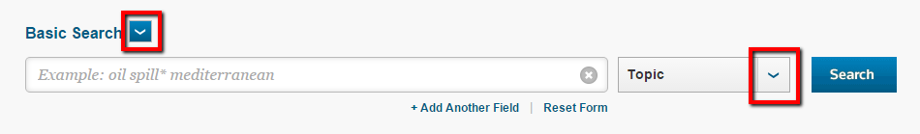

Next, in the search results, select the publications that are yours and use the checkboxes to add them to a Marked List. View your Marked List using the link in the upper right, then use Create Citation Report to view a citation report, h-index, etc. that you can then export or print.

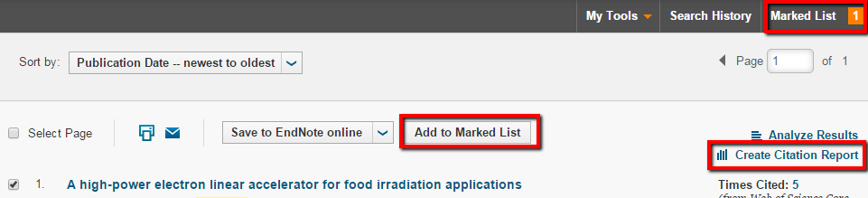

**Calculating Author Impact Using Scopus**

[Scopus](http://www.scopus.com/)is a multi-disciplinary database that indexes journal articles, conference publications, and more. Complete citation data is available from 1996 to present, so citation data prior to 1996 may be incomplete.

To calculate measures of your author impact in [Scopus](http://www.scopus.com/), first do an author search by entering information in this search form:

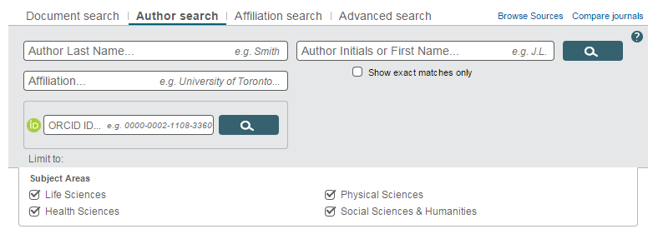

You will then get a list of author profiles that match your search criteria - you can click on the linked name to view the author profile. Because your name may appear differently in different publications, or your affiliation may have changed, you may want to skim the list and select all matches. Documents with insufficient data to be matched to an author profile can be included by selecting *Show Profile Matches with One Document*from the top of the page. If necessary, you can also use the criteria on the left side to narrow the list.

Once you've selected all variations of your name, you can show documents, view a citation overview that includes the h-index, or request to merge authors into a single profile. You can print or export the citation overview.

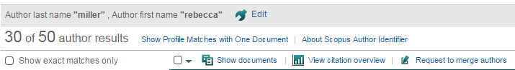

## Author Identifiers - Distinguish Yourself!

Author identifiers are meant to help with author name disambiguation. In order to measure your impact as an author, you want to be sure you get credit for all your research output. Publishing under variations of your name, having a common name, changing your name, changing institutions - all of these can lead to your work being incorrectly associated with another author, or you can end up with several author profiles. As a solution, register for an ORCID identifier, then associate it with your ResearcherID, Scopus profile, My NCBI account, etc. The boxes on this page explain how to do this.

**ORCID**

ORCID

[Open Researcher and Contributor ID (ORCID)](http://orcid.org/) is a persistent digital identifier for researchers. Registering for an ORCID identifier is free and easy. Once you have your unique ORCID identifier, you can create a profile and/or link it to your other author IDs and profiles (e.g., ResearcherID, My NCBI, LinkedIn). You can associate existing publications with your ORCID profile by importing from sources like Scopus and Web of Science. Going forward, use your ORCID identifier in all stages of your research workflow (grant applications, manuscript submissions, etc.) to make sure that you get credit for your work.

* [Register for an ORCID ID](https://orcid.org/register)
* [Help with ORCID](http://support.orcid.org/knowledgebase/topics/32827-website-user)
* [ORCID Author Data Integration with SciENcv / My NCBI](http://www.nlm.nih.gov/pubs/techbull/so14/so14_sciencv_orcid.html)

**Scopus Author Identifier**

[Scopus](http://www.scopus.com/) automatically generates an author identifier for authors in the Scopus database and attempts to disambiguate authors and build an author profile. Citation metrics are included with each author profile. You cannot edit your author profile yourself, but you can request corrections if publications are incorrectly assigned (or missing from) your profile or you find other errors.

* [Author Feedback Wizard](https://www.scopus.com/feedback/author/home.uri#/)

Collect all your Scopus records in one unique author profile.

* [Request changes to your Scopus Author Profile](http://help.elsevier.com/app/answers/detail/a_id/2321/p/8150/c/8750)

**ResearcherID**

ResearcherID

[ResearcherID](http://wokinfo.com/researcherid/) is integrated with the [Web of Science](http://webofknowledge.com/WOS) database. Your ResearcherID facilitates citation metrics and publication tracking using Web of Science tools and includes you in the Web of Science author index. You can create an author profile in ResearcherID that allows other researchers to learn more about your work and affiliations.

* [Register for ResearcherID](http://www.researcherid.com/SelfRegistration.action)
* [ResearcherID and ORCID Integration](http://wokinfo.com/researcherid/integration/)
* [ResearcherID Training Videos](http://wokinfo.com/training_support/training/researcher-id/#overview)

**Google Scholar Citations**

Google Scholar

Set up an author profile in [Google Scholar Citations](https://scholar.google.com/intl/en/scholar/citations.html) and you can view citation metrics for your publications and get an email alert every time one of your publications is cited.

* [Using Google Scholar Citations](https://scholar.google.com/intl/en/scholar/citations.html)

**Disambiguating Institutions**

* [Ringgold Identify Database](http://www.ringgold.com/identify)

An author's Institutional affiliation(s) can be another source of confusion since an institution may have multiple name variations. Ringgold is trying to disambiguate institutions by assigning them unique IDs

**What are Altmetrics?**

Altmetrics, or alternative metrics, are new measures that take into account online reader behavior, network interactions with content, and social media. Altmetrics are meant to complement, not completely replace, traditional impact measures and are measures of online attention and engagement.

Examples of Altmetrics include:

* mentions on Facebook, Twitter, or online news sites
* exports to citation management systems like Mendeley or Zotero
* downloads (of full text articles, software, etc.)
* comments in blogs or other online forums

Strengths of Altmetrics

* Currency - Altmetrics can be gathered and calculated immediately, compared with traditional citations that accumulate slowly.
* Diversity - Altmetrics capture data from a variety of sources, not just the traditional academic publishing setting, and thus may reflect the broader impact of research beyond the scholarly community. Additionally, altmetrics can be captured for research outputs beyond articles, like data sets, software, molecular structures, etc.

**Altmetrics in Scopus**

[Scopus](http://www.scopus.com/) is a large, interdisciplinary article database that is a good source of traditional impact measures (citation counts, author impact, journal impact). Scopus has incorporated article-level altmetrics via a third-party application. A summary of article-level metrics displays in the right sidebar of an article's detail page (the page you see when you click the linked title in the search results). The summary includes field-weighted benchmarking and a link to an expanded view of the metrics.

Here is an example from Scopus: At the time of this writing, this article, [Thelwall M, Haustein S, Larivière V, Sugimoto CR. Do Altmetrics Work? Twitter and Ten Other Social Web Services. PLoS ONE. 2013;8(5)](http://journals.plos.org/plosone/article?id=10.1371/journal.pone.0064841" \t "_blank), had been cited 84 times and had the following altmetrics:

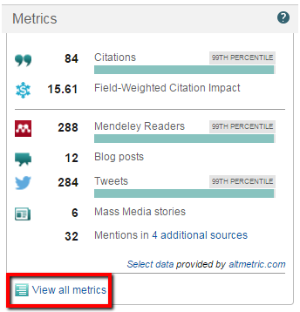

**Read More on Altmetrics**

* [Research impact: Altmetrics make their mark](http://www.nature.com/naturejobs/science/articles/10.1038/nj7463-491a)

Article from Nature

* [Altmetrics: Value all research products](http://www.nature.com/nature/journal/v493/n7431/full/493159a.html)

Discusses use of altmetrics in demonstrating value of research products that are not publications.

* [altmetrics: a manifesto](http://altmetrics.org/manifesto/)

Also includes links to tools, media, workshops, and events.

* [Altmetrics: What, Why, and Where](http://www.asis.org/Bulletin/Apr-13/AprMay13_Piwowar.html)

Introduction to special section of the Association for Information Science and Technology's Bulletin devoted to altmetrics.

* [Rise of 'Altmetrics' Revives Questions About How to Measure Impact of Research](http://chronicle.com/article/Rise-of-Altmetrics-Revives/139557/)

Article from the Chronicle of Higher Education

**Using Altmetrics to Show Research Impact**

* [Altmetrics for Professional Advancement](http://guides.mclibrary.duke.edu/c.php?g=217135&p=1434259)

Great information from Duke University librarians on how to use altmetrics in your CV, dossier, grant application, personal website, etc.

**Other Sources of Altmetrics**

* [Altmetric Bookmarklet](http://www.altmetric.com/bookmarklet.php)

Install bookmarklet in your bookmarks toolbar in Chrome, Firefox, or Safari, then get one-click article-level metrics when reading an online journal article.

* [Impactstory](https://impactstory.org/)

Open-source, web-based tool that helps scientists "tell data-driven stories about their impacts." The founders are active in the almetrics community and hope to help build a "new scholarly reward system that values and encourages web-native scholarship." Profiles in Impactstory require a paid subscription, though there are free trials.

* [Embeddable Altmetric Badges](https://api.altmetric.com/embeds.html)

Embed code to create the colorful Altmetric 'donut' for a particular article using its DOI, PMID, or other unique ID.

* [Altmetrics Tools](http://altmetrics.org/tools/)

"Noteworthy" altmetrics apps.

* [Plum Analytics](http://www.plumanalytics.com/)

Company that collects impact metrics in 5 major categories: usage, captures, mentions, social media, and citations. Tracks data for research outputs including journal articles, books, videos, presentations, conference proceedings, datasets, source code, cases, and more

**What are Article-Level Metrics?**

Article-level metrics (ALMs) attempt to provide a snapshot of how an individual article is being discussed, shared, and used.

ALMs combine traditional metrics, such as number of times cited, with [altmetrics](http://guides.lib.berkeley.edu/researchimpact/altmetrics) (e.g., mentions in blogs, downloads).

**Where do I find them?**

Whether or not ALMs are available for a particular article will depend on the platform or publisher.

* [PLOS Article Level Metrics](http://article-level-metrics.plos.org/)

Available for works published in PLoS (Public Library of Science) journals. ALM data, API, and widgets are available.

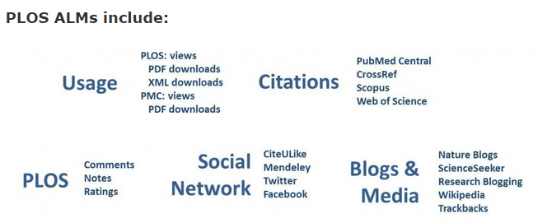

The following publishers and platforms include ALMs that are provided by [Altmetric](https://api.altmetric.com/" \t "_blank) (i.e., the colorful donut):

* [Wiley Online Library Altmetrics](http://olabout.wiley.com/WileyCDA/Section/id-822263.html)
* [Scopus Altmetrics](http://guides.lib.berkeley.edu/c.php?g=270775&p=1807432#s-lg-box-wrapper-6500588)
* [Nature Article Level Metrics](http://www.nature.com/press_releases/article-metrics.html)
* [BioMed Central Article Level Metrics](http://blogs.biomedcentral.com/bmcblog/2012/05/25/assessing-research-impact-at-the-article-level/)
* [SpringerLink Altmetrics](http://www.springer.com/about+springer/media/pressreleases?SGWID=0-11002-6-1453458-0)

PlumX / Plum Print is a different altmetric widget that you may see in databases. Currently it is integrated in CINAHL, and it may soon be added to other EBSCOhost databases.

PlumX Metrics Logo

* [The Plum Print: Coming to a Result List Near You](http://plumanalytics.com/plum-print-coming-result-list-near/)

# Measuring Research Impact: Broaden Your Impact

**Researcher Networks**

Below are a few of the more widely-used interdisciplinary, scholarly networking tools. Being part of a network may help you find collaborators and publicize your work more widely. Discipline-specific online networking communities also exist.

* [Academia.edu](https://www.academia.edu/)

Network for researchers to share research and discover research being done by others.

* [LinkedIn](https://www.linkedin.com/nhome/)

Social networking tool for professionals in all fields. A LinkedIn profile is similar to an online CV. You can search LinkedIn for people in particular fields of work or with a particular affiliation.

* [Mendeley](http://www.mendeley.com/)

Known also as a citation management tool, Mendeley includes a social networking element. Researchers can create profiles and build and share their libraries of citations. Mendeley tracks how often citations are saved to libraries as a type of altmetric.

* [ResearchGate](http://www.researchgate.net/)

Social network for scientists enabling sharing of research, collaboration, and some altmetrics. It also has active Q and A forums where you can get help and advice.

* [Twitter](https://twitter.com/)

Although not specifically a network for researchers, Twitter can still be a good place to network and publicize your research.

More on networking for researchers:

* [A Beginner’s Guide to Establishing a Professional Online Presence](https://www.insidehighered.com/blogs/gradhacker/beginner%E2%80%99s-guide-establishing-professional-online-presence)

From Inside Higher Ed

* [How to Curate Your Digital Identity as an Academic](http://chronicle.com/article/How-to-Curate-Your-Digital/151001/?cid=gn&utm_source=gn&utm_medium=en)

Article from the Chronicle of Higher Education

**Boosting Your Altmetrics**

In addition to using your networks to raise awareness of your research and publications, here are other tips and tools:

* [5 tips for improving your article’s Altmetric score](http://exchanges.wiley.com/blog/2014/09/18/5-tips-for-improving-your-articles-altmetric-score/)

From Wiley.

* [Kudos](https://www.growkudos.com/about)

Web-based service that "helps researchers and their institutions and funders to maximize the visibility and impact of their published articles.

**Use an Author Identifier**

Using an author ID will help distinguish you from other authors with similar names and will make sure that all your research output is grouped together - both good steps in broadening your impact. Registering for an [ORCID identifier](http://guides.lib.berkeley.edu/researchimpact/author-profiles#s-lg-box-wrapper-6500531) is a great place to start!

* [Author IDs](http://guides.lib.berkeley.edu/researchimpact/author-profiles)

**Maximize Impact of Your Published Work**

* [Publish for Impact in the Sciences](http://guides.lib.berkeley.edu/impact)

Great tips from librarian Jeff Loo. Includes tips and resources on writing.

**Research Impact Beyond Published Articles**

There are several initiatives to try to develop reward systems that recognize researchers' contributions beyond their publications in 'top' journals. Here are a few:

* [Rapid Science's "C-Score"](http://www.rapidscience.org/reward-metrics/)

A collaboration score that will attempt to measure "participants’ contributions to discovery processes that require robust group involvement"

* [Publons](https://publons.com/)

A way to record and showcase your peer review contributions

**Related Topic: Broader Impacts**

Addressing the 'broader impacts' of your research is a requirement for some grants, like the [National Science Foundation (NSF) grants](http://www.nsf.gov/pubs/2007/nsf07046/nsf07046.jsp). Here are a few resources devoted to broader impacts:

* [Addressing Broader Impacts](http://vcresearch.berkeley.edu/brdo/addressing-broader-impacts)

From the Berkeley Research Development Office

* [National Alliance for Broader Impacts](http://broaderimpacts.net/)