Created by ISI (the Institute for Scientific Information, now known as [Thomson Reuters](http://thomsonreuters.com/products_services/science/science_products/scientific_research/)), the **Impact Factor** is the most widely-recognized method for attempting to gauge a journal's rank/importance.  It is particularly well-known in the Sciences and Social Sciences.

The impact factor is based on two figures:  the number of citations to a given journal over the previous two years **(A)** and the number of research articles and review articles published by that journal over the same two-year period **(B)**, so: **A/B = Impact Factor**

Note that there is a discrepancy between the type of content counted for each factor: A = any type of content (including letters, news items, etc.), but B = research or review articles only, making the Impact Factor not a true average.

Where to Find It

Find the Impact Factor for your journal using the various Thomson Reuters products listed below.  Impact factors are also usually listed on individual journal publisher pages.

* [JCR: Journal Citation Reports](https://proxy.bc.edu/login?url=http://jcr.incites.thomsonreuters.com)

A resource for journal evaluation using citation data drawn from scholarly and technical journals worldwide in the areas of science, technology, and the social sciences. Multidisciplinary and international, JCR includes two editions: the Science Edition and the Social Sciences Edition (scroll down to find check-boxes to select).

* [Web of Science](https://proxy.bc.edu/login?url=http://isiknowledge.com/wos)

Web of Science (aka "Web of Knowledge") provides access to contents of the major journals in the various disciplines of the sciences, social sciences, arts and humanities. On any given article record in Web of Science, look to the right for a link to the JCR page for impact factor information.

***Informed and careful use of these impact data is essential. Users may be tempted to jump to ill-formed conclusions based on impact factor statistics unless several caveats are considered.***When considering the use of the impact factor (IF), keep these aspects in mind:

* IF analysis is limited to citations from the journals indexed by the Web of Science/Web of Knowledge.  Currently, the Web of Science indexes only 8621 journals across the full breadth of the sciences, and just 3121 in the social sciences.
* A high IF/citation rate says nothing about the quality -- or even, validity -- of the references being cited.  Notorious or even retracted articles often attract a lot of attention, hence a high number of citations. The notority related to the first publication on "cold fusion" is one such example.
* Journals that publish more "review articles" are often found near the top of the rankings.  While not known for publishing new, creative findings, these individual articles tend to be heavily cited.
* The IF measures the average number of citations to articles in the journal -- given this, a small number of highly-cited articles will skew the figure.
* It takes several years for new journals to be added to the list of titles indexed by the Web of Science/Web of Knowledge, so these newer titles will be under-represented.
* It's alleged that journal editors have learned to "game" the system, encouraging authors to cite their works previously published in the same journal.

Impact factors have often been used in advancement and tenure decision-making.  Many recognize that this is a coarse tool for such important decisions, and that a multitude of factors should be taken into account in these deliberations.

Comparing Journals Across Disciplines -- Don't Do It

Using Impact Factors within a given discipline should only be done with great care, as described above.  Using impact factor data to compare journals across disciplines is even more problematic.  Here are some of the reasons:

* Disciplines where older literature is still referenced, such as Chemistry and Mathematics, offer challenges to the methodolgy since older citations (older than two years) are not used to calculate the impact factor for a given journal.  (Five-year impact factor analysis, which can be calculated using the Journal Citation Index database, helps smooth out this problem only to some degree.)
* Different disciplines have different practices regarding tendency to cite larger numbers of references.  Higher overall citation rates will bump upward impact factor measurements.
* Where it's common for large numbers of authors to collaborate on a single paper, such as in Physics, the tendency of authors to cite themselves (and in this case, more authors) will result in increased citation rates.

Finding Impact Factors Using Journal Citation Reports

Access [Journal Citation Reports](http://libguides.bc.edu/go.php?c=5088908), then select either the Science or Social Sciences Edition and Year.

1. Search by Subject Category or for a specific journal.  The same journal may appear under several categories, and its impact will vary according to the group.

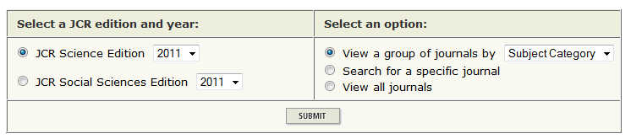

2. Search by Subject Category and choose Sort by Impact Factor.

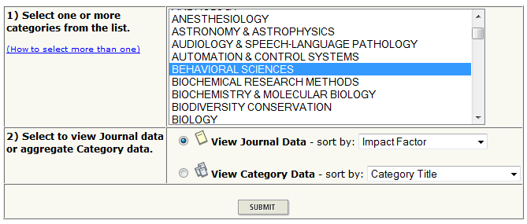

3. Here are the results for a search in the Behavioral Sciences category (shown in two parts due to the width of the display):

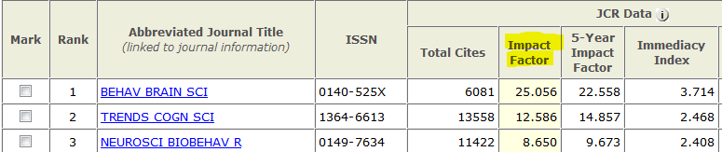

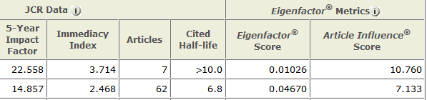

You'll see that additional metrics, such as the **Eigenfactor** and **Article Influence** scores, are also captured in this display.

From the Journal Citation Reports Help pages:

**Eigenfactor Score**  
The *Eigenfactor* Score calculation is based on the number of times articles from the journal published in the past five years have been cited in the JCR year, but it also considers which journals have contributed these citations so that highly cited journals will influence the network more than lesser cited journals.  References from one article in a journal to another article from the same journal are removed, so that *Eigenfactor* Scores are not influenced by journal self-citation.  
  
**Article Influence Score**  
The *Article Influence* determines the average influence of a journal's articles over the first five years after publication.  It is calculated by dividing a journal’s *Eigenfactor* Score by the number of articles in the journal, normalized as a fraction of all articles in all publications.  This measure is roughly analogous to the 5-Year Journal Impact Factor in that it is a ratio of a journal’s citation influence to the size of the journal’s article contribution over a period of five years.

The mean *Article Influence* Score is 1.00. A score greater than 1.00 indicates that each article in the journal has above-average influence. A score less than 1.00 indicates that each article in the journal has below-average influence.

Eigenfactor Score and Article Influence Score



Like the [Impact Factor](http://admin-apps.webofknowledge.com.proxy.bc.edu/JCR/help/h_impfact.htm), the [*Eigenfactor*® Score](http://www.eigenfactor.org/) and *Article Influence®*Score use citation data to assess and track the influence of a journal in relation to other journals. The *Eigenfactor* Score calculation is based on the number of times articles from the journal published in the past five years have been cited in the JCR year, but it also considers which journals have contributed these citations so that highly cited journals will influence the network more than lesser cited journals.

The *Article Influence* determines the average influence of a journal's articles over the first five years after publication.  It is calculated by dividing a journal’s *Eigenfactor* Score by the number of articles in the journal, normalized as a fraction of all articles in all publications.  The mean *Article Influence* Score is 1.00. A score greater than 1.00 indicates that each article in the journal has above-average influence. A score less than 1.00 indicates that each article in the journal has below-average influence.

Google Scholar Metrics



[Google Scholar Metrics](http://scholar.google.com/intl/en/scholar/metrics.html) (GSM) allows one to gauge the visibility and influence of recent articles in scholarly journals. Particularly interesting is GSM’s listing of the [top 100 publications in several languages](http://scholar.google.com/citations?view_op=top_venues), ordered by their five-year *h-index* and *h-median* metrics. [More details](http://scholar.google.com/intl/en/scholar/metrics.html).

Article Level Metrics

Many other methods of measuring the impact of published articles involve metrics computed at the article or author level rather than the journal level.

For a fuller explanation of those methods, see our guide to [**Assessing Article and Author Influence**](http://libguides.bc.edu/content.php?pid=445061).

PLoS is one example of the use of article-level metrics.

[PLoS Article-Level Metrics](http://article-level-metrics.plos.org/)**measure the dissemination and reach of published research articles.**

Traditionally, the impact of research articles has been measured by the publication journal. But a more informative view is one that examines the overall performance and reach of the articles themselves. Article-Level Metrics are a comprehensive set of impact indicators that enable numerous ways to assess and navigate research most relevant to the field itself, including:

* usage
* citations
* social bookmarking and dissemination activity
* media and blog coverage
* discussion activity and ratings

Article-Level Metrics are available, upon publication, for every article published by PLOS.

## SCImago Journal Rank

[SCImago Journal Rank (SJR indicator)](http://www.scimagojr.com/index.php) is a measure of scientific influence of scholarly journals contained in the [Scopus®](http://www.info.sciverse.com/scopus/scopus-in-detail/facts) database from 1996.

The main difference between SJR and the I[mpact Factor](http://admin-apps.webofknowledge.com.proxy.bc.edu/JCR/help/h_impfact.htm) is that the IF gives equal weight to all citations, making no distinction between citations published in some obscure journals and citations published in Nature or Lancet.   To address this issue, SJR uses mathematical approach behind the Google's PageRank algorithm and adapts it to journal metrics. The PageRank model type weights citations from journals according to how highly cited the journal itself is.  
  
Apart from assigning different values to citations depending on the importance of the journals, there are other essential differences between IF and JCR.

- breadth of SJR's scientific, technical and medical journal coverage.  SJR makes use of data supplied by Scopus which covers almost 20,000 journals, including many STM journals not tracked by Thomson Scientific. Thomson Scientific often waits several years before including new journals in, and in some cases may not track some journals at all, even though they are highly cited.  Scopus has a more systematic policy on content inclusion, including OA journals.

- impact factors are derived from citations in a single year to articles from the two preceding years, the SJR  looks at citations made in a three year period, of articles published in an earlier, but overlapping, three year period. This makes the SJR a more stable indicator of trends than impact factors, which often fluctuate  
substantially from year to year

What is AltMetrics?

*Altmetrics* is the creation and study of new metrics based on the Social Web for analyzing, and informing scholarship.  It goes beyond traditional citation-based indicators and raw usage factors such as downloads or click-through numbers.  Instead it explores readership, diffusion and reuse indicators that can be tracked via blogs, social media, peer production systems, collaborative annotation tools,  including social bookmarking and reference management services.   Read more about *Altmetrics* in [Altmetrics manifesto.](http://altmetrics.org/manifesto/)

AltMetrics Tools

**Noteworthy altmetrics tools and services:**

* [Altmetric.com](http://altmetric.com/)
* [ImpactStory](http://total-impact.org/)
* [Plum Analytics](http://www.plumanalytics.com/)
* [PeerEvaluation](http://www.peerevaluation.org/)
* [Research Scorecard](http://researchscorecard.com/)
* [Mendeley](http://www.mendeley.com/)
* [Acumen](http://research-acumen.eu/)

ACUMEN



[ACUMEN](http://research-acumen.eu/) is a European research collaboration aimed at understanding the ways in which researches are evaluated by their peers and by institutions and at assessing how the science system can be improved and enchanced.  This FP7 project is a cooperation amont [nine European research institutes](http://research-acumen.eu/partners).

Mendeley



[Mendeley](http://www.mendeley.com/features/) is an online research-collaboration platform and academic database.  Mendeley's metrics include how often papers are downloaded, shared with colleagues, and commented on.

## Altmetrics



[Altmetric](http://www.altmetric.com/index.php) tracks mentions of scholarly works on social media sites, scholarly bookmarking services and in science news outlets.

[The Altmetric Explore](http://www.altmetric.com/aboutexplorer.php) is a commerical product that measures the attention that scholarly articles receive online.

Altmetric collects the relevant discussions around each article from Twitter, Facebook, science blogs, mainstream news outlets and other sources.  Each article is given a score that measures the quantity & quality of attention it has received.  The Altmetric Explore can also show demographics such as country and professional occupation for the social network users mentioning each paper.

[The Altmetric Bookmarklet](http://www.altmetric.com/bookmarklet.php) instantly gets article-level metrics for any recent paper.

## Data Citation Index

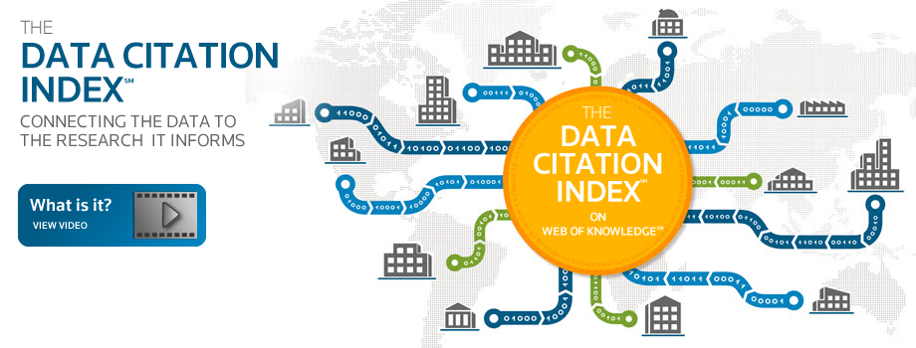

Thomson Reuters's [Data Citation Index (DCI)](http://wokinfo.com/products_tools/multidisciplinary/dci/) provides a single point of access to quality research data from repositories across disciplines and around the world.  Scholars can discover, attribute, and receive credit for the creation of scholarly digital research data