Google Scholar can be a great tool for supplementing your research. However, only searching Google Scholar means missing important research and spending extra time verifying if an article is peer reviewed.

Google Scholar it is not a replacement for the library databases. Think about using it as a supplement your UCSC Library database searches and not as the only place you search.

**Benefits:**

* Links to related articles, how often cited and by whom, provides citation styles
* Quick link to full text via the UCSC Library
* Allows you to save both citations and articles to read later
* Searches the full text for your keywords
* Sometimes finds free full text for items not in the library

**Drawbacks**

* Does not include all journals and not everything is scholarly
* Don't know what specific sites are being searched
* No full-text or peer review limit
* Hard to do more complex searches (e.g. can't search or limit by subject headings)
* Ranks relevancy differently than library databases

**How are search results ranked?**

## How are search results ranked?

Google Scholar ranks search results based on a number of criteria:

* How often it has been cited in other scholarly literature, not rigor or accuracy
* The full text of a document
* Where it was published
* Who it was written by
* How recently it has been cited in other scholarly literature

## Google Scholar Search Tips

se operators to refine your search terms. Google Scholar also supports most of the advanced operators in Google web search:

* **the "-" operator** excludes all results that include this search term, as in [[biomedicine -magnetic](http://scholar.google.com/scholar?q=biomedicine+-magnetic)]
* **phrase search** only returns results that include this exact phrase, as in [["as you like it"](http://scholar.google.com/scholar?q=%22as+you+like+it%22)]
* **the "~" operator** will find synonyms for that word, as in [[~robotics](http://scholar.google.com/scholar?q=~robotics)]
* **the "OR" operator** returns results that include either of your search terms, as in [[soccer OR football](http://scholar.google.com/scholar?q=soccer+OR+football)]
* **the "intitle:" operator** as in [[intitle:mars](http://scholar.google.com/scholar?q=intitle%3Amars" \t "_blank)] only returns results that include your search term in the document's title
* **the "author" operator** [[author:flowers](http://scholar.google.com/scholar?q=author%3Aflowers)] returns papers written by people with the name Flowers, whereas [[flowers -author:flowers](http://scholar.google.com/scholar?q=flowers+%2Dauthor%3Aflowers)] returns papers about flowers, and ignores papers written by people with the name Flowers
* **using quotes around a common word** makes sure your results include common words, letters or numbers that Google's search technology generally ignores, as in [["the" border](http://scholar.google.com/scholar?q=%22the%22+border)]

## Automatic Related Term Searching

Google Scholar automatically searches for simple singular and plural forms of terms you enter, along with additional different endings to some words, and for some related terms.  For example:

* **sport**returns     **sport ;  sports**
* **diet**returns       **diet ;  diets ;  dietary**
* **woman**may return   **woman**  or  **woman ;** **women ;  female**

The number of related terms included in the results may depend on the search being conducted. This feature cannot be turned off, and there is no separate truncation search that allows the user to designate that a term should be searched with any possible ending

## Advanced Search Features

The Advanced Scholar Search menu has eight ways of searching, organized into three broad sections. You are able to mix and match these different search options together.

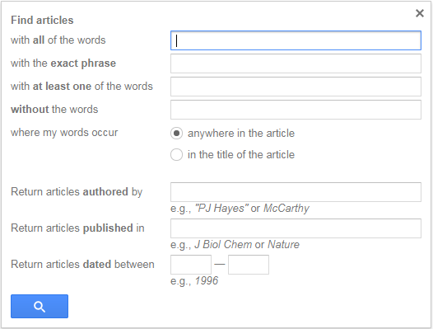

##### All / Exact Phrase / At Least One / Without

Helps you control the search words you are searching with.

* Words typed into the first search bar must **all be included** in your result. This is how a regular Google Scholar search works.
* Words types into the second search bar will be searched as an **exact phrase**. Not only must all of those words be included in each results, they must be included together in the exact order you wrote them in.
  + You can also do this in the regular search bar by putting the words in quotes. Ex. "myocardial infarction"
* When words are typed into the third search bar, Google Scholar will give you any result that included **at least one of those words**. This can be a good way to incorporate synonyms or related ideas into your search.
  + You can also do this in the regular search bar by putting "OR" in between your search words. Ex. Missouri politics OR government
* When words are typed into the fourth search bar, Google Scholar will only return results **without those words**. This can be useful if your results are cluttered with things that are not relevant to your search.
  + You can also do this in the regular search bar by putting a minus sign (-) before a word. Ex. Shakespeare -tragedies

##### Where My Words Occur

Controls where Google Scholar will look for your search words.

* Selecting "anywhere in the article" will likely turn up a larger number of results, because the search engine can look for your keywords in more places. This is the Google Scholar default.
* Selecting "in the title of the article" may help improve the relevance of your results, because if your keyword is in the title, it is likely more important to what the article is about.

##### Authored by/Published in/ Dated Between

* The first search bar lets you search for results by a certain **author**.
  + You can also do this in the regular search bar by putting "author:" before the author's name. Ex. intersectionality author:Crenshaw
* The second search bar lets you search for results in a particular **scholarly journal**. Google Scholar understands many common ways of abbreviating journal titles.
* The last search tool lets you search for results from within a **range of publication dates**

## My Citations in Google Scholar

You can track who has cited your work in Google Scholar.  You'll need a Google Account to do so.

Click on My Citations near the top of the Google Scholar home page (or in the right corner of a search results screen).  Fill out the biographical information.  Google Scholar will look for your work within the databases.  Sometimes this is successful, sometimes it is not.  You can also upload your citations to the product.

Once you have set this up, Google Scholar will email you when it finds that your work has been cited.

**Is Google Scholar right for my research?**

**Google Scholar is good for...**

* Helping a beginning researcher identify journal titles and authors connected with subjects of interest.
* Finding "gray literature" like conference proceedings. It includes many articles that wouldn't get included in other indexing services.
* Locating obscure references that are proving difficult to find in conventional databases.
* Locating more information on partial citations.

**Google Scholar cannot...**

* Sort/search by disciplinary field
* Browse by title
* Limit search results
* Search the deep web

**Keep in Mind:**

* You may get a long list of results, but you will only have access to the text of articles that the University of Illinois Library has paid subscriptions for, or that are freely available.
* Not everything in Google Scholar is scholarly. Google Scholar searches academic websites (.edu) as well as journals and publisher websites. Search results can include PowerPoints, news announcements or unpublished materials as well as articles and books.
* Searching in Google Scholar is imprecise when compared with discipline-specific databases.
* [Wikipedia Article on Gray Literature](http://en.wikipedia.org/wiki/Gray_literature)
* [A-Z Subject Guide](http://guides.library.illinois.edu/az.php)

Use the Library's Database by Subject Guide for more precise searching than you'll get in Google Scholar.

**Connect Your Account**

Google Scholar often prompts you to pay for full text articles. In many cases these articles are freely accessible to U of I affiliates through one of the Library's many subscription databases or journals. You can use Google Scholar's Library Links feature to identify yourself as a University of Illinois affiliate. This allows you to find full text library resources directly through Google Scholar results.

This is what Google Scholar search results look like when you're off-campus and haven't yet identified yourself as a University of Illinois affiliate:

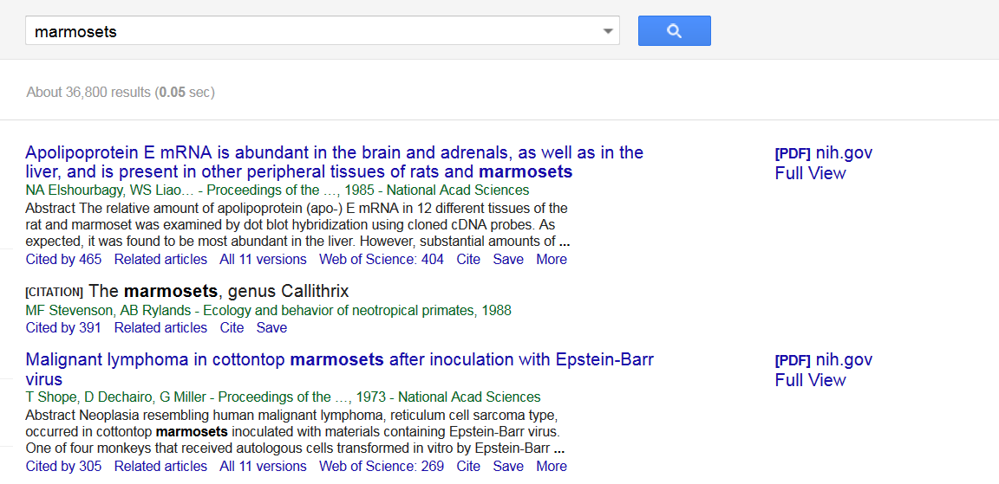

**Note:** If you're using Google Scholar from an on-campus computer, the Discover UIUC Full Text links will display automatically without any special configuration.

* To identify yourself as a University of Illinois affiliate, go to **Settings** at the the top of the Google Scholar search screen, then select **Library links**.
* Search for University of Illinois and select the "University of Illinois at Urbana-Champaign - Discover UIUC Full Text" checkbox.
* Make sure this box is checked and click **Save**.

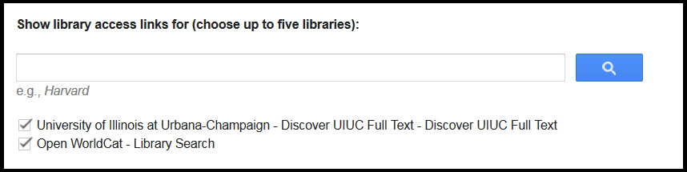

* Now, when you run searches in Google Scholar, you should see a link More below the results. Click on this link to see more options, like a cached view of the website or searching the university's print resources.

Please note that, even if you don't see a Discover link next to an article, it doesn't mean that we don't have it! The University of Illinois Library has access to thousands of journals online and in print, and not all of them are accessible through Discover. If you need help locating a particular article that you found through Google Scholar, please [Ask a Librarian](http://www.library.illinois.edu/cms/askus/index.old2).

* [Library Links](https://scholar.google.com/scholar_settings?sciifh=1&hl=en&as_sdt=0,14#2)

Google Scholar's Library Links page allows you to set up connections to your affiliated library!

**Advanced Search Results**

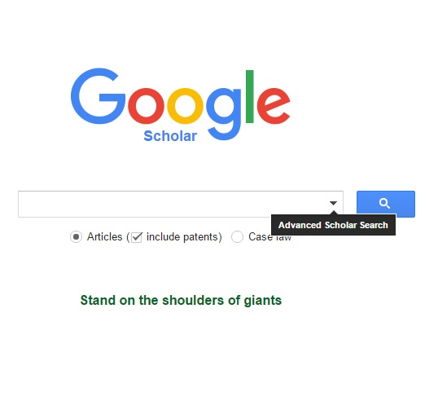

Above, you'll notice that if you hover over the down arrow, you will get access to Google Scholar's advanced search features. By clicking on that arrow, a box will pop up with many options that will allow you to refine your search. This advanced search will allow you to sort by specific phrases, as well as authors and date ranges.

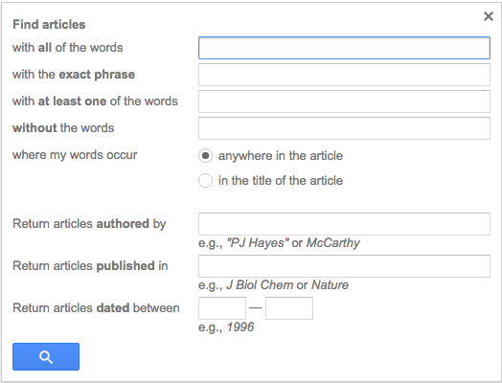

**Article Specifics**

Once you are looking at a single result, there are a few options for the item. Some of these include:

* "Cited By" will show you a list of works that cited this article.
* "Related Articles" will direct you to articles on the same or a similar subject.
* "Discover UIUC Full Text" will direct you to library databases that contain the article.

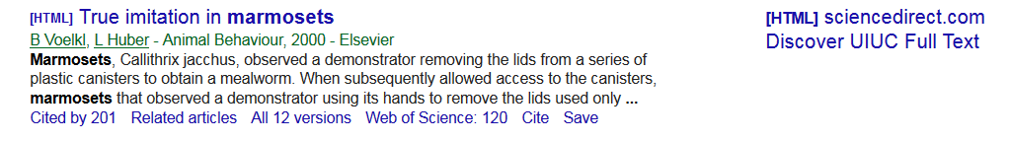

**How to incorporate Google Scholar into your research**

Google Scholar searches specifically for scholarly materials such as journal articles, research reports, dissertations and theses, preprints, technical reports, patents, manuscripts in preparation, working papers and *many* other document types.

When you do a search in Google Scholar, you get a list of citations. You'll get links to the full text in the following cases:

* Ifthe Illinois library subscribes to the journal title
* If it's from an open access journal
* If the researcher posted the article on her/his website.

We don't know exactly how Google Scholar indexes items, but this is how Google Scholar [defines its metrics](https://scholar.google.com/intl/en/scholar/metrics.html)

**Google Scholar Strengths**

* Getting the "big picture" of the scholarly discourse around a topic.
* Viewing books, articles, conference proceedings, and more in one list.
* Determining authors and publications in an area of interest.
* Tracking down incomplete citations.

|  |
| --- |
| **Google Scholar Weaknesses** |
|  |

* Limiting and sorting results by type (eg. peer reviewed articles, full-text, reviews).
* Searching within a specific discipline
* Browsing by journal title.
* Doing a comprehensive search for a literature review.
* Using controlled vocabulary to search by subject.
* Emailing lists of search results