**Creative Commons Licences**

Every time a work is created, such as when a journal article/ book is written, a photograph taken, a song is recorded, that work is automatically protected by copyright. Copyright protection prevents others from using the work in certain ways, such as copying the work or putting the work online without asking the copyright owner’s permission.

The Creative Commons is an international non-profit organization based on USA which facilitates the copyright owners to permit others to use their materials through some licences called Creative Common Licences. CC licences allow the creator of the work to select how they want others to use the work. When a creator releases their work under a CC licence, members of the public know what they can and can’t do with the work. This means that they only need to seek the creator’s permission when they want to use the work in a way not permitted by the licence. The great thing is that all CC licences allow works to be used for educational purposes. As a result, teachers and students can freely copy, share and sometimes modify and remix a CC work without seeking the permission of the creator.

**Optional Licence Elements of** **Creative Commons**

The Creative Commons Licences are constituted of 4 optional elements. These elements allow the creator to select the different ways they want the public to use their work. The creator can mix and match the elements to produce the CC licence they want. This process is a simple and quick way for creators to indicate how they wish their work to be used. Each element has its own icon and abbreviation, making them easy to identify.

1. **Attribution**

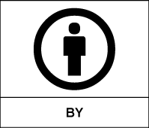

The ‘Attribution’ CC licence element is represented by the abbreviation ‘BY’ and the symbol given above. It says that others who use your work in any way must give you attribution/credit. If they want to use your work without giving you credit or for endorsement purposes, they must get your permission first.

1. **Non-Commercial**

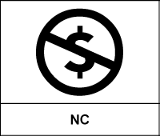

The ‘Non-Commercial’ CC licence element is represented by the abbreviation ‘NC’ and the symbol given above. It says that any use of the work must be for non-commercial purposes only and no revenue should be generated by a person using your work.

1. **No Derivative Works**

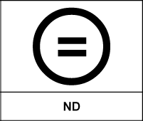

The ‘No Derivative**’** CC licence element is represented by the abbreviation ‘ND’ and the symbol given above. It says that your work can only be used exactly how it is. The work cannot be adapted or modified in any way. This means a person needs to get extra permission from you to remix the work, crop a photo, edit down text or use a song in a film.

1. **ShareAlike**

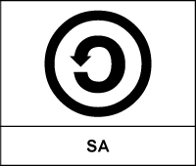

The ‘ShareAlike’ CC licence element is represented by the abbreviation ‘SA’ and the symbol given above. It says that you let others to copy, distribute, display, perform, and modify your work, as long as they distribute any modified work on the same terms. If they want to distribute modified works under other terms, they must get your permission first.

**Six Standard Creative Commons Licences**

The four CC licence elements ‘Attribution’, ‘Non-Commercial’, ‘Non-Derivatives’ and ‘Share Alike’ are mixed and matched to create the six standard CC licences as given below.

1. **Creative Common Licence-1 : Attribution**

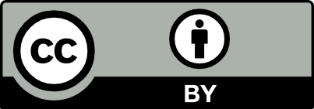

This CC licence permits others to copy/display/distribute/perform/modify your work both for commercial & non-commercial purposes with proper attribution to you.

1. **Creative Common Licence-2: Attribution, Non-commercial**

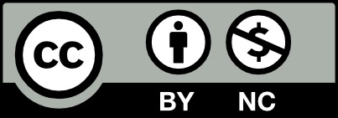

This CC licence permits others to copy/display/distribute/perform/modify your work for non-commercial purpose with proper attribution to you**.**

1. **Creative Common Licence-3: Attribution, No Derivative**

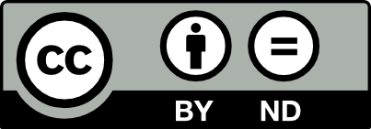

This CC licence permits others to copy/display/distribute/perform your work for commercial & non-commercial purposes with proper attribution to you and without making any change in the work (verbatim).

1. **Creative Common Licence-4: Attribution, Share Alike**



This CC licence permits others to copy/display/distribute/perform/modify your work with proper attribution to you for commercial or non-commercial purposes and with the condition that the new work produced must be made available under the same licence as the original work.

1. **Creative Common Licence-5: Attribution, Non-Commercial, Share Alike**



This CC licence permits others to copy/display/ distribute/ perform/ modify your work with proper attribution to you for non-commercial purposes only with the conditions that the new work produced must be made available under the same licence as the original work.

1. **Creative Common Licence-6: Attribution, Non-Commercial, No Derivative**

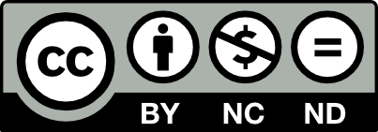

This CC licence permits others to copy/ display/distribute/ perform your work for non-commercial purposes with proper attribution to you and without making any change in the work (verbatim copies).