Objectives
- Knows where to start looking for information
- Aware of a broad range of information sources
- Is familiar with major reference collections in his or her discipline and selects from among them appropriately
- Conducts electronic database searches effectively (e.g., knows how to use quotation marks, Boolean operators such as or/and/not, and other technical strategies
- Knows how to evaluate information sources;
- Understands what plagiarism is and some of the complexities of copyright law, the ethical use of information, intellectual property, etc.
- Has learned how to cite material appropriately and develop a bibliography
- Recognizes that a set of specific information literacy skills is transferrable and can be applied throughout life, for both professional and personal learning objectives
II. Locate and Gather Information: Able to execute a plan for locating information by developing a search strategy and identifying sources of information

- Identify subject-specific collections of information such as gateways and portals29
- • Is able to identify the available search tools, such as general and subject specific resources at different levels30
- • Is able to identify different formats in which information may be provided31

- Create a plan for searching
- Identify various sources of help in searching (e.g. library and classroom faculty, library staff, peers, library guides, etc.)
Major Program:
- Identify core subject research databases
- Use advanced search features in subject research databases
- Use recursive searching techniques
- Identify a breadth of primary and secondary sources of information in the field (e.g., scholarly journals, trade publications, books, government information, web-based resources, subject experts, etc.)
- Interpret and use citations to find additional literature
- Recognize tools for acquiring resources outside of GVSU collections (e.g. Document Delivery, Interlibrary Loan, etc.)
Evaluate Sources: Able to evaluate the quality, usefulness, and relevance of the information they discover
- • Use appropriate quality criteria to filter results, and also to focus on the most relevant information within documents34

- Differentiate between scholarly, trade, and popular sources
- Evaluate resources for authority, accuracy, reliability, coverage, and timeliness
- Evaluate found resources for relevance to the topic and adjust topic accordingly
- Identify possible biases within an information source
- Define peer reviewed
- Seek feedback from peers and professors
- Make use of review tools to evaluate information sources (e.g., book reviews, annotated bibliographies, etc.)
Graduate Programs:
- Differentiate between types of research (e.g., qualitative, quantitative, etc.)
- Evaluate research methods within studies
- Identify research biases within studies
Apply evaluation criteria in the identification and use of key sources of information (e.g., journal impact factors)
Manage Information: Able to manage information from a variety of sources
- • Interpret database results (e.g. bibliographic or full text), and use results functionality (e.g. sorting, saving, exporting)35
- • Understands the importance of citation in their learning/research context40

- Develop a strategy for logging and retrieving information found
- Recognize information overload and develop strategies to manage information anxiety
Major Program:
- Use a citation management system (e.g., RefWorks or EndNote)
- Recognize how current awareness technologies (e.g., RSS feeds, blogs, listservs) can be used to stay informed in areas of interest
Graduate Programs:
- Use current awareness technologies (e.g., RSS feeds, blogs, listservs) to stay versed in research
Preserve/archive research, data, portfolio, thesis, project, etc. to ensure its future accessibility.
Use Information Ethically: Understand the legal and ethical implications of using information appropriately and responsibly
- • Develop an awareness of how copyright and IPR issues impact on your work51

- Recognize the basics of plagiarism and copyright
- Cite sources appropriately
Major Program:
- Develop an increasing awareness of responsible use of information and types of plagiarism
- Recognize ethical and legal considerations specific to the discipline
- Use information ethically as global and local citizens
Graduate Programs:
- Choose whether to retain author rights for future use of research output
Adhere to professional ethical guidelines (e.g. HIPAA, FERPA, HRRC/IRB, etc.)
Communicate Knowledge:Understand the disciplinary and societal context in which information is presented and created, and is able to contribute to that body of information
- • Is able to develop a personal profile in the community using appropriate personal networks and digital technologies (e.g. discussion lists, social networking sites, blogs, etc.)36

- Synthesize information from various sources
- Develop awareness of publication lifecycle
- Recognize the financial forces driving the availability of information
Major Program:
- Apply content knowledge to service learning environments
- Identify post-graduate resources for professional development, leadership, scholarly communication and community involvement
- Use government information to foster informed citizenry
Graduate Programs:
- Contribute to associations and networks related to the discipline
- Participate in the academic process of one's discipline (e.g. discovery, proposal, funding, research design, dissemination, etc.)
Share findings with peers in open for a.
  - The information literate student determines the nature and extent of the information needed.
2. The information literate student accesses needed information effectively and efficiently.
3. The information literate student evaluates information and its sources critically and incorporates selected information into his or her knowledge base and value system.
4. The information literate student, individually or as a member of a group, uses information effectively to accomplish a specific purpose.
5. The information literate student understands many of the economic, legal, and social issues surrounding the use of information and accesses and uses information ethically and legally.

Summarise the key ways you can use and share information without infringing another’s rights83
• Distinguish between collaboration and collusion84
• Develop strategies as appropriate for working within the legal framework85
• Is able to meet standards of conduct for academic integrity86
• Understands their personal responsibility to store and share information and data87
• Understands the concept of attribution88
• Summarise the key methods of publishing research findings in your discipline (including self‐publication, e.g. blogging)73

Range of information sources

Electronic and print periodicals, chapters in books, government documents, archival material, and microfilm), and can distinguish among the various types of resources (e.g., scholarly work, informed opinions of practitioners, and trade literature);

Information literacy is a set of abilities requiring individuals to "recognize when information is needed and have the ability to locate, evaluate, and use effectively the needed information."  Information literacy also is increasingly important in the contemporary environment of rapid technological change and proliferating information resources. Because of the escalating complexity of this environment, individuals are faced with diverse, abundant information choices--in their academic studies, in the workplace, and in their personal lives. Information is available through libraries, community resources, special interest organizations, media, and the Internet--and increasingly, information comes to individuals in unfiltered formats, raising questions about its authenticity, validity, and reliability. | 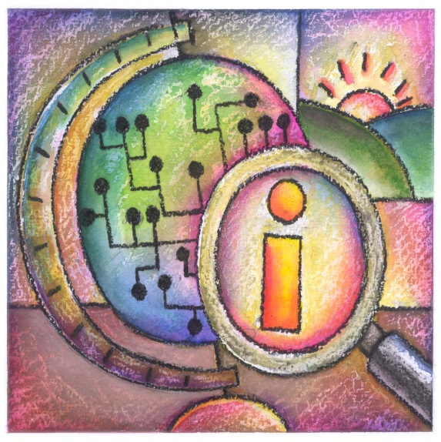
In addition, information is available through multiple media, including graphical, aural, and textual, and these pose new challenges for individuals in evaluating and understanding it. The uncertain quality and expanding quantity of information pose large challenges for society. The sheer abundance of information will not in itself create a more informed citizenry without a complementary cluster of abilities necessary to use information effectively.
Information literacy forms the basis for lifelong learning. It is common to all disciplines, to all learning environments, and to all levels of education. It enables learners to master content and extend their investigations, become more self-directed, and assume greater control over their own learning. An information literate individual is able to:
- Determine the extent of information needed
- Access the needed information effectively and efficiently
- Evaluate information and its sources critically
- Incorporate selected information into one’s knowledge base
- Use information effectively to accomplish a specific purpose
- Understand the economic, legal, and social issues surrounding the use of information, and access and use information ethically and legally

