Writing a journal manuscript

Publishing your results is a vital step in the research lifecycle and in your career as a scientist. Publishing papers is necessary to get your work seen by the scientific community, to exchange your ideas globally and to ensure you receive the recognition for your results. The following information is designed to help you write the best paper possible by providing you with points to consider, from your background reading and study design to structuring your manuscript and figure preparation.

By the end of the tutorial you should know on how to:

* prepare prior to starting your research
* structure your manuscript and what to include in each section
* get the most out of your tables and figures so that they clearly represent your most important results.

You will also have the opportunity to test your learning by completing a quiz at the end.

Before you begin writing

A good research paper begins long before you start writing. Giving some deep thought as to the topic you are researching, the question you are answering and the study design, as well as ensuring you follow appropriate research laws and regulations, all contribute to making a publishable paper.

In the first half of the module we will cover:

* Identifying hot topics and background reading
* Study design
* Reference managers
* Types of journal manuscripts

Identifying your research question

Making informed decisions about what to study, and defining your research question, even within a predetermined field, is critical to a successful research career, and can be one of the hardest challenges for a scientist.

Being knowledgeable about the state of your field and up-to-date with recent developments can help you:

* Make decisions about **what to study** within niche research areas
* Identify **top researchers** in your field whose work you can follow and potentially collaborate with
* Find **important journals** to read regularly and publish in
* Explain to others **why your work is important** by being able to recount the bigger picture

How can you identify a research question?

Reading regularly is the most common way of identifying a good research question. This enables you to keep up to date with recent advancements and identify certain issues or unsolved problems that keep appearing.

Begin by searching for and reading literature in your field. Start with **general interest** journals, but don’t limit yourself to journal publications only; you can also look for clues in the news or on research blogs. Once you have identified a few interesting topics, you should be reading the table of contents of journals and the abstracts of most articles in that subject area. Papers that are directly related to your research you should read in their entirety.

*TIP Keep an eye out for****Review papers****and****special issues****in your chosen subject area as they are very helpful in discovering new areas and hot topics.*

*TIP: you can sign up to receive table of contents or notifications when articles are published in your field from most journals or publishers.*

*TIP: Joining a journal club is a great way to read and dissect published papers in and around your subject area. Usually consisting of 5-10 people from the same research group or institute they meet to evaluate the good and bad points of the research presented in the paper. This not only helps you keep up to date with the field but helps you become familiar with what is necessary for a good paper which can help when you come to write your own.*

If possible, communicate with some of the authors of these manuscripts via email or in person. Going to conferences if possible is a great way to meet some of these authors. Often, **talking with the author** of an important work in your research area will give you more ideas than just reading the manuscript would.

Study design

You must have a good study design to get publishable results. When designing an experiment you will need to decide:

* What is your **hypothesis**or research question?
* What are the **aim(s)** of your study?
* What are the best **methods**for achieving your aims?
* Do you have the necessary **resources**to carry out your methods?
* Which positive and negative **controls**will you use?
* Do you have the required ethics and regulatory **permissions**? For example, if your experiment will have animal subjects, you will probably need approval from your institution’s review board. If you are publishing a clinical trial then you need register it in a clinical trials registry. Not getting the correct permissions will stop you from publishing your work in reputable journals.
* Will your experiment have enough **statistical power** to give useful results? Is your sample size large enough to draw valid conclusions? Which statistical tests will you use for your analysis? If you are not sure, **consult a statistician**; they can provide you with expert advice that may save you a lot of time.

# Reference managers

Reference managers (or reference formatting software such as BibTeX for LaTeX documents) make it easy to organize and format citations. They can also assist with managing libraries containing citations, PDFs, and image files by organizing important documents by subject and allowing you to search your library using keywords. Add and organize any papers that are relevant to your research as you read them. This will help you remember to appropriately cite articles that you have read.

Some widely used reference management and formatting software applications are:  
[BibTeX](http://www.bibtex.org/)  
[EndNote](http://endnote.com/)  
[Mendeley](https://www.mendeley.com/)  
[Papers](http://papersapp.com/)  
[RefWords](http://www.refworks.com/)  
[Zotero](http://www.zotero.org/)  
[ReadCube](https://www.readcube.com/)

TIP: When using a reference manager, make sure you have the correct style file for your target journal. The reference style used by the journal can usually be found in the Instructions for Authors on their website. Formatting references using a reference manager with a style file is very simple.

# Types of journal articles

It is helpful to familiarise yourself with the different types of articles published by journals. Although it may appear there are a large number of types of articles published due to the wide variety of names they are published under, most articles published are one of the following types; Original Research, Review Articles, Short reports or Letters, Case Studies, Methodologies.

**Original Research:**

This is the most common type of journal manuscript used to publish full reports of data from research. It may be called an Original Article, Research Article, Research, or just Article, depending on the journal. The Original Research format is suitable for many different fields and different types of studies. It includes full Introduction, Methods, Results, and Discussion sections.

**Short reports or Letters:**

These papers communicate brief reports of data from original research that editors believe will be interesting to many researchers, and that will likely stimulate further research in the field. As they are relatively short the format is useful for scientists with results that are time sensitive (for example, those in highly competitive or quickly-changing disciplines). This format often has strict length limits, so some experimental details may not be published until the authors write a full Original Researchmanuscript. These papers are also sometimes called Brief communications.

**Review Articles:**

Review Articles provide a comprehensive summary of research on a certain topic, and a perspective on the state of the field and where it is heading. They are often written by leaders in a particular discipline after invitation from the editors of a journal. Reviews are often widely read (for example, by researchers looking for a full introduction to a field) and highly cited. Reviews commonly cite approximately 100 primary research articles.

TIP: If you would like to write a Review but have not been invited by a journal, be sure to check the journal website as some journals to not consider unsolicited Reviews. If the website does not mention whether Reviews are commissioned it is wise to send a pre-submission enquiry letter to the journal editor to propose your Review manuscript before you spend time writing it.

**Case Studies:**

These articles report specific instances of interesting phenomena. A goal of Case Studies is to make other researchers aware of the possibility that a specific phenomenon might occur. This type of study is often used in medicine to report the occurrence of previously unknown or emerging pathologies.

**Methodologies or Methods**

These articles present a new experimental method, test or procedure. The method described may either be completely new, or may offer a better version of an existing method. The article should describe a demonstrable advance on what is currently available.

# Structuring your manuscript

Once you have completed your experiments it is time write it up into a coherent and concise paper which tells the story of your research. Researchers are busy people and so it is imperative that research articles are quick and easy to read. For this reason papers generally follow a standard structure which allows readers to easily find the information they are looking for. In the next part of the course we will discuss the standard structure and what to include in each section.

### **Overview of IMRaD structure**

IMRaD refers to the standard structure of the body of research manuscripts (after the Title and Abstract):

* **I**ntroduction
* **M**aterials and Methods
* **R**esults
* **D**iscussion and Conclusions

Not all journals use these section titles in this order, but most published articles have a structure similar to IMRaD. This standard structure:

* Gives a logical flow to the content
* Makes journal manuscripts consistent and easy to read
* Provides a “map” so that readers can quickly find content of interest in any manuscript
* Reminds authors what content should be included in an article

Provides all content needed for the work to be replicated and reproduced  
Although the sections of the journal manuscript are published in the order: Title, Abstract, Introduction, Materials and Methods, Results, Discussion, and Conclusion, this is not the best order for writing the sections of a manuscript. One recommended strategy is to write your manuscript in the following order:

1. Materials and Methods

2. Results

These can be written first, as you are doing your experiments and collecting the results.

3. Introduction

4. Discussion

5. Conclusion

Write these sections next, once you have had a chance to analyse your results, have a sense of their impact and have decided on the journal you think best suits the work

6. Title

7. Abstract

Write your Title and Abstract last as these are based on all the other sections.

Following this order will help you write a logical and consistent manuscript.

**Use the different sections of a manuscript to ‘tell a story’ about your research and its implications.**

# Title, Abstract and Keywords

### **The Importance of Titles**

The title of your manuscript is usually the first introduction readers (and reviewers) have to your work. Therefore, you must select a title that grabs attention, accurately describes the contents of your manuscript, and makes people want to read further.

An effective title should:

* Convey the **main topics** of the study
* Highlight the **importance**of the research
* Be **concise**
* **Attract**readers

Writing a good title for your manuscript can be challenging. First, list the topics covered by the manuscript. Try to put all of the topics together in the title using as few words as possible. A title that is too long will seem clumsy, annoy readers, and probably not meet journal requirements.

Example:

Does Vaccinating Children and Adolescents with Inactivated Influenza Virus Inhibit the Spread of Influenza in Unimmunized Residents of Rural Communities?

**This title has too many unnecessary words.**

Influenza Vaccination of Children: A Randomized Trial

**This title doesn’t give enough information about what makes the manuscript interesting.**

Effect of Child Influenza Vaccination on Infection Rates in Rural Communities: A Randomized Trial  
**This is an effective title. It is short, easy to understand, and conveys the important aspects of the research.**

Think about why your research will be of interest to other scientists. This should be related to the reason you decided to study the topic. If your title makes this clear, it will likely attract more readers to your manuscript.  
TIP: Write down a few possible titles, and then select the best to refine further. Ask your colleagues their opinion. Spending the time needed to do this will result in a better title.

### **Abstract and Keywords**

The Abstract is:

* A **summary**of the content of the journal manuscript
* A time-saving **shortcut**for busy researchers
* A **guide**to the most important parts of your manuscript’s written content

Many readers will only read the Abstract of your manuscript. Therefore, it has to be able to **stand alone**. In most cases the abstract is the only part of your article that appears in indexing databases such as Web of Science or PubMed and so will be the most accessed part of your article; making a good impression will encourage researchers to read your full paper.

A well written abstract can also help speed up the peer-review process. During peer review, referees are usually only sent the abstract when invited to review the paper. Therefore, the abstract needs to contain enough information about the paper to allow referees to make a judgement as to whether they have enough expertise to review the paper and be engaging enough for them to want to review it.

Your Abstract should answer these questions about your manuscript:

* What was done?
* Why did you do it?
* What did you find?
* Why are these findings useful and important?

Answering these questions lets readers know the most important points about your study, and helps them decide whether they want to read the rest of the paper. Make sure you follow the proper journal manuscript formatting guidelines when preparing your abstract.

TIP: Journals often set a maximum word count for Abstracts, often 250 words, and no citations. This is to ensure that the full Abstract appears in indexing services.

**Keywords**are a tool to help indexers and search engines find relevant papers. If database search engines can find your journal manuscript, readers will be able to find it too. This will increase the number of people reading your manuscript, and likely lead to more citations.

However, to be effective, Keywords must be chosen carefully. They should:

* **Represent**the content of your manuscript
* Be **specific**to your field or sub-field

Examples:

**Manuscript title:** Direct observation of nonlinear optics in an isolated carbon nanotube

**Poor keywords:** molecule, optics, lasers, energy lifetime

**Better keywords:**single-molecule interaction, Kerr effect, carbon nanotubes, energy level structure

**Manuscript title:**Region-specific neuronal degeneration after okadaic acid administration  
**Poor keywords:** neuron, brain, OA (an abbreviation), regional-specific neuronal degeneration, signaling

**Better keywords:**neurodegenerative diseases; CA1 region, hippocampal; okadaic acid; neurotoxins; MAP kinase signaling system; cell death

**Manuscript title:**Increases in levels of sediment transport at former glacial-interglacial transitions

**Poor keywords:**climate change, erosion, plant effects  
**Better keywords:** quaternary climate change, soil erosion, bioturbation

# Introduction, Methods and Results

### **Introduction**

The Introduction should provide readers with the background information needed to understand your study, and the reasons why you conducted your experiments. The Introduction should answer the question: what question/problem was studied?

While writing the background, make sure your citations are:

* **Well balanced:**If experiments have found conflicting results on a question, have you cited studies with both kinds of results?
* **Current:** Every field is different, but you should aim to cite references that are not more than 10 years old if possible. Although be sure to cite the first discovery or mention in the literature even if it older than 10 years.
* **Relevant:**This is the most important requirement. The studies you cite should be strongly related to your research question.

TIP: ***Do not*** write a literature review in your Introduction, but ***do***cite reviews where readers can find more information if they want it.

Once you have provided background material and stated the problem or question for your study, tell the reader the purpose of your study. Usually the reason is to fill a gap in the knowledge or to answer a previously unanswered question. For example, if a drug is known to work well in one population, but has never been tested in a different population, the purpose of a study could be to test the efficacy and safety of the drug in the second population.

The final thing to include at the end of your Introduction is a clear and exact statement of your study aims. You might also explain in a sentence or two how you conducted the study.

### **Materials and Methods**

This section provides the reader with all the details of how you conducted your study. You should:

* Use **subheadings**to separate different methodologies
* Describe what you did in the **past tense**
* Describe new methods in enough detail that another researcher can reproduce your experiment
* Describe established methods briefly, and simply cite a reference where readers can find more detail
* State **all**statistical tests and parameters

TIP: Check the ‘Instructions for Authors’ for your target journal to see how manuscripts should present the Materials and Methods. Also, as another guide, look at previously published papers in the journal or sample reports on the journal website.

### **Results**

In the Results section, simply state what you found, but **do not** interpret the results or discuss their implications.

* As in the Materials and Methods section, use **subheadings**to separate the results of different experiments.
* Results should be presented in a **logical order**. In general this will be in order of importance, not necessarily the order in which the experiments were performed. Use the **past tense** to describe your results; however, refer to figures and tables in the present tense.
* **Do not duplicate data** among figures, tables, and text. A common mistake is to re-state much of the data from a table in the text of the manuscript. Instead, use the text to summarize what the reader will find in the table, or mention one or two of the most important data points. It is usually much easier to read data in a table than in the text.
* Include **the results of statistical analyses** in the text, usually by providing p values wherever statistically significant differences are described.

TIP: There is a famous saying in English: “A picture is worth a thousand words.” This means that, sometimes, an image can explain your findings far better than text could. So make good use of figures and tables in your manuscript! However, avoid including redundant figures and tables (e.g. two showing the same thing in a different format), or using figures and tables where it would be better to just include the information in the text (e.g. where there is not enough data for a table or figure).

Discussion and Conclusions

Your Discussion and Conclusions sections should answer the question: What do your results mean?

In other words, the majority of the Discussion and Conclusions sections should be an interpretation of your results. You should:

* Discuss your conclusions in order of **most to least important.**
* **Compare**your results with those from other studies: Are they consistent? If not, discuss possible reasons for the difference.
* Mention any **inconclusive results** and explain them as best you can. You may suggest additional experiments needed to clarify your results.
* Briefly describe the **limitations**of your study to show reviewers and readers that you have considered your experiment’s weaknesses. Many researchers are hesitant to do this as they feel it highlights the weaknesses in their research to the editor and reviewer. However doing this actually makes a positive impression of your paper as it makes it clear that you have an in depth understanding of your topic and can think objectively of your research.
* Discuss **what your results may mean** for researchers in the same field as you, researchers in other fields, and the general public. How could your findings be applied?
* State how your results **extend the findings** of previous studies.
* If your findings are preliminary, suggest **future studies** that need to be carried out.
* At the end of your Discussion and Conclusions sections, **state your main conclusions once again**.

# Figures and tables

Figures and tables (display items) are often the quickest way to **communicate large amounts of complex information** that would be complicated to explain in text.

**Many readers will only look at your display items** without reading the main text of your manuscript. Therefore, ensure your display items can stand alone from the text and communicate clearly your most significant results.

Display items are also important for **attracting readers** to your work. Well designed and attractive display items will hold the interest of readers, compel them to take time to understand a figure and can even entice them to read your full manuscript.

Finally, high-quality display items give your work a **professional appearance**. Readers will assume that a professional-looking manuscript contains good quality science. Thus readers may be more likely to trust your results and your interpretation of those results.

When deciding which of your results to present as display items consider the following questions:

* Are there any data that readers might rather see as a display item rather than text?
* Do your figures supplement the text and not just repeat what you have already stated?
* Have you put data into a table that could easily be explained in the text such as simple statistics or p values?

### **Tables**

Tables are a concise and effective way to present large amounts of data. You should design them carefully so that you clearly communicate your results to busy researchers.

The following is an example of a well-designed table:

* Clear and concise legend/caption
* Data divided into categories for clarity
* Sufficient spacing between columns and rows
* Units are provided
* Font type and size are legible

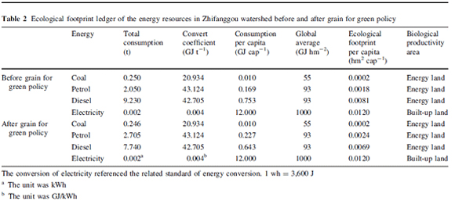

Source: Environmental Earth Sciences (2009) 59:529–536

### **Figures**

Figures are ideal for presenting:

* Images
* Data plots
* Maps
* Schematics

Just like tables all figures need to have a clear and concise legend caption to accompany them.

**Images**

Images help readers visualize the information you are trying to convey. Often, it is difficult to be sufficiently descriptive using words. Images can help in achieving the accuracy needed for a scientific manuscript. For example, it may not be enough to say, “The surface had nanometer scale features.” In this case, it would be ideal to provide a microscope image.

For images, be sure to:

* Include scale bars
* Consider labeling important items
* Indicate the meaning of different colours and symbols used

**Data plots**

Data plots convey large quantities of data quickly. The goal is often to show a functional or statistical relationship between two or more items. However, details about the individual data points are often omitted to place emphasis on the relationship that is shown by the collection of points. Here, we have examples of figures combining images and a plots in multiple panels.

For data plots, be sure to:

* Label all axes
* Specify units for quantities
* Label all curves and data sets
* Use a legible font size

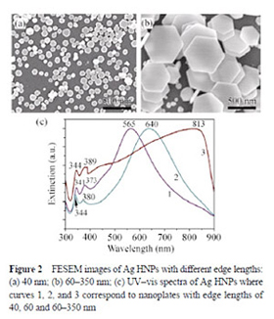

Source: Nano Research (2010) 3:843–851

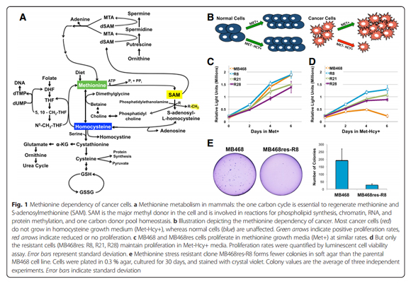

Source: Borrego et al. Cancer & Metabolism 2016 4:9

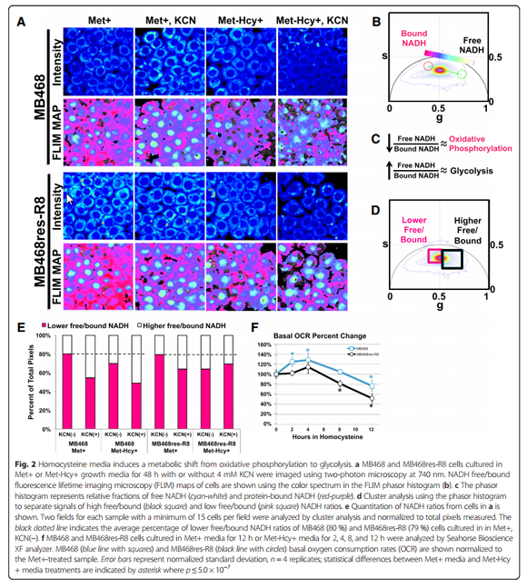

Source: Borrego et al. Cancer & Metabolism 2016 4:9

**Maps**

Maps are important for putting field work in the context of the location where it was performed. A good map will help your reader understand how the site affects your study. Moreover, it will help other researchers reproduce your work or find other locations with similar properties. Here, we have a map used in a study about salmon.

For maps, be sure to:

* Include latitude and longitude
* Include scale bars
* Label important items
* Consider adding a map legend

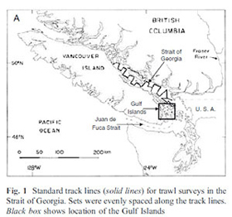

Source: Environmental Biology of Fishes (2011) DOI: 10.1007/s10641-011-9783-5

**Schematics**

Schematics help identify the key parts to a system or process. They should highlight only the key elements because adding unimportant items may clutter the image. A schematic only includes the drawings the author chooses, offering a degree of flexibility not offered by images. They can also be used in situations where it is difficult or impossible to capture an image. Below is a schematic explaining how nanotubes could be used to harvest energy from a fluid.

For schematics, be sure to:

* Label key items
* Provide complementary explanations in the caption and main text

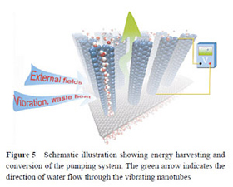

Source: Nano Research (2011) 4:284–289

TIP: it’s important to consider how your figures will look in print as well as online. A resolution of 72 ppi is sufficient for online publication whilst in print 100 ppi is recommended. You can adjust the resolution of your figure within the original program you used to create it at the time you save the file.

TIP: There are two main colour models; RGB which stands for red, green, blue and CMYK or cyan, magenta, yellow and black. Most microscopes will take images using the RGB however CMYK is the standard used for printing so it is important to check that your figures will display well in this format.

### **Avoiding image manipulation**

You should never knowingly manipulate your images to change or improve you results. To avoid inadvertent manipulation you should only minimally process your figures before submitting them to the journal, your submitted images should faithfully represent the original image files.

* Adjusting the brightness or contrast of an image, in fluorescent microscopy for example, is only acceptable if applied equally across all images including the controls
* The cropping of images in the creation of figures should be avoided unless it significantly improves the clarity of conciseness of presentation. Be sure that the cropping does not exclude any necessary information for the understanding of the figure, such as molecular markers in electrophoresis gels.
* Any adjustments or processing software used should be stated.

TIP: keep copies of the original images, files and metadata used to create your figures as these can be requested by the journal during the review process.

# Acknowledgments and References

### **Acknowledgments**

This usually follows the Discussion and Conclusions sections. Its purpose is to thank all of the people who helped with the research but did not qualify for authorship (check the target journal’s Instructions for Authors for authorship guidelines). Acknowledge anyone who provided intellectual assistance, technical help (including with writing and editing), or special equipment or materials.

TIP: The International Committee of Medical Journal Editors has detailed guidelines on who to list as an author and who to include in the Acknowledgments that are useful for scientists in all fields.

Some journals request that you use this section to provide information about funding by including specific grant numbers and titles. Check your target journal’s instruction for authors for specific instructions. If you need to include funding information, list the name(s) of the funding organization(s) in full, and identify which authors received funding for what.

### **References**

As references have an important role in many parts of a manuscript, failure to sufficiently cite other work can reduce your chances of being published. Every statement of fact or description of previous findings requires a supporting reference.

TIP: Be sure to cite publications whose results disagree with yours. Not citing conflicting work will make readers wonder whether you are really familiar with the research literature. Citing conflicting work is also a chance to explain why you think your results are different.

It is also important to be concise. You need to meet all the above needs without overwhelming the reader with too many references—only the most relevant and recent articles need to be cited. There is no correct number of references for a manuscript, but be sure to check the journal’s guidelines to see whether it has limits on numbers of references.

TIP: Never cite a publication based on what you have read in a different publication (such as a review), or based only on the publication’s abstract. These may mislead you and readers. Read the publication itself before you cite it, and then check the accuracy of the citation again before submitting your manuscript.

You should reference other work to:

* **Establish the origin of ideas**

When you refer to an idea or theory, it is important to let your readers know which researcher(s) came up with the idea. By citing publications that have influenced your own work, you give credit to the authors and help others evaluate the importance of particular publications. Acknowledging others’ contributions is also an important ethical principle.

* **Justify claims**

In a scientific manuscript, all statements must be supported with evidence. This evidence can come from the results of the current research, common knowledge, or from previous publications. A citation after a claim makes it clear which previous study supports the claim.

* **Provide a context for your work**

By highlighting related works, citations help show how a manuscript fits into the bigger picture of scientific research. When readers understand what previous studies found and what puzzles or controversies your study relates to, they will better understand the meaning of your work.

* **Show there is interest your field of research**

Citations show that other researchers are performing work similar to your own. Having current citations will help journal editors see that there is a potential audience for your manuscript.

Formatting your manuscript

It is important to format your manuscript according to your target journal’s requirements, which can be found in the Instructions for Authors. This will speed up the submission process because the journal’s editorial team will not have to send your manuscript back to you for formatting. It can also increase your chances of success because you will not omit materials that the journal might require.

*TIP: Before writing a complete draft of your manuscript, it is a good idea to select an initial target journal. Read the formatting requirements for the journal on its website, then write your draft. This could save you a lot of time, as you won’t have to reformat an already-written manuscript after selecting the journal!*

Review all guidelines and ensure that your manuscript meets them. Have you:

* Obeyed all wor**d and character limits** (title, running title, abstract, manuscript text)?
* Included all **required**sections?
* Met **language**requirements (US or UK English)?
* Supplied all requested **contact information**?
* Inserted **figures**in the correct location (in text, end of manuscript, separate files)?
* Correctly formatted **references**?
* Used the correct **file format** for your images (.jpg, .png, .pdf, .ppt)?
* Stated **ANY conflicts of interest**?
* Included details of any required ethics and regulatory **permissions**?
* Obtained consent from ALL authors?

*TIP: Some journals provide templates to assist authors. Also look for template style files for use with your reference manager.*

*Click to download the free 'Writing a Journal Article: Cheat Sheet'*