Cite the data you use and produce

... to credit the data producer and to help readers find the data

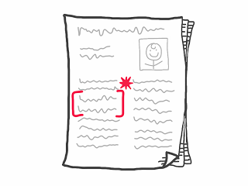

Cite the dataset following the [instructions here](http://www.dcc.ac.uk/resources/how-guides/cite-datasets#x1-5000).  Alternatively, cite the publication that describes the data.

Prevent data distortions and manipulation

... to retain data integrity and the accuracy of research results   
  
Conduct the following completely and accurately:

* Write descriptions of the data collection conditions
* Record the equipment used and its responses
* Retain a copy of the raw original data
* Document all changes made to the data

Know your intellectual property rights and obligations for data

... to protect your interests and to prevent infringements   
  
You can **not** copyright data, but you can copyright an expression of the data like a table or chart in a book.  If this raises concerns for you, re-consider data sharing.  Furthermore, laws about data vary outside the U.S.

Data providers may license data with limits on how the data can be used (e.g., forbidding for-profit use or requiring attribution).  Therefore, when using data collected from other sources, check for a license and its terms of use.

Follow the ethical and legal requirements for research data

... to ensure compliance with federal, state, and university regulations