DEPARTMENT OF PREVENTION OF COMMUNICATION DISORDERS (POCD)

**MONTHLY REPORT**- **AUGUST-2018**

**1 ACADEMIC ACTIVITIES**

1. **No. of short-term training programs organized: Nil**
2. **No. of orientation/Sensitization programs organized: 11**

As part of primary prevention activities, several orientation/Sensitization programs are being conducted regularly. The objective of the orientation programs was to create awareness among general public and various other professionals such as Medical doctors, Nurses, Health related workers, teachers, school students etc., on different types of communication disorders, its prevention and early identification methods and their appropriate referral and timely management. Table 1& 2 shows the details of the orientation programs conducted by the dept. of POCD.

Table 1: Orientation Programs conducted by the Department of POCD in the month of August 2018.

|  |  |  |  |  |  |  |
| --- | --- | --- | --- | --- | --- | --- |
| **I. Orientation Programs at POCD : 3** | | | | | | |
| Theme/Topic of the program: Prevention & early identification of communication disorders  Coordinators: Dr. Swapna. N, Dr. Prawin Kumar & Mr. Arunraj K. | | | | | | |
| **Sl.No** | **Date** | **Name of the institute/**  **Hospital** | **Target group** | **Total participants** | **Oriented by** | |
| 1. | 24.08.2018 | Sigma Hospital , Mysore | Nurses | 10 | Ms. Nayana (Audiologist G-I) and  Ms. Pavana (Audiologist G-II) | |
| 2. | 31.08.2018 | Govt Higher primary School, Nagawala ,Mysore | Teachers | 06 | Mr. Rajith (Audiologist G-I) and Ms. Shreelakshmi (Audiologist G-I) | |
| 3. | 31.08.2018 | Christ College,  Bangalore | UG Students | 35 | Ms. Pavana (Audiologist G-II) | |
| **II. Orientation Programs at NBS centres:2** | | | | | | |
| Theme/Topic of the program: Prevention & early identification of communication disorders Coordinators: Dr. Swapna. N, , Dr. Prawin Kumar & Mr. Arunraj K. | | | | | | |
| 1. | 30.08.2018 | RIMS, Ranchi | Nursing student | 27 | Mr. Mukesh Kumar (Audiologist G-I) | |
| 2. | 28.08.2018 | RIMS Hospital, Imphal | Doctors | 45 | Ms. P. Meenakshi Chanu (Audiologist G-I) | |
| **III. Orientation Programs at OSC centres: 6** | | | | | | |
| Theme/Topic of the program: Prevention & early identification of communication disorders Coordinators: Dr. Swapna. N, , Dr. Prawin Kumar & Mr. Arunraj K. | | | | | | |
|  | 29.08.2018 | Nirmala convent High School  sagara | School Student | 30 | | Mr. Mohan Das (Audiologist G-I) |
|  | 16.08.2018 | PHC, Hullahalli | Parents | 7 | | Ms Tanuja  (Intern, AIISH) |
|  | 07.08.2018 | VMH, Saragur | ASHA workers | 21 | | Ms. Lavanya  (Audiologist G-I) |
|  | 13.08.2018 | VMH, Saragur | ASHA workers | 14 | | Ms. Lavanya  (Audiologist G-I) |
|  | 17.08.2018 | VMH, Saragur | ASHA workers | 27 | | Ms. Deepashree  (Audiologist G-I) |
|  | 21.08.2018 | VMH, Saragur | ASHA workers | 32 | | Ms. Lavanya  (Audiologist G-I) |
| **Total** | | | | **254** | | |

Table 2: Total number of participants oriented in the month of August 2018.

|  |  |  |  |  |
| --- | --- | --- | --- | --- |
| **S.No** | **Target group** | **Gender** | | **Total number of Participants** |
| **Male** | **Female** |
|  | Students | 6 | 59 | 30 |
|  | Nursing Students | 1 | 36 | 27 |
|  | ASHA worker | 0 | 94 | 94 |
|  | School Teachers | 3 | 3 | 6 |
|  | Parents | 0 | 7 | 7 |
|  | Doctors | 18 | 16 | 34 |
|  | Audiologist/ Speech Therapist | 6 | 5 | 11 |
| **Total** | | **34** | **220** | **254** |

**iii.Training programs conducted: Nil**

**iv.Clinical Observation postings of students from other Institutes: 6**

|  |  |  |  |  |
| --- | --- | --- | --- | --- |
| Sl.no | Date of Postings | UG/PG Students | Designation | Institute/University |
| 1 | 18.07.2018-03.08.2018 | Intern | B.ASLP | [Ashtavakra Institute of Rehabilitation Sciences](http://int.search.myway.com/search/GGmain.jhtml?ct=ARS&n=781c55df&p2=%5EGR%5Exdm731%5ETTAB02%5Ein&pg=GGmain&pn=1&ptb=FF220395-40C6-4664-A316-6878D1E3B162&qs=&si=YLyHErnWXd&ss=sub&st=tab&trs=wtt&searchfor=Ashtavakra+Institute+of+Rehabilitation+Sciences&feedurl=ars%252Ffeedback%253ForiginalQuery%253Dashtavakra%252Buniversity%2526relatedQuery%253Dashtavakra%252Binstitute%252Bof%252Brehabilitation%252Bsciences&tpr=jrel3) and research,  Delhi |
| 2 | 06.08.2018-14.08.2018 | Intern | B.ASLP | [Ashtavakra Institute of Rehabilitation Sciences](http://int.search.myway.com/search/GGmain.jhtml?ct=ARS&n=781c55df&p2=%5EGR%5Exdm731%5ETTAB02%5Ein&pg=GGmain&pn=1&ptb=FF220395-40C6-4664-A316-6878D1E3B162&qs=&si=YLyHErnWXd&ss=sub&st=tab&trs=wtt&searchfor=Ashtavakra+Institute+of+Rehabilitation+Sciences&feedurl=ars%252Ffeedback%253ForiginalQuery%253Dashtavakra%252Buniversity%2526relatedQuery%253Dashtavakra%252Binstitute%252Bof%252Brehabilitation%252Bsciences&tpr=jrel3) and research,  Delhi |
| 3 | 20.08.2018-31.08.2018 | Intern | B.ASLP | [Ashtavakra Institute of Rehabilitation Sciences](http://int.search.myway.com/search/GGmain.jhtml?ct=ARS&n=781c55df&p2=%5EGR%5Exdm731%5ETTAB02%5Ein&pg=GGmain&pn=1&ptb=FF220395-40C6-4664-A316-6878D1E3B162&qs=&si=YLyHErnWXd&ss=sub&st=tab&trs=wtt&searchfor=Ashtavakra+Institute+of+Rehabilitation+Sciences&feedurl=ars%252Ffeedback%253ForiginalQuery%253Dashtavakra%252Buniversity%2526relatedQuery%253Dashtavakra%252Binstitute%252Bof%252Brehabilitation%252Bsciences&tpr=jrel3) and research,  Delhi |
| 4 | 01.08.2018 | Postgraduate | M.Sc. Food sciences and Nutrition | University of Mysore,  Manasagangothri,  Mysore |
| 5 | 21.08.2018 | Postgraduate | M.Sc. Cognitive Neuro-sciences | JSS College, Mysore |
| 6 | 21.08.2018 | Postgraduate | M.Sc. Cognitive Neuro-sciences | JSS College, Mysore |

V. No. of Seminars/ Conferences /Lectures /Workshop organized by the dept – Nil

Workshops organized by the Department: Nil

Conferences organized by the Department: Nil

Vi. No. of Seminars/ Conferences /Lectures /Workshop attended by the staff of the Dept

No. of Conferences attended by Staff of POCD: Nil

Workshops attended by Staff of POCD: Nil

Seminars attended by Staff of POCD: Nil

Guest Lectures attended by staff of POCD: Nil

vii. No. of Guest Lectures organized: Nil

viii. No. of Invited Talks delivered by faculty and staff: Nil

ix. Any other:

* Student clinical training: As part of human resource development, clinical training for Undergraduates (B.Sc Speech & Hearing), Postgraduates (M.Sc SLP & AUD) & Internship students on early identification, prevention & rehabilitation of communication disorders and Community based rehabilitation at OSCs were carried out. The details on the number of students who had undergone training are given below.

|  |  |  |
| --- | --- | --- |
| **Internal (AIISH)** | | |
| **Class** | **No of students Newly posted** | **No of Students continuing** |
| II B.ASLP students | 9 | 0 |
| I M.Sc (Speech ) students | 5 | 0 |
| I M.Sc (Audiology) students | 10 | 0 |
| B.ASLP Internship students | 6 | 4 |
| **Total** | **30** | **4** |
| **External** | | |
| BASLP Student (Intern) | 2 | 1 |
| M.Sc. cognitive neuro-sciences | 2 | 0 |
| M.Sc. Food sciences and Nutrition | 1 | 0 |
| **Total** | **5** | **1** |

* **Staff/Student Enrichment Programs: Nil**

1. **Research Projects: Nil**
2. **Doctoral and Post-Doctoral Programs:** Nil
3. **Research papers presented in National conferences/seminars:** Nil
4. **Research papers presented at International conferences/seminars:** Nil
5. **Research Papers published in National Conference/Seminar Proceedings:** Nil
6. **Research Papers published in International Conference/Seminar Proceedings:** Nil
7. **Research Papers published in National Journals:** Nil
8. **Research Papers published in International Journals:** Nil
9. **Book / Chapters Published:** Nil
10. **Books / Manuals/ Seminar proceedings Edited: NIL**
11. **Scholarly Reviewing Activities:** Nil
12. **Research Proposal:** Nil

3. CLINICAL SERVICES

1. General Clinical Services
2. Follow-up evaluation- Detailed evaluation

The newborns/infants referred during the newborn screening were followed up through telephone calls to parents/caregivers of infants. A complete test battery was administered for those clients who came for follow-up. Table 4 (a) & (b) depicts the statistics related to this activity.

Table 4 (a): Details of the results of follow-up evaluation for newborns and infants.

|  |  |  |  |  |  |  |  |  |  |  |  |
| --- | --- | --- | --- | --- | --- | --- | --- | --- | --- | --- | --- |
| **Categories** | **AIISH + Cheluvamba** | **OSC Sarguru** | **OSC-Sagara** | **Ajmer** | **Cuttack** | **Imphal** | **Puducherry** | **Ranchi** | **Jabalpur** | **Lucknow** | **Total** |
| **Normal** | 2 | 12 | 1 | 0 | 05 | 19 | 35 | 0 | 0 | 08 | **82** |
| **ENT disorders** | 0 | 0 | 0 | 0 | 00 | 3 | 0 | 0 | 0 | 00 | **3** |
| **Auditory Maturation delay** | 0 | 0 | 0 | 0 | 00 | 00 | 0 | 0 | 0 | 0 | **0** |
| **Hearing impairment** | 0 | 0 | 0 | 0 | 05 | 1 | 09 | 0 | 0 | 03 | **18** |
| **Speech & language disorder** | 0 | 0 | 0 | 0 | 00 | 6 | 0 | 0 | 0 | 0 | **6** |
| **Multiple Disorder** | 0 | 0 | 0 | 0 | 00 | 1 | 0 | 0 | 0 | 0 | **1** |
| **Incomplete testing** | 0 | 0 | 1 | 16 | 00 | 0 | 03 | 0 | 0 | 0 | **20** |
| **Total** | **2** | **12** | **2** | **16** | **10** | **30** | **47** | **0** | **0** | **11** | **130** |

The at-risk babies were monitored regularly by administering the speech-language & hearing checklist through phone call. The babies who are identified with delay in the milestones were referred to AIISH/concern NBS centre for detailed evaluation.

Table 4(b)**:** Follow-up evaluation- Phone follow-up

|  |  |  |  |
| --- | --- | --- | --- |
| **Categories** | **Mysuru Centre (POCD)** | **NBS Centers** | **OSC Centers** |
| Normal speech, language & hearing milestones | 0 | 179 | 15 |
| Referred for detailed evaluation | 0 | 12 | 10 |
| **Total Phone follow up** | **0** | **191** | **25** |

ii) Hearing evaluation of industrial workers at AIISH: Nil

iii) Specialized Clinical services: Nil

iv) Clinical Support Services to Patients and Family: Nil

v)Clinical Electronic Services: Nil

B) EXTENSION ACTIVITIES

i) Newborn screening for Communication Disorders

The department of POCD is actively involved in carrying out various extension activities such as screening, diagnostic and rehabilitation services outside the institute campus. The activities include newborn/infant screening, screening of school children, screening of elderly citizens, screening of industrial workers, conducting camps and also clinical services offered at the outreach service centers of AIISH.

Table 5: Total number of newborns/infants screened and identified at-risk for Communication disorders.

|  |  |  |  |  |  |  |  |  |  |
| --- | --- | --- | --- | --- | --- | --- | --- | --- | --- |
| **SN** | **Hospitals/Immunization Centers** | **Total births** | **Total No. Screened** | | | | **Total No. at risk** | | |
| **Male** | **Female** | | **Total** | **Male** | **Female** | **Total** |
|  |  | **AIISH- Mysuru** | | | | | | |  |
|  | Combined Hospital (CH) | **45** | 16 | 18 | | **34** | 0 | 1 | **1** |
|  | Kamakshi Hospital (KH) | **172** | 65 | 63 | | **128** | 1 | 0 | **1** |
|  | KR Hospital (KRH)- Cheluvamba | **955** | 370 | 379 | | **749** | 4 | 4 | **8** |
|  | Mission Hospital (MH) | **67** | 27 | 25 | | **52** | 2 | 1 | **3** |
|  | S.M.T.D.H Hospital | **57** | 17 | 21 | | **38** | 0 | 0 | **0** |
|  | Railway Hospital (RH) | **NA** | 0 | 2 | | **2** | 0 | 0 | **0** |
|  | Ashwini Nursing Home (ANH) | **24** | 11 | 8 | | **19** | 0 | 0 | **0** |
|  | Shree Devi Nursing Home (SNH) | **30** | 11 | 5 | | **16** | 0 | 0 | **0** |
|  | GopalaGowdaShanthaveri Memorial Hospital (GGSMH) | **13** | 9 | 7 | | **16** | 1 | 0 | **1** |
|  | Mahadeshwara Nursing Home (MNH) | **38** | 12 | 3 | | **15** | 0 | 0 | **0** |
|  | Sigma Hospital (SH) | **62** | 33 | 27 | | **60** | 0 | 0 |  |
|  | Brindavan Hospital | **57** | 13 | 19 | | **32** | 2 | 0 | **2** |
|  | **Total (Mysuru hospitals)** | **1520** | **584** | **577** | | **1161** | **10** | **6** | **16** |
| **Newborn screening at OSC Centers** | | | | | | | | | |
| 1. 18. | Sub-divisional hospital, K R Nagar Taluk | **176** | 22 | 21 | | **43** | 0 | 0 | **0** |
| 1. 19. | Sub-divisional hospital, T NarsipuraTaluk | **74** | 17 | 9 | | **26** | 0 | 1 | **1** |
| 1. 20. | Sub-divisional Hospital, SagaraTaluk | **121** | 60 | 47 | | **107** | 2 | 1 | **3** |
| 1. 21 | Sub-divisional hospital, Sarguru | **248** | 125 | 113 | | **238** | 7 | 3 | **10** |
| Immunization\* | **NA** | 10 | 6 | | **4** | 0 | 0 | **0** |
| 1. 22. | Community Health Centre (CHC), Hullahalli | **16** | 1 | 9 | | **10** | 0 | 0 | **0** |
| 1. 23. | Community Health Centre (CHC), Santhemarahalli | **13** | 2 | 2 | | **4** | 0 | 0 | **0** |
| 1. 24. | Primary Health Centre (PHC), Akkihebbalu | **5** | 0 | 3 | | **3** | 0 | 0 | **0** |
|  | **Total (OSCs)** | **653** | **237** | **210** | | **447** | **9** | **5** | **14** |
| **Screening at NBS Centers** | | | | | | | | | |
| 1. 25. | Sri RamachandraBhanj Medical College and Hospital (SCB MCH), Cuttack | **367** | 200 | 66 | **266** | | 19 | 05 | **24** |
| 1. 26. | Regional Institute of Medical Sciences (RIMS), Imphal | **327** | 155 | 167 | **322** | | 8 | 10 | **18** |
| 1. 27. | Janana Hospital & JLNMCH, Ajmer | **991** | 444 | 434 | **964** | | 60 | 26 | **86** |
| 1. 28. | JIPMER, Puducherry | **1430** | 611 | 589 | **1200** | | 36 | 17 | **53** |
| 1. 29. | NetajiSubhash Chandra Bose Medical College (NSCB), Jabalpur | **566** | 289 | 224 | **513** | | 92 | 64 | **156** |
| 1. 30. | Rajendra Institute of Medical Sciences, Baritayu, Ranchi | **523** | 214 | 170 | **384** | | 22 | 16 | **38** |
| 1. 31. | Kings George’s Medical University, Lucknow | **NA** | 193 | 149 | **342** | | 21 | 15 | **36** |
|  | **Total (NBS centers)** | **4204** | **2106** | **1799** | **3905** | | **258** | **153** | **411** |
|  | **Overall Total** | **12469** | **2927** | **2586** | **5513** | | **277** | **164** | **441** |

**ii) School/ Anganawadi screening: 6**

|  |  |  |  |  |  |  |  |  |  |
| --- | --- | --- | --- | --- | --- | --- | --- | --- | --- |
| **Sl. No** | **Date** | **Name of the Anganawadi/ School** | **Total screened** | **Total identified with communication disorders** | | | | | |
| **Ear related disorder** | **Hearing loss** | **Speech language disorders** | | | |
| **Fluency** | **voice** | **language** | **Articulation** |
| 1 | 28/08/2018 | St. Joseph higher primary School, Sagara | 440 | 2 | 2 | 0 | 0 | 6 | 0 |
| 2 | 29/08/2018 | Nirmala convent High School, Sagara | 349 | 1 | 4 | 0 | 0 | 2 | 0 |
| 3 | 27.08.2018 and 31.08.2018 | Govt. Higher primary school, Nagawala, Mysore | 143 | 5 | 1 | 0 | 1 | 1 | 2 |
|  | **Total** | | **932** | **8** | **7** | **12** | | | |

**iii)Hearing screening of Industrial employees: Nil**

**iv)Clinical services for the Elderly citizens: Nil**

**v)**. **Clinical Services at Outreach Service Centers (OSCs):**

The clinical activities are not only restricted to in and around Mysore, but also extended to rural areas where facilities for clinical services for persons with communication disorders were meager. Currently 05 OSCs (01 VMH, Saragur, HD Kote; 02 Sub-divisional taluk hospital at Sagara taluk, Shivamogga District; 03 Primary Health Centre - PHC at Hullahalli, Mysuru district; 04 Akkihebbalu, Mandya district & 05 Karuna trust, Gumballi, Chamarajanagara district) were initiated to meet the objective of extending the services of the institute to rural areas. The OSCs are functioning as a well-equipped unit for screening, diagnostics and therapeutic services for persons with communication disorders. The services include screening, diagnostic and rehabilitation which includes newborn/infant screening, screening of school children, Speech and Language evaluation, Audiological evaluation, ENT evaluation, Speech-Language therapy, issue of free body level hearing aids and ear molds, and counseling and guidance to individuals with communication disorders. The other details are tabulated below in tables 8, 9 & 10.

Table 8: Details of clients identified with communication disorders at the OSCs.

|  |  |  |  |  |  |  |  |  |
| --- | --- | --- | --- | --- | --- | --- | --- | --- |
| **OSC** | **Total Registered** | **ENT Evaluation=95**  **Registered=124** | | | **Hearing Evaluation=62**  **Registered=47** | | **Speech & Language Evaluation=11**  **Registered= 19** | |
| **Normal (Ear Wise)** | **Disorder (Ear wise)** | **ENT related**  **Others** | **Normal (Ear Wise)** | **Disorder (Ear wise)** | **Normal (Individuals)** | **Disorder (Individuals)** |
| **Primary Health Centre (PHC), Hullahalli** | 31 | 10 | 30 | 4 | 0 | 12 | 0 | 1 |
| **Primary Health Centre (PHC), Akkihebbalu** | 36 | 11 | 37 | 8 | 0 | 8 | 0 | 0 |
| **Primary Health Centre (PHC), Gumballi** | 55 | 19 | 37 | 11 | 2 | 24 | 0 | 3 |
| **Sub-divisional Hospital (PHC), Sagara** | 26 | 0 | 0 | 0 | 12 | 36 | 0 | 2 |
| **VMH, Sarguru** | 20 | 0 | 0 | 0 | 13 | 17 | 1 | 4 |
| **Total** | **168** | **40** | **104** | **23** | **27** | **97** | **1** | **10** |

Table 8a.: Details of clients followed up (Old clients) at the OSCs.

|  |  |  |  |  |  |  |  |  |
| --- | --- | --- | --- | --- | --- | --- | --- | --- |
| **OSC** | **Total Follow up** | **ENT Evaluation =54** | | | **Hearing Evaluation=21** | | **Speech & Language Evaluation= 2** | |
| **Normal (Ear Wise)** | **Disorder (Ear wise)** | **ENT related**  **Others** | **Normal (Ear Wise)** | **Disorder (Ear wise)** | **Normal (Individuals)** | **Disorder (Individuals)** |
| **Primary Health Centre (PHC), Hullahalli** | 19 | 3 | 11 | 6 | 0 | 12 | 0 | 0 |
| **Primary Health Centre (PHC), Akkihebbalu** | 20 | 10 | 12 | 1 | 0 | 16 | 0 | 0 |
| **Primary Health Centre (PHC), Gumballi** | 36 | 9 | 31 | 2 | 0 | 26 | 0 | 1 |
| **Sub-divisional Hospital (PHC), Sagara** | 0 | 0 | 0 | 0 | 0 | 0 | 0 | 0 |
| **VMH, Sarguru** | 16 | 0 | 0 | 0 | 2 | 18 | 0 | 6 |
| **Total** | **91** | **22** | **54** | **9** | **2** | **72** | **0** | **7** |

Table 9: Details of clients identified with different types of communication disorders across OSCs (New and old cases)

|  |  |  |  |  |  |
| --- | --- | --- | --- | --- | --- |
| **Type of Disorders** | **OSC** | | | |  |
| Primary Health Centre (PHC), Hullahalli | Primary Health Centre (PHC), Akkihebbalu | Primary Health Centre (PHC), Gumballi | Sub-divisional Hospital, Sagara (PHC) Taluk | VMH,Sarguru |
| **Hearing disorders (Ear-wise data)** | | | | | |
| Normal | 0 | 0 | 0 | 12 | 15 |
| Conductive | 0 | 0 | 0 | 9 | 2 |
| Sensorineural | 22 | 21 | 12 | 20 | 21 |
| Mixed | 0 | 1 | 0 | 6 | 8 |
| Profound | 2 | 2 | 0 | 1 | 4 |
| **Total (ears)** | **24** | **24** | **12** | **48** | **50** |
| **Speech &Language disorders (Individuals)** | | | | | |
| Voice | 0 | 0 | 0 | 0 | 0 |
| Fluency | 0 | 0 | 0 | 1 | 1 |
| Articulation disorders | 0 | 0 | 0 | 0 | 1 |
| Language disorders | 1 | 0 | 1 | 1 | 8 |
| **Total (Individuals)** | **1** | **0** | **1** | **2** | **10** |

Table 10**:** Rehabilitation services provided at Outreach service centers

|  |  |  |  |  |
| --- | --- | --- | --- | --- |
| **OSC** | **Hearing Aids Dispensed** | **Speech-language therapy** | | **Medical Line of Treatment** |
| **No. of clients** | **No. of sessions** |
| Primary Health Centre (PHC), Hullahalli | 6 | 1 | 8 | 38 |
| Primary Health Centre (PHC), Akkihebbalu | 8 | 1 | 13 | 42 |
| Primary Health Centre (PHC), Gumballi | 6 | 3 | 12 | 41 |
| Sub-divisional Hospital, Sagara (PHC) Taluk | 1 | 19 | 85 | 0 |
| VMH, Sarguru | 5 | 13 | 27 | 0 |
| **Total** | **26** | **37** | **145** | **121** |

C)Communication Disorders Screening Camps:Nil

i. Organized by the Institute/POCD/ Others: Nil

D. SPECIAL ACTIVITIES

1. Library and information services – Nil
2. Public Information Activities – Nil
3. Exhibition: Nil
4. Material Development

Department of Prevention of Communication Disorders (POCD) is actively involved in the preparation of Public Education Materials (PEMs) as part of primary prevention. As a part of Annual Day celebration on 9th August 2018, the following pamphlets were released.

**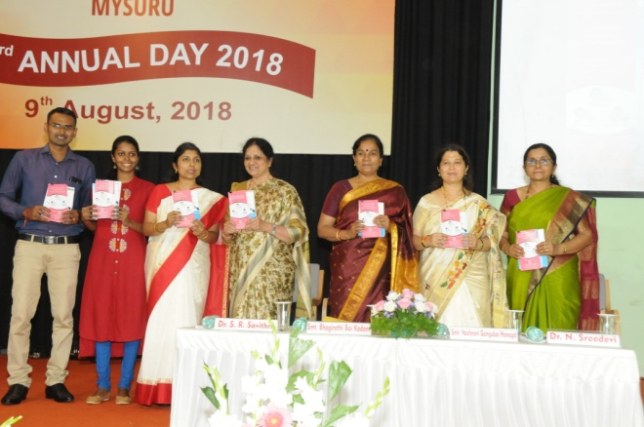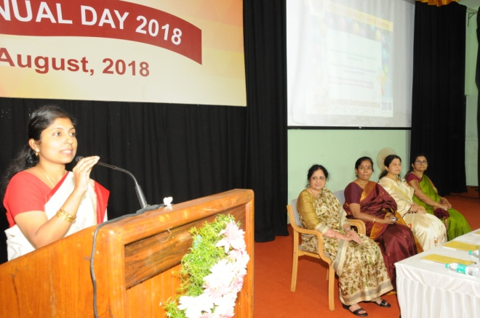**

* Know more about Voice and its disorders (English)
* Know this to prevent communication disorders (English)
* Specific Language Impairment (English)
* Communication disorders in elderly (English)
* Know more about Dementia (English)
* Prevention of developmental disorders (English)
* Communication disorders in Intellectual disability (English)
* Attention Deficit Hyperactivity Disorder (Kannada, Hindi, Tamil, Malayalam & Marathi)
* Ear discharge and its prevention (Hindi, Tamil)
* **Press Releases and Media Coverage:** Nil

v) PUBLIC LECTURE SERIES: Nil

vi) AWARDS AND HONOURS RECEIVED BY FACULTY AND STAFF: Nil

vii) TECNOLOGICAL CONSULTANCY SERVICES: Nil

viii) EXTRA CURRICULLAR ACTIVITIES: As a part of Annual Day celebration,a dance performance was given by Dr. Swapna N, HOD-POCD, Ms. Pavana Mohan & Ms. Nayana Mstaff of POCD along with staff from other Dept. of AIISH on 9th August 2018.

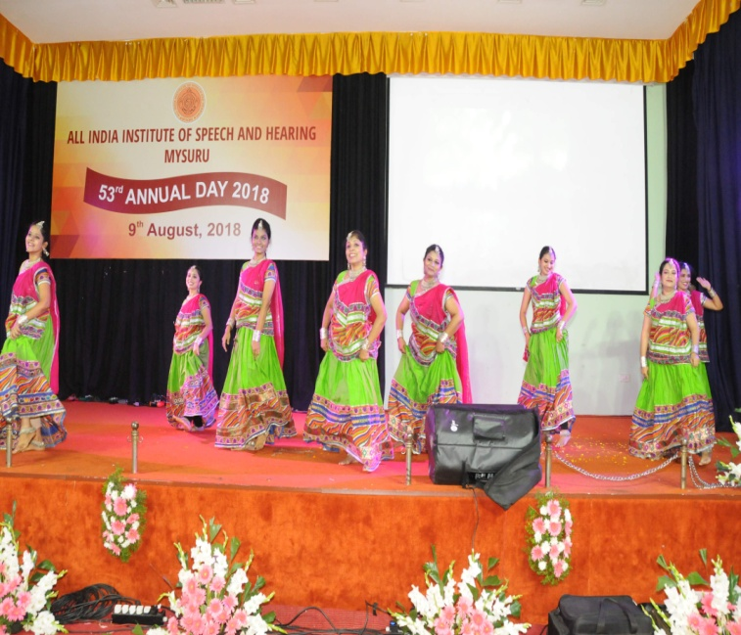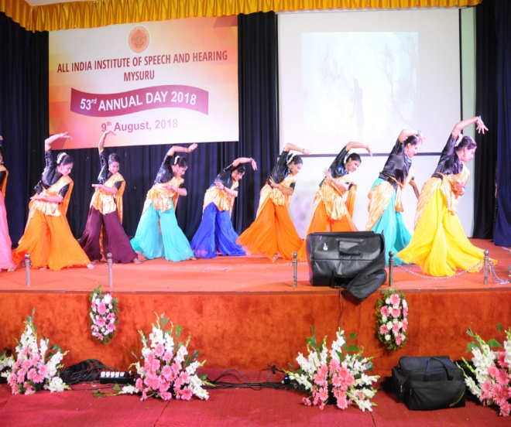

ix)VISITORS: Mr. Basavaraju V. S., State commissioner for Persons with Disability, Bengaluru visited Dept. of POCD on 9th August 2018.HOD, POCD gave a brief introduction about the activities carried out by Dept.

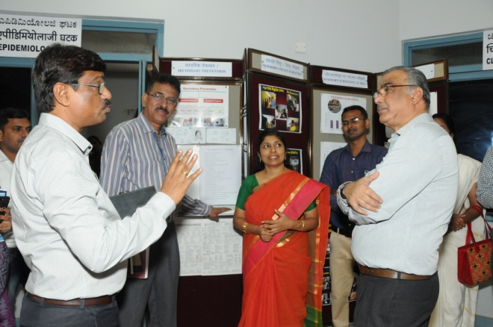

x) MAJOR EVENTS OF THE MONTH:

* Inauguration of two new NBS centers at Kings George Medical Hospital, Lucknow and Jawahar Lal Nehru Medical College and Hospital, Bhagalpur on AIISH Annual day on 9th August 2018 by byShri V S Basavaraju

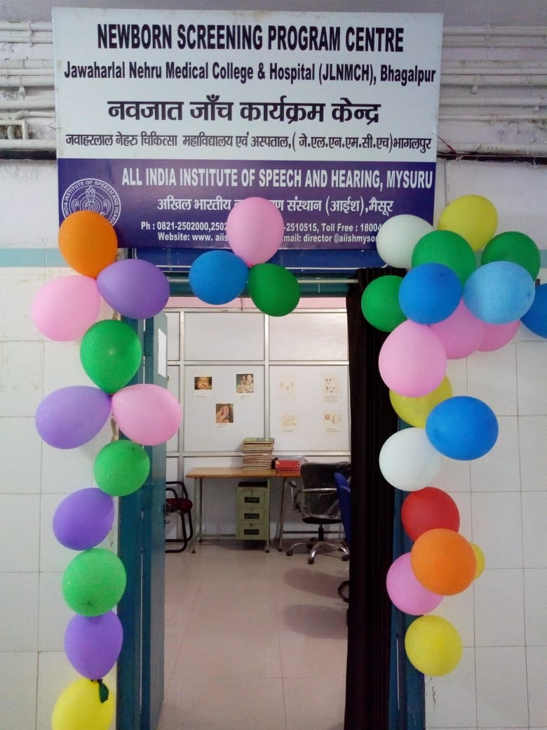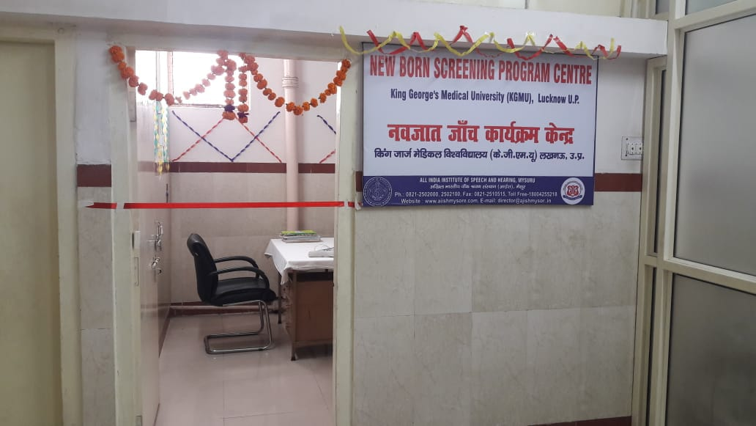

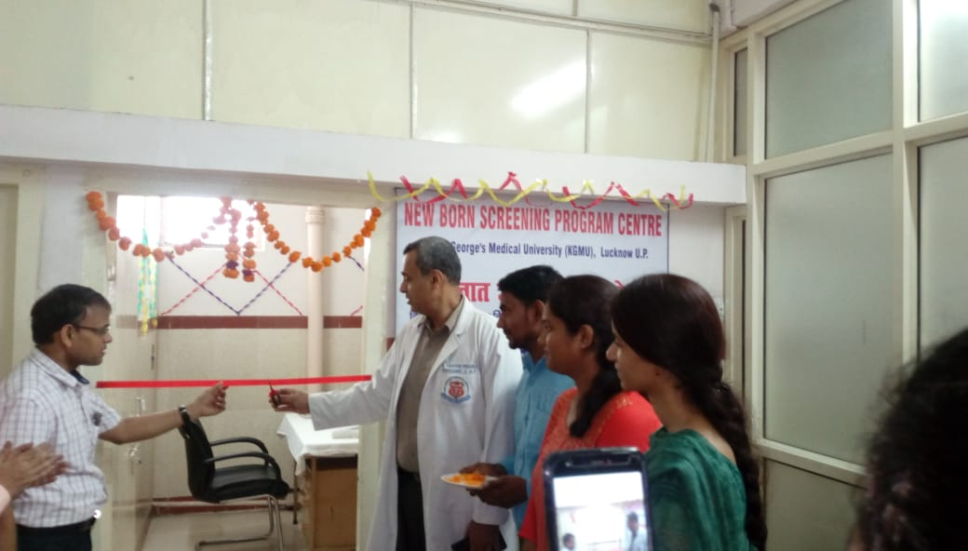

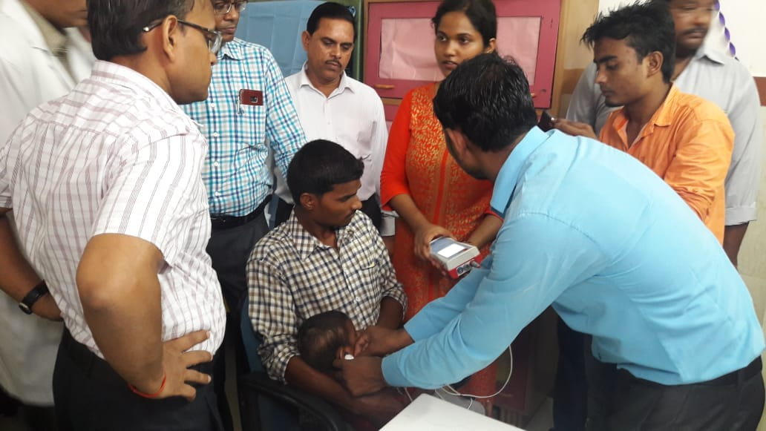

* Newborn Hearing Screening card, which will be given to the caretakers of newborn for documentation propose was released on 53rd Annual day 9th August 2018 by by **Shri V S Basavaraju.**

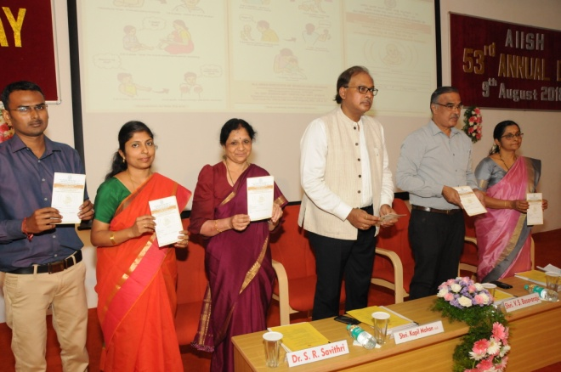

**xi) OTHERS:**

|  |  |  |
| --- | --- | --- |
| Dept. Related | | |
| S.No | Particulars |  |
|  | Computerization activities | OSC computerisation is in process. Audiology OPD format, Speech OPD format, two speech proformas were corrected. Three speech and language Proformas were given for correction. |
| b | OSC Related- | Nil |
| c | NBS related- | * Inauguration of two new NBS centers at KGMCH, Lucknow and JLNMCH, Bhagalpur on AIISH Annual day on 9th August 2018 by Shri V S Basavaraju. * NBS screening card was released on AIISH Annual day on 9th August 2018. * NBS meeting was conducted with Medical Officers in hospitals (Kamakshi, Sigma, SMTDH and ANH) for providing the room to the initiate AABR on 3rd August 2018. * Initiated AABR in Sigma hospital and Ashwini nursing home, Mysore. |

**xii) Following staffs were relieved from the department: 1**

|  |  |  |  |
| --- | --- | --- | --- |
| **Sl.No** | **Name of the staff** | **Designation** | **Reliving date** |
| 1 | Ms. Preethi.K | Data entry operator | 27.08.2018 |

**xiii)Following staffs were newly recruited to the department: Nil**

|  |  |  |  |
| --- | --- | --- | --- |
| **xiv)Activities carried out by the following staffs from the department** | | | |
| **Sl.No** | **Name of the staff** | **Designation** | **Activities** |
|  | Dr. Swapna. N | Associate Professor in Speech Pathology | Attended meeting with Medical Officers in hospitals (Kamakshi, Sigma, SMTDH and ANH) for providing the room to the initiate AABR on 3rd August 2018.  *Delivered 01 talk in the Orientation program on “*Prevention & early identification of communication disorders” organized by the Dept. of POCD for Mr. Basavaraju V. S., State commissioner for Persons with Disability, Bengaluru on 9th August 2018.  As a part of Annual Day celebration, a dance performance was given on 9th August 2018. |
|  | Dr. Prawin Kumar | Associate Professor in Audiology | Attended meeting with Medical Officers in hospitals (Kamakshi, Sigma, SMTDH and ANH) for providing the room to the initiate AABR on 3rd August 2018. |
|  | Ms. Sreelakshmi H D | Audiologist Grade I | *Delivered 01 talk in the Orientation program on “*Prevention & early identification of communication disorders” organized by the Dept of POCD for  School teachers of Nagawala, Govt. Higher primary School, Mysore on 31thAugust 2018.  Attended School screening conducted in Nagawala, Mysore on 31st August 2018. |
|  | Mr. Rajith B N | Audiologist Grade I | *Delivered 03 talk in the Orientation program on “*Prevention & early identification of communication disorders” organized by the Dept. of POCD for   * School teachers of Nagawala, Govt. Higher primary School, Mysore on 31thAugust 2018.   Attended School screening conducted in Nagawala, Mysore on 31st August 2018. |
|  | Ms. Akshatha Y | Audiologist Grade I | Prepared letters for requesting fund from external agencies for conducting national seminar. |
|  | Nayana M | Audiologist Grade I | *Delivered 03 talk in the Orientation program on “*Prevention & early identification of communication disorders” organized by the Dept. of POCD for   * Nurses of Sigma Hospital,Mysore on 24thAugust 2018.   As a part of Annual Day celebration, a dance performance was given on 9th August 2018. |
|  | Devamma V | Audiologist Grade I | Attended School screening conducted in Nagawala, Mysore on 27th August 2018.  Attended meeting with Medical Officers in hospitals (Kamakshi, Sigma, SMTDH and ANH) for providing the room to the initiate AABR on 3rd August 2018. |
|  | Bincy R Kalam | Speech Language Pathologist Grade I | Attended School screening conducted in Nagawala, Mysore on 31st August 2018.  Attended meeting with Medical Officers in hospitals (Kamakshi, Sigma, SMTDH and ANH) for providing the room to the initiate AABR on 3rd August 2018. |
|  | Pavana Mohan | Audiologist Grade II | *Delivered 03 talk in the Orientation program on “*Prevention & early identification of communication disorders” organized by the Dept. of POCD for   * Nurses of Sigma Hospital,Mysore on 24thAugust 2018. * College students of Christ College, Bangalore on 31st August 2018.   Attended School screening conducted in Nagawala, Mysore on 27th August 2018.  As a part of Annual Day celebration, a dance performance was given on 9th August 2018. |
|  | Usharani N S | Audiologist Grade II | Attended School screening conducted in Nagawala, Mysore on 27th August 2018. |
|  | Anju V A | Speech Language Pathologist Grade II | Attended School screening conducted in Nagawala, Mysore on 27th August 2018. |
|  | Ms. Tejaswini | Audiologist Grade I | Attended School screening conducted in Nagawala, Mysore on 27th August 2018. |

**Sd/-**

**Head, Dept. of POCD**

DEPARTMENT OF PREVENTION OF COMMUNICATION DISORDERS (POCD)

CUMMILATIVE REPORT

April 2018 to August 2018

1. **ACADEMIC ACTIVITIES**

* **Orientation/Short-term Training Programs: Nil**
* **No. of orientation/Sensitization programs organized: 58**

As part of primary prevention activities, several orientation/Sensitization programs were conducted regularly. The objective of this orientation programs was to create awareness among general public and various other professionals such as Medical doctors, Nurses, Health related workers, teachers, school students etc., on different types of communication disorders, its prevention and early identification methods and their appropriate referral and timely management. The table below shows the details of the orientation programs conducted by the dept. of POCD, OSCs & NBS centers.

|  |  |  |  |  |  |  |
| --- | --- | --- | --- | --- | --- | --- |
| **Sl. No** | **Date** | **Theme/Topic of the program** | **Name of the institute/**  **Hospital** | **Target group** | **Total participants** | **Oriented by** |
| **Organized by dept. of POCD**  **Coordinators: Dr.**  **Dr. Swapna. N** **& Mr. Arunraj K** | | | | | | |
|  | 25.04.2018 | “Prevention, early identification and management of communication disorders” | Govt. Ayurvedic College | Student | 48 | Ms. Anju  ( SLP Grade II)  &  Ms. Tejaswini (Audiologist Grade I) |
|  | 29.04.2018 | “Prevention, early identification and management of communication disorders” | SGS Hospital, Mysore | Elderly population | 29 | Dr. Swapna N Reader in Speech Pathology and Head, Department of POCD |
|  | 09.04.2018 | “Prevention, early identification and management of communication disorders” | PHC, Hampapura | Pregnant women and family members | 12 | Ms. Lavanya Audiologist Grade I |
|  | 26.04.2018 | “Prevention, early identification and management of communication disorders” | Regional institute of nursing, Jabalpur | Nursing student | 14 | MsThupakula  Saraswathi, Audiologist Gr. I |
|  | 27/04/2018 | “Prevention, early identification and management of communication disorders” | RIMS, Ranchi | Nursing student | 16 | Mukesh Kumar  Audiologist Gr. I |
|  | 27/04/2018 | “Prevention, early identification and management of communication disorders” | KGMU | DHLS students | 21 | Ms Meghana N  Audiologist Gr. I |
|  | 24/04/18 | “Prevention, early identification and management of communication disorders” | Naari Shala | Women at Rehabilitation centre (Naari Shala) and newborn caretakers | 21 | Mr. Anuj Kumar Neupane  Audiologist Gr. I |
|  | 04.05.2018 | “Prevention, early identification and management of communication disorders” | ROHCS, Bangalore | Industrial medical officer | 25 | Mr. Arun Raj  (Clinical Audiologist)  Ms.Pavana (Audiologist  Grade II)  Ms. Devamma (Audiologist  Grade I) |
|  | 18.05.2018 | “Prevention, early identification and management of communication disorders” | St. Agnes College  Mangalore | Psychology Students | 7 | Ms. Nayana (Audiologist Grade I) |
|  | 28.05.2018 | “Prevention, early identification and management of communication disorders” | Sarvodaya College of Education, Virajpet | B.Ed Student | 37 | Ms. Akshatha  & Ms.Sreelakshmi  (Audiologist Grade I) |
|  | 24/05/2018 | “Prevention, early identification and management of communication disorders” | RIMS, Ranchi | 2nd & 3rd year B. Sc. nursing student of Florence College of Nursing, Irba, Ranchi. | 29 | Mr.Mukesh Kumar  (Audiologist Grade I) |
|  | 26.05.2016 | “Prevention, early identification and management of communication disorders” | Nursing college, JIPMER | 2nd year nursing students | 10 | Ms Sylvia Treesa Sibi  (Audiologist Grade I) |
|  | 2/6/ 18 | “Prevention, early identification and management of communication disorders” | Primary Health Centre, Lamding , Thoubal District, Manipur. | ASHA workers, Doctor, Staff nurses and public. | 60 | Ms. P.Meenakshi Chanu  (Audiologist Grade I)  &  Mr. E. Dilip Singh  (Audiologist Grade I) |
|  | 27/04/2018 | “Prevention, early identification and management of communication disorders” | Qeen Mary’s Hospital  Lucknow | Nurses | 11 | Ms Meghana N  (Audiologist Grade I) |
|  | 19.05.2018 | “Prevention, early identification and management of communication disorders” | Sub Divisional Hospital Sagar | Publics | 40 | Mr.Mohan Dass. & M Jeena. TK  (Audiologist Grade I) |
|  | 23.05.2018 | “Prevention, early identification and management of communication disorders” | VMH, Sargur | Health facilitators/ Supervisors/ Program managers | 35 | Ms. Deepashree  (Audiologist Grade I) |
|  | 31.05.2018 | “Prevention, early identification and management of communication disorders” | VMH, Sargur | Mothers | 15 | Ms. Lavanya  (Audiologist Grade I) |
|  | 08.06.18 | Prevention, early identification and management of communication disorders” | St. Agnes College, Mangalore | Student | 8 | Ms. Anju  (Speech Language Pathologist Grade II)  & Ms. Nayana  (Audiologist GradeI) |
|  | 27.06.18 | Prevention, early identification and management of communication disorders” | St. Agnes College, Mangalore | Student | 7 | Ms. Nayana  (Audiologist GradeI) |
|  | 07.06.2016 | Prevention, early identification and management of communication disorders” | Nursing college, JIPMER | Medical record technicians, JIPMER | 22 | Ms. Sylvia Treesa Sibi  (Audiologist & Speech Language Pathologist) |
|  | 29/6/ 18 | Prevention, early identification and management of communication disorders” | Gyneacological Department Regional Institute of Medical Sciences, RIMS, IMPHAL | Pregnant women and women with High risk pregnancy | 70 | Ms. P.Meenakshi Chanu  (Speech Language Pathologist)  Mr. E. Dilip Singh  (Speech and Hearing Technician) |
|  | 28/06/2018 | Prevention, early identification and management of communication disorders” | RIMS, Ranchi | 1st year GNM nursing student of Hill View Nursing School, Bariatu Ranchi | 19 | Mr. Mukesh Kumar  (Audiologist GradeI) |
|  | 22/06/2018 | Prevention, early identification and management of communication disorders” | KGMU  Trauma Centre | Residental doctors | 05 | Ms Meghana N  (Audiologist GradeI) |
|  | 22.06.2018 | Prevention, early identification and management of communication disorders” | Govt PU College, Akkiheballu | Student | 66 | Ms. Lekshmi, Mr. Shobhan  (Interns)  & Ms. Bincy (Speech Language Pathologist Grade I) |
|  | 25.06.2018 | Prevention, early identification and management of communication disorders” | PHC, Akkiheballu | Anganawadi workers | 37 | Ms. Kajol, Ms. Rinsha (Interns)  & Mr. Rajith (Audiologist GradeI) |
|  | 26.06.2018 | Prevention, early identification and management of communication disorders” | PHC, Akkiheballu | ASHA workers | 8 | Ms. Kajol, & Ms. Rinsha  (Interns) |
|  | 19.06.2018 | Prevention, early identification and management of communication disorders” | VMH, Saragur | Health facilitators, Supervisors | 37 | Ms. Deepashree (Audiologist GradeI) |
|  | 20.06.2018 | Prevention, early identification and management of communication disorders” | VMH, Saragur | Health facilitators, Supervisors | 37 | Ms. Deepashree (Audiologist GradeI) |
|  | 22.06.2018 | Prevention, early identification and management of communication disorders” | VMH, Saragur | Aganawadi workers | 33 | Ms. Lavanya (Audiologist GradeI) |
|  | 25.06.2018 | Prevention, early identification and management of communication disorders” | VMH, Saragur | Counselling staff | 5 | Ms. Anoopa (Audiologist GradeI) |
|  | 29.06.2018 | Prevention, early identification and management of communication disorders” | VMH, Saragur | Aganawadi workers | 33 | Ms. Lavanya (Audiologist GradeI) |
|  | 18.07.18 | Prevention, early identification of Noise induced hearing loss | Bannari  Sugar factory, Nanjangudu | Industrial workers | 12 | Ms. Nayana, (Audiologist Grade I)  Ms. Sreelakshmi, (Audiologist Grade I) |
|  | 19.07.18 | Prevention, early identification of Noise induced hearing loss | Bannari  Sugar factory, Nanjangudu | Industrial workers | 09 | Ms Bincy  (SLP Grade I)  & Ms Tejaswini, (Audiologist Grade I) |
|  | 21.07.18 | Prevention, early identification and management of communication disorders” | Greenhill Public School, Wayanad | Students  (Intern) | 43 | Ms Jijinu  ( Intern) &  Ms Joel  (Intern) |
|  | 21.07.18 | Prevention, early identification and management of communication disorders” | Devivilasam Higher secondary school, Wayanad | Students  (Intern) | 91 | Ms Jessica,  (Intern) &  Ms Jayashree, (Intern) |
|  | 23.07.18 | Prevention, early identification of Noise induced hearing loss | Triton Industry,  Mysore | Industrial workers | 8 | Ms Sreelakshmi, (Audiologist Grade I) |
|  | 30.07.18 | Prevention, early identification and management of communication disorders” | JSS nursing college,  Mysore | Nursing Student | 71 | Ms Sreelakshmi, (Audiologist Grade I) &  Ms Yashaswini, (SLP Grade I) |
|  | 25/07/2018 | Prevention, early identification and management of communication disorders” | RIMS,  Ranchi | 2nd year GNM nursing student of RIMS, Bariatu Ranchi | 38 | Mr.Mukesh Kumar  (Audiologist Grade I) |
|  | 17.07.2018 | Prevention, early identification and management of communication disorders” | KGMU  Lucknow | Medical Internship student | 06 | As. Meghana N  (Audiologist Grade I) |
|  | 21.07.18 | Prevention, early identification and management of communication disorders” | **G**urumalleshwara School,  TNpura | Student | 74 | Mr Madhu, (Intern) |
|  | 20.07.18 | Prevention, early identification and management of communication disorders” | Girl High School, Yelandur | Students | 53 | Ms Bincy  ( SLP Grade I) & Ms Tejaswini  (Audiologist Grade I) |
|  | 20.07.18 | Prevention, early identification and management of communication disorders” | Karuna Trust, Gumballi | ASHA workers | 22 | Ms Bincy  ( SLP Grade I) & Ms Tejaswini  (Audiologist Grade I) |
|  | 10/07/2018 | Prevention, early identification and management of communication disorders” | Shivalingappa High School  Sagara | Teachers and Student | 176 | Ms. Rachna (Intern) |
|  | 02.07.2018 | Prevention, early identification and management of communication disorders” | VMH,  Saragur | Family Members of CP children | 14 | Dr Swapna N  Reader in Speech Pathology |
|  | 02.07.2018 | Prevention, early identification and management of communication disorders” | VMH,  Saragur | School Teachers | 14 | Dr Prawin Kumar  Reader in Audiology |
|  | 20.07.2018 | Prevention, early identification and management of communication disorders” | VMH,  Saragur | Aganawadi workers | 36 | Ms. Lavanya  (Audiologist Grade I) |
|  | 28.07.2018 | “Prevention, early identification and management of communication disorders” | VMH,  Saragur | Aganawadi workers | 22 | Ms. Lavanya (Audiologist Grade I) |
|  | 24.08.2018 | “Prevention, early identification and management of communication disorders” | Sigma Hospital , Mysore | Nurses | 10 | Ms. Nayana (Audiologist G-I) and  Ms. Pavana(Audiologist G-II) |
|  | 31.08.2018 | “Prevention, early identification and management of communication disorders” | Govt Higher primary School, Nagawala ,Mysore | Teachers | 06 | Ms. Rajith(Audiologist G-I) and Ms. Shreelakshmi(Audiologist G-I) |
|  | 31.08.2018 | “Prevention, early identification and management of communication disorders” | Christ College,  Bangalore | Students | 35 | Ms. Pavana(Audiologist G-II) |
|  | 30/08/2018 | “Prevention, early identification and management of communication disorders” | RIMS, Ranchi | 3rd year GNM nursing student of RIMS, Bariatu Ranchi | 27 | Mukesh Kumar (Audiologist G-I) |
|  | 28/08/2018 | “Prevention, early identification and management of communication disorders” | RIMS Hospital | Doctors | 45 | Ms. P.Meenakshi Chanu(Audiologist G-I) & Mr. E. Dilip Singh(Audiologist G-I) |
|  | 29/08/2018 | “Prevention, early identification and management of communication disorders” | Nirmala convent High School  sagara | Student | 30 | Mr. Mohan Dass (Audiologist G-I) |
|  | 16.08.2018 | “Prevention, early identification and management of communication disorders” | PHC, Hullahalli | Parents | 7 | Ms Tanuja (Speech and hearing Tachnicia) & Ms Ansiline(Audiologist G-I) |
|  | 07.08.2018 | “Prevention, early identification and management of communication disorders” | VMH, Saragur | ASHA workers | 21 | Ms. Lavanya(Audiologist G-I) |
|  | 13.08.2018 | “Prevention, early identification and management of communication disorders” | VMH, Saragur | ASHA workers | 14 | Ms. Lavanya(Audiologist G-I) |
|  | 17.08.2018 | “Prevention, early identification and management of communication disorders” | VMH, Saragur | ASHA workers | 27 | Ms. Deepashree(Audiologist G-I) |
|  | 21.08.2018 | “Prevention, early identification and management of communication disorders” | VMH, Saragur | ASHA workers | 32 | Ms. Lavanya(Audiologist G-I) |
| **Total Participants** | | | | | **1506** | |

**Table 1 (b): Total number of target groups oriented during the year 2018-19**

|  |  |  |  |  |
| --- | --- | --- | --- | --- |
| Sl. No | Target group | Male | Female | Total number of Participants |
|  | Nursing student | 23 | 253 | 276 |
|  | Pregnant women and family members | 4 | 8 | 12 |
|  | Elderly population | 11 | 18 | 29 |
|  | Student | 159 | 499 | 658 |
|  | DHLS students | 10 | 11 | 21 |
|  | Women at Rehabilitation centre | 0 | 15 | 15 |
|  | Newborn caretakers | 1 | 5 | 6 |
|  | Industrial medical officer/ workers | 46 | 8 | 54 |
|  | Psychology Students | 0 | 7 | 7 |
|  | Publics | 23 | 97 | 120 |
|  | Health facilitators/ Supervisors/ Program managers | 85 | 29 | 114 |
|  | Mothers | 1 | 35 | 36 |
|  | ASHA | 0 | 156 | 156 |
|  | Doctors | 30 | 22 | 52 |
|  | Media | 1 | 1 | 2 |
|  | Anganawadi | 0 | 161 | 161 |
|  | Speech and hearing professionals | 6 | 5 | 11 |
|  | Teachers | 7 | 23 | 30 |
| Total | | 407 | 1353 | 1760 |

1. **Clinical Observation postings of students:**
2. **From other institutes: 10**

|  |  |  |  |  |
| --- | --- | --- | --- | --- |
| **Sl.no** | **Date of Postings** | **Number of Students** | **Desingation** | **Institute/University** |
|  | 3.05.2017 | 09 students | Psychology Interns | St. Agnes Centre for Post graduate studies and Research, Mangalore |
|  | 8.06.2018& 27.06.2018 | 15 Students | MSc Psychology students | St. Agnes college Mangalore University |
|  | 02.07.2018-17.07.2018 | 1 student | BASLP | * [Ashtavakra Institute of Rehabilitation Sciences](http://int.search.myway.com/search/GGmain.jhtml?ct=ARS&n=781c55df&p2=%5EGR%5Exdm731%5ETTAB02%5Ein&pg=GGmain&pn=1&ptb=FF220395-40C6-4664-A316-6878D1E3B162&qs=&si=YLyHErnWXd&ss=sub&st=tab&trs=wtt&searchfor=Ashtavakra+Institute+of+Rehabilitation+Sciences&feedurl=ars%252Ffeedback%253ForiginalQuery%253Dashtavakra%252Buniversity%2526relatedQuery%253Dashtavakra%252Binstitute%252Bof%252Brehabilitation%252Bsciences&tpr=jrel3) and research,   Delhi |
|  | 18.07.2018-31.07.2018 | 1 student | BASLP | * [Ashtavakra Institute of Rehabilitation Sciences](http://int.search.myway.com/search/GGmain.jhtml?ct=ARS&n=781c55df&p2=%5EGR%5Exdm731%5ETTAB02%5Ein&pg=GGmain&pn=1&ptb=FF220395-40C6-4664-A316-6878D1E3B162&qs=&si=YLyHErnWXd&ss=sub&st=tab&trs=wtt&searchfor=Ashtavakra+Institute+of+Rehabilitation+Sciences&feedurl=ars%252Ffeedback%253ForiginalQuery%253Dashtavakra%252Buniversity%2526relatedQuery%253Dashtavakra%252Binstitute%252Bof%252Brehabilitation%252Bsciences&tpr=jrel3) and research,   Delhi |
|  | 18.07.2018-03.08.2018 | Ms.Bhawna | BASLP | [Ashtavakra Institute of Rehabilitation Sciences](http://int.search.myway.com/search/GGmain.jhtml?ct=ARS&n=781c55df&p2=%5EGR%5Exdm731%5ETTAB02%5Ein&pg=GGmain&pn=1&ptb=FF220395-40C6-4664-A316-6878D1E3B162&qs=&si=YLyHErnWXd&ss=sub&st=tab&trs=wtt&searchfor=Ashtavakra+Institute+of+Rehabilitation+Sciences&feedurl=ars%252Ffeedback%253ForiginalQuery%253Dashtavakra%252Buniversity%2526relatedQuery%253Dashtavakra%252Binstitute%252Bof%252Brehabilitation%252Bsciences&tpr=jrel3) and research,  Delhi |
|  | 06.08.2018-14.08.2018 | Ms.Sakshi | BASLP | [Ashtavakra Institute of Rehabilitation Sciences](http://int.search.myway.com/search/GGmain.jhtml?ct=ARS&n=781c55df&p2=%5EGR%5Exdm731%5ETTAB02%5Ein&pg=GGmain&pn=1&ptb=FF220395-40C6-4664-A316-6878D1E3B162&qs=&si=YLyHErnWXd&ss=sub&st=tab&trs=wtt&searchfor=Ashtavakra+Institute+of+Rehabilitation+Sciences&feedurl=ars%252Ffeedback%253ForiginalQuery%253Dashtavakra%252Buniversity%2526relatedQuery%253Dashtavakra%252Binstitute%252Bof%252Brehabilitation%252Bsciences&tpr=jrel3) and research,  Delhi |
|  | 20.08.2018-31.08.2018 | Ms.Apurva Singh | BASLP | [Ashtavakra Institute of Rehabilitation Sciences](http://int.search.myway.com/search/GGmain.jhtml?ct=ARS&n=781c55df&p2=%5EGR%5Exdm731%5ETTAB02%5Ein&pg=GGmain&pn=1&ptb=FF220395-40C6-4664-A316-6878D1E3B162&qs=&si=YLyHErnWXd&ss=sub&st=tab&trs=wtt&searchfor=Ashtavakra+Institute+of+Rehabilitation+Sciences&feedurl=ars%252Ffeedback%253ForiginalQuery%253Dashtavakra%252Buniversity%2526relatedQuery%253Dashtavakra%252Binstitute%252Bof%252Brehabilitation%252Bsciences&tpr=jrel3) and research,  Delhi |
|  | 01.08.2018 | Ms.Hemalatha K B | MSc Food sciences and Nutrition | University of Mysore,  Manasagangothri,  Mysore |
|  | 21.08.2018 | Ms. Keerthana | MSc Cognitive Neuro-sciences | JSS College, Mysore |
|  | 21.08.2018 | Ms. Keerthi | MSc Cognitive Neuro-sciences | JSS College, Mysore |

1. **From AIISH:** As part of human resource development, Clinical training for under graduates (B.Sc Speech & Hearing), Post graduates (M.Sc- SLP) & Internship students on Early identification, prevention & rehabilitation of communication disorders and Community based rehabilitation at OSCs were carried out. The details on number of students who had undergone training are given below.

|  |  |
| --- | --- |
| **Course/Specializations** | **Total Students trained** |
| II B.Sc students | 50 |
| M.Sc students | 28 |
| Internship students | 25 |
| Psychology Student/Other institutes | 29 |
| **Total** | **132** |

1. **No. of Seminars/ Conferences /Lectures /Workshop/Training program: Nil**
2. **Workshops organized by the Department: Nil**
3. **Conferences organized by the Department: Nil**
4. **Training programs conducted: Nil**
5. **No of Seminars attended by the Staff of POCD: Nil**
6. **Conferences attended by Staff of POCD: Nil**
7. **Workshops attended by Staff of POCD: 1**

|  |  |  |  |  |  |
| --- | --- | --- | --- | --- | --- |
| **Sl.No** | **Date** | **Title of the program** | **Organized by** | **Venue** | **Staff attended** |
| 1. | 12.07.2018 | ‘The recent advances in the Management of stuttering’ | Depart of speech language pathology | AIISH  Seminar hall | Ms. Yashaswini B C |

1. **Guest Lectures attended by Staff of POCD: 1**

|  |  |  |  |  |  |
| --- | --- | --- | --- | --- | --- |
| **Sl.No** | **Date** | **Title of the program** | **Organized by** | **Venue** | **Staff attended** |
| 2 | 16.07.2018 | ‘Intentional communication in children with Autism’ | Tele-center for persons with communication disorders | AIISH  Seminar hall | Ms. Yashaswini B C |

1. **Training programs attended by Staff of POCD**: **Nil**
2. **Orientation attended by staff of POCD: Nil**
3. **Staff Enrichment Programs: 11**

**1. Theme/Topic:** Development and analysis of a low cost screening tool to identify and classify hearing loss in children- A proposal for Developing countries

**Coordinator:** Dr.Swapna N, Dr. Prawin Kumar, Mr Arunraj K

**Presenters:** Ms. Karunika & Ms. Prathyasha (I MSc-SLP)

**Number of Participants:** Dr. Swapna. N., Mr. Arunraj K, AkshataY., Ms. Ms. Nayana M., Ms. Devamma V., Ms. Bincy R. K. , Ms. Anju V. A. Ms. Pavana M & Ms. Usha Rani N. S and Ms. Tejaswini S

**Date:** 06.04.2018

**2.Theme/Topic:** Characterization of Newborn hearing screening failures in multi- gestational births.

**Coordinator:** Dr.Swapna N, Dr. Prawin Kumar, Mr Arunraj K

**Presenters:** Ms. Shalini. M & Ms. Malavika (IMSc-SLP)

**Number of Participants:** Dr. Swapna. N., Mr. Arunraj K, Ms. Ms. Nayana M., , Ms. Bincy R. K. , Ms. Anju V. A., Ms. Sreelakshmi H. D & Pavana M.

**Date:** 16.04.2018

**3.Theme/Topic:** Hearing impairment and its risk factors by newborn screening in north western Indian

**Coordinator:** Dr.Swapna N, Dr. Prawin Kumar, Mr Arunraj K

**Presenters:** Ms**.** Navya Kesav., Ms. Reny Raju & Ms. Vijaya varshaa(I MSc-SLP)

**Number of Participants:** Dr. Swapna. N., Mr. Arunraj K, Ms. Ms. Nayana M., , Ms. Bincy R. K. , Ms. Anju V. A., Ms. Sreelakshmi H. D ., Mr. Rajith B N., Ms Akshatha & Ms. Pavana M.

**Date:** 23.04.2018

**4.Theme/Topic:** High risk factors associated with early childhood hearing loss: A 3 year review

**Coordinator:** Dr.Swapna N, Dr. Prawin Kumar, Mr Arunraj K

**Presenters:** Ms. Shalini. M & Ms. Malavika (IMSc-SLP)

**Number of Participants:** Dr. Swapna. N., Mr. Arunraj K, Ms. Ms. Nayana M., Ms. Bincy R. K. , Ms. Anju V. A. Ms. Sreelakshmi H. D ., Mr. Rajith B N., Ms Akshatha & Ms. Pavana Mohan.

**Date:** 26.04.2018

**5.Theme/Topic:** Newborn hearing screening failure and maternal factors during pregnancy

**Coordinator:** Dr.Swapna N, Dr. Prawin Kumar, Mr Arunraj K

**Presenters:** S.Shivaranjini and V. Monish (I MSc-SLP)

**Number of Participants:** Ms. Nayana M., Ms. Devamma V., Ms. Bincy R. K. , Ms. Anju V. A. Ms. Pavana M & Ms. Usha Rani N. S

**Date:** 03.05.2018

**6.Theme/Topic:** Case history risk factors for specific language impairment: A systematic review and meta-analysis

**Coordinator:** Dr.Swapna N, Dr. Prawin Kumar, Mr Arunraj K

**Presenters:** Pooja C & Shital J (I MSc-SLP)

**Number of Participants:** Ms. Devamma V., Ms. Bincy R. K. , Ms. Anju V. A. Ms. Pavana M & Ms. Usha Rani N. S

**Date:** 03.05.2018

**7.Theme/Topic:** Effect of gentamycin and levels of ambient sound on hearing screening outcomes in the neonatal intensive care unit: A pilot study

**Coordinator:** Dr.Swapna N, Dr. Prawin Kumar, Mr Arunraj K

**Presenters:** Susan, Safa, Lydia and Spoorthy (I MSc-SLP)

**Number of Participants:** Ms. Nayana M., Ms. Devamma V., Ms. Bincy R. K. , Ms. Anju V. A. Ms. Pavana M., Ms. Usha Rani N. S., Ms. Yashaswini B.C., Sreelakshmi H.D., & Mr. Rajith B.N.

**Date:** 03.05.2018

**8.Theme/Topic:** Infant Diagnostic evaluation via tele-audiology following Newborns Screening in North Carolina

**Coordinator:** Dr.Swapna N, Dr. Prawin Kumar, Mr Arunraj K

**Presenters:** Anusha, Dafiah, Keren and Anita(I MSc-AUD)

**Number of Participants:** Ms. Nayana M., Ms. Devamma V., Ms. Pavana M., Ms. Usha Rani N. S., Ms. Yashaswini B.C., Sreelakshmi H.D., Ms. Tejaswini S & Mr. Rajith B.N.

**Date:** 28.05.2018

**9.Theme/Topic:** Recovery of abnormal ABR in neonates and infants at risk of hearing loss.

**Coordinator:** Dr.Swapna N, Dr. Prawin Kumar, Mr Arunraj K

**Presenters:** Divya, Abinaya,Ashique and Ajay(I MSc-AUD)

**Number of Participants:** Ms. Pavana M., Ms. Usha Rani N. S., Ms. Yashaswini B.C., Ms. Tejaswini S & Ms. Akshatha Yogendra.

**Date:** 28.05.2018

**10.Theme/Topic:** Current developmental, issues. Challenges of Universal newborn hearing screening in Malaysia

**Coordinator:** Dr.Swapna N, Dr. Prawin Kumar, Mr Arunraj K

**Presenters:** Saranya M and Satish Patel (I MSc-AUD)

**Number of Participants:** Ms. Anju V.A., Ms. Pavana M., Ms. Usha Rani N. S., Ms. Tejaswini S Ms. Sreelakshmi & Ms. Devamma V.

**Date:** 28.05.2018

**11.Theme/Topic:** Analysis of risk factors associated with unilateral hearing loss in children who initially passed newborn hearing screening

**Coordinator:** Dr.Swapna N, Dr. Prawin Kumar, Mr Arunraj K

**Presenters:** Jijina and Amratha (I MSc-SLP)

**Number of Participants:** Ms. Anju V.A., Ms. Bincy R Kalam., Ms. Pavana M., Ms. Usha Rani N. S and Ms. Tejaswini S Ms.

**Date:** 29.05.2018

**D Student Enrichment Programs: 1**

|  |  |  |  |  |  |
| --- | --- | --- | --- | --- | --- |
| **Sl.No** | **Date** | **Topic** | **Coordinator** | **Presenters** | **Number of Participants** |
| 1. | 22.06.2018 | Guidelines on OSC postings | Dr.Swapna N, Dr.Prawin Kumar,  Mr Arunraj K | Ms. Usha Rani and Ms. Pavana Mohan | 24  (Internship students of AIISH) |

1. **No. of Guest Lectures organized: Nil**
2. **Additional Academic Services rendered by the Faculty and Staff**
3. **No. of Invited Talks delivered by faculty and staff**: Nil
4. **Curriculum Development:** Nil
5. **Development of Materials to support learning: Nil**
6. **Service in Academic bodies of other organizations: Nil**
7. **Participation in committee’s/Task forces and panels set up by other organization/ agencies: Nil**
8. **Any other: Nil**
9. **RESEARCH ACTIVITIES**
10. **Extra Mural projects: Nil**
11. **Postgraduate Research Completed: NA**
12. **Postgraduate Research ongoing: NA**
13. **Research papers presented in National/International conferences/Seminars: NA**
14. **Research Papers published:Nil**
15. **Paper published in National/International Journals:**
16. **Paper published in National Conference/Seminar Proceedings:**
17. **Book Published: Nil**
18. **Book Chapters Published: Nil**
19. **Books / Manuals/ Seminar proceedings Edited: Nil**
20. **Journal Editorship: NA**
21. **Scholarly Reviewing Activities:** NA
22. **Research Proposal:** Nil
23. **CLINICAL SERVICES**
24. **General Clinical Services**
25. **Newborn Follow-up evaluation:**
26. **Phone follow-up**

The at-risk babies were monitored regularly through a virtual mode (Phone call) by administrating Speech-language & hearing developmental checklist. The babies who are identified with delay in any of the developmental milestones were referred to AIISH/concern center for detailed evaluation.

Table 1: Details of the Phone follow-up of newborns and infants

|  |  |  |  |
| --- | --- | --- | --- |
| **Centers** | **Pass (Normal Milestones)** | **Referred**  **(Delayed Milestones)** | **Total** |
| AIISH | 0 | 0 | 0 |
| OSCs | 45 | 43 | 88 |
| Ajmer NBS | 143 | 3 | 146 |
| Cuttack NBS | 93 | 6 | 99 |
| Imphal NBS | 35 | 31 | 66 |
| Jabalpur NBS | 157 | 11 | 168 |
| Puducherry NBS | 107 | 2 | 109 |
| Ranchi NBS | 326 | 19 | 345 |
| Lucknow NBS | 0 | 0 | 0 |
| **Total** | **906** | **115** | **1021** |

1. **Detailed Assessment**

The newborns/infants referred during the newborn screening were followed up through telephone calls to parents/caregivers of infants. Those who had referred through phone follow up and also referred through newborn screening program were advised for detailed evaluation at AIISH/NBS centers/OSCs. A complete test battery was administered for those clients who came for follow-up. Table 2a & 1b depicts the statistics related to this activity.

Table 2a: Details of the overall results of follow-up evaluation for newborns and infants

|  |  |
| --- | --- |
| **Categories** | **Total** |
| Clinically Normal (CN) | **437** |
| ENT disorders (ENT) | **5** |
| Auditory Maturation delay (AMD) | **6** |
| Hearing disorder (HI) | **84** |
| Speech &language disorder (SLD) | **35** |
| Multiple disorder (MD) | **3** |
| Incomplete testing (IT) | **105** |
| **Total registered for follow up testing** | **675** |

Table 2b: Details of the overall test results of follow up program at each NBS & OSC centers

|  |  |  |  |  |  |  |  |  |
| --- | --- | --- | --- | --- | --- | --- | --- | --- |
| Centers | CN | ENT | AMD | HI | SLD | MD | IT | **Total** |
| AIISH | 32 | 0 | 0 | 3 | 0 | 0 | 4 | **39** |
| OSCs | 97 | 0 | 3 | 3 | 1 | 1 | 6 | **111** |
| Ajmer NBS | 0 | 0 | 0 | 0 | 0 | 0 | 82 | **82** |
| Cuttack NBS | 41 | 0 | 1 | 33 | 0 | 0 | 0 | **75** |
| Imphal NBS | 34 | 4 | 2 | 12 | 27 | 1 | 0 | **80** |
| Jabalpur NBS | 12 | 1 | 0 | 13 | 6 | 0 | 1 | **33** |
| Puducherry NBS | 192 | 0 | 0 | 11 | 1 | 1 | 12 | **217** |
| Ranchi NBS | 0 | 0 | 0 | 0 | 0 | 0 | 0 | **0** |
| Lucknow | 29 | 0 | 0 | 9 | 0 | 0 | 0 | **38** |
| **Total** | **437** | **5** | **6** | **84** | **35** | **3** | **105** | **675** |

1. **Hearing evaluation of industrial workers at AIISH: 1**

The industrial employees during the Industrial screening were followed for detail evaluation. A complete test battery was administered for those clients who came for follow-up. Table 4 (c) depicts the statistics related to this activity.

|  |  |  |  |
| --- | --- | --- | --- |
| **Name of the industry** | **Total Evaluated** | **Total Number of ears with** | |
| **Normal hearing**  **(Ear wise)** | **Hearing loss**  **(Ear wise)** |
| **Bannari Industry,**  **Nangungud** | **21** | **24** | **18** |

1. **Specialized Clinical services:** Nil
2. **Clinical Support Services to Patients and Family:** Nil
3. **Clinical Electronic Services: Nil**
4. **EXTENSION ACTIVITIES**
5. **Rehabilitation and Education through Distant Mode:** Nil
6. **Prevention of Communication Disorders**

The department of POCD is actively involved in carrying out various extension activities such as screening, diagnostic and rehabilitation services outside the institute campus. The activities include newborn/infant screening, screening of school children, screening of elderly citizens, screening of industrial workers, conducting camps and also clinical services offered at the outreach service centers of AIISH.

1. **Newborn Screening for communication disorders:** Newborn screening is conducted in various hospitals in and around Mysuru; in Outreach Service centers of AIISH (Mysuru, Mandya, Chamarajanagara&Shivamogga districts); and in Newborn screening centers of AIISH (Ajmer, Cuttack, Imphal, Jabalphur, Ranchi, Lucknow and Puducherry)

Table 4: Total number of newborns/infants screened and identified at-risk for communication disorders.

|  |  |  |  |  |  |  |  |  |  |  |  |
| --- | --- | --- | --- | --- | --- | --- | --- | --- | --- | --- | --- |
| SN | Hospitals/Immunization Centers | Total births | Total No. Screened | | | Total No. at risk | | | Total referred for Phone follow up | | |
| Male | Female | Total | Male | Female | Total | Male | Female | Total |
|  |  | AIISH- Mysuru | | | | | | | | | |
|  | Basappa Memorial Hospital (BMH) | 1 | 0 | 0 | 0 | 0 | 0 | 0 | 0 | 0 | 0 |
|  | Combined Hospital (CH) | 165 | 46 | 50 | 96 | 4 | 1 | 5 | 6 | 3 | 9 |
|  | Kamakshi Hospital (KH) | 598 | 281 | 220 | 501 | 3 | 3 | 6 | 9 | 6 | 15 |
|  | KR Hospital (KRH)- Cheluvamba | 4276 | 1543 | 1687 | 3230 | 45 | 32 | 77 | 63 | 44 | 107 |
|  | Makkalakoota Immunization Center (MIC) | NA | 36 | 29 | 65 | 0 | 1 | 1 | 0 | 0 | 0 |
|  | Mission Hospital (MH) | 341 | 142 | 128 | 270 | 10 | 9 | 19 | 7 | 5 | 12 |
|  | Immunization Center at Mission Hospital (ICMH) | NA | 15 | 6 | 21 | 2 | 0 | 2 | 1 | 0 | 1 |
|  | N.P.C Hospital | 116 | 21 | 21 | 42 | 0 | 0 | 0 | 0 | 1 | 1 |
|  | S.M.T.D.H Hospital | 292 | 98 | 108 | 206 | 0 | 0 | 0 | 1 | 3 | 4 |
|  | Railway Hospital (RH) | 25 | 10 | 10 | 20 | 0 | 0 | 0 | 0 | 0 | 0 |
|  | Employees State Insurance (ESI) Hospital | 3 | 1 | 1 | 2 | 0 | 0 | 0 | 0 | 1 | 1 |
|  | Ashwini Nursing Home (ANH) | 75 | 25 | 30 | 55 | 0 | 0 | 0 | 0 | 1 | 1 |
|  | Shree Devi Nursing Home (SNH) | 127 | 54 | 34 | 88 | 0 | 1 | 1 | 0 | 1 | 1 |
|  | GopalaGowdaShanthaveri Memorial Hospital (GGSMH) | 84 | 23 | 25 | 48 | 2 | 1 | 3 | 2 | 2 | 4 |
|  | Mahadeshwara Nursing Home (MNH) | 161 | 36 | 21 | 57 | 1 | 0 | 1 | 1 | 0 | 1 |
|  | Sigma Hospital (SH) | 241 | 144 | 118 | 262 | 0 | 4 | 4 | 4 | 9 | 13 |
|  | Brindavan Hospital(BH) | 212 | 33 | 41 | 74 | 3 | 2 | 5 | 3 | 5 | 8 |
|  | Total (Mysuru hospitals) | **6717** | **2508** | **2529** | **5037** | **70** | **54** | **124** | **97** | **81** | **178** |
|  | | | | | | | | | | | |
|  | Sub-divisional hospital, K R Nagar Taluk | 858 | 100 | 105 | 205 | 01 | 1 | 2 | 1 | 3 | 4 |
|  | Sub-divisional hospital, T NarsipuraTaluk | 410 | 81 | 63 | 144 | 0 | 1 | 1 | 1 | 0 | 1 |
|  | Sub-divisional Hospital, SagaraTaluk | 747 | 347 | 312 | 659 | 20 | 17 | 37 | 0 | 0 | 0 |
|  | VMH, Sarguru | 1323 | 615 | 564 | 1179 | 53 | 40 | 93 | 0 | 0 | 0 |
| Immunization\* | NA | 67 | 55 | 122 | 0 | 0 | 0 | 0 | 0 | 0 |
|  | Community Health Centre (CHC), Hullahalli | 98 | 36 | 29 | 65 | 2 | 3 | 5 | 0 | 0 | 0 |
|  | Community Health Centre (CHC), Santhemarahalli | 79 | 16 | 14 | 30 | 0 | 0 | 0 | 0 | 1 | 1 |
|  | Primary Health Centre (PHC), Akkihebbalu | 34 | 6 | 11 | 17 | 1 | 0 | 1 | 0 | 2 | 2 |
|  | **Total (OSCs)** | **3549** | **1268** | **1153** | **2421** | **77** | **62** | **139** | **2** | **6** | **8** |
|  |  | NBS of AIISH | | | | | | | | | |
|  | Sri RamachandraBhanj Medical College and Hospital (SCB MCH), Cuttack | 1867 | 1013 | 425 | 1438 | 123 | 54 | 177 | 0 | 0 | 0 |
|  | Regional Institute of Medical Sciences (RIMS), Imphal | 1607 | 793 | 802 | 1595 | 34 | 39 | 73 | 0 | 0 | 0 |
|  | Janana Hospital & JLNMCH, Ajmer | 4726 | 2166 | 2097 | 4263 | 300 | 162 | 250 | 0 | 0 | 0 |
|  | JIPMER, Puducherry | 6841 | 3081 | 2767 | 5848 | 218 | 136 | 354 | 0 | 0 | 0 |
|  | NetajiSubhash Chandra Bose Medical College (NSCB), Jabalpur | 1928 | 1229 | 977 | 2206 | 335 | 230 | 565 | 0 | 0 | 0 |
|  | Rajendra Institute of Medical Sciences, Baritayu, Ranchi | 2592 | 1028 | 897 | 1925 | 109 | 92 | 919 | 0 | 0 | 0 |
|  | KGMU, Lucknow | NA | 948 | 685 | 1633 | 94 | 69 | 163 | 0 | 0 | 0 |
|  | **Total (NBS centre’s)** | **19561** | **10258** | **8650** | **18908** | **1213** | **782** | **1995** | **0** | **0** | **0** |
|  | **Overall Total** | **29827** | **14034** | **12332** | **26366** | **1360** | **898** | **2258** | **99** | **87** | **186** |

1. **Screening of School children\ Anganawadi Screening for communication disorders: No. of Schools Screened :18**

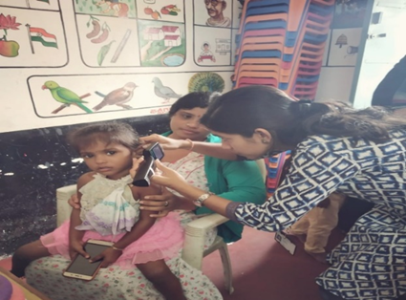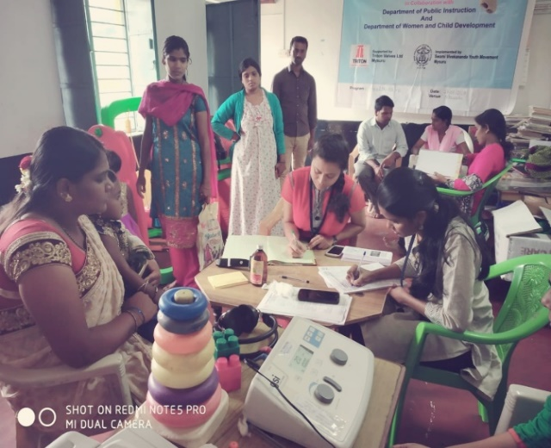 Screening of preschool, primary school children and Anganawadi was conducted focusing on the early identification of communication disorders and early rehabilitation of children at risk for communication disorders.

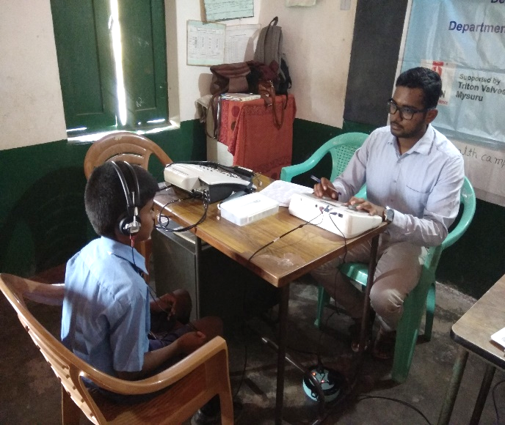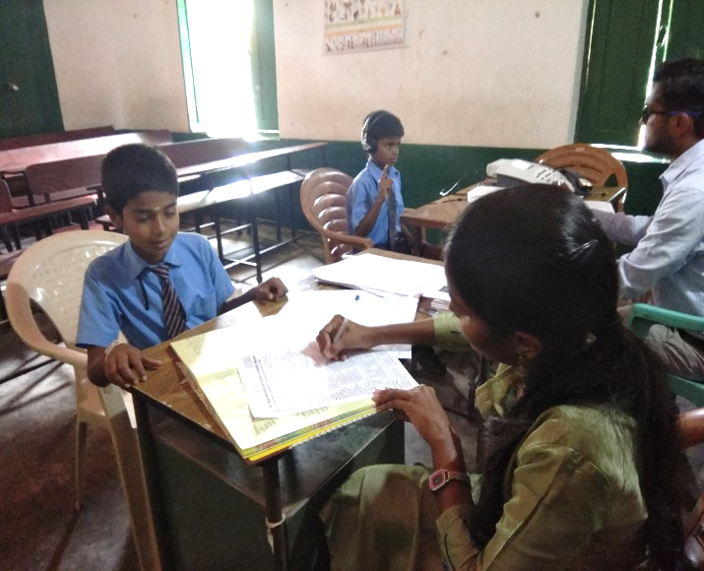Table 5 : Total number of children screened for communication disorders and identified.

|  |  |  |  |  |  |  |  |  |  |
| --- | --- | --- | --- | --- | --- | --- | --- | --- | --- |
| **SL No** | **Date** | **Name of the Anganawadi** | **Total screened** | **Total identified with communication disorders** | | | | | |
| **Ear related disorder** | **Hearing loss** | **Speech language disorders** | | | |
| **Fluency** | **voice** | **language** | **Articulation** |
|  | 11.04.2018 | Mosarahalla ANW  Sarguru | 14 | 0 | 0 | 0 | 0 | 1 | 0 |
|  | 09.05.2018 | Kandegala  Sarguru | 7 | 0 | 0 | 0 | 0 | 0 | 0 |
|  | 09.05.2018 | Nandinathpura ANW  Sarguru | 15 | 0 | 0 | 0 | 0 | 1 | 0 |
|  | 09.05.2018 | Agathur ANW -1  Sarguru | 15 | 0 | 0 | 0 | 0 | 0 | 0 |
|  | 09.05.2018 | Agathur ANW -2  Sarguru | 20 | 0 | 1 | 0 | 0 | 1 | 0 |
|  | 09.05.2018 | Agathur ANW -3  Sarguru | 14 | 0 | 0 | 0 | 0 | 0 | 0 |
|  | 09.05.2018 | Sagare Colony  Sarguru | 6 | 0 | 0 | 0 | 0 | 0 | 0 |
|  | 08/06/2018 | Govt Higher Primary School, Sagar. | 35 | 0 | 0 | 0 | 0 | 2 | 0 |
|  | 13/06/2018 | Vanashri higher primary school, sagar | 143 | 0 | 3 | 0 | 0 | 3 | 0 |
|  | 27.7.2018 | Yelawala  Anganawadi I, Mysore | 20 | 3 | 0 | 0 | 0 | 0 | 0 |
|  | 27.7.2018 | Koorgalli  Anganawadi II, Mysore | 22 | 1 | 0 | 0 | 0 | 3 | 0 |
|  | 14.07.2018 | Government primary school, vilpuram | 18 | 01 | 06 | 0 | 0 | 10 | 0 |
|  | 10/07/2018 | Shivalingappa High School,  saragur | 156 | 8 | 0 | 0 | 0 | 1 | 0 |
|  | 27/07/2018 | Government Tank Higher Primary School,  saragur | 110 | 0 | 0 | 0 | 0 | 3 | 0 |
|  | 30/07/2018 | Anganwadi School,  saragur | 15 | 0 | 0 | 0 | 0 | 0 | 0 |
|  | 28/08/2018 | St. Joseph higher primary School | 440 | 2 | 2 | 0 | 0 | 6 | 0 |
|  | 29/08/2018 | Nirmala convent High School | 349 | 1 | 4 | 0 | 0 | 2 | 0 |
|  | 27.08.2018 and 31.08.2018 | Govt. Higher primary school, Nagawala , Mysore | 143 | 5 | 1 | 0 | 1 | 1 | 2 |
| **Total** | | | **1542** | **21** | **17** | **37** | | | |

1. **Hearing screening of Industrial employees: 1**

All the industrial employees were screened for hearing loss and those were referred are advised for detailed evaluation at AIISH. Employees and employers are also oriented on harmful effects of Noise on hearing, importance of hearing conservation program and also use of hearing protective devices in noisy areas.

|  |  |  |  |  |  |  |  |
| --- | --- | --- | --- | --- | --- | --- | --- |
| IMG-20180723-WA0010 | | | | IMG-20180802-WA0022 | | | |
| IMG-20180802-WA0024 | | | | IMG-20180802-WA0015 | | | |
| **Sl.No** | **Month** | **Name of the Industry** | **Total Registered** | | **Total no. of individuals ears identified with Hearing impairment** | **Total no. of individuals with normal ears** | **Total no. of individuals ears identified with ENT disorders** |
| 1 | 24.01.2018 | Triton Valves Ltd,  Mysore | 154 | | 42` | 111 | 1 |
| **Total** | | | **154** | | **42** | **111** | **1** |

1. 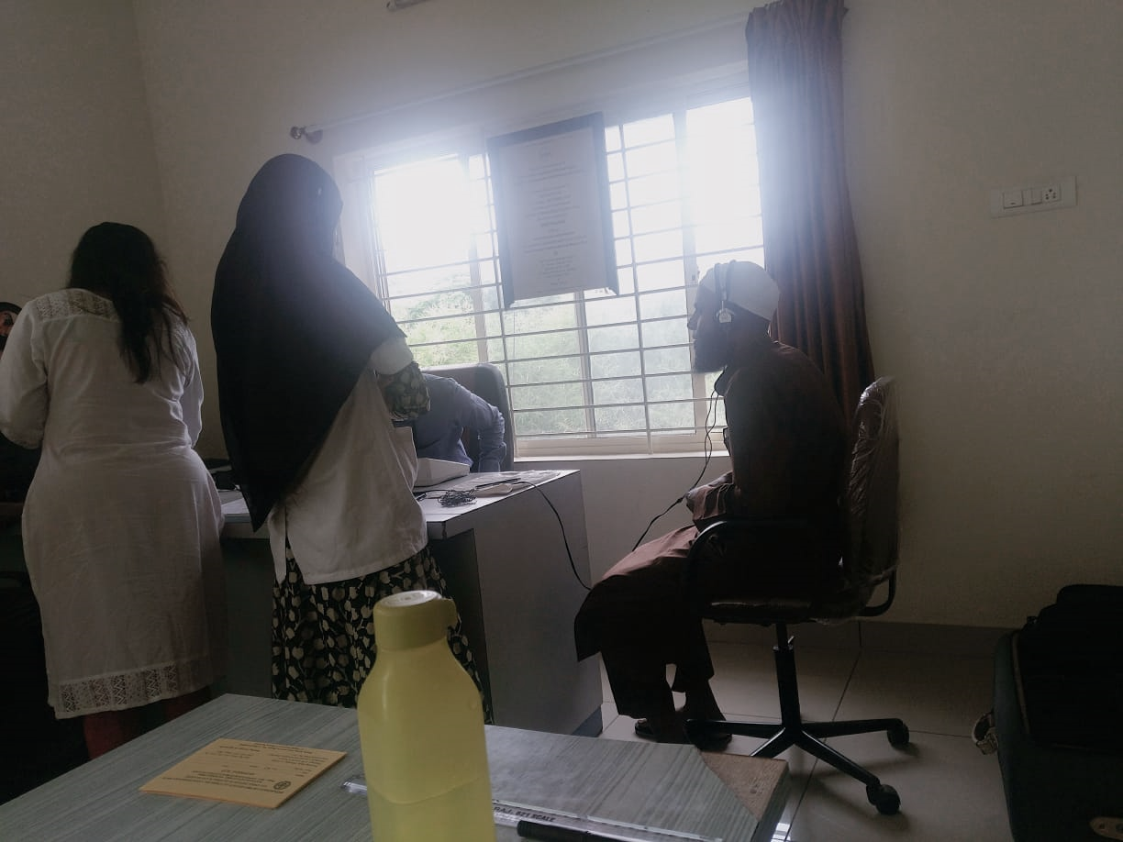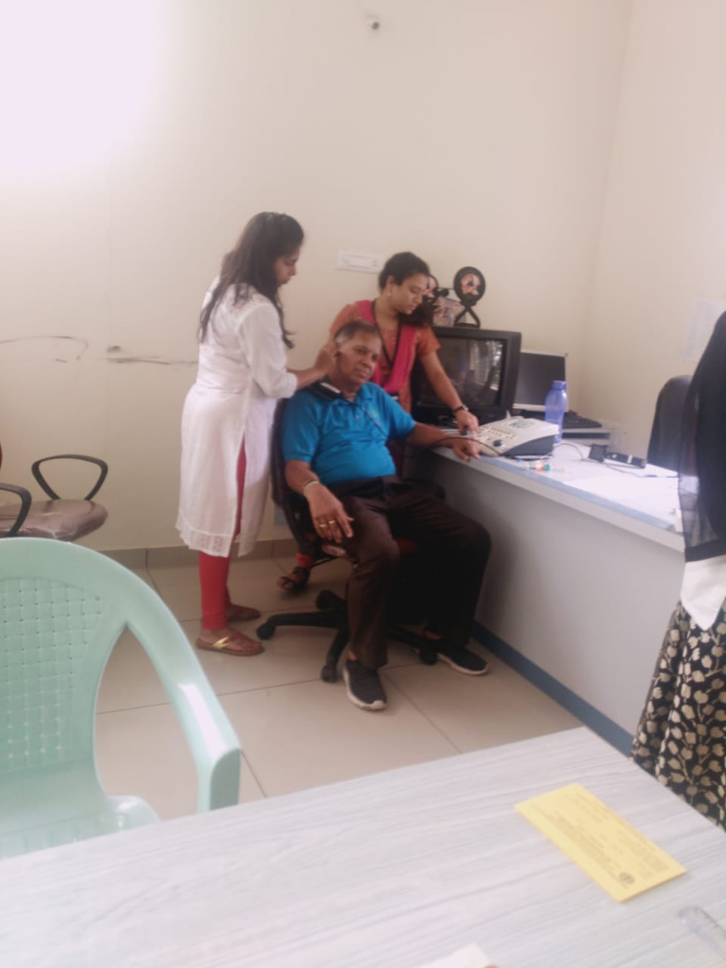**Clinical services for the elderly citizens: 3**

|  |  |  |  |  |  |  |  |  |  |  |  |
| --- | --- | --- | --- | --- | --- | --- | --- | --- | --- | --- | --- |
|  | | | | **Total identified with communication disorders** | | | | | | | **Total rehabilitated for communication disorders** |
| **Sl. No** | **Date** | **Name of the Place** | **Total screened** | **Normal** | **Ear related disorder (ears)** | **Hearing Impairment (ears)** | **Speech language disorders** | | | | **Issue of Hearing aids** |
| **Fluency** | **voice** | **language** | **Articulation** |
| 1 | 25.05.201 | Sri Ganapathy Sachidananda ashrama | 27 | 4 | 50 | 0 | 0 | 0 | 0 | 0 | 4 |
| 2 | 13.07.18 | Chayadevi, Mysore | 14 | 4 | 0 | 24 | 0 | 0 | 0 | 0 | 0 |
| 3 | 30.07.18 | SGS,  Mysore | 27 | 22 | 10 | 22 | 0 | 0 | 0 | 0 | 0 |
|  | **Total** | | **68** | **30** | **60** | **46** | **0** | | | | **4** |

1. **Clinical Services at Outreach Service Centers (OSCs):**

The clinical activities are not only restricted to in and around Mysuru, but also extended to rural areas where facilities for clinical services for persons with communication disorders were meager. Currently 04 OSCs (01 sub-divisional taluk hospital at Sagara taluk, Shivamogga District; 01 Community Health Center (CHC) at Hullahalli, Mysuru district, Primary Health Centre (PHC) at Akkihebbalu, Mandya district &Primary Health Centre (PHC) at Gumballi, Chamarajanagara district) were initiated to meet the objective of extending the services of the institute to rural areas. The details of those who were registered and availed various services/benefits at the OSCs are tabulated below in tables 8 & 9.

Table 8: Details of clients identified with communication disorders at the OSCs.

|  |  |  |  |  |  |  |  |  |
| --- | --- | --- | --- | --- | --- | --- | --- | --- |
| **OSC** | **Total registered** | **ENT Evaluation** | | | **Hearing Evaluation** | | **Speech & Language Evaluation** | |
| **Normal**  **ears** | **Disorder ears** | **others** | **Normal**  **ears** | **Disorder**  **ears** | **Normal Individuals** | **Disorder Individuals** |
| **CHC, Hullahalli** | 222 | 73 | 211 | 41 | 0 | 64 | 0 | 7 |
| **PHC, Akkihebbalu** | 156 | 40 | 158 | 33 | 0 | 40 | 0 | 5 |
| **PHC, Gumballi** | 310 | 135 | 269 | 60 | 4 | 70 | 0 | 11 |
| **Sub-divisional Hospital, Sagara** | 129 | 0 | 0 | 0 | 42 | 196 | 0 | 10 |
| **VMH, Sarguru** | 115 | 0 | 0 | 0 | 70 | 78 | 5 | 36 |
| **Total** | **932** | **248** | **638** | **134** | **116** | **448** | **5** | **69** |

Table 8a.: Details of clients followed up at the OSCs.

|  |  |  |  |  |  |  |  |  |
| --- | --- | --- | --- | --- | --- | --- | --- | --- |
| **OSC** | **Total Follow up** | **ENT Evaluation** | | | **Hearing Evaluation** | | **Speech & Language Evaluation** | |
| **Normal (Ear Wise)** | **Disorder (Ear wise)** | **others** | **Normal (Ear Wise)** | **Disorder (Ear wise)** | **Normal (Individuals)** | **Disorder (Individuals)** |
| **Primary Health Centre (PHC), Hullahalli** | 81 | 27 | 57 | 22 | 0 | 34 | 0 | 0 |
| **Primary Health Centre (PHC), Akkihebbalu** | 98 | 33 | 71 | 14 | 0 | 62 | 0 | 1 |
| **Primary Health Centre (PHC), Gumballi** | 175 | 77 | 103 | 17 | 0 | 132 | 0 | 2 |
| **Sub-divisional Hospital (PHC), Sagara** | 3 | 0 | 0 | 0 | 1 | 5 | 0 | 0 |
| **VMH, Sarguru** | 57 | 0 | 0 | 0 | 27 | 57 | 0 | 15 |
| **Total** | **414** | **137** | **231** | **53** | **28** | **290** | **0** | **18** |

Table 9: Details of clients identified with different type’s communication disorders across OSCs

|  |  |  |  |  |  |
| --- | --- | --- | --- | --- | --- |
| **Type of Disorders** | **OSC** | | | | |
| Primary Health Centre (PHC), Hullahalli | Primary Health Centre (PHC), Akkihebbalu | Primary Health Centre (PHC), Gumballi | Sub-divisional Hospital, Sagara (PHC) Taluk | VMH,Sarguru |
| **Hearing disorders** | | | | | |
| Normal | 2 | 0 | 4 | 42 | 97 |
| Conductive | 1 | 7 | 0 | 50 | 34 |
| Sensori- neural | 79 | 75 | 149 | 109 | 68 |
| Mixed | 7 | 8 | 2 | 33 | 24 |
| Profound | 9 | 12 | 11 | 8 | 9 |
| **Total (ears)** | 98 | 102 | 166 | 242 | 232 |
| **Speech &Language disorders** | | | | | |
| Voice | 1 | 2 | 0 | 0 | 0 |
| Fluency | 0 | 1 | 0 | 1 | 4 |
| Articulation disorders | 0 | 1 | 1 | 0 | 4 |
| Language disorders | 6 | 1 | 9 | 9 | 44 |
| **Total (Individuals)** | **7** | **5** | **10** | **10** | **52** |

Table 10**:** Rehabilitation services provided at Outreach service centers

|  |  |  |  |
| --- | --- | --- | --- |
| OSC | **Hearing Aids Dispensed** | **Speech-language therapy** | |
| No. of clients | No. of sessions |
| CHC, Hullahalli | 30 | 4 | 24 |
| PHC, Akkihebbalu | 40 | 9 | 16 |
| PHC, Gumballi | 51 | 18 | 51 |
| Sub-divisional Taluk Hospital, Sagara | 14 | 96 | 390 |
| VMH, Sarguru | 6 | 85 | 257 |
| **Total** | **141** | **212** | **738** |

1. **Communication Disorders Screening Camps:**
2. **Organized by the Plan Project of AIISH: Nil**
3. **Organized by the Institute/POCD: 1**

|  |  |  |  |  |  |  |  |
| --- | --- | --- | --- | --- | --- | --- | --- |
| **Date** | **Name of the Place** | **Total Registered** | **Total identified with communication disorders** | | | **No of Hearing aid issued** | **Psychology** |
| **Ear related disorder (ears)** | **Hearing loss (ears)** | **Speech language disorders** |
| 28th June 2018 | Hospet, Bellary District and organized by Rotary Club, Hospet. | 271 | 49 | 140 | 56 | 99 | 26 |
| **Total** | | **271** | **49** | **140** | **56** | **99** | **26** |

1. **TECHNOLOGICAL CONSULTANCY SERVICES-**Nil
2. **CENTRAL FACILITIES-**
3. **Library and information services –** Nil
4. **Public Information Activities –**
5. **Exhibition- Nil**
6. **Radio talks- Nil**
7. **Rallies: Nil**

**Street Plays-** The Department of POCD conducted three street plays on various communication disorders in the rural villages, emphasizing on prevention and early identification of communication disorders.

**Coordinators:** Dr. Swapna N, Dr. Prawin Kumar & Mr. Arunraj K.

**In charge:** Ms. Usharani N S, Ms. Bincy R Kalam & Ms. Anju V A

**Target group:** General Public

Table 11: Details of street play program conducted

|  |  |  |  |  |
| --- | --- | --- | --- | --- |
| **Sl. No** | **Dates** | **Place** | **Participants** | **Performer** |
| 1 | 07.04.2018 | Mullusoge | 32 (students)+11 (staffs) | Interns |
| 2 | 07.04.2018 | Kudige | 32 (students)+11 (staffs) | Interns |
| 3 | 07.04.2018 | Kudumangalore | 32 (students)+11 (staffs) | Interns |

|  |  |
| --- | --- |
| 4 | 10 |

**4. Public Lecture Series: Nil**

**5. Press Releases and Media Coverage:**

The Department of Prevention of Communication Disorders had organized and conducted the street play as a part of the outreach clinical curriculum of the internship students on 07.04.2018 in Mullusoge , Kudige and Kudumangalore villages, Somvarpet taluk, Madikeri district. The street play intended for creating awareness and educating the public regarding the prevention and early identification of communication disorders. Street play got extensive publicity in print media.

**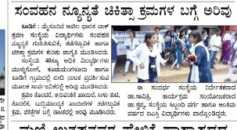**

1. **Material Development:**

**Designing of the following mentioned pamphlets was done and these pamphlets are ready to release for Annual day 2018.**

* Know more about Voice and its disorders (English)
* Know this to prevent communication disorders (English)
* Specific Language Impairment (English)
* Communication disorders in elderly (English)
* Know more about Dementia (English)
* Prevention of developmental disorders (English)
* Communication disorders in Intellectual disability (English)
* Attention Deficit Hyperactivity Disorder (Kannada, Hindi, Tamil, Malayalam & Marathi)
* Ear discharge and its prevention (Hindi, Tamil)

Department of Prevention of Communication Disorders (POCD) is actively involved in the preparation of Public Education Materials (PEMs) as part of primary prevention. As a part of **Annual Day celebration** on 9th August 2018, the following pamphlets were released.

* Know more about Voice and its disorders (English)
* Know this to prevent communication disorders (English)
* Specific Language Impairment (English)
* Communication disorders in elderly (English)
* Know more about Dementia (English)
* Prevention of developmental disorders (English)
* Communication disorders in Intellectual disability (English)
* Attention Deficit Hyperactivity Disorder (Kannada, Hindi, Tamil, Malayalam & Marathi)
* Ear discharge and its prevention (Hindi, Tamil)

|  |  |
| --- | --- |
| **F:\Mothly reports 2018\August 2018\DSC_9904.JPG** | **F:\Mothly reports 2018\August 2018\DSC_9911.JPG** |

1. **AWARDS AND HONOURS RECEIVED BY FACULTY AND STAFF: Nil**
2. **EXTRA CURRICULLAR ACTIVITIES:** As a part of Annual Day celebration, a dance performance was given by Dr. Swapna N, HOD-POCD, Ms. Pavana Mohan & Ms. Nayana M staff of POCD along with staff from other Dept. of AIISH on 9th August 2018.



1. **AIISH Gymkhana: Nil**
2. **NSS: Nil**
3. **Others:** Nil
4. **MAJOR EVENTS OF THE YEAR**:

* Inauguration of two new NBS centers at Kings George Medical Hospital, Lucknow and Jawahar Lal Nehru Medical College and Hospital, Bhagalpur on AIISH Annual day on 9th August 2018 by by Shri V S Basavaraju





* Newborn Hearing Screening card, which will be given to the caretakers of newborn for documentation propose was released on 53rd Annual day 9th August 2018 by by **Shri V S Basavaraju.**

1. **EMINENT VISITORS**

* **UGC expert committee** had visited the Department on 4th May 2018 and was oriented regarding the activities of POCD.
* Industrial medical officers from ROHCS, Bangalore had visited the Department on 4th Nay 2018 and were oriented on the “Prevention, early identification and management of communication disorders” majorly focusing on **Noise induced hearing loss.**
* Mr. Basavaraju V. S., State commissioner for Persons with Disability, Bengaluru visited Dept. of POCD on 9th August 2018.HOD, POCD gave a brief introduction about the activities carried out by Dept.



1. **ANYOTHERS:**

|  |  |  |
| --- | --- | --- |
| * + - 1. **Dept. Related** | | |
| **S.No** | **Particulars** |  |
| 1. | Computerization activities | Given corrections in computerization of elderly screening.  Given corrections in computerization of elderly screening. Initiation of Phase II of computerisation. Initiation of Statistical report of elderly screening.  Initiation of Phase II of computerisation.  Correction of Statistical report of elderly screening.  Initiated OSC computerisation. Audiology OPD format, Speech OPD format, and two speech and language Proforma were given for computerisation.  OSC computerisation is in process. Audiology OPD format, Speech OPD format, two speech proformae were corrected. Three speech and language Proforma were given for correction. |
| 2. | Purchase meeting | Indent of furniture for COE was submitted to Director |
| 3. | **RE BE 2018-19-20** | **RE BE** wasprepared for POCD activity |
| **2. OSC Related** | | |
| **1..** | **OSC- Saragur and Sarguru** | Annual consumable indent has been sent to OSC centers at Sagara and Sarguru.  HOD, faculty and OSC in charge (staff) visited OSC centers at Sarguru, Akkihebalu, Hulahalli, KR Nagara Taluk Hospital, Santhemarali Government Hospital and Gumballi.  HOD, faculty and OSC in charge (staff) visited OSC centers, Sagara on 5th and 6th July 2018. |
| * + - 1. **NBS Related** | | |
|  | NBS | Meeting was conducted over the telephone regarding the issues in the NBS centers at Bhagalpur and Lucknow  NBS screening card was prepared (which will be given for the mother of infants) for documentation proposes.  Inauguration of two new NBS centers at Kings George Medical Hospital, Lucknow and Jawahar Lal Nehru Medical College and Hospital, Bhagalpur on AIISH Annual day on 9th August 2018 by Shri V S Basavaraju.  NBS screening card was released on AIISH Annual day on 9th August 2018.  NBS meeting was conducted with Medical Officers in hospitals (Kamakshi, Sigma, SMTDH and ANH) for providing the room to the initiate AABR on 3rd August 2018.  Initiated AABR in Sigma and ANH |

1. **Recruitment/Relief of duties for the reporting year: Nil**

|  |  |  |  |  |
| --- | --- | --- | --- | --- |
| **Sl.No** | **Name of the staff** | **Designation** | **Joining date** | **Reliving date** |
| 1. | Mr Dharm Pal Singh | Speech and hearing technician  Lucknow | 22.05.2018 | - |
| 2. | Ms. Tejaswikumari | Speech and hearing technician  Bhagalpur | 22.05.2018 | - |
| 3. | Ms. Preethi.K | Data entry operator | - | 27.08.2018 |

**Sd/-**

**Head, Dept. of POCD**