**ALL INDIA INSTITUTE OF SPEECH AND HEARING, MYSURU-6**

**अखिल भारतीय वाक श्रवण संस्थान, मैसूर-६**

**DEPARTMENT OF SPECIAL EDUCATION**

**विशेषशिक्षाविभाग**

**MONTHLY REPORT–August 2018**

1. **ACADEMIC ACTIVITIES**
2. **Orientation Programs (For outsiders):**The following orientation programswere conducted to orient about the activities of the departmentand also to provide the knowledge about the educational facilities and welfare measures for children with special needs. : 01

|  |  |  |  |  |
| --- | --- | --- | --- | --- |
| **Sl. No.** | **Coordinator** | **Targeted Audience** | **Number**  **of Participants** | **Date** |
|  | Ms. Lakshmi Prabha J K | 2 staffs, 40 MSW students, SJR College, Bangalore | 42 | 16.08.2018 |

**Dr.Pushpavathi M, HOD – Special Education**

* Presented the department activity in Peer review on 8.9.18 and supervised the work related to preparation of teaching models .

**Faculty report**

|  |  |  |  |  |  |  |
| --- | --- | --- | --- | --- | --- | --- |
| **Name of the Faculty** | | **Dr.Alok Kumar** | **Dr. G. Malar** | **Dr.Prithi**  **Venkatesh** | **Dr. P. Vijetha** | **Ms.LakshmiPrabha J.K** |
| **Clinics** | | | | | |  |
| **No. of cases evaluated at SEA-U** | | 08 | * Screening: 13 clients in 13 sessions * Assessment: 2 clients in 6 sessions | She was on Maternity leave | 13 | Screening: 16 clients in 16sessions  Assessment: 1 client in 3 sessions |
| **No. of cases supervised individually** | | 01( It took 4 hours)Administered Educational assessment tool | * 8 children in 2 groups |  | 32 |  |
| **No. of groups supervised** | | 06 | * 8 |  | 19 | 8 preschool groups |
| **No. of meeting with parents** | | 05 | * 8 meetings in 8 groups |  | 8 | 8 meetings in 8preschool groups |
| **Educational Guidance** | | 02 | * 4 clients * 4sessions |  | 4 clients (6 sessions) |  |
| **Academics** | | | | | | |
| **Classes taken** | | | | | |  |
| **B.Ed.**  **Spl.Edn.(HI)** | **Theory** | 20 classes | * 27 (including 4 extra) |  | 18 classes | * 14 hours |
| **Practical** | 27 hours | * 32 hours |  | 32 hours | * 34 hours (Trial teaching of II year B.Ed.Spl.Ed (HI) students) |
| **Any others** |  |  |  |  | Submitted C1 marks on 17th & 24th August 2018 |  |
| **Any other** | | | | | |  |
| **Meeting held** | |  | * 1 monthly meeting each with I& II B.Ed. Spl.Ed. (HI) * 8 monthly meetings with 8 preschool groups |  | * Peer review meeting with HOD was attended on 7th August 2018. * Attended peer review meeting on 8th August 2018. * Prepared, discussed and Presented Research proposal for ARF funds on 29th August 2018. | * 8 meetings with preschool parents |
| **Meeting attended** | |  | * 3 Meetings with HOD regarding DPE, TLM development B.Ed.Spl.Ed. (HI) student attendance & other departmental affairs * Condolence meeting for former PM |  | * On 3rd and 4th August 2018, attended orientation on Grammarly and J-gate by Library in Seminar hall. | * 1 meetings with HOD and faculty members regarding peer review |
| **Brouchre** | |  |  |  |  |  |
| **Serve as Resource person** | |  | * Workshop on LD for KV school teachers at KV ZIET, Mysuru on 31.08.2018 |  |  |  |
| **Roles & Responsibilities** | | | | | |  |
| **Co-ordination** | | Parent Infant Program Unit  Preschool Parent Enrichment Program Unit | * CBCS Coordinator for I& II B.Ed.Spl.Ed. (HI) * Compilation of M.S.Ed. Student Dissertation-based Articles 2014-15 * Intra-Department * SEA-U * Research & Database Unit |  | 1. **Services for School age children**  * Lesson plans and children availing services have been checked. * Conducted monthly meeting on 31st August 2018. * Five new admissions have been made.  1. **Others**   For 53rd Annual day celebrations of the institute, served as a member of catering committee. |  |
| **Member secretary** | | Pre School | * Services for School-Aged Children (in Department of Special Education) |  | NIL |  |
| **Member in** | | Special education assessment Unit and Assistan warden | * TCPD * LD Clinic (in DCS) * Product Development Cell * Preschool Supervision * Allied member of ISHA * Life member of NCED |  | SEA-U | Cultural Activities committee member, Annual Day - August 2018 |
| **Mentor** | | M.Sc 2year Audiology | * Mentor for I & II B.Ed.Spl.Ed. (HI) |  | II BASLP A section  Conducted meeting on 31st August 2018 |  |

1. Clinical /Educational Observation Postings of Students from other Institutes:NIL

Following are the details of students posted for observation/ practice teaching

|  |  |  |  |  |
| --- | --- | --- | --- | --- |
| **Sl.No.** | **Name of the Institute** | **Programme/Course** | **Number of Students** | **Dates** |

1. Seminars/Conferences/**Workshops**/Training Programs:NIL
2. Staff Enrichment / **In-house training Programmes***(For own staff members)* : NIL

|  |  |  |  |  |  |
| --- | --- | --- | --- | --- | --- |
| **Theme/Topic** | **Resource Person** | **Coordinator** | **Objectives** | **Targeted Audience** | **Date** |

1. **Guest Lectures :**
2. Additional Academic Services rendered by the Faculty and Staff
3. **Invited Talks: 01**

|  |  |  |  |  |
| --- | --- | --- | --- | --- |
| **Staff** | **Topic** | **Date** | **Programme** | **Institution** |
| G. Malar | * Education of Physically & Socially Challenged Children in Inclusive Settings | 31.08.2018 | Workshop on Learning Disabilities for KendriyaVidyalaya Teachers | KendriyaVidyalayaZonal Institute for Education & Training, Mysuru |

1. **Curriculum Development: 01**

* Development of Material to Support Learning: G. Malar – Revision of Training Manual – Visual Arts for Preschoolers

1. Development of Material to Support Learning :NIL
2. Service in Academic Bodies of other Organizations: NIL
3. Participation in Committees/Taskforce and Panels setup by other organizations/agencies:

|  |  |  |  |  |  |  |
| --- | --- | --- | --- | --- | --- | --- |
| **Sl No** | **Name of the staff** | **Name of Organization/Agency** | **Participation in Committees/**  **Taskforce** | **Programme** | **Name of Institute Visited** | **Date of Visit** |
|  |  |  |  |  |  |  |

1. **Any Others (Please Specify)**
2. Research Projects (ARF)
3. Completed -NIL
4. New Research Projects- NIL
5. **Ongoing Research Projects –02**
6. **Title of ARF** - Development and Evaluation of Indigenous curriculum oriented computer based tutor for concept learning in preschool children with special needs.

Principal Investigator – Ms. P.V. Ramanakumari

Co-Investigators – Dr.Ajish K Abraham and Ms. P.V. Manjula

Research Assistant – Mr. Anil Abbur R.

Date of Starting – 18th January 2017

Progress –

* Review of literature.
* Voice recording of the story dialogues.
* Gave module 4 for animation developing (out sourcing).
* Administration of Module 3.
* Checking of Module 4

1. **Title**: Effect of Resource Materials on Impact of Inclusive Education in Children with Intellectual Disabilities (ID) and Learning Disabilities (LD)

Investigators: Dr. G. Malar, Ms. S. Prathima&Mr. D. Gururaj

Duration: 12 months from January 2017

Budget: Rs. 3,85,000/-

Progress: Suspended till appointment of staff for extension in July &

August 2018

1. Postgraduate Research Completed:- NIL
2. C. Postgraduate Research ongoing: NIL
3. D**.** Research Papers presented at National/International Conferences/Seminars :- NIL

E.Research Papers Published

**i) Papers published in National / International Journals: 06**

**Singh N. &Upadhyay A.K.** Shravanvadhitvidharthionmeinmonvagyanikprakriyasamandhi vicar avmuttapansamaseyonkaaddhyan, Search Look, 6(1):58-63.

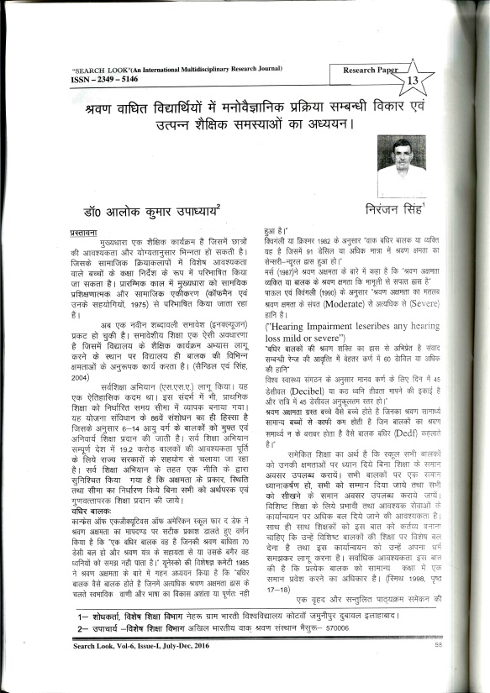

***Singh N. & Upadhyay A.K.***.Samaveshi batabaran mein addhyanrat sharvan badhit vidharthon mein manovagyanik prakriya samndhi vikaron ka addhyan, *Search Look,* 6(1):64-71.

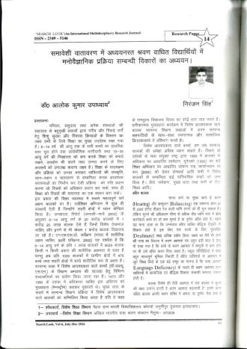

**Madushri D.C &UpadhyayA.K(2018).**Survey of accessibility to students with hearing impairment in inclusive educational set ups,Student research at AIISH,13(c):14-19

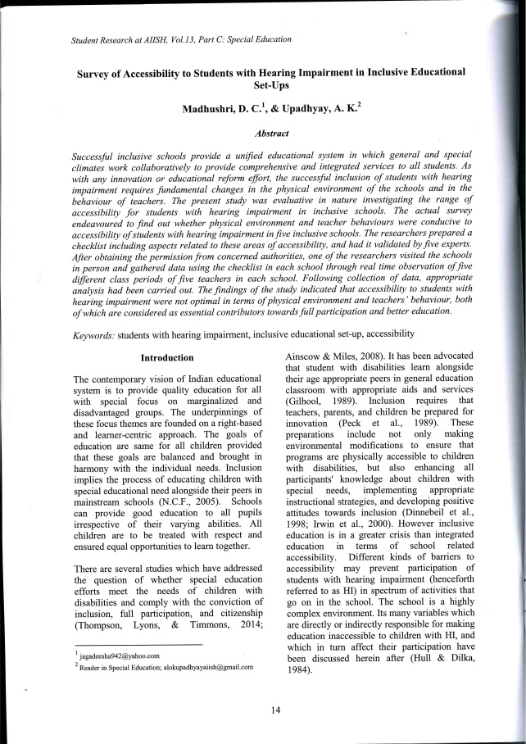

**Shaik G. J., &Upadhyay A. K (2018)**,Effectiveness of teaching learning material in instruction of environmental science to primary school children with hearing impairment, Student research at AIISH,13(c):28-33

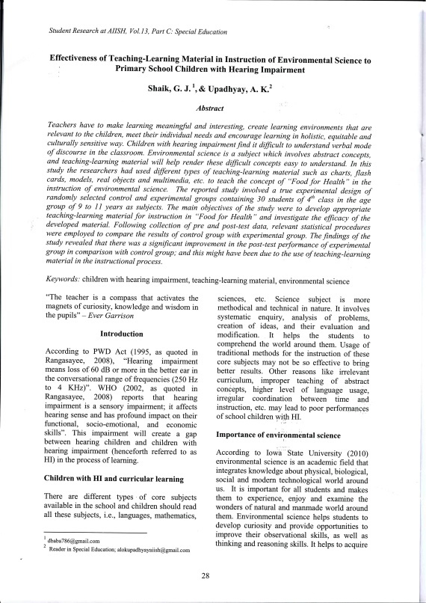

**Krishan, S., Malar, G., & Antony, F. (2018).**Development of screening checklist for post school transition of Indian adolescents with hearing impairment. In Savithri, S. R., & G. Malar (Eds.) (2018). Student research at AIISH: A compendium of research articles based on postgraduate dissertations at the All India Institute of Speech and Hearing, Mysuru , Vol. 13, Part C – Special Education (pp. 34-42). Mysuru, India: AIISH.



**Singh, T., & Malar, G. (2018).**Study of influence of co-curricular training in visual arts on development of pre-academic skills in preschool children with hearing impairment. In Savithri, S. R., & G. Malar (Eds.) (2018). *Student research at AIISH: A compendium of research articles based on postgraduate dissertations at the All India Institute of Speech and Hearing, Mysuru* , Vol. 13, Part C – Special Education (pp. 43-50). Mysuru, India: AIISH.



ii) Abstracts published in Conference / Seminar Proceedings: NIL

F. **Books published (in APA format)**

1. **Books published: 01**

**Savithri, S. R., & G. Malar (Eds.) (2018).***Student research at AIISH: A compendium of research articles based on postgraduate dissertations at the All India Institute of Speech and Hearing, Mysuru* (Vol. 13, Part C – Special Education). Mysuru, India: AIISH.



**G.Book chapters published (in APA format): 03**

**Malar, G. (2018).**Pre-academic skill development in children with learning disabilities. In S. R. Savithri& K. S. Prema (Eds.) *Resource material on learning disability* (pp. 87-106), developed through national level collaborative pilot project for ‘Capacity building in KendriyaVidyalaya teachers for identification and management of children with LD in classrooms. Mysuru, India: AIISH.



**Malar, G. (2018).**Pre-academic skill development in children with learning disabilities. In S. R. Savithri& K. S. Prema (Eds.) *Resource material on learning disability* (pp. 107-118), developed through national level collaborative pilot project for ‘Capacity building in KendriyaVidyalaya teachers for identification and management of children with LD in classrooms. Mysuru, India: AIISH.



**Mondreti, P. V., & Malar, G. (2018).**Sibling disposition towards children with special needs. In S. K. Gupta & S. Venkatesan (Eds.) Handbook of research on psychosocial perspectives of human communication disorders (pp. 97-109). Hershey, PA: IGI Global.



10. Books/Manuals/Seminar

H .Books/Manuals/Seminar Proceedings edited: NIL

1. Journal Editorship: NIL

J. Scholarly Reviewing Activities:

1. Special Educational Services Offered through Teacher Trainees Outside Campus: NIL

**III CLINICAL SERVICES**

1. General Clinical Services: **Not Applicable**
2. Specialized Clinical/ Educational Services
3. **Preschool Training and Special Education**

**Educational services for children with special needs**

|  |  |  |  |  |  |  |  |  |  |  |  |  |
| --- | --- | --- | --- | --- | --- | --- | --- | --- | --- | --- | --- | --- |
| **S. No.** | **Nature of Services (I/C)** | | | | | | | | | | | |
| 1. Special Educational Assessment Services (Dr. G. Malar) | | | | | | | | | | | | |
|  |  | Nature of Special Need  Language | ASD / PDD NOS | Hearing Loss | Intellectual Disability | Learning Disability | Motor Problems | Multiple Disabilities | Others | No. of Clients | No. of Sessions | ***Total No. of Sessions*** |
| 1. | Screening & Referral | Kannada | 4 | 9 | 7 | 1 | 0 | 2 | 1 | ***24*** | ***24*** | ***50*** |
| Malayalam | 2 | 4 | 2 | 1 | 0 | 2 | 2 | ***13*** | ***13*** |
| Hindi | 1 | 0 | 1 | 0 | 0 | 0 | 0 | ***2*** | ***2*** |
| Urdu | 0 | 0 | 0 | 0 | 0 | 0 | 0 | ***0*** | ***0*** |
| English | 1 | 1 | 2 | 3 | 0 | 0 | 1 | ***8*** | ***8*** |
| Telugu | 0 | 1 | 0 | 0 | 0 | 0 | 0 | ***1*** | ***1*** |
| Tamil | 1 | 1 | 0 | 0 | 0 | 0 | 0 | ***2*** | ***2*** |
| Any Other | 0 | 0 | 0 | 0 | 0 | 0 | 0 | ***0*** | ***0*** |
| ***Total No. of Clients*** | ***9*** | ***16*** | ***12*** | ***5*** | ***0*** | ***4*** | ***4*** | ***50*** | ***50*** |
| 2. | Assessment & Report | Kannada | 0 | 1 | 2 | 0 | 0 | 0 | 0 | ***3*** | ***8*** | ***23*** |
| Malayalam | 0 | 0 | 0 | 1 | 0 | 0 | 0 | ***1*** | ***0*** |
| Hindi | 0 | 0 | 0 | 0 | 0 | 0 | 0 | ***0*** | ***0*** |
| Urdu | 0 | 0 | 0 | 0 | 0 | 0 | 0 | ***0*** | ***0*** |
| English | 0 | 1 | 1 | 6 | 0 | 0 | 1 | ***9*** | ***15*** |
| Telugu | 0 | 0 | 0 | 1 | 0 | 0 | 0 | ***1*** | ***0*** |
| Tamil | 0 | 0 | 0 | 0 | 0 | 0 | 0 | ***0*** | ***0*** |
| Any Other | 0 | 0 | 0 | 0 | 0 | 0 | 0 | ***0*** | ***0*** |
| ***Total No. of Clients*** | ***0*** | ***2*** | ***3*** | ***8*** | ***0*** | ***0*** | ***1*** | ***14*** | ***23*** |
| Places from which seen: (1)Karnataka: 34 (2)Kerala: 12 (3)AP: 01 (4)Telengana: Nil (5)TN: 02 (6)Other Parts of India: 1(MP) (7)Any other: Nil | | | | | | | | | | | |
| Age groups seen:(1)Birth to 2.5yrs: 04 (2)2.5+ to 6 yrs: 25 (3)6yrs+ to 16 years: 20 (4)16yrs+: 01 | | | | | | | | | | | |
| Total No. of Referrals: (1)Educational Assessment: 14 (2)Educational Guidance: 02 (3)PIP: 07 (4)PPEP/ PBC/ GECS: 41 (5)CSS/IEP/NFE/DET: 04 (6)Any Other Services at AIISH: 01(7)Any Other Services Outside AIISH: Nil | | | | | | | | | | | |
| No. of Reports Issued/Ready for Issue: (1) School Readiness: 01 (3) Curriculum-Based Assessment: 03 (4) Post-School: Nil | | | | | | | | | | | |

|  |
| --- |
| **PreschoolTraining:Preparatory programme for schooling providing training in self-help, cognitive, language and (pre) academic skills, Preschool Supplementary Services (PSS)** |
| |  |  |  |  | | --- | --- | --- | --- | | **Language & Disability** | **No. of Groups** | **No. of Children** | | |  |  | MALE | FEMALE | | Kannada ASD & ID &MD | 15 | 49 | 24 | | Kannada HL | 8 | 43 | 21 | | Malayalam HL | 1 | 2 | 3 | | Malayalam ASD & ID & MD | 8 | 18 | 13 | | Hindi HL | 2 | 8 | 6 | | Hindi MD & ID & ASD | 2 | 7 | 3 | | English ID, ASD | 1 | 3 | 2 | | Telugu ASD & ID & MD | 1 | 6 | 3 | | TOTAL Number of children |  | **136** | **75** | | **TOTAL No. Groups** | **38** | **211** | | | **Sessions** | **3192 ( Groupwise)** | | | |

|  |  |  |  |  |  |
| --- | --- | --- | --- | --- | --- |
| **Curricular Support Services – Supportive training to augment education in mainstream school/ other educational programmes** | **Language** | **HL** | **ID/CP/ASD/MD/LD/DD** | **Total No. of clients** | **No. Of sessions** |
| Kannada | 9 | 14 | 23 | 109 |
| Malayalam | 1 | 1 | 2 | 5 |
| Hindi | -- | 1 | 1 | 6 |
| English | -- | 7 | 7 | 30 |
| Telugu | - | 2 | 2 | 6 |
| Tamil | 1 | - | 1 | 4 |
| **Total** | | | | **36** | **160** |
| |  |  |  |  |  |  | | --- | --- | --- | --- | --- | --- | | **Individualised Educational Programme (IEP) – Training in functional academics for out of school individuals** | **Language** | **HL** | **ID/CP/ASD/MD/LD/DD** | **Total No. of clients** | **No. Of sessions** | | Kannada | 4 | 6 | 10 | 43 | | Malayalam | - | 1 | 1 | 13 | | Hindi | - | 2 | 2 | 16 | | English | - | 2 | 2 | 6 | | Telugu | - | - | - | - | | Tamil | - | - | - | - | | **Total** | - | - | **15** | **78** | | | | | | |
| |  |  |  |  |  |  | | --- | --- | --- | --- | --- | --- | | **Demonstration Educational Training – Short-term demonstration to caregivers in any of the above** | **Language** | **HL** | **ID/CP/ASD/MD/LD/DD** | **Total No. of clients** | **No. Of sessions** | | Kannada | 1 | 2 | 3 | 11 | | Malayalam | 1 | - | 1 | 10 | | Hindi | - | - | - | - | | English | - | - | - | - | | Telugu | - | - | - | - | | Tamil | - | - | - | - | | **Total** | - | - | **4** | **21** | | | | | | |
| **Total clients:55**  **Old clients:- 68**  **New clients: - 03**  **Discharged(DET):-01**  **Discharged(CSS):- NIL**  **Discharged(IEP):- 02**  **Discontinued(DET):- NIL**  **Discontinued(CSS):- 02**  **Discontinued(IEP):- 01**  **Promoted from CSS/IEP/DET to PPEP: NIL**  **No. of remaining clients: 55** | | | | | |

|  |  |  |  |  |  |  |  |  |  |  |  |
| --- | --- | --- | --- | --- | --- | --- | --- | --- | --- | --- | --- |
| **Preschool Parent Empowerment Programme – PPEP** | | | | | | | | | | | |
|  | **Language** | **HL** | **ID** | **CP** | **ASD** | **MD** | **LD** | **DD** | **SLD** | **VI** | **Total No. of clients** | **Group** | **No. Of sessions** |
| Kannada | 31 | 17 | 3 | 8 | 9 | -- | 4 | -- | -- | 72 | 11 | 231 |
| Malayalam | 9 | 6 | 1 | 3 | 4 | -- | 4 | -- | -- | 27 | 5 | 105 |
| Hindi | 8 | -- | -- | 2 | 1 | -- | -- | -- | -- | 11 | 2 | 42 |
| English | 1 | 1 | -- | 2 | 2 | -- | -- | -- | -- | 6 | 1 | 21 |
| Telugu | -- | 1 | -- | -- | -- | -- | -- | -- | -- | 1 | 1 | 21 |
| Tamil | 2 | 3 | -- | 2 | -- | -- | -- | -- | -- | 7 | 1 | 21 |
| **Total** | | | | | | | | | | **124** | | **20** | **441** |
| No. of clients promoted to the next higher level(Preschool) of service: NIL  No. Of discharged : NIL  No. Of discontinued: 03  No. Of New clients (August) : 26  Shifted from PPEP to PIP: NIL  No. of remaining cilents: 121 | | | | | | | | | | | | | |

|  |  |  |  |  |  |
| --- | --- | --- | --- | --- | --- |
| **Parent-Infant Programme – PIP(Birth to 2 ½ years)** | | | | | |
| Parent-Infant Programme | **Language** | **HL** | **ID/CP/ASD/MD/LD/DD** | **Total No. of clients** | **Total No. Of sessions** |
| Kannada | 10 | 11 | 21 | 94 |
| Malayalam | 12 | 14 | 26 | 97 |
| Hindi | 01 | 01 | 02 | 02 |
| English | 01 | 00 | 01 | 00 |
| Telugu | 00 | 00 | 00 | 00 |
| Tamil | 01 | 01 | 02 | 02 |
|  | **Total** | | | **52** | **195** |
| No. of Old clients :45  No. of New clients enrolled: 07  Total cilents:52  No. discharged :nil  No. discontinued:nil  No. of Promoted to next level: nil  No. of Remaining:52 | | | | | |

|  |  |  |
| --- | --- | --- |
| **Library of Books & Toys** – LiBoToy  Services issuing educational toys & books for home-based training. | Total number of members enrolled –127  No. of new members: - 34  Amount – 1700/-  Total number of sessions –24 | |
| **Age group** | **Total number** |
| 0-2.6 yrs | 4 |
| 2.6-4 yrs | 15 |
| 4.0-6yrs | 105 |
| 6 yrs and above | 3 |

|  |  |  |
| --- | --- | --- |
| **Services** | **Number of Clients** | **Number of Sessions** |
| Co-Curricular Training | 215 | 21 |

**Supports for Empowering Caregivers**

|  |  |  |  |
| --- | --- | --- | --- |
| Name of Training Unit | No. of Parent  Beneficiaries | No. of Sessions | Content of Training |
| Caregiver Computer Training Unit | 04 | 36 | Painting, typing in word, shut down and on |
| Caregiver Literacy Training Unit | 08 | 25 |  |

1. Clinical Support Services to Clients and Family
2. **Counselling and guidance**

|  |  |
| --- | --- |
| No. of Clients | Sessions |
| 198 | 98 |

1. U-SAFE

|  |  |
| --- | --- |
| No. of Clients | Sessions |
| -- | -- |

1. Details of Certificates Issued:NIL

|  |  |  |  |
| --- | --- | --- | --- |
| **Sl.No.** | **Nature of Special Needs in Clients** | **No. of Certificates Issued** | **Purpose** |
|  |  |  |  |

1. Financial Aid- NIL
2. Legal advice -NIL
3. Any other(Please Specify):
4. Parent enrichment programs (PEP): - This program aims to enrich knowledge of the caregivers of CWSN by experts from various fields.

|  |  |  |  |  |  |
| --- | --- | --- | --- | --- | --- |
| Theme/Topic | Coordinator | Objectives | Targeted Audience | Date | Photo |

1. **Staff Enrichment Program (SEP):- 01**

|  |  |  |  |  |
| --- | --- | --- | --- | --- |
| **Theme/Topic** | **Coordinator** | **Objectives** | **Targeted Audience** | **Date** |

**Attended to workshop/Seminar/Orientation program in AIISH institute 2018-19:01**

|  |  |  |
| --- | --- | --- |
| **Name of Staff** | **Attended to workshop title name** | **Date** |
| Mr.Sharanaiah M M, Special Educator | National Seminar on "Psychosocial Perspectives of Children and Adolescents with Neurodevelopmental Disorders"  By Dept. of clinical psychology | 30-31, Aug 2018 |

**Attended to workshop/Seminar/Orientation program in Outside institute 2018-19:NIL**

|  |  |  |
| --- | --- | --- |
| **Name of Staff** | **Attended to workshop title name** | **Date** |
|  |  |  |

EXTENSION ACTIVITIES

1. Public Lecture Series
   * 1. TECHNLOGICAL CONSULTANCY SERVICES: Not applicable
        1. CENTRAL FACILITIES
        2. Library and Information Services
        3. Public Information Activities
        4. Major Events of the Year with a brief account:

* **Name of the Programme/ Event:** Annual Day 2018
* **Date:** 15.08.2018
* **Coordinated by: -**AIISH

Preschool Children and Staffs participated in cultural program

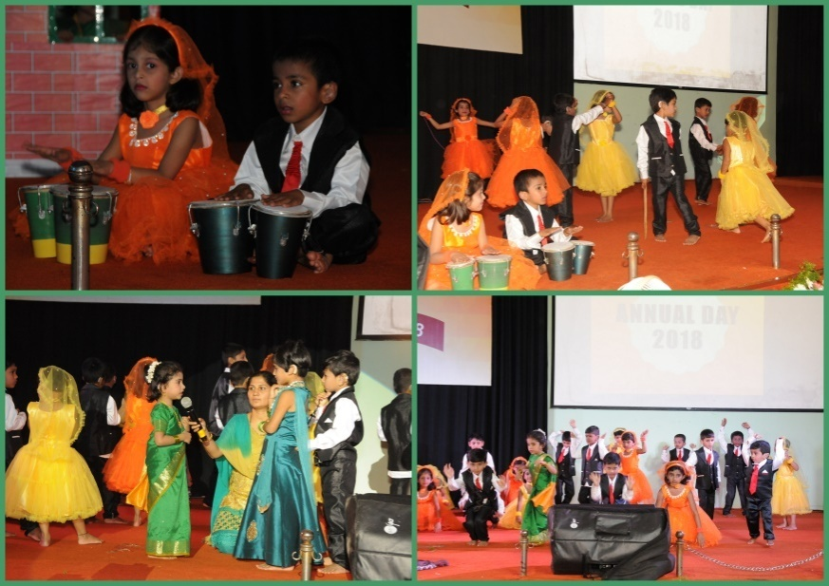

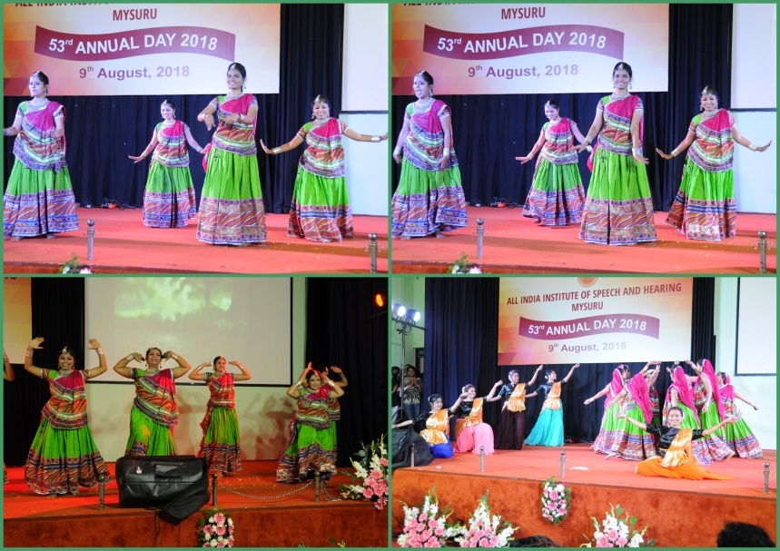

* **Name of the Programme/ Event:** Independence day 2017
* **Date:** 15.08.2018
* **Coordinated by: -**Ms.Ramanakumari P. V, Ms.Leena C. C, Ms.Asha S. A., Ms.Leelarani S. B.

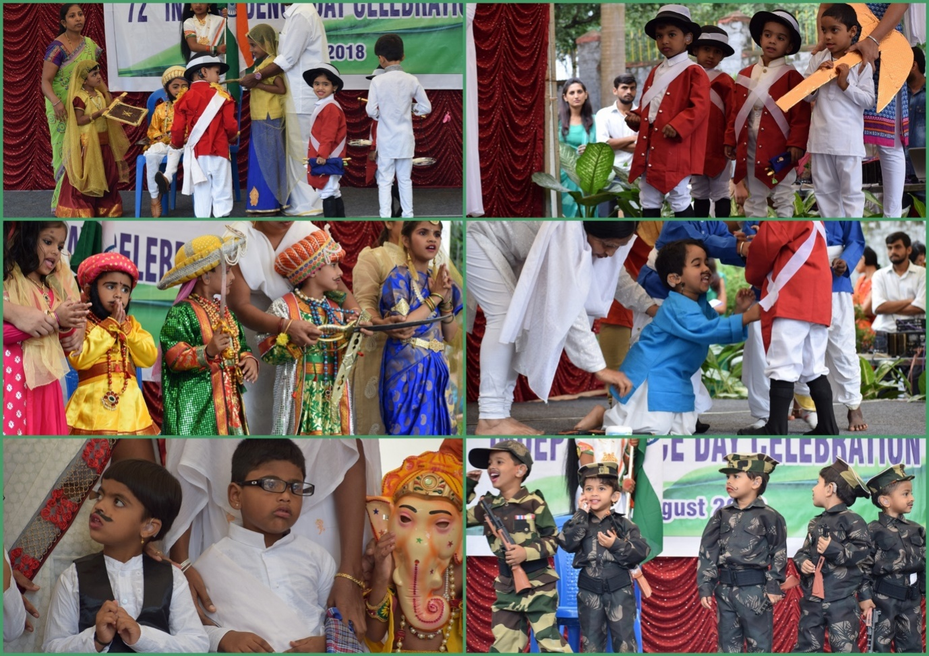

* + - 1. Press Releases and Media Coverage: NIL

**C) Material Development :**The following Teaching Learning Materials and Prepare for training children with various communication disorders an preschool.

|  |  |  |  |
| --- | --- | --- | --- |
| **Sl.**  **No.** | **Nature of**  **Teaching-Learning**  **Materials** | **Skill** | **Number** |
| 1. | Flash cards | For all skill areas | 59 |
| 2. | Work Cards | For all skill areas | 74 |
| 3. | Charts | For all skill areas | 20 |
| 4. | PPT | For all skill areas | 145 |
| 5. | Models | For all skill areas | 52 |
| 6. | Sentence strips | For all skill areas | 48 |
| 7. | Story cards | For all skill areas | 67 |
| 8 | Others | For all skill areas | -- |

1. **AWARDS AND HONORS RECEIVED BY FACULTY AND STAFF**
2. EXTRA CURRICULAR ACTIVITIES
   * + - 1. AIISH Gymkhana
3. EMINENT VISITORS:

XI. **ANY OTHER**

* **OfficialLanguage Implementation:**
* Hindi Word a day
* No of notings/letters (**August 2018**): Hindi: 36, English: 12

Sd/-

HOD- Special Education