DEPARTMENT OF PREVENTION OF COMMUNICATION DISORDERS (POCD)

**MONTHLY REPORT**- **JULY-2018**

1. **ACADEMIC ACTIVITIES**
2. **No. of short-term training programs organized: Nil**
3. **No. of orientation/Sensitization programs organized: 16**

As part of primary prevention activities, several orientation/Sensitization programs are being conducted regularly. The objective of the orientation programs was to create awareness among general public and various other professionals such as Medical doctors, Nurses, Health related workers, teachers, school students etc., on different types of communication disorders, its prevention and early identification methods and their appropriate referral and timely management. Table 1& 2 shows the details of the orientation programs conducted by the dept. of POCD.

Table 1: Orientation Programs conducted by the Department of POCD in the month of July 2018.

|  |  |  |  |  |  |  |
| --- | --- | --- | --- | --- | --- | --- |
| **I. Orientation Programs at POCD : 06** | | | | | | |
| Theme/Topic of the program: Prevention & early identification of communication disorders  Coordinators: Dr. Swapna. N, Dr. Prawin Kumar & Mr. Arunraj K. | | | | | | |
| **Sl.No** | **Date** | **Name of the institute/**  **Hospital** | **Target group** | **Total participants** | **Oriented by** | |
| 1 | 18.07.18 | Bannari  Sugar factory, Nanjangudu | Industrial workers | 12 | Ms. Nayana, (Audiologist Grade I)  Ms. Sreelakshmi, (Audiologist Grade I) | |
| 2 | 19.07.18 | Bannari  Sugar factory, Nanjangudu | Industrial workers | 09 | Ms Bincy  (SLP Grade I)  & Ms Tejaswini, (Audiologist Grade I) | |
| 3 | 21.07.18 | Greenhill Public School, Wayanad | High school  Students | 43 | Intern student  AIISH | |
| 4 | 21.07.18 | Devivilasam Higher secondary school, Wayanad | High school  Students | 91 | Intern student  AIISH | |
| 5 | 23.07.18 | Triton Industry,  Mysore | Industrial workers | 8 | Ms Sreelakshmi, (Audiologist Grade I) | |
| 6 | 30.07.18 | JSS nursing college,  Mysore | BSc Nursing Student | 71 | Ms Sreelakshmi, (Audiologist Grade I) &  Ms Yashaswini, (SLP Grade I) | |
| **II. Orientation Programs at NBS centres:2** | | | | | | |
| Theme/Topic of the program: Prevention & early identification of communication disorders Coordinators: Dr. Swapna. N, , Dr. Prawin Kumar & Mr. Arunraj K. | | | | | | |
| 1. | 25/07/2018 | RIMS,  Ranchi | 2nd year GNM nursing student of RIMS, Bariatu Ranchi | 38 | Mr.Mukesh Kumar  (Audiologist Grade I) | |
| 2. | 17.07.2018 | KGMU  Lucknow | MBBS Internship student | 06 | As. Meghana N  (Audiologist Grade I) | |
| **III. Orientation Programs at OSC centres: 8** | | | | | | |
| Theme/Topic of the program: Prevention & early identification of communication disorders Coordinators: Dr. Swapna. N, , Dr. Prawin Kumar & Mr. Arunraj K. | | | | | | |
| 1 | 21.07.18 | **G**urumalleshwara School,  TNpura | School  Student | 74 | | Intern student  AIISH |
| 2 | 20.07.18 | Girl High School, Yelandur | School  Student | 53 | | Ms Bincy  ( SLP Grade I) & Ms Tejaswini  (Audiologist Grade I) |
| 3 | 20.07.18 | Karuna Trust, Gumballi | ASHA workers | 22 | | Ms Bincy  ( SLP Grade I) & Ms Tejaswini  (Audiologist Grade I) |
| 4 | 10/07/2018 | Shivalingappa High School  Sagara | Teachers and Student | 176 | | Ms. Rachna (Intern) |
| 5 | 02.07.2018 | VMH,  Saragur | Family Members of CP children | 14 | | Dr Swapna N  Reader in Speech Pathology |
| 6 | 02.07.2018 | VMH,  Saragur | School Teachers | 14 | | Dr Prawin Kumar  Reader in Audiology |
| 7 | 20.07.2018 | VMH,  Saragur | Aganawadi workers | 36 | | Ms. Lavanya  (Audiologist Grade I) |
| 8 | 28.07.2018 | VMH,  Saragur | Aganawadi workers | 22 | | Ms. Lavanya (Audiologist Grade I) |
| **Total** | | | | **689** | | |

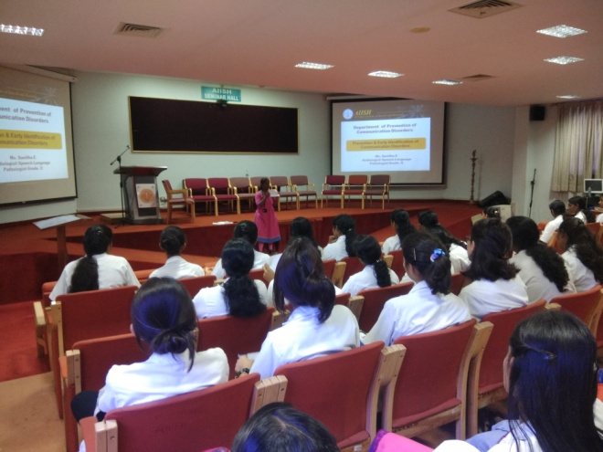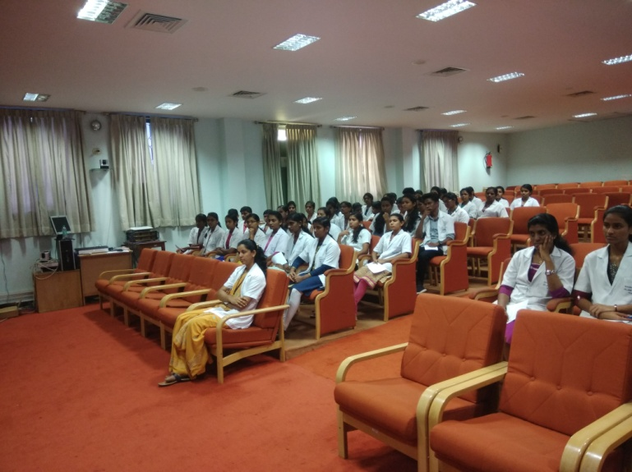

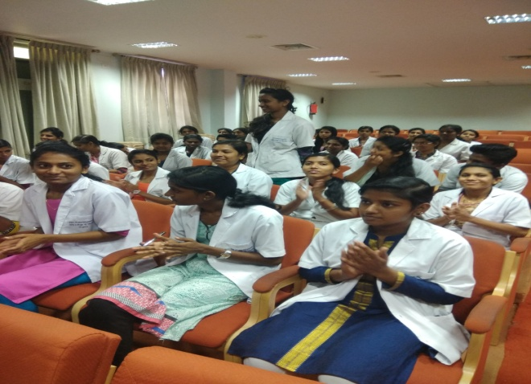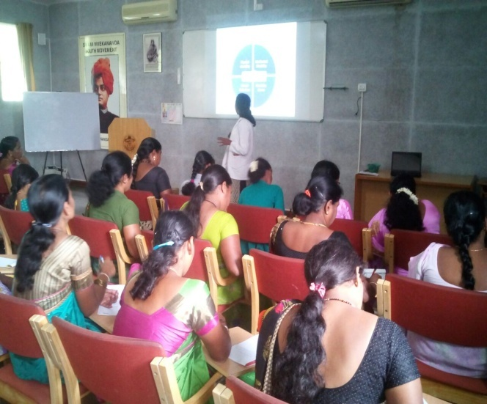

Table 2: Total number of participants oriented in the month of July 2018.

|  |  |  |  |  |
| --- | --- | --- | --- | --- |
| **S.No** | **Target group** | **Gender** | | **Total number of Participants** |
| **Male** | **Female** |
|  | Students | 104 | 323 | **427** |
|  | Nursing Students | 03 | 106 | 109 |
|  | Industrial workers | 29 | 0 | 29 |
|  | ASHA worker | 0 | 22 | 22 |
|  | Family Members of CP children | 1 | 13 | 14 |
|  | School Teachers | 4 | 20 | 24 |
|  | Anganawadi workers | 0 | 58 | 58 |
|  | Medical students | 4 | 2 | 6 |
| **Total** | | **145** | **544** | **689** |

1. **Training programs conducted: Nil**
2. **Clinical Observation postings of students from other Institutes:2**

|  |  |  |  |  |
| --- | --- | --- | --- | --- |
| Sl.no | Date of Postings | Name of the Students | Designation | Institute/University |
| 1 | 02.07.2018-17.07.2018 | Nitin | * BASLP | * [Ashtavakra Institute of Rehabilitation Sciences](http://int.search.myway.com/search/GGmain.jhtml?ct=ARS&n=781c55df&p2=%5EGR%5Exdm731%5ETTAB02%5Ein&pg=GGmain&pn=1&ptb=FF220395-40C6-4664-A316-6878D1E3B162&qs=&si=YLyHErnWXd&ss=sub&st=tab&trs=wtt&searchfor=Ashtavakra+Institute+of+Rehabilitation+Sciences&feedurl=ars%252Ffeedback%253ForiginalQuery%253Dashtavakra%252Buniversity%2526relatedQuery%253Dashtavakra%252Binstitute%252Bof%252Brehabilitation%252Bsciences&tpr=jrel3) and research,   Delhi |
| 2 | 18.07.2018-31.07.2018 | Bhawna | * BASLP | * [Ashtavakra Institute of Rehabilitation Sciences](http://int.search.myway.com/search/GGmain.jhtml?ct=ARS&n=781c55df&p2=%5EGR%5Exdm731%5ETTAB02%5Ein&pg=GGmain&pn=1&ptb=FF220395-40C6-4664-A316-6878D1E3B162&qs=&si=YLyHErnWXd&ss=sub&st=tab&trs=wtt&searchfor=Ashtavakra+Institute+of+Rehabilitation+Sciences&feedurl=ars%252Ffeedback%253ForiginalQuery%253Dashtavakra%252Buniversity%2526relatedQuery%253Dashtavakra%252Binstitute%252Bof%252Brehabilitation%252Bsciences&tpr=jrel3) and research,   Delhi |

**V. No. of Seminars/ Conferences /Lectures /Workshop organized by the dept – Nil**

* Workshops organized by the Department: Nil
* Conferences organized by the Department: Nil

**Vi. No. of Seminars/ Conferences /Lectures /Workshop attended by the staff of the Dept**

* No. of Conferences attended by Staff of POCD: Nil
* Workshops attended by Staff of POCD: 01

|  |  |  |  |  |  |
| --- | --- | --- | --- | --- | --- |
| **Sl.No** | **Date** | **Title of the program** | **Organized by** | **Venue** | **Staff attended** |
| 1. | 12.07.2018 | ‘The recent advances in the Management of stuttering’ | Depart of speech language pathology | AIISH  Seminar hall | Ms. Yashaswini B C |

* Seminars attended by Staff of POCD: Nil
* Guest Lectures attended by staff of POCD:1

|  |  |  |  |  |  |
| --- | --- | --- | --- | --- | --- |
| **Sl.No** | **Date** | **Title of the program** | **Organized by** | **Venue** | **Staff attended** |
| 1. | 16.07.2018 | ‘Intentional communication in children with Autism’ | Tele-center for persons with communication disorders | AIISH  Seminar hall | Ms. Yashaswini B C |

**vii. No. of Guest Lectures organized: Nil**

**viii. No. of Invited Talks delivered by faculty and staff: Nil**

**ix. Any other:**

* **Student clinical training:** As part of human resource development, clinical training for Undergraduates (B.Sc Speech & Hearing), Postgraduates (M.Sc SLP & AUD) & Internship students on early identification, prevention & rehabilitation of communication disorders and Community based rehabilitation at OSCs were carried out. The details on the number of students who had undergone training are given below.

|  |  |  |
| --- | --- | --- |
| **Internal (AIISH)** | | |
| **Class** | **No of students Newly posted** | **No of Students continuing** |
| II B.ASLP students | 5 | 4 |
| I M.Sc students (Speech ) | 0 | 0 |
| I M.Sc students (Audiology) | 0 | 0 |
| Internship students | 6 | 6 |
| **Total** | **11** | **10** |
| **External** | | |
| BASLP Student (Intern) | 2 | 0 |
| **Total** | **2** | **0** |

* **Staff/Student Enrichment Programs: Nil**
  1. **Research Projects :**Nil
  2. **Doctoral and Post-Doctoral Programs:** Nil
  3. **Research papers presented in National conferences/seminars:** Nil
  4. **Research papers presented at International conferences/seminars:** Nil
  5. **Research Papers published in National Conference/Seminar Proceedings:** Nil
  6. **Research Papers published in International Conference/Seminar Proceedings:** Nil
  7. **Research Papers published in National Journals:** Nil
  8. **Research Papers published in International Journals:** Nil
  9. **Book / Chapters Published:** Nil
  10. **Books / Manuals/ Seminar proceedings Edited: NIL**
  11. **Scholarly Reviewing Activities:** Nil
  12. **Research Proposal:** Nil

**3. CLINICAL SERVICES**

1. **General Clinical Services**
2. **Follow-up evaluation- Detailed evaluation**

The newborns/infants referred during the newborn screening were followed up through telephone calls to parents/caregivers of infants. A complete test battery was administered for those clients who came for follow-up. Table 4 (a) & (b) depicts the statistics related to this activity.

Table 4 (a): Details of the results of follow-up evaluation for newborns and infants.

|  |  |  |  |  |  |  |  |  |  |  |  |
| --- | --- | --- | --- | --- | --- | --- | --- | --- | --- | --- | --- |
| **Categories** | **AIISH + Cheluvamba** | **OSC Sarguru** | **OSC-Sagara** | **Ajmer** | **Cuttack** | **Imphal** | **Puducherry** | **Ranchi** | **Jabalpur** | **Lucknow** | **Total** |
| Normal | 12 | 13 | 1 | 0 | 05 | 15 | 43 | 0 | 0 | 10 | **99** |
| ENT disorders | 0 | 0 | 0 | 0 | 00 | 1 | 0 | 0 | 0 | 0 | **1** |
| Auditory Maturation delay | 0 | 2 | 0 | 0 | 00 | 0 | 0 | 0 | 0 | 0 | **2** |
| Hearing impairment | 0 | 0 | 0 | 0 | 05 | 0 | 02 | 0 | 0 | 06 | **13** |
| Speech & language disorder | 0 | 0 | 0 | 0 | 00 | 2 | 0 | 0 | 0 | 0 | **2** |
| Multiple Disorder | 0 | 0 | 0 | 0 | 00 | 0 | 0 | 0 | 0 | 0 | **0** |
| Incomplete testing | 0 | 0 | 1 | 16 | 00 | 0 | 09 | 0 | 0 | 0 | **26** |
| **Total** | **12** | **15** | **2** | **16** | **10** | **18** | **54** | **0** | **0** | **16** | **143** |

The at-risk babies were monitored regularly by administering the speech-language & hearing checklist through phone call. The babies who are identified with delay in the milestones were referred to AIISH/concern NBS centre for detailed evaluation.

Table 4(b)**:** Follow-up evaluation- Phone follow-up

|  |  |  |  |
| --- | --- | --- | --- |
| **Categories** | **Mysuru Centre (POCD)** | **NBS Centers** | **OSC Centers** |
| Normal speech, language & hearing milestones | 0 | 208 | 4 |
| Referred for detailed evaluation | 0 | 11 | 6 |
| **Total Phone follow up** | **0** | **219** | **10** |

1. **Hearing evaluation of industrial workers at AIISH:**

The industrial employees during the Industrial screening were followed for detail evaluation. A complete test battery was administered for those clients who came for follow-up. Table 4 (c) depicts the statistics related to this activity.

Table 4 (c): Details of the results of follow-up evaluation for Industrial employees.

|  |  |  |  |
| --- | --- | --- | --- |
| **Name of the industry** | **Total Evaluated** | **Total Number of ears with** | |
| **Normal hearing**  **(Ear wise)** | **Hearing loss**  **(Ear wise)** |
| **Bannari Industry,**  **Nangungud** | **21** | **24** | **18** |

1. **Specialized Clinical services: Nil**
2. **Clinical Support Services to Patients and Family: Nil**
3. **Clinical Electronic Services: Nil**

**B) EXTENSION ACTIVITIES**

1. **Newborn screening for Communication Disorders**

The department of POCD is actively involved in carrying out various extension activities such as screening, diagnostic and rehabilitation services outside the institute campus. The activities include newborn/infant screening, screening of school children, screening of elderly citizens, screening of industrial workers, conducting camps and also clinical services offered at the outreach service centers of AIISH.

Table 5: Total number of newborns/infants screened and identified at-risk for

Communication disorders.

|  |  |  |  |  |  |  |  |  |  |
| --- | --- | --- | --- | --- | --- | --- | --- | --- | --- |
| **SN** | **Hospitals/Immunization Centers** | **Total births** | **Total No. Screened** | | | | **Total No. at risk** | | |
| **Male** | **Female** | | **Total** | **Male** | **Female** | **Total** |
|  |  | **AIISH- Mysuru** | | | | | | |  |
|  | Basappa Memorial Hospital (BMH) | **0** | 0 | 0 | | **0** | 0 | 0 | **0** |
|  | Combined Hospital (CH) | **NA** | 10 | 8 | | **18** | 1 | 0 | **1** |
|  | Kamakshi Hospital (KH) | **156** | 50 | 43 | | **93** | 1 | 0 | **1** |
|  | KR Hospital (KRH)- Cheluvamba | **788** | 319 | 329 | | **648** | 3 | 8 | **11** |
|  | Makkalakoota Immunization Center (MIC) | **NA** | 7 | 5 | | **12** | 0 | 1 | **1** |
|  | Mission Hospital (MH) | **76** | 29 | 32 | | **61** | 1 | 3 | **4** |
|  | Immunization Center at Mission Hospital (ICMH) | **NA** | 2 | 1 | | **3** | 0 | 0 | **0** |
|  | N.P.C Hospital | **NA** | 4 | 1 | | **5** | 0 | 0 | **0** |
|  | S.M.T.D.H Hospital | **64** | 21 | 24 | | **45** | 0 | 0 | **0** |
|  | Railway Hospital (RH) | **9** | 6 | 2 | | **8** | 0 | 0 | **0** |
|  | Employees State Insurance (ESI) Hospital | **0** | 0 | 0 | | **0** | 0 | 0 | **0** |
|  | Ashwini Nursing Home (ANH) | **12** | 7 | 5 | | **12** | 0 | 0 | **0** |
|  | Shree Devi Nursing Home (SNH) | **25** | 8 | 7 | | **15** | 0 | 0 | **0** |
|  | GopalaGowdaShanthaveri Memorial Hospital (GGSMH) | **23** | 3 | 3 | | **6** | 1 | 0 | **1** |
|  | Mahadeshwara Nursing Home (MNH) | **27** | 4 | 6 | | **10** | 0 | 0 | **0** |
|  | Sigma Hospital (SH) | **42** | 15 | 23 | | **38** | 0 | 0 | **0** |
|  | Brindavan Hospital | **45** | 5 | 5 | | **10** | 0 | 0 | **0** |
|  | **Total (Mysuru hospitals)** | **1267** | **490** | **494** | | **984** | **7** | **12** | **19** |
| **Newborn screening at OSC Centers** | | | | | | | | | |
| 18. | Sub-divisional hospital, K R Nagar Taluk | **144** | 20 | 20 | | **40** | 0 | 0 | **0** |
| 19. | Sub-divisional hospital, T NarsipuraTaluk | **77** | 16 | 9 | | **25** | 0 | 0 | **0** |
| 20. | Sub-divisional Hospital, SagaraTaluk | **120** | 52 | 52 | | **104** | 2 | 0 | **2** |
| 21 | Sub-divisional hospital, Sarguru | **257** | 134 | 103 | | **237** | 9 | 10 | **19** |
| Immunization* | **NA** | 5 | 7 | | **12** | 0 | 0 | **0** |
| 22. | Community Health Centre (CHC), Hullahalli | **10** | 7 | 7 | | **14** | 1 | 1 | **2** |
| 23. | Community Health Centre (CHC), Santhemarahalli | **7** | 2 | 0 | | **2** | 0 | 0 | **0** |
| 24. | Primary Health Centre (PHC), Akkihebbalu | **10** | 4 | 8 | | **12** | 1 | 0 | **1** |
|  | **Total (OSCs)** | **625** | **240** | **206** | | **446** | **13** | **11** | **24** |
| **Screening at NBS Centers** | | | | | | | | | |
| 25. | Sri RamachandraBhanj Medical College and Hospital (SCB MCH), Cuttack | **383** | 234 | 100 | **334** | | 15 | 12 | **27** |
| 26. | Regional Institute of Medical Sciences (RIMS), Imphal | **325** | 170 | 148 | **318** | | 9 | 7 | **16** |
| 27. | Janana Hospital & JLNMCH, Ajmer | **991** | 444 | 434 | **878** | | 60 | 26 | **86** |
| 28. | JIPMER, Puducherry | **1444** | 681 | 642 | **1323** | | 51 | 37 | **88** |
| 29. | NetajiSubhash Chandra Bose Medical College (NSCB), Jabalpur | **418** | 205 | 150 | **355** | | 60 | 34 | **94** |
| 30. | Rajendra Institute of Medical Sciences, Baritayu, Ranchi | **537** | 229 | 199 | **428** | | 17 | 20 | **37** |
| 31. | Kings George’s Medical University, Lucknow | **NA** | 212 | 165 | **377** | | 23 | 17 | **40** |
|  | **Total (NBS centers)** | **4098** | **2175** | **1838** | **4013** | | **235** | **153** | **388** |
|  | **Overall Total** | **5990** | **2905** | **2538** | **5443** | | **255** | **176** | **431** |

1. **School/ Anganawadi screening: 6**

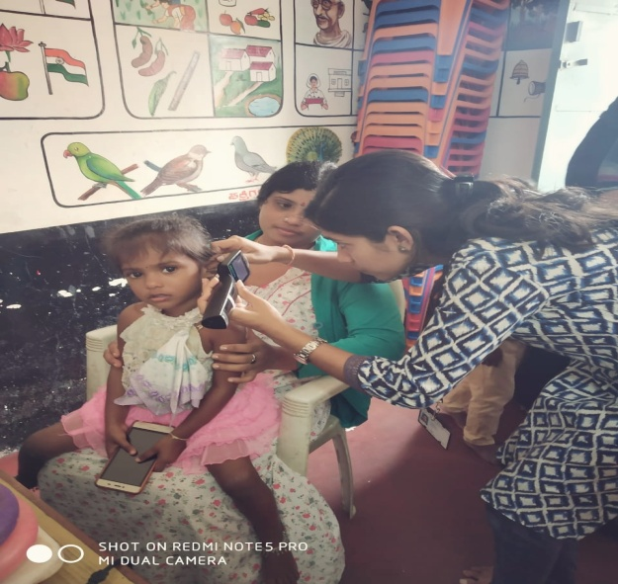 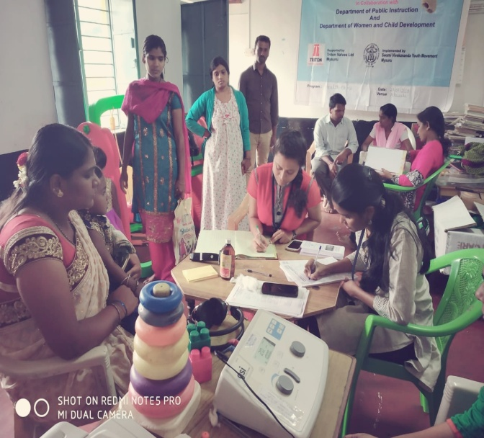

|  |  |  |  |  |  |  |  |  |  |
| --- | --- | --- | --- | --- | --- | --- | --- | --- | --- |
| **Sl. No** | **Date** | **Name of the Anganawadi/ School** | **Total screened** | **Total identified with communication disorders** | | | | | |
| **Ear related disorder** | **Hearing loss** | **Speech language disorders** | | | |
| **Fluency** | **voice** | **language** | **Articulation** |
| 1 | 27.7.2018 | Yelawala  Anganawadi I, Mysore | 20 | 3 | 0 | 0 | 0 | 0 | 0 |
| 2 | 27.7.2018 | Koorgalli  Anganawadi II, Mysore | 22 | 1 | 0 | 0 | 0 | 3 | 0 |
| 3 | 14.07.2018 | Government primary school, vilpuram | 18 | 01 | 06 | 0 | 0 | 10 | 0 |
| 4 | 10/07/2018 | Shivalingappa High School,  saragur | 156 | 8 | 0 | 0 | 0 | 1 | 0 |
| 5 | 27/07/2018 | Government Tank Higher Primary School,  saragur | 110 | 0 | 0 | 0 | 0 | 3 | 0 |
| 6 | 30/07/2018 | Anganwadi School,  saragur | 15 | 0 | 0 | 0 | 0 | 0 | 0 |
|  | **Total** | | **341** | **13** | **6** | **17** | | | |

1. **Hearing screening of Industrial employees:**

All the industrial employees were screened for hearing loss and those were referred are advised for detailed evaluation at AIISH. Employees and employers are also oriented on harmful effects of Noise on hearing, importance of hearing conservation program and also use of hearing protective devices in noisy areas.

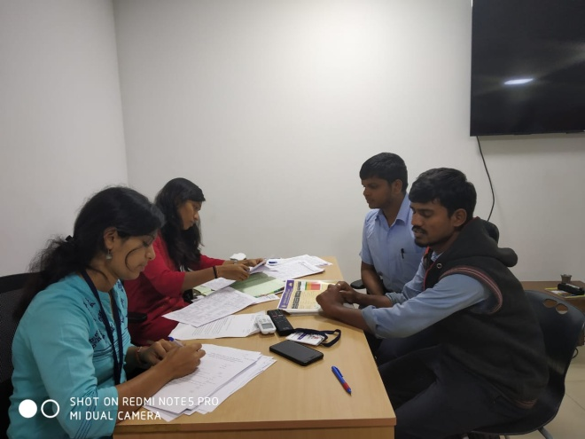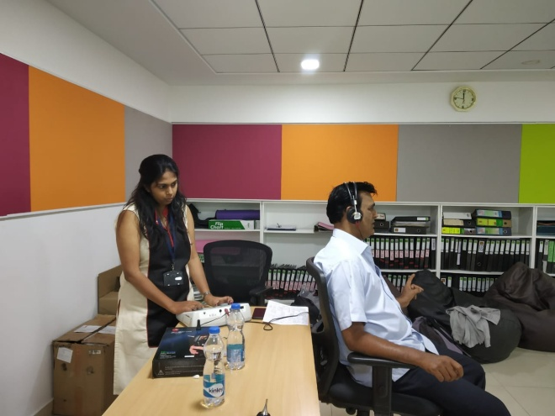

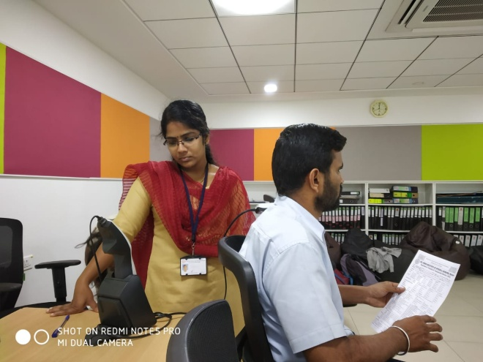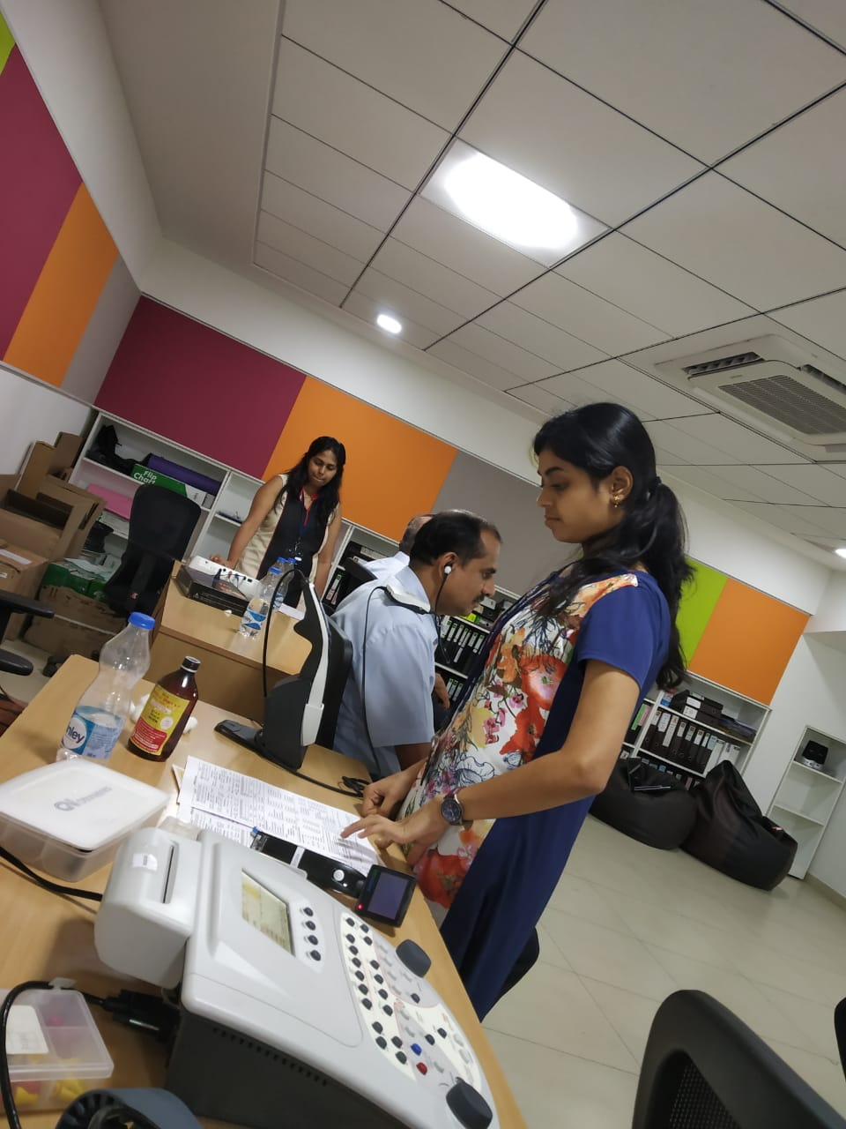

Table 6: Total number of employees screened and identified with hearing loss

|  |  |  |  |  |  |  |
| --- | --- | --- | --- | --- | --- | --- |
| **Sl.No** | **Month** | **Name of the Industry** | **Total Registered** | **Total no. of individuals ears identified with Hearing impairment** | **Total no. of individuals with normal ears** | **Total no. of individuals ears identified with ENT disorders** |
| 1 | 24.01.2018 | Triton Valves Ltd,  Mysore | 154 | 42` | 111 | 1 |
| **Total** | | | **154** | **42** | **111** | **1** |

1. **Clinical services for the Elderly citizens: 2**

The Department of POCD conducted a speech language and hearing camp for elderly individuals residing at different old age homes located in and around Mysore.

Table 7: Total number of the elderly citizens screened and identified with communication disorder.

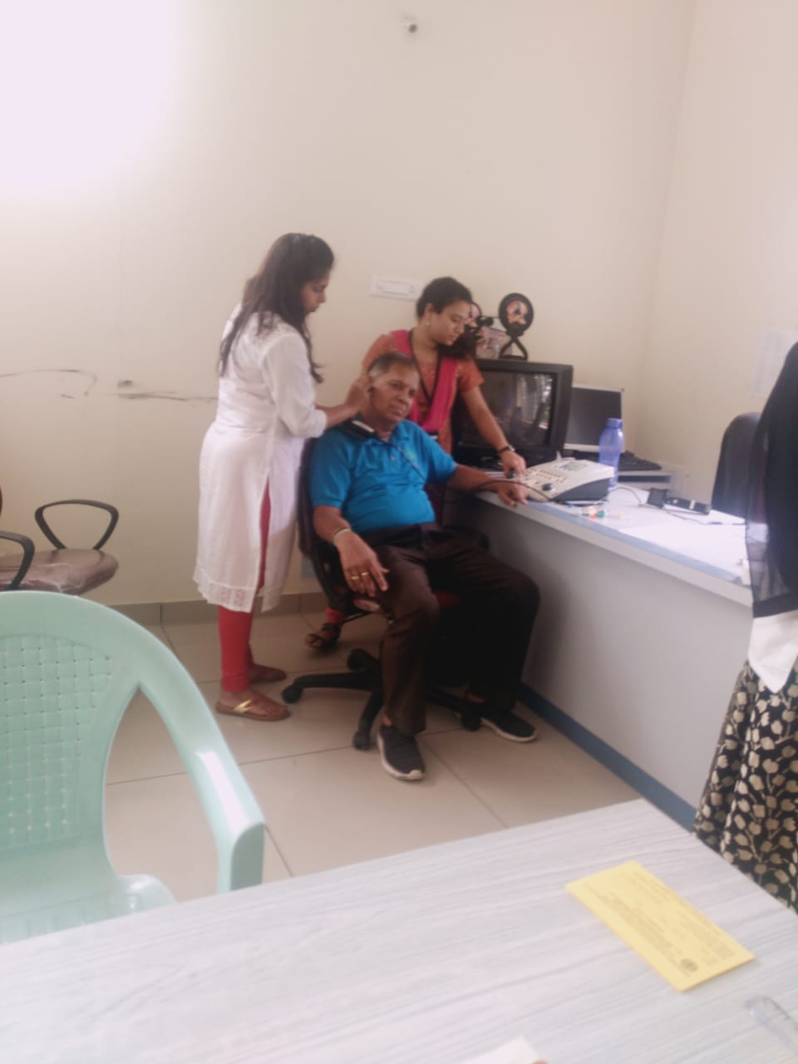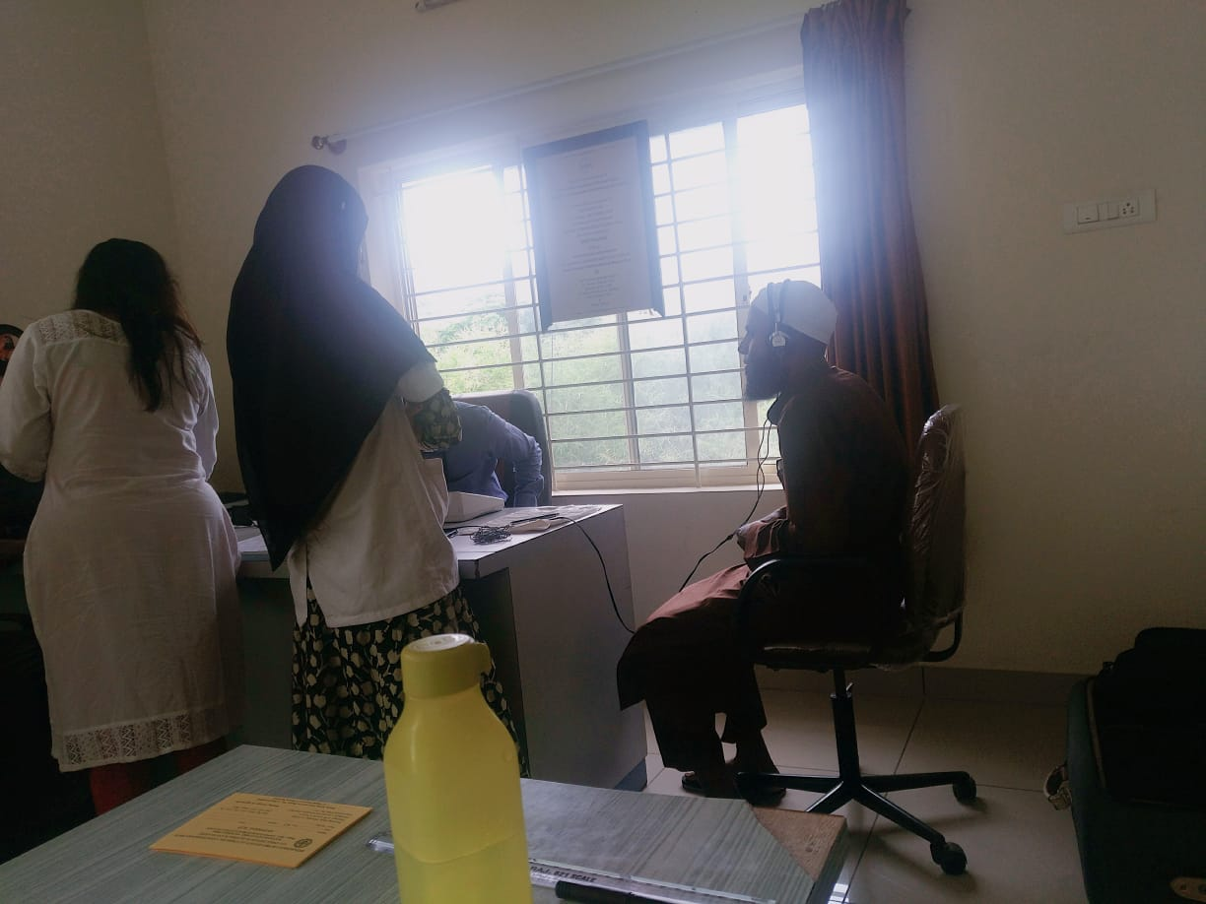

|  |  |  |  |  |  |  |  |  |  |  |  |
| --- | --- | --- | --- | --- | --- | --- | --- | --- | --- | --- | --- |
| **Sl.No** | **Date** | **Place** | **Total screened** | **Normal**  **(ear wise)** | **ENT**  **( no of ears)** | **HE( no of ears)** | **Speech- Language disorders** | | | | **Hearing aid Issued** |
| **Voice** | **Fluency** | **Articul-ation** | **Language** |
| 1 | 13.07.18 | Chayadevi, Mysore | 14 | 4 | 0 | 24 | 0 | 0 | 0 | 0 | 0 |
| 2 | 30.07.18 | SGS,  Mysore | 27 | 22 | 10 | 22 | 0 | 0 | 0 | 0 | 0 |
| **Total** | | | **41** | **26** | **10** | **46** | **0** | | | | **0** |

**vii**. **Clinical Services at Outreach Service Centers (OSCs):**

The clinical activities are not only restricted to in and around Mysore, but also extended to rural areas where facilities for clinical services for persons with communication disorders were meager. Currently 05 OSCs (01 VMH, Saragur, HD Kote; 02 Sub-divisional taluk hospital at Sagara taluk, Shivamogga District; 03 Primary Health Centre - PHC at Hullahalli, Mysuru district; 04 Akkihebbalu, Mandya district & 05 Karuna trust, Gumballi, Chamarajanagara district) were initiated to meet the objective of extending the services of the institute to rural areas. The OSCs are functioning as a well-equipped unit for screening, diagnostics and therapeutic services for persons with communication disorders. The services include screening, diagnostic and rehabilitation which includes newborn/infant screening, screening of school children, Speech and Language evaluation, Audiological evaluation, ENT evaluation, Speech-Language therapy, issue of free body level hearing aids and ear molds, and counseling and guidance to individuals with communication disorders. The other details are tabulated below in tables 8, 9 & 10.

Table 8: Details of clients identified with communication disorders at the OSCs.

|  |  |  |  |  |  |  |  |  |
| --- | --- | --- | --- | --- | --- | --- | --- | --- |
| **OSC** | **Total Registered** | **ENT Evaluation**  **Registered=124** | | | **Hearing Evaluation**  **Registered=47** | | **Speech & Language Evaluation**  **Registered= 19** | |
| **Normal (Ear Wise)** | **Disorder (Ear wise)** | **ENT related**  **Others** | **Normal (Ear Wise)** | **Disorder (Ear wise)** | **Normal (Individuals)** | **Disorder (Individuals)** |
| Primary Health Centre (PHC), Hullahalli | **59** | 26 | 56 | 15 | 0 | 2 | 0 | 2 |
| Primary Health Centre (PHC), Akkihebbalu | **34** | 7 | 35 | 8 | 0 | 6 | 0 | 2 |
| Primary Health Centre (PHC), Gumballi | **55** | 19 | 37 | 11 | 2 | 24 | 0 | 3 |
| Sub-divisional Hospital (PHC), Sagara | **21** | 0 | 0 | 0 | 4 | 34 | 0 | 2 |
| VMH, Sarguru | **21** | 0 | 0 | 0 | 6 | 16 | 2 | 8 |
| **Total** | **190** | **52** | **128** | **34** | **12** | **82** | **2** | **17** |

Table 8a. : Details of clients followed up (Old clients) at the OSCs.

|  |  |  |  |  |  |  |  |  |
| --- | --- | --- | --- | --- | --- | --- | --- | --- |
| **OSC** | **Total Follow up** | **ENT Evaluation =54** | | | **Hearing Evaluation=21** | | **Speech & Language Evaluation= 2** | |
| **Normal (Ear Wise)** | **Disorder (Ear wise)** | **ENT related**  **Others** | **Normal (Ear Wise)** | **Disorder (Ear wise)** | **Normal (Individuals)** | **Disorder (Individuals)** |
| Primary Health Centre (PHC), Hullahalli | 17 | 2 | 20 | 2 | 0 | 8 | 0 | 0 |
| Primary Health Centre (PHC), Akkihebbalu | 21 | 5 | 23 | 5 | 0 | 2 | 0 | 1 |
| Primary Health Centre (PHC), Gumballi | 36 | 9 | 31 | 2 | 0 | 26 | 0 | 1 |
| Sub-divisional Hospital (PHC), Sagara | 1 | 0 | 0 | 0 | 1 | 1 | 0 | 0 |
| VMH, Sarguru | **2** | 0 | 0 | 0 | 0 | 4 | 0 | 0 |
| **Total** | **77** | **16** | **74** | **9** | **1** | **41** | **0** | **2** |

Table 9: Details of clients identified with different types of communication disorders across OSCs (New and old cases)

|  |  |  |  |  |  |
| --- | --- | --- | --- | --- | --- |
| **Type of Disorders** | **OSC** | | | |  |
| Primary Health Centre (PHC), Hullahalli | Primary Health Centre (PHC), Akkihebbalu | Primary Health Centre (PHC), Gumballi | Sub-divisional Hospital, Sagara (PHC) Taluk | VMH,Sarguru |
| **Hearing disorders (Ear-wise data)** | | | | | |
| Normal | 0 | 0 | 4 | 4 | 6 |
| Conductive | 1 | 1 | 0 | 6 | 5 |
| Sensorineural | 5 | 5 | 42 | 20 | 10 |
| Mixed | 2 | 1 | 0 | 6 | 3 |
| Profound | 2 | 1 | 6 | 2 | 2 |
| **Total (ears)** | **10** | **8** | **52** | **38** | **26** |
| **Speech &Language disorders (Individuals)** | | | | | |
| Voice | 1 | 2 | 0 | 0 | 0 |
| Fluency | 0 | 0 | 0 | 0 | 1 |
| Articulation disorders | 0 | 1 | 1 | 0 | 0 |
| Language disorders | 1 | 0 | 3 | 2 | 7 |
| **Total (Individuals)** | **2** | **3** | **4** | **2** | **8** |

Table 10**:** Rehabilitation services provided at Outreach service centers

|  |  |  |  |  |
| --- | --- | --- | --- | --- |
| **OSC** | **Hearing Aids Dispensed** | **Speech-language therapy** | | **Medical Line of Treatment** |
| **No. of clients** | **No. of sessions** |
| Primary Health Centre (PHC), Hullahalli | 6 | 0 | 0 | 69 |
| Primary Health Centre (PHC), Akkihebbalu | 2 | 1 | 4 | 48 |
| Primary Health Centre (PHC), Gumballi | 14 | 4 | 12 | 61 |
| Sub-divisional Hospital, Sagara (PHC) Taluk | 4 | 19 | 89 | 0 |
| VMH, Sarguru | 1 | 12 | 42 | 0 |
| **Total** | **27** | **36** | **147** | **178** |

1. **Communication Disorders Screening Camps:Nil**
   1. **Organized by the Institute/POCD/ Others: Nil**
2. **SPECIAL ACTIVITIES**
3. **Library and information services – Nil**
4. **Public Information Activities – Nil**
5. **Exhibition: Nil**
6. **Material Development**

**Designing of the following mentioned pamphlets was done and these pamphlets are ready to release for Annual day 2018.**

* Know more about Voice and its disorders (English)
* Know this to prevent communication disorders (English)
* Specific Language Impairment (English)
* Communication disorders in elderly (English)
* Know more about Dementia (English)
* Prevention of developmental disorders (English)
* Communication disorders in Intellectual disability (English)
* Attention Deficit Hyperactivity Disorder (Kannada, Hindi, Tamil, Malayalam & Marathi)
* Ear discharge and its prevention (Hindi, Tamil)

1. **Press Releases and Media Coverage:** Nil
2. **Public Lecture Series:** Nil
3. **AWARDS AND HONOURS RECEIVED BY FACULTY AND STAFF:** Nil
4. **TECNOLOGICAL CONSULTANCY SERVICES:** Nil
5. **EXTRA CURRICULLAR ACTIVITIES:** Nil
6. **VISITORS:** Nil
7. **MAJOR EVENTS OF THE MONTH:** Nil
8. **OTHERS:**

|  |  |  |
| --- | --- | --- |
| 1. **Dept. Related** | | |
| **S.No** | **Particulars** |  |
|  | **Computerization activities** | Initiation of Phase II of computerisation.  Correction of Statistical report of elderly screening.  Initiated OSC computerisation. Audiology OPD format, Speech OPD format, and two speech and language Proforma were given for computerisation. |
| **b** | **OSC Related-** | HOD, faculty and OSC in charge (staff) visited OSC centers, Sagara on 5th and 6th July 2018. |
| **c** | **NBS related-** | NBS screening card was prepared (which will be given for the mother of infants) for documentation proposes. |
| **d** | **RE BE 2018-19-20** | **RE BE** wasprepared for POCD activity |

|  |  |  |  |
| --- | --- | --- | --- |
| 1. **Activities carried out by the following staffs from the department** | | | |
| **Sl.No** | **Name of the staff** | **Designation** | **Activities** |
|  | Dr. Swapna. N | Reader in Speech Pathology | Visited OSC centers at Sarguru, on 2nd and Sagara on 5th and 6th July 2018.  Conducted orientation program on vegetative skill management for the caregivers of children with cerebral palsy on 2nd July 2018  Carried out meeting through skype for Lucknow and Ranchi centers on 10th July  Had a meeting wuth Dr. Arun Alexander, NBS coordinator of Puducherry center on 11th July  Submitted REBE of the Dept. |
|  | Dr. Prawin Kumar | Reader in Audiology | Visited OSC centers at Sarguru, on 2nd and Sagara on 5th and 6th July 2018.  Conducted orientation program on*“*Prevention & early identification of communication disorders” for the teacher on 2nd July 2018 |
|  | Ms. Yashaswini B C | Speech Language Pathologist Grade I | *Delivered 01 talk in the Orientation program on “*Prevention & early identification of communication disorders” organized by the Dept of POCD for   * Nursing student of JSS nursing college, Mysore on 30th July 2018.   Attended National seminar on ‘The recent advances in the Management of stuttering’ on 12th July 2018.  Attended guest lecture on ‘Intentional communication in children with Autism’ on 16th July 2018.  Designing of Screening card for Newborns.  Working on SFC proposal for NBS and OSC center at Kolar District.  Consulted DCP to conduct Sensitization program on Noise induced hearing loss in Traffic Police. |
|  | Ms. Sreelakshmi H D | Audiologist Grade I | *Delivered 01 talk in the Orientation program on “*Prevention & early identification of communication disorders” organized by the Dept of POCD for   * Industrial workers of Bannari, Nanjungud on 18th July 2018. * Industrial workers of Triron, Mysore on 23rd July 2018. * Nursing student of JSS nursing college, Mysore on 30th July 2018   Attended Industrial screening conducted in Triton Valves Ltd, Mysore on 23rd July 2018 |
|  | Mr. Rajith B N | Audiologist Grade I | Attended Elderly screening conducted in Sri Sacchidananda Ashrama, Mysore on 30th  July 2018  Consulted DCP to conduct Sensitization program on Noise induced hearing loss in Traffic Police |
|  | Ms. Akshatha Y | Audiologist Grade I | Visited OSC centers at Sarguru, on 2nd and Sagara on 5th and 6th July 2018.  Working on SFC proposal for NBS and OSC center at Kolar District. |
|  | Nayana M | Audiologist Grade I | *Delivered 01 talk in the Orientation program on “*Prevention & early identification of communication disorders” organized by the Dept of POCD for   * Industrial workers of Bannari, Nanjungud on 18th July 2018.   Attended Industrial screening conducted in Triton Valves Ltd, Mysore on 20rd and 23rd July 2018  Attended School screening conducted in Koorgalli and Yelawala, Mysore on 27th  July 2018  Attended Elderly screening conducted in Chayadevi and Sri Sacchidananda Ashrama, Mysore on 13th and 30th July 2018 respectively. |
|  | Devamma V | Audiologist Grade I | Attended Industrial screening conducted in Triton Valves Ltd, Mysore on 23rd July 2018.  Attended School screening conducted in Koorgalli and Yelawala, Mysore on 27th July 2018. |
|  | Bincy R Kalam | Speech Language Pathologist Grade I | Attended School screening conducted in Koorgalli and Yelawala, Mysore on 27th  July 2018  *Delivered 03 talk in the Orientation program on “*Prevention & early identification of communication disorders” organized by the Dept of POCD for   * Industrial workers of Bannari, Nanjungud on 19th July 2018. * Stuents of Girl High School, Yelandur on 23rd July 2018 * ASHA workers of Karuna Trust, Gumballi on 23rd July 2018.   Designing and final corrections of **14** pamphlets made.  Initiated OSC computerisation. Audiology OPD format, Speech OPD format, and two speech and language Proforma were given for computerisation. |
|  | Pavana Mohan | Audiologist Grade II | Attended Industrial screening conducted in Triton Valves Ltd, Mysore on 20rd July 2018  Attended School screening conducted in Koorgalli and Yelawala, Mysore on 27th  July 2018  Attended Elderly screening conducted in Sri Sacchidananda Ashrama, Mysore on 30th  July 2018  Initiated OSC computerisation. Audiology OPD format, Speech OPD format, and two speech and language Proforma were given for computerisation. |
|  | Usharani N S | Audiologist Grade II | Designing and final corrections of **14** pamphlets made.  Attended Industrial screening conducted in Triton Valves Ltd, Mysore on 20rd July 2018  Attended Elderly screening conducted in Chayadevi, Mysore on 13th July 2018. |
|  | Anju V A | Speech Language Pathologist Grade II | Attended Elderly screening conducted in Chayadevi and Sri Sacchidananda Ashrama, Mysore on 13th and 30th July 2018 respectively.  *Delivered 01 talk in the Orientation program on “*Prevention & early identification of communication disorders” organized by the Dept of POCD for   * Caregivers in Mother and child hospital, K.R nagar on3rd July 2018. |
|  | Ms. Tejaswini | Audiologist Grade I | Attended School screening conducted in Koorgalli and Yelawala, Mysore on 27th  July 2018  *Delivered 03 talk in the Orientation program on “*Prevention & early identification of communication disorders” organized by the Dept of POCD for   * Industrial workers of Bannari, Nanjungud on 19th July 2018. * Stuents of Girl High School, Yelandur on 23rd July 2018 * ASHA workers of Karuna Trust, Gumballi on 23rd July 2018.   Attended Elderly screening conducted in Sri Sacchidananda Ashrama, Mysore on 30th  July 2018 |

1. **Following staffs were relieved from the department: Nil**
2. **Following staffs were newly recruited to the department: Nil**

**Sd/-**

**Head, Dept. of POCD**

DEPARTMENT OF PREVENTION OF COMMUNICATION DISORDERS (POCD)

CUMMILATIVE REPORT

April 2018 to July 2018

1. **ACADEMIC ACTIVITIES**

* **Orientation/Short-term Training Programs: Nil**
* **No. of orientation/Sensitization programs organized: 47**

As part of primary prevention activities, several orientation/Sensitization programs were conducted regularly. The objective of this orientation programs was to create awareness among general public and various other professionals such as Medical doctors, Nurses, Health related workers, teachers, school students etc., on different types of communication disorders, its prevention and early identification methods and their appropriate referral and timely management. The table below shows the details of the orientation programs conducted by the dept. of POCD, OSCs & NBS centers.

|  |  |  |  |  |  |  |
| --- | --- | --- | --- | --- | --- | --- |
| **Sl. No** | **Date** | **Theme/Topic of the program** | **Name of the institute/**  **Hospital** | **Target group** | **Total participants** | **Oriented by** |
| **Organized by dept. of POCD**  **Coordinators: Dr.**  **Dr. Swapna. N** **& Mr. Arunraj K** | | | | | | |
|  | 25.04.2018 | “Prevention, early identification and management of communication disorders” | Govt. Ayurvedic College | Student | 48 | Ms. Anju  ( SLP Grade II)  &  Ms. Tejaswini (Audiologist Grade I) |
|  | 29.04.2018 | “Prevention, early identification and management of communication disorders” | SGS Hospital, Mysore | Elderly population | 29 | Dr. Swapna N Reader in Speech Pathology and Head, Department of POCD |
|  | 09.04.2018 | “Prevention, early identification and management of communication disorders” | PHC, Hampapura | Pregnant women and family members | 12 | Ms. Lavanya Audiologist Grade I |
|  | 26.04.2018 | “Prevention, early identification and management of communication disorders” | Regional institute of nursing, Jabalpur | Nursing student | 14 | MsThupakula  Saraswathi, Audiologist Gr. I |
|  | 27/04/2018 | “Prevention, early identification and management of communication disorders” | RIMS, Ranchi | Nursing student | 16 | Mukesh Kumar  Audiologist Gr. I |
|  | 27/04/2018 | “Prevention, early identification and management of communication disorders” | KGMU | DHLS students | 21 | Ms Meghana N  Audiologist Gr. I |
|  | 24/04/18 | “Prevention, early identification and management of communication disorders” | Naari Shala | Women at Rehabilitation centre (Naari Shala) and newborn caretakers | 21 | Mr. Anuj Kumar Neupane  Audiologist Gr. I |
|  | 04.05.2018 | “Prevention, early identification and management of communication disorders” | ROHCS, Bangalore | Industrial medical officer | 25 | Mr. Arun Raj  (Clinical Audiologist)  Ms.Pavana (Audiologist  Grade II)  Ms. Devamma (Audiologist  Grade I) |
|  | 18.05.2018 | “Prevention, early identification and management of communication disorders” | St. Agnes College  Mangalore | Psychology Students | 7 | Ms. Nayana (Audiologist Grade I) |
|  | 28.05.2018 | “Prevention, early identification and management of communication disorders” | Sarvodaya College of Education, Virajpet | B.Ed Student | 37 | Ms. Akshatha  & Ms.Sreelakshmi  (Audiologist Grade I) |
|  | 24/05/2018 | “Prevention, early identification and management of communication disorders” | RIMS, Ranchi | 2nd & 3rd year B. Sc. nursing student of Florence College of Nursing, Irba, Ranchi. | 29 | Mr.Mukesh Kumar  (Audiologist Grade I) |
|  | 26.05.2016 | “Prevention, early identification and management of communication disorders” | Nursing college, JIPMER | 2nd year nursing students | 10 | Ms Sylvia Treesa Sibi  (Audiologist Grade I) |
|  | 2/6/ 18 | “Prevention, early identification and management of communication disorders” | Primary Health Centre, Lamding , Thoubal District, Manipur. | ASHA workers, Doctor, Staff nurses and public. | 60 | Ms. P.Meenakshi Chanu  (Audiologist Grade I)  &  Mr. E. Dilip Singh  (Audiologist Grade I) |
|  | 27/04/2018 | “Prevention, early identification and management of communication disorders” | Qeen Mary’s Hospital  Lucknow | Nurses | 11 | Ms Meghana N  (Audiologist Grade I) |
|  | 19.05.2018 | “Prevention, early identification and management of communication disorders” | Sub Divisional Hospital Sagar | Publics | 40 | Mr.Mohan Dass. & M Jeena. TK  (Audiologist Grade I) |
|  | 23.05.2018 | “Prevention, early identification and management of communication disorders” | VMH, Sargur | Health facilitators/ Supervisors/ Program managers | 35 | Ms. Deepashree  (Audiologist Grade I) |
|  | 31.05.2018 | “Prevention, early identification and management of communication disorders” | VMH, Sargur | Mothers | 15 | Ms. Lavanya  (Audiologist Grade I) |
|  | 08.06.18 | Prevention, early identification and management of communication disorders” | St. Agnes College, Mangalore | Student | 8 | Ms. Anju  (Speech Language Pathologist Grade II)  & Ms. Nayana  (Audiologist GradeI) |
|  | 27.06.18 | Prevention, early identification and management of communication disorders” | St. Agnes College, Mangalore | Student | 7 | Ms. Nayana  (Audiologist GradeI) |
|  | 07.06.2016 | Prevention, early identification and management of communication disorders” | Nursing college, JIPMER | Medical record technicians, JIPMER | 22 | Ms. Sylvia Treesa Sibi  (Audiologist & Speech Language Pathologist) |
|  | 29/6/ 18 | Prevention, early identification and management of communication disorders” | Gyneacological Department Regional Institute of Medical Sciences, RIMS, IMPHAL | Pregnant women and women with High risk pregnancy | 70 | Ms. P.Meenakshi Chanu  (Speech Language Pathologist)  Mr. E. Dilip Singh  (Speech and Hearing Technician) |
|  | 28/06/2018 | Prevention, early identification and management of communication disorders” | RIMS, Ranchi | 1st year GNM nursing student of Hill View Nursing School, Bariatu Ranchi | 19 | Mr. Mukesh Kumar  (Audiologist GradeI) |
|  | 22/06/2018 | Prevention, early identification and management of communication disorders” | KGMU  Trauma Centre | Residental doctors | 05 | Ms Meghana N  (Audiologist GradeI) |
|  | 22.06.2018 | Prevention, early identification and management of communication disorders” | Govt PU College, Akkiheballu | Student | 66 | Ms. Lekshmi, Mr. Shobhan  (Interns)  & Ms. Bincy (Speech Language Pathologist Grade I) |
|  | 25.06.2018 | Prevention, early identification and management of communication disorders” | PHC, Akkiheballu | Anganawadi workers | 37 | Ms. Kajol, Ms. Rinsha (Interns)  & Mr. Rajith (Audiologist GradeI) |
|  | 26.06.2018 | Prevention, early identification and management of communication disorders” | PHC, Akkiheballu | ASHA workers | 8 | Ms. Kajol, & Ms. Rinsha  (Interns) |
|  | 19.06.2018 | Prevention, early identification and management of communication disorders” | VMH, Saragur | Health facilitators, Supervisors | 37 | Ms. Deepashree (Audiologist GradeI) |
|  | 20.06.2018 | Prevention, early identification and management of communication disorders” | VMH, Saragur | Health facilitators, Supervisors | 37 | Ms. Deepashree (Audiologist GradeI) |
|  | 22.06.2018 | Prevention, early identification and management of communication disorders” | VMH, Saragur | Aganawadi workers | 33 | Ms. Lavanya (Audiologist GradeI) |
|  | 25.06.2018 | Prevention, early identification and management of communication disorders” | VMH, Saragur | Counselling staff | 5 | Ms. Anoopa (Audiologist GradeI) |
|  | 29.06.2018 | Prevention, early identification and management of communication disorders” | VMH, Saragur | Aganawadi workers | 33 | Ms. Lavanya (Audiologist GradeI) |
|  | 18.07.18 | Prevention, early identification of Noise induced hearing loss | Bannari  Sugar factory, Nanjangudu | Industrial workers | 12 | Ms. Nayana, (Audiologist Grade I)  Ms. Sreelakshmi, (Audiologist Grade I) |
|  | 19.07.18 | Prevention, early identification of Noise induced hearing loss | Bannari  Sugar factory, Nanjangudu | Industrial workers | 09 | Ms Bincy  (SLP Grade I)  & Ms Tejaswini, (Audiologist Grade I) |
|  | 21.07.18 | Prevention, early identification and management of communication disorders” | Greenhill Public School, Wayanad | Students  (Intern) | 43 | Ms Jijinu  ( Intern) &  Ms Joel  (Intern) |
|  | 21.07.18 | Prevention, early identification and management of communication disorders” | Devivilasam Higher secondary school, Wayanad | Students  (Intern) | 91 | Ms Jessica,  (Intern) &  Ms Jayashree, (Intern) |
|  | 23.07.18 | Prevention, early identification of Noise induced hearing loss | Triton Industry,  Mysore | Industrial workers | 8 | Ms Sreelakshmi, (Audiologist Grade I) |
|  | 30.07.18 | Prevention, early identification and management of communication disorders” | JSS nursing college,  Mysore | Nursing Student | 71 | Ms Sreelakshmi, (Audiologist Grade I) &  Ms Yashaswini, (SLP Grade I) |
|  | 25/07/2018 | Prevention, early identification and management of communication disorders” | RIMS,  Ranchi | 2nd year GNM nursing student of RIMS, Bariatu Ranchi | 38 | Mr.Mukesh Kumar  (Audiologist Grade I) |
|  | 17.07.2018 | Prevention, early identification and management of communication disorders” | KGMU  Lucknow | Medical Internship student | 06 | As. Meghana N  (Audiologist Grade I) |
|  | 21.07.18 | Prevention, early identification and management of communication disorders” | **G**urumalleshwara School,  TNpura | Student | 74 | Mr Madhu, (Intern) |
|  | 20.07.18 | Prevention, early identification and management of communication disorders” | Girl High School, Yelandur | Students | 53 | Ms Bincy  ( SLP Grade I) & Ms Tejaswini  (Audiologist Grade I) |
|  | 20.07.18 | Prevention, early identification and management of communication disorders” | Karuna Trust, Gumballi | ASHA workers | 22 | Ms Bincy  ( SLP Grade I) & Ms Tejaswini  (Audiologist Grade I) |
|  | 10/07/2018 | Prevention, early identification and management of communication disorders” | Shivalingappa High School  Sagara | Teachers and Student | 176 | Ms. Rachna (Intern) |
|  | 02.07.2018 | Prevention, early identification and management of communication disorders” | VMH,  Saragur | Family Members of CP children | 14 | Dr Swapna N  Reader in Speech Pathology |
|  | 02.07.2018 | Prevention, early identification and management of communication disorders” | VMH,  Saragur | School Teachers | 14 | Dr Prawin Kumar  Reader in Audiology |
|  | 20.07.2018 | Prevention, early identification and management of communication disorders” | VMH,  Saragur | Aganawadi workers | 36 | Ms. Lavanya  (Audiologist Grade I) |
|  | 28.07.2018 | Prevention, early identification and management of communication disorders” | VMH,  Saragur | Aganawadi workers | 22 | Ms. Lavanya (Audiologist Grade I) |
| **Total Participants** | | | | | **1506** | |

**Table 1 (b): Total number of target groups oriented during the year 2018-19**

|  |  |  |  |  |
| --- | --- | --- | --- | --- |
| **Sl. No** | **Target group** | **Male** | **Female** | **Total number of Participants** |
|  | Nursing student | 22 | 217 | **239** |
|  | Pregnant women and family members | 4 | 8 | **12** |
|  | Elderly population | 11 | 18 | **29** |
|  | Student | 153 | 440 | **593** |
|  | DHLS students | 10 | 11 | **21** |
|  | Women at Rehabilitation centre | 0 | 15 | **15** |
|  | Newborn caretakers | 1 | 5 | **6** |
|  | Industrial medical officer/ workers | 46 | 8 | **54** |
|  | Psychology Students | 0 | 7 | **7** |
|  | Publics | 23 | 97 | **120** |
|  | Health facilitators/ Supervisors/ Program managers | 85 | 29 | **114** |
|  | Mothers | 1 | 28 | **29** |
|  | ASHA | 0 | 62 | **62** |
|  | Doctors | 12 | 6 | **18** |
|  | Media | 1 | 1 | **2** |
|  | Anganawadi | 0 | 161 | **161** |
|  | Teachers | 4 | 20 | **24** |
| **Total** | | **373** | **1133** | **1506** |

1. **Clinical Observation postings of students:**
2. **From other institutes:**

|  |  |  |  |  |
| --- | --- | --- | --- | --- |
| **Sl.no** | **Date of Postings** | **Number of Students** | **Desingation** | **Institute/University** |
| 1. | 3.05.2017 | 09 students | Psychology Interns | St. Agnes Centre for Post graduate studies and Research, Mangalore |
| 2. | 8.06.2018& 27.06.2018 | 15 Students | MSc Psychology students | St. Agnes college Mangalore University |
| 3. | 02.07.2018-17.07.2018 | 1 student | BASLP | * [Ashtavakra Institute of Rehabilitation Sciences](http://int.search.myway.com/search/GGmain.jhtml?ct=ARS&n=781c55df&p2=%5EGR%5Exdm731%5ETTAB02%5Ein&pg=GGmain&pn=1&ptb=FF220395-40C6-4664-A316-6878D1E3B162&qs=&si=YLyHErnWXd&ss=sub&st=tab&trs=wtt&searchfor=Ashtavakra+Institute+of+Rehabilitation+Sciences&feedurl=ars%252Ffeedback%253ForiginalQuery%253Dashtavakra%252Buniversity%2526relatedQuery%253Dashtavakra%252Binstitute%252Bof%252Brehabilitation%252Bsciences&tpr=jrel3) and research,   Delhi |
| 4. | 18.07.2018-31.07.2018 | 1 student | BASLP | * [Ashtavakra Institute of Rehabilitation Sciences](http://int.search.myway.com/search/GGmain.jhtml?ct=ARS&n=781c55df&p2=%5EGR%5Exdm731%5ETTAB02%5Ein&pg=GGmain&pn=1&ptb=FF220395-40C6-4664-A316-6878D1E3B162&qs=&si=YLyHErnWXd&ss=sub&st=tab&trs=wtt&searchfor=Ashtavakra+Institute+of+Rehabilitation+Sciences&feedurl=ars%252Ffeedback%253ForiginalQuery%253Dashtavakra%252Buniversity%2526relatedQuery%253Dashtavakra%252Binstitute%252Bof%252Brehabilitation%252Bsciences&tpr=jrel3) and research,   Delhi |

1. **From AIISH:** As part of human resource development, Clinical training for under graduates (B.Sc Speech & Hearing), Post graduates (M.Sc- SLP) & Internship students on Early identification, prevention & rehabilitation of communication disorders and Community based rehabilitation at OSCs were carried out. The details on number of students who had undergone training are given below.

|  |  |
| --- | --- |
| **Course/Specializations** | **Total Students trained** |
| II B.Sc students | 41 |
| M.Sc students | 13 |
| Internship students | 19 |
| Psychology Student/Other institutes | 24 |
| **Total** | **97** |

1. **No. of Seminars/ Conferences /Lectures /Workshop/Training program: Nil**
2. **Workshops organized by the Department: Nil**
3. **Conferences organized by the Department: Nil**
4. **Training programs conducted: Nil**
5. **No of Seminars attended by the Staff of POCD: Nil**
6. **Conferences attended by Staff of POCD: Nil**
7. **Workshops attended by Staff of POCD: 1**

|  |  |  |  |  |  |
| --- | --- | --- | --- | --- | --- |
| **Sl.No** | **Date** | **Title of the program** | **Organized by** | **Venue** | **Staff attended** |
| 1. | 12.07.2018 | ‘The recent advances in the Management of stuttering’ | Depart of speech language pathology | AIISH  Seminar hall | Ms. Yashaswini B C |

1. **Guest Lectures attended by Staff of POCD: 1**

|  |  |  |  |  |  |
| --- | --- | --- | --- | --- | --- |
| **Sl.No** | **Date** | **Title of the program** | **Organized by** | **Venue** | **Staff attended** |
| 2 | 16.07.2018 | ‘Intentional communication in children with Autism’ | Tele-center for persons with communication disorders | AIISH  Seminar hall | Ms. Yashaswini B C |

1. **Training programs attended by Staff of POCD**: **Nil**
2. **Orientation attended by staff of POCD: Nil**
3. **Staff Enrichment Programs: 11**

**1. Theme/Topic:** Development and analysis of a low cost screening tool to identify and classify hearing loss in children- A proposal for Developing countries

**Coordinator:** Dr.Swapna N, Dr. Prawin Kumar, Mr Arunraj K

**Presenters:** Ms. Karunika & Ms. Prathyasha (I MSc-SLP)

**Number of Participants:** Dr. Swapna. N., Mr. Arunraj K, AkshataY., Ms. Ms. Nayana M., Ms. Devamma V., Ms. Bincy R. K. , Ms. Anju V. A. Ms. Pavana M & Ms. Usha Rani N. S and Ms. Tejaswini S

**Date:** 06.04.2018

**2.Theme/Topic:** Characterization of Newborn hearing screening failures in multi- gestational births.

**Coordinator:** Dr.Swapna N, Dr. Prawin Kumar, Mr Arunraj K

**Presenters:** Ms. Shalini. M & Ms. Malavika (IMSc-SLP)

**Number of Participants:** Dr. Swapna. N., Mr. Arunraj K, Ms. Ms. Nayana M., , Ms. Bincy R. K. , Ms. Anju V. A., Ms. Sreelakshmi H. D & Pavana M.

**Date:** 16.04.2018

**3.Theme/Topic:** Hearing impairment and its risk factors by newborn screening in north western Indian

**Coordinator:** Dr.Swapna N, Dr. Prawin Kumar, Mr Arunraj K

**Presenters:** Ms**.** Navya Kesav., Ms. Reny Raju & Ms. Vijaya varshaa(I MSc-SLP)

**Number of Participants:** Dr. Swapna. N., Mr. Arunraj K, Ms. Ms. Nayana M., , Ms. Bincy R. K. , Ms. Anju V. A., Ms. Sreelakshmi H. D ., Mr. Rajith B N., Ms Akshatha & Ms. Pavana M.

**Date:** 23.04.2018

**4.Theme/Topic:** High risk factors associated with early childhood hearing loss: A 3 year review

**Coordinator:** Dr.Swapna N, Dr. Prawin Kumar, Mr Arunraj K

**Presenters:** Ms. Shalini. M & Ms. Malavika (IMSc-SLP)

**Number of Participants:** Dr. Swapna. N., Mr. Arunraj K, Ms. Ms. Nayana M., Ms. Bincy R. K. , Ms. Anju V. A. Ms. Sreelakshmi H. D ., Mr. Rajith B N., Ms Akshatha & Ms. Pavana Mohan.

**Date:** 26.04.2018

**5.Theme/Topic:** Newborn hearing screening failure and maternal factors during pregnancy

**Coordinator:** Dr.Swapna N, Dr. Prawin Kumar, Mr Arunraj K

**Presenters:** S.Shivaranjini and V. Monish (I MSc-SLP)

**Number of Participants:** Ms. Nayana M., Ms. Devamma V., Ms. Bincy R. K. , Ms. Anju V. A. Ms. Pavana M & Ms. Usha Rani N. S

**Date:** 03.05.2018

**6.Theme/Topic:** Case history risk factors for specific language impairment: A systematic review and meta-analysis

**Coordinator:** Dr.Swapna N, Dr. Prawin Kumar, Mr Arunraj K

**Presenters:** Pooja C & Shital J (I MSc-SLP)

**Number of Participants:** Ms. Devamma V., Ms. Bincy R. K. , Ms. Anju V. A. Ms. Pavana M & Ms. Usha Rani N. S

**Date:** 03.05.2018

**7.Theme/Topic:** Effect of gentamycin and levels of ambient sound on hearing screening outcomes in the neonatal intensive care unit: A pilot study

**Coordinator:** Dr.Swapna N, Dr. Prawin Kumar, Mr Arunraj K

**Presenters:** Susan, Safa, Lydia and Spoorthy (I MSc-SLP)

**Number of Participants:** Ms. Nayana M., Ms. Devamma V., Ms. Bincy R. K. , Ms. Anju V. A. Ms. Pavana M., Ms. Usha Rani N. S., Ms. Yashaswini B.C., Sreelakshmi H.D., & Mr. Rajith B.N.

**Date:** 03.05.2018

**8.Theme/Topic:** Infant Diagnostic evaluation via tele-audiology following Newborns Screening in North Carolina

**Coordinator:** Dr.Swapna N, Dr. Prawin Kumar, Mr Arunraj K

**Presenters:** Anusha, Dafiah, Keren and Anita(I MSc-AUD)

**Number of Participants:** Ms. Nayana M., Ms. Devamma V., Ms. Pavana M., Ms. Usha Rani N. S., Ms. Yashaswini B.C., Sreelakshmi H.D., Ms. Tejaswini S & Mr. Rajith B.N.

**Date:** 28.05.2018

**9.Theme/Topic:** Recovery of abnormal ABR in neonates and infants at risk of hearing loss.

**Coordinator:** Dr.Swapna N, Dr. Prawin Kumar, Mr Arunraj K

**Presenters:** Divya, Abinaya,Ashique and Ajay(I MSc-AUD)

**Number of Participants:** Ms. Pavana M., Ms. Usha Rani N. S., Ms. Yashaswini B.C., Ms. Tejaswini S & Ms. Akshatha Yogendra.

**Date:** 28.05.2018

**10.Theme/Topic:** Current developmental, issues. Challenges of Universal newborn hearing screening in Malaysia

**Coordinator:** Dr.Swapna N, Dr. Prawin Kumar, Mr Arunraj K

**Presenters:** Saranya M and Satish Patel (I MSc-AUD)

**Number of Participants:** Ms. Anju V.A., Ms. Pavana M., Ms. Usha Rani N. S., Ms. Tejaswini S Ms. Sreelakshmi & Ms. Devamma V.

**Date:** 28.05.2018

**11.Theme/Topic:** Analysis of risk factors associated with unilateral hearing loss in children who initially passed newborn hearing screening

**Coordinator:** Dr.Swapna N, Dr. Prawin Kumar, Mr Arunraj K

**Presenters:** Jijina and Amratha (I MSc-SLP)

**Number of Participants:** Ms. Anju V.A., Ms. Bincy R Kalam., Ms. Pavana M., Ms. Usha Rani N. S and Ms. Tejaswini S Ms.

**Date:** 29.05.2018

**D Student Enrichment Programs: 1**

|  |  |  |  |  |  |
| --- | --- | --- | --- | --- | --- |
| **Sl.No** | **Date** | **Topic** | **Coordinator** | **Presenters** | **Number of Participants** |
| 1. | 22.06.2018 | Guidelines on OSC postings | Dr.Swapna N, Dr.Prawin Kumar,  Mr Arunraj K | Ms. Usha Rani and Ms. Pavana Mohan | 24  (Internship students of AIISH) |

1. **No. of Guest Lectures organized: Nil**
2. **Additional Academic Services rendered by the Faculty and Staff**
3. **No. of Invited Talks delivered by faculty and staff**: Nil
4. **Curriculum Development:** Nil
5. **Development of Materials to support learning: Nil**
6. **Service in Academic bodies of other organizations: Nil**
7. **Participation in committees/Task forces and panels set up by other organization/ agencies : Nil**
8. **Any other: Nil**
9. **RESEARCH ACTIVITIES**
10. **Extra Mural projects: Nil**
11. **Postgraduate Research Completed: NA**
12. **Postgraduate Research ongoing: NA**
13. **Research papers presented in National/International conferences/Seminars: NA**
14. **Research Papers published:Nil**
15. **Paper published in National/International Journals:**
16. **Paper published in National Conference/Seminar Proceedings:**
17. **Book Published: Nil**
18. **Book Chapters Published: Nil**
19. **Books / Manuals/ Seminar proceedings Edited: Nil**
20. **Journal Editorship: NA**
21. **Scholarly Reviewing Activities:** NA
22. **Research Proposal:** Nil
23. **CLINICAL SERVICES**
24. **General Clinical Services**
25. **Newborn Follow-up evaluation:**
26. **Phone follow-up**

The at-risk babies were monitored regularly through a virtual mode (Phone call) by administrating Speech-language & hearing developmental checklist. The babies who are identified with delay in any of the developmental milestones were referred to AIISH/concern center for detailed evaluation.

Table 1: Details of the Phone follow-up of newborns and infants

|  |  |  |  |
| --- | --- | --- | --- |
| **Centers** | **Pass (Normal Milestones)** | **Referred**  **(Delayed Milestones)** | **Total** |
| AIISH | 0 | 0 | **0** |
| OSCs | 30 | 33 | **63** |
| Ajmer NBS | 143 | 3 | **146** |
| Cuttack NBS | 78 | 6 | **84** |
| Imphal NBS | 22 | 24 | **46** |
| Jabalpur NBS | 124 | 10 | **134** |
| Puducherry NBS | 65 | 2 | **67** |
| Ranchi NBS | 250 | 15 | **265** |
| **Total** | **712** | **93** | **805** |

1. **Detailed Assessment**

The newborns/infants referred during the newborn screening were followed up through telephone calls to parents/caregivers of infants. Those who had referred through phone follow up and also referred through newborn screening program were advised for detailed evaluation at AIISH/NBS centers/OSCs. A complete test battery was administered for those clients who came for follow-up. Table 2a & 1b depicts the statistics related to this activity.

Table 2a: Details of the overall results of follow-up evaluation for newborns and infants

|  |  |
| --- | --- |
| **Categories** | **Total** |
| Clinically Normal (CN) | **355** |
| ENT disorders (ENT) | **2** |
| Auditory Maturation delay (AMD) | **6** |
| Hearing disorder (HI) | **66** |
| Speech &language disorder (SLD) | **29** |
| Multiple disorder (MD) | **4** |
| Incomplete testing (IT) | **85** |
| **Total registered for follow up testing** | **547** |

Table 2b: Details of the overall test results of follow up program at each NBS & OSC centers

|  |  |  |  |  |  |  |  |  |
| --- | --- | --- | --- | --- | --- | --- | --- | --- |
| **Centers** | **CN** | **ENT** | **AMD** | **HI** | **SLD** | **MD** | **IT** | **Total** |
| AIISH | 30 | 0 | 0 | 3 | 0 | 0 | 4 | **37** |
| OSCs | 84 | 0 | 3 | 3 | 1 | 1 | 5 | **97** |
| Ajmer NBS | 0 | 0 | 0 | 0 | 0 | 0 | 66 | **66** |
| Cuttack NBS | 36 | 0 | 1 | 28 | 0 | 0 | 0 | **65** |
| Imphal NBS | 15 | 1 | 2 | 11 | 21 | 2 | 0 | **52** |
| Jabalpur NBS | 12 | 1 | 0 | 13 | 6 | 0 | 1 | **33** |
| Puducherry NBS | 157 | 0 | 0 | 2 | 1 | 1 | 9 | **170** |
| Ranchi NBS | 0 | 0 | 0 | 0 | 0 | 0 | 0 | **0** |
| Lucknow | 21 | 0 | 0 | 6 | 0 | 0 | 0 | **27** |
| **Total** | **355** | **2** | **6** | **66** | **29** | **4** | **85** | **547** |

1. **Hearing evaluation of industrial workers at AIISH: 1**

The industrial employees during the Industrial screening were followed for detail evaluation. A complete test battery was administered for those clients who came for follow-up. Table 4 (c) depicts the statistics related to this activity.

|  |  |  |  |
| --- | --- | --- | --- |
| **Name of the industry** | **Total Evaluated** | **Total Number of ears with** | |
| **Normal hearing**  **(Ear wise)** | **Hearing loss**  **(Ear wise)** |
| **Bannari Industry,**  **Nangungud** | **21** | **24** | **18** |

1. **Specialized Clinical services:** Nil
2. **Clinical Support Services to Patients and Family:** Nil
3. **Clinical Electronic Services: Nil**
4. **EXTENSION ACTIVITIES**
5. **Rehabilitation and Education through Distant Mode:** Nil
6. **Prevention of Communication Disorders**

The department of POCD is actively involved in carrying out various extension activities such as screening, diagnostic and rehabilitation services outside the institute campus. The activities include newborn/infant screening, screening of school children, screening of elderly citizens, screening of industrial workers, conducting camps and also clinical services offered at the outreach service centers of AIISH.

1. **Newborn Screening for communication disorders:** Newborn screening is conducted in various hospitals in and around Mysuru; in Outreach Service centers of AIISH (Mysuru, Mandya, Chamarajanagara&Shivamogga districts); and in Newborn screening centers of AIISH (Ajmer, Cuttack, Imphal, Jabalphur, Ranchi, Lucknow and Puducherry)

Table 4: Total number of newborns/infants screened and identified at-risk for communication disorders.

|  |  |  |  |  |  |  |  |  |  |  |  |
| --- | --- | --- | --- | --- | --- | --- | --- | --- | --- | --- | --- |
| **SN** | **Hospitals/Immunization Centers** | **Total births** | **Total No. Screened** | | | **Total No. at risk** | | | **Total referred for Phone follow up** | | |
| **Male** | **Female** | **Total** | **Male** | **Female** | **Total** | **Male** | **Female** | **Total** |
|  |  | **AIISH- Mysuru** | | | | | | | | | |
|  | Basappa Memorial Hospital (BMH) | **1** | 0 | 0 | **0** | 0 | 0 | **0** | 0 | 0 | **0** |
|  | Combined Hospital (CH) | **120** | 30 | 32 | **62** | 4 | 0 | **4** | 4 | 3 | **7** |
|  | Kamakshi Hospital (KH) | **426** | 216 | 157 | **373** | 2 | 3 | **5** | 7 | 5 | **12** |
|  | KR Hospital (KRH)- Cheluvamba | **3321** | 1173 | 1308 | **2481** | 41 | 28 | **69** | 48 | 33 | **81** |
|  | Makkalakoota Immunization Center (MIC) | **NA** | 36 | 29 | **65** | 0 | 1 | **1** | 0 | 0 | **0** |
|  | Mission Hospital (MH) | **274** | 115 | 103 | **218** | 8 | 8 | **16** | 5 | 4 | **9** |
|  | Immunization Center at Mission Hospital (ICMH) | **NA** | 15 | 6 | **21** | 2 | 0 | **2** | 1 | 0 | **1** |
|  | N.P.C Hospital | **116** | 21 | 21 | **42** | 0 | 0 | **0** | 0 | 1 | **1** |
|  | S.M.T.D.H Hospital | **239** | 81 | 87 | **168** | 0 | 0 | **0** | 1 | 2 | **3** |
|  | Railway Hospital (RH) | **25** | 10 | 8 | **18** | 0 | 0 | **0** | 0 | 0 | **0** |
|  | Employees State Insurance (ESI) Hospital | **3** | 1 | 1 | **2** | 0 | 0 | **0** | 0 | 1 | **1** |
|  | Ashwini Nursing Home (ANH) | **51** | 14 | 22 | **36** | 0 | 0 | **0** | 0 | 0 | **0** |
|  | Shree Devi Nursing Home (SNH) | **97** | 43 | 29 | **72** | 0 | 1 | **1** | 0 | 1 | **1** |
|  | GopalaGowdaShanthaveri Memorial Hospital (GGSMH) | **71** | 14 | 18 | **32** | 1 | 1 | **2** | 2 | 2 | **4** |
|  | Mahadeshwara Nursing Home (MNH) | **123** | 24 | 18 | **42** | 1 | 0 | **1** | 1 | 0 | **1** |
|  | Sigma Hospital (SH) | **179** | 111 | 91 | **202** | 0 | 4 | **4** | 2 | 8 | **10** |
|  | Brindavan Hospital(BH) | **155** | **20** | **22** | **42** | **1** | **2** | **3** | **3** | **5** | **8** |
|  | **Total (Mysuru hospitals)** | **5201** | **1924** | **1952** | **3876** | **60** | **48** | **108** | 74 | 65 | **139** |
|  | | | | | | | | | | | |
| 18. | Sub-divisional hospital, K R Nagar Taluk | **682** | 78 | 84 | **162** | 01 | 1 | **2** | **0** | **2** | **2** |
| 19. | Sub-divisional hospital, T NarsipuraTaluk | **336** | 64 | 54 | **118** | 0 | 0 | **0** | **0** | **0** | **0** |
| 20. | Sub-divisional Hospital, SagaraTaluk | **626** | 287 | 265 | **552** | 18 | 16 | **34** | 0 | 0 | **0** |
| 21. | VMH, Sarguru | **1075** | 490 | 451 | **941** | 46 | 37 | **83** | 0 | 0 | **0** |
| Immunization* | **NA** | 57 | 49 | **106** | 0 | 0 | **0** | 0 | 0 | **0** |
| 22. | Community Health Centre (CHC), Hullahalli | **82** | 35 | 20 | **55** | 2 | 3 | **5** | 0 | 0 | **0** |
| 23. | Community Health Centre (CHC), Santhemarahalli | **66** | 14 | 12 | **26** | 0 | 0 | **0** | 0 | 1 | **1** |
| 24. | Primary Health Centre (PHC), Akkihebbalu | **29** | 6 | 8 | **14** | 1 | 0 | **1** | 0 | 1 | **1** |
|  | **Total (OSCs)** | **2896** | **1031** | **943** | **1974** | **68** | **57** | **125** | **0** | **4** | **4** |
|  |  | **NBS of AIISH** | | | | | | | | | |
| 25. | Sri RamachandraBhanj Medical College and Hospital (SCB MCH), Cuttack | **1500** | 813 | 359 | **1172** | 104 | 49 | **153** | 0 | 0 | **0** |
| 26. | Regional Institute of Medical Sciences (RIMS), Imphal | **1280** | 638 | 635 | **1273** | 26 | 29 | **55** | 0 | 0 | **0** |
| 27. | Janana Hospital & JLNMCH, Ajmer | **3735** | 1722 | 1663 | **3385** | 240 | 136 | **208** | 0 | 0 | **0** |
| 28. | JIPMER, Puducherry | **5411** | 2470 | 2178 | **4648** | 182 | 119 | **301** | 0 | 0 | **0** |
| 29. | NetajiSubhash Chandra Bose Medical College (NSCB), Jabalpur | **1362** | 940 | 753 | **1693** | 243 | 166 | **409** | 0 | 0 | **0** |
| 30. | Rajendra Institute of Medical Sciences, Baritayu, Ranchi | **2069** | 814 | 727 | **1541** | 87 | 76 | **710** | 0 | 0 | **0** |
| **31** | **KGMU, Lucknow** | **NA** | 755 | 536 | **1291** | 73 | 54 | **127** | 0 | 0 | **0** |
|  | **Total (NBS centre’s)** | **15357** | **8152** | **6851** | **15003** | **955** | **629** | **1584** | 0 | 0 | **0** |
|  | **Overall Total** | **23454** | **11107** | **9746** | **20853** | **1083** | **734** | **1817** | **74** | **69** | **143** |

1. **Screening of School children\ Anganawadi Screening for communication disorders: No. of Schools Screened :15**

 Screening of preschool, primary school children and Anganawadi was conducted focusing on the early identification of communication disorders and early rehabilitation of children at risk for communication disorders.



Table 5 : Total number of children screened for communication disorders and

identified.

|  |  |  |  |  |  |  |  |  |  |
| --- | --- | --- | --- | --- | --- | --- | --- | --- | --- |
| **SL No** | **Date** | **Name of the Anganawadi** | **Total screened** | **Total identified with communication disorders** | | | | | |
| **Ear related disorder** | **Hearing loss** | **Speech language disorders** | | | |
| **Fluency** | **voice** | **language** | **Articulation** |
|  | 11.04.2018 | Mosarahalla ANW  Sarguru | 14 | 0 | 0 | 0 | 0 | 1 | 0 |
|  | 09.05.2018 | Kandegala  Sarguru | 7 | 0 | 0 | 0 | 0 | 0 | 0 |
|  | 09.05.2018 | Nandinathpura ANW  Sarguru | 15 | 0 | 0 | 0 | 0 | 1 | 0 |
|  | 09.05.2018 | Agathur ANW -1  Sarguru | 15 | 0 | 0 | 0 | 0 | 0 | 0 |
|  | 09.05.2018 | Agathur ANW -2  Sarguru | 20 | 0 | 1 | 0 | 0 | 1 | 0 |
|  | 09.05.2018 | Agathur ANW -3  Sarguru | 14 | 0 | 0 | 0 | 0 | 0 | 0 |
|  | 09.05.2018 | Sagare Colony  Sarguru | 6 | 0 | 0 | 0 | 0 | 0 | 0 |
|  | 08/06/2018 | Govt Higher Primary School, Sagar. | 35 | 0 | 0 | 0 | 0 | 2 | 0 |
|  | 13/06/2018 | Vanashri higher primary school, sagar | 143 | 0 | 3 | 0 | 0 | 3 | 0 |
|  | 27.7.2018 | Yelawala  Anganawadi I, Mysore | 20 | 3 | 0 | 0 | 0 | 0 | 0 |
|  | 27.7.2018 | Koorgalli  Anganawadi II, Mysore | 22 | 1 | 0 | 0 | 0 | 3 | 0 |
|  | 14.07.2018 | Government primary school, vilpuram | 18 | 01 | 06 | 0 | 0 | 10 | 0 |
|  | 10/07/2018 | Shivalingappa High School,  saragur | 156 | 8 | 0 | 0 | 0 | 1 | 0 |
|  | 27/07/2018 | Government Tank Higher Primary School,  saragur | 110 | 0 | 0 | 0 | 0 | 3 | 0 |
|  | 30/07/2018 | Anganwadi School,  saragur | 15 | 0 | 0 | 0 | 0 | 0 | 0 |
| **Total** | | | **610** | **13** | **10** | **25** | | | |

1. **Hearing screening of Industrial employees: 1**

All the industrial employees were screened for hearing loss and those were referred are advised for detailed evaluation at AIISH. Employees and employers are also oriented on harmful effects of Noise on hearing, importance of hearing conservation program and also use of hearing protective devices in noisy areas.

|  |  |
| --- | --- |
| F:\Mothly reports 2018\july 2018\IMG-20180723-WA0010.jpg | F:\Mothly reports 2018\july 2018\IMG-20180802-WA0022.jpg |
| F:\Mothly reports 2018\july 2018\IMG-20180802-WA0024.jpg | F:\Mothly reports 2018\july 2018\IMG-20180802-WA0015.jpg |

|  |  |  |  |  |  |  |
| --- | --- | --- | --- | --- | --- | --- |
| **Sl.No** | **Month** | **Name of the Industry** | **Total Registered** | **Total no. of individuals ears identified with Hearing impairment** | **Total no. of individuals with normal ears** | **Total no. of individuals ears identified with ENT disorders** |
| 1 | 24.01.2018 | Triton Valves Ltd,  Mysore | 154 | 42` | 111 | 1 |
| **Total** | | | **154** | **42** | **111** | **1** |

1. **Clinical services for the elderly citizens: 3**



|  |  |  |  |  |  |  |  |  |  |  |  |
| --- | --- | --- | --- | --- | --- | --- | --- | --- | --- | --- | --- |
|  | | | | **Total identified with communication disorders** | | | | | | | **Total rehabilitated for communication disorders** |
| **Sl. No** | **Date** | **Name of the Place** | **Total screened** | **Normal** | **Ear related disorder (ears)** | **Hearing Impairment (ears)** | **Speech language disorders** | | | | **Issue of Hearing aids** |
| **Fluency** | **voice** | **language** | **Articulation** |
| 1 | 25.05.201 | Sri Ganapathy Sachidananda ashrama | 27 | 4 | 50 | 0 | 0 | 0 | 0 | 0 | 4 |
| 2 | 13.07.18 | Chayadevi, Mysore | 14 | 4 | 0 | 24 | 0 | 0 | 0 | 0 | 0 |
| 3 | 30.07.18 | SGS,  Mysore | 27 | 22 | 10 | 22 | 0 | 0 | 0 | 0 | 0 |
|  | **Total** | | **68** | **30** | **60** | **46** | **0** | | | | **4** |

1. **Clinical Services at Outreach Service Centers (OSCs):**

The clinical activities are not only restricted to in and around Mysuru, but also extended to rural areas where facilities for clinical services for persons with communication disorders were meager. Currently 04 OSCs (01 sub-divisional taluk hospital at Sagara taluk, Shivamogga District; 01 Community Health Center (CHC) at Hullahalli, Mysuru district, Primary Health Centre (PHC) at Akkihebbalu, Mandya district &Primary Health Centre (PHC) at Gumballi, Chamarajanagara district) were initiated to meet the objective of extending the services of the institute to rural areas. The details of those who were registered and availed various services/benefits at the OSCs are tabulated below in tables 8 & 9.

Table 8: Details of clients identified with communication disorders at the OSCs.

|  |  |  |  |  |  |  |  |  |
| --- | --- | --- | --- | --- | --- | --- | --- | --- |
| **OSC** | **Total registered** | **ENT Evaluation** | | | **Hearing Evaluation** | | **Speech & Language Evaluation** | |
| **Normal**  **ears** | **Disorder ears** | **others** | **Normal**  **ears** | **Disorder**  **ears** | **Normal Individuals** | **Disorder Individuals** |
| CHC, Hullahalli | **191** | 63 | 181 | 37 | 0 | 52 | 0 | 6 |
| PHC, Akkihebbalu | **120** | 29 | 121 | 25 | 0 | 32 | 0 | 4 |
| PHC, Gumballi | **255** | 116 | 232 | 49 | 2 | 46 | 0 | 8 |
| Sub-divisional Hospital, Sagara | **103** | 0 | 0 | 0 | 30 | 160 | 0 | 8 |
| VMH, Sarguru | **95** | 0 | 0 | 0 | 57 | 61 | 4 | 32 |
| **Total** | **764** | **208** | **534** | **111** | **89** | **351** | **4** | **58** |

Table 8a. : Details of clients followed up at the OSCs.

|  |  |  |  |  |  |  |  |  |
| --- | --- | --- | --- | --- | --- | --- | --- | --- |
| **OSC** | **Total Follow up** | **ENT Evaluation** | | | **Hearing Evaluation** | | **Speech & Language Evaluation** | |
| **Normal (Ear Wise)** | **Disorder (Ear wise)** | **others** | **Normal (Ear Wise)** | **Disorder (Ear wise)** | **Normal (Individuals)** | **Disorder (Individuals)** |
| Primary Health Centre (PHC), Hullahalli | 62 | 24 | 46 | 16 | 0 | 22 | 0 | 0 |
| Primary Health Centre (PHC), Akkihebbalu | 78 | 23 | 59 | 13 | 0 | 46 | 0 | 1 |
| Primary Health Centre (PHC), Gumballi | 148 | 68 | 90 | 15 | 0 | 106 | 0 | 1 |
| Sub-divisional Hospital (PHC), Sagara | 3 | 0 | 0 | 0 | 1 | 5 | 0 | 0 |
| VMH, Sarguru | 41 | 0 | 0 | 0 | 25 | 39 | 0 | 9 |
| **Total** | **332** | **115** | **195** | **44** | **26** | **218** | **0** | **11** |

Table 9: Details of clients identified with different type’s communication disorders across OSCs

|  |  |  |  |  |  |
| --- | --- | --- | --- | --- | --- |
| **Type of Disorders** | **OSC** | | | | |
| Primary Health Centre (PHC), Hullahalli | Primary Health Centre (PHC), Akkihebbalu | Primary Health Centre (PHC), Gumballi | Sub-divisional Hospital, Sagara (PHC) Taluk | VMH,Sarguru |
| **Hearing disorders** | | | | | |
| Normal | 2 | 0 | 4 | 30 | 82 |
| Conductive | 1 | 7 | 0 | 41 | 32 |
| Sensori- neural | 57 | 54 | 137 | 89 | 47 |
| Mixed | 7 | 7 | 2 | 27 | 16 |
| Profound | 7 | 10 | 11 | 7 | 5 |
| **Total (ears)** | **74** | **78** | **154** | **194** | **182** |
| **Speech &Languaue disorders** | | | | | |
| Voice | 1 | 2 | 0 | 0 | 0 |
| Fluency | 0 | 1 | 0 | 0 | 3 |
| Articulation disorders | 0 | 1 | 1 | 0 | 3 |
| Language disorders | 5 | 1 | 8 | 8 | 36 |
| **Total (Individuals)** | **6** | **5** | **9** | **8** | **42** |

Table 10**:** Rehabilitation services provided at Outreach service centers

|  |  |  |  |
| --- | --- | --- | --- |
| OSC | **Hearing Aids Dispensed** | **Speech-language therapy** | |
| No. of clients | No. of sessions |
| CHC, Hullahalli | 24 | 3 | 16 |
| PHC, Akkihebbalu | 22 | 8 | 33 |
| PHC, Gumballi | 45 | 15 | 39 |
| Sub-divisional Taluk Hospital, Sagara | 13 | 77 | 308 |
| VMH, Sarguru | 1 | 72 | 230 |
| **Total** | **105** | **175** | **626** |

1. **Communication Disorders Screening Camps:**
2. **Organized by the Plan Project of AIISH: Nil**
3. **Organized by the Institute/POCD: 1**

|  |  |  |  |  |  |  |  |
| --- | --- | --- | --- | --- | --- | --- | --- |
| **Date** | **Name of the Place** | **Total Registered** | **Total identified with communication disorders** | | | **No of Hearing aid issued** | **Psychology** |
| **Ear related disorder (ears)** | **Hearing loss (ears)** | **Speech language disorders** |
| 28th June 2018 | Hospet, Bellary District and organized by Rotary Club, Hospet. | 271 | 49 | 140 | 56 | 99 | 26 |
| **Total** | | **271** | **49** | **140** | **56** | **99** | **26** |

1. **TECHNOLOGICAL CONSULTANCY SERVICES-**Nil
2. **CENTRAL FACILITIES-**
3. **Library and information services –** Nil
4. **Public Information Activities –**
5. **Exhibition- Nil**
6. **Radio talks- Nil**
7. **Rallies: Nil**

**Street Plays-** The Department of POCD conducted three street plays on various communication disorders in the rural villages, emphasizing on prevention and early identification of communication disorders.

**Coordinators:** Dr. Swapna N, Dr. Prawin Kumar & Mr. Arunraj K.

**In charge:** Ms. Usharani N S, Ms. Bincy R Kalam & Ms. Anju V A

**Target group:** General Public

Table 11: Details of street play program conducted

|  |  |  |  |  |
| --- | --- | --- | --- | --- |
|  |  |  |  |  |
| 1 | 07.04.2018 | Mullusoge | 32 (students)+11 (staffs) | Interns |
| 2 | 07.04.2018 | Kudige | 32 (students)+11 (staffs) | Interns |
| 3 | 07.04.2018 | Kudumangalore | 32 (students)+11 (staffs) | Interns |

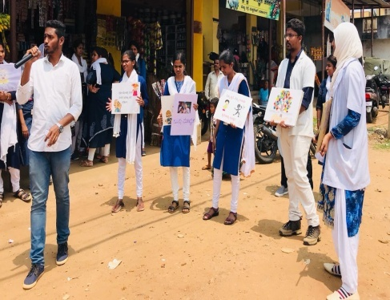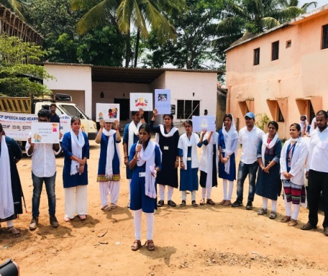

**4. Public Lecture Series: Nil**

**5. Press Releases and Media Coverage:**

The Department of Prevention of Communication Disorders had organized and conducted the street play as a part of the outreach clinical curriculum of the internship students on 07.04.2018 in Mullusoge , Kudige and Kudumangalore villages, Somvarpet taluk, Madikeri district. The street play intended for creating awareness and educating the public regarding the prevention and early identification of communication disorders. Street play got extensive publicity in print media.

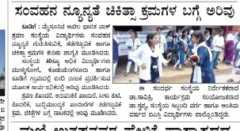

1. **Material Development:**

**Designing of the following mentioned pamphlets was done and these pamphlets are ready to release for Annual day 2018.**

* Know more about Voice and its disorders (English)
* Know this to prevent communication disorders (English)
* Specific Language Impairment (English)
* Communication disorders in elderly (English)
* Know more about Dementia (English)
* Prevention of developmental disorders (English)
* Communication disorders in Intellectual disability (English)
* Attention Deficit Hyperactivity Disorder (Kannada, Hindi, Tamil, Malayalam & Marathi)
* Ear discharge and its prevention (Hindi, Tamil)

1. **AWARDS AND HONOURS RECEIVED BY FACULTY AND STAFF: Nil**
2. **EXTRA CURRICULLAR ACTIVITIES: Nil**
3. **AIISH Gymkhana: Nil**
4. **NSS: Nil**
5. **Others:** Nil
6. **MAJOR EVENTS OF THE YEAR**: **Nil**
7. **EMINENT VISITORS**

* **UGC expert committee** had visited the Department on 4th May 2018 and was oriented regarding the activities of POCD.
* Industrial medical officers from ROHCS, Bangalore had visited the Department on 4th Nay 2018 and were oriented on the “Prevention, early identification and management of communication disorders” majorly focusing on **Noise induced hearing loss.**

1. **ANYOTHERS:**

|  |  |  |
| --- | --- | --- |
| * + - 1. **Dept. Related** | | |
| **S.No** | **Particulars** |  |
| 1. | Computerization activities | Given corrections in computerization of elderly screening.  Given corrections in computerization of elderly screening. Initiation of Phase II of computerisation. Initiation of Statistical report of elderly screening.  Initiation of Phase II of computerisation.  Correction of Statistical report of elderly screening.  Initiated OSC computerisation. Audiology OPD format, Speech OPD format, and two speech and language Proforma were given for computerisation. |
| 2. | Purchase meeting | Indent of furniture for COE was submitted to Director |
| 3. | **RE BE 2018-19-20** | **RE BE** wasprepared for POCD activity |
| **2. OSC Related** | | |
| **1..** | **OSC- Saragur and Sarguru** | Annual consumable indent has been sent to OSC centers at Sagara and Sarguru.  HOD, faculty and OSC in charge (staff) visited OSC centers at Sarguru, Akkihebalu, Hulahalli, KR Nagara Taluk Hospital, Santhemarali Government Hospital and Gumballi.  HOD, faculty and OSC in charge (staff) visited OSC centers, Sagara on 5th and 6th July 2018. |
| * + - 1. NBS Related | | |
|  | NBS | Meeting was conducted over the telephone regarding the issues in the NBS centers at Bhagalpur and Lucknow  NBS screening card was prepared (which will be given for the mother of infants) for documentation proposes. |

1. **Recruitment/Relief of duties for the reporting year: Nil**

|  |  |  |  |  |
| --- | --- | --- | --- | --- |
| **Sl.No** | **Name of the staff** | **Designation** | **Joining date** | **Reliving date** |
| 1. | Mr Dharm Pal Singh | Speech and hearing technician  Lucknow | 22.05.2018 | - |
| 2. | Ms. Tejaswikumari | Speech and hearing technician  Bhagalpur | 22.05.2018 | - |

**Sd/-**

**Head, Dept. of POCD**